Network Traffic Analyzer

ABSTRACT
Networking, which is one of the most significant aspects of information technology revolution, is developing increasingly day after day. This is because it offers a huge amount of knowledge, resources and human experiences. On the one hand, it contains a considerable amount of harmful content, because of misusing. On the other hand, sitting for a long time in front of PC’s or other network-based devices can affect body badly. As enterprise computing environments become more network-oriented, the importance of network traffic monitoring and analysis intensifies. Most existing traffic monitoring and analysis tools focus on measuring the traffic loads of individual network segments. Further, they typically have complicated user interfaces. This paper introduces and presents the design an application and implementation of an MS Windows-compatible software tool that is used to manage networks usage and keep track of every network user activity. An application consists of two parts client and server. The client side is a backgroundapplication runs whenever the PC is run, it turns off only when the PC is turned off and launched with its startup. The server side is more complex-GUI application that is responsible mainly for receiving data sent by clients group, managing and updating data to provide network owner up to date view. The effectiveness of an application has been verified by applying it to an enterprise network environment.
CHAPTER 2
2. SYSTEM ANALYSIS
  - EXISTING SYSTEM

- Most existing traffic monitoring and analysis tools focus on measuring the traffic loads of individual network segments.
- The system uses exist networking protocols to communicate with router, and other devices and control them remotely.
- Traffic measurement and analysis are crucial to the design, operation and maintenance of wide-area networks based on Internet Protocol.
- This measurement data is used for traffic engineering, performance debugging, network operations, and to measure compliance with performance targets.
2.1.1 DRAWBACKS OF EXISTING SYSTEM :
- They require additional modern network traffic analysis tools in order to manage network, solve the network problems quickly to avoid network failure, and handle the network security.
- The decision tree (DT) is powerful and popular supervised machine learning for decision-making and classification problems.
- Neural networks provide a solution to the problem of network traffic prediction by applying numbers of techniques.
2.2. PROPOSED SYSTEM
- This paper presents a review of several techniques proposed, used and practiced for network traffic analysis and prediction.
- The graph based clustering algorithm is proposed for partition data set into a number of clusters. They proposed rough set theory to extract the relevant attributes from entire data set and for classification.
- The objective of the proposed project here that it is designed an application to help networks owners to control their networks in a proper way by providing them necessary data and controlling permissions over their clients.
2.2.1. ADVANTAGES OF PROPOSED SYSTEM
- The sensitivity and false positive rate metrics are applied to measure the performances of algorithms.
- A number of current studies have reported that the SVM results of giving higher performance with respect to classification accuracy than the other classification approaches.
- The detection rate metric is presented to measure the performance of rough set theory approach.
- They used positive rate, accuracy metrics at the training and testing time to measure performance of their approaches.

Literature Survey:
TITLE | AUTHORS | DESCRIPTION
Large-scale network traffic monitoring with DBStream, a system for rolling big data analysis | Bär, A., Finamore, A., Casas, P., Golab, L., & Mellia, M. (2014, October). | The complexity of the Internet has rapidly increased, making it more important and challenging to design scalable network monitoring tools.
Evaluating Efficiency of Multi-Layered Switch Architecture in All-Optical Networks | Daadoo, M., Tarapiah, S., & Atalla, S. (2016). | We propose and analyze layered switch architectures that possess high design flexibility, greatly reduced switch size, and high expandability.
Searching of optimum characteristics of multilayer switching architecture in all-optical networks | Daadoo, M., & Daraghmi, Y. (2015, August). | While designing competitive switchboard, we should consider several services including the possibility of authorization, performance, number of ports, encryption, data compression, class of service (CoS) and quality of service (QoS).
High speed network traffic analysis with commodity multi-core systems | Fusco, F., & Deri, L. (2010, November). | This work presents common pitfalls of network monitoring applications when used with multi-core systems, and presents solutions to these issues.

2.3 FEASIBILITY STUDY
The feasibility Analysis is an analytical program through project manager determines the project success ratio and through feasibility study project manager able to see either project. The key considerations involved in the feasibility analysis are:
- Economic Feasibility
- Technical Feasibility
- Operational Feasibility
- Environmental Feasibility
2.3.1 ECONOMICAL FEASIBILITY
Hence this project is economically feasible there is no need to involve any cost for this project.
2.3.2 TECHNICAL FEASIBILITY
Software Technologies used are PHP and MySql. In the educational institutions, it is possible to update the system in future. No special hardware is required for the purpose of using this system. Hence it is declared that this project is technically feasible.
2.3.3 OPERATIONAL FEASIBILITY
As the admin work mainly to maintain the Patient and Doctor .Doctor will predict patient cancer disease. Hence it is easy to operate with training. Therefore it is operationally feasible for implementation.
2.3.4 ENVIRONMENTAL FEASIBILITY
This project environment is correct as a admin has developed this system and no expenditure is involved under any head and this process is part of admin document management, this project environment is accessible.

2.4 SYSTEM REQUIREMENTS
- System : Pentium IV 2.4 GHz.
- Hard Disk : 40 GB.
- Monitor : 15 inch VGA Color.
- Mouse : Logitech Mouse.
- Ram : 512 MB
- Keyboard : Standard Keyboard

2.4.1 HARDWARE REQUIREMENTS
The Hardware of the computer consists of physical component such as Input Devices, Storage Devices, Processing & Control units and Output Devices. Computer includes external storage unit to store data in programs.
The Hardware Configuration involved in this project
- System : Pentium IV 2.4 GHz.
- Hard Disk : 40 GB.
- Monitor : 15 inch VGA Color.
- Mouse : Logitech Mouse.
- Ram : 512 MB
- Keyboard : Standard Keyboard

2.4.2 SOFTWARE REQUIREMENTS
Software is a group of programs that computers need to do a particular task. It is an essential requirement of Computer System. The Software used to develop the project is
- Operating System : Windows XP.
- Platform : DOT NET TECHNOLOGY
- Front End : ASP.Net 3.5
- Back End : SQL SERVER 2005

CHAPTER 3
SYSTEM DESIGN AND DEVELOPEMENT
SYSTEM ARCHICTURE

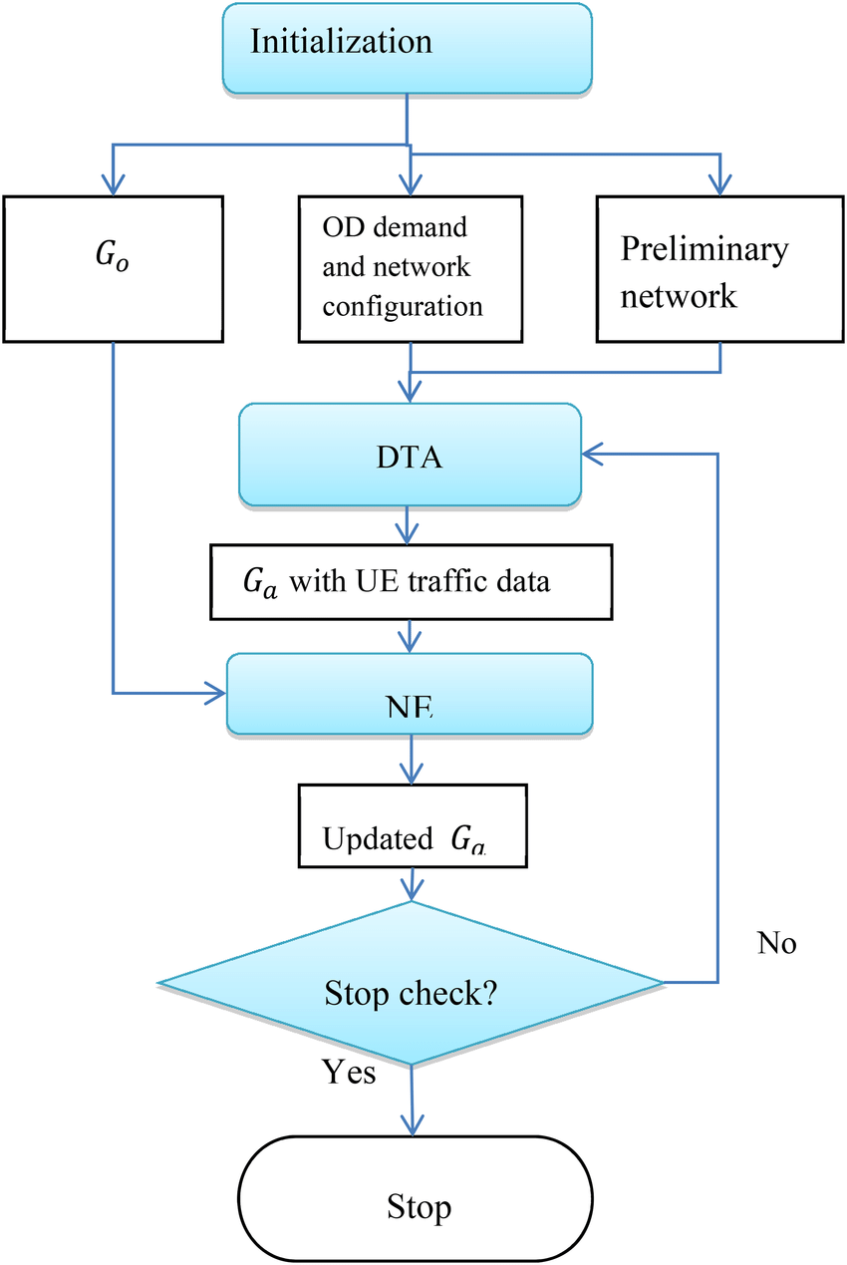

CHAPTER 4
TESTING AND IMPLEMENTATION

  - TESTING
Implementation is the stage of the project when the theoretical design is turned into a working system. This is the final and important phase in the system life cycle It is actually the process of converting the new system into a operational one.

4.1.1Unit Testing
Unit testing comprises the set of tests performed by an individual programmer prior to integration of the unit into a larger system. The module interface is tested to ensure that information properly flows into and out of the program unit. The local data structure is examined to ensure that data stored temporarily maintains its integrity during all steps in an algorithm’s execution. Boundary conditions are tested to ensure that the module operates properly at boundaries established to limit or restrict processing. All independent paths through the control structure are tested. All error-handling paths are tested.

4.1.2 Block Box Testing
Black-box testing is a method of software testing that examines the functionality of an application without peering into its internal structures or workings. This method of test can be applied virtually to every level of software testing: unit, integration, system and acceptance. It is sometimes referred to as specification-based testing.

4.2 SYSTEM IMPLEMENTATION
Implementation is the stage of the project when the theoretical design is turned into a working system. This is the final and important phase in the system life cycle It is actually the process of converting the new system into a operational one.

CHAPTER 5
CONCLUSION:
In this study of network management system, the proposed approach is implementing a set of wellknown networking protocols to find everything about them and monitor the full state of the network. It is an efficient method that provides all needed knowledge about network suitable way that optimizes the needed owner interactions that is necessary to configure things as desired. The solution is programmatically modeled by using a set of simple and effective algorithmic techniques that manage client’s communications do requests to the router pages, file transferring and screen sharing with basic controlling. Moreover, the way in which application designed improves user control efficiency when using remote techniques, because of providing control of up to five devices concurrently adjacent tabs that control devices by visiting from remote sessions and windows remote connection utility, which provides each remote session in an independent window that causes difficulty in managing them by two remote sessions.

CHAPTER-6
REFERENCE
- 1. Bär, A., Finamore, A., Casas, P., Golab, L., & Mellia, M. (2014, October). Large-scale network traffic monitoring with DBStream, a system for rolling big data analysis. In Big Data (Big Data), 2014 IEEE International Conference on (pp. 165-170). IEEE.
- 2. Daadoo, M., Tarapiah, S., & Atalla, S. (2016). Evaluating Efficiency of Multi-Layered Switch Architecture in All-Optical Networks. International Journal of Applied Engineering Research, 11(22), 11030-11036.
- 3. Daadoo, M., & Daraghmi, Y. (2015, August). Searching of optimum characteristics of multilayer switching architecture in all-optical networks. In Heterogeneous Networking for Quality, Reliability, Security and Robustness (QSHINE), 2015 11th International Conference on (pp. 50-55). IEEE.
- 4. Fusco, F., & Deri, L. (2010, November). High speed network traffic analysis with commodity multi-core systems. In Proceedings of the 10th ACM SIGCOMM conference on Internet measurement (pp. 218-224). ACM.
- 5. Remote Desktop Protocol. Wikimedia Foundation, n.d. Web. 18 June 2016.
- 6. I.Klevecka, Forecasting Network Traffic loads neural network and Linear (ISSN 1407-5806, 2009) Vol.14, No.2 , pp.20-28.
- 7. E. S. Yu, C.Y.R.Chen, Traffic Prediction Using Neural Networks ( IEEE , 1993) 0-7803-0917-0.
- 8. T. Qin, X. Guan, W. Li, P.Wang, Monitoring Malicious Traffic Flow Based on Independent Component Analysis, ( IEEE ,2009) 978-1-4244-3434-3.
- 9. G. Rutka, Some Aspects of Traffic Analysis used for Internet Traffic Prediction (ISSN, 2009) 1392 – 1215.
- 10. S. Chabaa1, A. Zeroual1, J. Antari1, Identification and Prediction of Internet Traffic Using Artificial Neural Networks (scientific research, 2010) 2, 147-155.

