Milk pasteurization other than heat treatment

ABSTRACT
This paper deals with milk processing with emphasis on pasteurization. The heat treatment of milk is important in terms of product quality and health safety. The goal of this paper is determination of heat consumption, inactivation effect and Pasteur criterion, by which pasteurization effectiveness is evaluated. The methodical part contains calculations, which were used for estimation of results and description of a pasteurization station used for milk processing. Results obtained in usual working time confirmed that necessary heating and cooling performance were achieved for guarantee of high-quality milk production. Real specific heat consumption was 51.69 kJ/kg. It was achieved by use of regeneration sections in the pasteurizer. These sections allow for a repeated use of 82 % of heat used for heating of raw milk in pasteurization.

CHAPTER 2
2. SYSTEM ANALYSIS
  - EXISTING SYSTEM

- Some potentially dangerous microorganism may exist when we use conventional method for milk pasteurization.
- Several different standard protocols exist for conducting ALP assays, each based on different sample preparatory methods or ALP substrate.
- Some concern exists about these different tests with regard to their status as validated ALP assays. Under standard conditions of assay, the ALP method has been shown to be are markably valuable tool for the routine assessment of milk pasteurization validation, yet some concerns still exist.
2.1.1 DRAWBACKS OF EXISTING SYSTEM :
- The aim of this study was to determine the impact of different milk pasteurization temperature and time combinations on the survival of the selected microbes.
- Milk contains bacteria when improperly handles create conditions where bacteria can multiply Antibiotic residues in milk due to use of antibiotics widely in food producing animals, supposed problems for the both dairy industry and consumers.
- The use of sunshine to cook and pasteurize contaminated water and milk could provide a new approach to these debilitating problems.
2.2. PROPOSED SYSTEM
- In order to inactivate highly heat-resistant spores, higher temperatures (≥150◦C) for very short times (<1 s) have been proposed.
- A study was conducted by the International Dairy Federation and the International Organization for Standardization to evaluate the reproducibility of a chemilumine scent method for ALP at 50,100,350, and 500mU/mL in the whole milk of multiple species to meet new regulations in the US and proposed regulations in the EC.
- This method is proposed as an alternative for dairy industries and remote areas where expensive instruments are unavailable.
2.2.1. ADVANTAGES OF PROPOSED SYSTEM
- The energy demand of food production is compared to its nutrition energy efficiency.
- The efficient surface of plates is burnished, which, combined with turbulent flow, is manifested by minimizing of incrustations and dirt generation.
- The pasteurization process of milk is efficient if the milk retains pasteurization temperature for the duration needed to inactivate pathogenic microbiota in the milk.

2.3 FEASIBILITY STUDY
The feasibility Analysis is an analytical program through project manager determines the project success ratio and through feasibility study project manager able to see either project. The key considerations involved in the feasibility analysis are:
- Economic Feasibility
- Technical Feasibility
- Operational Feasibility
- Environmental Feasibility
2.3.1 ECONOMICAL FEASIBILITY
Hence this project is economically feasible there is no need to involve any cost for this project.
2.3.2 TECHNICAL FEASIBILITY
Software Technologies used are PHP and MySql. In the educational institutions, it is possible to update the system in future. No special hardware is required for the purpose of using this system. Hence it is declared that this project is technically feasible.
2.3.3 OPERATIONAL FEASIBILITY
As the admin work mainly to maintain the Patient and Doctor .Doctor will predict patient cancer disease. Hence it is easy to operate with training. Therefore it is operationally feasible for implementation.
2.3.4 ENVIRONMENTAL FEASIBILITY
This project environment is correct as a admin has developed this system and no expenditure is involved under any head and this process is part of admin document management, this project environment is accessible.

2.4 SYSTEM REQUIREMENTS
- System : Pentium IV 2.4 GHz.
- Hard Disk : 40 GB.
- Monitor : 15 inch VGA Color.
- Mouse : Logitech Mouse.
- Ram : 512 MB
- Keyboard : Standard Keyboard

2.4.1 HARDWARE REQUIREMENTS
The Hardware of the computer consists of physical component such as Input Devices, Storage Devices, Processing & Control units and Output Devices. Computer includes external storage unit to store data in programs.
The Hardware Configuration involved in this project
- System : Pentium IV 2.4 GHz.
- Hard Disk : 40 GB.
- Monitor : 15 inch VGA Color.
- Mouse : Logitech Mouse.
- Ram : 512 MB
- Keyboard : Standard Keyboard

2.4.2 SOFTWARE REQUIREMENTS
Software is a group of programs that computers need to do a particular task. It is an essential requirement of Computer System. The Software used to develop the project is
- Operating System : Windows XP.
- Platform : DOT NET TECHNOLOGY
- Front End : ASP.Net 3.5
- Back End : SQL SERVER 2005

CHAPTER 3
SYSTEM DESIGN AND DEVELOPEMENT
SYSTEM ARCHICTURE

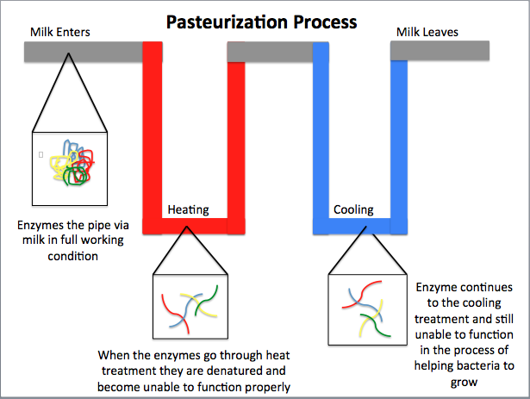

CHAPTER 4
TESTING AND IMPLEMENTATION

  - TESTING
Implementation is the stage of the project when the theoretical design is turned into a working system. This is the final and important phase in the system life cycle It is actually the process of converting the new system into a operational one.

4.1.1Unit Testing
Unit testing comprises the set of tests performed by an individual programmer prior to integration of the unit into a larger system. The module interface is tested to ensure that information properly flows into and out of the program unit. The local data structure is examined to ensure that data stored temporarily maintains its integrity during all steps in an algorithm’s execution. Boundary conditions are tested to ensure that the module operates properly at boundaries established to limit or restrict processing. All independent paths through the control structure are tested. All error-handling paths are tested.

4.1.2 Block Box Testing
Black-box testing is a method of software testing that examines the functionality of an application without peering into its internal structures or workings. This method of test can be applied virtually to every level of software testing: unit, integration, system and acceptance. It is sometimes referred to as specification-based testing.

4.2 SYSTEM IMPLEMENTATION
Implementation is the stage of the project when the theoretical design is turned into a working system. This is the final and important phase in the system life cycle It is actually the process of converting the new system into a operational one.

CHAPTER 5
CONCLUSION:
The research paper deals with the heat treatment of milk, which is an important part of the production of high-qualityand healthy milk for human nutrition. Pasteurization is the main heat process in dairy industry. Results of the work show that the operation of the pasteurizer, together with machine control and automation achieves necessary heating and cooling capacity for production of high-quality milk and dairy products. Theoretical specific heat consumption for pasteurization of milk is 287.15 kJ/kg, but real specific heat consumption was 51.69 kJ/kg. It was achieved by using regeneration sections in the pasteurizer. These sections allow reusing 82 % of heat used in pasteurization.

