Develop an application to facilitate IPR filing for the grassroots community

ABSTRACT
The primary driver for innovations in the formal sector is credited to the institution of patenting. Intellectual property rights (IPRs) as the extrinsic motivational factor have supported innovations by firms and industries which have a large market and resources to commercialise their products. Grassroots innovations, on the other hand, represent a culture of individual innovators outside formal sector who innovate out of adversity, curiosity and needs. Most of the innovators have cited intrinsic motivation behind the innovation and are unaware of IPR. However, there is a paucity of literature on the relation between IPR and innovations in the informal sector. Drawing on the literature on IPR and innovations in the formal sector, we examine whether the same theories and rationales apply to a different nature of innovations in the informal sector. This is an exploratory study and to map the current scenario of patenting for grassroots innovations secondary data were collected from the National Innovation Foundation (NIF) website. To understand the innovators’ perception, we interviewed them through various means and on different sites. The study finds that although there was no initial intention to innovate for extrinsic incentives like patenting, there is an increasing trend in filing patents for grassroots innovations by the NIF in India.

CHAPTER 2
2. SYSTEM ANALYSIS
  - EXISTING SYSTEM

- The quantitative expansion of existing activities generates growth or horizontal expansion.
- Community capacity is the interaction of human capital, organizational resources, and social capital existing within a given community that can be leveraged to solve collective problems and improve or maintain the well-being of that community.
- It may operate through informal social processes and/or organized efforts by individuals, organizations, and social networks that exist among them and between them and the larger systems of which the community is a part.
2.1.1 DRAWBACKS OF EXISTING SYSTEM :
- It also has a group of disadvantaged people that require support networks. The governance arrangements did create some minor disadvantages for the facilitator.
- This is an important ethical issue for funding bodies and researchers alike to consider before embarking on what may seem an altruistic endeavour.
- This is particularly relevant in rural and remote areas where there is limited capacity to import expertise into the community, and rationalisation and centralisation of the state and corporate sector has much more impact on rural than metropolitan communities.
2.2. PROPOSED SYSTEM
- The main social purpose of protection of copyright and related rights is to encourage and reward creative work.
- The social purpose is to provide protection for the results of investment in the development of new technology, thus giving the incentives and means to finance research and development activities.
- The exclusive rights include the right of reproduction and the right of importation, sale and other distribution for commercial purposes.
2.2.1. ADVANTAGES OF PROPOSED SYSTEM
- The granting of patents for inventions claiming substances intended for use or capable of being used as, food, medicine or drug or all substances resulting from chemical processes was withdrawn.
- An industrial design is that aspect of a useful article, which is ornamental or aesthetic. It may consist of three-dimensional features such as the shape or surface of the article, or two dimensional features such as patterns, lines or color.
- It does require that a person lawfully in control of such information must have the possibility of preventing it from being disclosed to, acquired by, or used by others without his/her consent in a manner contrary to honest commercial practices.
Literature Survey:
TITLE | AUTHORS | DESCRIPTION
Building Community Capacity | Chaskin RJ, Brown P, Venkatesh S and Vidal A (2001) | Community capacity building is often the means by which the outcome of increased community empowerment can be achieved.
Building collaborative capacity in community coalitions: A review and integrative framework | Foster-Fishman PG, Berkowitz SL, Lousbury DW, Jacovson S and Allen NA (2001) | The purpose of this review was to develop an integrative framework that captures the core competencies and processes needed within collaborative bodies to facilitate their success.
Grassroots involvement | Kaye G (2001) | A multi-stage sample procedure was adopted, involving the random sampling technique which was used in selecting 2 communities from each of the 5 clans in the LGA.
Building development capacity in non-metropolitan communities | McGuire M, Rubin B, Agranoff R and Richards C (1994) | Its main objectives are to implement an entrepreneurship program and design a plan of capacity building and education for business in order to promote the development of rural areas.

2.3 FEASIBILITY STUDY
The feasibility Analysis is an analytical program through project manager determines the project success ratio and through feasibility study project manager able to see either project. The key considerations involved in the feasibility analysis are:
- Economic Feasibility
- Technical Feasibility
- Operational Feasibility
- Environmental Feasibility
2.3.1 ECONOMICAL FEASIBILITY
Hence this project is economically feasible there is no need to involve any cost for this project.
2.3.2 TECHNICAL FEASIBILITY
Software Technologies used are PHP and MySql. In the educational institutions, it is possible to update the system in future. No special hardware is required for the purpose of using this system. Hence it is declared that this project is technically feasible.
2.3.3 OPERATIONAL FEASIBILITY
As the admin work mainly to maintain the Patient and Doctor .Doctor will predict patient cancer disease. Hence it is easy to operate with training. Therefore it is operationally feasible for implementation.
2.3.4 ENVIRONMENTAL FEASIBILITY
This project environment is correct as a admin has developed this system and no expenditure is involved under any head and this process is part of admin document management, this project environment is accessible.

2.4 SYSTEM REQUIREMENTS
- System : Pentium IV 2.4 GHz.
- Hard Disk : 40 GB.
- Monitor : 15 inch VGA Color.
- Mouse : Logitech Mouse.
- Ram : 512 MB
- Keyboard : Standard Keyboard

2.4.1 HARDWARE REQUIREMENTS
The Hardware of the computer consists of physical component such as Input Devices, Storage Devices, Processing & Control units and Output Devices. Computer includes external storage unit to store data in programs.
The Hardware Configuration involved in this project
- System : Pentium IV 2.4 GHz.
- Hard Disk : 40 GB.
- Monitor : 15 inch VGA Color.
- Mouse : Logitech Mouse.
- Ram : 512 MB
- Keyboard : Standard Keyboard

2.4.2 SOFTWARE REQUIREMENTS
Software is a group of programs that computers need to do a particular task. It is an essential requirement of Computer System. The Software used to develop the project is
- Operating System : Windows XP.
- Platform : DOT NET TECHNOLOGY
- Front End : ASP.Net 3.5
- Back End : SQL SERVER 2005

CHAPTER 3
SYSTEM DESIGN AND DEVELOPEMENT
SYSTEM ARCHICTURE

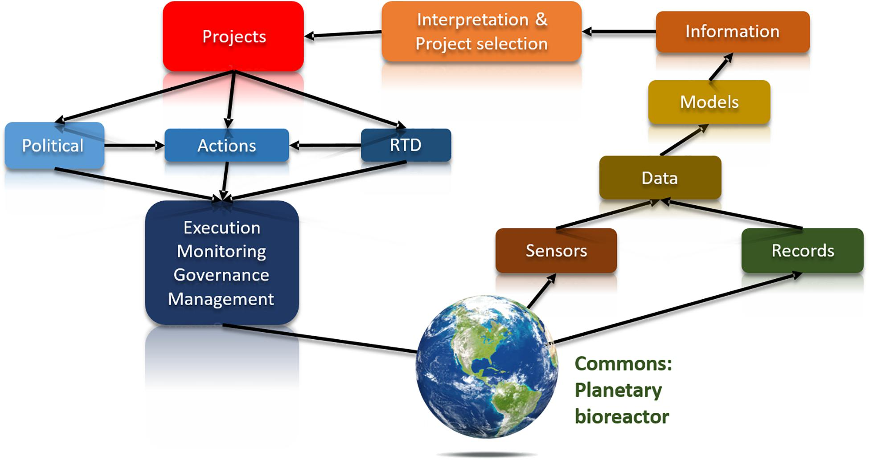

CHAPTER 4
TESTING AND IMPLEMENTATION

  - TESTING
Implementation is the stage of the project when the theoretical design is turned into a working system. This is the final and important phase in the system life cycle It is actually the process of converting the new system into a operational one.

4.1.1Unit Testing
Unit testing comprises the set of tests performed by an individual programmer prior to integration of the unit into a larger system. The module interface is tested to ensure that information properly flows into and out of the program unit. The local data structure is examined to ensure that data stored temporarily maintains its integrity during all steps in an algorithm’s execution. Boundary conditions are tested to ensure that the module operates properly at boundaries established to limit or restrict processing. All independent paths through the control structure are tested. All error-handling paths are tested.

4.1.2 Block Box Testing
Black-box testing is a method of software testing that examines the functionality of an application without peering into its internal structures or workings. This method of test can be applied virtually to every level of software testing: unit, integration, system and acceptance. It is sometimes referred to as specification-based testing.

4.2 SYSTEM IMPLEMENTATION
Implementation is the stage of the project when the theoretical design is turned into a working system. This is the final and important phase in the system life cycle It is actually the process of converting the new system into a operational one.

CHAPTER 5
CONCLUSION:
It is clear that it is unfair and unrealistic to expect communities with very little existing community cohesion to rise to the challenge of building significant capacity without special consideration of their unique challenges. This is particularly relevant in rural and remote areas where there is limited capacity to import expertise into the community, and rationalisation and centralisation of the state and corporate sector has much more impact on rural than metropolitan communities. Funding such communities without consideration of these issues runs the risk of damaging them and reducing their future community building capacity. This is an important ethical issue for funding bodies and researchers alike to consider before embarking on what may seem an altruistic endeavour.

CHAPTER-6
REFERENCE
- Chaskin RJ, Brown P, Venkatesh S and Vidal A (2001) Building Community Capacity. New York: Aldine de Gruyter.
- Foster-Fishman PG, Berkowitz SL, Lousbury DW, Jacovson S and Allen NA (2001) Building collaborative capacity in community coalitions: A review and integrative framework. American Journal of Community Psychology 29(2): 241-261.
- Howe B and Cleary R (2001) Community building: Policy issues and Strategies for the Victorian Government, Melbourne: Victorian Government.
- I & J Management Services (2002) Community Capacity Building Initiative: Interim Review. Sunbury, Vic.: I & J Management Services.
- Kaye G (2001) Grassroots involvement. American Journal of Community Psychology 29(2): 269-275.
- Larner W and Butler M (2004) Governmentalities of local partnerships. Research Paper Number 12. Auckland: Local Partnerships and Governance Research Group.
- Marinetto M (2003) Who wants to be an active citizen? The politics and practice of community involvement. Sociology 37(1): 103-120.
- McGuire M, Rubin B, Agranoff R and Richards C (1994) Building development capacity in non-metropolitan communities. Public Administration Review 54(5): 426-433.
- Moore AB and Brooks R (2000) Learning communities and community development: Describing the process. International Journal of Adult and Vocational Learning 1: 1-15.
- O’Meara P, Chesters J and Han G-S (2004) Outside - Looking In: evaluating a community capacity building project. Rural Society 14(2): 126-141.

