Develop a digital platform for assimilating data of operational performance of existing STPs CETPs ETPs through creation of data exchange interface and flashing messages against defaults Problem Statements

ABSTRACT
Predicting future changes in ecosystem services is not only highly desirable but is also becoming feasible as several forces (e.g., available big data, developed data assimilation (DA) techniques, and advanced cyber-infrastructure) are converging to transform ecological research into quantitative forecasting. To realize ecological forecasting, we have developed an Ecological Platform for Assimilating Data (EcoPAD, v1.0) into models. EcoPAD (v1.0) is a web-based software system that automates data transfer and processing from sensor networks to ecological forecasting through data management, model simulation, data assimilation, forecasting, and visualization. It facilitates interactive data–model integration from which the model is recursively improved through updated data while data are systematically refined under the guidance of model. EcoPAD (v1.0) relies on data from observations, process-oriented models, DA techniques, and the web-based workflow. We applied EcoPAD (v1.0) to the Spruce and Peatland Responses Under Climatic and Environmental change (SPRUCE) experiment in northern Minnesota. The EcoPAD-SPRUCE realizes fully automated data transfer, feeds meteorological data to drive model simulations, assimilates both manually measured and automated sensor data into the Terrestrial ECOsystem (TECO) model, and recursively forecasts the responses of various biophysical and biogeochemical processes to five temperature and two CO₂ treatments in near-real time (weekly).
CHAPTER 2
2. SYSTEM ANALYSIS
  - EXISTING SYSTEM

- More importance than the ease of re-using existing apps, source code, platforms and standards, is the fact that this can significantly lower the investment cost in terms of money, effort and expertise.
- However, it can be a challenge to find existing apps with development documentation that is thorough, up-to-date, and also includes feedback.
- When such structured vocabularies exist, either as dictionaries, glossaries, gazetteers, or ontologies, they can serve as knowledge entities that can drive further NLP systems.
2.1.1 DRAWBACKS OF EXISTING SYSTEM :
- Data assimilation is growing in importance as process-based ecological models, despite largely simplifying the real systems, need to be complex enough to address sophisticated ecological issues.
- These ecological issues are composed of an enormous number of biotic and abiotic factors interacting with each other.
- Such shifts quantify the potential acclimation of methane production to warming, and future climate warming is likely to have a smaller impact on emissions than most current predictions that do not take account of acclimation.
2.2. PROPOSED SYSTEM
- The proposed framework is part of a platform developed by the hackAIR project2 that gathers and fuses environmental data and specifically particulate matter (PM) measurements from official open sources and from user generated content.
- The proposed model involves the use of a negative log-log ordinal classifier to fit the ordinal output well, and the use of a new activation function for photo air pollution level estimation.
- We believe that these two repositories cover adequately the needs of the proposed framework and there is no need for a specialized webcam discovery framework.
2.2.1. ADVANTAGES OF PROPOSED SYSTEM
- It is usually unidirectional as data are normally used to train models, while the guidance of the model for efficient data collection is limited.
- Similarly to these systems, EcoPAD (v1.0) takes advantage of modern information technology, especially the metadata catalog, to manage diverse data streams.
- Users will also be able to access data directly through programming environments like R, Python, and MATLAB. Simplicity, ease of use, and interoperability are among the main advantages of this API, which enables web-based modeling.
Literature Survey:
TITLE | AUTHORS | DESCRIPTION
Robustness and uncertainty in terrestrial ecosystem carbon response to CMIP5 climate change projections | Ahlstrom, A., Schurgers, G., Arneth, A., and Smith, B. | We found robust patterns in terms of an extra-tropical loss of carbon, except for a temperature induced shift in phenology, leading to an increased spring uptake of carbon.
The data assimilation research testbed A Community Facility | Anderson, J., Hoar, T., Raeder, K., Liu, H., Collins, N., Torn, R., and Avellano, A. | The DART community ensemble data assimilation facility provides students, educators, and scientists with unprecedented access to free, state-of-the-art assimilation tools.
A new crop yield forecasting model based on satellite measurements applied across the Indus Basin, Pakistan | Bastiaanssen, W. G. M. and Ali, S. | The computations were executed in a GIS environment using 20 satellite measurements of the advanced very high resolution radiometer (AVHRR) to cover an annual crop rotation cycle.
The limits to prediction in ecological systems | Beckage, B., Gross, L. J., and Kauffman, S. | When realized predictability is low relative to intrinsic predictability, prediction can be improved through improved model structure or specification of parameters.

2.3 FEASIBILITY STUDY
The feasibility Analysis is an analytical program through project manager determines the project success ratio and through feasibility study project manager able to see either project. The key considerations involved in the feasibility analysis are:
- Economic Feasibility
- Technical Feasibility
- Operational Feasibility
- Environmental Feasibility
2.3.1 ECONOMICAL FEASIBILITY
Hence this project is economically feasible there is no need to involve any cost for this project.
2.3.2 TECHNICAL FEASIBILITY
Software Technologies used are PHP and MySql. In the educational institutions, it is possible to update the system in future. No special hardware is required for the purpose of using this system. Hence it is declared that this project is technically feasible.
2.3.3 OPERATIONAL FEASIBILITY
As the admin work mainly to maintain the Patient and Doctor .Doctor will predict patient cancer disease. Hence it is easy to operate with training. Therefore it is operationally feasible for implementation.
2.3.4 ENVIRONMENTAL FEASIBILITY
This project environment is correct as a admin has developed this system and no expenditure is involved under any head and this process is part of admin document management, this project environment is accessible.

2.4 SYSTEM REQUIREMENTS
- System : Pentium IV 2.4 GHz.
- Hard Disk : 40 GB.
- Monitor : 15 inch VGA Color.
- Mouse : Logitech Mouse.
- Ram : 512 MB
- Keyboard : Standard Keyboard

2.4.1 HARDWARE REQUIREMENTS
The Hardware of the computer consists of physical component such as Input Devices, Storage Devices, Processing & Control units and Output Devices. Computer includes external storage unit to store data in programs.
The Hardware Configuration involved in this project
- System : Pentium IV 2.4 GHz.
- Hard Disk : 40 GB.
- Monitor : 15 inch VGA Color.
- Mouse : Logitech Mouse.
- Ram : 512 MB
- Keyboard : Standard Keyboard

2.4.2 SOFTWARE REQUIREMENTS
Software is a group of programs that computers need to do a particular task. It is an essential requirement of Computer System. The Software used to develop the project is
- Operating System : Windows XP.
- Platform : DOT NET TECHNOLOGY
- Front End : ASP.Net 3.5
- Back End : SQL SERVER 2005

CHAPTER 3
SYSTEM DESIGN AND DEVELOPEMENT
SYSTEM ARCHICTURE

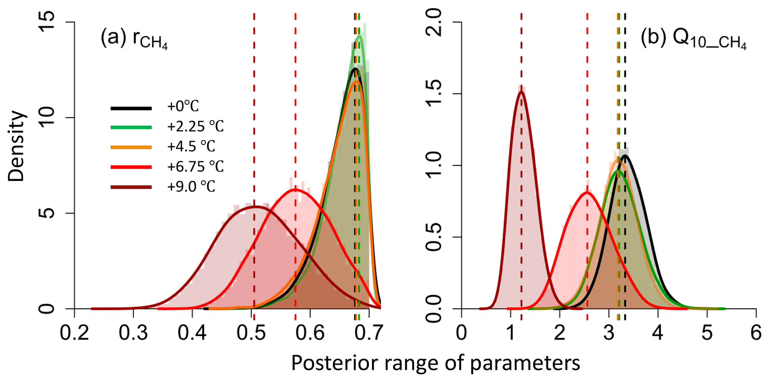

CHAPTER 4
TESTING AND IMPLEMENTATION

  - TESTING
Implementation is the stage of the project when the theoretical design is turned into a working system. This is the final and important phase in the system life cycle It is actually the process of converting the new system into a operational one.

4.1.1Unit Testing
Unit testing comprises the set of tests performed by an individual programmer prior to integration of the unit into a larger system. The module interface is tested to ensure that information properly flows into and out of the program unit. The local data structure is examined to ensure that data stored temporarily maintains its integrity during all steps in an algorithm’s execution. Boundary conditions are tested to ensure that the module operates properly at boundaries established to limit or restrict processing. All independent paths through the control structure are tested. All error-handling paths are tested.

4.1.2 Block Box Testing
Black-box testing is a method of software testing that examines the functionality of an application without peering into its internal structures or workings. This method of test can be applied virtually to every level of software testing: unit, integration, system and acceptance. It is sometimes referred to as specification-based testing.

4.2 SYSTEM IMPLEMENTATION
Implementation is the stage of the project when the theoretical design is turned into a working system. This is the final and important phase in the system life cycle It is actually the process of converting the new system into a operational one.

CHAPTER 5
CONCLUSION:
The fully interactive web-based Ecological Platform for Assimilating Data (EcoPAD, v1.0) into models aims to promote data–model integration towards predictive ecology by making complex ecosystem model and data assimilation techniques accessible to different audience. It is supported by meta-databases of biogeochemical variables, libraries of modules for process models, a toolbox of inversion techniques, and a scalable scientific workflow. Through these components, it automates data management, model simulation, data assimilation, ecological forecasting, and result visualization, providing an open, convenient, transparent, flexible, scalable, traceable, and readily portable platform to systematically conduct data–model integration towards better ecological forecasting.

CHAPTER-6
REFERENCE
- Ahlstrom, A., Schurgers, G., Arneth, A., and Smith, B.: Robustness and uncertainty in terrestrial ecosystem carbon response to CMIP5 climate change projections, Environ. Res. Lett., 7, 044008,2012 .
- Anderson, J., Hoar, T., Raeder, K., Liu, H., Collins, N., Torn, R., and Avellano, A.: The data assimilation research testbed A Community Facility, B. Am. Meteorol. Soc., 90, 1283–1296, 2009 .
- Bastiaanssen, W. G. M. and Ali, S.: A new crop yield forecasting model based on satellite measurements applied across the Indus Basin, Pakistan, Agr. Ecosyst. Environ., 94, 321–340, 2003 .
- Beckage, B., Gross, L. J., and Kauffman, S.: The limits to prediction in ecological systems, Ecosphere, 2, UNSP 125, 2011 .
- Clark, J. S., Lewis, M., McLachlan, J. S., and HilleRisLambers, J.: Estimating population spread: What can we forecast and how well?, Ecology, 84, 1979–1988, 2003 .
- Cressie, N., Calder, C. A., Clark, J. S., Hoef, J. M. V., and Wikle, C. K.: Accounting for uncertainty in ecological analysis: the strengths and limitations of hierarchical statistical modeling, Ecol. Appl., 19, 553–570, 2009.
- Dietze, M. C., Lebauer, D. S., and Kooper, R.: On improving the communication between models and data, Plant Cell Environ., 36, 1575–1585, 2013 .
- Ellison, A. M.: Repeatability and transparency in ecological research, Ecology, 91, 2536–2539, 2010 .
- Farquhar, G. D., Caemmerer, S. V., and Berry, J. A.: A biochemical-model of photosynthetic CO₂ assimilation in leaves of C₃ species, Planta, 149, 78–90, 1980 .
- Gao, C., Wang, H., Weng, E. S., Lakshmivarahan, S., Zhang, Y. F., and Luo, Y. Q.: Assimilation of multiple data sets with the ensemble Kalman filter to improve forecasts of forest carbon dynamics, Ecol. Appl., 21, 1461–1473, 2011.

