Use of digital technology or making physical prototype for micro irrigation system to improve Water Use Efficiency of Irrigation sector

ABSTRACT
A systematic attempt to determine the conditions under which, micro irrigation (MI) systems become the “best bet technology” in terms of realizing the potential benefits, and extent of reduction in crop water requirement possible through such systems is crucial for assessing our ability to address future water scarcity at the regional and national level. The ultimate objective of this research is to find out under what conditions micro irrigation system offer the best bet technology, and what benefits it can yield. The research aims at determining the potential benefits from the use of MI systems in India. This is done through assessing: a] the conditions that are favourable for MI system adoption; b] the field level and aggregate level impacts of the systems on water use; and c] the yield and economic benefits from adoption. The research also aims at assessing the potential future coverage of MI systems in India, and the potential reduction in aggregate water requirement in crop production. The research used extensive review of published and unpublished literature on the feasibility, and physical and economic impacts of various MI systems; results from field experiments carried out by IWMI in one location in Gujarat on the techno-economic viability of some MI devices; data from field-based research carried out by IWMI researchers on the economic viability of MI systems; and statistics on MI adoption in India.
CHAPTER 2
2. SYSTEM ANALYSIS
  - EXISTING SYSTEM

- The creation of WUAs supports the active participation of communities and ensures required capacity building in user groups for enhanced implementation of projects and conservation of existing water resources.
- Non-existent electric feeders at farms as electricity provides better pressured water.
- Water is an absolute imperative for the existence of life on earth and a common driver of various economic activities (agriculture, industry, etc.).
2.1.1 DRAWBACKS OF EXISTING SYSTEM :
- Such efforts are crucial for assessing our ability to address problems of water scarcity in the future at the regional and national level.
- They cited high initial cost (including mis-targetted subsidies), clogging of drippers and cracking of pipes, lack of adequate technical inputs, damages done by rodents; high cost of spare components; and insufficient extension education effort as the major problems in the slow rate of adoption of drips.
- In areas where agricultural processing units are concentrated, provision of all critical inputs including subsidies would not be a problem, as they could come from these processing units.
2.2. PROPOSED SYSTEM
- In surface irrigation systems in particular, adaptive real-time control has been proposed for the management of temporal infiltration variability.
- Water used for industrial and domestic purposes account for approximately 20% and 10% of the total global water usage, respectively.
- This has led to improved WUE, and some of the water saved has been used for environmental purposes.
2.2.1. ADVANTAGES OF PROPOSED SYSTEM
- The actual field performance in the irrigation systems is not as good as that shown in experiments and demonstrations.
- The incremental value of outputs, an important factor which influences the economic performance of drip system is the cost of installation of the system.
- The farmers should be made to pay the full cost of the system initially, and subsidies be paid in installments based on periodic review of system performance.

2.3 FEASIBILITY STUDY
The feasibility Analysis is an analytical program through project manager determines the project success ratio and through feasibility study project manager able to see either project. The key considerations involved in the feasibility analysis are:
- Economic Feasibility
- Technical Feasibility
- Operational Feasibility
- Environmental Feasibility
2.3.1 ECONOMICAL FEASIBILITY
Hence this project is economically feasible there is no need to involve any cost for this project.
2.3.2 TECHNICAL FEASIBILITY
Software Technologies used are PHP and MySql. In the educational institutions, it is possible to update the system in future. No special hardware is required for the purpose of using this system. Hence it is declared that this project is technically feasible.
2.3.3 OPERATIONAL FEASIBILITY
As the admin work mainly to maintain the Patient and Doctor .Doctor will predict patient cancer disease. Hence it is easy to operate with training. Therefore it is operationally feasible for implementation.

2.3.4 ENVIRONMENTAL FEASIBILITY
This project environment is correct as a admin has developed this system and no expenditure is involved under any head and this process is part of admin document management, this project environment is accessible.
2.4 SYSTEM REQUIREMENTS
- System : Pentium IV 2.4 GHz.
- Hard Disk : 40 GB.
- Monitor : 15 inch VGA Color.
- Mouse : Logitech Mouse.
- Ram : 512 MB
- Keyboard : Standard Keyboard

2.4.1 HARDWARE REQUIREMENTS
The Hardware of the computer consists of physical component such as Input Devices, Storage Devices, Processing & Control units and Output Devices. Computer includes external storage unit to store data in programs.
The Hardware Configuration involved in this project
- System : Pentium IV 2.4 GHz.
- Hard Disk : 40 GB.
- Monitor : 15 inch VGA Color.
- Mouse : Logitech Mouse.
- Ram : 512 MB
- Keyboard : Standard Keyboard

2.4.2 SOFTWARE REQUIREMENTS
Software is a group of programs that computers need to do a particular task. It is an essential requirement of Computer System. The Software used to develop the project is
- Operating System : Windows XP.
- Platform : DOT NET TECHNOLOGY
- Front End : ASP.Net 3.5
- Back End : SQL SERVER 2005

CHAPTER 3
SYSTEM DESIGN AND DEVELOPEMENT
SYSTEM ARCHICTURE

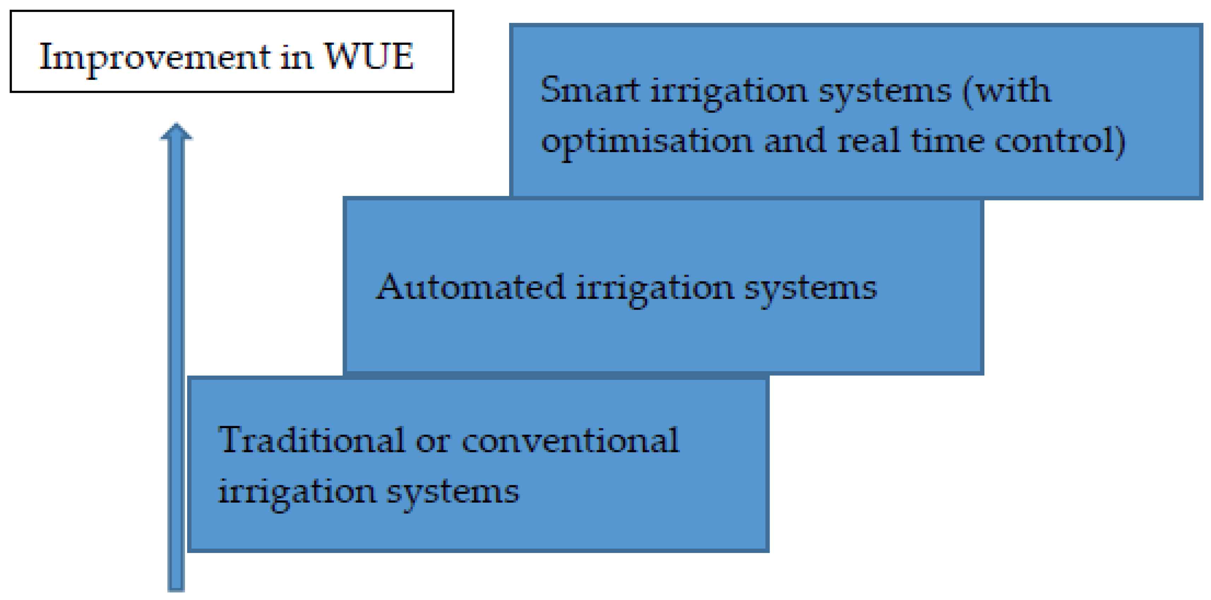

CHAPTER 4
TESTING AND IMPLEMENTATION

  - TESTING
Implementation is the stage of the project when the theoretical design is turned into a working system. This is the final and important phase in the system life cycle It is actually the process of converting the new system into a operational one.

4.1.1Unit Testing
Unit testing comprises the set of tests performed by an individual programmer prior to integration of the unit into a larger system. The module interface is tested to ensure that information properly flows into and out of the program unit. The local data structure is examined to ensure that data stored temporarily maintains its integrity during all steps in an algorithm’s execution. Boundary conditions are tested to ensure that the module operates properly at boundaries established to limit or restrict processing. All independent paths through the control structure are tested. All error-handling paths are tested.

4.1.2 Block Box Testing
Black-box testing is a method of software testing that examines the functionality of an application without peering into its internal structures or workings. This method of test can be applied virtually to every level of software testing: unit, integration, system and acceptance. It is sometimes referred to as specification-based testing.

4.2 SYSTEM IMPLEMENTATION
Implementation is the stage of the project when the theoretical design is turned into a working system. This is the final and important phase in the system life cycle It is actually the process of converting the new system into a operational one.

CHAPTER 5
CONCLUSION:
Adoption of MI systems is likely to pick up fast in arid and semi arid, well-irrigated areas, where farmers have independent irrigation sources, and where groundwater is scarce. Further, high average land holdings, large size of individual plots, and a cropping system dominated by widely spaced row crops, which are also highvalued, would provide the ideal environment for the same. The extent of real water-saving and water productivity improvements at the field level through adoption of MI systems would be high for widely spaced row crops, in arid and semi arid conditions, when the groundwater table is deep or aquifer is saline. In hard rock areas with poor groundwater potential, MI adoption would result in improved efficiency of water use, but would not reduce the total groundwater draft.

CHAPTER-6
REFERENCE
- Ahmad, M. D., I, Masih and H. Turral (2004), Diagnostic analysis of spatial and temporal variations in crop water productivity: A field scale analysis of the rice-wheat cropping system of Punjab, Pakistan, Journal of Applied Irrigation Science, 39 (10).
- Behera, B.P. and N. Sahoo, (1998), Economic evaluation of a drip irrigation system in Orissa. Environment and Ecology, Vol. 16(2): 297-299.
- Central Ground Water Board (1998), Groundwater Problems of Mehsana District. Report, Central Ground Water Board, West-Central region, Ahmedabad.
- Chavez, H. and F. Andrew (1974), Drip irrigation increase yields, lowers water costs. Citrus and Vegetable Magazine, Vol. 38: 1,6 and 18.
- Dahake, S.G., S. P. Lambe, H.V. Kalpande; D.M. Nikhade and V.V. Kalpande (1998), Utility perception of orange growers about drip irrigation system. Jouranal of Soils and Crops, Vol. 8(2): 154-156.
- Desale, P.G., P.P. Pawar and R.P. Patil (2003), Economics analysis of drip irrigation for banana. Indian Journal of Agricultural Economics, July-September, Vol. 58, No. 3, p. 506.
- Deepak, and others (2005), Water Demand Management: A Strategy to Deal with Water Scarcity, paper presented at the 4th Annual Partners’ Meet of IWMI-Tata Water Policy Research Programme, February
- Dhawan, B. D. (2000), Drip Irrigation: Evaluating Returns, Economic and Political Weekly, pp 3775-3780, October 14.
- Frederick, K. D. (1993), Balancing Water Demand with Supplies: The Role of Management in a World of Increasing Scarcity, Technical Paper 189, World Bank, Washington D. C.,
- Kumar, M. Dinesh and O. P. Singh (2001), Market Instruments for Demand Management in the Face of Scarcity and Overuse of Water in Gujarat, Western India, Water Policy, 5 (3): 387-403.

