Standalone desktop application for analysis, visualization and interpretation of hydro chemical data

ABSTRACT
Integrating advanced simulation techniques and data analysis tools in a freeware Geographic Information System (GIS) provides a valuable contribution to the management of conjunctive use of groundwater (the world's largest freshwater resource) and surface-water. To this aim, we describe here the FREEWAT (FREE and open source software tools for WATer resource management) platform. FREEWAT is a free and open source, QGIS- integrated interface for planning and management of water resources, with specific attention to groundwater. The FREEWAT platform couples the power of GIS geo-processing and post-processing tools in spatial data analysis with that of process-based simulation models. The FREEWAT environment allows storage of large spatial datasets, data management and visualization, and running of several distributed modelling codes (mainly belonging to the MODFLOW family). It simulates hydrologic and transport processes, and provides a database framework and visualization capabilities for hydrochemical analysis. Examples of real case study applications are provided.

CHAPTER 2
2. SYSTEM ANALYSIS
  - EXISTING SYSTEM

- There likely exists alternative RDBMSs which are faster at reading and writing data.
- The maximum value of the ID column is calculated and a column containing a sequence of ID values greater than the maximum existing values are added to the raw data.
- An effort is being made to store all new data and move all existing data into relational database management systems (RDBMS), commonly referred to as “databases”.
2.1.1 DRAWBACKS OF EXISTING SYSTEM :
- Modelers may take advantage of integrating advanced hydrological modelling codes within a GIS environment, thus reducing model setup and analysis time, and avoiding data isolation, data integrity problems and broken data flows between model implementation and pre- and post-processing step.
- A synthetic problem was designed to show the application of FMP in FREEWAT as a tool to address water management issues in urban and rural areas.
- In FREEWAT, MODFLOW-OWHM is used to deal with the con-junctive use of ground- and surface-water for water management issues.
2.2. PROPOSED SYSTEM
- It was not possible to foresee the exact direction that WAVE was going take when the idea was first proposed.
- The DCR also handled the organization of these data files and databases within the DCR’s network. UMass proposed multiple test versions of the application which received feedback from the DCR.
- GitHub is used for many purposes related to WAVE and WAVE development and system processes. The application code is stored on GitHub which offers advanced version control and collaboration features during development.
2.2.1. ADVANTAGES OF PROPOSED SYSTEM
- There is the opportunity to take advantage of this large mass of data and information to develop dynamically growing and efficient ground water management plans.
- Geographic Information Systems (GISs) have been applied to sup-port environmental modelling and, being able to store, manage/analyse and visualize large temporal, spatial and non-spatial datasets, they are the most efficient tools to deal with geometric and alphanumerical data.
- The interface allows non software programming Users to take advantage of the library features and manage temporal data in the modelling environment.
Literature Survey:
TITLE | AUTHORS | DESCRIPTION
RIPGIS-NET: a GIStool for riparian groundwater evapotranspiration in MODFLOW | Ajami, H., Maddock, T., Meixner, T., Hogan, J.F., Guertin, D.P., 2012. | RIPGIS-NET, a pre- and post-processor for RIP-ET, incorporates spatial variability of riparian vegetation and land surface elevation into ETg estimation in MODFLOW groundwater models.
Scripting MODFLOW model development using Python and FloPy | Bakker, M., Post, V., Langevin, C.D., Hughes, J.D., White, J.T., Starn, J.J., Fienen, M.N.,2016. | One advantage of Python is that there are many packages available to facilitate the model development process, including packages for plotting, array manipulation, optimization, and data analysis.
Towards integrating GIS and catchment models | Pullar, D., Springer, D., 2000. | The development of spatially distributed hydrologic models has led to improved model forecasting at the cost of requiring more detailed spatial information.
Estimates of the globalwater budget and its annual cycle using observational and model data | Trenberth, K.E., Smith, L., Qian, T., Dai, A., Fasullo, J., 2006. | These include monthly estimates of P, evapotranspiration E, atmospheric moisture convergence over land, and changes in atmospheric storage, for the major continental landmasses, zonal means over land, hemispheric land means, and global land means.

2.3 FEASIBILITY STUDY
The feasibility Analysis is an analytical program through project manager determines the project success ratio and through feasibility study project manager able to see either project. The key considerations involved in the feasibility analysis are:
- Economic Feasibility
- Technical Feasibility
- Operational Feasibility
- Environmental Feasibility
2.3.1 ECONOMICAL FEASIBILITY
Hence this project is economically feasible there is no need to involve any cost for this project.

2.3.2 TECHNICAL FEASIBILITY
Software Technologies used are PHP and MySql. In the educational institutions, it is possible to update the system in future. No special hardware is required for the purpose of using this system. Hence it is declared that this project is technically feasible.
2.3.3 OPERATIONAL FEASIBILITY
As the admin work mainly to maintain the Patient and Doctor .Doctor will predict patient cancer disease. Hence it is easy to operate with training. Therefore it is operationally feasible for implementation.
2.3.4 ENVIRONMENTAL FEASIBILITY
This project environment is correct as a admin has developed this system and no expenditure is involved under any head and this process is part of admin document management, this project environment is accessible.
2.4 SYSTEM REQUIREMENTS
- System : Pentium IV 2.4 GHz.
- Hard Disk : 40 GB.
- Monitor : 15 inch VGA Color.
- Mouse : Logitech Mouse.
- Ram : 512 MB
- Keyboard : Standard Keyboard

2.4.1 HARDWARE REQUIREMENTS
The Hardware of the computer consists of physical component such as Input Devices, Storage Devices, Processing & Control units and Output Devices. Computer includes external storage unit to store data in programs.
The Hardware Configuration involved in this project
- System : Pentium IV 2.4 GHz.
- Hard Disk : 40 GB.
- Monitor : 15 inch VGA Color.
- Mouse : Logitech Mouse.
- Ram : 512 MB
- Keyboard : Standard Keyboard
2.4.2 SOFTWARE REQUIREMENTS
Software is a group of programs that computers need to do a particular task. It is an essential requirement of Computer System. The Software used to develop the project is
- Operating System : Windows XP.
- Platform : DOT NET TECHNOLOGY
- Front End : ASP.Net 3.5
- Back End : SQL SERVER 2005

CHAPTER 3
SYSTEM DESIGN AND DEVELOPEMENT
SYSTEM ARCHICTURE

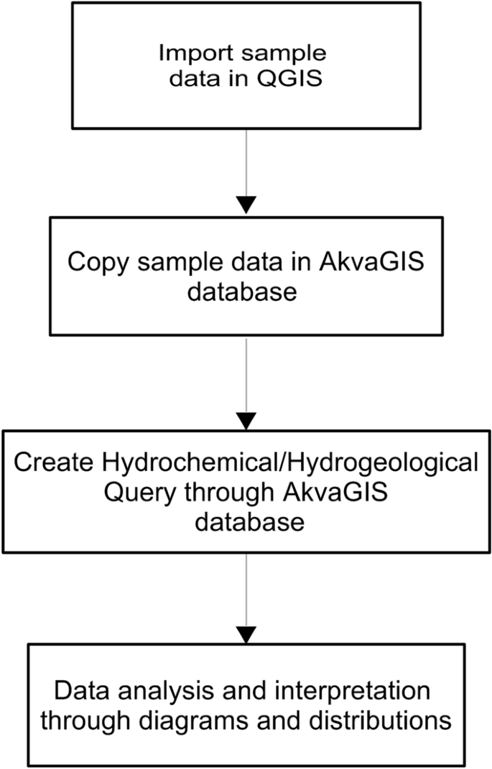

CHAPTER 4
TESTING AND IMPLEMENTATION

  - TESTING
Implementation is the stage of the project when the theoretical design is turned into a working system. This is the final and important phase in the system life cycle It is actually the process of converting the new system into a operational one.

4.1.1Unit Testing
Unit testing comprises the set of tests performed by an individual programmer prior to integration of the unit into a larger system. The module interface is tested to ensure that information properly flows into and out of the program unit. The local data structure is examined to ensure that data stored temporarily maintains its integrity during all steps in an algorithm’s execution. Boundary conditions are tested to ensure that the module operates properly at boundaries established to limit or restrict processing. All independent paths through the control structure are tested. All error-handling paths are tested.

4.1.2 Block Box Testing
Black-box testing is a method of software testing that examines the functionality of an application without peering into its internal structures or workings. This method of test can be applied virtually to every level of software testing: unit, integration, system and acceptance. It is sometimes referred to as specification-based testing.

4.2 SYSTEM IMPLEMENTATION
Implementation is the stage of the project when the theoretical design is turned into a working system. This is the final and important phase in the system life cycle It is actually the process of converting the new system into a operational one.

CHAPTER 5
CONCLUSION:
Groundwater is a critical resource for people and ecosystems. Tools are needed for efficient data management so that more technically sound and community-supported decisions may be made. In this view, development and diffusion of robust open source and free software constitutes a cornerstone to enhance groundwater management, thus empowering as much as possible technical units in water authorities, academia and private companies, also in communities/countries with limited resources. In recent years, several efforts have addressed these issues by developing tools in GIS and coupling GIS and numerical hydrological models. Often, commercial software was used to this scope, but the cost of such software is usually prohibitive in many areas of the world.

CHAPTER-6
REFERENCE
- Ajami, H., Maddock, T., Meixner, T., Hogan, J.F., Guertin, D.P., 2012. RIPGIS-NET: a GIStool for riparian groundwater evapotranspiration in MODFLOW. Groundwater 50 (1),154–158.R. Rossetto et al. Environmental Modelling and Software 107 (2018) 210–230227
- Aquaveo, 2012. Arc hydro groundwater – modflow Analyst. http://www.aquaveo.com/archydro-groundwater, Accessed date: 30 March 2016.
- Argus Holdings Ltd, 1995. Argus ONE Open Numerical Environments. http://www.argusone.com/index.html, Accessed date: 3 September 2017.
- Bakker, M., Post, V., Langevin, C.D., Hughes, J.D., White, J.T., Starn, J.J., Fienen, M.N.,2016. Scripting MODFLOW model development using Python and FloPy.Groundwater. http://dx.doi.org/10.1111/gwat.12413.
- Bakker, M., Post, V., Langevin, C.D., Hughes, J.D., White, J.T., Starn, J.J., Fienen, M.N.,2017. FloPy v3.2.8. U.S. Geological Survey Software Release, 18 December 2017
- Pullar, D., Springer, D., 2000. Towards integrating GIS and catchment models. Environ.Model. Software 15 (5), 451–459.
- QGIS Development Team, 2009. QGIS Geographic Information System. Open SourceGeospatial Foundation Project.
- Refsgaard, J.C., Storm, B., Clausen, T., 2010. Système Hydrologique Europeén (SHE):review and perspectives after 30 years development in distributed physically-basedhydrological modelling. Nord. Hydrol 41 (5), 355–377.
- Regione Toscana, 2017. GEOscopio. http://www.regione.toscana.it/-/geoscopio,Accessed date: 4 September 2017.
- Trenberth, K.E., Smith, L., Qian, T., Dai, A., Fasullo, J., 2006. Estimates of the globalwater budget and its annual cycle using observational and model data. J.Hydrometeorol. 8, 758–769.

