Need to develop digitally the dynamic model to integrate the impact of climate change (CC) indicators with assessment of vulnerability and adaptation at localized scale for agriculture sector

ABSTRACT
Agriculture and climate change are internally correlated with each other in various aspects, as climate change is the main cause of biotic and abiotic stresses, which have adverse effects on the agriculture of a region. The land and its agriculture are being affected by climate changes in different ways, e.g., variations in annual rainfall, average temperature, heat waves, modifications in weeds, pests or microbes, global change of atmospheric CO₂ or ozone level, and fluctuations in sea level. The threat of varying global climate has greatly driven the attention of scientists, as these variations are imparting negative impact on global crop production and compromising food security worldwide. According to some predicted reports, agriculture is considered the most endangered activity adversely affected by climate changes. To date, food security and ecosystem resilience are the most concerning subjects worldwide. Climate-smart agriculture is the only way to lower the negative impact of climate variations on crop adaptation, before it might affect global crop production drastically. In this review paper, we summarize the causes of climate change, stresses produced due to climate change, impacts on crops, modern breeding technologies, and biotechnological strategies to cope with climate change, in order to develop climate resilient crops. Revolutions in genetic engineering techniques can also aid in overcoming food security issues against extreme environmental conditions, by producing transgenic plants.
CHAPTER 2
2. SYSTEM ANALYSIS
  - EXISTING SYSTEM

- Therefore the paper reviews existing interpretations, concepts and frameworks of vulnerability approaches in the climate change context.
- However, while there are agreed indicators to measure the impact of climate change, there seem to exist no agreed metrics to describe vulnerability (e.g. of crop yields or agricultural income).
- As climate change brings new uncertainties, risks and changes to already existing risks, one of the most efficient ways for agriculture to adapt is increasing its resilience.
2.1.1 DRAWBACKS OF EXISTING SYSTEM :
- These climatic problems severely distress plant development and yield, produce enormous responses, comprising molecular, biochemical, physiological, and morphological modifications.
- Food security and safety are threatened by the severe weather conditions and it is not a recent problem. But formerly, no consideration was adopted to tackle this problem.
- Because of climate change, food quality, supply, and safety are still the biggest problems for researchers.
2.2. PROPOSED SYSTEM
- One objective of climate change research is not to propose testable long-range hypotheses rather to provide indicative forecasts to guide pre-emptive policy-making.
- It is important to assess in advance any risks to health from proposed technological adaptations.
- The benefit-cost criterion is straightforward: if the winners under a proposed policy value the change more highly than do the losers, it is said that the policy has positive net benefits and enhances efficiency.
2.2.1. ADVANTAGES OF PROPOSED SYSTEM
- Genetic divergence analysis is used for polymorphism, inbreeding, assessment, assortment, and recombination to attain plant perfection, and is amongst the main aspects for defining accomplished inbreeding.
- In genome editing technology site specific endonucleases are used comprising of zinc-finger nucleases (ZFNs), transcription activator like effector nucleases (TALENs), and CRISPR-Cas9.
- The CRISPR/Cas9 strategy was used to develop tomato mutant lines which showed a considerably enhanced concentration of proline, malondialdehyde, and H₂O₂.

Literature Survey:
TITLE | AUTHORS | DESCRIPTION
The Routledge Handbook of Agricultural Economics | Arunanondchai P., Fei C., Fisher A., McCarl B.A., Wang W., Yang Y. | The Routledge Handbook of Agricultural Economics explores a broad variety of topics including welfare economics, econometrics, agribusiness, and consumer economics.
Environmental impacts of the cultivation-phase associated with agricultural crops for feed production | Noya I., González-García S., Bacenetti J., Fiala M., Moreira M.T. | The crop variety (out of 3 and 4 varieties of barley and rye, respectively) and cultivation regime (single vs. double cropping of sorghum) with the lowest impacts per kg of crude protein (mass-based functional unit) were identified.
The effects of climate change associated abiotic stresses on maize phytochemical defenses | Vaughan M.M., Block A., Christensen S.A., Allen L.H., Schmelz E.A. | Climate changes are expected to increase the frequency and intensity of both abiotic and biotic stress.
Climate change impacts on global food security | Wheeler T., Von Braun J. | A robust and coherent global pattern is discernible of the impacts of climate change on crop productivity that could have consequences for food availability.

2.3 FEASIBILITY STUDY
The feasibility Analysis is an analytical program through project manager determines the project success ratio and through feasibility study project manager able to see either project. The key considerations involved in the feasibility analysis are:
- Economic Feasibility
- Technical Feasibility
- Operational Feasibility
- Environmental Feasibility
2.3.1 ECONOMICAL FEASIBILITY
Hence this project is economically feasible there is no need to involve any cost for this project.
2.3.2 TECHNICAL FEASIBILITY
Software Technologies used are PHP and MySql. In the educational institutions, it is possible to update the system in future. No special hardware is required for the purpose of using this system. Hence it is declared that this project is technically feasible.
2.3.3 OPERATIONAL FEASIBILITY
As the admin work mainly to maintain the Patient and Doctor .Doctor will predict patient cancer disease. Hence it is easy to operate with training. Therefore it is operationally feasible for implementation.
2.3.4 ENVIRONMENTAL FEASIBILITY
This project environment is correct as a admin has developed this system and no expenditure is involved under any head and this process is part of admin document management, this project environment is accessible.

2.4 SYSTEM REQUIREMENTS
- System : Pentium IV 2.4 GHz.
- Hard Disk : 40 GB.
- Monitor : 15 inch VGA Color.
- Mouse : Logitech Mouse.
- Ram : 512 MB
- Keyboard : Standard Keyboard

2.4.1 HARDWARE REQUIREMENTS
The Hardware of the computer consists of physical component such as Input Devices, Storage Devices, Processing & Control units and Output Devices. Computer includes external storage unit to store data in programs.
The Hardware Configuration involved in this project
- System : Pentium IV 2.4 GHz.
- Hard Disk : 40 GB.
- Monitor : 15 inch VGA Color.
- Mouse : Logitech Mouse.
- Ram : 512 MB
- Keyboard : Standard Keyboard

2.4.2 SOFTWARE REQUIREMENTS
Software is a group of programs that computers need to do a particular task. It is an essential requirement of Computer System. The Software used to develop the project is
- Operating System : Windows XP.
- Platform : DOT NET TECHNOLOGY
- Front End : ASP.Net 3.5
- Back End : SQL SERVER 2005

CHAPTER 3
SYSTEM DESIGN AND DEVELOPEMENT
SYSTEM ARCHICTURE

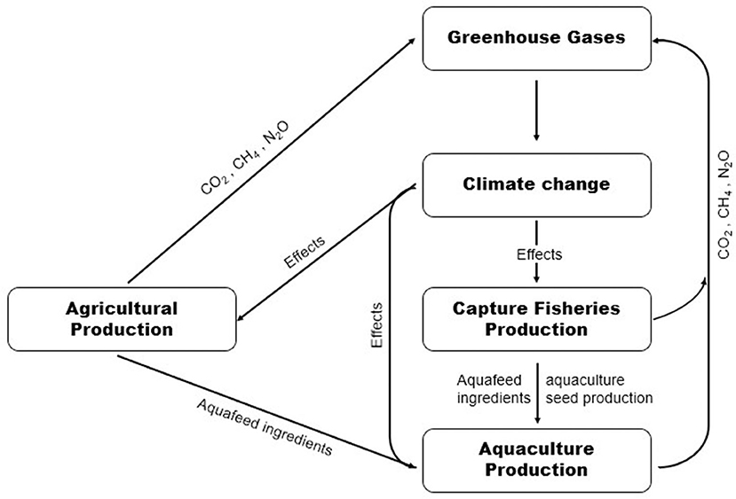

CHAPTER 4
TESTING AND IMPLEMENTATION

  - TESTING
Implementation is the stage of the project when the theoretical design is turned into a working system. This is the final and important phase in the system life cycle It is actually the process of converting the new system into a operational one.

4.1.1Unit Testing
Unit testing comprises the set of tests performed by an individual programmer prior to integration of the unit into a larger system. The module interface is tested to ensure that information properly flows into and out of the program unit. The local data structure is examined to ensure that data stored temporarily maintains its integrity during all steps in an algorithm’s execution. Boundary conditions are tested to ensure that the module operates properly at boundaries established to limit or restrict processing. All independent paths through the control structure are tested. All error-handling paths are tested.

4.1.2 Block Box Testing
Black-box testing is a method of software testing that examines the functionality of an application without peering into its internal structures or workings. This method of test can be applied virtually to every level of software testing: unit, integration, system and acceptance. It is sometimes referred to as specification-based testing.

4.2 SYSTEM IMPLEMENTATION
Implementation is the stage of the project when the theoretical design is turned into a working system. This is the final and important phase in the system life cycle It is actually the process of converting the new system into a operational one.

CHAPTER 5
CONCLUSION:
Climate changes are alarming the world by hampering agriculture and its products. Industrialization and poisonous gases cause global warming, which ultimately disturbs the world’s environment. Climate change has devastating effects on plant growth and yield. Abiotic stresses are the major type of stresses that plants suffer. To understand the plant responses under different abiotic conditions the most pressing current need is to explore the genetic basis underlying these mechanisms. Some bottleneck molecular and physiological challenges present in plants need to be resolved for better plant adaptation under abiotic conditions. Temperature fluctuations and variations in rainfall spells are a very crucial indicators of environmental stresses. Weather variations collectively have positive and negative outcomes but the negative effects are more thought-provoking. It is very difficult to overcome the imbalance in agriculture by climate change. How to tackle this problem and what strategies we should apply are still ambiguous.

CHAPTER-6
REFERENCE
- 1. Arunanondchai P., Fei C., Fisher A., McCarl B.A., Wang W., Yang Y. The Routledge Handbook of Agricultural Economics. Routledge; Abingdon-on-Thames, UK: 2018. How does climate change affect agriculture.
- 2. Noya I., González-García S., Bacenetti J., Fiala M., Moreira M.T. Environmental impacts of the cultivation-phase associated with agricultural crops for feed production. J. Clean. Prod. 2018;172:3721–3733. doi: 10.1016/j.jclepro.2017.07.132.
- 3. Vaughan M.M., Block A., Christensen S.A., Allen L.H., Schmelz E.A. The effects of climate change associated abiotic stresses on maize phytochemical defenses. Phytochem. Rev. 2018;17:37–49. doi: 10.1007/s11101-017-9508-2.
- 4. FAO. UNICEF. WFP. WHO . The State of Food Security and Nutrition in the World 2017: Building Resilience for Peace and Food Security. Food and Agriculture Organization of the United Nations (FAO); Rome, Italy: 2018.
- 5. Rosenzweig C., Elliott J., Deryng D., Ruane A.C., Müller C., Arneth A., Boote K.J., Folberth C., Glotter M., Khabarov N. Assessing agricultural risks of climate change in the 21st century in a global gridded crop model intercomparison. Proc. Natl. Acad. Sci. USA. 2014;111:3268–3273. doi: 10.1073/pnas.1222463110.
- 6. Wheeler T., Von Braun J. Climate change impacts on global food security. Science. 2013;341:508–513. doi: 10.1126/science.1239402.
- 7. Ashraf M.A., Akbar A., Askari S.H., Iqbal M., Rasheed R., Hussain I. Advances in Seed Priming. Springer; Berlin/Heidelberg, Germany: 2018. Recent Advances in Abiotic Stress Tolerance of Plants Through Chemical Priming: An Overview; pp. 51–79.
- 8. Benevenuto R.F., Agapito-Tenfen S.Z., Vilperte V., Wikmark O.-G., Van Rensburg P.J., Nodari R.O. Molecular responses of genetically modified maize to abiotic stresses as determined through proteomic and metabolomic analyses. PLoS ONE. 2017;12:e0173069. doi: 10.1371/journal.pone.0173069.
- 9. Suzuki N., Rivero R.M., Shulaev V., Blumwald E., Mittler R. Abiotic and biotic stress combinations. New Phytol. 2014;203:32–43. doi: 10.1111/nph.12797.
- 10. Pachauri R.K., Allen M.R., Barros V.R., Broome J., Cramer W., Christ R., Church J.A., Clarke L., Dahe Q., Dasgupta P. Climate Change 2014: Synthesis Report. IPCC; Geneva, Switzerland: 2014. Contribution of Working Groups I, II and III to the Fifth Assessment Report of the Intergovernmental Panel on Climate Change.

