To develop Waste water management system in villages

ABSTRACT
The study area where the wastewater treatment is proposed is Rajouri in Jammu And Kashmir State. The growth of population at a faster rate, lack of education, poverty especially in rural areas has polluted the environment to a great extent. Here the paper gives the details about the population of the area, the drainage details, the water supply details and the ground water quality In this paper it has been tried to explain as how we can treat wastewater in rural areas by proposing a wastewater treatment process. Once treated wastewater can be used for number of purposes like growing plants, vegetables etc.

CHAPTER 2
2. SYSTEM ANALYSIS
  - EXISTING SYSTEM

- An existing treatment system is to be renovated or a new system built, the planning should ensure that all the goals of treatment be considered, that different options be evaluated, and that costs for construction and maintenance of all the options be compared.
- It is simple to renovate existing systems to install this alternative. The toilet is replaced with an urine separating stool, and a new, separate pipe or hose is installed to a collection tank.
- It is also advantageous that the existing sedimentation basins in the pump station and treatment plant can be used for sedimentation, while the existing building can be used to protect and isolate the trickling filter.
2.1.1 DRAWBACKS OF EXISTING SYSTEM :
- The major disadvantage of the septic tank is that it produce adverse impact on the ground water quality.
- The problem of eutrophication in inland waters remained, due to discharge of phosphorus in the wastewater.
- The wetland-agriculture rotation, has no problem meeting this requirement since it is a complete eco cycle system in itself.
- Smell is not a problem during normal operation, although odours can occur during sludge removal.
2.2. PROPOSED SYSTEM
- The proposed tariff structures are designed to achieve full cost recovery through revenue obtained from the users and beneficiaries of the wastewater system.
- The local EPB is responsible for conducting monthly site inspections to assure that any environmental mitigation measure proposed in the EIA, as well as other local and national requirements are being implemented.
- The purpose of the interceptor tank is to remove settleable solids before they enter the main low gradient sewer to prevent potential clogging of the sewer line.
2.2.1. ADVANTAGES OF PROPOSED SYSTEM
- They are designed to take advantage of many of the same processes that occur in natural wetlands, but do so within a more controlled environment.
- Resue of water have many advantages such as reduce in water bill, less depended on singe resource, reduction in pollution due to waste water, reduces load on STP.
- Water resource is developing at a rapid pace all over the world, so the water resources available in a particular area should be protected from pollution and only then it should be used for various purposes.
2.3 FEASIBILITY STUDY
The feasibility Analysis is an analytical program through project manager determines the project success ratio and through feasibility study project manager able to see either project. The key considerations involved in the feasibility analysis are:
- Economic Feasibility
- Technical Feasibility
- Operational Feasibility
- Environmental Feasibility
2.3.1 ECONOMICAL FEASIBILITY
Hence this project is economically feasible there is no need to involve any cost for this project.
2.3.2 TECHNICAL FEASIBILITY
Software Technologies used are PHP and MySql. In the educational institutions, it is possible to update the system in future. No special hardware is required for the purpose of using this system. Hence it is declared that this project is technically feasible.
2.3.3 OPERATIONAL FEASIBILITY
As the admin work mainly to maintain the Patient and Doctor .Doctor will predict patient cancer disease. Hence it is easy to operate with training. Therefore it is operationally feasible for implementation.
2.3.4 ENVIRONMENTAL FEASIBILITY
This project environment is correct as a admin has developed this system and no expenditure is involved under any head and this process is part of admin document management, this project environment is accessible.

2.4 SYSTEM REQUIREMENTS
- System : Pentium IV 2.4 GHz.
- Hard Disk : 40 GB.
- Monitor : 15 inch VGA Color.
- Mouse : Logitech Mouse.
- Ram : 512 MB
- Keyboard : Standard Keyboard

2.4.1 HARDWARE REQUIREMENTS
The Hardware of the computer consists of physical component such as Input Devices, Storage Devices, Processing & Control units and Output Devices. Computer includes external storage unit to store data in programs.
The Hardware Configuration involved in this project
- System : Pentium IV 2.4 GHz.
- Hard Disk : 40 GB.
- Monitor : 15 inch VGA Color.
- Mouse : Logitech Mouse.
- Ram : 512 MB
- Keyboard : Standard Keyboard

2.4.2 SOFTWARE REQUIREMENTS
Software is a group of programs that computers need to do a particular task. It is an essential requirement of Computer System. The Software used to develop the project is
- Operating System : Windows XP.
- Platform : DOT NET TECHNOLOGY
- Front End : ASP.Net 3.5
- Back End : SQL SERVER 2005

CHAPTER 3
SYSTEM DESIGN AND DEVELOPEMENT
SYSTEM ARCHICTURE

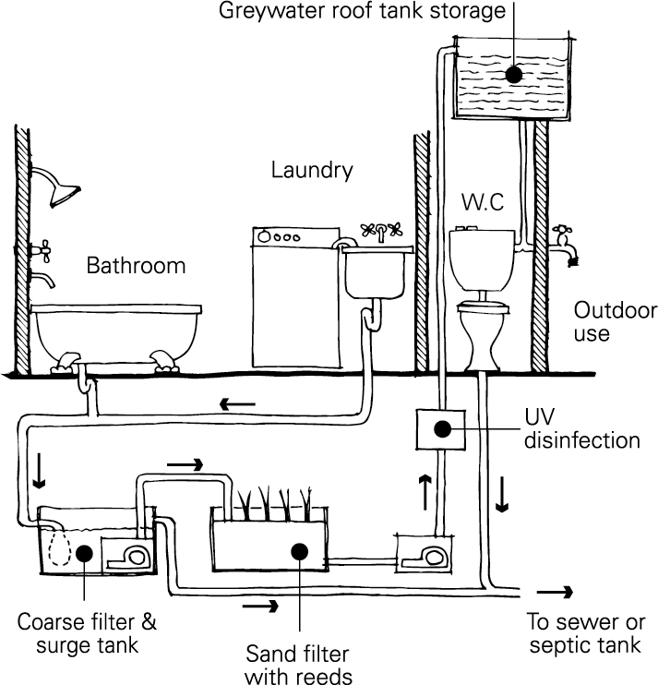

CHAPTER 4
TESTING AND IMPLEMENTATION

  - TESTING
Implementation is the stage of the project when the theoretical design is turned into a working system. This is the final and important phase in the system life cycle It is actually the process of converting the new system into a operational one.

4.1.1Unit Testing
Unit testing comprises the set of tests performed by an individual programmer prior to integration of the unit into a larger system. The module interface is tested to ensure that information properly flows into and out of the program unit. The local data structure is examined to ensure that data stored temporarily maintains its integrity during all steps in an algorithm’s execution. Boundary conditions are tested to ensure that the module operates properly at boundaries established to limit or restrict processing. All independent paths through the control structure are tested. All error-handling paths are tested.

4.1.2 Block Box Testing
Black-box testing is a method of software testing that examines the functionality of an application without peering into its internal structures or workings. This method of test can be applied virtually to every level of software testing: unit, integration, system and acceptance. It is sometimes referred to as specification-based testing.

4.2 SYSTEM IMPLEMENTATION
Implementation is the stage of the project when the theoretical design is turned into a working system. This is the final and important phase in the system life cycle It is actually the process of converting the new system into a operational one.

CHAPTER 5
CONCLUSION:
This paper highlights a number of recent problems related with the wastewater discharges in rural areas, and also gives us an idea towards our first step in the development of wastewater treatment in these area. This paper also provides information about the present and future population scenario and water supply demand of the study area. We also proposed the waste water treatment process i.e. wetland. This proposal is intended to reduce pollutant loading rates and generally improve the condition of our rural environment through the delivery of cost-effective wastewater solutions.

CHAPTER-6
REFERENCE
- Bowman, J.J., Lough Ree: 1996. An investigation of eutrophication and its causes, Environmental Protection Agency.
- Cooper, P., Day, M., Thomas, V., 1994. Process options for phosphorus and nitrogen removal from waste water, J.IWEM, 8, 1, 84-92.
- Foot, R.J., Robinson, M.S., Forster, C.F. 1993. Operational aspects of three 'selectors' in relation to aeration tank ecology and stable foam formation. J.IWEM, 7, 304-309.
- Ground water information booklet Rajauri district, jammu and kashmir, north western Himalayan region Jammu, November 2009.
- Muthukumaran N. and Dr. N.K. Ambujam- Tiruchirappalli City Water Planning – A Case study –Proceedings of the International symposium on Challenges of water resources management in the developing countries in the 21 century at Andhra University, Visakapatnam, 2001.
- National Onsite Wastewater Recycling Association. Model Code Framework for the Decentralized Wastewater Infrastructure. http://www.modelcode.org/publications. html. 2007.

