Online registration and processing of dairy farmers producing milk and other livestock products

ABSTRACT
The study was conducted to assess the general milk production system, handling practices, processing, utilization and marketing system of raw cow milk produced in Mizan Aman, Debub and Shey Bench Districts. A total of 270 respondents (thirty respondents from each study area) were selected using simple random sampling technique and interviewed by using a semi structured questionnaires. The results of current study showed that the respondents of Shey Bench and Debub Bench were entirely (100%) engaged in farming activities, predominately mixed production system. Similarly, majority (82.2%) of the respondents of Mizan Aman were also pre-dominantly involved in mixed crop livestock production while the remaining 17.8% were involved only in Peri-urban production system. Majority of the respondents in the three districts (91.1, 100 and 90% of Mizan Aman, Debub and Shey Bench) had dairy cows from 1 to 5, some had from 6 to 10 and 11 to 15. About 95.6, 94.4 and 78.9% of the respondents in Mizan Aman, Debub and Shey Bench use plastic buckets for milking. As reported by most of the respondents (95.6, 58.9 and 55.6% of Mizan Aman, Debub and Shey Bench districts, respectively), clay pot is used for storage of milk until the wanted amount is accumulated for processing. About 60.0, 26.7 and 20.0% of the respondents utilize raw milk or fresh milk in Mizan Aman, Debub and Shey Bench districts, respectively. Majority of the respondents (97.8, 92.2 and 70.0% in the Mizan Aman, Debub and Shey Bench districts) reported that scarcity of milk is the main problem of milk and milk products marketing in the study areas. The common milk production constraints and prioritized by the sampled farmers were shortage of feed and scarcity of land, diseases, accessibility to marketing place, limitation of market information and inadequate infrastructure. Therefore, it was concluded that the majority of the milk produced in the study areas were not processed, marketed and mainly utilized by household family for home consumption. These suggest the need for enriched dairy cattle production scheme in the study areas.

CHAPTER 2
2. SYSTEM ANALYSIS
  - EXISTING SYSTEM

- When based on long-term trends in the size of the crossbred, indigenous, and buffalo dairy herds, projections suggest that India can sustain growth and meet targets for dairy production with its existing mix of domestic and trade policies.
- An important factor is likely to be the extent to which the private-sector processors catalyze increases in the scale of dairy production enterprises, along with improved management and productivity, a reported trend for which there is currently little data with which to assess future impacts.
2.1.1 DRAWBACKS OF EXISTING SYSTEM :
- That scarcity of milk and milk products marketing are the major problem in the study areas.
- The improvement of infrastructure should alleviate the problem of dairy cattle milk production, handling and increase the number of marketing options which is available to smallholder farmers.
- The most common problem was adulteration with water, which introduces health risks associated with frequently unsafe water supplies, as well as reducing nutritional value.
2.2. PROPOSED SYSTEM
- India has an array of indigenous cattle breeds, some of which are productive milking breeds and others that are bred for draught (animal traction) purposes.
- As with cropland, ownership of cattle and water buffalo in India is fragmented, with a large number of small farmers each raising a few animals for draught (animal traction) or milking purposes.
- Import policies for animals and genetics for the purpose of upgrading India’s bovine herd give preference to import of semen and embryos, rather than live animals.
2.2.1. ADVANTAGES OF PROPOSED SYSTEM
- These constraints interactively affect the performance of the genetic potential of animals leading to subsistence level of milk production.
- To some extent, the variations in performance likely reflect differences in the genetic potential of the particular buffalo breeds available in each region.
- A high level of adaptation to climatic and disease conditions in many regions of India, and the capability to efficiently convert many of the available low-quality indigenous grasses and feeds.
2.3 FEASIBILITY STUDY
The feasibility Analysis is an analytical program through project manager determines the project success ratio and through feasibility study project manager able to see either project. The key considerations involved in the feasibility analysis are:
- Economic Feasibility
- Technical Feasibility
- Operational Feasibility
- Environmental Feasibility
2.3.1 ECONOMICAL FEASIBILITY
Hence this project is economically feasible there is no need to involve any cost for this project.
2.3.2 TECHNICAL FEASIBILITY
Software Technologies used are PHP and MySql. In the educational institutions, it is possible to update the system in future. No special hardware is required for the purpose of using this system. Hence it is declared that this project is technically feasible.
2.3.3 OPERATIONAL FEASIBILITY
As the admin work mainly to maintain the Patient and Doctor .Doctor will predict patient cancer disease. Hence it is easy to operate with training. Therefore it is operationally feasible for implementation.
2.3.4 ENVIRONMENTAL FEASIBILITY
This project environment is correct as a admin has developed this system and no expenditure is involved under any head and this process is part of admin document management, this project environment is accessible.
2.4 SYSTEM REQUIREMENTS
- System : Pentium IV 2.4 GHz.
- Hard Disk : 40 GB.
- Monitor : 15 inch VGA Color.
- Mouse : Logitech Mouse.
- Ram : 512 MB
- Keyboard : Standard Keyboard

2.4.1 HARDWARE REQUIREMENTS
The Hardware of the computer consists of physical component such as Input Devices, Storage Devices, Processing & Control units and Output Devices. Computer includes external storage unit to store data in programs.
The Hardware Configuration involved in this project
- System : Pentium IV 2.4 GHz.
- Hard Disk : 40 GB.
- Monitor : 15 inch VGA Color.
- Mouse : Logitech Mouse.
- Ram : 512 MB
- Keyboard : Standard Keyboard

2.4.2 SOFTWARE REQUIREMENTS
Software is a group of programs that computers need to do a particular task. It is an essential requirement of Computer System. The Software used to develop the project is
- Operating System : Windows XP.
- Platform : DOT NET TECHNOLOGY
- Front End : ASP.Net 3.5
- Back End : SQL SERVER 2005

CHAPTER 3
SYSTEM DESIGN AND DEVELOPEMENT
SYSTEM ARCHICTURE

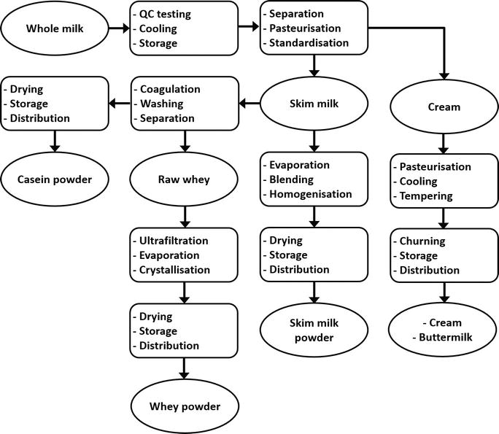

CHAPTER 4
TESTING AND IMPLEMENTATION

  - TESTING
Implementation is the stage of the project when the theoretical design is turned into a working system. This is the final and important phase in the system life cycle It is actually the process of converting the new system into a operational one.

4.1.1Unit Testing
Unit testing comprises the set of tests performed by an individual programmer prior to integration of the unit into a larger system. The module interface is tested to ensure that information properly flows into and out of the program unit. The local data structure is examined to ensure that data stored temporarily maintains its integrity during all steps in an algorithm’s execution. Boundary conditions are tested to ensure that the module operates properly at boundaries established to limit or restrict processing. All independent paths through the control structure are tested. All error-handling paths are tested.

4.1.2 Block Box Testing
Black-box testing is a method of software testing that examines the functionality of an application without peering into its internal structures or workings. This method of test can be applied virtually to every level of software testing: unit, integration, system and acceptance. It is sometimes referred to as specification-based testing.

4.2 SYSTEM IMPLEMENTATION
Implementation is the stage of the project when the theoretical design is turned into a working system. This is the final and important phase in the system life cycle It is actually the process of converting the new system into a operational one.

CHAPTER 5
CONCLUSION:
The results of present study showed that all the respondents were engaged in agricultural activities which are dominated by crop-livestock mixed production system. Almost all the respondents in three areas had dairy cows from 1 to 5. Smaller dairy cow holding in the current study could be justified by reduction of grazing land due to expansion of cultivation land, and population growth was forced to reduce their cattle number. All the respondents milk their cows by using hand milking either by washing cow teats or letting calf to suckle its dam for minutes to stimulate milk let-down. The types of utensils used for milking, transportation, collection and storage of milk were plastic buckets, nickel (Aluminum) and some stainless steel. The majority of the respondents did not practice recommended hygienic practices (such as hand and udder washing) during milking and further handling (processing, storage and marketing) of milk and milk products. The common milk products manufactured and utilized in this study areas include raw milk, butter, Ayib (cottage cheese), whey (Aguate), Ergo (naturally fermented milk) and buttermilk (Arrera).

CHAPTER-6
REFERENCE
- Abebe B, Zelalem Y, Ajebu N (2012). Hygienic and microbial quality of raw whole cow’s milk produced in Ezha district of the Gurage zone, Southern Ethiopia. Wudpecker J. Agric. Res. 1(11):459-465.
- BMZFED (Bench Maji Zone Finance and Economic Development) (2015). Annual report of Bench Maji zone finance and economic development main department. Mizan-Teferi, Ethiopia.
- CSA (Central Statistical Agency) (2015). Agricultural Sample Survey. Report on Livestock and Livestock Characteristics (Private Peasant Holdings). Volume V. Addis Ababa, Ethiopia, pp. 109-126.
- Food Hygiene Regulations (2006). A practical guide for milk producers to the food hygiene regulations, England. 6 p.
- Teklemichael T (2012). Quality and Safety of Raw and Pasteurized Cow Milk Produced and Marketed in Dire Dawa Town, M.Sc. Thesis. Haramaya University, Ethiopia.
- Lemma F (2004). Assessment of butter quality and butter making efficiency of new churns compared to smallholders’ butter making techniques in East Shoa Zone of Oromia. MSc thesis. Alemaya University, Alemaya, Ethiopia.
- Tesfaye M (2007). Characterization of cattle milk and meat production, processing and marketing system in Metema district, Ethiopia, M.S. thesis, Hawassa University, Awassa, Ethiopia.
- Teshome G, Fikadu B, Mitiku E (2014). Handling Practices and Microbial Quality of Raw Cow's Milk Produced and Marketed in Shashemene Town, Southern Ethiopia. Intl. J. Agric. Soil Sci. 2(9):153-162.
- Yitaye A, Wurzinger M, Azage T, Zollitsch W (2009). Handling, processing and marketing of milk in the North western Ethiopian highlands. Livest. Res. Rur. Dev. 21(7).
- O’Mahony F, Peters J (2004). Options for Smallholder Milk Processing in Sub-Saharan Africa. International Livestock Center for Africa (ILCA) Bulletin 27. Addis Ababa, Ethiopia pp. 206-247.

