Drought Information and Management

ABSTRACT
Drought is the most complex of all natural hazards. The lack of progress in drought preparedness planning and the development of national drought policies is a reflection of this complexity. With the demand for water increasing because of expanding population, urbanization, changes in land use, and many other factors, the time to move to a more risk-based drought management approach is now. Given projected increases in temperature and uncertainties regarding the amount, distribution, and intensity of precipitation, the frequency, severity, and duration of drought may increase in the future. Making the transition from crisis to drought risk management is difficult because governments and individuals typically address drought-related issues through a reactive approach and very little institutional capacity exists in most countries for altering this paradigm. Drought mitigation planning is directed at building the institutional capacity necessary to move away from this crisis management paradigm. This change is not expected to occur quickly – it is in fact a gradual process that requires changes in government policies and human behavior. Developing improved drought monitoring and early warning systems in support of drought preparedness planning and policy is an urgent need for all drought-prone counties.

CHAPTER 2
2. SYSTEM ANALYSIS
  - EXISTING SYSTEM

- In addition, drought response is post-impact and relief tends to reinforce existing resource management methods.
- It is precisely these existing resource management practices that have often increased societal vulnerability to drought. The provision of drought relief only serves to reinforce the status quo in terms of resource management.
- Many governments and others now understand the fallacy of crisis management and are striving to learn how to employ proper risk management techniques to reduce societal vulnerability to drought and, therefore, lessen the impacts associated with future drought events.
2.1.1 DRAWBACKS OF EXISTING SYSTEM :
- Making the transition from crisis to drought risk management is difficult because governments and individuals typically address drought-related issues through a reactive approach and very little institutional capacity exists in most countries for altering this paradigm.
- Drought also tends to affect large numbers of people principally because of its impact on both water supply and demand.
- When a natural hazard event and resultant disaster has occurred, governments and donors have followed with impact assessment, response, recovery, and reconstruction activities to return the region or locality to a pre-disaster state.
2.2. PROPOSED SYSTEM
- The purpose of the planning process is to derive a plan that is dynamic, reflecting the changing government policies, technologies, and natural resource management practices.
- The survey found that quality assurance and quality control are practiced by a majority of these networks, but meta datasets are highly variable, as would be expected with the wide range of purposes and inception dates.
- The purpose of crop yield monitoring and forecasting, the indicators obviously have to be crop specific.
2.2.1. ADVANTAGES OF PROPOSED SYSTEM
- Preparedness for drought necessitates greater institutional capacity at all levels of government and more efficient coordination between different levels of government.
- SPI represents the amount of rainfall over a given time scale, with the advantage that it also gives an indication of what this amount is in relation to the normal, thus leading to the definition of whether a station is experiencing drought or not.
- It has also been useful as a drought monitoring tool and has been used to trigger actions associated with drought contingency plans.
Literature Survey:
TITLE | AUTHORS | DESCRIPTION
Regions at Risk: A Geographical Introduction to Disasters | Hewitt, K. (1997). | An introduction to hazards, human vulnerability and disaster, paying particular attention to the more severe or novel risks and disaster that affect the general public.
How to Reduce Drought Risk | Knutson, C., Hayes, M. and Phillips, T. (1998). | In drought management, making the transition from crisis to risk management is difficult because little has been done to understand and address the risks associated with drought.
Drought planning: A process for state government | Wilhite, D.A. (1991). | The primary purpose of this paper is to present a planning process that can facilitate the preparation of drought contingency plans by state government decision makers.
Drought as a natural hazard: Concepts and definitions | Wilhite, D.A. (2000a). | Drought is one of the most underreported natural disasters because the sources of most of these statistics are international aid or donor organizations.

2.3 FEASIBILITY STUDY
The feasibility Analysis is an analytical program through project manager determines the project success ratio and through feasibility study project manager able to see either project. The key considerations involved in the feasibility analysis are:
- Economic Feasibility
- Technical Feasibility
- Operational Feasibility
- Environmental Feasibility
2.3.1 ECONOMICAL FEASIBILITY
Hence this project is economically feasible there is no need to involve any cost for this project.
2.3.2 TECHNICAL FEASIBILITY
Software Technologies used are PHP and MySql. In the educational institutions, it is possible to update the system in future. No special hardware is required for the purpose of using this system. Hence it is declared that this project is technically feasible.
2.3.3 OPERATIONAL FEASIBILITY
As the admin work mainly to maintain the Patient and Doctor .Doctor will predict patient cancer disease. Hence it is easy to operate with training. Therefore it is operationally feasible for implementation.
2.3.4 ENVIRONMENTAL FEASIBILITY
This project environment is correct as a admin has developed this system and no expenditure is involved under any head and this process is part of admin document management, this project environment is accessible.

2.4 SYSTEM REQUIREMENTS
- System : Pentium IV 2.4 GHz.
- Hard Disk : 40 GB.
- Monitor : 15 inch VGA Color.
- Mouse : Logitech Mouse.
- Ram : 512 MB
- Keyboard : Standard Keyboard

2.4.1 HARDWARE REQUIREMENTS
The Hardware of the computer consists of physical component such as Input Devices, Storage Devices, Processing & Control units and Output Devices. Computer includes external storage unit to store data in programs.
The Hardware Configuration involved in this project
- System : Pentium IV 2.4 GHz.
- Hard Disk : 40 GB.
- Monitor : 15 inch VGA Color.
- Mouse : Logitech Mouse.
- Ram : 512 MB
- Keyboard : Standard Keyboard

2.4.2 SOFTWARE REQUIREMENTS
Software is a group of programs that computers need to do a particular task. It is an essential requirement of Computer System. The Software used to develop the project is
- Operating System : Windows XP.
- Platform : DOT NET TECHNOLOGY
- Front End : ASP.Net 3.5
- Back End : SQL SERVER 2005

CHAPTER 3
SYSTEM DESIGN AND DEVELOPEMENT
SYSTEM ARCHICTURE

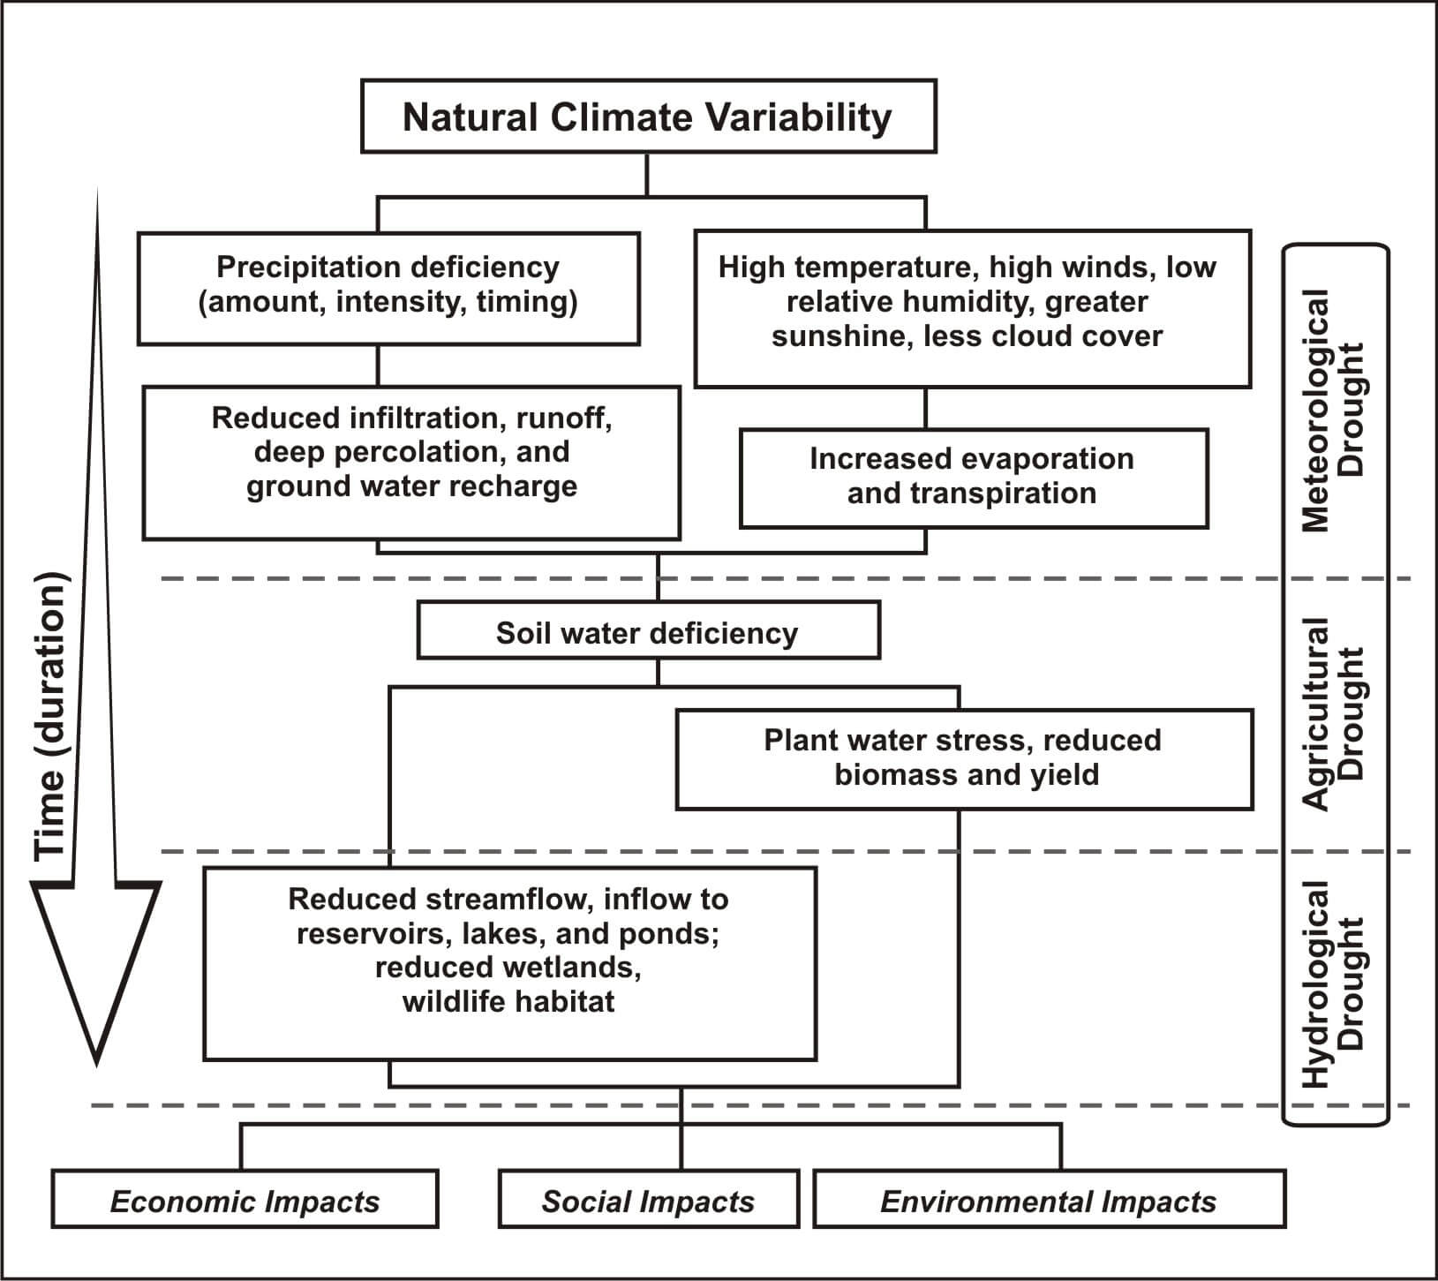

CHAPTER 4
TESTING AND IMPLEMENTATION

  - TESTING
Implementation is the stage of the project when the theoretical design is turned into a working system. This is the final and important phase in the system life cycle It is actually the process of converting the new system into a operational one.

4.1.1Unit Testing
Unit testing comprises the set of tests performed by an individual programmer prior to integration of the unit into a larger system. The module interface is tested to ensure that information properly flows into and out of the program unit. The local data structure is examined to ensure that data stored temporarily maintains its integrity during all steps in an algorithm’s execution. Boundary conditions are tested to ensure that the module operates properly at boundaries established to limit or restrict processing. All independent paths through the control structure are tested. All error-handling paths are tested.

4.1.2 Block Box Testing
Black-box testing is a method of software testing that examines the functionality of an application without peering into its internal structures or workings. This method of test can be applied virtually to every level of software testing: unit, integration, system and acceptance. It is sometimes referred to as specification-based testing.

4.2 SYSTEM IMPLEMENTATION
Implementation is the stage of the project when the theoretical design is turned into a working system. This is the final and important phase in the system life cycle It is actually the process of converting the new system into a operational one.

CHAPTER 5
CONCLUSION:
Drought is the most complex of all natural hazards. The lack of progress in drought preparedness planning and the development of national drought policies is a reflection of this complexity. As countries move towards a higher level of preparedness, drought monitoring and early warning systems become paramount because these systems provide the information necessary to make timely decision regarding the management of water and other natural resources. Just as critically important is the development of delivery systems that provide decision makers at all levels and for all primary sectors with data and information that will assist them in making timely decisions. These decision support tools provide end users with information they need to reduce the most serious consequences of drought and reduce the need for government and donor intervention in the form of drought assistance and relief. The goal is to create more drought resilient societies. With the demand for water increasing because of expanding population, urbanization, changes in land use, and many other factors, the time to move to a more risk-based drought management approach is now. Given projected increases in temperature and uncertainties regarding the amount, distribution, and intensity of precipitation, the frequency, severity, and duration of drought may increase in the future. Developing improved drought monitoring and early warning systems in support of drought preparedness planning and policy is an urgent need for all drought-prone countries.

CHAPTER-6
REFERENCE
- Bender, S. (2002). Development and use of natural hazard vulnerability assessment techniques in the Americas. Natural Hazards Review, 3(4): 136-138.
- Changnon, S.A. (1993). Are we doomed to fail in drought management? In: Proc. of the 8th Conference on Applied Climatology. American Meteorological Society, Boston, pp. 191-194.
- CRED, Centre for Research on the Epidemiology of Disasters (2006). CRED CRUNCH newsletter, December, Brussels, Belgium (http://www.em-dat.net/documents/CRED%20CRUNCH%207%20-% 20December%202006.pdf).
- Hewitt, K. (1997). Regions at Risk: A Geographical Introduction to Disasters. Addison-Wesley Longman, UK.
- Knutson, C., Hayes, M. and Phillips, T. (1998). How to Reduce Drought Risk. Preparedness and Mitigation Working Group of the Western Drought Coordination Council, Lincoln, Nebraska (http://drought.unl.edu/handbook/risk.pdf).
- Obasi, G.O.P. (1994). WMO's role in the International Decade for Natural Disaster Reduction. Bulletin of the American Meteorological Association, 75(9): 1655-1661.
- Wilhite, D.A. (1991). Drought planning: A process for state government. Water Resources Bulletin, 27(1): 29-38.
- Wilhite, D.A. (2000a). Drought as a natural hazard: Concepts and definitions. In: Drought: A Global Assessment, Vol. 1, Wilhite, D.A. (ed.). Routledge, New York, pp. 1-18.
- Wilhite, D.A., Hayes, M.J., Knutson, C.L. and Smith, K.H. (2000). Planning for drought: Moving from crisis to risk management. Journal of American Water Resources Association, 36(4): 697-710.
- WMO, World Meteorological Organization (2006). Drought monitoring and early warning: Concepts, progress and future challenges. WMO-No. 1006.

