A web portal to manage and strengthen dairy infrastructure of dairy processors of the Cooperative and private dairy sector

ABSTRACT
India is the world’s largest producer and consumer of milk and has the world’s largest dairy herd, comprised of water buffalo and indigenous and crossbred cattle. Annual growth in milk production and consumption has been a robust 4.2 percent since 2000, and India has also emerged as a small net exporter of dairy products. Water buffalo and crossbred cattle account for all of the growth in the dairy herd and milk production, but average milk yields remain well below both international standards and those achieved under domestic best practices. Future production prospects depend heavily on productivity gains, primarily through improved breeding and feeding practices, and demand for feeds and improved genetics may offer opportunities for increased trade. India’s dairy cooperatives have played a key role in expanding milk and milk-product marketing, and private-sector processors may play an increasingly important role in catalyzing more production of both milk and milk products. India’s future role as a trader in dairy products is uncertain because there is significant scope for future growth in both production and consumption. Recent trade behavior indicates that domestic dairy price stability is a key priority, with policy facilitating either imports or exports depending on domestic market conditions. Most dairy products imported into India are currently subject to certification that source animals have never been fed materials of ruminant origin, effectively prohibiting access for most U.S. dairy products.
CHAPTER 2
2. SYSTEM ANALYSIS
  - EXISTING SYSTEM

- Milk production generally takes place in rural areas, whereas the profitable market exists in urban areas.
- The dairy cooperatives generally do not have capacity to hire high-calibre professionals, the only out is to invest in extensive training and education to upgrade the skills of the existing manpower.
- The large body of scientific evidence available to policy makers and of increasing public concern over animal welfare, the report calls for a general animal welfare law that should address all the gaps currently existing in animal protection in the EU.
2.1.1 DRAWBACKS OF EXISTING SYSTEM :
- The top factor constraining yields was determined to be use of feed and fodder, followed by breeding problems, diseases, and management issues.
- The most common problem was adulteration with water, which introduces health risks associated with frequently unsafe water supplies, as well as reducing nutritional value.
- An important factor is likely to be the extent to which the private-sector processors catalyze increases in the scale of dairy production enterprises, along with improved management and productivity, a reported trend for which there is currently little data with which to assess future impacts.
2.2. PROPOSED SYSTEM
- In the sense of the considerations proposed in this paper can be regarded as a preliminary study for further research.
- The possible explanation is that education puts a person in a better position to comprehend likely benefits of being a member.
- The purpose for issuance of the control order is in the interest of the society at large.
- These important planks of dairy business, a remunerative procurement pricing policy of milk and a sound technical input delivery _system are by far the most important for the industry.
2.2.1. ADVANTAGES OF PROPOSED SYSTEM
- The advantage of capturing the more recent trends in animal numbers, particularly any changes in the crossbred and buffalo herds, but, by relying on only two data points, may also be more subject to aberrations in the data that distort the trends.
- To some extent, the variations in performance likely reflect differences in the genetic potential of the particular buffalo breeds available in each region.
- Developing reliable projections for Indian milk production is complicated by uncertainties inherent in assessing the pace of change in factors such as feed use, the size and composition of the dairy herd, the scale and efficiency of dairy operations, and milk yields.
Literature Survey:
TITLE | AUTHORS | DESCRIPTION
Economic Losses Due to Various Constraints in Dairy Production in India | Birthal, P.S., and A.K. Jha, 2005. | The growth in milk production occurred from both increase in number of dairy animals as well as their productivity
Structural Transformation in Dairy Sector of India | Kumar, A., S. Parappurathu, and P.K. Joshi. 2013. | A conspicuous shift has been observed in the composition of dairy herd from traditional to crossbred cows and buffaloes, and this led to improvements in milk-yield.

2.3 FEASIBILITY STUDY
The feasibility Analysis is an analytical program through project manager determines the project success ratio and through feasibility study project manager able to see either project. The key considerations involved in the feasibility analysis are:
- Economic Feasibility
- Technical Feasibility
- Operational Feasibility
- Environmental Feasibility

2.3.1 ECONOMICAL FEASIBILITY
Hence this project is economically feasible there is no need to involve any cost for this project.
2.3.2 TECHNICAL FEASIBILITY
Software Technologies used are PHP and MySql. In the educational institutions, it is possible to update the system in future. No special hardware is required for the purpose of using this system. Hence it is declared that this project is technically feasible.
2.3.3 OPERATIONAL FEASIBILITY
As the admin work mainly to maintain the Patient and Doctor .Doctor will predict patient cancer disease. Hence it is easy to operate with training. Therefore it is operationally feasible for implementation.
2.3.4 ENVIRONMENTAL FEASIBILITY
This project environment is correct as a admin has developed this system and no expenditure is involved under any head and this process is part of admin document management, this project environment is accessible.
2.4 SYSTEM REQUIREMENTS
- System : Pentium IV 2.4 GHz.
- Hard Disk : 40 GB.
- Monitor : 15 inch VGA Color.
- Mouse : Logitech Mouse.
- Ram : 512 MB
- Keyboard : Standard Keyboard
2.4.1 HARDWARE REQUIREMENTS
The Hardware of the computer consists of physical component such as Input Devices, Storage Devices, Processing & Control units and Output Devices. Computer includes external storage unit to store data in programs.
The Hardware Configuration involved in this project
- System : Pentium IV 2.4 GHz.
- Hard Disk : 40 GB.
- Monitor : 15 inch VGA Color.
- Mouse : Logitech Mouse.
- Ram : 512 MB
- Keyboard : Standard Keyboard

2.4.2 SOFTWARE REQUIREMENTS
Software is a group of programs that computers need to do a particular task. It is an essential requirement of Computer System. The Software used to develop the project is
- Operating System : Windows XP.
- Platform : DOT NET TECHNOLOGY
- Front End : ASP.Net 3.5
- Back End : SQL SERVER 2005

CHAPTER 3
SYSTEM DESIGN AND DEVELOPEMENT
SYSTEM ARCHICTURE

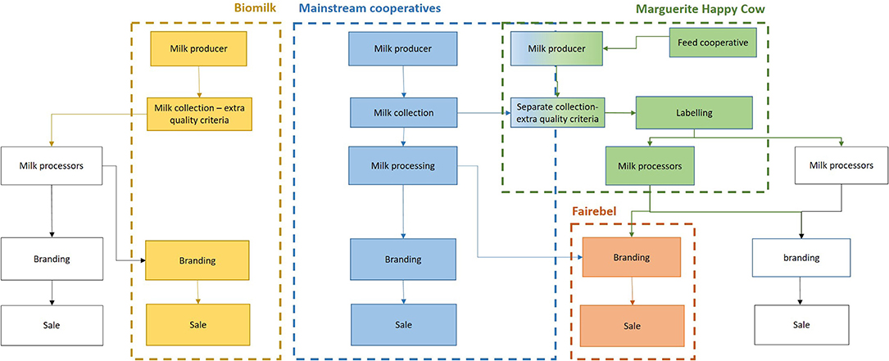

CHAPTER 4
TESTING AND IMPLEMENTATION

  - TESTING
Implementation is the stage of the project when the theoretical design is turned into a working system. This is the final and important phase in the system life cycle It is actually the process of converting the new system into a operational one.

4.1.1Unit Testing
Unit testing comprises the set of tests performed by an individual programmer prior to integration of the unit into a larger system. The module interface is tested to ensure that information properly flows into and out of the program unit. The local data structure is examined to ensure that data stored temporarily maintains its integrity during all steps in an algorithm’s execution. Boundary conditions are tested to ensure that the module operates properly at boundaries established to limit or restrict processing. All independent paths through the control structure are tested. All error-handling paths are tested.

4.1.2 Block Box Testing
Black-box testing is a method of software testing that examines the functionality of an application without peering into its internal structures or workings. This method of test can be applied virtually to every level of software testing: unit, integration, system and acceptance. It is sometimes referred to as specification-based testing.

4.2 SYSTEM IMPLEMENTATION
Implementation is the stage of the project when the theoretical design is turned into a working system. This is the final and important phase in the system life cycle It is actually the process of converting the new system into a operational one.

CHAPTER 5
CONCLUSION:
India’s large dairy sector is understudied, and there is limited public data on aspects of the sector that are important in assessing progress, future developments, or policy options. There are significant gaps in data collection in the areas of feed availability and use, changes in the size and cost structure of dairy production enterprises, and on the supply and use of most dairy products. Important topics for ongoing analysis and research include the changing dynamics of the crossbred and buffalo dairy herds, changes in the supply and use of dairy animal feeds, the expansion and activities of private-sector processors, and changes in the land and animal holdings of milk producers.

CHAPTER-6
REFERENCE
- Birthal, P.S., and A.K. Jha, 2005. Economic Losses Due to Various Constraints in Dairy Production in India, Indian Journal of Animal Sciences, 75 (12): 1470-1475, Dec.
- Dikshit, A.K., and P.S. Birthal. 2010. India’s Livestock Feed Demand: Estimates and Projections, Agricultural Economics Research Review, Vol. 23, January-June 2010, pp. 15-28.
- Hemme, T., M.M. Uddin, and O. A. Ndambi. 2014. Benchmarking Cost of Milk Production in 46 Countries, Journal of Reviews on Global Economics, 2014, 3, 254-270.
- Kumar, A., S. Parappurathu, and P.K. Joshi. 2013. Structural Transformation in Dairy Sector of India, Agricultural Economics Research Review, 26 (2), July-December 2013, pp 209-219.
- Landes, M.R., A. Melton, and S. Edwards. 2016. From Where the Buffalo Roam: India’s Beef Exports, Livestock, Dairy, and Poultry Outlook No. (LDPM-264-01) 36 pp, June 2016.
- Mullen, K., D. Orden, and A. Gulati. 2005. Agricultural Policies in India: Producer Support Estimates 1985-2002, International Food Policy Research Institute, MTID Discussion Paper No. 82, 135 pp., February.
- Rada, N., and D. Schimmelpfennig. 2015. Propellers of Agricultural Productivity in India, ERR No. 203, USDA/ERS, December.
- Rakotoarisoa, M., and A. Gulati. 2006. Competitiveness and Trade Potential of India’s Dairy Industry, Food Policy, 31 (2006), pp. 216-227.
- Taneja, V. K. 1999. Dairy Breeds and Selection, in Smallholder Dairying in the Tropics, (L. Falvey and C. Chanatalakhana, eds.), International Livestock Research Institute, Nairobi.
- USDA, National Agricultural Statistics Service. 2012. Census of Agriculture, Available: https:// www.agcensus.usda.gov/Publications/2012/

