Identification of missing LSBs which can be added in the road network to minimize the travel time

ABSTRACT
A wide range of relatively short-term disruptive events such as partial flooding, visibility reductions, traction hazards due to weather, and pavement deterioration occur on transportation networks on a daily basis. Despite being relatively minor when compared to catastrophes, these events still have profound impacts on traffic flow. To date there has been very little distinction drawn between different types of network-disruption studies and how the methodological approaches used in those studies differ depending on the specific research objectives and on the disruption scenarios being modeled. In this paper, we advance a methodological approach that employs different link-based capacity-disruption values for identifying and ranking the most critical links and quantifying network robustness in a transportation network. We demonstrate how an ideal capacity-disruption range can be objectively determined for a particular network and introduce a scalable system-wide performance measure, called the Network Trip Robustness (NTR) that can be used to directly compare networks of different sizes, topologies, and connectivity levels. Our approach yields results that are independent of the degree of connectivity and can be used to evaluate robustness on networks with isolating links. We show that system-wide travel-times and the rank-ordering of the most critical links in a network can vary dramatically based on both the capacity-disruption level and on the overall connectivity of the network. We further show that the relationships between network robustness, the capacity-disruption level used for modeling, and network connectivity are non-linear and not necessarily intuitive. We discuss our findings with respect to Braess’ Paradox.

CHAPTER 2
2. SYSTEM ANALYSIS
  - EXISTING SYSTEM

- The SSNN is a non-linear model with many degrees of freedom there exist (in principle) infinite parameter settings that would fit a particular travel time prediction problem well.
- There exists a wide and detailed body of theoretical and empirical knowledge on the propagation and operation of vehicular traffic.
- We argue that if the number of inputs to a problem is not too large, and either sound theoretical or statistical methods exist to determine the appropriate inputs and input time lags, a feed-forward ANN approach is certainly suitable for dynamic problems.
2.1.1 DRAWBACKS OF EXISTING SYSTEM :
- Network-disruption analysis is a methodological approach that has been successfully applied to transportation maintenance and planning problems to identify and rank the most critical links in a network and to evaluate the robustness of the network as a whole.
- The most obvious problem resulting from completely removing a network links to model disruptions is the creation of isolated sub-networks, which are no longer accessible when the single link connecting them to the network has been removed.
- A shortcoming in the original formulation of the NRI was the inability to address the problem of isolating links in a methodologically sound manner.
2.2. PROPOSED SYSTEM
- Several approximations are proposed that correct for the overestimation of mean speed (and thus underestimation of travel time) through arithmetic time averaging.
- We propose robust and easy-to-implement procedures that account for the missing data and allow accurate predictions even at high degrees of input failure.
- The central component in the proposed framework is inevitably the data driven short term freeway travel time prediction model, which predicts travel times on the freeway route of interest based on current and / or near-past traffic conditions.
2.2.1. ADVANTAGES OF PROPOSED SYSTEM
- It is equally important to have a sound methodological foundation for the assumptions used in the model and to define exactly what performance measures are used and how they are derived.
- Within the domain of network-disruption literature, different network performance measures are frequently used.
- The modified NRI and NTR have advantages over, and increased policy-relevance when compared to well-known and widely used performance measures such as the V/C because they account for the relative value of each link to the entire network as opposed to providing only a localized measure of the value of each link.
Literature Survey:
TITLE | AUTHORS | DESCRIPTION
Reliability measures of an origin and destination pair in a deteriorated network with variable flow | Asakura, Y., 1996. | This paper aims to show reliability measures of an origin and destination (OD) pair in a road network when some links are possibly damaged by natural disasters and may be closed to traffic.
Vulnerability: a model-based case study of the road network in Stockholm | Berdica, K., Mattsson, L.G., 2007. | This paper presents the results from a model-based case study, performed with the overall objective to study how vulnerable the Stockholm road network is in different respects.
Capacity reliability of a road network: an assessment methodology and numerical results | Chen, A., 2000. | The proposed capacity reliability index includes connectivity reliability as a special case and also provides travel time reliability as a side product.
Residual closeness in networks | Dangalchev, C., 2006. | This characteristic is more sensitive than the well-known measures of vulnerability it captures the result of actions even if they are small enough not to disconnect the graph.

2.3 FEASIBILITY STUDY
The feasibility Analysis is an analytical program through project manager determines the project success ratio and through feasibility study project manager able to see either project. The key considerations involved in the feasibility analysis are:
- Economic Feasibility
- Technical Feasibility
- Operational Feasibility
- Environmental Feasibility
2.3.1 ECONOMICAL FEASIBILITY
Hence this project is economically feasible there is no need to involve any cost for this project.
2.3.2 TECHNICAL FEASIBILITY
Software Technologies used are PHP and MySql. In the educational institutions, it is possible to update the system in future. No special hardware is required for the purpose of using this system. Hence it is declared that this project is technically feasible.
2.3.3 OPERATIONAL FEASIBILITY
As the admin work mainly to maintain the Patient and Doctor .Doctor will predict patient cancer disease. Hence it is easy to operate with training. Therefore it is operationally feasible for implementation.
2.3.4 ENVIRONMENTAL FEASIBILITY
This project environment is correct as a admin has developed this system and no expenditure is involved under any head and this process is part of admin document management, this project environment is accessible.

2.4 SYSTEM REQUIREMENTS
- System : Pentium IV 2.4 GHz.
- Hard Disk : 40 GB.
- Monitor : 15 inch VGA Color.
- Mouse : Logitech Mouse.
- Ram : 512 MB
- Keyboard : Standard Keyboard

2.4.1 HARDWARE REQUIREMENTS
The Hardware of the computer consists of physical component such as Input Devices, Storage Devices, Processing & Control units and Output Devices. Computer includes external storage unit to store data in programs.
The Hardware Configuration involved in this project
- System : Pentium IV 2.4 GHz.
- Hard Disk : 40 GB.
- Monitor : 15 inch VGA Color.
- Mouse : Logitech Mouse.
- Ram : 512 MB
- Keyboard : Standard Keyboard

2.4.2 SOFTWARE REQUIREMENTS
Software is a group of programs that computers need to do a particular task. It is an essential requirement of Computer System. The Software used to develop the project is
- Operating System : Windows XP.
- Platform : DOT NET TECHNOLOGY
- Front End : ASP.Net 3.5
- Back End : SQL SERVER 2005

CHAPTER 3
SYSTEM DESIGN AND DEVELOPEMENT
SYSTEM ARCHICTURE

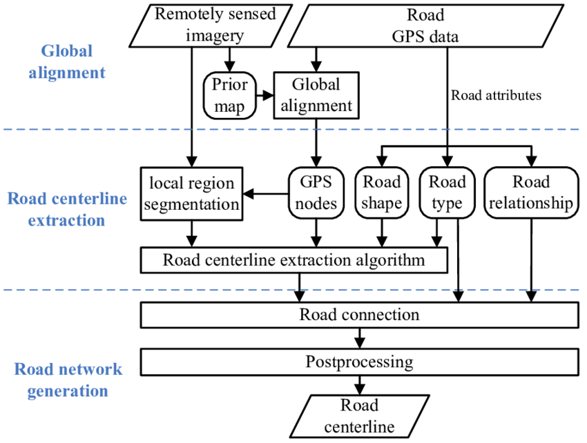

CHAPTER 4
TESTING AND IMPLEMENTATION

  - TESTING
Implementation is the stage of the project when the theoretical design is turned into a working system. This is the final and important phase in the system life cycle It is actually the process of converting the new system into a operational one.

4.1.1Unit Testing
Unit testing comprises the set of tests performed by an individual programmer prior to integration of the unit into a larger system. The module interface is tested to ensure that information properly flows into and out of the program unit. The local data structure is examined to ensure that data stored temporarily maintains its integrity during all steps in an algorithm’s execution. Boundary conditions are tested to ensure that the module operates properly at boundaries established to limit or restrict processing. All independent paths through the control structure are tested. All error-handling paths are tested.

4.1.2 Block Box Testing
Black-box testing is a method of software testing that examines the functionality of an application without peering into its internal structures or workings. This method of test can be applied virtually to every level of software testing: unit, integration, system and acceptance. It is sometimes referred to as specification-based testing.

4.2 SYSTEM IMPLEMENTATION
Implementation is the stage of the project when the theoretical design is turned into a working system. This is the final and important phase in the system life cycle It is actually the process of converting the new system into a operational one.

CHAPTER 5
CONCLUSION:
The NTR is a scalable network performance measure that can be used to directly compare different physical transportation networks to one another regardless of scale, topology, or level of connectivity. The NTR can be used to project the effects of future expansion or disruption scenarios that may end up altering the connectivity and/or topology of a specific network. This is useful when large-scale budgeting decisions need to be made between numbers of disparate networks – within a state for example. We employ a variety of link-based capacity-disruption values from 99% to 30% to model network robustness and to identify the most critical links for three test networks and compare the results using the NTR. We show that identifying an appropriate capacity-disruption level is imperative, as the performance results and rank-ordering of the most critical links in the network can change dramatically as the capacity-disruption level changes.

CHAPTER-6
REFERENCE
- Asakura, Y., 1996. Reliability measures of an origin and destination pair in a deteriorated network with variable flow. In: Bell, M.H. (Ed.), Transportation Network: Recent Methodological Advances. Pergamon Press, Oxford.
- Berdica, K., Mattsson, L.G., 2007. Vulnerability: a model-based case study of the road network in Stockholm. Critical Infrastructure, 81–106.
- CCMPO, 2008. CCMPO Regional Transportation Model Documentation, 2000 Base Year Model, Version 2.3.0. Prepared by Resource Systems Group of White River Junction, Vermont for the Chittenden County Metropolitan Planning Organization, January 24, 2008.
- Chen, A., 2000. Capacity reliability of a road network: an assessment methodology and numerical results. Transportation Research Part B 36 (3), 225–252.
- Dangalchev, C., 2006. Residual closeness in networks. Physica A: Statistical Mechanics and its Applications 365 (2), 556–564.
- FHWA, 2008. Our Nation’s Highways 2008. The US Department of Transportation, Federal Highway Administration.
- Grubesic, T.H., 2005. Vital nodes, interconnected infrastructures, and the geographies of network survivability. Annals of the Association of American Geographers 96 (1), 64–83.
- Holmgren, Å., 2007. A framework for vulnerability assessment of electric power systems. Critical Infrastructure, 31–55.
- Jenelius, E., 2007a. Considering the User Inequity of Road Network Vulnerability. Division of Transport and Location Analysis, The Royal Institute of Technology (KTH), Stockholm.
- Matisziw, T.C., 2007. Evaluating vulnerability and risk in interstate highway operation. In: TRB 86th Annual Meeting, Washington, DC

