RECOMMENDER BASED E-COMMERCE WEBSITE

ABSTRACT
To overcome the product overload of online shoppers, a variety of recommendation methods have been developed. Recommender systems are being utilized by an ever increasing number of E-commerce sites to help consumers discover products to buy. The most of existing system gives the recommendation based on best selling product, on demographics of the consumer, or on an analysis of the past buying behavior of the consumer. Our purposed system based on the consumer reviews and advanced multi-criteria search engine. In this paper, we used a text mining approach to mine product features, opinions and their semantic similarity from Web opinion sources. The consumer can clearly see the strengths and Weaknesses of each product in the minds of existing consumer’s opinion. The system assists on-line shoppers or goal oriented shopper by suggesting the most effective navigation products for their specified criteria and preferences.

SYSTEM ANALYSIS
EXISTING SYSTEM

- The existing recommendation system lacks the capability of creating the difference on respective systems specifications meaning a review on specific attribute of system is utilized to measure the overall system or item’s rating.
- These kinds of feedbacks are accountable in existing systems while rating or comparing the complete product.
- The provided recommendations are user opinions based on products feature; the user can clearly understand the strengths and Weaknesses of each product in the minds of existing users.
DRAWBACKS OF EXISTING SYSTEM :
- It is very challenging to recommend the products to new customers, therefore Demographics techniques are used to handle this kind of problem.
- To address this problem statement our recommendation system focuses on the product’s features, opinion and recommends & condemns it depending upon its feature, opinion and requirements of users fairly considering the reviews in the system.
- A new assessment mechanism is introduced to short out the new consumer problem of E- commerce recommendation.
PROPOSED SYSTEM
- The proposed method involves forecasting an expected mistake that each system will generate for each user based on their historical behavior.
- The proposed system depends on statistical analysis to solve the problem of a cold-start by providing a recommendation depending on the preferences matrix of the products.
- The proposed system is a part of the commercial environment, which involves an e-commerce website, an e-bank system, and customers.
ADVANTAGES OF PROPOSED SYSTEM
- Goal-oriented shopping is efficient and purposeful, with a preplanned purchase in mind.
- We can rely on this product to make text analysis easier and more efficient for our research because it is a linguistics-based solution.
- The advantage of recommender system is their user-friendliness they don't need any extra search terms, they just use certain keyword according to user knowledge. This can be a significant advantage for inexperienced internet users.

Literature Survey:
TITLE | AUTHORS | DESCRIPTION
Work and/or fun: measuring hedonic and utilitarian shopping value | Babin, Barry J., William R. Darden, and Mitch Griffin. | This article describes the development of a scale measuring both values obtained from the pervasive consumption experience of shopping.
Marketing in hypermedia computer-mediated environments: conceptual foundations | Hoffman, Donna L., and Thomas P. Novak. | Our approach considers hypermedia CMEs to be large-scale (i.e. national or global) networked environments, of which the World Wide Web on the Internet is the first and current global implementation.
Customer profile classification using transactional data | Apeh, Edward Tersoo, Bogdan Gabrys, and Amanda Schierz. | It is often the case that due to reasons such as high cost of data acquisition and/or protection, only the transactional data are available for data mining operations.
Data mining for web personalization | Mobasher, Bamshad | These phases include data collection and pre- processing, pattern discovery and evaluation, and finally applying the discovered knowledge in real-time to mediate between the user and the Web.

FEASIBILITY STUDY
The feasibility Analysis is an analytical program through project manager determines the project success ratio and through feasibility study project manager able to see either project. The key considerations involved in the feasibility analysis are:
- Economic Feasibility
- Technical Feasibility
- Operational Feasibility
- Environmental Feasibility
ECONOMICAL FEASIBILITY
Hence this project is economically feasible there is no need to involve any cost for this project.
TECHNICAL FEASIBILITY
Software Technologies used are PHP and MySql. In the educational institutions, it is possible to update the system in future. No special hardware is required for the purpose of using this system. Hence it is declared that this project is technically feasible.
OPERATIONAL FEASIBILITY
As the admin work mainly to maintain the Patient and Doctor .Doctor will predict patient cancer disease. Hence it is easy to operate with training. Therefore it is operationally feasible for implementation.

ENVIRONMENTAL FEASIBILITY
This project environment is correct as a admin has developed this system and no expenditure is involved under any head and this process is part of admin document management, this project environment is accessible.
SYSTEM REQUIREMENTS
HARDWARE SPECIFICATION
Processor : Dual core processor2.6.0 GHZ
RAM : 2GB
HARD DISK : 256 GB
Keyboard : Standard Keyboard
Monitor : 15 inch Color monitor
SOFTWARE SPECIFICATION
Browser : CHROME/FIREFOX
Font-End : HTML
Back-End : MYSQL
Server : XAMPP
Language : PHP

SYSTEM ARCHIECTURE

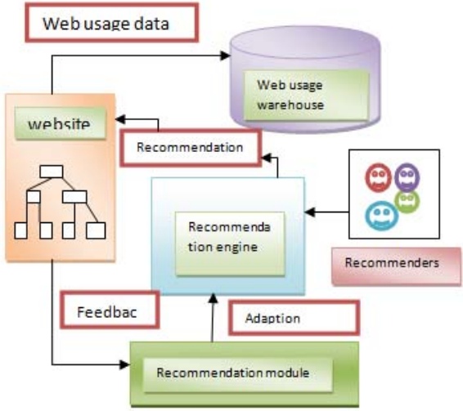

MODULES
In this project have four module, they are
- Vendor Registration
- Customer Registration
- Admin Registration
- Login
MODULES DESCRIPTION

VENDOR REGISTRATION
In this page of Vendor Registration, the vendor fill personal data which contains Full name, User name, password, address, E-mail and another crucial data.
CUSTOMER REGISTRATION
In the page of Customer Registration, the customer fill personal data which contains Full name, User name, password, address, E-mail and another crucial data.
ADMIN REGISTRATION
In the page of Admin Registration, the admin fill personal data which contains Full name, User name, password, address, E-mail and another crucial data.

LOGIN
In the Home Page, User asked to enter username and password to login, our task to check if the user logged in were admin, customer or vendor. If user name of logged user in customers table so the logged user was customer if not we will check admin table. If password not match we will redirect to error page to show error message (Please Enter Right Password) and from that page user can use back button to return to login form to be able to enter right password.

DATABASE DESIGN
USER INFORMATION:
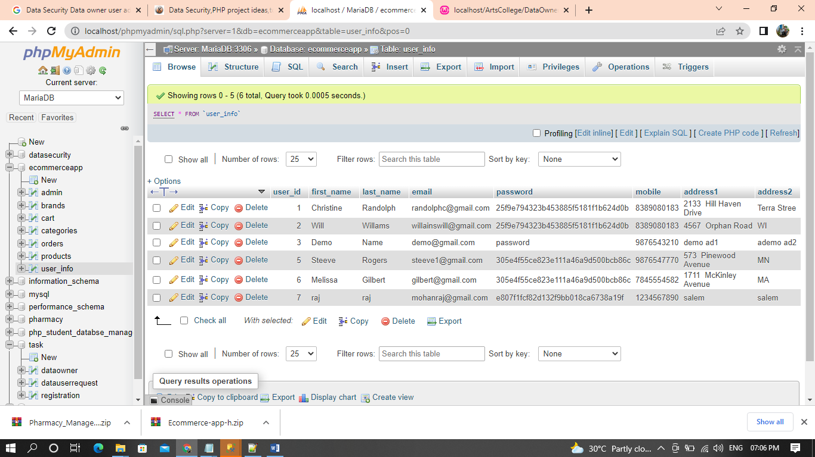

ADMIN INFORMATION:
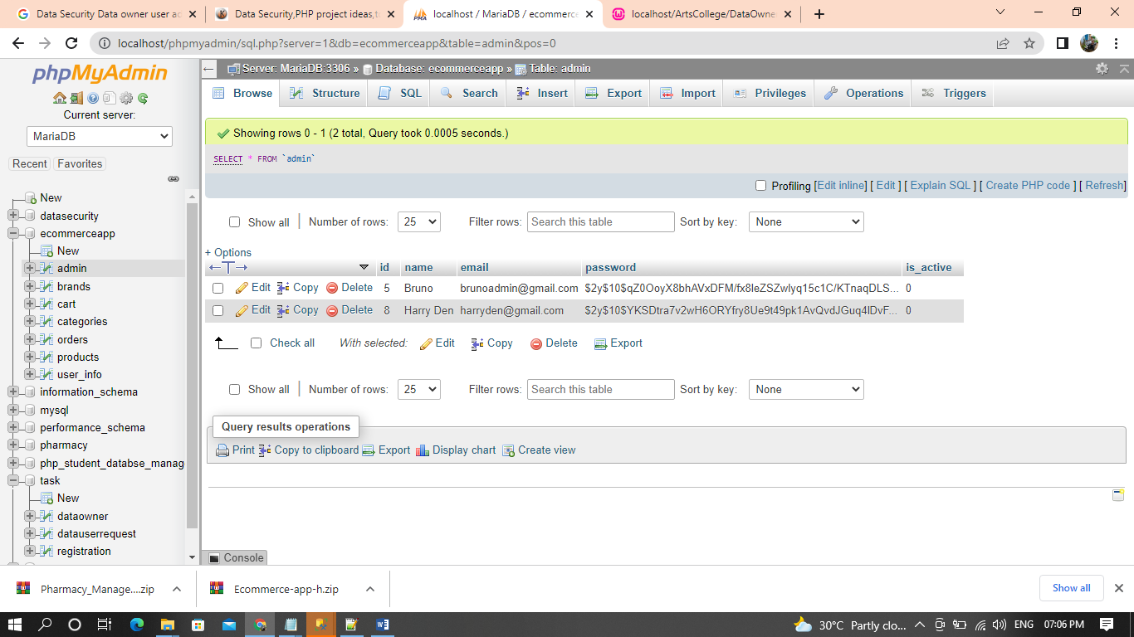

PRODUCTS:
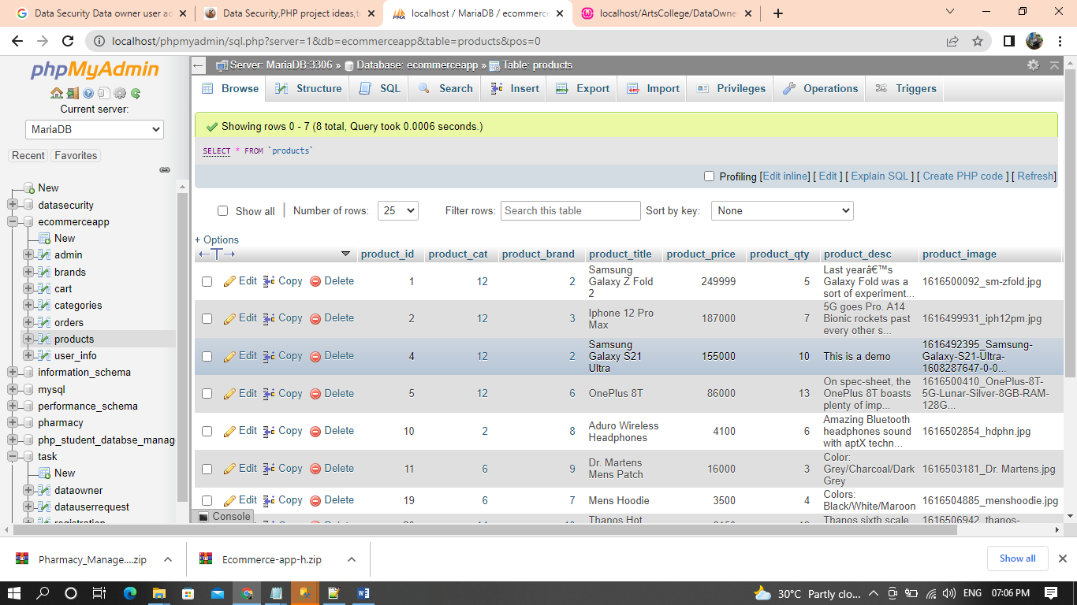

SCREEN SHOTS
REGISTER:
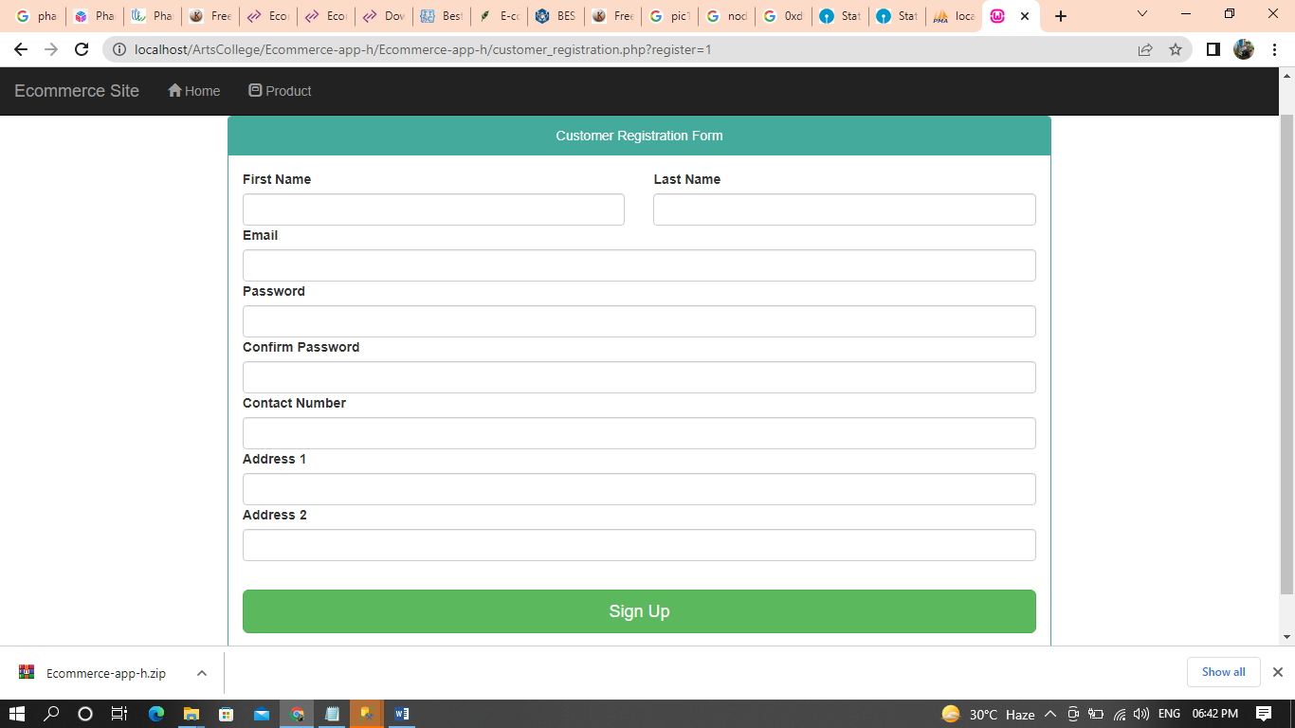

LOGIN
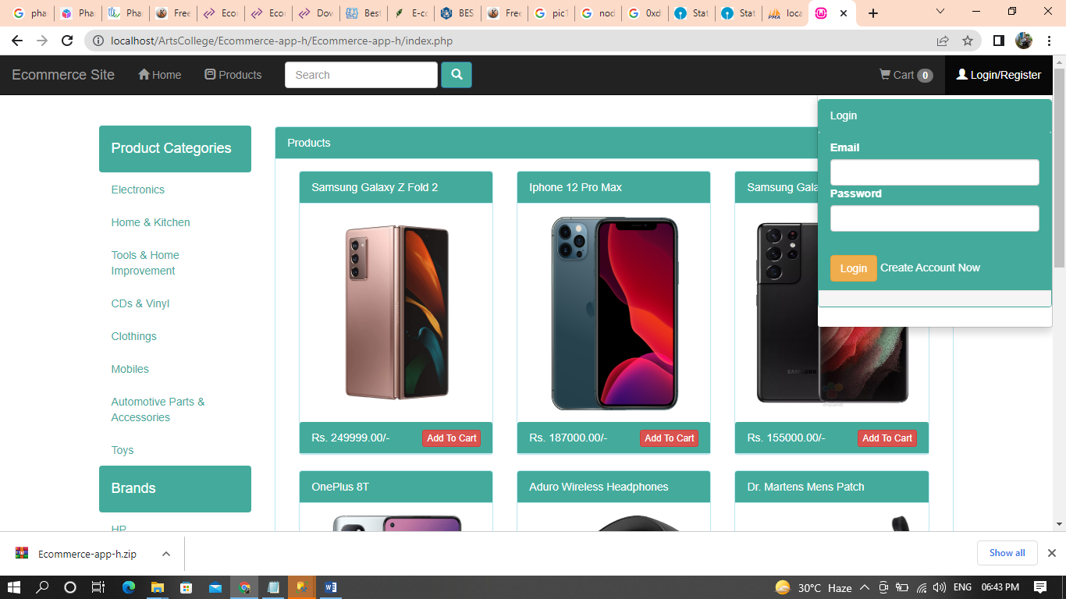

PRODUCT VIEWS
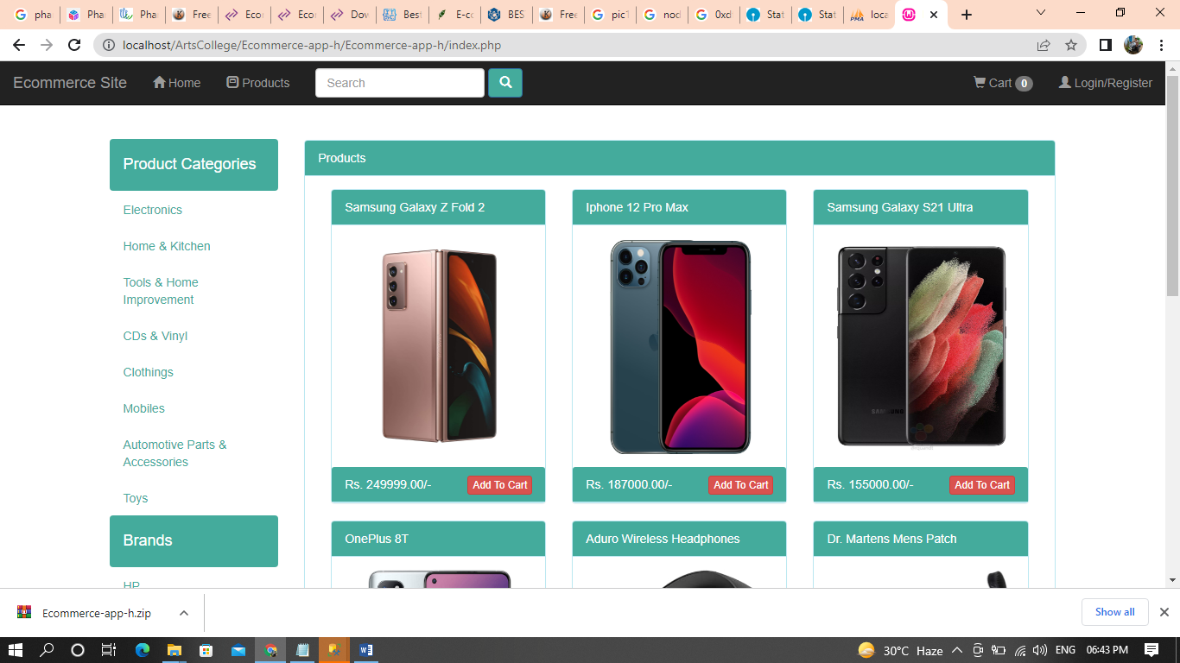

DATA FLOW DIAGRAM
Admin:

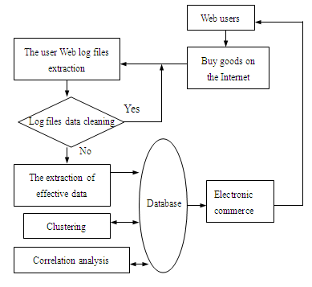

User:

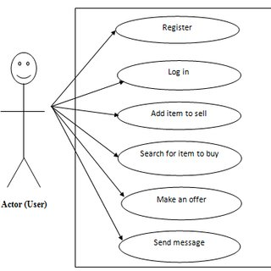

CONCLUSION
The rapid expansion of e-commerce forces existing recommender systems to deal with a large number of customers and products and to ensure high quality of recommendations. In this paper, we have studied about the Ecommerce web interface and online reviews available on web and extraction product features opinion and categorization, from online product reviews using the IBM SPSS Text Analytics for Surveys. We utilize the semantic knowledge similarity measures to calculate the similarities and categorize product features into different feature groups. The experimental results have demonstrated the effectiveness of our proposed model. In this article, a new assessment mechanism is introduced to short out the new consumer problem of E- commerce recommendation.

REFERENCE
- [1] Babin, Barry J., William R. Darden, and Mitch Griffin. "Work and/or fun: measuring hedonic and utilitarian shopping value." Journal of consumer research (1994): 644-656.
- [2] Hoffman, Donna L., and Thomas P. Novak. "Marketing in hypermedia computer-mediated environments: conceptual foundations." The Journal of Marketing (1996): 50-68.
- [3] Hoffman, Donna L., Thomas P. Novak, and Ann Schlosser. "Consumer control in online environments." Elab. vanderbilt. edu (2000).
- [4] Apeh, Edward Tersoo, Bogdan Gabrys, and Amanda Schierz. "Customer profile classification using transactional data." Nature and Biologically Inspired Computing (NaBIC), 2011 Third World Congress on. IEEE, 2011.
- [5] Mobasher, Bamshad. "Data mining for web personalization." The adaptive web. Springer Berlin Heidelberg, 2007. 90-135.
- [6] Jakob, Niklas. "Extracting Opinion Targets from UserGenerated Discourse with an Application to Recommendation Systems." (2011).
- [7] Yousefi, Ayoub, and Jie Tang. "E-commerce: Consumer Online Shopping in Canada." Contemporary Research on E-business Technology and Strategy. Springer Berlin Heidelberg, 2012. 1-14.
- [8] Gretzel, Ulrike, and Daniel R. Fesenmaier. "Persuasion in recommender systems." International Journal of Electronic Commerce 11.2 (2006): 81-100.
- [9] Chen, Yen-Liang, et al. "Market basket analysis in a multiple store environment." Decision support systems 40.2 (2005): 339-354.
- [10] Lin, Qi-Yuan, et al. "Mining inter-organizational retailing knowledge for an alliance formed by competitive firms." Information & management 40.5 (2003): 431-442.

