LOSSLESS DATA HIDING BASED ON HOMOMORPHIC CRYPTOSYSTEM

ABSTRACT
With the development of cloud server, reversible data hiding in encrypted domain has received widespread attention for management of encrypted media. Most of existing reversible data hiding methods are based on stream ciphers, which are mainly concerned with data storage security. While homomorphic ciphers focus on data processing security, which is popular in cloud and other third-party platforms. Reversible data hiding with homomorphic cryptography has been an active topic in the research filed. In this paper, we propose a new lossless data hiding method based on homomorphic cryptosystem. After a content owner generates encrypted media with homomorphic ciphers, a data hider embeds secret data by establishing a mapping between secret bits and losslessly modifying encrypted media. At the receiver side, the embedded data is extracted from encrypted domain with a little auxiliary message. And original media is recovered by directly decrypting marked encrypted media. During the embedding process, the modification of encrypted media does not change the corresponding original media owing to homomorphic and probabilistic properties. Thus, no distortion is introduced in the whole procedures of data embedding. And directly decrypted media containing embedded data is the same as the original media. Meanwhile, the proposed method achieves a high embedding rate through efficient mapping and skillful use of expanded pixel values. The experimental results show that compared with state-of-the-art methods, the proposed method has higher embedding rate without distortion.

SYSTEM ANALYSIS
EXISTING SYSTEM

- In the existing public key cryptosystem, the one with the highest encryption strength per bit is the difficulty of the ECC math problem, thus it is safe to encrypt images with EC-EG compared to using Paillier to encrypt images.
- When a new algorithm is produced or an existing algorithm is revised, intruders or hackers break the algorithm.
- The proposed scheme maintains (t, n) threshold of secret image sharing and obtains a better EC compared with the existing RDH-ED algorithms.
DRAWBACKS OF EXISTING SYSTEM :
- The elliptic curve discrete logarithm problem is more difficult to deal with than the discrete logarithm problem on the finite field, and the security is also higher.
- This paper mainly uses polynomial interpolation technique to realize secret sharing and then solve the RDH problem for multiple receivers.
- In this paper, we address the issue concerning the separation of the roles of the data provider and the data processor, and both images and data are encrypted before transmission to the data processor.
PROPOSED SYSTEM
- In this paper, a lossless data-hiding scheme for public-keyencrypted images is proposed. There are three parties in the scheme: an image provider, a data hider, and a receiver.
- In our proposed scheme, after the space is reserved and encrypted, the MCC is constructed. The extra information is embedded into the bit plane of the corresponding plaintext by homomorphic addition.
- The proposed scheme uses the homomorphic addition feature of EC-EG to protect the embedded extra information.
ADVANTAGES OF PROPOSED SYSTEM
- The image distortion is reduced, thus its performance is generally higher than the scheme in our paper.
- The distortion introduced by constructing MCGs is also getting larger and larger, which leads to faster performance degradation of the algorithm.
- The performance of our scheme is better than the one in when the embedded capacity is high.
- The method of statistical analysis can test the anti-attack performance of encryption algorithm in chaos and diffusion from different angles.

Literature Survey:
TITLE | AUTHORS | DESCRIPTION
Encrypted Signal-Based Reversible Data Hiding with Public Key Cryptosystem | Y.-C. Chen, C.-W. Shiu, and G. Horng, | In this paper, we propose an encrypted signal-based reversible data hiding (ESRDH) with public key cryptosystem, not only for images.
High Capacity Lossless Data Embedding Technique for Palette Images Based on Histogram Analysis | N. A. Saleh, H. N. Boghdad, S. I. Shaheen, A. M. Darwish, | In general lossless data hiding techniques suffer from limited capacity as the host image should be kept intact.
Reversible Data Hiding in Encrypted Images by Reserving Room Before Encryption | K. Ma, W. Zhang, X. Zhao, N. Yu, and F. Li, | In this paper, we propose a novel method by reserving room before encryption with a traditional RDH algorithm, and thus it is easy for the data hider to reversibly embed data in the encrypted image.
Reversible Data Hiding with Optimal Value Transfer | X. Zhang, | In this paper, the optimal rule of value modification under a payload-distortion criterion is found by using an iterative procedure, and a practical reversible data hiding scheme is proposed.

FEASIBILITY STUDY
The feasibility Analysis is an analytical program through project manager determines the project success ratio and through feasibility study project manager able to see either project. The key considerations involved in the feasibility analysis are:
- Economic Feasibility
- Technical Feasibility
- Operational Feasibility
- Environmental Feasibility
ECONOMICAL FEASIBILITY
Hence this project is economically feasible there is no need to involve any cost for this project.
TECHNICAL FEASIBILITY
Software Technologies used are PHP and MySql. In the educational institutions, it is possible to update the system in future. No special hardware is required for the purpose of using this system. Hence it is declared that this project is technically feasible.
OPERATIONAL FEASIBILITY
As the admin work mainly to maintain the Patient and Doctor .Doctor will predict patient cancer disease. Hence it is easy to operate with training. Therefore it is operationally feasible for implementation.
ENVIRONMENTAL FEASIBILITY
This project environment is correct as a admin has developed this system and no expenditure is involved under any head and this process is part of admin document management, this project environment is accessible.

SYSTEM REQUIREMENTS

HARDWARE SPECIFICATION
Processor : Dual core processor2.6.0 GHZ
RAM : 2GB
HARD DISK : 256 GB
Keyboard : Standard Keyboard
Monitor : 15 inch Color monitor
SOFTWARE SPECIFICATION
Browser : CHROME/FIREFOX
Font-End : HTML
Back-End : MYSQL
Server : XAMPP
Language : PHP

SYSTEM ARCHIECTURE

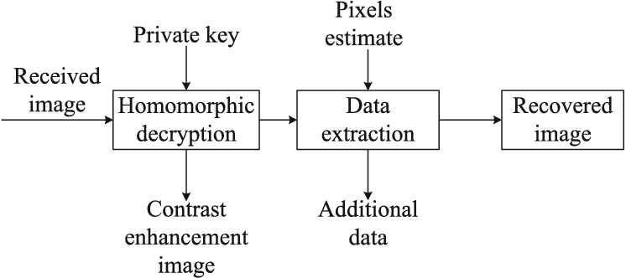

MODULES
In this project have 3 module, they are
- Crypto Module
- Security Module
- Retrieving Module

MODULE DESCRIPTION
CRYPTO MODULE
- For crypto module the following steps are considered for encrypting the data.
- Insert text for encryption.
- Apply AES algorithm using 128 bit key.
- Generate Cipher Text in hexadecimal form.
SECURITY MODULE
- Separate the alphapets and digits from the cipher text.
- Keep track of the original position of the alphapet and the digits in the form of a secret key.
- Separate first seven alphapets retrieved from first step and add the remaining alphapets at the end of the separated digits as in the first step. This generates the second key.
RETRIEVED TEXT
- Retrieve data using decryption.
- Decryption is the process of convert encrypted value into normal readable value.
DATABASE DESIGN
REGISTRATION
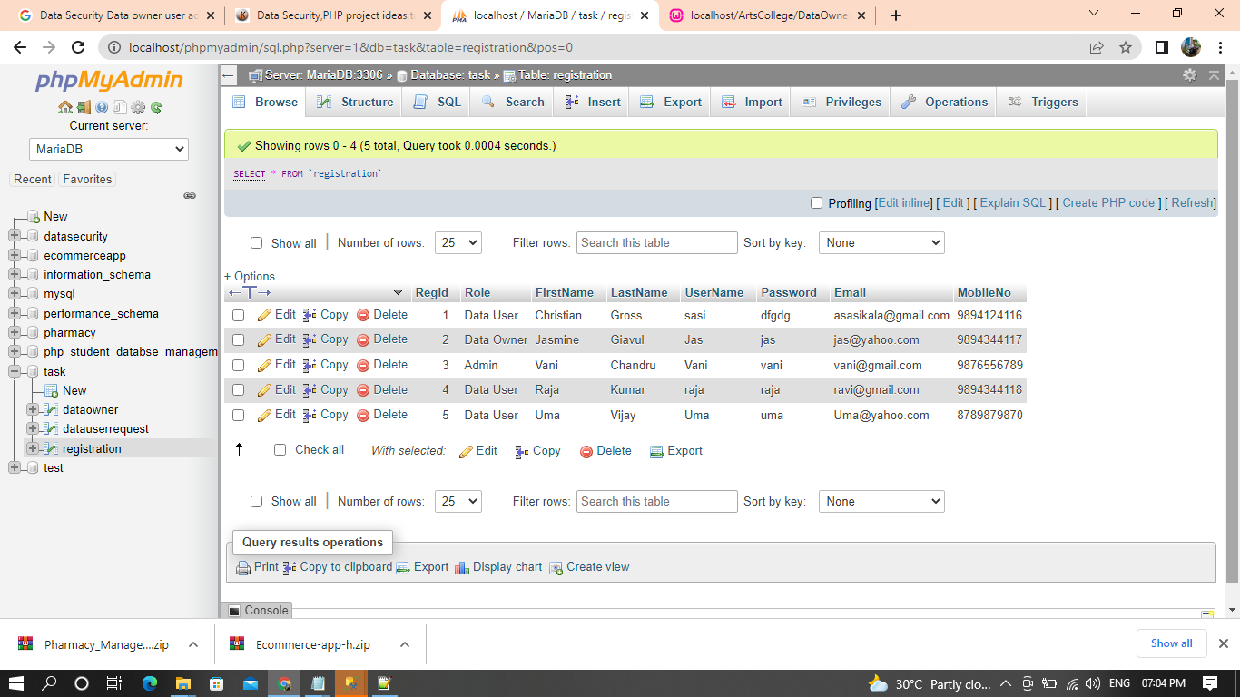

DATA OWNER
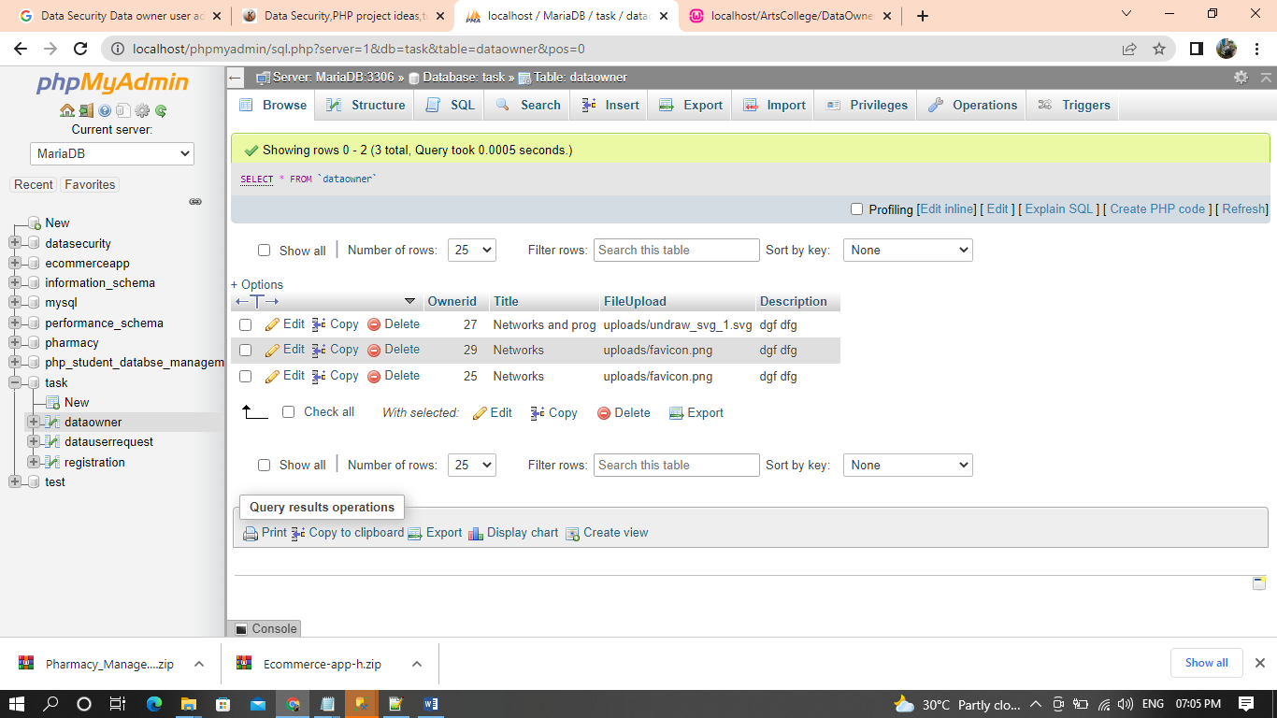

DATA REQUEST
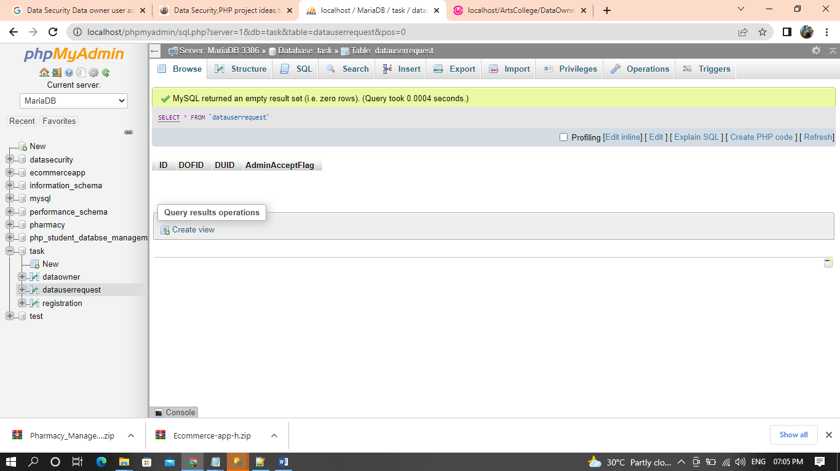

SCREEN SHOTS

REGISTER OWNER/ ADMIN/ USER


LOGIN


DATA INFORMATION

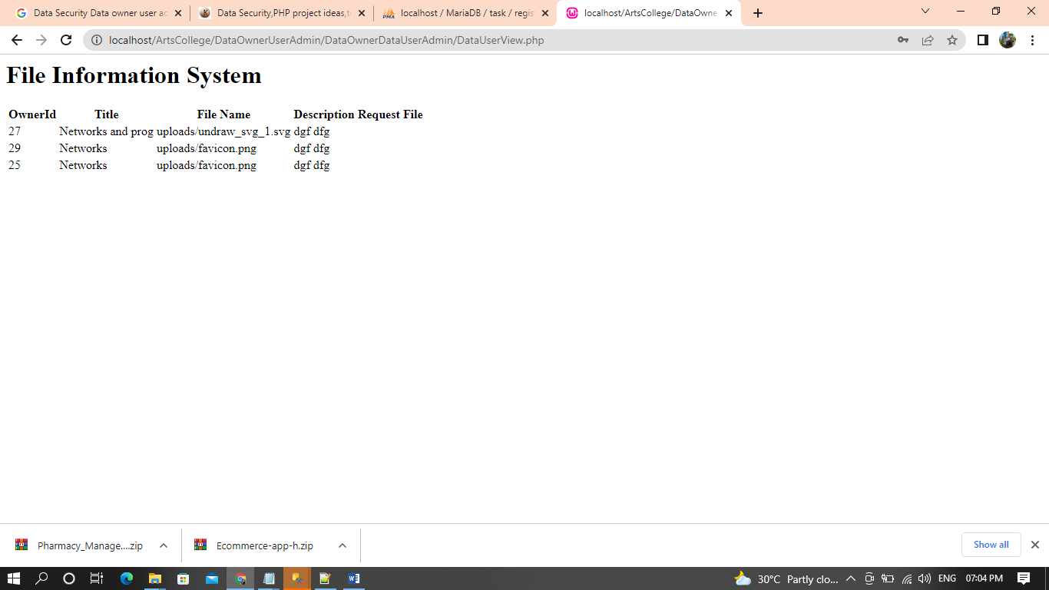

DATA FLOW DIAGRAM
Admin:

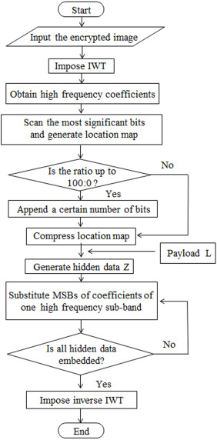

USER
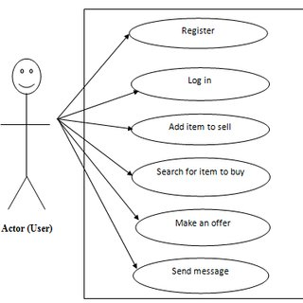

CONCLUSION:
In the lossless scheme, the embedded data can be directly extracted from the encrypted domain, and the data embedding operation does not affect the decryption of original plaintext image. In the reversible scheme, the additional data can be extracted from the plaintext domain, and, although a slight distortion is introduced in decrypted image, the original plaintext image can be recovered without any error. Due to the compatibility of the two schemes, the data embedding operations of the lossless and the reversible schemes can be simultaneously performed in an encrypted image. So, the receiver may extract a part of embedded data in the encrypted domain, and extract another part of embedded data and recover the original plaintext image in the plaintext domain.

REFERENCE
- [1].Y.-C. Chen, C.-W. Shiu, and G. Horng, “Encrypted Signal-Based Reversible Data Hiding with Public Key Cryptosystem,” Journal of Visual Communication and Image Representation, 25, pp. 1164-1170, 2014..
- [2]. N. A. Saleh, H. N. Boghdad, S. I. Shaheen, A. M. Darwish, “ High Capacity Lossless Data Embedding Technique for Palette Images Based on Histogram Analysis,” Digital Signal Processing, 20, pp. 1629−1636, 2010.
- [3]. K. Ma, W. Zhang, X. Zhao, N. Yu, and F. Li, “Reversible Data Hiding in Encrypted Images by Reserving Room Before Encryption,” IEEE Trans. Information Forensics & Security, 8(3), pp. 553-562, 2013.
- [4]. X. Zhang, “Commutative Reversible Data Hiding and Encryption,” Security and Communication Networks, 6, pp. 1396−1403, 2013.
- [5]X. Zhang, “Reversible Data Hiding with Optimal Value Transfer, IEEE Trans. On Multimedia, 15(2), 316?325, 2013.
- [6] J. Fridrich, M. Goljan, P. Lisonek, and D. Soukal, ” Writing on Wet Paper,” IEEE Trans. Signal Processing, 53(10), pp. 3923-3935, 2005.
- [7].W. Puech, M. Chaumont, and O. Strauss, “ A Reversible Data Hiding Method for Encrypted Images,” Security, Forensics, Steganography, and Watermarking of Multimedia Contents X, Proc. SPIE, 6819, 2008.
- [8].X. Zhang, “ Separable Reversible Data Hiding in Encrypted Image,” IEEE Trans. Information Forensics & Security, 7(2), pp. 526−532, 2012.
- [9].X. Zhang, “Reversible Data Hiding with Optimal Value Transfer,” IEEE Trans. on Multimedia, 15(2), 316−325, 2013
- [10] N. A. Saleh, H. N. Boghdad, S. I. Shaheen, A. M. Darwish, “High Capacity Lossless Data Embedding Technique for Palette Images Based on Histogram Analysis,” Digital Signal Processing, 20, pp. 1629−1636, 2010.

