Website and Application For convergence with MoLE initiatives

ABSTRACT
The term Web 2.0 describes web-based applications such as social networking sites, wikis, and blogs that facilitate collaboration, creativity, and sharing among users. Web 2.0 applications are often enabled by reusing content from other web-based applications or web services. This trend is largely parallel to the principles of service-oriented architecture (SOA), which encourages integration and reuse of online services. In this paper, we discuss the possibility of convergence of Web 2.0 and SOA, which is illustrated by a multimodal social networking system built using web services. We also present the results of benchmarking experiments aimed to study the latency caused by web service composition and integration and its effects on the end-user experience.

CHAPTER 2
2. SYSTEM ANALYSIS
  - EXISTING SYSTEM

- We recommend starting with any existing guidance you can find from your vendor or those available from the various existing security organizations such as OWASP, CERT, and SANS and then tailoring them for your particular needs.
- Use an existing configuration tool or develop your own. A number of such tools already exist.
- You can also use disk replication tools such as Ghost to take an image of an existing hardened server, and then replicate that image to new servers.
2.1.1 DRAWBACKS OF EXISTING SYSTEM :
- Web services offer a standards-based solution to the problem of connecting producers and consumers of information over the Internet.
- One of the possible solutions addressing this problem is to leverage the capabilities of SOA by creating a specialized social network-oriented framework of web services that would help interconnect people and content in more meaningful ways.
- The distributed nature of SeeCCT architecture can lead to a problem where the invocation and integration of various web services can generate latency in the system that may be unacceptable to a user.
2.2. PROPOSED SYSTEM
- In this paper, we propose using flow as a fundamental notion underlying understanding of activities in Web Services.
- This proposed flow model is a promising approach to software development in service-oriented applications.
- Object-oriented analysis and design and UML-based diagrams are typically used in the software development process.
- Web Services technology is based on the concept of service-oriented computing.
2.2.1. ADVANTAGES OF PROPOSED SYSTEM
- Speech remains the most basic and the most efficient form of interpersonal communication, and facilitating voice communication remains the main function of even the simplest mobile phone.
- One of the main advantages of SOA is an ability to rapidly develop applications using loosely coupled and reusable services that are accessible via standardized interfaces used to hide the complexity of their implementation.
- We conducted a series of experiments to gauge the latency of the system’s interaction with the users using its speech interface, which reveal some possible ways for improving the system by taking advantage of a more aggressive caching or pre-fetching of audio data.
Literature Survey:
TITLE | AUTHORS | DESCRIPTION
A Multimodal Interaction Guide for Pervasive Services Access | A. Augello, A. Santangelo, S. Sorce, G. Pilato, A. Gentile, A. Genco, S. Gaglio, | The aim of the work is to offer a more natural, context sensitive access to information with respect to traditional audio/visual pre-recorded guides.
Context Aware Middleware for Anytime, Anywhere Social Networks | D. Bottazzi, R. Montanari, A. Toninelli, | SAMOA, a semantic context-aware middleware approach, lets you create anytime, anywhere social networks among users in physical proximity.
The Future of Social Networks on the Internet | J. Breslin, S.Decker, | A possible solution is to build semantic social networking into the fabric of the next-generation Internet itself-interconnecting both content and people in meaningful ways.
Classifying Multimedia Resources Using Social Relationships | S. Föll, J. Pontow, D. Linner, I. Radusch, | In particular, the mass of shared user generated content and strong multimedia diversity lead to a vast amount of heterogeneous and unstructured information.

2.3 FEASIBILITY STUDY
The feasibility Analysis is an analytical program through project manager determines the project success ratio and through feasibility study project manager able to see either project. The key considerations involved in the feasibility analysis are:
- Economic Feasibility
- Technical Feasibility
- Operational Feasibility
- Environmental Feasibility
2.3.1 ECONOMICAL FEASIBILITY
Hence this project is economically feasible there is no need to involve any cost for this project.
2.3.2 TECHNICAL FEASIBILITY
Software Technologies used are PHP and MySql. In the educational institutions, it is possible to update the system in future. No special hardware is required for the purpose of using this system. Hence it is declared that this project is technically feasible.
2.3.3 OPERATIONAL FEASIBILITY
As the admin work mainly to maintain the Patient and Doctor .Doctor will predict patient cancer disease. Hence it is easy to operate with training. Therefore it is operationally feasible for implementation.
2.3.4 ENVIRONMENTAL FEASIBILITY
This project environment is correct as a admin has developed this system and no expenditure is involved under any head and this process is part of admin document management, this project environment is accessible.

2.4 SYSTEM REQUIREMENTS
- System : Pentium IV 2.4 GHz.
- Hard Disk : 40 GB.
- Monitor : 15 inch VGA Color.
- Mouse : Logitech Mouse.
- Ram : 512 MB
- Keyboard : Standard Keyboard

2.4.1 HARDWARE REQUIREMENTS
The Hardware of the computer consists of physical component such as Input Devices, Storage Devices, Processing & Control units and Output Devices. Computer includes external storage unit to store data in programs.
The Hardware Configuration involved in this project
- System : Pentium IV 2.4 GHz.
- Hard Disk : 40 GB.
- Monitor : 15 inch VGA Color.
- Mouse : Logitech Mouse.
- Ram : 512 MB
- Keyboard : Standard Keyboard

2.4.2 SOFTWARE REQUIREMENTS
Software is a group of programs that computers need to do a particular task. It is an essential requirement of Computer System. The Software used to develop the project is
- Operating System : Windows XP.
- Platform : DOT NET TECHNOLOGY
- Front End : ASP.Net 3.5
- Back End : SQL SERVER 2005

CHAPTER 3
SYSTEM DESIGN AND DEVELOPEMENT
SYSTEM ARCHICTURE

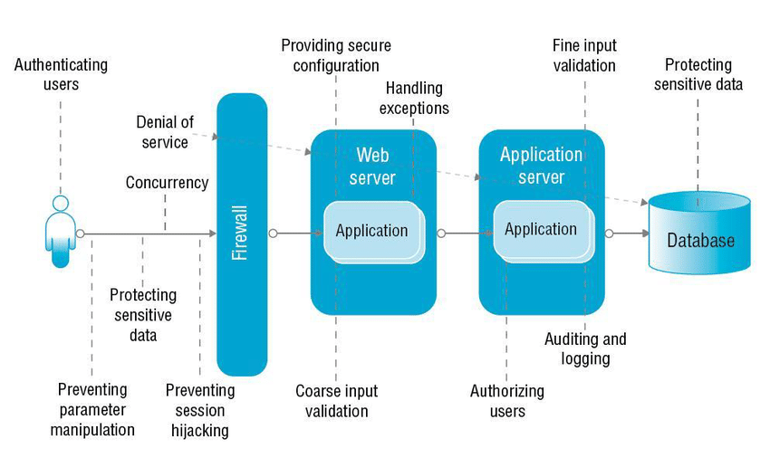

CHAPTER 4
TESTING AND IMPLEMENTATION

  - TESTING
Implementation is the stage of the project when the theoretical design is turned into a working system. This is the final and important phase in the system life cycle It is actually the process of converting the new system into a operational one.

4.1.1Unit Testing
Unit testing comprises the set of tests performed by an individual programmer prior to integration of the unit into a larger system. The module interface is tested to ensure that information properly flows into and out of the program unit. The local data structure is examined to ensure that data stored temporarily maintains its integrity during all steps in an algorithm’s execution. Boundary conditions are tested to ensure that the module operates properly at boundaries established to limit or restrict processing. All independent paths through the control structure are tested. All error-handling paths are tested.

4.1.2 Block Box Testing
Black-box testing is a method of software testing that examines the functionality of an application without peering into its internal structures or workings. This method of test can be applied virtually to every level of software testing: unit, integration, system and acceptance. It is sometimes referred to as specification-based testing.

4.2 SYSTEM IMPLEMENTATION
Implementation is the stage of the project when the theoretical design is turned into a working system. This is the final and important phase in the system life cycle It is actually the process of converting the new system into a operational one.

CHAPTER 5
CONCLUSION:
In this paper, we demonstrated the viability of such an approach. SeeCCT is an SNS that is built using the SOA approach facilitated by a number of web services, including those provided by a VoiceXML portal. As a proof-of-concept application, it is limited in scope, but its web service-based architecture is scalable and will allow the system to embrace a larger scope of localities. We conducted a series of experiments to gauge the latency of the system’s interaction with the users using its speech interface, which reveal some possible ways for improving the system by taking advantage of a more aggressive caching or pre-fetching of audio data.

CHAPTER-6
REFERENCE
- [1] G. Alonzo, Web Services: Concepts, Architectures and Applications, Springer, Berlin, 2004.
- [2] A. Augello, A. Santangelo, S. Sorce, G. Pilato, A. Gentile, A. Genco, S. Gaglio, “A Multimodal Interaction Guide for Pervasive Services Access,” IEEE International Conference on Pervasive Services, 2007, pp. 250-256.
- [3] J. Barnett, M. Bodell, D. Raggett, A. Wahbe (Eds.), “Multimodal Architecture and Interfaces,” W3C Working Draft (2006), Retrieved on Mar 1, 2008 from http://www.w3.org/TR/2006/WD-mmi-arch-20061211.
- [4] D. Bottazzi, R. Montanari, A. Toninelli, “ContextAware Middleware for Anytime, Anywhere Social Networks,” IEEE Intelligent Systems, Sep 2007, pp. 23-32.
- [5] J. Breslin, S.Decker, “The Future of Social Networks on the Internet,” Internet Computing, IEEE, Nov-Dec 2007, pp. 86-90.
- [6] F. Curbera, M. Duftler, R. Khalaf, W. Nagy, N. Mukhi, S. Weerawarana, “Unraveling the Web Services Web” Internet Computing, Mar-Apr 2002, pp. 86–93.
- [7] S. Föll, J. Pontow, D. Linner, I. Radusch, “Classifying Multimedia Resources Using Social Relationships,” 8th IEEE International Symposium on Multimedia, 2006, pp. 690-695.
- [8] G. Frattini, F. Gaudino, V. di Carlo, “Mobile Multimodal Applications on Mass-market Devices: Experiences,” 18th International Conference on Database and Expert Systems Applications, 2007, pp. 89-93.
- [9] R. Högg, M. Meckel, K. Stanoevska-Slabeva, R. Martignoni, “Overview of Business Models for Web 2.0 Communities,” Proceedings of GeNeMe, Dresden, 2006, pp. 23-37.
- [10] T. Ishikawa, P. Klaisubun, M. Honma, “Navigation Efficiency of Social Bookmarking Service,” IEEE/WIC/ACM International Conferences on Web Intelligence and Intelligent Agent Technology, 2007, p. 280-283.

