Develop a system for high compressionand decompressionof Photograph and documents without loss of Quality

ABSTRACT
JPEG Decompression methods are exceptionally helpful in 3G/4G based markets, handheld gadgets and frameworks. There are many testing systems in already proposed decompression techniques, as high computational cost, and overwhelming distortion in ringing and blocking artifacts which makes the picture imperceptible. To enhance the visual nature of the JPEG record pictures at low piece rate and at low computational cost, we have actualized the decompression technique for JPEG document and color images. We initially isolate the JPEG document images into smooth and non-smooth pieces with the help of Discrete Cosine Transform(DCT). At that point the smooth pieces (background, uniform region) are decoded in the change area by limiting the Total Block Boundary Variation(TBBV). The non-smooth block of the document images contains the text and design/line drawing objects. Next the decompression of non-smooth block is presented. The inverse DCT gives the result of the decompressed images. So the execution of the non-smooth square decompression will be done here. At long last, the result shows that our framework is superior to the current. Also, it demonstrates the quality change of decompressed JPEG record and regular picture.

CHAPTER 2
2. SYSTEM ANALYSIS
  - EXISTING SYSTEM

- The number of existing systems related to artifact-free JPEG decompression indicates that the resolution of this problem is of high awareness to the community of digital imaging.
- In proposed system we have implemented a system to deal with the major disadvantages of existing system like distortion in the blocking and ringing artifacts, visual quality of the reconstructed image.
- It shows our method is quite efficient with respect to other methods in existing.
2.1.1 DRAWBACKS OF EXISTING SYSTEM :
- The systematic management of the infinite dimensional problem construction provides a basis for further research on qualitative things of solutions and usage of more sophisticated numerical algorithms, possibly for presentations in a different context.
- The number of existing systems related to artifact-free JPEG decompression indicates that the resolution of this problem is of high awareness to the community of digital imaging.
- The novel post-processing methods to deal with coding artifacts for such specific document content would be an attractive problem for researchers.
2.2. PROPOSED SYSTEM
- In this proposed technique, the analog image pixels are transformed to discrete image pixel, and therefore compression is preformed.
- A novel technique for post-processing the JPEG encoded images is proposed for minimizing coding artifacts & improvises quality of visualization.
- A significant working schema has been proposed for addressing the improvisation of DCT compressed images.
2.2.1. ADVANTAGES OF PROPOSED SYSTEM
- This efficient TBBV measure is used as an objective function that recovers the smooth squares.
- The rapidly growing variety of multipurpose computerized imaging gadgets (e.g., cameras, cell phones, electronic camera-pen frameworks), the utilization of record pictures has turned out to be significantly more advantageous, accordingly to the massive development of archive information.
- A promising and proficient approach is to misuse the advantages of low piece rate compression originations.

Literature Survey:
TITLE | AUTHORS | DESCRIPTION
Effective Decompression of JPEG document images | The-Anh Pham, Mathieu Delalandre, | Our main goal is targeted to time-critical applications, especially to those situated on mobile network infrastructures.
Reducing artifact in jpeg decompression via a learned dictionary | H. Chang, M. Ng, and T. Zeng, | In this paper, a novel artifact reducing approach for the JPEG decompression is proposed via sparse and redundant representations over a learned dictionary.
A document image model and estimation algorithm for optimized jpeg decompression | T. Wong, C. Bouman, I. Pollak, and Z. Fan, | We propose a JPEG decompression algorithm which is designed to produce substantially higher quality images from the same standard JPEG encodings.
Image denoising via sparse and redundant representations over learned dictionaries | M. Elad and M. Aharon, | We address the image denoising problem, where zero-mean white and homogeneous Gaussian additive noise is to be removed from a given image.

2.3 FEASIBILITY STUDY
The feasibility Analysis is an analytical program through project manager determines the project success ratio and through feasibility study project manager able to see either project. The key considerations involved in the feasibility analysis are:
- Economic Feasibility
- Technical Feasibility
- Operational Feasibility
- Environmental Feasibility
2.3.1 ECONOMICAL FEASIBILITY
Hence this project is economically feasible there is no need to involve any cost for this project.
2.3.2 TECHNICAL FEASIBILITY
Software Technologies used are PHP and MySql. In the educational institutions, it is possible to update the system in future. No special hardware is required for the purpose of using this system. Hence it is declared that this project is technically feasible.
2.3.3 OPERATIONAL FEASIBILITY
As the admin work mainly to maintain the Patient and Doctor .Doctor will predict patient cancer disease. Hence it is easy to operate with training. Therefore it is operationally feasible for implementation.
2.3.4 ENVIRONMENTAL FEASIBILITY
This project environment is correct as a admin has developed this system and no expenditure is involved under any head and this process is part of admin document management, this project environment is accessible.

2.4 SYSTEM REQUIREMENTS
- System : Pentium IV 2.4 GHz.
- Hard Disk : 40 GB.
- Monitor : 15 inch VGA Color.
- Mouse : Logitech Mouse.
- Ram : 512 MB
- Keyboard : Standard Keyboard

2.4.1 HARDWARE REQUIREMENTS
The Hardware of the computer consists of physical component such as Input Devices, Storage Devices, Processing & Control units and Output Devices. Computer includes external storage unit to store data in programs.
The Hardware Configuration involved in this project
- System : Pentium IV 2.4 GHz.
- Hard Disk : 40 GB.
- Monitor : 15 inch VGA Color.
- Mouse : Logitech Mouse.
- Ram : 512 MB
- Keyboard : Standard Keyboard

2.4.2 SOFTWARE REQUIREMENTS
Software is a group of programs that computers need to do a particular task. It is an essential requirement of Computer System. The Software used to develop the project is
- Operating System : Windows XP.
- Platform : DOT NET TECHNOLOGY
- Front End : ASP.Net 3.5
- Back End : SQL SERVER 2005

CHAPTER 3
SYSTEM DESIGN AND DEVELOPEMENT
SYSTEM ARCHICTURE

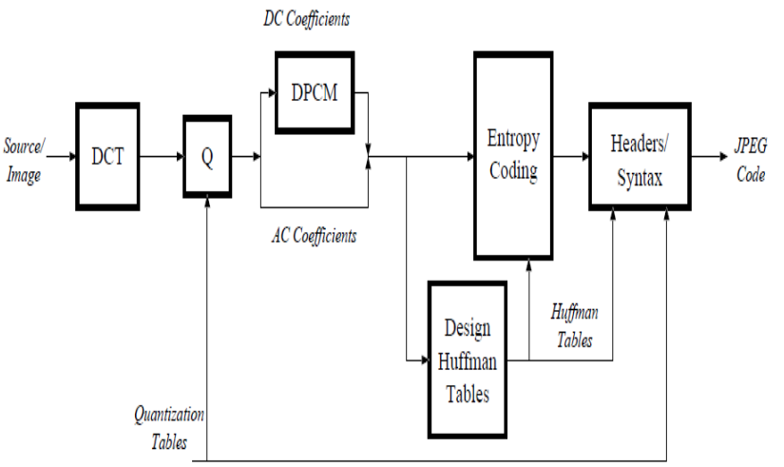

CHAPTER 4
TESTING AND IMPLEMENTATION

  - TESTING
Implementation is the stage of the project when the theoretical design is turned into a working system. This is the final and important phase in the system life cycle It is actually the process of converting the new system into a operational one.

4.1.1Unit Testing
Unit testing comprises the set of tests performed by an individual programmer prior to integration of the unit into a larger system. The module interface is tested to ensure that information properly flows into and out of the program unit. The local data structure is examined to ensure that data stored temporarily maintains its integrity during all steps in an algorithm’s execution. Boundary conditions are tested to ensure that the module operates properly at boundaries established to limit or restrict processing. All independent paths through the control structure are tested. All error-handling paths are tested.

4.1.2 Block Box Testing
Black-box testing is a method of software testing that examines the functionality of an application without peering into its internal structures or workings. This method of test can be applied virtually to every level of software testing: unit, integration, system and acceptance. It is sometimes referred to as specification-based testing.

4.2 SYSTEM IMPLEMENTATION
Implementation is the stage of the project when the theoretical design is turned into a working system. This is the final and important phase in the system life cycle It is actually the process of converting the new system into a operational one.

CHAPTER 5
CONCLUSION:
In this paper, we have proposed Decompression technique that increases the visual quality of the JPEG document and color images. Which is supportive for third generation / fourth generation based handheld devices and infrastructures. The extensive use of document image becomes necessity for mobile users. People want to access and retrieve good quality images at low bandwidth, and needs fast response time and efficient usage. So the decompression technique for JPEG document is developed for the improvement the visual quality of the document and natural color images. In this paper, we have implemented decompression technique of JPEG document and natural images. First, the n*n DCT squares are classified into smooth square and non-smooth square. Specific decoding algorithms are developed for each type of square. For smooth blocks, we did the minimization of total block boundary variation (TBBV) in the DCT domain. This efficient TBBV measure is used as an objective function that recovers the smooth squares. Reconstruction of nonsmooth square is performed by incorporating a text model that occurs the characteristics of the document content.

CHAPTER-6
REFERENCE
- [1] The-Anh Pham, Mathieu Delalandre, IEEE Transaction on ―Effective Decompression of JPEG document images‖, Aug. 2016.
- [2] K. Bredies, K. Kunisch, and T. Pock, ―Total generalized variation,‖ SIAM Journal on Imaging Sciences, vol. 3, no. 3, pp. 492–526, 2010.
- [3] H. Chang, M. Ng, and T. Zeng, ―Reducing artifact in jpeg decompression via a learned dictionary,‖ Transactions on Signal Processing (TSP), vol. 62, no. 3, pp. 718–728, 2013.
- [4] T. Wong, C. Bouman, I. Pollak, and Z. Fan, ―A document image model and estimation algorithm for optimized jpeg decompression,‖ Transactions on Image Processing (TIP), vol. 18, no. 11, pp. 2518–2535, 2009.
- [5] M. Elad and M. Aharon, ―Image denoising via sparse and redundant representations over learned dictionaries,‖ IEEE Transactions on Image Processing, vol. 15, no. 12, pp. 3736– 3745, 2006.
- [6] K. Bredies and M. Holler, ―A total variation-based jpeg decompression model,‖ SIAM Journal on Scientific Computing, vol. 5, no. 1, pp. 366– 393, 2012.
- [7] B. Oztan, A. Malik, Z. Fan, and R. Eschbach, ―Removal of artifacts from jpeg compressed document images,‖ in Society of Photo-Optical Instrumentation Engineers (SPIE) Conference Series, vol. 6493, Jan 2007, pp. 1–9.
- [8] E. Y. Lam, ―Compound document compression with model-based biased reconstruction,‖ Journal of Electronic Imaging, vol. 13, no. 1, pp. 191– 197, 2004
- [9] A. Chambolle, ―An algorithm for total variation minimization and applications,‖ Journal of Mathematical Imaging and Vision, vol. 20, no.1-2, pp. 89–97, 2004
- [10] G. K. Wallace, ―The jpeg still picture compression standard,‖ Communications of the ACM, vol. 34, no. 4, pp. 30–44, 1991.

