Development of a happiness index for schools (including mental health and well-being parameters, among others) with self-assessment facilities

ABSTRACT
Schools are increasingly concerned with the well-being of the whole child – likely, more so since the COVID-19 pandemic – and goals here were to document the psychometric properties of a brief new measure of adolescent mental health, the Well-Being Index (WBI). The measure assesses 4 symptom areas, 2 each of internalizing and externalizing symptoms—Depression, Anxiety, Rule-Breaking, and Substance Use—and an optional scale on Isolation at School. A total of 2,444 students from 2 high schools completed the WBI, the Youth Self-Report (YSR), and other related measures. Alpha coefficients showed acceptable internal consistency, with values for the 5 WBI subscales at .83, .84, .78, .79, and .74, respectively. Both exploratory and confirmatory factor analyses demonstrated consistent factorial validity. Correlations with corresponding YSR subscales indicated good convergent and discriminant validity. The WBI Substance Use and Isolation at School subscales, similarly, had high correlations with subscales from preexisting measures. Criterion-related validity was indicated in significant correlations between WBI subscales and conceptually related dimensions of close relationships. Also examined was the percentage of youth falling above clinical cutoffs on both the WBI and YSR, and findings demonstrated high concurrent validity. Collectively, results suggest the promise of the WBI as a brief, psychometrically sound measure to assess the adjustment of adolescents, along with perceptions of school climate that can be modified toward fostering their overall well-being.

CHAPTER 2
2. SYSTEM ANALYSIS
  - EXISTING SYSTEM

- On the other hand, existing measures of symptoms that have the advantage of being brief and thus more feasible for school-wide assessments, these tend to focus on limited domains of youths’ maladjustment.
- The creation of new measures in psychology, items were created by first generating statements that paraphrased each category of symptoms to be captured, relying on existing, relevant theoretical and empirical literatures.
- The WBI Isolation at School subscale was significantly related to school climate subscales from pre-existing measures.
2.1.1 DRAWBACKS OF EXISTING SYSTEM :
- Happiness research has revealed that economic progress or other traditional prosperity measures like health, living standard individually do not necessarily translate into increase in people’s quality of life.
- Provision of basic services and amenities to citizens do not necessarily guarantee happiness.
- There is need for bottom up approach to measure happiness of citizens to improve/ enhance quality of life.
- There is a need to develop a methodology to identify happiness indicators; to collect data; and to measure/ assess happiness, as a framework to identify the disparity; and to propose targeted policy interventions and amendments.
2.2. PROPOSED SYSTEM
- Government will come to know the inconsistency in various facilities which are directly associated with people's happiness/overall life satisfaction, needs of its residents which may help further to propose policy intervention or any amendment.
- These approaches have in common is that they propose core strengths that when developed form the foundation for broad positive development in family, school, and community contexts.
- As positive psychology interventions are now including multiple components, likewise comprehensive measurement approaches are needed to assess student needs and to evaluate effectiveness.
2.2.1. ADVANTAGES OF PROPOSED SYSTEM
- It also provide information on individual's performance on each domain.
- To examine convergent and discriminant validity in greater depth, we compared the magnitude of coefficients where the WBI subscale was conceptually (a) similar to the YSR subscale vs. (b)dissimilar, using asymptotic z tests.
- In a similar manner, related to qualitative studies, we do not know if our search strategy were as efficient in identifying studies of relevance if this was not the main theme or focus of the study.
- The main foci of research within the field of social media and mental health and well-being among adolescents, as well as the type of data sources and research instruments used so far.
Literature Survey:
TITLE | AUTHORS | DESCRIPTION
The geography of happiness: Connecting twitter sentiment and expression, demographics, and objective characteristics of place | Mitchell, L., et al., | We conduct a detailed investigation of correlations between real-time expressions of individuals made across the United States and a wide range of emotional, geographic, demographic, and health characteristics.
Measuring the happiness of large-scale written expression: Songs, blogs, and presidents | Dodds, P.S. and C.M. Danforth, | In recognizing the importance of quantifying wellbeing, we have seen substantial interest and progress in measuring how individuals feel in a wide range of contexts, particularly in the fields of psychology and behavioral economics.
A City of Wellbeing: The what, why & how of measuring community wellbeing: City of Santa Monica Office of Wellbeing | Warner, K., & Kern, M., | Promoting a better life for citizens is a core goal of democratic governments. Leaders are elected on the implied promise that they will somehow improve people’s lives.
High income improves evaluation of life but not emotional well-being | Kahneman, D. and A. Deaton, | Emotional well-being refers to the emotional quality of an individual's everyday experience--the frequency and intensity of experiences of joy, stress, sadness, anger, and affection that make one's life pleasant or unpleasant.

2.3 FEASIBILITY STUDY
The feasibility Analysis is an analytical program through project manager determines the project success ratio and through feasibility study project manager able to see either project. The key considerations involved in the feasibility analysis are:
- Economic Feasibility
- Technical Feasibility
- Operational Feasibility
- Environmental Feasibility
2.3.1 ECONOMICAL FEASIBILITY
Hence this project is economically feasible there is no need to involve any cost for this project.
2.3.2 TECHNICAL FEASIBILITY
Software Technologies used are PHP and MySql. In the educational institutions, it is possible to update the system in future. No special hardware is required for the purpose of using this system. Hence it is declared that this project is technically feasible.
2.3.3 OPERATIONAL FEASIBILITY
As the admin work mainly to maintain the Patient and Doctor .Doctor will predict patient cancer disease. Hence it is easy to operate with training. Therefore it is operationally feasible for implementation.
2.3.4 ENVIRONMENTAL FEASIBILITY
This project environment is correct as a admin has developed this system and no expenditure is involved under any head and this process is part of admin document management, this project environment is accessible.
2.4 SYSTEM REQUIREMENTS
- System : Pentium IV 2.4 GHz.
- Hard Disk : 40 GB.
- Monitor : 15 inch VGA Color.
- Mouse : Logitech Mouse.
- Ram : 512 MB
- Keyboard : Standard Keyboard
2.4.1 HARDWARE REQUIREMENTS
The Hardware of the computer consists of physical component such as Input Devices, Storage Devices, Processing & Control units and Output Devices. Computer includes external storage unit to store data in programs.
The Hardware Configuration involved in this project
- System : Pentium IV 2.4 GHz.
- Hard Disk : 40 GB.
- Monitor : 15 inch VGA Color.
- Mouse : Logitech Mouse.
- Ram : 512 MB
- Keyboard : Standard Keyboard
2.4.2 SOFTWARE REQUIREMENTS
Software is a group of programs that computers need to do a particular task. It is an essential requirement of Computer System. The Software used to develop the project is
- Operating System : Windows XP.
- Platform : DOT NET TECHNOLOGY
- Front End : ASP.Net 3.5
- Back End : SQL SERVER 2005

CHAPTER 3
SYSTEM DESIGN AND DEVELOPEMENT
SYSTEM ARCHICTURE

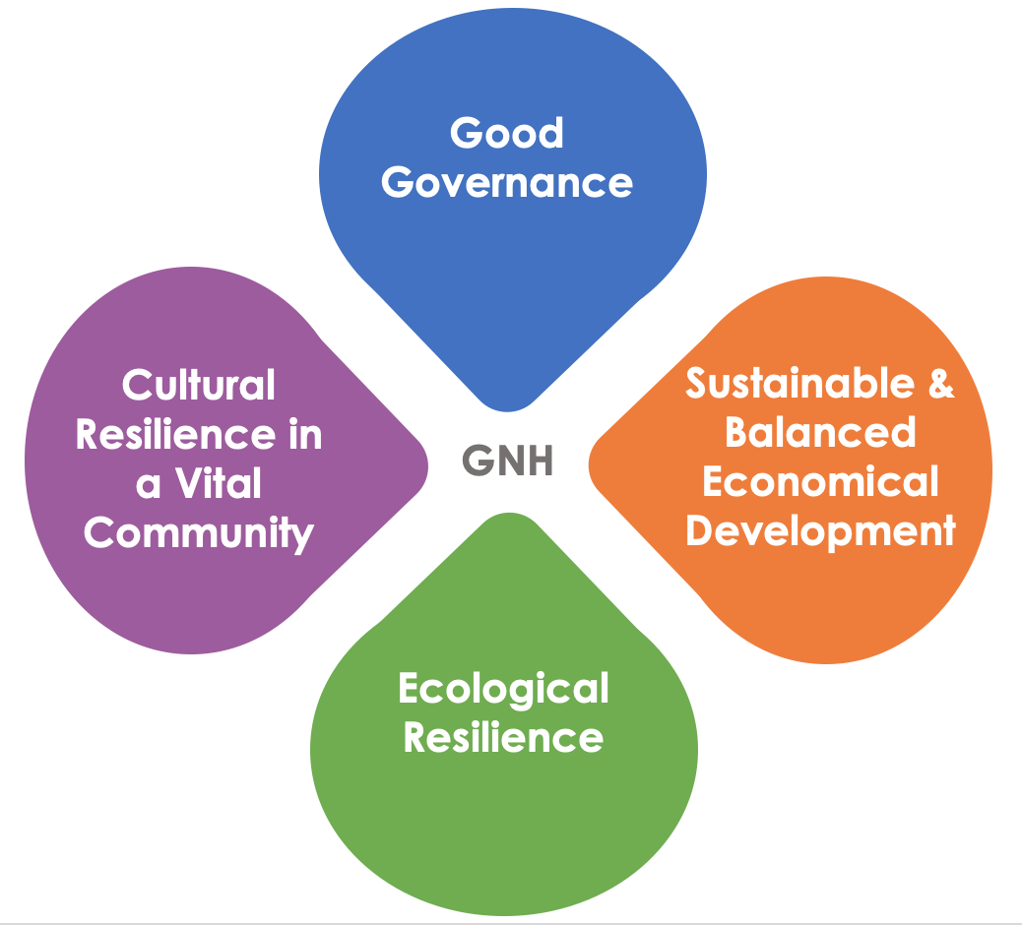

CHAPTER 4
TESTING AND IMPLEMENTATION

  - TESTING
Implementation is the stage of the project when the theoretical design is turned into a working system. This is the final and important phase in the system life cycle It is actually the process of converting the new system into a operational one.

4.1.1Unit Testing
Unit testing comprises the set of tests performed by an individual programmer prior to integration of the unit into a larger system. The module interface is tested to ensure that information properly flows into and out of the program unit. The local data structure is examined to ensure that data stored temporarily maintains its integrity during all steps in an algorithm’s execution. Boundary conditions are tested to ensure that the module operates properly at boundaries established to limit or restrict processing. All independent paths through the control structure are tested. All error-handling paths are tested.

4.1.2 Block Box Testing
Black-box testing is a method of software testing that examines the functionality of an application without peering into its internal structures or workings. This method of test can be applied virtually to every level of software testing: unit, integration, system and acceptance. It is sometimes referred to as specification-based testing.

4.2 SYSTEM IMPLEMENTATION
Implementation is the stage of the project when the theoretical design is turned into a working system. This is the final and important phase in the system life cycle It is actually the process of converting the new system into a operational one.

CHAPTER 5
CONCLUSION:
The Model is developed to assess happiness, both for Individual & aggregate level along with informing user about those factors which are affecting their happiness strongly by highlighting in an App. According to the survey, the significant indicators which influence the happiness strongly are from Health, Social Network & Living Standards domains. The foremost indicators are lack of Education and its facilities, increasing stress, health issues, and inconsistencies in social ties, Income and Work life balance. So, the implication for Governments and policy makers is that to focus on these basic needs, to improve citizen's happiness and alternatively zonal development. There is still scope to enhance this study in terms of geo tagging the responses and analyzing the data spatially. This kind of study will be very effective in making specific area based policy. The mobile app can be made more user friendly and additional features like auto pop up, auto reminder and visualization dashboards for users’ location can be added. This was a cross sectional research and the indicators used in the study are highly significant in measurement of happiness, but there is still possibility to add/subtract indicators based on their significance over a period of time through longitudinal research.

CHAPTER-6
REFERENCE
- 1. Wikipedia. Happiness. 2016 [cited 2016 17-June-2016]; Available from: https://en.wikipedia.org/wiki/Happiness
- 2. Mitchell, L., et al., The geography of happiness: Connecting twitter sentiment and expression, demographics, and objective characteristics of place. PloS one, 2013. 8(5): p. e64417.
- 3. Dodds, P.S. and C.M. Danforth, Measuring the happiness of large-scale written expression: Songs, blogs, and presidents. Journal of Happiness Studies, 2010. 11(4): p. 441-456.
- 4. MacKerron, G., & Mourato, S. Mappiness. 2016; Available from: http://www.mappiness.org.uk/.
- 5. Warner, K., & Kern, M., A City of Wellbeing: The what, why & how of measuring community wellbeing: City of Santa Monica Office of Wellbeing. 2013.
- 6. Harter, J. and R. Arora, Social time crucial to daily emotional well-being in US. Gallup. com, June, 2008. 5: p. 2008.
- 7. Deaton, A., Income, health and wellbeing around the world: Evidence from the Gallup World Poll. The journal of economic perspectives: a journal of the American Economic Association, 2008. 22(2): p. 53.
- 8. Kahneman, D. and A. Deaton, High income improves evaluation of life but not emotional well-being. Proceedings of the national academy of sciences, 2010. 107(38): p. 16489-16493.
- 9. Helliwell, J.F. and H. Huang, Comparing the happiness effects of real and on-line friends. PloS one, 2013. 8(9): p. e72754.
- 10. Helliwell, J.F. and S. Wang, Trust and well-being. 2010, National Bureau of Economic Research.

