POWER QUALITY IMPROVEMENT IN PFC BRIDGELESS-LUO CONVERTER FED BLDC MOTOR DRIVE

ABSTRACT
This paper presents a PFC (Power Factor Correction) based BL-Luo (Bridgeless-Luo) converter fed BLDC (Brush less DC) motor drive. A single voltage sensor is used for the speed control of BLDC motor and PFC at AC mains. The voltage follower control is used for a BL-Luo converter operating in DICM (Discontinuous Inductor Current Mode). The speed of the BLDC motor is controlled by an approach of variable DC link voltage, which allows a low frequency switching of VSI (Voltage Source Inverter) for electronic commutation of BLDC motor; thus offers reduced switching losses. The proposed BLDC motor drive is designed to operate over a wide range of speed control with improved power quality at AC mains. The power quality indices thus obtained are under the recommended limits of IEC 61000-3-2. The performance of the proposed drive is validated with test results obtained on a developed prototype of the drive.

CHAPTER – I
INTRODUCTION
BLDC (Brush less DC) motors have become increasingly popular in the past decade due to the advantages such as high efficiency, high power density, compact size, high ruggedness, lower maintenance requirements and their immunity to EMI (Electro-Magnetic Interference) problems. A BLDC motor is a three phase synchronous motor having torque-speed characteristics of a DC motor. It has three phase windings on the stator which are excited by a VSI (Voltage Source Inverter) and permanent magnets on the rotor. It does not require any brushes and commutator assembly; rather an electronic commutation based on the rotor position as sensed by Hall Effect position sensors is used. Hence the problems such as sparking, wear and tear of brushes, EMI and noise interference are eliminated in the BLDC motor. A conventional BLDC motor drive using a front end DBR (Diode Bridge Rectifier) and a high value of DC link capacitor draws highly distorted peaky current which is rich in harmonics. This leads to a very low power factor of the order of 0.7-0.8 and high THD (Total Harmonic Distortion) of supply current at AC mains. Such types of power quality indices are not acceptable under the limits of international power quality standards such as IEC 61000-3-2. Hence, IPQC's (Improved Power Quality Converters) are used for improving the power quality at AC mains. An IPQC may be designed to operate in either of CCM (Continuous Conduction Mode) or DCM (Discontinuous Conduction Mode) operation. A CCM offers an advantage of lower stress on a PFC converter switch, but requires a two control loop (i.e. voltage and current control loops) for achieving a DC link voltage control with PFC at AC mains. This requires three sensors for the operation, which is a costly option, and hence preferred for high power ratings (> lkW). Whereas, the converter operating in DCM acts as an inherent power factor corrector and hence requires a single voltage control loop (i.e. single voltage sensor) for DC link voltage control. But, a higher stress on PFC converter switch is obtained in it for a PFC converter operating in DICM; hence this mode is preferred for low power applications. Many configurations of PFC converter feeding a BLDC motor drive have been reported in the literature.
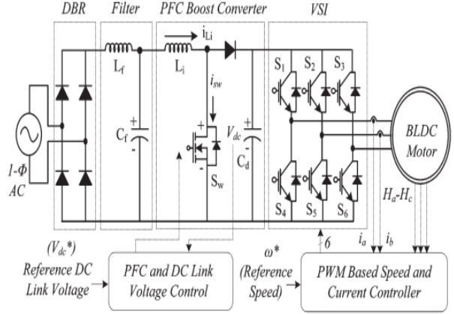
Conventional PFC-based BLDC motor drive
A boost-PFC converter fed BLDC motor drive has been the most widely used configuration but it utilizes a constant DC link voltage with PWM (Pulse Width Modulation) based VSI for speed control. A high switching loss on account of high switching frequency occurs which drastically reduces the efficiency. Moreover, it requires high number of sensors and complex control for its operation. A concept of variable DC link voltage for speed control of BLDC motor has been reported in. Gopalarathnam et. al., have proposed a SEPIC (Single Ended Primary Inductance Converter) for feeding a BLDC motor drive using the concept of variable DC link voltage. It uses a bifilar winding which uses a PWM based control of VSI and have high switching losses. Singh et. at, have proposed a Cuk converter fed BLDC motor drive using the control of variable DC link voltage. This utilizes a Cuk converter operating in CCM; hence requires three sensors and is preferred for higher power rating. Bridgeless converter configurations have gained importance in the past decade due to their high efficiency. The front end DBR is eliminated in these configurations which reduce the conduction losses associated in them. The bridgeless buck and boost converters have been reported in respectively. They suffer from a limited voltage conversion ratio «1 for buck and > 1 for boost converter) which limits its application for a wide range of speed control by varying DC link voltage. The bridgeless Cuk and SEPIC converters have also gained popularity due to a wide voltage conversion ratio . A Luo converter has been widely used due to its inherent characteristics of voltage lifting. Many versions of Luo converter voltage lifting technique such as re-lift, super-lift and ultra-lift have been reported in the literature. The use of Luo converter as a PFC has been explored in. Inheriting the advantages of the Luo converter, a bridge less configuration of the Luo converter is explored in this paper for feeding a BLDC motor as a low cost solution for low power applications.
Agriculture sector is facing a severe challenge owing to frequent power cuts, reduced quality of power supply, increased power tariff. Hence, people are more interested in shifting to renewable based energy sources, especially solar based water pumping to improve the agricultural outcome. Since the solar energy is available in abundant with free of cost, it has become the most attractive choice in almost all fields.Though the initial setup cost is higher, it gives a good payback period. In, the solar water pumping system employs a DC Motor and so it doesn’t require any intermediate voltage conversion. But the presence of commutator and brushes in DC motor demands regular maintenance. The DC Motor is replaced with an induction motor in due to its reliability and ruggedness feature. The control of induction motor is obtained using field oriented technique, which also requires intermediate voltage conversion and complex in implementing. The problems with these motors can be avoided by using BLDC motor, which has appreciable features like small size, noiseless operation, long life, less maintenance. The BLDC motor is conventionally fed with a combination of diode bridge rectifier and dc bus capacitor. The presence of capacitor draws highly distorted current from the supply. The continuous conduction mode requires sensing of supply voltage, DC link voltage and input current, which offers BLDC motor drive employed with different multi-level inverter topologies. In, the BLDC Motor coupled with Cuk Derived converter is proposed for power quality improvement, but the cost and mode of implementation is complex.
OBJECTIVE
- A boost-PFC converter fed BLDC motor drive has been the most widely used configuration but it utilizes a constant DC link voltage with PWM (Pulse Width Modulation) based VSI for speed control.
- A high switching loss on account of high switching frequency occurs which drastically reduces the efficiency.
- Bridgeless converter configurations have gained importance in the past decade due to their high efficiency.
SCOPE OF THE PROJECT
- The proposed PFC based BL-Luo converter fed BLDC motor drive. A single-phase supply followed by filter and a BL-Luo converter is used to feed a VSI driving a BLDC motor.
- The BL-Luo converter is designed to operate in DICM (Discontinuous Inductor Current Mode) to act as an inherent power factor pre-regulator.
- The speed of the BLDC motor is controlled by adjusting the DC link voltage of VSI using a single voltage sensor.
- This allows VSI to operate at fundamental frequency switching (i.e. electronic commutation of BLDC motor) and hence has low switching losses in it; which are considerably high in PWM based VSI feeding a BLDC motor.
- The proposed scheme is designed and its performance is simulated for achieving an improved power quality at AC mains for a wide range of speed control and supply voltage variations.

CHAPTER 2
LITERATURE SURVEY

1. A Voltage-Controlled PFC Cuk Converter Based PMBLDCM Drive for Air-Conditioners
This paper deals with a Cuk dc–dc converter as a single-stage power-factor-correction converter for a permanentmagnet (PM) brushless dc motor (PMBLDCM) fed through a diode bridge rectifier from a single-phase ac mains. A three-phase voltage-source inverter is used as an electronic commutator to operate the PMBLDCM driving an air-conditioner compressor. The speed of the compressor is controlled to achieve optimum air-conditioning using a concept of the voltage control at dc link proportional to the desired speed of the PMBLDCM. The stator currents of the PMBLDCM during step change in the reference speed are controlled within the specified limits by an addition of a rate limiter in the reference dc link voltage. THE use of a permanent-magnet (PM) brushless dc motor (PMBLDCM) in low-power appliances is increasing because of its features of high efficiency, wide speed range, and low maintenance. It is a rugged three-phase synchronous motor due to the use of PMs on the rotor. The commutation in a PMBLDCM is accomplished by solid state switches of a three-phase voltage-source inverter (VSI). Its application to the compressor of an air-conditioning (Air-Con) system results in an improved efficiency of the system if operated under speed control while maintaining the temperature in the airconditioned zone at the set reference consistently. The Air-Con exerts constant torque (i.e., rated torque) on the PMBLDCM while operated in speed control mode.

2. Comprehensive Study of Single-Phase AC-DC Power Factor Corrected Converters With High-Frequency Isolation
Solid-state switch mode AC-DC converters having high-frequency transformer isolation are developed in buck, boost, and buck-boost configurations with improved power quality in terms of reduced total harmonic distortion (THD) of input current, power-factor correction (PFC) at AC mains and precisely regulated and isolated DC output voltage feeding to loads from few Watts to several kW. This paper presents a comprehensive study on state of art of power factor corrected single-phase AC-DC converters configurations, control strategies, selection of components and design considerations, performance evaluation, power quality considerations, selection criteria and potential applications, latest trends, and future developments. SOLID state AC-DC converters with high-frequency (HF) transformer isolation is extensively used in switched mode power supplies (SMPS), uninterruptible power supplies (UPS), welding units, battery charging, induction heaters, electronic ballasts, power supplies for telecommunication systems, measurement and testing equipments, small rating adjustable speed drives (ASDs) in biomedical equipments, small rating refrigeration, heating, ventilation and air conditioning (HVAC), etc. Conventionally, these AC-DC converters are developed in two stages. In the first stage, AC voltage is converted into an uncontrolled DC voltage using diode rectifiers, which is cascaded with the second stage of isolated DC-DC converters using HF transformer for isolation. These problems can be avoided using newly developed single-stage improved power quality AC-DC converters with HF transformer isolation. They are also known as input current shapers, high power-factor single-stage converters, powerfactor correction (PFC) converters, universal input single-stage PFC isolated converters, etc.

3. DSP Implementation of a Power Factor Correction Strategy for BLDC Motor Drive
The paper develops a power factor correction mechanism for a brushless dc permanent magnet (BLDC-PM) motor drive system through the use of a front end boost converter. It evolves a wave shaping mechanism to arrive at the sinusoidal nature for the input current in an effort to improve the input power factor. The theory is articulated using a closed loop algorithm to revolve around the operating range of the drive motor. The performance is evaluated on a MATLAB platform to elucidate the viability of the scheme in addition to highlighting its speed regulating capability. Power Factor Correction (PFC) circuits appear to occupy the input stages in almost every medium and high power switching power supply systems operating at the voltage mains. The most often used configuration includes a boost converter at the primary stage, stabilizing the input to the second stage. Conventional off-line power converters with front - end diode-capacitor rectifier inherit a distorted input current waveform with high harmonic content. Though a variety of passive and active PFC techniques are in vogue, the passive techniques may be the best choice only in low-power and cost sensitive applications. The Brushless DC motors (BLDC) continues to attract the drive industry owing to its simplicity, low-cost and robust structure and it is suitable for variable-speed applications. The structure though simple draws a pulsating AC line current resulting in low power factor and high harmonic line current. However with the increasing demand for improved power quality, there is a definite need for better strategies to accomplish a high performance BLDC motor drive.

4. PMBLDC motor drive with Power Factor correction controller
The different techniques like SEPIC converter, Isolated-Zeta converter, Boost converter, four quadrant operation of BLDC motor, Landsman converter, BL-CSC converter are discussed. For choosing the proper converter for BLDC motor drive for power factor correction the corresponding simulation results for the converters operating. In various industries such as medical, automotive, appliances, aerospace, etc. the BLDC motors are used due to their high efficiency, compact size, noiseless operation, low maintenance, high power density, etc. There are no commutators in BLDC motors hence the external means for commutation is needed. Therefore the BLDC motor is powered from a single phase supply through a diode bridge rectifier and three phase voltage source inverter. The various considerations also has to be taken into account while choosing the correct PFC converter for the system such as cost, mode of operation etc. The cost of the sensors such as Hall effect sensors increases the overall cost of the drive which again depends on the mode of the PFC converter. The PFC converters which operates in continuous conduction mode of operation requires more number of sensors for sensing supply voltage, supply current and dc link voltage whereas those which operate in discontinuous mode of operation requires only one sensor for dc link voltage. But the stress on the switches in CCM is less than that in DCM. So DCM mode of operation can be used in low power application only. This paper presents different PFC techniques to improve the power factor and hence the power quality. The control algorithms of BLDC motor are become advanced which make them suitable for applications where precision is important such as position control in machine tools, robotics, high precision servos etc. A dual buck boost converter used in both positive and negative cycle in which, one is operating at positive half cycle and the other operating during the negative half cycle.

5. Bridgeless High-Power-Factor Buck Converter
A bridgeless buck power factor correction rectifier that substantially improves efficiency at low line of the universal line range is introduced. By eliminating input bridge diodes, the proposed rectifier’s efficiency is further improved. Moreover, the rectifier doubles its output voltage, which extends useable energy of the bulk capacitor after a dropout of the line voltage At lower power levels, i.e., below 850 W, the drawbacks of the universal-line boost PFC front-end may partly be overcome by implementing the PFC front-end with a buck topology. As it has been demonstrated in, the universal-line buck PFC front-end with an output voltage in the 80 V range maintains a high-efficiency across the entire line range. In addition, a lower input voltage to the dc/dc output stage has beneficial effects on its light-load performance because lower voltagerated semiconductor devices can be used for the dc/dc stage and because lower input voltage reduces the loss and size of the transformer. The buck PFC converter operation in both discontinuous current mode and continuous current mode (CCM) was described first in, whereas additional analysis and circuit refinements were described in. Because the buck PFC converter does not shape the line current around the zero crossings of the line voltage, i.e., during the time intervals when the line voltage is lower than the output voltage, it exhibits increased total harmonic distortion (THD) and a lower PF compared to its boost counterpart. As a result, in applications where IEC61000-3-2 and corresponding Japanese specifications (JIS-C-61000-3-2) need to be met, the buck converter PFC employment is limited to lower power levels. In this paper, a bridgeless buck PFC rectifier that further improves the low-line (115 V) efficiency of the buck front-end by reducing the conduction loss through minimization of the number of simultaneously conducting semiconductor components is introduced. Because the proposed bridgeless buck rectifier also works as a voltage doubler, it can be designed to meet harmonic limit specifications with an output voltage that is twice that of a conventional buck PFC rectifier.

CHAPTER 3

EXISTING SYSTEM

PMSM works in the torque loop state in the normal running of the vehicle in the process. And the output torque follows VCU given torque demand. The AMT gear may produce teeth crash during shifting process if the PMSM works in the torque control mode. At the same time, it is very difficult to ensure the fast shifting and prolongs the shift time, which would result in large shift impact or shift failure. The motor speed loop control must be realize during the shifting process. DC supply connected to dc-dc converter which can be convention dc converter .it is voltage conversion ratio low.

DISADVANTAGE

- High value of DC link capacitor
- No higher gain possible in the conventional converter.
- Ripple current might be higher compare to proposed.
- Increases the design complexity, cost, and weight.
- It have hard switching operation.
- very low power factor

CHAPTER 4
PROPOSED SYSTEM
A conventional BLDC motor drive using a front end DBR (Diode Bridge Rectifier) and a high value of DC link capacitor draws highly distorted peaky current which is rich in harmonics. This leads to a very low power factor of the order of 0.7-0.8 and high THD (Total Harmonic Distortion) of supply current at AC mains. A high switching loss on account of high switching frequency occurs which drastically reduces the efficiency. Moreover, it requires high number of sensors and complex control for its operation. A concept of variable DC link voltage for speed control of BLDC motor.

ADVANTAGE
- Sparking, wear and tear of brushes, EMI and noise interference are eliminated
- The front end DBR is eliminated in these configurations which reduce the conduction losses
- A wide voltage conversion ratio

CHAPTER 5

BLOCK DIAGRAM

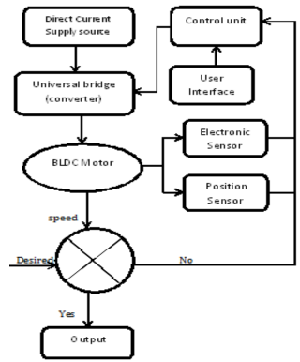

Block diagram of BL DC Motor Control scheme

CHAPTER 6
MOTOR DRIVE
6.1 Motor Drive System
An electric motor is a device that converts electrical energy to mechanical energy. It also can be viewed as a device that transfers energy from an electrical source to a mechanical load. The system in which the motor is located and makes it spin is called the drive, also referred to as the electric drive or motor drive. The function of the motor drive is to draw electrical energy from the electrical source and supply electrical energy to the motor, such that the desired mechanical output is achieved. Typically, this is the speed of the motor, torque, and the position of the motor shaft. shows the block diagram of a motor drive.

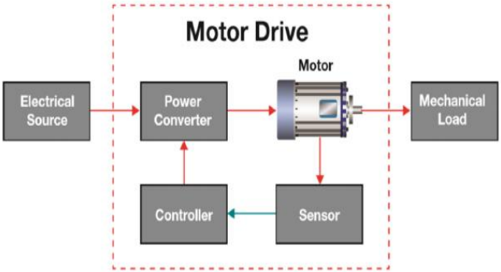
Block diagram of a motor drive system
The functions of the power converter circuit in the motor drive are: Transfer electrical energy from a source that could be of a given voltage, current at a certain frequency and phase as the input to an electrical output of desired voltage, current, frequency and phase to the motor such that the required mechanical output of the motor is achieved to drive the load Controller regulates energy through feedback coming from the sensor block Signals measured by sensors from the motor are low-power, which are then sent to the controller tells the converter what it needs to be doing. A closed-loop feedback system is the method of comparing what is actually happening to what the motor should be outputting, then adjusting the output accordingly to maintain the target output.
6.2 Motor Drive Efficiency
Electric motors represent 45 percent of all electrical energy consumption across all applications. Increasing the efficiency of motor-drive systems could potentially result in a significant reduction in global electricity consumption. With increasing demand of electricity along with industrialization and urbanization across the globe, the ability to supply energy is becoming even more challenging. As part of a global effort to reduce energy consumption and carbon emissions on the environment, various regulations across many countries have put forth and are continually working on governmental mandates to improve motor drive efficiency. All these requirements make it compelling to have an efficient power converter system using switched mode power supplies (SMPS). The SMPS uses semiconductor power switches (also called power electronic switches) in a switch mode and on and off states only, that yields 100 percent efficiency in an ideal situation. Power electronics systems are primarily designed using silicon-based power management with power semiconductor switches. These switches are power MOSFETs, bipolar junction transistors (BJTs), and isolated gate bipolar transistors (IGBTs) that have made significant improvements in their performances. Examples include lower on-state resistance, increased blocking voltage, and higher drive currents.
6.3 Motor Drive Classifications
The BLDC motor has several advantages over other motors. The advantages of the BLDC motor when compared against a brushed DC motor and an AC induction motor. This application note introduces the motor fundamentals, with special attention to BLDC motors. As described in this document, a BLDC motor has many advantages over a brushed DC motor and an AC induction motor:
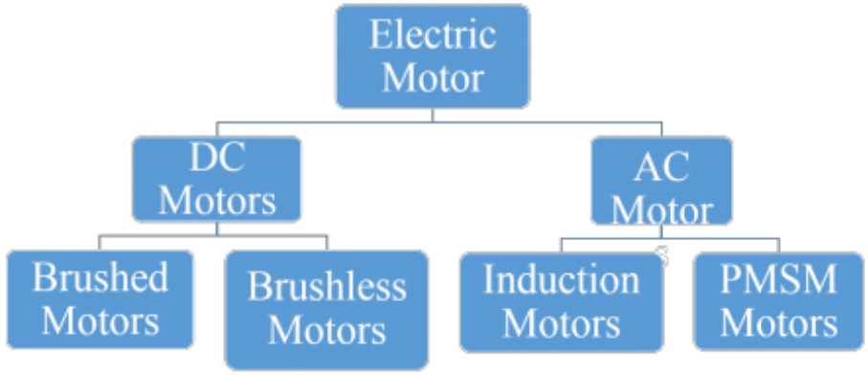
Basic classification of motors
It is easily controlled with position feedback sensors and generally performs well, especially in speed/torque. With these advantages, BLDC motor will spread to more applications. Moreover, with the development of sensor less technology, BLDC motor will become convenient or indispensable in applications with environmental limitations.
6.4 Conventional BLDC Motor Drive
A conventional BLDC motor drive using a front-end diode bridge rectifier (DBR) and a high value of DC link capacitor draws highly distorted peaky current which is rich in harmonics. Fig. 3 shows the conventional scheme of BLDC motor drive fed by a pulse width modulation (PWM) based VSI for speed control. Such configuration leads to a very low power factor of the order of 0.72 and high total harmonic distortion (THD) of supply current at AC mains. Such power quality indices are not acceptable under the limits of international power quality standards such as IEC 61000-3-2. Moreover, such power quality indices also increase the EMI in the PFC converter. These EMIs are classified into two categories as conducted and radiated EMI, respectively. At lower frequencies, the EMI is primarily caused by the conduction and at higher frequencies; the EMI is caused by the radiation. Such EMI causes problems such as skin effect, high overshoot transients, hysteresis loss, eddy current loss and voltage drop which affect the overall efficiency and performance of the system. Therefore, improved power quality converters (IPQC) are used for improving the power quality at AC mains which also reduce such EMI problems.

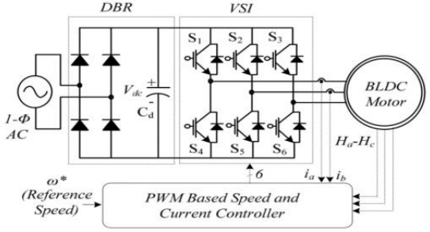
Brush less DC Motor Drive with DBR
6.5 Dc-Dc Converters
Fundamental DC-DC Converters
The viewpoint of input and output voltages V 1 and V 0, the fundamental converters are:
a. Step-down or buck converters
b. Step-up or boost converters
c. Step down/up or buck-boost converters.
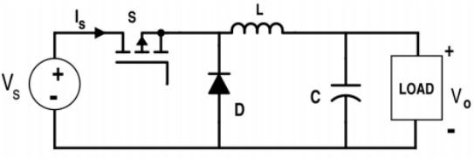
Circuit Diagram of Buck converter
In ideal operating conditions (no voltage loss on the switch S, the average voltage across inductors L at steady state zero, no current loss on capacitors C, and no voltage loss on diode at forward conduction) the equations of ratio V 0/V 1 are:
1. for the buck converter V 0/V 1 = D (3.1) where, D is the duty cycle of PWM signal of switch S.
2. for the boost converter V 0/V 1 = 1/(1 − D) (3.2) where, D is the duty cycle of PWM signal of switch S.
3. for the buck-boost converter V 0/V 1 = D/(1 − D) (3.3) where, D is the duty cycle of PWM signal of switch S. D = ton/T (3.4) where, ton is the conduction time of switch S and T is the period of PWM signal.
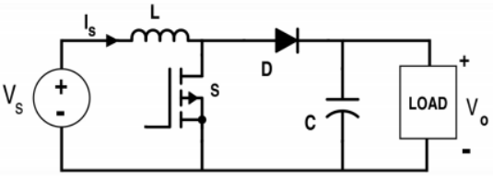
Circuit Diagram of Boost converter
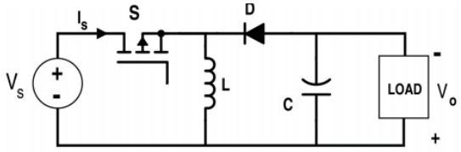
Circuit Diagram of Buck-Boost converter
Developed DC-DC Converters
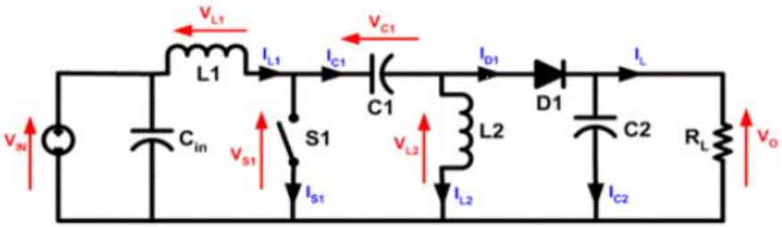
Circuit Diagram of SEPIC converter
These converters are used in different applications, such as with solar panels, in systems supplied with electrical energy where the output voltage V 0 of converter can be superior or inferior of the input voltage V 1 of converter. The fundamental converters don’t accept this situation. The capacitor C assures the galvanic insulation between input and output. The short circuits or others breakdown of the load don’t affect the power supply. The output voltage becomes zero if the PWM control signal of switch S is missing. The diode D can be replaced by a transistor switched synchronized with the main switch in the synchronous converters. The differences between these topologies are: SEPIC and Cuk converters are formed from the boost converter, and ZETA and Luo converter are formed from the buck-boost converter. The ripple current in the load is greater for Cuk and ZETA converters than SEPIC, because the SEPIC converter has an inductor L2 that smooth the current spikes. The switch S of SEPIC and Cuk converters is an N channel MOS transistor that needs a Low Side driver, when the ZETA converter has a P channel MOS transistor that needs a High Side driver. LUO converter based PV power generation along with the incremental conductance is more efficient with reduced voltage ripple. Among the many configurations of PFC converter feeding a BLDC motor drive.
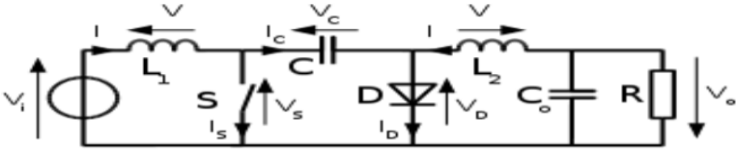
Circuit Diagram of Cuk converter
A boost-PFC converter fed BLDC motor drive has been the most widely used configuration but it utilizes a constant DC link voltage with PWM (Pulse Width Modulation) based VSI for speed control. This scheme suffers from high switching loss on account of high switching frequency of PWM pulses for VSI which drastically reduces the efficiency of overall system. Moreover, it also requires high number of sensors and complex control for its operation. A concept of variable DC link voltage for speed control of BLDC motor uses the concept of using converters like a SEPIC (Single Ended Primary Inductance Converter) for feeding a BLDC motor drive. It uses a bifilar winding which uses a PWM based control of VSI and have high switching losses and a PFC Cuk converter fed BLDC motor drive using the control of variable DC link voltage. This utilizes a Cuk converter operating in CCM; hence requires three sensors and is preferred for higher power rating. Bridge-less converter configurations have gained importance in the past decade due to their high efficiency. The front end DBR is eliminated in these configurations which reduce the conduction losses associated in them. The bridge-less buck and boost converters suffer from a limited voltage conversion ratio (1 for boost converter) which limit its application for a wide range of speed control by varying DC link voltage. The bridge-less Cuk and SEPIC converters have also gained popularity due to a wide voltage conversion ratio. A Luo converter has been widely used due to its inherent characteristics of voltage lifting. Many versions of Luo converter voltage lifting technique such as re-lift, super-lift and ultra-lift are there. A bridge-less configuration of the Luo converter can be used for feeding a BLDC motor as a low cost solution for low power applications.
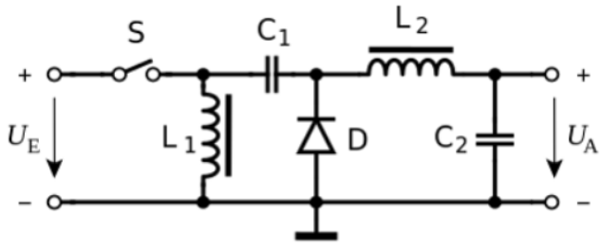
Circuit Diagram of Zeta converter
6.6 PFC Based BLDC Motor Drive
In the PFC based BL-Luo converter fed BLDC motor drive. A single phase supply followed by filter and a BL-Luo converter is used to feed a VSI driving a BLDC motor. The BL-Luo converter is designed to operate in DICM to act as an inherent power factor pre-regulator. The speed of the BLDC motor is controlled by adjusting the DC link voltage of VSI using a single voltage sensor. This allows VSI to operate at fundamental frequency switching (i.e. electronic commutation of BLDC motor) and hence has low switching losses in it; which are considerably high in PWM based VSI feeding a BLDC motor. The proposed scheme is designed and its performance is simulated for achieving an improved power quality at AC mains for a wide range of speed control and supply voltage variations.
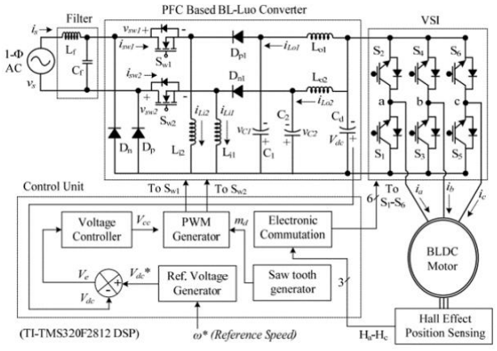
PFC based BL-Luo converter fed BLDC motor drive

6.7 BLDC Motor Applications
BLDC motors find applications in every segment of the market. Some of the applications are described below:
- Consumer: PC cooling fans, washing machine, vacuum cleaner, air conditioner, refrigerator, toys.
- Medical: artificial heart, microscopes, centrifuges, dental surgical tools, organ transport pump system.
- Automobile: automotive applications, electric and hybrid vehicle etc.
We can categorize the BLDC motor control into three major types such as
- Constant load
- Varying loads
- Positioning applications
- Constant Loads
For single-speed applications, induction motors are more suitable, but if the speed has to be maintained with the variation in load, then becauseof the flat speed-torque curve of BLDC motor, BLDC motors are a good fit for such applications.
- Varying Loads
BLDC motors become a more suitable fit for such applications because variable speed induction motors will also need an additional controller, thus adding to system cost.
- Positioning Applications
BLDC motors used in Position control application require more complex controller, optical encoders or High resolution resolvers to calculate speed of motor, two or more closed loop are operated simultaneously.
6.8 BLDC Motor Drive control scheme
Brushless DC motor known as permanent magnet synchronous motor or may be described as electronically commuted motor which do not have brushes, which means their rotor and stator runs at same frequency that are powered with direct current (DC) inverter/switching power supply, which is build up by using a universal bridge.
The basic block diagram of BLDC Motor control consist power converter, permanent magnet-synchronous machine (PMSM) sensors, and control algorithm. Three phase inverter transforms power from the source to the PMSM which in turn converts electrical energy to mechanical energy. BLDC motor has rotor position sensors controlled by the command signals, the command signal may be classified as torque, voltage, and speed command and so on. The type of the BLDC motor is determined by the structure of the control algorithms due to which there are two main types voltage source and current source based drives. Permanent magnet synchronous machine with either sinusoidal or non-sinusoidal back-emf waveforms is used by both voltage source and current source based drive. The speed control is obtained by using either PI controller or by using Fuzzy Logic controller.
6.9 PI Speed Control Of BLDC Motor
The basic building blocks of the PMBLDC Motor drive. The drive consists of speed controller, reference current generator, PWM current controller, position sensor, the motor and IGBT based current controlled voltage source inverter (CC-VSI).
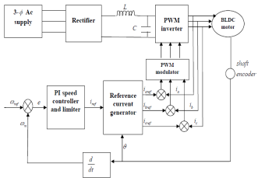
PI Speed Controller of the BLDCM Drive

CHAPTER 7
CUK DERIVED PFC CONVERTERS
Bridgeless Cuk converter has the following advantages because of its features:
- Easy implementation of transformer isolation.
- Natural protection against inrush current occurring at start up or overload current, lower input current ripple.
- Less electromagnetic interference associated with discontinuous conduction mode (DCM) topology.
- Cuk converter has both input and output currents with a low current ripple.
- Can achieve power factor near to the unity. For applications, which require a low current ripple at the input and output ports of the converter, the Cuk converter seems to be a potential candidate in the basic converter topologies.
The three new Cuk derived topologies are derived from the conventional PFC Cuk rectifiers. The bridgeless Cuk derived converter is a combination of two dc-dc converters. One for each half line period (T/2) of the input voltage. There are one or two semiconductor switches in the current flowing path. Current stresses in the active and passive switches are further reduced. Circuit efficiency is improved as compared to conventional Cuk rectifier. They do not suffer from high common mode noise problem and common mode emission performance is similar to the conventional PFC topologiesthe three new Cuk rectifiers are compared based on components count, mode of operation in DCM and driver circuit complexity as tabulated in Table 1. The bridgeless PFC Cuk rectifiers of Fig.1 utilize two power switches (Q1and Q2). However, the two power switches can be driven by the same control signal, which significantly simplifies the control circuitry.
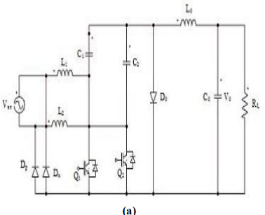
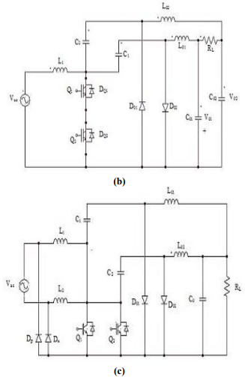
CUK Derived Converter Topologies (a) Type I (b) Type II (c) Type III

7.1 OPERATION OF BL CUK CONVERTERS
The choice of mode of operation of a PFC converter is a critical issue because it directly affects the cost and rating of the components used in the PFC converter. Continuous Conduction Mode (CCM) and Discontinuous Conduction Mode (DCM) are widely used in practice. In CCM or DCM, the inductor’s current or the voltage across intermediate capacitor in a PFC converter remains continuous or discontinuous in a switching period respectively. To operate a PFC converter in CCM, one requires three sensors (two voltage, one current) while a DCM operation can be achieved using a single voltage sensor. The stresses on PFC converter switch operating in DCM are comparatively higher as compared with its operation in CCM. By operating the rectifier in DCM, several advantages can be gained such as:
- Natural near-unity power factor.
- The power switches are turned ON at zero current and the output diodes are turned OFF at zero current.
- The mode of operation is an application dependent.CCM is suitable for high power applications and DCM for low power applications.
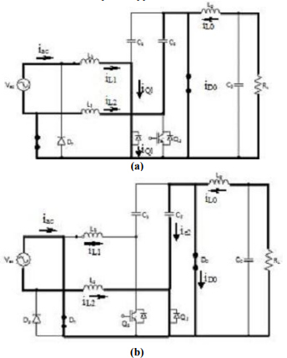
Circuits of Type I Cuk rectifier (a) During positive half cycle (b) During negative half cycle
Thus, the losses due to the turn-on switching and the reverse recovery of the output diodes are considerably reduced. Conversely, DCM operation significantly increases the conduction losses due to the increased current stress through circuit components. As a result, this leads to one disadvantage of the DCM operation, which limits its use to low-power applications (less than 300 W).
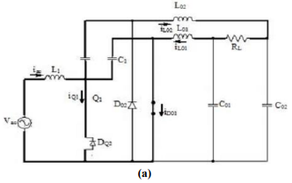
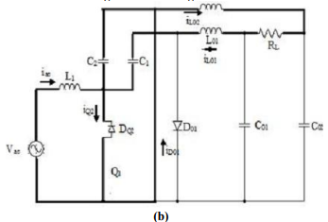
Circuits of Type II Cuk rectifier (a) during positive half cycle. (b)During negative half cycle
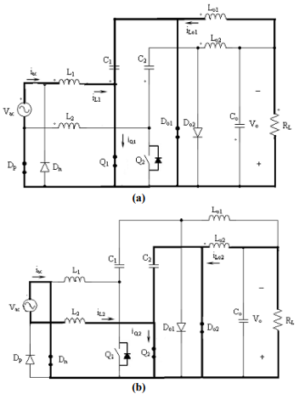
Circuits of Type III Cuk rectifier(a) during positive half cycle.(b)During negative half cycle
7.2 PFC BL-Luo CONVERTER
The operation of proposed PFC BL-Luo converter is classified into two parts which include the operation during the positive and negative half cycles of supply voltage and during the complete switching cycle.
A. Operation during Positive and Negative Half Cycle of Supply Voltage
The operation of PFC BL-Luo converter for positive and negative half cycles of supply voltage respectively. The bridgeless converter is designed such that two different switches operate for a positive and negative half cycles of supply voltages. switch Sw" inductors Li' and Lo' and diodes Dp and Dp' conduct during the positive half cycle of supply voltage. In a similar manner, switch Sw2, inductors Li2 and Lo2 and diodes Dn and Dnl conduct during the negative half cycle of supply voltage as the associated waveforms demonstrating the vanatlOn of different parameters such as supply voltage (vs), discontinuous input inductor currents (iLil and iLi2), output inductor current (iLol and iLo2) and the intermediate capacitor's voltage (V c, and V C2) during complete cycle of supply voltage.
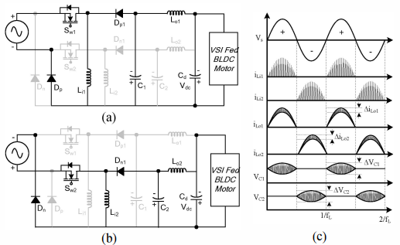
Operation of the PFC BL-Luo converter during positive and negative half cycle of supply voltage.
B. Operation during Complete Switching Cycle
The operation of PFC BL-Luo converter during a complete switching period for positive half cycle of supply voltage.
Mode I: When switch Swl is turned-on, the input side inductor (Li!) stores energy depending upon the current (iLi) flowing through it and the inductor value (Li')' Moreover, the energy stored in intermediate capacitor (C,) is transferred to the DC link capacitor (Cd) and the output side inductor (Lio). Hence, the voltage across intermediate capacitor (V c,) decreases, whereas the current in output inductor (iLol) and the DC link voltage (V de) are increased.
Mode II: When switch Sw' is turnedoff, the input side inductor (Li,) transfers its energy to the intermediate capacitor (C,) via diode Dp" Hence, the current iLi' decreases till it reaches zero, whereas the voltage across intermediate capacitor (V Cl) increases. DC link capacitor (Cd) provides the required energy to the load; hence DC link voltage V de reduces in this mode of operation.
Mode III: No energy is left in the input inductor (Lil) i.e. current iLiI becomes zero and enters into discontinuous conduction mode of operation. The intermediate capacitor (Ca and output inductor (Lol) are discharged; hence current iLol and voltage V Cl are reduced and DC link voltage V de increases in this mode of operation. The operation is repeated when switch Swl is turned-on again. In a similar way, for negative half cycle of supply voltage the inductor's Li2 and L02, diode Dnl and intermediate capacitor C2 conduct to achieve a desired operation.
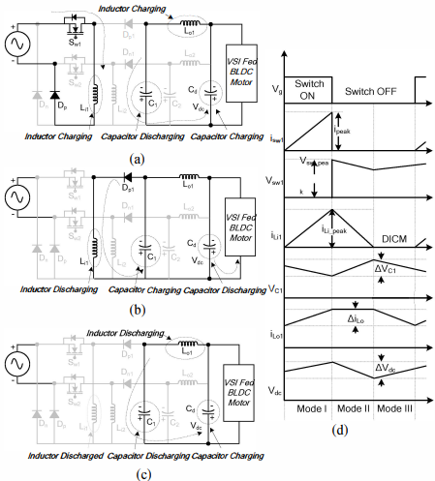
Operation of the PFC BL-Luo converter during complete switching cycle for positive half cycle of supply voltage

7.3 Classifications of PFC Converter
The classification of proposed PFC buck-boost converters in five different categories are described as follows.
A. Non-Isolated PFC Converters
A non-isolated PFC buck-boost converter is widely used configuration for voltage control with unity power factor at AC mains. Moreover, PFC Cuk, Single Ended Primary Inductance Converter (SEPIC), Zeta and Luo converters are also used in various applications requiring low current and voltage ripples in different components of PFC converter. These converters also have good dynamic performance, high light load efficiency and good light load voltage regulation capability. A PFC based canonical switching cell (CSC) converter is also used as a modification of a PFC Cuk converter with single inductor and therefore has lower conduction losses in it. In a similar way, two-switch configurations of non-isolated PFC buck-boost converters named Sheppard-Taylor converter and switched-capacitor buck-boost converter are also used invariably forpower factor correction at AC mains. PFC Sheppard-Taylor converter possesses an inherent capability to overcome control detuning problems i.e. inability of PFC converter to draw sinusoidal supply current at lower values of supply voltages. These non-isolated PFC converters are used for variable DC link voltage control of VSI feeding BLDC motor via VSI operating as an electronic commutator. The circuit configuration of one such converter belonging to non-isolated category i.e. PFC Cuk converter feeding BLDC motor drive.
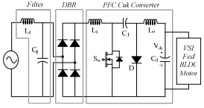
A PFC Cuk converter fed BLDC motor drive
B. Bridgeless Non-Isolated PFC Converters
Recently, bridgeless PFC converters have gained importance due to low conduction losses in the front-end converter by partial or complete elimination of DBR. Bridgeless-buck and bridgeless-boost converters derived from their counter-parts i.e. PFC buck and PFC boost converters are presented in respectively. These converters cannot be used for this application due to limited voltage transfer ratio i.e. 1 for bridgeless boost PFC converter. Hence a new configuration of a bridgeless buck-boost converter has been proposed. This configuration has very low components and thus exhibits highest efficiency of all configurations. Bridgeless configurations of PFC Cuk and SEPIC converters are also presented for improving the power quality at AC mains. These configurations of bridgeless non-isolated PFC converters are designed and developed for feeding BLDC motor drives. Moreover, some new bridgeless configurations of Zeta, Luo, CSC, Sheppard-Taylor, and switched-capacitor buck-boost PFC converters are also proposed for feeding BLDC motor drives with improved power quality at AC mains. The circuit configuration of a bridgeless Cuk converter feeding BLDC motor drive operating at variable DC link voltage control.
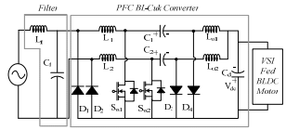
A PFC BL-Cuk converter fed BLDC motor drive

C. Isolated PFC Converters
There are many household appliances such as refrigerators where galvanic isolation between the input and output side has to be provided due to safety reasons. To deal with such issues, isolated PFC converters are used for feeding the BLDC motor drives.Many such configurations of isolated PFC converters have been reported in the literature. Configurations of PFC Flyback, Cuk, SEPIC and Zeta with high frequency isolation are presented in, respectively. In these configurations, PFC flyback converter has the minimum number of components but generally used in very low power applications due to stress on the PFC converter switch. However, other PFC converters such as Cuk, SEPIC and Zeta converters find applications in much higher power rating as compared to PFC flyback converter. Moreover, an isolated configuration of a PFC Sheppard-Taylor converter is also presented in with a capability to overcome control detuning problems. These configurations with a newly developed isolated PFC Luo-converter are used for improving the power quality at AC mains of BLDC motor drives. The proposed configuration is a low cost solution with minimal sensing requirements. A circuit configuration of a PFC isolated-Cuk converter fed BLDC motor drive.
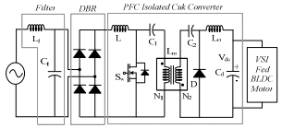
A PFC isolated Cuk converter fed BLDC motor drive
D. Bridgeless Isolated PFC Converters
Bridgeless isolated PFC converters combine the advantages of bridgeless PFC converter with high frequency isolation. Similar to non-isolated bridgeless PFC converters, these converters also offer low conduction losses in the front end. Bridgeless configurations of PFC flyback, isolated PFC Cuk, isolated PFC SEPIC and isolated PFC Zeta converters have been proposed in respectively. In this work, some new configurations of bridgeless isolated-Luo and bridgeless isolated Sheppard-Taylor converter are also proposed. Utilizing the twin benefits of bridgeless converter and high frequency isolation; these converters are used for feeding BLDC motor drive for improving the power quality at AC mains circuit configuration of a bridgeless isolated-Cuk converter feeding BLDC motor drive.
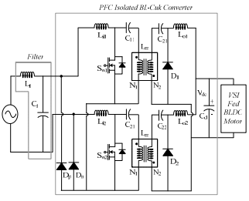
A PFC isolated BL-Cuk converter fed BLDC motor drive
E. Integrated and High Quality Rectifiers
Integrated and high quality rectifiers (IHQRR) are used in applications which require a good dynamic response, high light load regulations capability and high light load efficiency but at the cost of high number of components. The boost-integrated flyback rectifier energy-storage DC (BIFRED) converter and the boost integrated buck rectifier energy-storage DC (BIBRED) converter are the two configurations belonging to IHQRR. These are further classified into its non-isolated and isolated configurations. A non-isolated integrated buck-boost buck converter is also used which is a combination of buck-boost and a buck converter, which can provide a soft switching with extra one diode for reduced losses in the PFC converter switch. Moreover, single-stage, single-switch integrated PFC based power a supply (SSIPP) is presented in. These converters are the combination of a boost PFC converter with an isolated DC-DC converter. Here, the boost converter is used for achieving the improved power quality at AC mains, whereas second DC-DC converter is used for regulation of DC link voltage. Utilizing the benefits of these converters, an application of these configurations for power quality improvement at AC mains for BLDC motor drives is also presented in this work. Two configurations of the non-isolated and isolated BIFRED converter respectively for feeding BLDC motor drive.
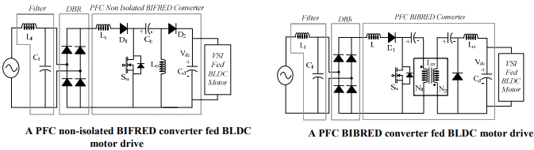

CHAPTER-8
CONTROL OF PFC BL-Luo CONVERTER FED BLDC MOTOR DRIVE
The control of the PFC BL-Luo converter fed BLDC motor vdc drive is classified into two parts as follows.
A. Control of Front-End PFC Converter: Voltage Follower Approach
The control of the front-end PFC converter generates the PWM pulses for the PFC converter switches (Swl and Sw2) for DC link voltage control with PFC operation. A single voltage control loop (voltage follower approach) is utilized for the PFC BL-Luo converter operating in DICM. A reference DC link voltage (V de *) is generated as, (9) where kv is motor's voltage constant and (0* is reference speed. Reference DC link voltage (V de *) is compared with sensed DC link voltage (V de) to generate voltage error signal (V e) given as, Ve(k) = Vdc *(k)- Vdc(k) (10) where k represents the k t h sampling instant. This error voltage signal (Ve) is given to the voltage PI controller to generate a controlled output voltage (Vee) as, Vee(k) = Vee (k -1) + kp {Ve(k) -Ve(k -I)} + kj Ve(k) (11) where kp and ki are proportional and integral gains of the voltage PI controller. Finally, output of voltage controller is compared with a high frequency saw-tooth signal (md) to generate the PWM pulses as, { if md(t) < vcc(t) then SWI =Sw2 ='ON'} (12) if md(t) Vcc(t) then Swl = Sw2 ='OFF' where Swl and Sw2 represent the switching signals to the switches of PFC converter.
B. Control of BLDC Motor: Electronic Commutation
An electronic commutation of the BLDC motor includes the proper switching of VSI in such a way that a symmetrical DC current is drawn from the DC link capacitor for 1200 and placed symmetrically at the centre of each phase. A rotor position on a span of 600 is required for electronic commutation; which is sensed by Hall Effect position sensors. The conduction states of two switches (Sl and S4) are shown in Fig. 4. A line current iab is drawn from the DC link capacitor which magnitude depends on the applied DC link voltage (V de), back emfs (ean and ebn), resistance (Ra and Rb) and self and mutual inductance (L., Lb and M) of the stator windings.
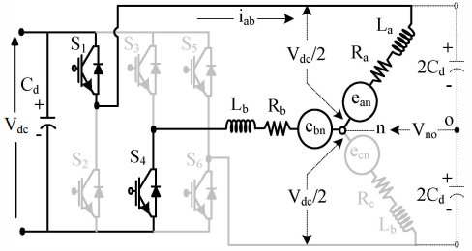
. A VSI feeding a BLOC motor
CONTROL OF PROPOSED BLDCMOTOR DRIVE FED BY MODIFIED CONVERTER
This is divided into two sub-sections as the control of a PFC converter for adjusting the DC bus voltage with PFC operation and the control for BLDC motor to achieve an electronic commutation.
a) Control of a Converter
This section deals with the generation of high frequency PWM pulses for solid-state switch (Sw) of PFC converter. For the control of Power factor correction converter a voltage follower approach using one voltage control loop is used. A reference voltage for DC bus capacitor (Vdc*) is as, Vdc* = kvω* where kv is motor voltage constant and Vdc* is reference speed. Inorder to generate Ve, the voltage error signal the sensed voltage of DC bus capacitor (Vdc) is compared with the reference voltage Vdc*. Ve (k) = Vdc *(k) −Vdc (k) kth sampling instant is represented by k To generated controlled output voltage Vcc the error voltage is given to PI controller, Vcc (k) = Vcc (k −1) + kp{Ve (k) − Ve (k −1)}+ kiVe (k) The gains of PI controller is given by kp and ki. The PWM pulses are generated by comparing the controller output voltage with a saw-tooth signal (md) of high frequency as, {if md < (t) Vcc (t) then Sw = 'ON} {if md (t) >Vcc (t) then S = 'OFF} Where Sw1 is the PWM signals given to solid-state switch of the PFC converter.
b) Electronic Commutation of Brushless DC Motor
The Brushless DC motor is commutated electronically which includes perfect switching of Voltage Source Inverter, such that a uniform direct current is drawn from DC bus for a 120° and placed uniformly at centre of back-EMF of each phase. The position of rotor is sensed over a span of 60° by Hall Effect sensors for commutating electronically Brushless DC motor. A new algorithm which consume less current is introduce in this paper.
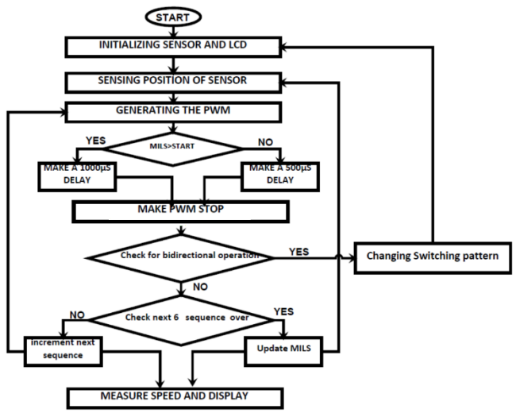
New minimum current algorithm
In this algorithm, the output of Hall Effect sensor is given to microcontroller. A count is stored in variable start. A timer is started at the beginning of first switching and stop at the end of switching. The value of the timer is compared with count. If value of timer is less than count means the speed of motor is not high, hence provide a small delay and hence the coils will energized for more time and results to increase the speed of motor. If value of timer is greater than count means the speed of motor high, hence provide a delay since the motor can run with the property of inertia, so the coils are too energized for only few time. The main advantage of proposed algorithm is that it draws only few currents compare to previous algorithm. It draws only 200mA. Bidirectional operation is done by changing the switching sequence.

CHAPTER 9
SIMULATION RESULTS
A MA TLAB/Simulink environment is used to evaluate the performance of proposed PFC BL-Luo converter fed BLDC motor drive for wide range of speed control and supply voltage variation using a standard model of BLDC motor. Performances indices such as supply voltage (vs), supply current (is), DC link voltage (V de), speed ((0), electromagnetic torque (Te), stator current (ia), inductor currents (iLi!, iLi2' iLol and iL02), intermediate capacitor's voltage (V CI and V C2) and PFC converter switch's voltage and current (vsw and isw) are analyzed for determining the performance of proposed BLDC motor drive. Power quality indices such as PF (Power Factor), DPF (Displacement Power Factor), CF (Crest Factor) and THD (Total Hannonic Distortion) of supply current at AC mains are analyzed for demonstrating the improved power quality at AC mains.
A. Steady State Performance of Proposed Drive
Steady state performance of proposed BLDC motor drive at rated load on BLDC motor with supply voltage as 220V and DC link voltage as 200V. A discontinuous input inductor current is obtained for every half cycle of supply voltage which confirms the DICM operation of a bridgeless based configuration. The obtained performance for a wide range of speed control. An improved power quality is obtained with power quality indices within the limits of IEC 61000-3-2. Harmonic spectra of supply current at AC mains for rated load conditions with DC link voltage as 200V and 50V.
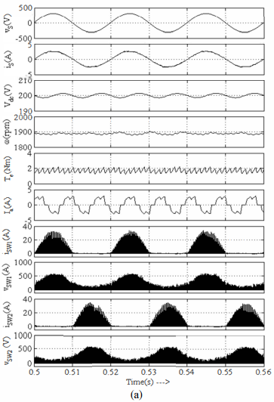
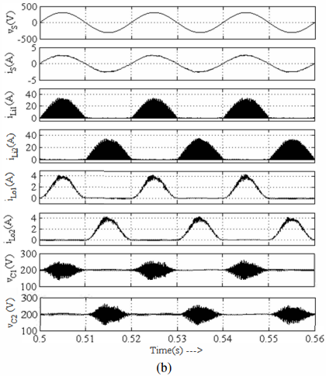
Steady state performance of the proposed PFC BL-Luo converter fed BLOC motor drive
B. Performance at Varying Supply Voltages
The performance of proposed BLDC motor drive is also evaluated for varying supply voltages to demonstrate its behavior at practical conditions. The obtained power quality indices at varying supply voltages from 170V to 270V. The harmonic spectra of the supply current at AC mains for rated load with supply voltage as 170V and 270V respectively.
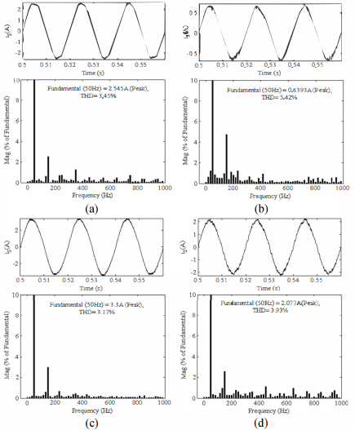
Harmonic spectra of supply current of the proposed PFC-Luo converter fed BLDC motor drive at rated load torque on BLOC motor with (a) Supply voltage as 220V and DC link voltage as 200V, (b) Supply voltage as 220V and DC link voltage as 50V, (c) Supply voltage as l70V and DC link voltage as 200V and (d) Supply voltage as 270V and DC link voltage as 200V.

C. Dynamic Performance of Proposed Drive
The dynamic performance of the proposed BLDC motor drive at different DC link voltage and supply voltages. The dynamic performance during starting at DC link voltage of 50Y and change in DC link voltage from lOOV to 150V. Performance during varying supply voltage from 270V to l70V. A smooth control of DC link voltage is obtained which shows a satisfactory performance of the closed loop control.
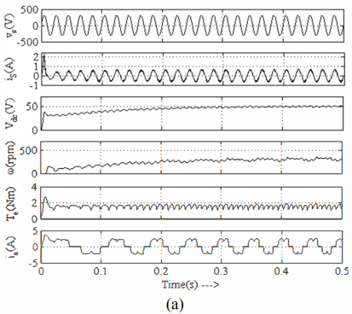
BLDC motor at DC link voltage of 50V
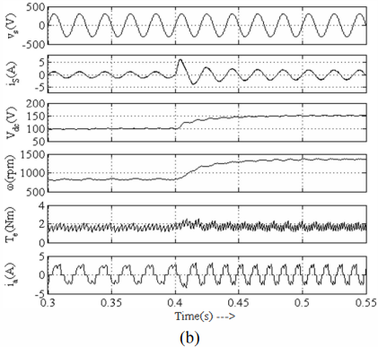
DC link voltage from 100V to 150V
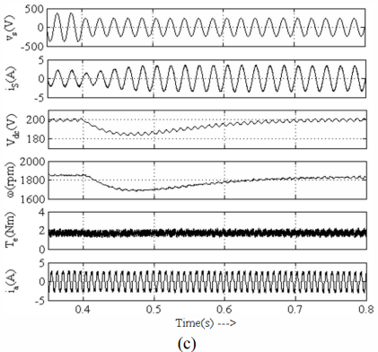
Supply voltage from 270V to 170V
D. Stress on PFC Converter Switches
The analysis of voltage and current stress with varying load on BLDC motor. A peak voltage and current stress of 560V and 29A are obtained which are acceptable for a PFC converter operating in DICM.

CHAPTER 10
CONCLUSION
A PFC based BL-Luo converter fed BLDC motor drive has been proposed for wide range of speeds and supply voltages. A single voltage sensor based speed control of BLDC motor using a concept of variable DC link voltage has been used. The PFC BL-Luo converter has been designed to operate in DICM and to act as an inherent power factor preregulator. An electronic commutation of the BLDC motor has been used which utilizes a low frequency operation of VSI for reduced switching losses. The proposed BLDC motor drive has been designed and its performance is simulated in MA TLAB/Simulink environment for achieving an improved power quality over wide range of speed control. Finally, the performance of proposed drive has been verified experimentally on a developed hardware prototype. A satisfactory performance of proposed drive has been achieved and is a recommended solution for low power applications.

CHAPTER 11
REFERENCES
[I] Chang Liang Xia, Permanent Magnet Brushless DC Motor Drives and Controls, Wiley Press, Beijing, 2012.

[2] T. Kenjo and S. Nagamori, Permanent Magnet Brushless DC Motors, Clarendon Press, Oxford, 1985.

[3] R. Krishnan, Electric Motor Drives: Modeling, Analysis and Control, Pearson Education, India, 200 I.

[4] T. J Sokira and W. Jaffe, Brushless DC Motors: Electronic Commutation and Control, Tab Books, USA, 1989.

[5] Hamid A. Toliyat and Steven Campbell, DSP-based Electromechanical Motion Control, CRC Press, New York, 2004.

[6] S. Singh and B. Singh, "A Voltage-Controlled PFC Cuk Converter Based PMBLDCM Drive for Air-Conditioners," iEEE Trans. ind. Appl., vol. 48, no. 2, pp. 832-838, March-April 2012.

[7] Limits for Harmonic Current Emissions (Equipment input current -:;.16 A per phase), International Standard IEC 61000-3-2,2000.

[8] B. Singh, B. N. Singh, A. Chandra, K. AI-Haddad, A. Pandey and D.P. Kothari, "A review of single-phase improved power quality AC-DC converters," iEEE Trans. industrial Electron., vol. 50, no. 5, pp. 962- 981, Oct. 2003.

[9] B. Singh, S. Singh, A. Chandra and K. AI-Haddad, "Comprehensive Study of Single-Phase AC-DC Power Factor Corrected Converters With High-Frequency Isolation," iEEE Trans. ind. informatics, voU, no.4, pp.540-556, Nov. 2011.

[10] R. Yijayarajeswaran, "DSP Implementation of a Power Factor Correction Strategy for BLDC Motor Drive," international Journal of Computer Science issues (iJCSi), vol. 9, Issue I, no. 3, January 2012.

[11] G. J. George, R. Rakesh and N. Arun, "PMBLDC motor drive with Power Factor correction controller," inter. Can! on Computing, Electronics and Electrical Technologies (JCCEET), pp.63-68, 21-22 March 2012.

[12] T. Gopalarathnam and H. A. Toliyat, "A new topology for unipolar brush less DC motor drive with high power factor," iEEE Trans. Power Electron., vol.l8, no.6, pp. 1397- 1404, Nov. 2003.

[13] Y. Jang and M. M. Jovanovic, "Bridgeless High-Power-Factor Buck Converter," iEEE Trans. Power Electron., voL26, no.2, pp.602-611, Feb. 2011.

[14] L. Huber, Y. Jang and M.M Jovanovic, "Performance Evaluation of Bridgeless PFC Boost Rectifiers," iEEE Trans. Power Electron., voL23, no.3, pp.1381-1390, May 2008.

[15] A. A. Fardoun, E. H. Ismail, A. J. Sabzali, M. A. AI-Saffar, "New Efficient Bridgeless Cuk Rectifiers for PFC Applications," iEEE Trans. Power Electron., voL27, no.7, pp.3292-3301, July 2012.

[16] M. Mahdavi and H. Farzanehfard, "Bridgeless SEPIC PFC Rectifier with Reduced Components and Conduction Losses," iEEE Trans. ind. Electron., vol. 58, no.9, pp.4153-4160, Sept. 2011.

[17] F. L. Luo, "Negative output Luo converters: voltage lift technique," iEE Proc. Electric Power Appl., voLl46, no.2, pp.208-224, Mar 1999 .

[18] B. Williams, "Generation and Analysis of Canonical Switching Cell DC-to-DC Converters," iEEE Trans. ind. Electron., 2013.

[19] F. L Luo, "Re-lift converter: design, test, simulation and stability analysis," iEE Proc. Electric Power Appl., vo1.l45, no.4, pp.315-325, Jul 1998.

[20] F. L. Luo and H. Ye, "Negative output super-lift converters," iEEE Trans. Power Electron., vol.l8, no.5, pp. 1113- 1121, Sept. 2003.

