Performance Analysis and Optimal Cooperative Cluster Size for Randomly Distributed Small Cells Under Cloud RAN

ABSTRACT
One major advantage of cloud/centralized radio access network (C-RAN) is the ease of implementation of multicell coordination mechanisms to improve the system spectrum efficiency (SE). Theoretically, large number of cooperative cells lead to a higher SE, however, it may also cause significant delay due to extra channel state information (CSI) feedback and joint processing computational needs at the cloud data center, which is likely to result in performance degradation. In order to investigate the delay impact on the throughput gains, we divide the network into multiple clusters of cooperative small cells and formulate a throughput optimization problem. We model various delay factors and the sum-rate of the network as a function of cluster size, treating it as the main optimization variable. For our analysis, we consider both base stations’ as well as users’ geometric locations as random variables for both linear and planar network deployments. The output SINR (signal-tointerference-plus-noise ratio) and ergodic sum-rate are derived based on the homogenous Poisson point processing (PPP) model. The sum-rate optimization problem in terms of the cluster size is formulated and solved. Simulation results show that the proposed analytical framework can be utilized to accurately evaluate the performance of practical cloud-based small cell networks employing clustered cooperation.

TABLE OF CONTENT
CHAPTER NO |  | TITLES | PAGE NO
 |  | ABSTRACT | ii
1 | 1.1 | INTRODUCTION | 1
 | 1.2 | MOTIVATION AND CONTRIBUTIONS | 4
 | 1.3 | SMALL CELL DEPLOYMENT | 6
 | 1.4 | TWO-TIMESCALE RESOURCE ALLOCATION FRAMEWORK | 10
 | 1.5 | REINFORCEMENT LEARNING-BASED WAVELENGTH ALLOCATION ALGORITHM | 11
 | 1.6 | COMP CLUSTERING AND DYNAMIC SPECTRUM ALLOCATION ALGORITHM | 13
 | 1.7 | DESIRED SIGNAL AND INTERFERENCE POWER | 15
 | 1.8 | CLUSTER SIZE OPTIMIZATION | 18
 | 1.9 | C-RAN TESTBED AND NETWORK | 20
2 |  | LITERATURE SURVEY | 28
3 |  | METHODOLOGY | 33
 | 3.1 | EXISTING SYSTEM | 33
 |  | - EXISTING SYSTEM FLOW | 33
 | 3.2 | PROPOSED SYSTEM | 34
 | 3.3 | BLOCK DIAGRAM | 34
4 |  | PROJECT IMPLEMENTATION | 39
 | 4.1 | Hardware features | 39
 | 4.2 | Software features | 39
5 |  | RESULT | 43
6 |  | CONCLUSION | 47
 |  | REFERENCES | 48

CHAPTER 1

INTRODUCTION
As a promising candidate technology for next generation wireless communications, cloud (or centralized) radio access network (C-RAN) has drawn significant attention by both academia and industry in the last few years. Apart from CRAN’s advantage of reducing radio site operations and capital costs, another benefit is relate to ease in the implementation of multi-cell coordination mechanisms such as coordinated multipoint transmission and reception (CoMP), thus promising higher system performance through efficient interference management. In addition, the cloud-based architecture provides the flexibility of splitting the radio access functionalities between the cloud and the remote sites depending on the backhaul link capacity and software/hardware processing capability of the access and cloud entities in the network.
One of the most popular functional split options in a C-RAN is to consider a high computational capability central processor taking high-complexity tasks in the cloud, and a set of densely deployed, low power, low-complexity radio remote heads (RRHs). This option can harness the benefit of deploying a low-cost dense small cell network, while at the same time efficient interference avoidance and cancelation algorithms across multiple small cells can be realized through centralized processing in order to improve network spectral efficiency (SE).
Theoretically, larger cooperation cluster size (i.e. number of cooperating cells) leads to better interference cancelation and higher system SE. However, this is in practice not true if real-world implementation factors, such as latency, are taken into account. Larger number of cooperating cells/antennas results in more complex channel estimation and precoding implementation; this is especially true for advanced channel estimators such as minimum mean square error (MMSE) and zero-forcing (ZF) precoders whose complexity is in cubic-order of the number of involved (transmitting or receiving) antennas. In addition, more antennas/cells/users in a cluster imply more CSI required for precoding, bringing further CSI feedback delay into the system. Furthermore, due to general-purpose hardware processing in the cloud data center, and also due to the uncertainties in availability of computational resource, significant processing delay may get added.
All these delays can cause mismatch between actual channels and the channel used for calculating precoder matrix, consequently, performance degradation results. Therefore, we conjecture that there must be an optimal cluster size, large enough to mitigate interference into a reasonable level yet small enough to save the performance loss due to the delaycaused channel mismatch. To optimize the cluster size of cloud-based small cell networks, building a mathematic link between the optimizing criterion in terms of sum-rate and the cluster size is the key.
Two problems arise in that building process: 1) how to model the signal model of the network as a function of the cluster size and 2) how to map the cluster size as a function of latency. For the first problem, we start our analysis from the deployment of cellular system, where typically the base stations (BS) are fixed in homogeneous grid. However, the most significant change that has to be taken into consideration for cooperation in small cells (in comparison with a point-to-point MIMO system) is the geometric location randomness which leads to the uncertainty of the large-scale fading.
Towards this end, several papers have considered large scale fading as well as small scale fading in analyzing the ergodic capacity of cooperative systems for uplink and downlink, considering BSs locations fixed while treating UEs locations as random variables. However, this model is likely to be inaccurate for heterogeneous networks consisting of small cell deployments both in urban and suburban areas, where cell radius varies significantly and should be modeled as a random variable in itself. In a befitting direction, in, an analysis was presented by introducing an extra source of randomness, i.e. modeling the position of the base station as a homogeneous Poisson point processing (PPP), which will be used as a framework in our analysis. In addition, a tractable model for non-coherent joint transmission base station cooperation is established and closed-form for SINR distribution by considering a single UE is proposed in. Regarding the second problem of mapping cluster size with latency, few works in literature so far have considered the impact of latency in multi-cell cooperation systems. The authors in considered CSI feedback delay in their analysis for distributed antenna systems.
Moreover, backhaul latency models for various backhaul topologies and technologies were only introduced in, however, the performance analysis and proposed algorithms are based on a single cooperative cluster instead of a network composed of multiple clusters that may interfere to each other. In this paper, we consider a set of clusters in a cloud-based network sharing the same cloud resources, where each cluster is composed by a number of RRHs performing joint processing and operating as multi-antenna BS.
In our work, we consider both RRHs’ and users’ geometric location as random variables based on homogeneous PPP as well as the effects of processing and CSI feedback delay. This approach is not only more generic but also more realistic considering the dynamic deployment nature of small cells in the future. The output SINR is derived in terms of the RRH and UE density in the presence of delay-caused channel mismatch. All of the parameters are converted into a function of cluster size to formulate the optimization problem.
We briefly summarize the contributions and constraints of our work on the cluster size optimization for cloud-based small cell networks as follows:
- By treating both UEs and RRHs locations as random variables, the path-loss in addition with the fast fading are considered in the channel model. In the presence of delay and given a specific cluster size, we derive the general output SINR expression in terms of node density ρU and ρR by considering two representative linear precoders: MRT (maximum ratio transmission) and ZF, respectively. The analysis is divided into two steps. The first one assumes UE is located at an arbitrary distance to the cluster center; and in the second step, the analysis is generalized by treating the arbitrary distance as a random variable. Both linear and planar deployment of cells is considered.
- Considering an FDD (frequency division duplex) system, we build a generic delay model for the cloud-based small cell networks comprising the computational processing delay at the cloud data center, CSI feedback delay due to the transmission capacity limit link from UE to RRH, channel estimation delay, the propagation delay and the backhaul latency due to the data exchanging between cloud and small cells. However, the model can be extended to TDD (time division duplex) system straightforwardly. We then model the precoder delay as a function of the cooperative cluster size to show its impact on the performance.
- We show that the ergodic output SINR can be expressed as a function of the cluster size. The geographic area of a network is considered to be divided into separate clusters and an optimization problem is formulated by expressing ergodic sum-rate in terms of the cooperative cluster size. Due to the complex relationship between the cost function and the cluster size, numerical methods are used to show its consistency to the simulation results. Both large-scale and small-scale factors are considered in the channel model, however, the shadowing factor of the large scale fading, is not considered for tractability of analysis.
- The paper focuses on one of the most popular functional split options in cloud-based architecture, consisting of low-complexity low-cost RRHs and a cloud data center that can take as much functionality implementation as possible with perfect (in terms of capacity) backhaul1 between them. However, the general method and optimization could be adopted for any other functional split options depending on the backhaul capacity and other hardware constraints.
1.2 MOTIVATION AND CONTRIBUTIONS
The aim of this work is to improve the performance, in terms of throughput, of the edge users of a 5G small cell C-RAN network where NOMA and MU-MIMO are combined and user mobility is a factor, without significantly undermining the performance of the non-edge UEs. The selected way to achieve this is via implementing JT-CoMP in which the transmission point clustering is based on a coalition formation game which takes into account the costs of cooperation and can adapt to the dynamic nature of the selected scenario. Furthermore, the obtained results are compared with those of a no-CoMP case, a case where the transmission point clustering is done in a static way and a case where a dynamic greedy clustering algorithm is applied in order to confirm the effectiveness of the proposed scheme to reliably and consistently mitigate the intercell interference and increase mobile user performance.
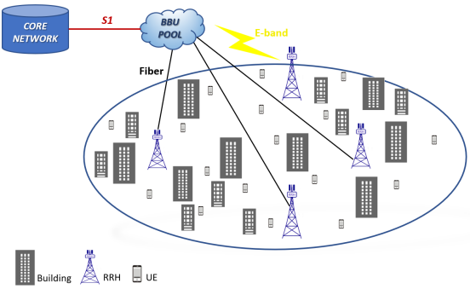

This paper’s contributions can be summarized as follows:
- To the authors’ knowledge, no other study is concerned with the combined implementation of NOMA, MUMIMO and JT-CoMP from a coalitional game theoretic perspective on a 5G small cell network consisting of low-power transmission points and moving users. Detailed equations for the received signal and SINR for each case are formulated, in addition to NOMA user cluster formation, with and without CoMP, power coefficient allocation and beamforming analysis.
- A coalition formation game is played on behalf of the network’s UEs, where the RRHs are the players, aiming to form the most beneficial JT-CoMP clusters for the UEs in the cell edges, while the performance of the rest in terms of throughput remains practically unaffected. For this purpose, appropriate utility and individual payoff functions are formulated, while a dynamic coalition formation algorithm is being developed.
- The effectiveness of the proposed approach, in which JT-CoMP is implemented via the proposed coalition formation algorithm in a network with mobile users, is verified via simulations. The performance of the proposed scheme is then compared to that of a conventional JT-CoMP case with static clustering, a case where JT-CoMP with a greedy clustering approach has been adopted and a case where JT-CoMP is not deployed.
Regarding notations, we will use lowercase or uppercase letters for scalars, boldface lowercase letters for vectors, boldface uppercase letters for matrices. Furthermore, the superscripts (·) T , (·) H, (·) −1 , (·) † denote the transpose, the conjugate transpose, the matrix inverse and the MoorePenrose pseudo-inverse respectively. Additionally, | · | and || · || indicate the norm and the Euclidean norm of a scalar and vector respectively.
1.3 SMALL CELL DEPLOYMENT
We focus on the refinement of the MBS’s strategy for SCP and UCA. If considering the SBSs as part of the environment, the MBS can learn user demands and refine small cell deployment every time receiving a decision feedback from such an environment. The feedback for a MBS’s decision is actually concluded by its subsequent SBSs’ decisions thus is non-stochastic. Then, solving the subproblem of small cell deployment stage by stage can be viewed as playing with an adversarial or non-stochastic bandit. In this model, one “arm” corresponds to one of the MBS’s possible actions, but its reward distribution depends on the SBSs’ responding actions and is thus not specifically known. After certain stages of trying (i.e., pulling arms), learning (i.e., updating reward beliefs), and adapting, the best global strategy of the MBS is attainable, which is capable of addressing the exploration-exploitation trade-off.
A. Adversarial Bandit
For a finite time horizon, i.e., for t = 1, 2,...,T , the MBS makes sequential decisions on small cell deployment by dealing with an adversarial bandit problem, which can be defined by a 2-tuple < LM × AM×N , R¯·(·) >: LM × AM×N is a set of possible actions for the MBS, who takes an action (Lt, At) ∈ LM × AM×N in stage t; R¯t(Lt, At) is a feedback reward/cost for the MBS, which evaluates the applied action (Lt, At) in stage t. In each stage t, the MBS selects an action (Lt, At) = (Lj , Aj ) from a probability distribution πt over LM × AM×N = {(Lj, Aj )| j = 1, 2,..., |LM × AM×N |}, in which each possible action (Lj, Aj ) is assigned with a probability πt(Lj , Aj ). It is required to ensure that j πt(Lj , Aj )=1. The reward/cost function R¯t needs to be defined to favor the strategy πt that minimizes the objective Ut in the problem P0 on average. Hence, we can have R¯t(Lt, At) = Ut(Lt, At, B∗ t , P∗ t ), (7) which is an evaluation of not only the MBS’s applied action (Lt, At) but also the SBSs’ best joint action (B∗ t , P∗ t ) in response (hidden by the environment for the MBS). In this way, minimizing the reward or actually the cost for spectrum sharing is equivalent to optimizing the global objective. In the finite time horizon, a mixed strategy of the MBS, say π = {πt |t = 1, 2,...,T }, is able to generate a sequence of applied actions (L1, A1),...,(LT , AT ). Comparing those π-chosen actions with the cost-minimizing one, the optimality of π is evaluated with respect to the criterion of either expected regret G¯π or pseudo-regret G˜π, which can be defined by G¯π = E T t=1 R¯t(Lt, At) − min j T t=1 R¯t(Lj , Aj ) , (8) G˜π = E T t=1 R¯t(Lt, At) − min j E T t=1 R¯t(Lj , Aj ) . (9) The final goal of the MBS is to derive a mixed strategy π∗ for small cell deployment such that π∗ = arg min π G¯π or arg min π G˜π, (10) supposing the best responses of the SBSs behind the environment for uplink resource allocation.
B. Sub problem Solution
It is still challenging to solve the adversarial bandit problem due to the huge size of the MBS’s action space LM ×AM×N . Fortunately, the two issues of SCP and UCA for small cell deployment can further be decoupled. Particularly, the MBS takes a primary action At ∈ AM×N for UCA in every stage t, i.e., to group N users into M clusters and associate each user cluster with a small cell. Based on At, the MBS takes a secondary action Lt ∈ LM for SCP, i.e., to place each small cell above its associated user cluster. It is beneficial to address UCA before SCP (and subsequent CRA and TPC), because the involvement of binary variables for UCA gives a finite number of possible actions (arms) for the MBS’s sequential decision making. Furthermore, each possible action At leads the other subsequent decisions within a stage, and can be evaluated by a feedback cost R¯t(At). Then, the action space can be downsized to AM×N . Before getting to find the optimal strategy or action of At for UCA in stage t, we put initial focus on deriving the optimal action of Lt for SCP assuming that At is given. Note that while handling the issue of SCP, the MBS does not directly manage the subsequent issues of CRA and TPC, which have become local to the SBSs after problem decoupling. In the phase of SCP without knowing next decisions on CRA and TPC, the MBS has to coarsely optimize the coverage of every small cell, i.e., to optimize a part of the objective function in (1), and help the SBSs further optimize the other part of it. The idea here is that the transmission and interference distances in the uplink can be minimized and maximized, respectively, through the optimal placement of small cells. This can be an indirect way of improving soft frequency reuse in the uplink. Thus for SCP, the objective function in (1) is truncated to V (m) t = n∈N(m) t λ(n) t w(m,n) t , (11) in which the values of λ(n) t for n ∈ N can be estimated stage by stage; the values of N (m) t and w(m,n) t for m ∈ M, n ∈ N (m) t are determined by At and Lt, respectively. The optimization of transmission/interference distances can be achieved by properly defining w(m,n) t for each pair of SBS m and user n. If assuming the basic ground-to-air path loss model, each value of propagation gain H(n,m) t in (2) is still inversely proportional to the Euclidean distance d (m,n) t = ||l (m) t −l (n) || (to the power of path loss exponent α), between SBS m at l (m) t ∈ L and user n at l (n) ∈ L. Then, each user weight can become a ratio of transmission/interference distances. Alternatively, each user weight can be directly defined like this, instead of following (2). Hence, we can rewrite the above V (m) t as V (m) t = n∈N(m) t λ(n) t (d(m,n) t ) α m∈M,m=m (d(m ,n) t ) −α. (12) Then, according to the original problem P0 of joint optimization, the subsubproblem of SCP per stage can be defined as PSCP : given : At; find : Lt; minimize : Vt = m∈M V (m) t ; s.t. : l (m) t ∈ L(m) form ∈ M. Each SBS m only searches a location space L(m) ⊂ L that is local to its associated users N (m) t . According to optimization theory, we can show that such a subsubproblem is directly solvable. Lemma 1: Given that in each stage t = 1, 2,...,T , the values of N (m) t for m ∈ M are fixed by a certain At, and the values of w(m,n) t for m ∈ M, n ∈ N (m) t are defined by (2), and each L(m) for m ∈ M is closed and convex, then there exists the optimal solution L∗ t to PSCP . Proof: The distance d ( ¯m,n¯) t between any SBS m¯ ∈ M and any user n¯ ∈ N only appears once in Vt. Specifically, if user n¯ is associated with SBS m¯ , their distance is considered as a transmission distance in the part of (d (m,n) t )α; if not, it is considered as an interference distance in the part of (d (m ,n) t )−α. We can see that the minimization of Vt for SCP contributes to the maximization of inter-cell interference distances as well as the minimization of intra-cell transmission distances. If considering Vt as a function of any l ( ¯m) t = (x( ¯m) t , y( ¯m) t , z( ¯m) t ) ∈ L( ¯m) , the objective function becomes the following form: Vt = n∈N( ¯m) t κ(n) t (d( ¯m,n) t ) α + n∈N( ¯m) t κ(n) t (d( ¯m,n) t ) −α + κt, (13) where each κ(n) t or κt is a positive constant. The first part is to minimize transmission distances in cell m¯ , and the second part is to maximize interference distances from the other cells. In a small enough search space L( ¯m) , the minimization of Vt is dominated by the minimization of the first part, which is a convex function of l ( ¯m) t . A typical contour plot of Vt with respect to (x( ¯m) t , y( ¯m) t ) (z ( ¯m) t = 10 [32]) is illustrated in Fig. 2, when associated users n ∈ N ( ¯m) t are generated near this region’s center and interfering users n ∈ N ( ¯m) t are distributed outside the local search space. Hence, any SBS m¯ can find its own optimal l ∗( ¯m) t that helps minimize Vt while temporarily fixing the other SBSs. Through alternating minimization, the optimal solution L∗ t that minimizes Vt is achievable for a given At. Existing non-linear optimization solvers, such as “fmincon” in MATLAB, can be applied to optimize SCP subject to UCA. For the reason that L∗ t (and subsequent (B∗ t , P∗ t ) for CRA and TPC) always follows At, the MBS’s sequential decision making can only involve finding At stage by stage.
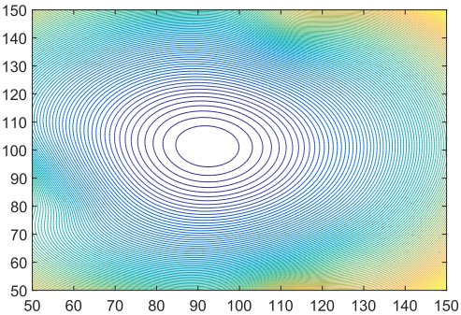
In this way, the strategy πt+1 to be utilized in stage t+1 can be derived based on only the currently observed cost R¯t(At) by the end of stage t. Generally speaking, if the applied action At = Aj returns a higher cost R¯t(Aj ), then this action Aj will be less preferred in the future and will be assigned with a lower probability πt+1(Aj ). The main steps are summarized in Algorithm 1. In the finite time horizon, we are able to show that this algorithm provides regret guarantees for UCA, but it is still heuristic due to the involvement of user uncertainty.
1.4 Two-Timescale Resource Allocation Framework
The goal of this paper is to improve the efficiency of transmission, which is restricted by fronthaul bottleneck and limited spectrum resources. Early works always optimize optical and wireless resources in a single timescale framework. To adapt to the real-time changes in wireless channel, the duration of the timescale is designed to be short to meet the characteristics of wireless channels. However, wavelength allocation should be performed on a longer time scale, since the load of wavelength changes relatively slowly. As the wavelength resource and wireless resource allocation occur in different timescales, we establish a two-timescale resource allocation framework. Each time frame contains T time slots in which a cooperative set is formed for the user according to the current network conditions, and then spectrum resources are allocated.
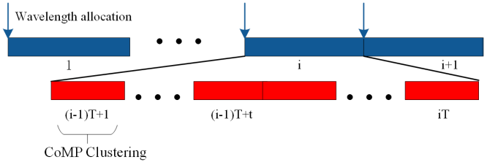
The two-timescale resource management framework can capture the stochastic nature of request distribution and channel conditions by allocating wavelengths in a longer timescale. It is assumed that the wavelength assignment matrix is fixed in each time frame, then we can derive the cooperative sets for each user in a timeslot. Let ψ ∗ Y (H, Q) define clustering result by the given wavelength allocation matrix Y , the current channel state information Q, and request distribution H. According to the three above matrix, we can assign wavelengths to RRUs at the beginning of a time frame. With wavelength allocation determined, a user-centric cluster is formed under the constraints of fronthaul capacity, effectively increasing system throughput and fronthaul efficiency.
1.5 Reinforcement Learning-Based Wavelength Allocation Algorithm
Since the performance of CoMP cooperative set is limited by available fronthaul bandwidth of RRUs which participating in collaboration, we propose an RLWA algorithm concerning fronthaul load caused by cooperative sets. RRUs belong to the same wavelength have more opportunities to collaborate since the data shared by cooperative RRUs are transmitted only once. In other words, RRU distributed in areas with high similarity of requested content generates less fronthaul demand. As the similarity decreases, RRUs need more fronthaul bandwidth to guarantee the access network performance when users cannot be served locally. In this section, taking the RRUs’ behavior in short timescale into account, then a wavelength allocation algorithm in long timescale according to the clustering result is designed. To relieve the contradiction between fronthaul overhead and access layer performance, we propose an algorithm considering the gain of cluster formation in the wavelength allocation process. Let ymn denote the wavelength allocation indicator, whereas ymn = 1 means that wavelength n is allocated to RRU m. Otherwise ymn = 0. If the wavelength n is allocated to any RRUs at the beginning of a time frame, it is considered to be occupied in all time slots regardless of how much data is carried. Therefore, in our algorithm, the fronthaul load is defined as the total capacity of occupied wavelength in a time frame. Let u(ψ ∗ Y (H, Q)) denote the throughput in each transmission slot. Then fronthaul efficiency ηFE is defined as the amount of data transmitted by the unit fronthaul, which can be calculated as Equation (1) ηFE= u(ψ ∗ Y (H, Q)) ∑ n VnDmax (1) Then in each time frame, the long-term revenue of the system can be expressed as the expected value of the fronthaul efficiency during that period, and the problem of wavelength allocation can be modeled as follows: max Y EH,Q[u(ψ ∗ Y (H, Q))] ∑ n VnDmax s.t.Vn = 1{ ∑ m∈MΩ ymn>0} (3) ∑ m∈MΩ ymn = 1 (4) The constraint (3) represents the wavelength activation state, where Vn = 1 represents that wavelength n is assigned to the RRU for data transmission. The constraint (4) imposes the wavelength availability constraint, i.e., ensuring that each RRU can only allocate a single wavelength. Since the clustering result of each transmission slot cannot be obtained by a closed expression, the problem is solved by reinforcement learning at this stage. Assuming that BBU has stored a historical profile Γ = {{H1, Q1}, {H2, Q2}, · · · , {HT, QT}}, the reinforcement learning agent obtains the wavelength allocation strategy by learning the historical environment. At the beginning of each transmission time slot, the agent selects a wavelength allocation strategy according to the ε−greedy and then executes CCDSA algorithms. The historical environment will feedback a reward signal rat , which is the throughput that the current time slot unit fronthaul network can support at the current time slot, as shown in Equation (5). rat= u(at , Ht , Qt) ∑ n Vn(at)Dmax (5) u(at , Ht , Xt) represents the revenue brought by the throughput of the current transmission time slot t, when action al , channel state information Ht and request distribution Qt are determined. ∑ n Vn(at)Dmax shows the wavelength transmission cost of the system after a given action. According to the reward value of each time slot, the update criterion for determining the expected cumulative reward value is shown in Equation (6). Q t+1 al = Q t al + λtφ{at=al} rat − Q t al (6) Among them, φ{at=al} indicates that the action is selected in the transmission time slot, and the optimal wavelength allocation result for each time frame can be expressed as a ∗ = arg max al Qal .
It is assumed that the channel distribution characteristic and request distribution characteristic remain unchanged for a long time. Then optimization problem (2)–(4) corresponding to the future period is the same as that of the historical period. In Algorithm 1, the historical information is used as the input to obtain the wavelength allocation strategy of the current time frame. In the beginning, the historical information Γ, exploration probability ε and learning rate λt are initialized. In learning process, each agent selects an action and execute Algorithm 2. Finally, a certain wavelength allocation matrix Y is obtained according to the updated Q value. The complexity analysis of Algorithm 1 is as follows. Since the complexity of generating a random number and Q value update is is O(1), the complexity of Algorithm 1 depends on the complexity of Algorithm 2, which is O(M(K + M)RK).
1.6 CoMP Clustering and Dynamic Spectrum Allocation Algorithm
As the wavelength allocation results in a long timescale is determined, we propose a CCDSA algorithm in a short timescale, which includes the user cooperative set selection and spectrum allocation. In the short time scale, RRU wavelength assignment has been determined by the RLWA algorithm, the objective of CCDSA algorithm is to maximize the system throughput of each transmission slot. Since the spectrum resources are limited, we consider a C-RAN based on OFDMA, in which the system bandwidth is divided into multiple orthogonal resource blocks. Let RΩ = {1, 2, · · · ,r, · · · , R} denote the set of the resource block, which is the smallest unit of radio resource. To achieve users’ QoS demand, a user can be allocated multiple RBs. Let zkr denote the RB allocation indicator, whereas zkr = 1 means that RB r is allocated to the user k. Otherwise zkr = 0. In order to ensure the consistency constraint, we define Rk = {r|zkr = 1, ∀r ∈ RΩ} as the RB set occupied by the user k . Considering the limitation of spectrum resources, assume that all RRUs share an RB resource pool and use RB resources in a certain proportion for data transmission. To further improve the utilization of RB resources, the transmission mode is adaptive to the network environment, which is divided into a non-cooperative mode and CoMPJT mode. In the non-cooperative mode, the user is served by only one RRU, while the cardinality of the cooperative set can be multiple in the CoMP-JT mode. Let xmk = 1 denote the user association indicator, whereas xmk = 1 means that RRU m participates in the data transmission service of the user k. Otherwise xmk = 0. Then the cooperative set of the user k can be defined as Sk = {m|xmk = 1, ∀m ∈ MΩ}, while the user set served by RRU m can be defined as Um = {k|xmk = 1, ∀k ∈ KΩ}. Then the interference set of user k can be defined as Ik = {m|∃r ∈ RΩ,s.t.zkr = zk 0r , ∀k 0 ∈ Um}, which refer to the RRUs use the same RB for transmission as the cooperative set of user k. Assuming that the power allocated to each resource block is constant, the SINR of user k can be calculated as Equation (7). SINRk = ∑ m∈Sk xkmPl−α km |Hkm| 2 σ 2 + ∑ m0∈Ik xkm0Pl−α km |Hkm0| 2 (7) When the user’s cooperative cluster and RB resources allocation are determined, the user’s achievable rate can be obtained as Equation (8). Vk = R ∑ r=1 zkrwlog2 (1 + SINRk ) (8) The user rate will be improved by adding more RRUs into the cooperative set. However, the fronthaul load will increase when RRU in the collaboration set does not cache the requested content. To exploit the broadcast characteristics of TWDM-PON, we can reduce the fronthaul load by promoting RRU cooperation at the same wavelength. For facilitate description, we define an auxiliary variable γnk, which represents the fronthaul load caused by the user k, shown in Equation (9). γnk = 1{ ∑ m∈MΩ xmkymn(1−cm f)>0} (9) Among them, xmkymn(1−cm f) = 1 indicates that the RRU m under the wavelength n serves the user k, and the user has to acquire the content by fronthaul network if there is no cache in the RRU of the cooperative set. When there is many RRUs in the cooperative set which satisfy ∑ m∈MΩ xmkymn(1 − cm f) > 0, then γnk = 1. It is assumed that fronthaul bit rate fk is proportional to user rate, represented by ηVk , in which η is a constant parameter [29]. Then the clustering problem in each transmission slot can be modeled as follows. max ∑ k∈K Vk (ψ ∗ Y (H, Q)) (10) ∑ k∈KΩ xmk ∑ r∈RΩ zkr ≤ W (11) ∑ k∈KΩ ∑ r∈RΩ xmkzkr = 1, ∀m ∈ Sk (12) ∑ k∈KΩ γnk fk ≤ Dmax (13) Vk ≥ V th k (14) The objective function (10) can be seen as the sum of the utility value seen by each user and the objective of proposed scheme is to maximize the sum rate of all users. Constraint (11) imposes the system bandwidth constraints, and constraint (12) represents the unique of radio frequency constraint for each user, i.e., ensuring that an RB should be allocated to only one user for an RRU. It is worth mentioning that RRUs under the same wavelength only transmits the user data once for cooperation, and the fronthaul load does not exceed the fronthaul capacity constraint, as shown in constraint (13). The constraint (14) is the QoS constraint, which means that the user rate should meet its minimum rate requirement. To improve user throughput, we select a cooperative set for each user under the constraints of radio resources and fronthaul resources. Since the association indicator and RB allocation indicator is highly coupled in Equation (12), the problem is NP-hard even if the number of RRUs and users are small. More importantly, in a user-centric clustering process, the relationship between users and RRUs is many-to-many, making the problem harder to solve. Moreover, due to the radio frequency unique constraint, the optimization scheme should balance the gain of its signal quality and the loss of other user’s resource availability.
1.7 DESIRED SIGNAL AND INTERFERENCE POWER
The SINR expression in is very difficult to analyze theoretically since it is a compound function of multiple variables including large-scale and fast fading of the channels, delay and precoding coefficients as well as multiple random deployed RRHs and users. As a solution, we will first derive the desired signal and interference power for single user case without considering delay impact and any specific precoding algorithm. In other words, we focus on user k and set ei,i,k = 0 and wi,l = 1, ∀i, l, in equation (9). However, we will consider all of these factors in the next section and we will demonstrate that the fast fading, and specific precoding coefficients along with delay-caused error can be treated independently.
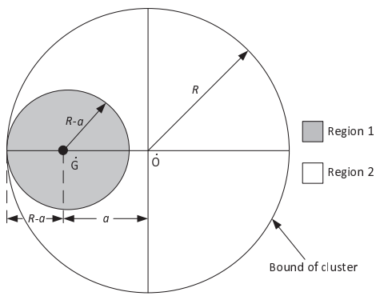
To solve the above problem we will take a step-by-step approach. Firstly, the desired signal and interference power will be derived considering the UE located at an arbitrary but fixed point in a cluster. Then, by treating the UE location as a random variable, the generic expressions will be derived. Note that all derivations will be for the more complex planar deployment in the first instance and then respective expressions for the linear case (e.g., for train line scenarios) will be provided.
A. UE at arbitrary fixed location
Without loss of generality, we assume that the UE is located at point G˙ with a distance of a ∈ [0, R] from the center of the cluster O˙ , as depicted in Fig. 3. Let’s first consider the desired signal power, which is contributed by two regions. P¯ x(a) = P¯ x1(a) + P¯ x2(a) . (13) The first part of equation (13), P¯ x1(a), is attributed to the RRHs in region 1, i.e. within circular area (G, R˙ − a), and it can be calculated straightforwardly by using equation (11) since this is a centrically symmetric region. Thus, replacing R with R − a in (11), we get: P¯ x1(a) = 2πM ρR Z R−a 0 g(r)rdr . (14) Depending on the values of R − a and R0 and considering (12), (14) could be expressed as: P¯ x1(a)=( 2πM ρR( R R0 0 R −η 0 rdr+ R R−a R0 r −η rdr) 2πM ρR R R−a 0 R −η 0 rdr = ( 2πM ρR( R 2−η 0 2 + (R−a) 2−η−R 2−η 0 2−η ) if R − a >R0 2πM ρR (R−a) 2 2 R −η 0 if R − a ≤R0 (15) The second part of equation (13), P¯ x,2(a), is attributed to the RRHs in region 2, i.e. within the subtraction area between circles (O, R˙ ) and (G, R˙ − a). The calculation of this part is not straightforward due to its asymmetric shape and an integral method has to be used, as shown in Fig. 10 in Appendix A; for a fixed a, region 2 is divided into slim arcs with a length of rθ and depth of dr, where θ is the intersection angle between the circle (O, R˙ ) and (G, r ˙ ) when r > R − a. By moving r from R − a to R + a and summing the power contribution from all slim arc areas, P¯ x2 can be given by: P¯ x2(a) = M ρR Z R+a R−a g(r)rθdr . (16) Finally, equation (16) can be written in terms of a as follows: P¯ x2(a) = 2M ρR Z R+a R−a g(r)rarccos r 2 + a 2 − R2 2ar dr . (17) Unfortunately, there is no close-form solution for (17) when η takes most of the possible values. For that reason numerical methods are adopted to verify the effectiveness of the derivation.
B. UE location as a random variable
So far, we have given the signal power of the UE with distance of a from the original point of the cluster circle (O, R˙ ). Next, we will treat a as a random variable which is evenly distributed in the cluster (O, R˙ ).
C. Interference power
Unlike the desired signal power, the expression of the interference power cannot be derived straightforwardly; as can be seen from Fig.2, the integral region is irregular and also depends on the location of the cluster within the network. However, it can be obtained indirectly by deriving the received power from the whole network and subtracting the desired signal power part. when the cluster is in the center of the network and the interfering area is much larger than the cluster size. In most cases, it is a practical assumption since the defined network with limited radius Rt will be surrounded by other networks and hence receive interference from them. We will see in the results section V that this approximation is quite accurate even for small number of clusters in the network.
D. Linear deployment
For the linear deployment, cluster size R refers to length from the center to the edge of the cluster. So far we have proposed a generic approach for evaluating the desired signal and interference power at UEs in randomly deployed small cell networks. In the next, we will focus on the optimization of cluster size in order to maximize system performance.
1.8 CLUSTER SIZE OPTIMIZATION
We first derive the expectation of the SINR in the presence of small-scale fast fading and the delay for two representative precoders: MRT and ZF, respectively. The CSI latency model in terms of cluster size and cloud/RRH.
A. Output SINR
This is due to the fact that ZF uses the spatial (i.e. antenna) degrees of freedom (DoF) to eliminate interference while MRT explores all DoF to maximize the desired signal power. Comparing the second part (after the multiplication sign) of (30) and (32), the only difference is that an extra term (1 − λ 2 i,i,1 ) is multiplied with ξ1 in the case of ZF precoding. This term is essentially the residual intra-cluster interference due to the delay caused mismatch; larger delay leads to smaller λ 2 i,i,1 and higher the residual intra-cluster interference. Note that in case of MRT precoding, this second part is not affected by the introduced delay.
B. Delay model
In general, the total delay of the precoding process is caused by several factors such as the pilot estimation and processing delay at the UE, propagation delay from UE to RRH and from RRH to cloud, CSI feedback (and scheduling) delay, RRH processing delay, cloud data center processing delay and backhaul latency.
1) Channel estimation delay: The first item in (35) ∆tchan−est, denotes the channel estimation delay at the UE and ̟1 stands for the number of channel coefficients to be estimated for one UE. Apparently, the more channels to be estimated, the larger the delay is likely to be.
2) CSI feedback and propagation delay: ∆tf b and ∆tprop−tot in (35) denote the average per channel coefficient feedback delay and total propagation delay, respectively. NUMNRNc stands for the total number of channel coefficients and qf b is a factor denoting how many channels can be fed back each time. ̟2 stands for the total number of times CSI is to be fed back for the whole network. Assuming that CSI feedback from UE to RRH has a capacity of Cf b and considering that each CSI is quantized to B1 bits, the feedback delay can be written as ∆tf b = B1/qf b. Moreover, the total propagation delay can be expressed as ∆tprop−tot = 2(su2r + sr2c)/cqf b, where c is the speed of light, and su2r and sr2c are the distances from UE to RRH and from RRH to cloud, respectively.
3) Cloud processing delay: ∆tprocess−cloud in (35) denotes the cloud processing delay, which is composed of two factors and can be written as ∆tprocess−cloud = ∆tT x1 + ∆tprecoder−cal. ∆tT x1 is attributed to the (part of) baseband processing (such as coding, modulation, precoding, IFFT, etc.) depending on the transmission chain functionality split between cloud and RRH. In general, the total delaycaused by baseband processing at the transmitter6 ∆tT x = ∆tT x1 + ∆tT x2 is assumed to be constant, where ∆tT x2 refers to the respective delay at RRH. ∆tprecoder−cal stands for the precoder calculation delay, which is a dominating factor when the cluster size is relatively large and the available computational resource is limited. Note also that different precoding algorithms lead to dramatically different computational complexity. For example, ZF has significant larger complexity than MRT precoding.
4) RRH processing delay: ∆tprocess−RRH in (35) denotes the RRH processing delay which also comprises of two parts, i.e. ∆tprocess−RRH = ∆tT x2 + ∆tCSI−fw. The first item, ∆tT x2, as already mentioned before is attributed to (part) of the baseband and RF implementation at the RRH. The second item, ∆tCSI−fw, stands for the delay due to CSI feedback from RRHs to the cloud in the uplink. Apparently, the total processing delay (both at the cloud and RRH) can be given by ∆tT x + ∆tprecoder−cal + ∆tCSI−fw.
5) Backhaul latency: The last item contains the backhaul latency given by the backhaul latency ∆tBH per hop multiplied with the number of backhaul hops ̟3 from the cloud data center to the small cells.
C. ERGODIC SUM-RATE AND OPTIMIZATION FORMULATION
The optimization problem for maximizing the ergodic sum-rate of the network in terms of cluster size The second equation of (41) is based on the assumption that the cellular network is surrounded by other non-overlapping and same configured networks. In that case, each cluster can be effectively considered at the center of a network, therefore, equally contributing to the sum-rate. The third equation in (41) holds when each UE is randomly and independently distributed within the network, where the total number of the UEs can be given in terms of the UE density and network volume as E{NcNU} = ρUV. Since it is very difficult to solve the ergodic sum-rate directly due to the expectation operation implemented outside of the logarithm, the well-known Jensen’s inequality is used in the fourth step of (41) to obtain an upper bound. Although the ergodic sum-rate upper bound can be a loose bound in some cases, in results we show that the optimal cluster size obtained from the proposed analytical framework match very well with the simulation results.
1.9 C-RAN TESTBED AND NETWORK
A C-RAN field testbed was set up in Beijing, which is used for proof of concept to new features and solutions with C-RAN architecture. Ericsson provided an end-to-end C-RAN solution for the field test, consisting of multi-standard base stations, EPC (Evolved Packet Core) network, OSS (Operation Support System) software. The tests are conducted using precommercial LTE terminals. The network is located around Ericsson office in Wangjing Science and Technology Park, which is a combination of urban and suburban radio environments. The network and base station configurations are shown in Figure 1 and Table 1 separately. There are four Macro cells, including one three-sector site (S1, 2, 3) and one one-sector site (S4). Distance between S4 and S1, 2, 3 is 460 meters. Each cell has two Tx/Rx antennas. This testbed can support TD-LTE, FDD LTE and GSM as well.
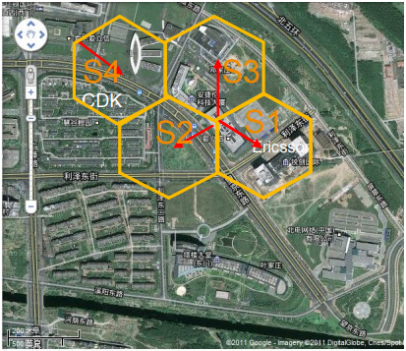
The uplink CoMP joint processing in this paper is tested under TD-LTE, 2.3GHz frequency band, 10MHz bandwidth system, using point to point (PtoP) fiber for CPRI (Common Public Radio Interface) transport. Despite we use TD-LTE in this test, the uplink CoMP joint processing can also work on FDD LTE systems. The C-RAN testbed hardware is shown in Figure 2. In order to emulate the baseband pool environment, one BBU (Base Band Unit) slice is used for one cell. For the CPRI transport between RRU (Remote Radio Unit) and BBU, we now have three alternative solutions: PtoP fiber, WDM-PON (Wavelength Division Multiplexing-PON) and E-band Microwave, which are shown in Figure 3. We also provide a SIU (Site Integration Unit) based LTE and GSM integrated backhaul solution from BBU to Core network in this testbed.
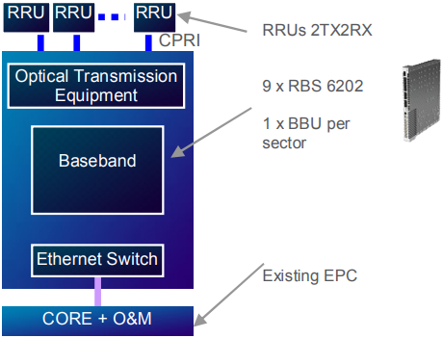
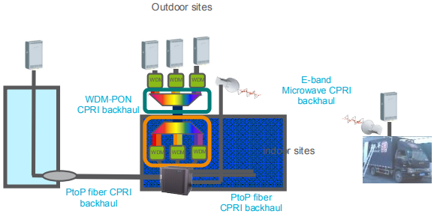
1.9.1 Uplink CoMP
A basic physical layer processing procedure for uplink CoMP joint processing. It consists of four parts:
- Channel estimation is performed individually per each receive antenna;
- Antenna selection is performed to potentially remove some unsuitable links;
- Covariance estimation is to capture interference estimation in a good way;
- Minimum Mean Square Error (MMSE) equalizer for IRC receiver is finally performed to gain a system by uplink joint processing with involved receive antennas.
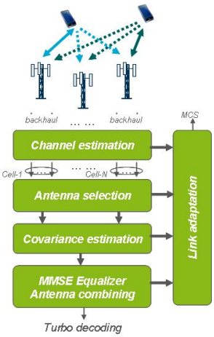
We have two test scenarios: intra-site CoMP and inter-site CoMP. We will introduce them in the following subsections.
a) Intra-site CoMP
For the intra-site CoMP test, sector S1 and S2 are selected to do uplink joint processing, shown in Figure 6. In the test, three test spots are tested to compare uplink throughput with MRC and full IRC CoMP to the uplink throughput when uplink CoMP. At all the test spots, the test user is attached to sector S1. The location of the test spots together with user RSRP and NRSRP (Neighbor cell RSRP or support link RSRP) are denoted. We test intra-site uplink CoMP both in non-interference scenario and in interfering scenario. During the interfering test, we add one interfering user. The interfering user is attached to the neighbor cell that is S2. The interfering user is located in the place where the RSRP to S1 and S2 are both -95dBm. The interfering user sends uplink traffic with full PUSCH power 23dBm. During the test, both the test user and the interfering user upload full buffer traffic. It should be noted that, there are high buildings along the street, some of the buildings are higher than the eNodeB antennas, therefore some of the test spots and interfering spots are in NLOS locations. Because of the uncertainty of radio link quality there are some fluctuations in RSRP during the test. We try to note a long time average on RSRP in Figure 6. Intra-site test results without interference. In, baseline throughput decreases with RSRP decreases. At the test spot with -90dBm RSRP and -90dBm NRSRP, the baseline throughput is good enough and almost reaches to peak throughput, and there is very little CoMP gain due to there is very small margin to increase the user data rate. In Figure 8, the CoMP gain increases when the radio condition becomes worse. The throughput gain reaches to 50% when the RSRP and NRSRP are around -101dBm.
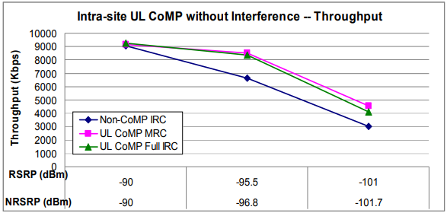
In, the baseline throughput decreases with radio conditions getting worse. Compare to the baseline throughput in, the throughput is lower because of interference. Because of interference and relatively worse supporting link compared the serving link, MRC CoMP almost shows no gain for the first two test spots. Full IRC CoMP, however, shows expected capability in interference mitigation. The CoMP gain is significant when RSRP and NRSRP are around -100dBm and reaches to 150%. This can be due to that with 4 receiver antennas, the IRC receiver can efficiently suppress one dominant interference.
b) Inter-site CoMP
For the Inter-site CoMP test, sector S2 and S4 are selected to do uplink joint processing. In this test, three test spots are selected to compare uplink throughput with MRC and full IRC CoMP respectively to the uplink throughput when without CoMP. At all the test spots, the test user is attached to sector S2. The location of the test spots together with their RSRP and NRSRP (The cell RSRP of the support link RSRP) are denoted. The inter-site uplink CoMP is tested both in non interference scenario and in interfering scenario. During the interfering test, we add one interfering user. The interfering user is attached to the neighbor cell that is S4, as shown in Figure 11 with the purple dot. The interfering user is located where the RSRP from S1 and S2 are the same: -95dBm. The interfering user sends uplink full buffer traffic with full PUSCH power 23dBm. The test user also send full buffer traffic in the uplink.
Again, it should be noted that, there are high buildings along the street and some of the buildings are higher than the eNodeB antennas, therefore some of the test spot and interfering spots are in NLOS locations. Because of the uncertainty of radio link quality there are some RSRP fluctuations during the tests.
We can see similar trends for baseline throughput as intra-site scenario and CoMP throughput gain increases as the RSRPs decreases. At the second test spot there is little CoMP gain especially for full IRC is because the supporting link is 9dB worse than the serving link, hence unbalanced receive signals contribute minor combination gain, which is fit for the theory expectations. In, CoMP throughput gain reaches to 70% when the RSRP and NRSRP are around -103dBm.
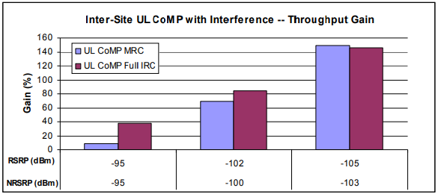
In this paper, C-RAN field testbed, uplink CoMP joint processing principle and field test results are introduced. From both the simulation and the field test results, it can be concluded that there is significant gain with uplink CoMP at cell edge both for intra-site CoMP and inter-site CoMP. CoMP gain increase at the poor radio conditions. When there is no interference the CoMP throughput gain is 30~50%. When there is one strong interference the gain can be even higher, and sometimes can reach 150%. Full IRC CoMP shows clear advantages when there is interference. With heterogeneous network deployment in the future, uplink CoMP can be further promising for interference suppression between Macro cell and Pico or Micro cells and eliminating uplink/downlink imbalance.

CHAPTER 2

`LITERATURE SURVEY

1. “QUANTITATIVE ANALYSIS OF SPLIT BASE STATION PROCESSING AND DETERMINATION OF ADVANTAGEOUS ARCHITECTURES FOR LTE” U.DOTSCH, M.DOLL, H.-P.MAYER, F.SCHAICH, J.SEGEL, AND P.SEHIER,
Centralization of the baseband processing in radio access networks may reduce radio site operations costs, reduce capital costs, and ease implementation of multi-site coordination mechanisms such as coordinated multipoint transmission and reception (CoMP). However, the initial architecture proposals for a centralized Long Term Evolution (LTE) deployment using transport of radio samples require a high-bandwidth, lowlatency interconnection network.
The concept has subsequently been generalized to span larger areas involving many radio sites—still using transport of radio samples between RRHs and centrally located BBUs.
The paper is structured as follows: We begin with a discussion of the centralized radio access network (CRAN) as initially proposed in terms of economy and expected benefits.
Some operators have reported operational expense reductions greater than 50 percent from field trials of centralized baseband. This is corroborated by our analysis, which found that operational expenses were reduced by 45 percent. To put these savings in perspective, this is roughly equivalent to eliminating all capital costs, getting site establishment civil works, radio and baseband equipment, and fi ber transport for free. Smaller reductions in capital expenses may also occur due to the elimination of civil works, air conditioners, and reduced batterybackup requirements.

DRAWBACKS
- To mitigate the impact on UL power-limited UEs, forced ACK may be combined with subframe bundling.
- The impact of delayed channel state information on system throughput has been studied in several theoretical papers.
2.“CLOUD TECHNOLOGIES FOR FLEXIBLE 5G RADIO ACCESS NETWORKS” P.ROST ET AL.,
The evolution toward 5G mobile networks will be characterized by an increasing number of wireless devices, increasing device and service complexity, and the requirement to access mobile services ubiquitously. Two key enablers will allow the realization of the vision of 5G: very dense deployments and centralized processing. This article discusses the challenges and requirements in the design of 5G mobile networks based on these two key enablers.
This enables the introduction of new mobile broadband services requiring high data rates and provides high connectivity to more devices.
These communication devices will be integrated in any imaginable way into daily use objects such as cars, household appliances, textiles, and health-critical appliances. The increasingly complex scenarios make it more challenging for mobile network operators to manage and operate networks efficiently while providing the demanded quality of experience.
Cloud technology has already received increasing attention for the deployment of mobile core network functionalities. Operators investigate the possibility of commodity hardware implementations in order to exploit the benefits of cloud technology (e.g., by means of network function virtualization (NFV) and software defined networking (SDN).
DRAWBACKS
- The flexible centralization of RAN functionality will impact the operation of the 3GPP LTE RAN protocol stack and may be limited by dependencies within the protocol stack.
3.“FIELD TEST OF UPLINK COMP JOINT PROCESSING WITH C-RAN TEST BED” L.LI, J.LIU, K. XIONG, AND P.BUTOVITSCH,
Inter-cell interference severely damages cell-edge user throughput. In the future heterogeneous network deployment, by introducing Micro or Pico cells into LTE Macro cell grid, interference problem between Macro and Micro or Pico becomes critical. Uplink Coordinated Multi-Point (CoMP) joint processing has the potential to improve the interference situation both in the macro grid cell edge and in the heterogeneous network scenarios.
A C-RAN field testbed was set up in Beijing, which is used for proof of concept to new features and solutions with C-RAN architecture. Ericsson provided an end-to-end C-RAN solution for the field test, consisting of multi-standard base stations, EPC (Evolved Packet Core) network, OSS (Operation Support System) software. The tests are conducted using precommercial LTE terminals. The network is located around Ericsson office in Wangjing Science and Technology Park, which is a combination of urban and suburban radio environments.
In this paper, C-RAN field testbed, uplink CoMP joint processing principle and field test results are introduced. With heterogeneous network deployment in the future, uplink CoMP can be further promising for interference suppression between Macro cell and Pico or Micro cells and eliminating uplink/downlink imbalance.

DRAWBACKS
- In the future heterogeneous network deployment, by introducing Micro or Pico cells into LTE Macro cell grid, interference problem between Macro and Micro or Pico becomes critical.

4.“A STUDY OF CHANNEL ESTIMATION IN OFDM SYSTEMS” S.COLIERI, M.ERGEN, A.PURI, AND A.BAHAI
The channel estimation based on comb type pilot arrangement is studied through different algorithms for both estimating channel at pilot frequencies and interpolating the channel. The estimation of channel at pilot frequencies is based on LS and LMS while the channel interpolation is done using linear interpolation, second order interpolation, low-pass interpolation, spline cubic interpolation, and time domain interpolation.
Orthogonal Frequency Division Multiplexing (OFDM) has recently been applied widely in wireless communication systems due to its high data rate transmission capability with high bandwidth efficiency and its robustness to multi-path delay.
A dynamic estimation of channel is necessary before the demodulation of OFDM signals since the radio channel is frequency selective and time-varying for wideband mobile communication systems.
The channel estimation can be performed by either inserting pilot tones into all of the subcarriers of OFDM symbols with a specific period or inserting pilot tones into each OFDM symbol. The first one, block type pilot channel estimation, has been developed under the assumption of slow fading channel. Even with decision feedback equalizer, this assumes that the channel transfer function is not changing very rapidly.
DRAWBACKS
- In, a lowrank approximation is applied to linear MMSE by using the frequency correlation of the channel to eliminate the major drawback of MMSE, which is complexity.
.5.“LINEAR TRANSMIT PROCESSING IN MIMO COMMUNICATIONS SYSTEM” M.JOHAM, W.UTSCHICK, AND J.A.NOSSEK,
The task of receive equalization filters is to remove the distortion due to the channel and to minimize the effect of the received noise. This lack of knowledge can be overcome by exploiting the slowly changing properties of the channel which are independent from frequency.
In this article, we assume that the fast changing properties of the multiple input, multiple output (MIMO) channel are known at the BS. However, besides the advantage of simplifying one side of the link, that is, the receiver for transmit processing and the transmitter for receive processing, the two approaches are of high practical importance in systems with noncooperative transmitters (e.g., uplink of a cellular system), where the transmit signals of the transmitters cannot be cooperatively pretransformed or noncooperative receivers (e.g., downlink of a cellular system or broadcast channel), where the received signals of the receivers cannot be cooperatively post-transformed.
The BER simulations revealed that the receive filters outperform the transmit filters for low SNR especially for colored noise, but the transmit filters show better results for high SNR.
DRAWBACKS
- The major drawback of receive filters is the increased complexity of the receiver, because channel estimation and adaptation of the receive filter is necessary.

CHAPTER 3

METHODOLOGY

EXISTING SYSTEM

These challenges, new and existing technologies need to coexist and cooperate in order for the emerging networks to fulfill the users’ needs for high Quality of Experience (QoE). Moreover, another factor that contributed to this throughput reduction is the intrabeam interference which increases for the previously existing UEs in the NOMA clusters when new edge users are added to them. The existence of singleton coalitions in the game JT-CoMP case, when the conditions of the proposed coalition formation algorithm are not satisfied, resulted in a small percentage of users having the same average throughput as in the case of no JT-CoMP.

3.1.1 EXISTING SYSTEM FLOW
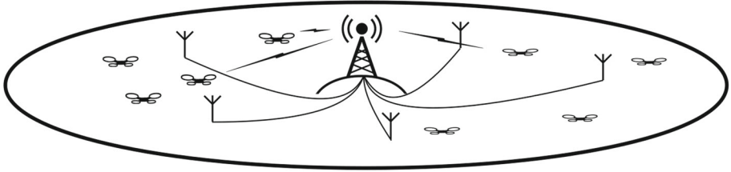
FIGURE3.1 SYSTEM FLOW
3.2 PROPOSED SYSTEM
One of the relatively recently proposed concepts, aiming to fulfill the needs of mobile users in 5G networks, is the Non Orthogonal Multiple Access (NOMA) technique. In, base station coordination with dirty paper coding was initially proposed with single-antenna transmitters and receivers in each cell. The schemes proposed therein include a dirty paper coding approach with perfect data and power cooperation among base stations with a pooled power constraint and several sub-optimal joint transmission schemes with per-base power constraints.

3.3 BLOCK DIAGRAM

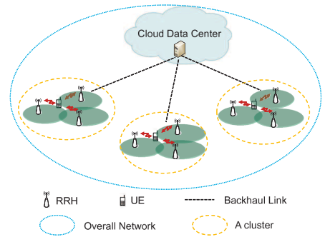
FIGURE3.2 BLOCK DIAGRAM

System model
Therefore each RRH in a cooperative cluster can only acquire a local CSI and global CSI is accumulated at the cloud by RRH feedback via the backhaul links. The precoding matrix calculations will be done in the cloud. However, there are two main options for the precoding implementation: a) the implementing at the cloud and then forwarding the precoded I/Q signals to individual RRH for transmission; b) cloud-assisted implementation at each individual RRH, i.e. the modulated I/Q signal (before precoding) and relevant precoding coefficients will be sent from the cloud to the each RRHs and the rest of physical layer processing will take place in RRH. There are pros and cons for each architecture. In this paper, we focus our investigation on case a) only, which is a more popular cloud architecture. To mitigate the expected delay under joint transmission operation (mainly due to CSI feedback and precoding matrix calculation), we need to divide the network into a set of clusters with each one consisting of reasonable number of cooperative RRHs. In this case, each cluster only requires CSI between the RRHs and the UEs within the cluster and the amount of feedback will drop since low dimension precoding requires less CSI. Meanwhile, precoding can be performed in the cloud separately for each cluster, therefore, the computational complexity will be reduced. Consequently, the introduced delays could be mitigated and performance loss due to the channel mismatch will be reduced. On the other hand, extra inter-cluster interference due to small cluster size may diminish throughput in each cluster. Therefore, there must be an optimal cluster size to trade off delay and interference for maximizing system performance.
A. Clustering Model
Consider a network served by a cloud in a d-dimensional space with a volume of V , where d could take the value of 1 or 2, corresponding to the linear or planar deployments, respectively. Here we assume the space is centrally symmetric and therefore the volume of the space could be generally expressed by cdRd t , where cd is the volume of the d-dimensional unit ball and Rt is the distance from the center to an arbitrary point on the bound of the d-dimensional space. Obviously, for linear and planar deployments, c1 = 2 and c2 = π, respectively. Focusing on the planar deployment for demonstration purposes, we consider the network is divided into Nc same area and same shape clusters, i.e. each cluster has an area of v = V /Nc. One practical cluster shape in order to avoid adjacent cluster overlap and to maximize the density of packing in this 2D space is the hexagonal shape. However, since hexagonal boundary is relatively difficult to analyze, the hexagonal cluster can be replaced by an equivalent circular cluster having the same central point and the same area as the hexagon. The approximation is practical and accurate since the sum-rate contribution from the edge of a cluster is marginal2. In addition, we consider a network comprising of b tiers clusters, i.e. the number of clusters in a network can only be 1 + 3b(b + 1), where b denotes the number of tiers.
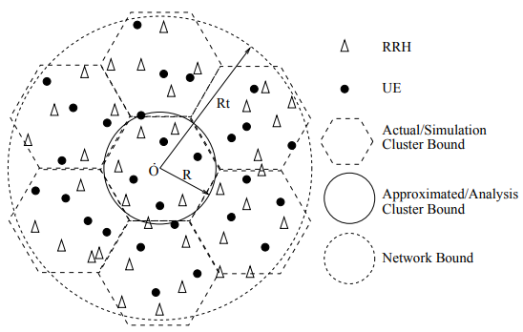
The assumption of network bounding with a circular one, the network is not completely overlapped by the clusters at the edge of the network. However, larger number of tiers (i.e. more clusters) leads to a negligible model error. In addition, the approximation is made at cluster edges, which contributes marginal sum-rate to the network3 . Note that the above approximation for the planar deployment is not required for the linear case, where each cluster evenly occupies the same portion (length) of the network. Next, we consider the active RRHs and UEs randomly scattered into the d-dimensional space with density ρU and ρR, respectively (see Fig. 2). We assume that each RRH is equipped with M antenna and each UE is equipped with single antenna. Thus, the number of UEs nU,i, RRHs nR,i and transmission antennas nA,i = MnR,i in each cluster (for i = 1, 2, · · · , Nc) are variables. Since the UEs and RRHs are dropped based on the homogeneous PPP model, we can express the expected number of RRHs NR, UEs NU, and total transmission antennas NA in any cluster i with volume v as [18]: NU = E(nU,i) = vρU , NR = E(nR,i) = vρR , NA = E(nA,i) = E(MnR,i) = MvρR , (1) Apparently, the expected number of UEs and RRHs in the region outside of the considered cluster i is (V − v)ρU and (V − v)ρR, respectively.

B. Channel Model
By considering both path-loss and small scale fast fading effects of the wireless access channel between RRH and UE, the baseband channel at time index t can be expressed as h¯ i,j,k[t] = hi,j,k[t]Gi,j,k , (2) where h¯ i,j,k[t] ∈ C 1×nA,j is the compound channel between the j-th RRH and k-th UE in the i-th cluster. Gi,j,k = diag[gi,j,k,1, gi,j,k,2, · · · , gi,j,k,nA,j ] ∈ R nA,j×nA,j is a diagonal matrix with g 2 i,j,k,l corresponding to the channel path-loss. hi,j,k[t] ∈ C 1×nA,j is the corresponding fast fading factor of the channel with complex Gaussian distribution CN (0, 1). The precoding matrix calculation is based on a delayed (outdated) version of the channel, at time t − △t, which can be written as: h¯ i,j,k[t − △t] = hi,j,k[t − △t]Gi,j,k , (3) where we have assumed that RRHs and UEs are essentially static and the path-loss Gi,j,k is kept as a constant during the △t period. Here we suppose that the channel is spatially uncorrelated but time correlated as follows [25]: hi,j,k[t] = hi,j,k[t − △t]Λi,j,k + ei,j,k[t] , (4) where Λi,j,k is a diagonal matrix defined as Λi,j,k = diag[λi,j,k,1, λi,j,k,2, · · · , λi,j,k,nA,j ] ∈ R nA,j×nA,j with λi,j,k,l = J0(2πfD,i,j,k,l△t) ≤ 1 being the temporal correlation factor. J0 is the zero-order Bessel function of first kind, fD,i,j,k,l is the Doppler spread from the l-th antenna that belongs to the j-th cluster to k-th UE of the i-th cluster. Since the cooperative RRHs in one cluster are assumed static, we will assume that λi,j,k,1 = λi,j,k,2 = · · · = λi,j,k,nA,j = λi,j,k in the rest of the paper for brevity. Finally, ei,j,k ∈ C 1×nA,j denotes the channel mismatch vector with each element being modeled as complex Gaussian distribution as CN (0, 1−λ 2 i,j,k) [25]. Substituting (4) into (2) and considering (3), we obtain following relationship between the current and outdated channels as follows: h¯ i,j,k[t] = λi,j,khi,j,k[t − △t]Gi,j,k+ei,jGi,j,k = λi,j,kh¯ i,j,k[t − △t]+ei,jGi,j,k . (5) It is apparent that since the calculation of the precoding matrix is based on the outdated channel h¯ i,j,k[t − △t] instead of the actual channel h¯ i,j,k[t], the performance of the joint transmission process will be affected. Note that in the following, for simplification we define: hˆ i,j,k[t] = h¯ i,j,k[t − △t] , (6) and we omit the time index. Thus, the received signal of the k-th UE in the i-th cluster can be written as: yi,k = √ γi h¯ i,i,kwi,kxi,k | {z } Desired signal + √ γi nXUE,i l=1,l6=k h¯ i,i,kwi,lxi,l | {z } Intra-cluster interference + X Nc j=1,j6=i √ γj nXUE,i l=1 h¯ i,j,kwj,lxj,l | {z } Inter-cluster interference + ni,k |{z} Noise , (7) where ni,k is the Gaussian noise with distribution CN (0, σ2 i,k), and wi,k ∈ C nA,i×1 and xi,k stand for the precoding vector and transmit signal for the k-th UE in the i-th cluster, respectively. xi,k and xj,l are assumed uncorrelated for (i, j) 6= (k, l) (for i, j = 1, · · · , Nc and k, l = 1, · · · , nU,i) and being zero mean and unit power variables, i.e. E{kxi,jk 2} = 1. Finally, γi denotes the transmitting power of the signal xi,k. Note that here we have supposed power is evenly allocated to each UE in a cooperative cluster. By substituting (5) into (7), the desired signal power, Px, and the interference power, PI , for the k-th UE in the i-th cluster can be expressed as: Px=γikλi,i,jhi,i,kGi,i,kwi,kxi,kk 2+γikei,i,kGi,i,kwi,kxi,kk 2 PI=k √ γi nXUE,i l=1,i6=k (λi,i,jhi,i,kGi,i,k + ei,i,kGi,i,k)wi,lxi,lk 2 +k √ γj X Nc j=1,j6=i nXUE,i l=1 h¯ i,j,kwj,lxj,lk 2 , (8) where we have used the fact that ei,i,k is independent of the channel vector hi,i,k and hi,i,k is independent of hi,j,k when i 6= j. Thus, the expectation of the output SINR in the presence of delay impact can be written as: SINRi,k = E{ Px PI + σ 2 i,k } .

CHAPTER 4

PROJECT IMPLEMENTATION

4.1 HARDWARE FEATURES
- Keyboard
- Mouse
- Hard disk 500GB
- Ram 4 Gb

4.2 SOFTWARE FEATURES
- Operating System : Windows 10
- Platform : DOT NET TECHNOLOGY
- Front End : ASP.Net 4.0
- Back End : SQL SERVER 2014

To implement MU-MIMO and NOMA, beamforming, user pairing and power allocation need to be determined. The selection of the appropriate techniques is crucial, as the intrabeam and interbeam interference that the users receive can be significantly reduced by exploiting the CSI reported by them to the BBU pool. This can increase the users’ persubcarrier and per-OFDM symbol SINR and, ultimately, their throughput. In this section, we define how beam forming is done to mitigate interbeam interference, how the per-user power coefficients al,n,k are assigned and the method for the NOMA user pairing to minimize the intrabeam interference. Also, the selected multi-user scheduling method is presented.
A. BEAMFORMING
To cancel the interbeam interference for users served by different beams of the same RRH, Zero-Forcing (ZF) beamforming can be deployed. ZF beamforming aims to minimize the interbeam interference inside a cell by generating beamforming vectors orthogonal to all the users’ channel vectors except the corresponding cell’s users. Assuming perfect CSI, the number of transmit antennas should be larger than or equal to the number of total receive antennas in a cell, in order to have enough degrees of freedom on the transmitter side to generate a beamforming matrix that eliminates the interbeam interference. In this paper, each RRH is equipped with N antennas, meaning that it can generate N beams. Each beam can serve at least two paired NOMA users scheduled in the same RB, which, in turn, means that this condition cannot be satisfied.
To implement ZF beamforming in NOMA, for each RB we select N scheduled users (one from each beam) with the higher channel gain. This selection is justified by the fact that their decoding order in their serving NOMA cluster is last and if they would receive interbeam inteference, the process for correctly decoding their received signal via SIC would be seriously affected. Then we calculate the beamforming vectors at each RB such as: hl,n,Kwl,n0 = 0, n 6= n 0 . To satisfy, first, we define the matrix Hl = [h T l,1,K, . . . h T l,n,K, . . . , h T l,N,K] T and then calculate the Moore-Penrose pseudo-inverse matrix of Hl , i.e.: (Hl) † = Wl = (Hl) H (Hl)(Hl) H −1 . Then, the beamforming vector wl,n for UEl,n,K can be obtained by normalizing the n-th column of Wl. Based on this choice of forming the beamforming vectors, only the user with the highest channel gain in each beam will avoid the interbeam interference.
B. POWER COEFFICIENTS ALLOCATION
Power domain NOMA multiplexes users in the power domain. This means that the distribution of a beam’s transmit power impacts significantly the performance of all the beam’s users. In our paper, for the non JT-CoMP case, each beam serves two NOMA users. When JT-CoMP is activated the number of users may vary. This means that a power allocation scheme which allows a fair extraction of the power coefficients is needed. However, the application of an optimal power allocation algorithm can increase the computational complexity so, a sub-optimal solution to this problem needs to be adapted. A suitable technique is the Fractional Transmit Power Control (FTPC) method. Based on this technique, the power coefficient of a user k, who is served by RRH l, inside beam n for the subcarriers of an RB is allocated according to the following equation: al,n,k = 1 PK j=1 Gl,n,j−pF T P C Gl,n,k−pF T P C , (19) where pF T P C (0 ≤ pF T P C ≤ 1) is the decay factor. When pF T P C =0, the power distribution for a beam’s UEs is equal. The more the decay factor increases, the more power is allocated to the user with the lowest channel gain. This parameter can also be subject of optimization. Also, Gl,n,k for user k, served by the l-th RRH in its n-th beam is defined as: Gl,n,k = khl,n,kk 2 .
C. NOMA USER PAIRING
Initially, before JT-CoMP is applied, we assume that each beam will serve exactly two users that are scheduled in the same RB, where one is considered the strong and one the weak user. This distinction is made based on the channel gains of the users, where the strong user’s channel gain is greater than the weak user’s. For a strong user, SIC and ZF beamforming will eliminate its received intrabeam and interbeam interferences respectively. Therefore, it is particularly important to define an efficient user pairing strategy in order to mitigate the intrabeam and interbeam interference for the weak UEs as well.
Based on equations (6), (10), (12) and (19), we can easily see that the greater the difference between the channel gains of the strong and the weak user, the more the performance improvement for a weak user. This is a consequence of the decreased power coefficients for the strong user, resulting in reduced intrabeam interference for the weak one. Also, based on, when ZF beamforming is applied and the channel hl,n,ks of the strong user is highly correlated with the channel hl,n,kw of the weak user, i.e. hl,n,ks ≈ c · hl,n,kw , where c is a constant, then hl,n,kw wl,n0 ≈ 0 for n 6= n 0 , which means that the interbeam interference for the weak user can be significantly mitigated when this NOMA pair is formed. Thus, the NOMA user pairing for the subcarriers and OFDM symbols of each RB is done in two stages. At the first stage the scheduled users in the RB are divided into strong users and weak users based on their channel gain. Then, in the second stage, each strong user forms a NOMA pair with the weak user that maximizes its correlation metric. The correlation metric is given via the following equation: Cks,kw = khl,n,ks h H l,n,kw k khl,n,ks kkhl,n,kw k . (21) When JT-CoMP is activated, depending on the beam assignment, each beam can serve more than two users, as edge UEs will be served by all the RRHs in a coalition for their scheduled RBs. Again, for JT-CoMP, the edge UEs are assigned to the NOMA clusters of the cooperating RRHs that maximize the correlation metric given by (21) in order to mitigate the interference from other beams of the cooperating RRHs, except the serving ones. It is important to note that the distinctions between an edge and non-edge user and strong and weak user are entirely different, e.g. based on its effective SINR value, a strong user may be an edge user and a weak user may be a non-edge user.
D. MULTI-USER SCHEDULING
In NOMA, the scheduler pairs multiple users for simultaneous transmission at each RB. To determine the set of users that are going to be served in the same RB, a Round Robin scheduler was implemented. At each TTI, the BBU pool creates a random sequence of unique UE IDs for each RRH which includes all the UEs connected to it. Then, according to the number of users per NOMA cluster and transmit antennas, a group of K · N UEs is selected to be served per RB in each cell. After that, the scheduled users in each cell are organized in N NOMA clusters according to the selected user-pairing method. For the following RB, the next K · N users are selected and the same procedure repeats by scheduling groups of UEs in a cyclic manner until the scheduler allocates all the available RBs at each cell.

CHAPTER 5

RESULT
We use Monte-Carlo simulations to investigate the proposed clustering optimization problem with ZF and MRT precoding algorithms for linear and planar dense small cell deployments. 1000 small cells and 1000 active UEs are uniformly distributed in a) a circular network area (planar deployment) with radius Rt = 500 meters and b) a linear network segment (linear deployment) of length Rt = 1000 meters. We assume the number of antennas at each RRH M = 2. For planar deployment, in order to approximate a circle bounded network we consider clusters formed by 1 to 7 tiers of cells, i.e. by considering that tier-1 consist of 7 cell, tier-2 of 19 cells and so on, cluster size will take values from the range set. The input signal to-noise (SNR) power is set to 30dB. The path-loss exponent is kept η = 2.2 and Rayleigh fast fading is considered to model channels between RRHs and UEs, as given by equation (3). The temporal correlation of the channel is modeled by equation (4) with Doppler spread fD = 10 Hz for all links. In either linear and planar deployment, R0 = 5 meters. Without loss of generality, we only consider the performance of the UEs in the central cluster and assume interference from outside of the network to these UEs is negligible.
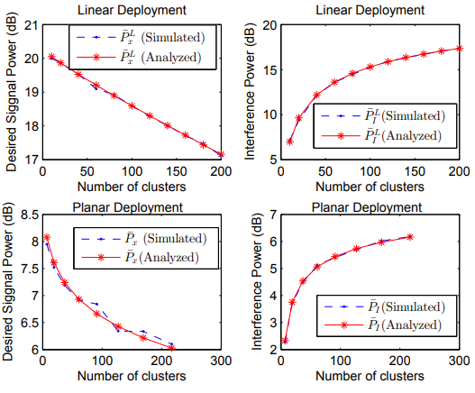
1) P¯ x, P¯ I and output SINR in the absence of latency: To investigate the effectiveness of our theoretical analysis (i.e. proposed system, channel and clustering model in Sections III and IV), we first evaluate P¯ x, P¯ I and output SINR in the absence of latency, i.e., ∆t = 0 and λ 2 = 1. P¯ x and P¯ I are evaluated using equation (19) and (23) for planar deployment (equations (27) and (28) for linear deployment) and compared with simulation results in Fig. 4, for different number of clusters within the network. It can be seen that the analytical results for both the desired signal and interference power match the simulation results perfectly for both planar and linear deployments. As expected, the desired signal power reduces with cluster size (i.e. larger number of clusters in the network) since less number of cooperating small cells contribute to the desired power. On the other hand, the interference power becomes larger as the number of clusters increases since the total number of interfering RRH outside the cluster is increased. Furthermore, the output SINR is evaluated using equation (30) and (32) for MRT and ZF precoding respectively and compared with simulation results in Fig. 5. We observe that all four graphs (Linear-MRT, Linear-ZF, Planar-MRT and Planar-ZF) show good consistency between analytical and simulation results. For all cases, the output SINR decreases with increasing number of clusters due to the fact that a smaller cluster tends to obtain less desired signal power while more interference is caused from outside the cluster. Note that small gaps can be observed between theoretical and simulated results due to the assumptions used in clustering model.
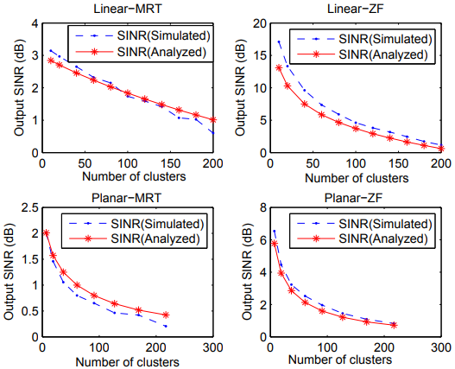
In the following we only focus on the more complex planar deployment due to similar observed behavior of planar and linear case in terms of output SINR. Nevertheless, analogous results can be provided for the linear case as well, following the respective analytical expressions and simulation model.
2) Performance optimization in the presence of latency: To evaluate performance in the presence of latency, we first set some practical values for the parameters in the delay model. To this end, we consider the worst-case of Tx processing time defined in 3GPP, i.e. ∆tT x = 2.3 ms ; the channel estimation and RRH processing delay are set to zero since they are not as sizeable factors as the processing or feedback delay. The factors for multiplication and division over addition are set to the typical values of ζ1 = 1 and ζ2 = 10, respectively. The average distance between UE and RRH plus the distance between RRH and cloud data center is considered to be su2r + sr2c = 1000 meters. The cloud is assumed to contain an Intel Xeon Processor E5- 2680 with processing capacity of 1.73×1011 double-precision floating-point operations per second (DP-FLOPS)8 . Assuming the addition operation is double-precision floating (64-bit), the available processing capacity for precoding calculation becomes Ccom = 1.73×1011/qc addition operations per second. Furthermore, the computational resource division factor qc is set to be 10, unless specified otherwise. The feedback capacity of the backhaul link from RRHs to cloud is set to Cf b = 107 bits per second and, unless specified otherwise, we set qf b = 1, i.e. feedback of one channel coefficient each time. We assume that each small cell is connected to the cloud data center by one hop Dark fibre with latency ∆tF B = 10 micro second per kilometer per hop as defined by.
Various cases of cloud processing capability are considered with the computational load changing from 2, 1/10, 1/40 to 1/80 (i.e. qc changing from 1/2, 10, 40, to 80). We observe that the analytical results (i.e. using equations (30) and (32)) roughly match the corresponding simulation results, especially for output SINR. More importantly, the peak points denoting the optimal cluster size are strictly overlapping with each other, for any specific configuration; thus, the optimal cluster size evaluation is not affected by the approximation in equation (41) where Jensen’s inequality and the upper bound of the sum-rate have been considered (obviously, the theoretic sum-rate for each qc is generally higher than the simulated results). We also note that the optimal cluster size decreases (i.e. optimal number of clusters increases) as the computational capability factor becomes larger. This is due to the fact that when qc increases, less computational resources become available, therefore, smaller cluster size is needed to keep the delay-caused channel mismatch at low levels.
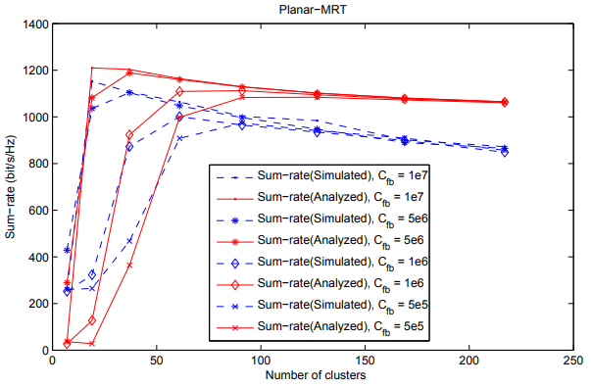
MRT-based precoding, where the precoding matrix calculation delay is negligible. Regarding the processing delay, the curve slopes are more flat for increasing number of clusters. This is due to the fact that the feedback-caused latency is only in the second order of the number of cooperative antennas; on the other hand, latency caused by the processing capability is in the cubic order of the number of cooperative antennas, thus, decreasing cluster size will lead to faster reduction of latency.

CHAPTER 5

CONCLUSION
Based on commonly used linear precoding algorithms (ZF and MRT) and linear and planar small cell deployment configurations, the paper proposed an approach for cluster size optimization in cloud-based distributed cooperative small cell networks in the presence of CSI latency, which is mainly caused by cloud processing delay and CSI feedback delay. An optimization problem is formulated in the aforementioned framework and desired signal and interference signal are calculated, which is followed by derivation of the output SINR by taking into consideration the channel mismatch caused by latency due to small cells cooperation. Both delay and output SINR have been derived as a function of cooperation cluster size and an optimization problem to trade off the interference and channel mismatch has been formulated for maximizing network sum-rate. Simulations reveal a small gap with the analytical results in terms of SINR and sum-rate evaluations, and the proposed concise analytical framework can be safely used in order identify the optimal cluster size for any specific deployment.

REFERENCES

[1] U. Doetsch, M. Doll, H.-P.Mayer, F. Schaich, J. Segel, and P. Sehier, “Quantitative analysis of split base station processing and determination of advantageous architectures for LTE,” Bell Labs Technical Journal, vol. 18, pp. 105–128, May 2013.
[2] D. Wubben, P. Rost, J. Bartelt, M. Lalam, V. Savin, M. Gorgoglione, A. Dekorsy, and G. Fettweis, “Benefits and impact of cloud computing on 5G signal processing,” IEEE Signal Processing Magazine, Special Issue on 5G Signal Processing, vol. 31, pp. 35–44, Nov. 2014.
[3] P. Rost, C. Bernardos, A. Domenico, M. Girolamo, M. Lalam, A. Maeder, D. Sabella, and D. Wubben, “Cloud technologies for flexible 5G radio access networks,” IEEE Communications Magazine, vol. 52, no. 5, pp. 68–76, May 2014.
[4] R. Irmer, H. Droste, P. Marsch, M. Grieger, G. Fettweis, S. Brueck, H.-P. Mayer, L. Thiele, V. Jungnickel, “Coordinated multipoint: Concepts, performance, and field trial results,” IEEE Communications Magazine, vol. 49, no. 2, pp.102–111, February 2011
[5] L. Li, J. Liu, K. Xiong, P. Butovitsch, “Field test of uplink CoMP joint processing with C-RAN testbed,” in IEEE Communications and Networking in China (CHINACOM), pp.753-757, 8–10 Aug. 2012
[6] J. Li, D. Chen, Y. Wang, J. Wu, “Performance evaluation of cloud-ran system with carrier frequency offset,” in IEEE Globecom Workshops (GC Wkshps), pp.222–226, 3-7 Dec. 2012
[7] 3GPP TR 36.872, “Small cell enhancements for E-UTRA and EUTRAN - physical layer aspects,” 3GPP, Tech. Rep., Sep. 2013.
[8] 3GPP TR 36.842, “Small cell enhancements for E-UTRA and EUTRAN - higher layer aspects,” 3GPP, Tech. Rep., May 2013.
[9] J.-J. van de Beek, O. Edfors, M. Sandell, S. Wilson, and P. Ola Borjesson, “On channel estimation in OFDM systems,” in IEEE Vehicular Technology Conference, vol. 2, pp. 815–819, Jul 1995.
[10] S. Colieri, M. Ergen, A. Puri, and A. Bahai, “A study of channel estimation in ofdm systems,” in IEEE Vehicular Technology Conference Fall, pp. 894–898, 2002.
[11] M. Joham, W. Utschick, and J. Nossek, “Linear transmit processing in MIMO communications systems,” IEEE Transactions on Signal Processing, vol. 53, no. 8, pp. 2700–2712, Aug 2005.
[12] M. Matthaiou, C. Zhong, M. McKay, and T. Ratnarajah, “Sum rate analysis of ZF receivers in distributed MIMO systems,” IEEE Journal on Selected Areas in Communications, vol. 31, no. 2, pp. 180–191, February 2013.
[13] D. Kaltakis, M. Imran, and C. Tzaras, “Information theoretic capacity of cellular multiple access channel with shadow fading,” IEEE Transactions on Communications, vol. 58, no. 5, pp. 1468–1476, May 2010.
[14] S.-R. Lee, S.-H. Moon, J.-S. Kim, and I. Lee, “Capacity analysis of distributed antenna systems in a composite fading channel,” IEEE Transactions on Wireless Communications, vol. 11, no. 3, pp. 1076– 1086, March 2012.
[15] W. Feng, X. Zhang, S. Zhou, J. Wang, and M. Xia, “Downlink power allocation for distributed antenna systems with random antenna layout,” in IEEE Vehicular Technology Conference, pp. 20-23, Sept 2009.
[16] F. Heliot, R. Hoshyar, and R. Tafazolli, “An accurate closed-form approximation of the distributed MIMO outage probability,” IEEE Transactions on Wireless Communications, vol. 10, no. 1, pp. 5–11, January 2011.
[17] J. Andrews, F. Baccelli, and R. Ganti, “A tractable approach to coverage and rate in cellular networks,” IEEE Transactions on Communications, vol. 59, no. 11, pp. 3122–3134, November 2011.
[18] M. Haenggi and R. K. Ganti, Interference in Large Wireless Networks. NOW, 2009.
[19] R. Tanbourgi, S. Singh, J.G. Andrews, and F.K. Jondral, ”A Tractable Model for Noncoherent Joint-Transmission Base Station Cooperation,” IEEE Transactions on Wireless Communications, vol.13, no.9, pp. 4959- 4973, Sept. 2014
[20] P. Marsch and G. Fettweis, “Rate region of the multi-cell multiple access channel under backhaul and latency constraints,” in IEEE Wireless Communications and Networking Conference, pp. 830–834, March 2008.

