OVER VOLTAGE AND UNDER VOLTAGE LOAD PROTECTION WITH ALERT SYSTEM

ABSTRACT

In the paper, GSM Modem SMS Alert aims to build a system that monitors voltage and provides a breakpoint based low and high voltage tripping mechanism that avoids any damage to the load and sends a text message (SMS) to alert the user whenever the condition of under-voltage or overvoltage occurs. There is a chance of damaging electronic devices due to the fluctuations the AC mains supply. Therefore, a tripping system is required to avoid any damage to these loads. This system consists of a tripping mechanism that monitors the input voltage and trips according to limits provides. It uses 8-bit microcontroller ATmega328 with a GSM modem and 16*2 LCD attached to it externally. As soon as the input voltage falls out of the window range, it delivers an error on screen. Here, a dc motor is used as a load. This system is also configured with a buzzer that goes on as soon as tripping takes place. The states of the system are displayed on the LCD. Whenever fault occurs the microcontroller sends message to the GSM modem, then the GSM modem sends alert SMS to the user to protect their device as soon as possible.

CHAPTER-1

INTRODUCTION

This project presents a novel system to protect the industrial and domestic loads from over voltage and under voltage in AC mains supply. The proposed system monitors the voltage and provides a breakpoint based over voltage and under voltage tripping mechanism and protects the load. The proposed system consists of a tripping mechanism that monitors the supply voltage and trips according to the limits provided. The main motivation behind this paper was to get an elaborate and in depth knowledge on the protection of load with GSM alert and to use this method in an efficient way. There is a chance of damaging electronic devices due to fluctuations in ac mains supply. So a tripping system is required to avoid any damage to these loads. The main objectives of this paper to design a circuit that will protect the system from fluctuations. Electrical power system can be divided into three sectors i.e. Generation, Transmission and Distribution. Electrical distribution system mainly comprises of electrical load. In this, electrical energy is distributed among different consumers. Consumers can be industrial, commercial or residential. Load forecasting can be done approximately but not accurately. Variation in load affects the voltage profile in power system. In power system, flat voltage profile i.e. constant voltage at every node is desirable.
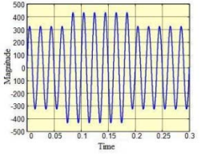
Overvoltage at any point can lead to insulation failure of power apparatus. It can even damage the power appliance. Under voltage is similarly undesirable. Under voltage can increase the losses of induction motor. Full potential of electrical appliance at lesser voltage cannot be exploited. Small deviation from standard or normal voltage (usually 5%) causes under voltage or over voltage. Sag and swell conditions in power system are more harmful than under voltage and over voltage. When the voltage falls below 90% of the rated normal voltage, then such condition is termed as voltage sag. Main reasons for voltage sag are heavy loading and shunt fault such as L-L fault, L-G fault etc. When the voltage rises above 110% of the rated normal voltage then this condition is called voltage swell.
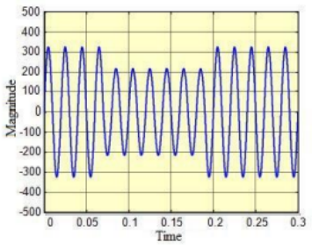

CHAPTER-2
LITERATURE SURVEY
[1] F. Shawki, M. El-Shahat Dessouki, A. I. Elbasiouny, A.N. Almazroui, F. M. R. Albeladi, “Microcontroller based smart home with security using GSM technology” in “Internatinoal Journal of Research in Engineering & Technology,” vol. 4, issue 6, June 2015.
Smart home is a house that uses information technology to monitor the environment, control the electric appliance and communicates with the outer world. Smart home is a complex technology, at the same time it is developing. A smart home automation system has been developed to automatically achieve some activities performed frequently in daily life to obtain more comfortable and easier life environment. Security has becoming an important issue everywhere. Home security is becoming necessary nowadays as the possibilities of intrusion are increasing day by day. Safety from theft, and fire are the most important requirements of home security system for people. A traditional home security system gives the signals in terms of alarm. With the help of technology development, this research take a chance to implement these technologies to help people to protect and control their home appliance remotely .The purpose of this research is to create a system that make the surveillance of home devices easily. The technology that used in this research are GSM (Global System for digital mobile telecommunication) and Microcontroller .The GSM module is used to communicate with the owner of the home whenever the sensor senses a fault , a specific message is sent to the owner in order to take a necessary action . The microcontroller is a tool that use a specific code to do some functions by using MikroC programmer. A smart home automation can turn on and off a fan, light, air condition and also can control the speed of fan with the help of a mobile controller according to user needs. Because mobile controlled home automation system provides a simpler solution of a Global System for Mobile GSM network. It will help to shut down the whole system, improves the convenience and comfort of the user while it provides security and energy efficiency. GSM is used to digitalize a signal or data and transmit signal or data to the receiver. GSM module can be used to send the signal over a mobile in a fixed frequency to other mobile phone connected with the receiver.
[2] Manish Paul, Antara Chaudhury, Snigdha Saikia,” Hardware implementation of Overvoltage and Under voltage Protection,” “International journal of innovative research in Electrical, Electronics, Instrumentation and Control Engineering,” Vol. 3, issue 6, June 2015.
A Overvoltage is defined as an increase in the r.m.s. value of the voltage up to a level between 1.1 pu to 1.8 pu at power frequency for periods ranging from a half cycle to a minute and a voltage which is below the optimum operational or rated value of a component, circuit or device is called an under voltage. Such a voltage may produce for instance a malfunction or failure of customer equipments. In computers and similar devices, under voltages can lead to data losses. Protection against sudden overv oltages in substations is a vital part of the overall reliability of power systems. The degree of surge protection afforded to a station is governed by the reliability required and the economics to obtain such reliability. Since major stations generally include strategic and highly valuable power equipment, surge protection is essential to avoid or minimize major system disturbances as well as major equipment failures. Transient overvoltage occurring in our power system can cause operational breakdown and also cause failure in industrial and household equipments as well. Under voltages are the most common power disturbance whose effect is quite severe especially in industrial and large commercial customers such as the damage of the sensitivity equipments and loss of daily productions and finances. The examples of the sensitive equipments are Programmable Logic Controller (PLC), Adjustable Speed Drive (ASD) and Chiller control. Undervoltage at the equipment terminal can be due to a short circuit fault hundreds of kilometers away in the transmission system.

[3] Yaleinkaya, M. H. J. Bollen and P.A. Crossley (1999), “Characterization of voltage sags in industrial distribution systems”, IEEE transactions on industry applications, vol.34, no. 4, pp. 682-688, July/August.
This paper describes the various characteristics of voltage sags experienced by customers within industrial distribution systems. Special emphasis is paid to the influence of the induction motor load on the characterization of voltage sags. During a fault, an induction motor operates as a generator for a short period of time and causes an increase in sag magnitude. Its reacceleration after the fault clearance results in an extended post-fault voltage sag. The influence of the induction motor on the imbalanced sags caused by single line-to-ground faults (SLGF’s) and line-to-line faults (LLF’s) has been analyzed in detail. For an imbalanced fault, the induction motor current contains only positive- and negative-sequence components. Induction motors create a low impedance path for the negative-sequence voltage due to an imbalanced fault. This causes a small sustained nonzero voltage with large phase-angle jump in the faulted phase and a voltage drop in the nonfaulted phases with a small phaseangle jump. The symmetrical components of the induction motor during the imbalanced sags have been studied. A voltage sag is most of the time described by two essential characteristics, one magnitude and one duration. However, the sag magnitude is not constant, due to the induction motor load present in many industrial systems. Previous work has shown that it is often difficult to define a constant sag magnitude for sags in an industrial system. Apart from the drop in voltage magnitude, the voltage also shows a jump in phase angle and three-phase imbalance. When an imbalanced voltage sag occurs at a certain voltage level (e.g., 33 kV) and is then transferred down to the equipment terminals (e.g., 660 V), the magnitude and phase-angle jumps in the three phases will change in the process. The transformer winding connections between the point of the fault and the equipment terminals swap the three phase voltages in case of an imbalanced sag. A single line-to-ground fault (SLGF) on the primary side of a delta/wye or wye/delta transformer will change into a phase-to-phase fault on the secondary side.
[4] G.A. Taylor, A.B. Burden (1997), “Wide Area Power Quality – Decision Processes and Options for Sensitive Users”, Proceedings of the 14th International Conference and Exhibition on Electricity Distribution (CIRED’97), pp. 2.30.1- 2.30.5, Birmingham, UK, June.
The electronics revolution has steadily gathered momentum over the past twenty years. Industries of all types have benefited from the higher quality and throughput achievable with automation and integration of processes. However, a consequence of this sophistication is that users have become increasingly sensitive to the fundamental quality of their electrical supply. Legislation and standards now exist to define the limits of supply quality and reliability that a customer can expect to receive but, in practice for some users, these limits are greater than those that can be tolerated by some of their equipment. Quality of supply is loosely defined but can be characterised as two principal issues. These are: Reliability, referring to the continuity of supply (and rapid restoration of service); and Power Quality, relating to the fundamental condition of each cycle of the 50 or 60 Hz sine wave received by the customers equipment. Although there is a distinct difference to the electrical utility, this distinction is less clear to customers who suffer equipment downtime as a result of either supply interruptions or quality defects. In an increasingly competitive environment where achieving maximum efficiency is paramount, such a lack of appreciation is surprising.

[5] Girish Chandra Thakur, Kumar Shantanu Kaushal, Manish Ranjan, sandip kumar gupta. “Implementation of Single Phasing, Over Voltage, Under Voltage, Protection of Three Phase Appliances without Using Microcontroller”, Int. Journal of Engineering Research and Applications, ISSN :2248-9622, Vol. 5, Issue 5, ( Part -6), pp.110- 115, May 2015.
This paper tends to develop for protection for costly appliances which require three-phase AC supply for operation. Failure of any of the phases or sudden change in voltage makes the appliance prone to erratic functioning and may even lead to failure. Hence it is of paramount importance to monitor the availability of the three-phase supply and proper voltage supply and switch off the appliance in the event of failure of one or two phases or if required voltage level is not available. The power to the appliance should resume with the availability of all phases of the supply with proper voltage level. The main advantage of this protector circuit is that it protects three-phase appliances from failure of any phase as well as from fluctuation of voltage. It is of paramount importance to monitor the availability of the three-phasesupply and switch off the appliancein the event of failure of one or twophases. The power to the appliance should resume with the availability ofall phases of the supply with certaintime delay in order to avoid surges and momentary fluctuations.It requires three-phase supply, three 12V relays and a timer IC NE555 along with 230V coil contactor having four poles. Relay act as a sensing device.The relays are connected in such a way that the combination of the relays forms a logical AND gate connected serially. Each type employs internal current limiting, thermal shutdown and safe operating area protection, making it essentially indestructible. If adequate heat sinking is provided, they can deliver over 1A output Current. Although designed primarily as fixed voltage regulators, these devices can be usedwith external components to obtain adjustable voltages and currents.

CHAPTER-3
EXISTING METHOD

3.1 INTRODUCTION OF EXISTING METHOD
Overvoltage are less common than under voltage but they also arise due to system faults. Overvoltage can occur due to single line to ground fault, which in turn will raise the voltage of the other phases. It can also cause due to disconnection of heavy industrial loads or switching on the capacitor banks. This is generally due to ungrounded or floating ground delta systems, where a change in ground reference would give voltage rise to the ungrounded system. The over voltages result because either the system is too weak for the desired voltage regulation or voltage controls are inadequate. Incorrect tap settings on transformers can also result in system over voltages. An under voltage is a decrease in the RMS value ac voltage to less than 90 percent or 0.90pu at the power frequency for a time period longer than 1 min. Under voltages are the result of switching events that are the opposite of the events that cause over voltage. The comparator will compare the supply voltage with desired preset voltage and will trip the relay coil if the voltage drops below the desired preset value.Under voltages are the most common power disturbance whose effect is quite severe especially in industrial and large commercial customers such as the damage of the sensitivity equipment’s and loss of daily productions and finances. The examples of the sensitive equipment’s are Programmable Logic Controller (PLC), Adjustable Speed Drive (ASD) and Chiller control. Under voltage at the equipment terminal can be due to a short circuit fault hundreds of kilometers away in the transmission system.

3.2 BLOCK DIAGRAM
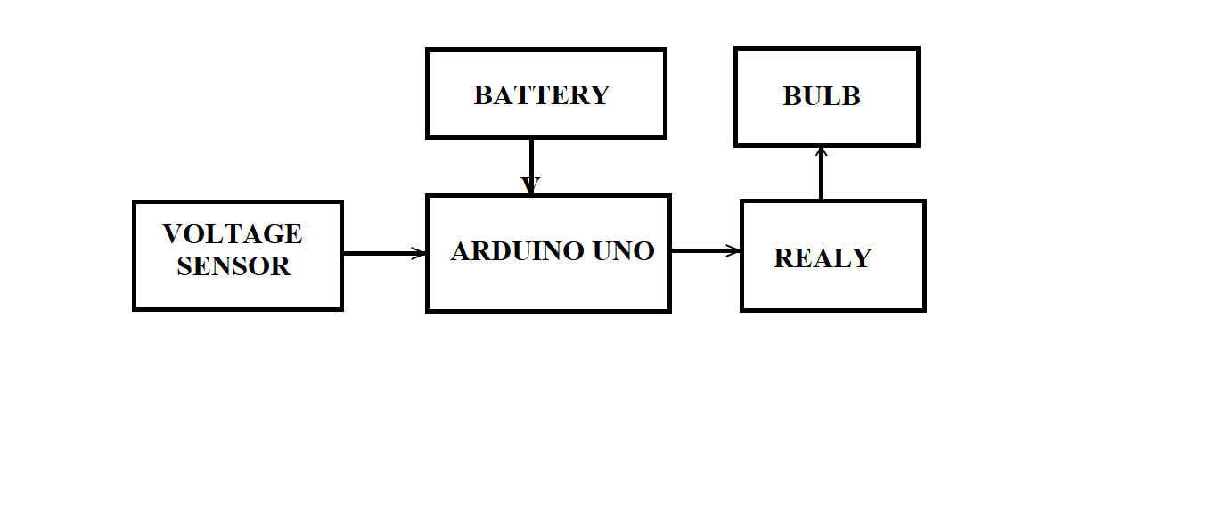
3.3 Advantage of Existing method
- Over-voltage protection Under-voltage protection
- Protection against transients
- High reliability
- High performance
- Low Cost
- Protection to load from frequent turning ON & OFF by providing time delay. Undervoltage relay, in case the mains voltage starts fluctuating in the vicinity of under or over voltage preset points.
- It can be used to protect loads such as refrigerator, T.V., and VCR from undesirable over and under line voltages.

3.4 Disadvantages of Existing method
- One major problem in industry as well as house hold is sudden over voltage or under voltage which results damage the equipment.
- It has cleared that of under voltage and overvoltage problem are very common and can create problem for consumer good and industrial application.
- The equipment in case of over voltage or under voltage and the study of over voltage and under voltage, various power quality issues.

CHAPTER 4
PROPOSED METHOD
4.1 INTRODUCTION
There are many sensors we have used in this system (like temperature sensor , motion sensor , etc) . In order to make home energy efficient we also paid attention on home devices like fans and lights .Moreover , the system also focus on outside environment such as main door , garage door and irrigation. The heart of this system is a PIC18F452 microcontroller which is controlling home devices. If the thermometer feels an increase in room temperature then an electrical signal is sent to microcontroller , the microcontroller takes a necessary action like turn the fan on which work as an airconditioning. In case , there is a smoke in home smoke sensor detects the smoke then send a signal to microcontroller to turn the extractor on, to take out the smoke from home . In order to detect the motion inside home while he away from home . If it detects a motion then send a signal to the microcontroller and microcontroller send a specific SMS message to the owner through GSM module . In order to take a necessary action like call the police station. Protection of home door is the important part in security system which is done in this system by using electromagnetic lock, LCD and keypad . The owner using keypad to enter the password which is displayed in LCD and if the password entered is correct then the electromagnetic lock is opened. Otherwise the password entered is wrong, the door will still locked .There are two ways of control for garage door which are wireless and manual. The first, wireless control is done by using GSM module technology that allow the owner to send a SMS message to GSM module then GSM module send a signal to microcontroller to open the garage door . The second, manual control which means there is a switch near garage door to open and close the door. The garden of house is the place where most people stay at rest time. This system including irrigation system for the garden, in order to take care of house garden. The irrigation is done by using pump which operates on timer.
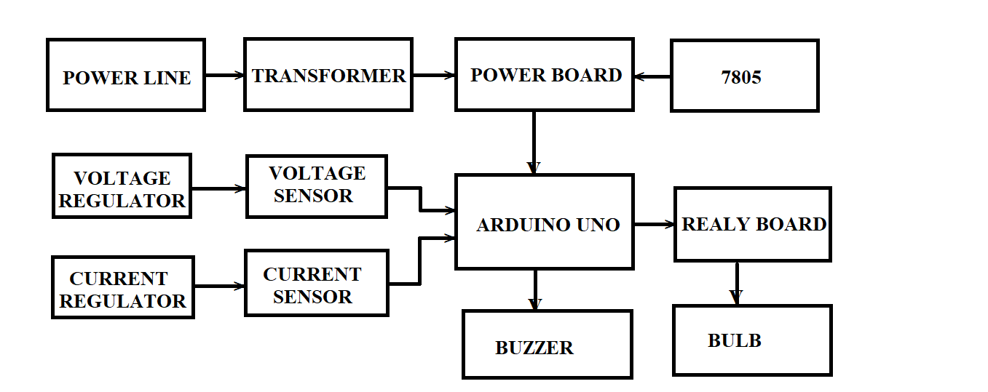

Fig:4.1 Block diagram of proposed method

4.2 ADVANTAGES:
- Over-voltage and under voltage protection is used to prevent damage as a result of electrical transients.
- It is a power supply feature which shuts down the supply or clamps the output when the voltage exceeds a preset level.
- Most power supplies need to use an over-voltage and under voltage protection circuit to prevent damage to the electronic components
4.3 APPLICATIONS
- This voltage protection circuit is designed to develop a low-voltage and high-voltage tripping mechanism to protect a load from any damage.
- It is used in the home appliances, industries to control the voltage fluctuations.
- With this project we can save the circuit from the short-circuits.

CHAPTER 5
HARDWARE DESCRIPTION

5.1 HARDWARE DESIGNING
This circuit protects refrigerators and other electronics appliances from over and under voltages. By the name itself we can say that if the input voltage is more or less than the required voltage then the electrical appliance gets turned off and it gets disconnected from its respective power supply. This voltage protection circuit is designed to develop a low voltage and high voltage tripping mechanism to protect a load from any damage. In many of the homes and industries fluctuation in AC mains supply take place frequently. The electronic devices get easily damaged due to the fluctuations. To overcome this problem, we can implement a tripping mechanism of under/over voltage protection circuit to protect the loads from undue damage.

A. RESISTIVE LOAD
The design of hardware for resistive load is done by connecting a bulb of 50 Watt. The bulb glows in the limit of 150V to 230V. If the voltage goes down below 150V than it is a case of undervoltage and if it exceeds 230V than it is a condition of over voltage. The limits of operating voltage can be changed using the two potentiometers connected in the hardware. . So the relay allows the supply voltage to be fed to the load.
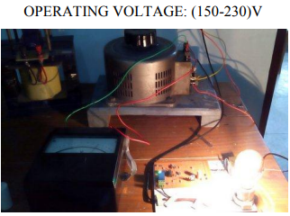
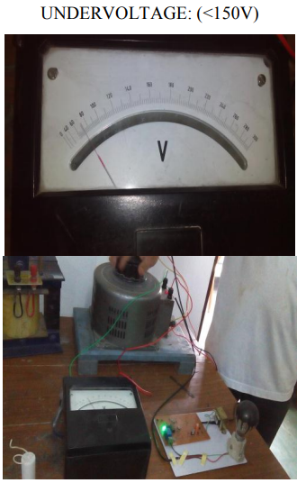
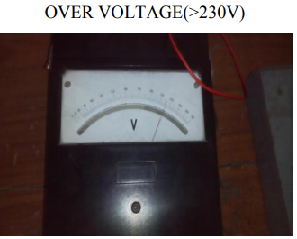

B. CAPACITIVE LOAD
The design of hardware for capacitive load is done by connecting a capacitor of 2.50µF±5%. The LED glows in the limit of 148V to 200V. If the voltage goes down below 148V than it is a case of undervoltage and if it exceeds 200V than it is a condition of over voltage. The limits of operating voltage can be changed using the two potentiometers connected in the hardware.

C. INDUCTIVE LOAD
The design of hardware for inductive load is done by connecting a choke coil. The LED glows in the limit of 148V to 230V. If the voltage goes down below 148V than it is a case of undervoltage and if it exceeds 230V than it is a condition of over voltage. The limits of operating voltage can be changed using the two potentiometers connected in the hardware.
HARDWARE DESIGNING
The fluctuation is quite frequent in AC mains. To protect the load from such fluctuations and thereby from getting damaged, certain measures are to be taken. This protection circuit providing tripping mechanism is designed in such a way thatit disconnects the load from the supply whenever the input supply voltage exceeds or falls down below the required optimum voltage. The internal logicallows the relay to initiate a tripping sequence whenanomalous conditions arise within the power system[7]. Further, this circuit, with the help of amicrocontroller and a GSM interface sends a message to the owner about the same. Also, this circuit allows the user to know the voltage status on his mobile, at any instant of time, just by sending a message to the GSM number inserted in GSM 900A module.A LCD is connected to show the value of the supply voltage whenever required.
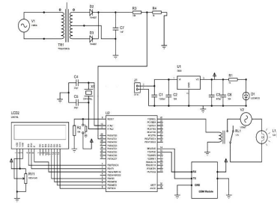
The circuit consists of a transformer to step down the voltage from 220V to 12V. With the help of center tap diode bridge and a potential divider a voltage of 5V is fed to the microcontroller. Any fluctuation in the input to the transformer causes a fluctuation in the voltage fed to the microcontroller. The Atmega32 microcontroller compares this voltage with the reference value and if the voltage exceeds the specified limits, it sends a signal to the relay, the GSM module and the LCD. The LCD displays the input voltage under normal operation whereas it displays the status ‘UnderVoltage’ and ‘OverVoltage’ when the corresponding phenomenon occurs. To power microcontroller, GSM module and the LCD, a power supply is given separately. For this a voltage regulator is provided which gives a constant 5V output. Whenever the voltage becomes more or less than the required voltage, the microcontroller sends a signal to the relay to trip the circuit and disconnect the electrical load from the supply. At the same instanceit sends a signal to the GSM module, which further sends a message to the specified mobile number.

5.2 MODEL
The block diagram of U/O protection of load (motor) with GSM alert . It comprises mainly of a transformer, GSM modem, self made Arduino board, ATmega328 microcontroller, motor and a tripping circuit. Here an IC LM324N is used to compare the voltage change and generates a signal to the relay to activate the buzzer and to trip the circuit.

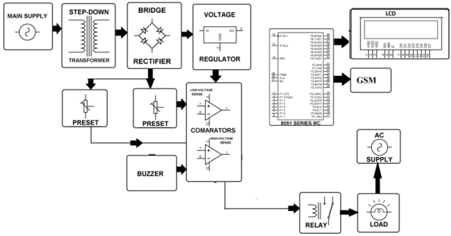
The hardware model of protection of load from overvoltage and under voltage condition .
5.3 MAIN COMPONENT USED
In the hardware model a GSM alert system is used with the interfacing between the components. A GSM modem is used to send SMS to the user’s mobile, Arduino basic circuit comprises of Atmega328 IC and LCD screen is used for the display purpose . The interfacing among various components .

A. GSM Modem
It is a complete Quadband GSM/GPRS solution in a SMT module which can be embedded in the customer applications. It delivers GSM/GPRS 850/900/1800/1900MHz performance for Data, voice, SMS, and Fax in a small form factor. It has a tiny configuration therefore; it can fit in almost all space requirements.
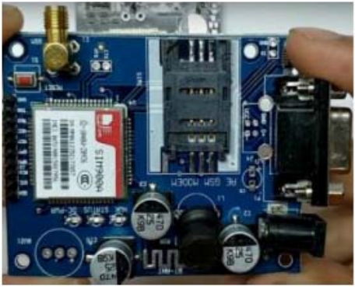

B. LCD Screen
LCD (Liquid Crystal Display) screen is an electronic display module and find a wide range of applications. It is a very basic module and is very commonly used in various devices and circuits.
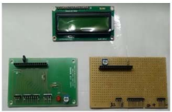
C. Arduino Basic Circuit
Arduino hardware as shown in Fig.8 is an open-source circuit board. It has a microprocessor and input/output pins for communication and controlling physical objects. It is powered via USB or an external power supply. It is similar to C++ & it allows code writing, compiling, and then uploading it to Arduino for standalone use.
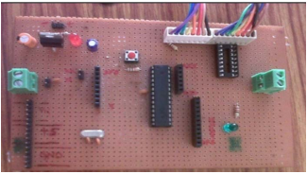
5.4 Equipment
5.4.1 Arduino:
Arduino is an open-source project that made microcontroller-based packs for building computerized gadgets and interactive objects that can detect and control physical devices. The venture depends on microcontroller board plans. These systems give sets of computerized and analog input/output (I/O) pins that can interface to different extension sheets (named shields) and different circuits. The sheets highlight serial correspondence interfaces, including Universal Serial Bus (USB) on a few models, for leading programs from PCs. For programming the microcontrollers, the Arduino extend gives an integrated development environment (IDE) in light of a programming dialect named Processing, which likewise underpins the dialects C and C++. An Arduino board comprises of an Atmel 8-, 16-or 32-bit AVR microcontroller with corresponding parts that encourage programming and joining into different circuits. An important part of the Arduino is its standard connectors, which let clients associate the CPU board to an assortment of tradable extra modules named shields.The reason of using Arduino is to control the circuit. In our project, Arduino plays a vital role. The reason behind this is, in our project voltage measurement, perfect tripping time, give notification to the user on time is very important. To control these things in parallel way, Arduino is important. In this project, we are willing to use Arduino UNO to fulfill all our necessity. The Arduino Uno is a microcontroller board based on the ATmega328. It has 14 digital input/output pins (of which 6 can be used as PWM outputs), 6 analog inputs, a 16 MHz crystal oscillator, a USB connection, a power jack, an ICSP header, and a reset button. It contains everything needed to support the microcontroller. We can easily connect it to a computer with a USB cable or power it with a AC-to-DC adapter or battery to get started. We could have used microcontroller. This would fulfill our all demand. But there are some drawbacks using microcontroller. The main superiority of using Arduino is it has a vast amount of library which microcontroller don’t have. Besides as we are thinking of making something that does not cost much. Arduino UNO is cheaper than microcontroller so if we think economically Arduino UNO is good for us. Microcontroller will make the device that we are trying to build quite big on the other hand Arduino UNO is small. For these reasons we chose to work with Arduino UNO.

5.4.2 Bridge Rectifier:
We used this rectifier as the supply is of ac so we need to convert the AC to DC. We can use full wave also but it is has more losses than this rectifier as we don’t use center tap in this rectifier as it forms continuous flow of direct current. We will use four diodes in this rectifier and one capacitor parallel to this acts as filtering of the ac currents from dc currents. It requires four diodes instead of two, but avoids the need for a center tapped transformer. During the positive half cycle of the secondary voltage, diodes D1 and D3 are conducting and D2 and D4 are no conducting. Therefore, current flows through the secondary winding, diode D1 and D3, resistor RL. During the negative half cycle of the secondary voltage, the diodes D2 &D4 conduct and diodes D1 and D3 do not conduct. Then current flows through the secondary winding, diode D2 D4 and Resistor RL. In both cases current passes through the load resistor in the same direction. A bridge rectifier, is a group of rectifiers (4 in a single phase) wired so that each half of an AC current is passed to respective positive and negative lines of a DC output. It provides full wave rectification of AC into DC. With the availabilities of low-cost, highly reliable and small-sized silicon diodes bridge rectifier is becoming more and more popular in comparison to center-tap and half-wave rectifier. It has many advantages over a center-tap and half-wave rectifier, as given below. The rectification efficiency of full-wave rectifier is double of that of a half-wave 12 rectifier. The ripple voltage is low and of higher frequency in case of full-wave rectifier so simple filtering circuit is required. Higher output voltage, higher output power and higher Transformer Utilization Factor (TUF) in case of a full-wave rectifier. In a full-wave rectifier, there is no problem due to dc saturation of the core because the dc current in the two halves of the two halves of the transformer secondary flow in opposite directions. No center tap is required in the transformer secondary so in case of a bridge rectifier the transformer required is simpler. If stepping up or stepping down of voltage is not required, transformer can be eliminated even. The PIV is one half that of center-tap rectifier. Hence bridge rectifier is highly suited for high voltage applications. Transformer utilization factor, in case of a bridge rectifier, is higher than that of a centertap rectifier. For a given power output, power transformer of smaller size can be used in case of the bridge rectifier because current in both (primary and secondary) windings of the supply transformer flow for the entire ac cycle. It will cost 0.4$ globally.
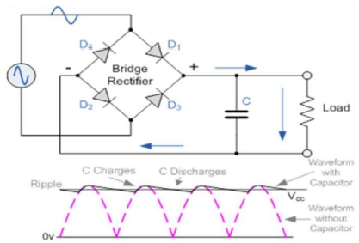

5.4.3 Capacitor:
Capacitors store and release electrical charge. They are used for filtering power supply lines, tuning resonant circuits, and for blocking DC voltages while passing AC signals, among numerous other uses. 470micro farads: 15 0.1 micro capacitor. AC capacitors will cost 0.5$ per piece.
5.4.4 Zener Diode:
We used diodes in this project near the low voltage and high voltage near low voltage we use 6.0v and near high voltage 6.8v diode. As this diodes are used as break down voltage constructions: The Zener diode's operation depends on the heavy doping of its p-n junction. The depletion region formed in the diode is very thin (<1 μm) and the electric field is consequently very high (about 500 kV/m) even for a small reverse bias voltage of about 5 V, allowing electrons to tunnel from the valence band of the p-type material to the conduction band of the n-type material. In the atomic scale, this tunneling corresponds to the transport of valence band electrons into the empty conduction band states; as a result of the reduced barrier between these bands and high electric fields that are induced due to the relatively high levels of doping on both sides. The breakdown voltage can be controlled quite accurately in the doping process. While tolerances within 0.05% are available, the most widely used tolerances are 5% and 10%. Breakdown voltage for commonly available Zener diodes can vary widely from 1.2 volts to 200 volts. 6.8V Zener diode costs 0.1$ per piece.

5.4.5 Transformer:
Transformers are also used extensively in electronic products to step-down the supply voltage to a level suitable for the low voltage circuits they contain. The transformer also electrically isolates the end user from contact with the supply voltage. We have used a 220V to 12V ac transformer.

5.4.6 Relay:
When an electric current is passed through the coil it generates a magnetic field that activates the, and the armature consequent movement of the movable contact(s) either makes or breaks (depending upon construction) a connection with a fixed contact. If the set of contacts was closed when the relay was de-energized, then the movement opens the contacts and breaks the connection, and vice versa if the contacts were open. When the current to the coil is switched off, the armature is returned by a force, approximately half as strong as the magnetic force, to its relaxed position. Usually this force is provided by a spring, but gravity is also used commonly in industrial motor starters. Most relays are manufactured to operate quickly. In a low-voltage application this reduces noise; in a high voltage or current application it reduces arcing. When the coil is energized with direct current, a diode is often placed across the coil to dissipate the energy from the collapsing magnetic field at deactivation, which would otherwise generate a voltage spike dangerous to semiconductor circuit components. Some automotive relays include a diode inside the relay case. Alternatively, a contact protection network consisting of a capacitor and resistor in series (snubber circuit) may absorb the surge. If the coil is designed to be energized with alternating current (AC), a small copper "shading ring" can be crimped to the end of the solenoid, creating a small out-of-phase current which increases the minimum pull on the armature during the AC cycle. A solid-state relay uses a thyristor or other solid-state switching device, activated by the control signal, to switch the controlled load, instead of a solenoid. An optocoupler (a light-emitting diode (LED) coupled with a photo transistor) can be used to isolate control and controlled circuits.

5.4.7 GSM Sim808:
SIM808 module is a total Quad-Band GSM/GPRS module which joins GPS innovation for satellite route. The conservative outline which incorporated GPRS and GPS in a SMT bundle will essentially spare both time and expenses for clients to create GPS empowered applications. Including an industry-standard interface and GPS work, it enables variable advantages for be followed flawlessly at any area and at whatever time with flag scope. The SIM808 module has to be connected to Uno as follows:
- Vcc to 5V Gnd to Gnd
- RXD to digital pin 10
- TXD to digital pin 9
This system has a supply voltage range of 3.4V ~ 5V.

BJT:
A bipolar intersection transistor (bipolar transistor or BJT) is a kind of transistor that utilizations both electron and opening charge transporters. Conversely, unipolar transistors, for example, field-impact transistors, just utilize one sort of charge bearer. For their operation, BJTs utilize two intersections between two semiconductor sorts, n-sort and p-sort. BJTs are made in two sorts, NPN and PNP, and are accessible as individual segments, or created in coordinated circuits, regularly in extensive numbers. The essential capacity of a BJT is to open up current. This enables BJTs to be utilized as intensifiers or switches, giving them wide relevance in electronic gear, including PCs, TVs, cell phones, sound enhancers, mechanical control, and radio transmitters. In this particular circuit configuration we have used BJT547.

5.4.8 Potentiometer:
A potentiometer is a three-terminal resistor with a sliding or turning contact that structures a flexible voltage divider. If just two terminals are utilized, one end and the wiper, it goes about as a variable resistor or rheostat. The measuring instrument called a potentiometer is basically a voltage divider utilized for measuring electric potential (voltage); the segment is a usage of a similar standard, thus its name. Potentiometers are usually used to control electrical gadgets, for example, volume controls on sound hardware. Potentiometers worked by a system can be utilized as position transducers, for instance, in a joystick. Potentiometers are once in a while used to straightforwardly control huge power (more than a watt), since the power scattered in the potentiometer would be practically identical to the power in the controlled load. We used potentiometer to convert 6V to 5V for Arduino use.

Opto Coupler:
In hardware, an opto-isolator, likewise called an optocoupler, photocoupler, or optical isolator, is a part that exchanges electrical flags between two confined circuits by utilizing light. Opto-isolators keep high voltages from influencing the framework getting the signal. Commercially accessible opto-isolators withstand contribution to-yield voltages up to 10 kV. A typical kind of opto-isolator comprises of a LED and a phototransistor in a similar misty bundle. Different sorts of source-sensor mixes incorporate LED-photodiode, LED-LASCR, and light photo resistor sets. Normally opto-isolators exchange computerized (on-off) signs, however a few methods enable them to be utilized with simple signs. An opto-isolator contains a source of light, quite often a close infrared lightemanating diode (LED) that believes electrical information motion into light, a shut optical channel and a photo sensor, which distinguishes approaching light and either creates electric vitality straightforwardly, or regulates electric current spilling out of an outside power supply. The sensor can be a photo resistor, a photodiode, a phototransistor, a silicon-controlled rectifier (SCR) or a triac. Since LEDs can detect light notwithstanding producing it, development of symmetrical, bidirectional opto-isolators is conceivable. An optocoupled strong state hand-off contains a photodiode opto-isolator which drives a power switch, more often than not a reciprocal combine of MOSFETs. An opened optical switch contains a wellspring of light and a sensor, yet its optical channel is open, permitting tweak of light by outer items discouraging the way of light or reflecting light into the sensor.

AC to DC Converter:
An AC to DC converter or widely known as rectifier, is an electrical gadget that rotates current (AC), which intermittently inverts bearing, to direct present (DC), which streams in just a single direction. Rectifiers have many utilizations, yet are regularly discovered filling in as parts of DC power supplies and high-voltage coordinate current power transmission systems. Because of the exchanging way of the info AC sine wave, the procedure of amendment alone creates a DC current that, however unidirectional, comprises of beats of current. Numerous uses of rectifiers, for example, control supplies for radio, TV and PC gear, require a relentless consistent DC current. The transformer in this experiment was AC, so needed a rectifier to make it DC.

Voltage Sensor:
A voltage sensor will be ready to decide and even screen and measure the voltage supply. It is then ready to take those estimations and transform them into a flag that one will at that point have the capacity to peruse. The flag will regularly go into a specific electronic gadget for recording, yet once in a while, an eyewitness will be available to physically read the sensor yield. We have fixed higher voltage to 235V and lower voltage to 200V, elsewise sensor will sense.
Current Controller:
Current controlling is the practice in electrical or electronic circuits of forcing a furthest point of confinement on the present that might be conveyed to a load with the motivation behind securing the circuit producing or transmitting the current from destructive impacts because of a short out or comparative issue in the load.

Diode:
A diode is a two-terminal electronic part that conducts fundamentally in one direction; it has low imperviousness to the current in one heading, and high resistance in the other. A semiconductor diode, the most well-known sort today, is a crystalline bit of semiconductor material with a p–n intersection associated with two electrical terminals. The most regular capacity of a diode is to enable an electric current to go in one heading (called the diode's forward bearing), while at the same time blocking current the other way (the reverse biasing).

LCD Display:
A liquid-crystal display (LCD) is a flat-panel display or optical device that uses the light-modulating properties of liquid crystals. LCD’s don't radiate light straightforwardly, rather utilizing a backdrop illumination or reflector to deliver pictures in shading or monochrome. LCDs are used in a wide range of applications including computer monitors, televisions, instrument panels, aircraft cockpit displays, and indoor and outdoor signage. Small LCD screens are common in portable consumer devices such as digital cameras, watches, calculators, and mobile telephones, including smartphones.

Bread Board:
A present day solderless breadboard attachment comprises of a punctured square of plastic with various tin plated phosphor bronze or nickel silver amalgam spring cuts under the holes. The clasps are regularly called tie focuses or contact focuses. The quantity of tie focuses is regularly given in the determination of the breadboard. The edge of the board has male and female scores so sheets can be cut together to shape an extensive breadboard.

5.5 Software design
All electrical devices can bear voltage up to certain limits. For example your home fan normal operating voltage is 220 volt AC. If voltage input to fan become greater than or less than about 20% of normal operating voltage of fan it many burn fan and in case of less voltage fan excessive current may flow which in turn cause short circuit in your home wiring. To avoid all these issues this project is designed which automatically turn on and turn off main power supply in case of issue in AC main power supply and on one need to control it manually. Microcontroller is embedded into this system to make it smart enough to handle all the issues intelligently and to provide control signals to turn on and off AC main power supply. Following things are the main components of this project for simulation. Function of each component used in this project will be described briefly with picture.

Voltage Sensor:
Voltage sensor is used to measure voltage of AC main power supply. Voltage sensor is used difference amplifier to step down voltage level from 220 volt AC to 2.8 volt AC or 311 volt peak of AC voltage to 3.96 volt of peak voltage of sine wave. Difference amplifier is used as a signal conditioning circuit to convert high voltage of AC main supply into low voltage which Arduino Uno can easily read. Because analog to digital converter cannot read voltage more than 5 volt and voltage more than 5 volt will eventually damage Arduino. So difference amplifier as a signal conditioning circuit is used to step down voltage by adjusting the gain of difference amplifier.
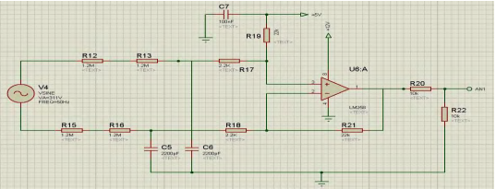

High speed relay:
Relay is used to turn on and turn off main power supply. Relay get control signal from Arduino Uno through a transistor. Diode is use in parallel with coil pin of relay to avoid sparking in case of back EMF (Electromagnetic Force). For relay to turn on, 12 volt DC is needed.
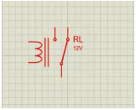

Liquid Crystal Display:
LCD is used to display value of voltage and status of your power supply. If AC voltage of main power supply is greater or less than 20% of normal operating voltage, LCD display “fault occur”. Otherwise LCD display “No fault”. LCD also displays value of AC main voltage supply. For simulation we used LM016L which is a 16x2 display.
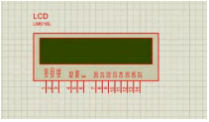
Voltage regulators:
As the name implies, voltage regulators are used to regulate voltages especially when low voltage is needed from high voltage. We used two regulators. 7805 and 7812. 7805 is used to get regulated 5 volts which is supply voltage for Arduino and 7812 is used to get regulated 12 volts which is supply voltage for relay. 220 to 12 volt step down transformer and rectifier full bridge is used to produce DC voltage which is input for the both voltage regulators.
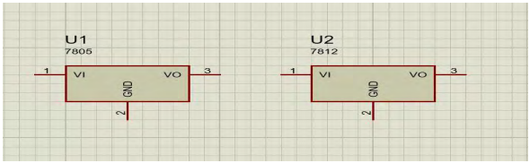

Arduino Uno:
Arduino Uno is use to make this project intelligent and smart. ADC of Arduino is used to measure analog AC voltage. Control signals is used to turn on or off transistor which control the relay. Arduino reads the analog value of voltage and display it on LCD. Actually embedding Arduino Uno make this project intelligent and smart enough so that it can take control actions automatically in case of under and over voltage. It can also automatically turn on or off power supply without having need of any person.
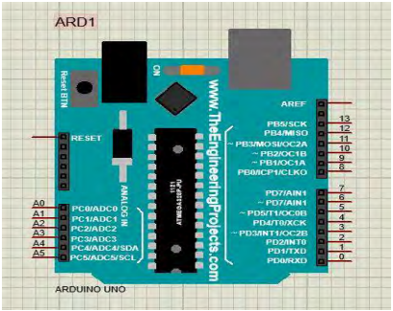

Protection System:
In a complete electric system there must have safety gauges and protection systems. Switchgear is such a system that allows electrical circuit to function with safety. Switchgear is a mix of electrical separate switches, wires or circuit breakers used to control, ensure and confine electrical hardware. Changes are sheltered to open under ordinary load current, while defensive gadgets are protected to open under fault current. Switchgear consists of CT, PT, isolator, busbar etc. The fundamental purposes of switchgear are as follows
1) Switch load currents;
2) Make onto a fault;
3) Carry fault current without blowing itself up;
4) Break normal and fault current.
Relays are widely used safety component around the globe. Relays are the devices, which monitor the conditions of a circuit and give instructions to open a circuit under unhealthy conditions. Electromechanical and static relays are mostly used relays.

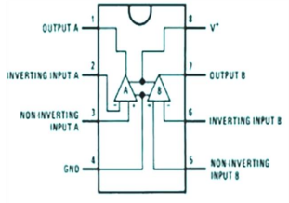
The proposed protecting system to protect the loads from over voltage and under voltage consists of various electrical and electronic components and devices such as step down transformer, rectifier, filter, voltage regulator, LM358 IC, resistors, capacitors, LEDs, diodes etc. The input of the transformer is connected to the mains i.e, 230VAC. The input can also be given to a variac which is variable AC power source. The output of transformer is 12V AC and it is fed to the input of 12VAC connector of the PCB. The principle of working of the circuit lies in the working of the Op amp IC. There is a potential divider network along with a zenor diode used for controlling the tripping of the power to the AC load connected to the system. The working range of voltage is set into the system with the help of the potential divider network. This set voltage range is for a working range of 180VAC up to 240VAC at the input of the 12VAC step down transformer. Whenever the voltage goes below 180VAC at the input of the transformer, it will trip down the relay and thus the load will automatically get disconnected in the under voltage condition. Similarly, at voltages higher than 240VAC, the over voltage sensing Op amp IC will trip down the relay, hence protecting it from over voltage condition. There is also a pot provided on the PCB. This is to demonstrate manually the change in voltages so that demonstration of this system can also be shown without the variac connected at the input of the transformer. The transformer in such case will directly be connected to AC supply and variations in AC will be simulated by varying the pot on the project thus demonstrating tripping of load relay in case of over and under voltages.

CHAPTER 6
RESULT & DISCUSSION
CONCLUSION
In this paper, a great way of protecting loads from voltage fluctuations either under voltage or overvoltage has been practically implemented. It proves to be cheap, requires very less maintenance and fully automatic. The GSM modem SMS technology alerts the user so that operator can respond as soon as possible to save load and other important equipments from getting damaged. The objective of this paper is to access the load in safe condition even when the operator is far away from the load side. The possibilities are numerous and can be explored further. Further modifications can be done to improve it in a better way.

FUTURE SCOPE
PSIM we can further extend or upgrade the operation of this protection device in the following ways:
- Although we are applying 1 phase power supply in the prepared hardware, the implementation of the hardware can also be done applying 3 phase power supply.
- The concept in future can be extended by integrating an alarm which sounds when voltage fluctuations occur. It can also be interfaced with a GSM modem to convey alert message to the user via sms to take appropriate actions.

REFERENCE

[1] F. Shawki, M. El-Shahat Dessouki, A. I. Elbasiouny, A.N. Almazroui, F. M. R. Albeladi, “Microcontroller based smart home with security using GSM technology” in “Internatinoal Journal of Research in Engineering & Technology,” vol. 4, issue 6, June 2015.

[2] “IEEE Recommended Practice for Monitoring Electric Power Quality,” IEEE Std. 1159-1995, June 1995.

[3] Manish Paul, Antara Chaudhury, Snigdha Saikia,”Hardware implementation of Overvoltage and Undervoltage Protection,” “International journal of innovative research in Electrical, Electronics, Instrumentation and Control Engineering,” Vol. 3, issue 6, June 2015.

[4] Electricity World. Avalable at: http://electricity2all.blogspot.com/2013/05/over-voltageand-voltage-swell.html

[5] Manish Paul, Antara Chaudhury, Snigdha Saikia,”Hardware implementation of Overvoltage and Undervoltage Protection,” “International journal of innovative research in Electrical, Electronics, Instrumentation and Control Engineering,” Vol. 3, issue 6, June 2015.
[6] Over & Under Voltage protection circuit . Available: https://www.elprocus.com/under-and over voltage protection-circuit/

[7] Interfacing 16*2 LCD With Arduino. Available: https://circuitdigest.com/microcontrollerprojects/ardu ino-lcdinterfacing-tutorial

[8] Over & Under Voltage protection circuit. Available: https://www.eleccircuit.com/over-voltage-and-lowvoltage-protectioncircuit/

[9] Over/Under Voltage Protection of Electrical Appliances. Available: https://electronicsforu.com/ele ctronicsprojects/under-over-voltage-protection.

[10] Yaleinkaya, M. H. J. Bollen and P.A. Crossley (1999), “Characterization of voltage sags in industrial distribution systems”, IEEE transactions on industry applications, vol.34, no. 4, pp. 682-688, July/August.

[11] G.A. Taylor, A.B. Burden (1997), “Wide Area Power¬ Quality – Decision Processes and Options for Sensitive Users”, Proceedings of the 14th International Conference and Exhibition on Electricity Distribution (CIRED’97), pp. 2.30.1- 2.30.5, Birmingham, UK, June.

[12] Girish Chandra Thakur, Kumar Shantanu Kaushal,¬ Manish Ranjan, sandip kumar gupta. “Implementation of Single Phasing, Over Voltage, Under Voltage, Protection of Three Phase Appliances without Using Microcontroller”, Int. Journal of Engineering Research and Applications, ISSN :2248-9622, Vol. 5, Issue 5, ( Part -6), pp.110- 115, May 2015.

