MONITORING AND ANALYSIS OF HAZARDOUS PARAMETERS IN COAL MINES USING SMART HELMET SYSTEM

ABSTRACT

Coal mining has always been a necessary evil. We need the coal for various operations, especially electrical power generation. However mining the coal has proven to be very dangerous and has caused many accidental deaths over the years. Keeping this in mind we have designed an intelligent system which can be used on helmets of these underground coal miners and can monitor/analyze a few major hazardous parameters found in these mines in real time. This includes humidity, temperature and gas contents such as methane and sulfur dioxide. These parameters, if above a certain level, can cause choking, suffocation, flooding, gas poisoning, roof collapse or explosions. Our system can detect these parameters, analyze them in real time and alert the ground control and the worker about the situation using a buzzer. Compact sensors and radio frequency modules are used to ensure practicality.

CHAPTER-1

INTRODUCTION

Conventionally, helmets with minimal protection and LED lighting are used in underground coal mines because of their light weight and low power consumption. However, nowadays with evolving VLSI technology and development of efficient embedded intelligent systems, it has become possible to design a smart, compact and efficient electronic system which can be embedded into these helmets to provide better security without sacrificing on weight and power consumption requirements of them.
The proposed system uses two sensor modules to monitor the aforementioned hazardous parameters in real time and feeds their data to the microcontroller. The microcontroller then analyzes these parameters and compares it with a set range, and sets off the buzzer in case any of the parameters are exceeding it. This system is convenient for the ground control as it can be used for real time surveillance of the staff as well.
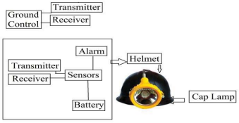
The use of a compact humidity & temperature sensor ensures a lightweight and power efficient circuit while the use of RF module helps in wireless communication between staff and ground control. With the use of microcontroller, it has also become possible to design smart lighting system for easy recognition in low-to-no light conditions which may occur in underground coal mines using various intensities and colors of modern RGB LEDs.

CHAPTER-2
LITERATURE SURVEY
[1] Pranoti Anandrao Salankar, Sheeja S. Suresh, “Zigbee Based Underground Mines Parameter Monitoring System for Rescue and Protection”. IOSR Journal of VLSI and Signal Processing (IOSR-JVSP) Volume 4, Issue 4, Ver. I (JulAug. 2014), PP 32-36 eISSN: 2319 – 4200, pISSN No. : 2319 – 4197
This paper based on continuous monitoring underground coal mines parameter such as carbon monoxide, temperature, water level and use wireless node MCU technology for communication. A microcontroller based system is used for collecting and storing data using respective sensors and making decision accordingly, based on which the mine worker is informed through different alarm tone as well as LED display system. Safety is the most vital part of any type of industry. In the mining industry safety and security is a fundamental aspect of all. To avoid any types of unwanted phenomena, all mining industry follows some basic precaution. Communication is the most vital key factor today, to monitor different parameters such as temperature, increasing water level, and carbon monoxide gas continuously using sensors such as LM35, water level indicator and carbon monoxide gas sensor MQ7 and to take necessary actions accordingly to avoid any types of hazards related to security using buzzer. To enhance safety in underground mines, a reliable communication system must be established between workers, moving in the mine, and a fixed base station. The communication network must not be interrupted at any moment and at any condition. Inside underground mines, the wired communication network system is not so effective.

[2] CHENG Qiang, sun ji_ping, zhangzhe, zhang IEEE paper on “Zigbee based intelligent helmet for coal miners”, February [2009] CSIE2009.653
The application followed node MCU wi-fi technology to build wireless sensor networks, found out actual-time surveillance with early-warning intelligence on temperature, leakage of gas in mining place, and alerting the control station the usage of wireless node MCU technology. This task addresses a cost-effective, supple, portable continuous tracking of underground parameter which includes excessive strain without air gap, collapsing of an atom, chemical reaction of molecules, grimy lifestyles cycle, waste control (chemical, nuclear and alcohol factories and many others..,) beneath the earth makes toxic amount of minerals causing toxic gases (CO, SO2, H2S, NH3, CH4, NOXIOUS and so forth.,) are detected by using gas sensor and automating collection of measuring records using microcontroller and transmit facts via digital wireless verbal exchange gadget (node MCU community) to controller. The controller gets information and send facts to them through LCD (PC) by way of the conversion of node MCU protocol to Ethernet protocol with the idea of M2M (Machine to gadget -controller room, gadget to cellularfireplace service, cell to cellular employees and public). The bizarre state of affairs may be projected with high precision, gentle controller, reliability, much less compatibility, much less electricity and large span of battery.

[3] Tanmoymaity, parthasarathidas, mithumukherjee, “Rescue and protection system for underground mine workers based on zigbee” vol.2 no.2 [June_December,2012] int.jr.of advanced computer eng. & architecture.
The proposed coal mine safety system using wireless sensor network replaces traditional coal mine safety which is wired system. This monitoring system is based on Wireless Sensor Network using Xbee. So there is important development in coal mine safety production which is safe and effective communication. Apart from this it is unsuitable to lay the cables which is costly and consumes more time. To solve this problem there is need to design and develop a Coal Mine Safety System using WSN. In this project there are two sections. The first section is underground section and second is ground section. In underground section the sensor senses the environmental parameters such a temperature, humidity, gas, vibration etc. If it is greater than that given value it give the signal to the buzzer as well as LED light which is start to alarming and glowing. This process starts at time in underground section simultaneously Arduino gives the signal to the Xbee. Xbee woks as trance-receiver it transmit the signal from one node to next node. The number of node is totally depends upon the total length of coal mine. After that next Xbee receive the signal it give to the next Arduino and it connect to the LCD display. All the parameter are display on the LCD display at the control panel room.

[4] A. Geetha, “Intelligent Helmet for Coal Miners with Voice over Zigbee and Environmental Monitoring” MiddleEast Journal of Scientific Research 20 (7): 825-827, 2014 ISSN 1990- 9233- 2014
A cost effective node MCU based wireless mine supervising system with voice over node MCU (VoZ) is presented here.Here we design a smart helmet, which enable the helmet as a mobile sensor node of node MCU wireless sensor networks, gathering parameters the temperature, humidity and illumination level of underground environment and will alert the central management unit in case of abnormal condition. Coal as an important source of energy in industrial production, it plays a pivotal role in the national economy. Coal mine incidents were unpredictable and it has many factors the event of an accident, not only causes huge economic losses, but a direct threat to the safety of miners. So intelligent helmets could collect production parameters timely and transmit to wireless base station. Control unit can send speech instruction to miners through node MCU networks andminers can also receive calling from others working at different coal phase smoothly through smart helmets. It is a good Monitoring Mine Safety System both under normal circumstances and unexpected accident.

[5] Shirish Gaidhane1, Mahendra Dhame, Rizwana Qureshi, “Smart Helmet for Coal Miners using Zigbee Technology” Imperial Journal of Interdisciplinary Research (IJIR) Vol-2, Issue6, 2016
The primary objective of this thesis is making use of smart helmet, management of accident events can be a real-time monitoring system. This system utilizes node MCU and sensor technology to connect to the server to transfer the specific data to the data centre In this paper we are going to use zig-bee technology and three sensors like temperature , humidity and gas sensor. Three sensors will observe the change in environment parameters and they will give the information to micro controller. They have the danger from the methane, carbon monoxide, and temperature. So we need to provide a strong security for the people who are working in the coal mining. The purpose of this project is to provide a solution to mining by wireless communication and safety monitoring. The person must use the helmet while working in the coal mining. Here we have to arrange our total circuit within the kit to provide safety to the person who is working in coal mining.In recent days coal mining has been very dangerous activity that can result in a number of adverse effects on the environment for example during mining operations methane, a known greenhouse gas, may be released into the air. Underground mining hazards include suffocation, gas poisoning, roof collapse and gas explosions.

CHAPTER-3
EXISTING METHOD

3.1 INTRODUCTION OF EXISTING METHOD
This present device A fee of effective Bluetooth based wireless mine supervising device with Bluetooth is offered right here. Here we layout a clever helmet, which allow the helmet as a mobile sensor node of Bluetooth wi-fi sensor networks, accumulating parameters the temperature, humidity and illumination stage of underground environment and will alert the valuable management unit in case of extraordinary situation. We additionally design a voice transmission system, based totally at the equal low-price wireless networks. So with environmental monitoring, the cool miners can talk with manage centres or with different miners through wireless Bluetooth verbal exchange.
3.2 BLOCK DIAGRAM
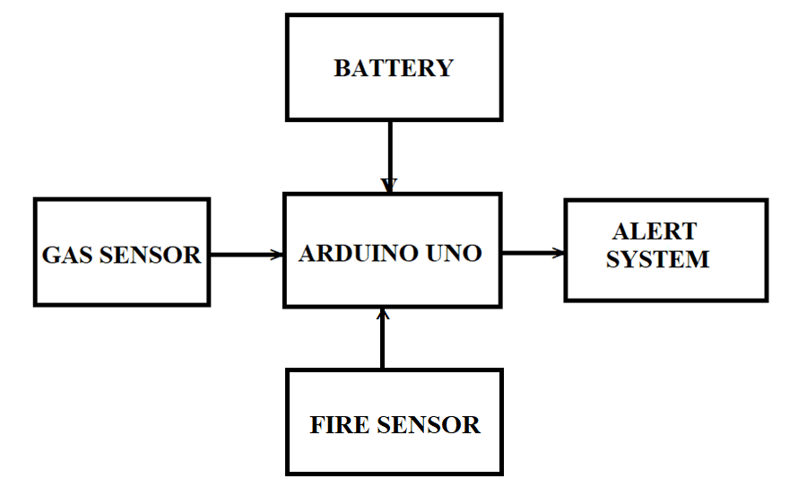
3.3 BLOCK DIAGRAM EXPLANATION
The MQ6 is used to monitor the level of Methane, LPG, Hydrogen, Carbon monoxide, Alcohol, and Smoke. The LM35 is used for monitoring temperature. The DHT11 is used to monitor the humidity. The LDR is used to detect the light intensity of the environment in which miners are working. To detect weather the miner is wearing helmet or not the IR sensor is used. These are semiconductor type sensor. The sensor senses the various environmental parameters like temperature, humidity, light, level of gases and transmitted real time data to the controller, the controller receive the data processing on it and transmitted to the base station using IOT module. At the same time if gases level is increases above threshold, alert signal will be send to the base station. The alerting device, buzzer is used for alerting to the supervisor or the person at the base station if any of the sensor data exceed than rated or threshold values. LCD displays the massage according to sensor values, like if LPG level increases then LCD will display “LPG detected”. If helmet is removed by miner then, “Helmet Removed” will be displayed on LED. All the data is received from helmet and transferred to the base station through IOT and display on PC. By using IOT module we will able to get mine’s update anywhere anytime through internet.
3.4 Advantage of Existing method
- To detect the various gases present in the environment, gas sensor is used. Humidity sensor senses, measures and reports both moisture and air temperature.
- The sensors used are Gas Sensor, Temperature Sensor, Humidity Sensor, LDR for light intensity, and IR sensor to detect weather the miner wearing helmet or not.
- It is widely used as alarm generator in electronic devices.
3.5 Disadvantages of Existing method
- The problem addressed is the improvement of a mining helmet in order to ensure more equipment, being aware of one’s surroundings can sometimes be challenging.

CHAPTER 4
PROPOSED METHOD
4.1 INTRODUCTION
The machine is a value powerful node MCU -based wireless mine supervising machine. Software adopted node MCU technology to build wireless sensor networks, determined out real-time surveillance with early-warning intelligence on temperature, leakage ofgasoline in mining place, and alerting the manage station the use of wireless node MCU technology. The device is used to reduce capacity protection troubles in coal manufacturing. node MCU is a WPAN era primarily based on the IEEE 802.15.4 popular. Unlike Bluetooth or wireless USB gadgets, node MCU devices have the capability to shape a mesh community among nodes. This technique allows the quick range of an person node to be accelerated and improved, covering a far larger region. This machine has transmitter phase interfaced to microcontroller to the helmet. The gadget has fuel sensortemperature sensorthe usage of node MCU generation. The machine also monitors the LPG gas leakages the usage of fuel detection sensor, fireplace the use of temperature sensor, in the mines and if it exceeds the threshold degree, it alerts via alarm the usage of buzzer and also displays on LCD to the person.
In mining industry worker safety is very important issue. Every year, thousands of miners die in accidents and many more get injured, especially in the processes of the coal mining and hard rock mining. The main reason of accidents are gas or dust explosions, gas intoxications, improper use of explosives, electrical burn, fires, collapsing of mine structures, rock falls from roofs, flooding, workers stumbling/falling/slipping, or errors from malfunctioning or improperly used mining equipment. In coal mine use of personal protective equipment like helmet, shoes etc. are not proper and proper arrangements were not there to check if the person is wearing personal protective equipment or not. The proper supervision for worker wear the protective element is very important factor for consideration. Underground mines are very dark so any miners are fall unconscious because of suffocation or falling of structure, supervisor don’t know about his health condition and proper treatment is not provided him in time. The main reason for miner death is harmful gases explosions. In coal mines carbon monoxide, methane, LPG gases existing and they are very harmful for human body. The proper supervision and proper communication is very important requirement of mining industries.
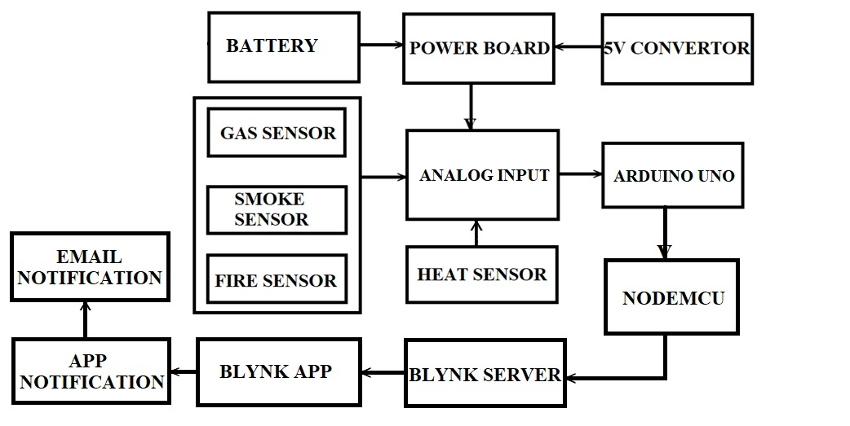

Fig:4.1 Block diagram of proposed method

4.2 ADVANTAGES:
- The Smart Helmet prototype worked efficiently when connected to a power bank, and provided correct readings over long durations of time.
- Based on the application use case, the same data could be used for training as well as predicting the output.

CHAPTER 5
HARDWARE DESCRIPTION
5.1 Hardware Design of the System:
5.1.1 Main Devices Selection
1) Wireless communication module:
Select node MCU wireless transceiver CC2420, the chip's sensitivity index is superior to standards of 802.15.4, this ensures effectiveness and reliability for short-distance communication, and the chip can be used to built a wireless network containing 65535 nodes to rapidly achieve a multi-point to multi-point network.
2) MCU:
MCU plays a central role in the whole node hardware, ATMEL's 8-bit VAR chip ATmega128 is used in the system. As the size of node MCU protocol stack is only a quarter of Bluetooth, the demand for hardware resources is very low, that 8-bit microprocessor can meet the requirements. ATmega128 is a low-power component and can enter sleep mode when no data acquisition, it is suitable for mobile sensor nodes which can only be powered by battery.
3) Sensors:
It is not necessary for each single node accuracy in the wireless sensor network to be very high, the system monitors multiple underground parameters by gas sensor MC112, temperature sensor LM35 , humidity sensor HM1 and so on.
i. IR Sensors
IR Sensors are nothing but Infrared Rays sensors which is an electronic device, that emits to sense some aspects of the surroundings. IR sensor can also be used to measure the heat of an object and detects the motion .These kind of sensors measures infrared radiation, rather than emitting it and it is called as a passive IR sensor.
ii. Alcohol Sensors
These sensors are mainly used to check the concentration of alcohol in a sample. An alcohol sensor detects the attentiveness of alcohol gas in the air and an analog voltage is an output reading. The sensor can activate at temperatures ranging from - 10 to 50° C with a power supply is less than 150 Ma to 5V.
iii. Vibration Sensor
Vibration causes havoc in many applications. From machine shafts and bearings to hard disk performance, vibration causes machine damage, early replacement, low performance, and inflicts a major hit on accuracy. Using vibration analysis as a tool to determine the specific cause and location of machinery problems can expedite repairs and minimize costs.
4) GPS (Global Positioning System)
GPS is nothing but a satellite navigation system which is used to determine the ground position of an object. Now-a-days, GPS receivers are included in many of the commercial products, such as automobiles, smart phones and watches.
5) GSM (Global System for Mobile)
GSM is a digital mobile network that is used by mobile phone. GSM uses a variation of TDMA which is time division multiple access and that is most widely used of the three digital wireless telephony technologies which are TDMA, GSM and CDMA(code-division multiple access) . These GSM digitizes and compresses the data, then sends it down a channel with two other streams of user data, each in its own time slot.
5.1.2 Design of Mobile Node Hardware
Mobile node is composed of sensor module, controll module, wireless communication module and power module. In power module 3V alkaline battery is used, as the normal working level of MCU is 5V, DC-DC conversion device TPS6112X is needed for transforming levels, even if battery voltage is as low as 0.7V the output to MCU is still around 5V; Control module controls all the business logic operations of the node; Wireless communication module is responsible for communicating with other nodes; Sensor module monitors information collecting in the regions, converts to digital signals, and transmits them to data processing module.
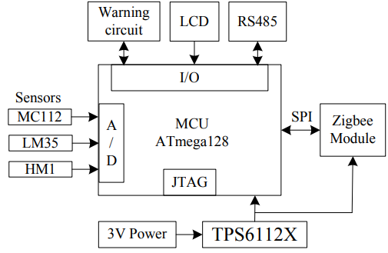

5.1.3 Design of Routing and Central Node
Routing node receives data from sensor nodes and sends it to central node. Routing node hardware designing is relatively simple, basing on the design of sensor node it only needs to reserve power module, controll module and wireless communication module. Central node is the control center in the whole network, it can actively scan sensor nodes within its coverage area, and it is responsible for network access and dynamic address assignment. It is the only one connecting with the monitoring system through the RS485 in the entire wireless sensor network. In the entire monitoring system it plays a role in connecting: On the one hand, it receives upper computer instructions for network setting, on the other hand, it packs wireless sensor network data and sends it to upper computer. Central node hardware design is different from routing node in the following aspects: First expand RS485 communication interface and LCD basing on routing nodes, then change the way of power supply, normally use cables for power supply, and automatically switch to backup battery when the power cables fail.
5.1.4 LPC2148 Microcontroller:
The ARM7 (advanced RISC gadget) pressers board primarily based complete on a 16/32-bit ARM7 its method of sixteen/32-bit ARM7 TDMI-S microcontroller, 8 computer reminiscence unit to forty pc reminiscence unit of onchip static RAM and 32 laptop memory unit to 512computer reminiscence unit on-chip flash memory; 128-bit Ingadget Programming (ISP). 32-bit timers/out of doors occasion counters, PWM pulse width modulation unit (six outputs) and watchdog, Low electricity of actual-Time Clock (RTC), a couple of serial interfaces which has 2 UARTs , fast I2C-bus (400kbit/. There are sixty 4 pins of ARM7 processer and a couple of ports (port0, port1) forty five pins are enter/output.
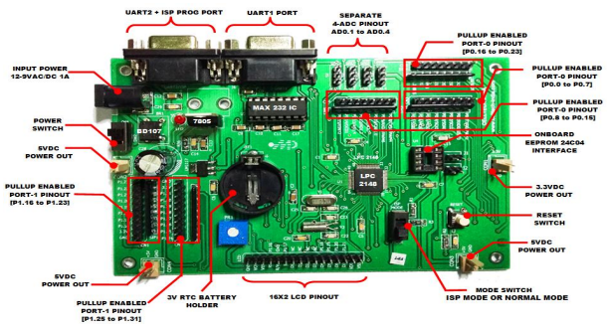

Microcontroller Unit
The microcontroller unit employed for helmet is atmega2560 MCU. It receives the data from all the sensor in real time and simultaneously checks the predefined safety limit to the values. All the data collected is transmitted to the ground receiver and if the limit exceeds the safety limit, an indication signal will be sent to both ground control and worker.
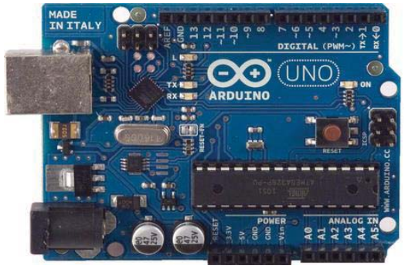
5.1.5 RF Transceiver
The transmitter is an NRF24L01 wireless module. It is an ultra low power, RF transceiver that works on 2.4 GHz ISM (Industrial, Scientific and Medical) band. Its ultra low power design grants it months of battery life as well as high range of 100m which can be further extended to more than 500m if an antenna is used. Other features of the NRF radio frequency module are that it include Enhanced Shock Burst hardware protocol accelerator supporting a high-speed SPI interface for the application controller. It is used as the wireless communication medium.
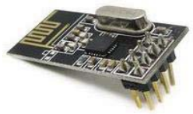
5.1.6 Gas Sensor MQ-4
Gas detector is being employed to measure Methane gas in underground coal mine. The range is between 300 to 10000ppm. Quick response and recovery makes it ideal to use.
In brand new-day technological know-how state of affairs, monitoring of gases produced may be very crucial. From home equipment along with air conditioners to electrical chimneys and safety programs at industries monitoring of gases would be very predominant. Gasoline sensors are very important part of such buildings. Small like a nostril, gasoline sensors spontaneously react to the gas gift, consequently keeping the system updated roughly any changes that arise throughout the attention of molecules at gaseous country.
As we are considering the coal mine there is severity of gases like CO,CH4,LPG which are dangerous for coal mine workers so according to that we have to use or have to choose the sensor which sense all the above gases. So considering this requirement where are choosing following sensor.
Gas Sensor 1
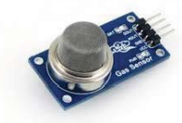
MQ2
Sensitive material of MQ-2 gas sensor is SnO2, which with lower conductivity in clean air. When the target combustible gas exist, The sensor's conductivity is more higher along with the gas concentration rising.Convert change of conductivity to correspond output signal of gas concentration. MQ-2 gas sensor has high sensitivity to LPG, Propane and Hydrogen, also could be used to Methane and other combustible steam, it is with low cost and suitable for different application.
TECHNICAL DETAILS
Detection range: 300 to 10000 PPMM
Characteristics of gas: 1000 PPM isobutene
Sensitivity: R in air/Rin typical gas >=5
Sensitive resistance: 1k ohm to 20k ohm in 50PPM toluene
Ambient temperature: -20 + 55?
Measure the voltage<=24V
Gas Sensor 2
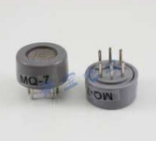
MQ7
This is a simple-to-use Carbon Monoxide (CO) sensor, suitable for sensing CO concentrations in the air. The MQ-7 can detect CO-gas concentrations anywhere from 20 to 2000ppm
TECHNICAL DETAILS
- High sensitivity to CH4，Natural gas
- Small sensitivity to alcohol, smoke
- Fast response
- Stable and long life
- Simple drive circuit
The gas sensor module consists of a steel exoskeleton under which a sensing element is housed.This sensing element is subjected to contemporary thru connecting leads. This modern-day is known as heating modern-day via it, the gases coming near the sensing element get ionized and are absorbed by using the sensing element.
DHT-11 Sensor
The DHT11 is a Temperature and Humidity Sensor which senses the temperature & humidity levels with a digital signal output. By using the exclusive digital-signal-acquisition technique and temperature & humidity sensing technology, it assures high reliability and excellent long-life stability. This sensor includes a resistive-type humidity measurement component and an NTC temperature measurement component, and connects to a high-performance 8-bit microcontroller, offering excellent quality, fast response, anti-interference ability and cost-effectiveness. Each DHT11 element is strictly verified in the laboratory that is extremely accurate on humidity and temperature detection. The calibration values are stored as programs in the OTP memory, which are used by the sensor’s internal signal detecting process. The component is a single-wire serial interface which makes system integration quick and easy. Its small size, low power consumption and up-to-20 meter signal transmission making it the best choice for various applications, including those most demanding ones. The structure of the component is a single row pin package with 4-pins. It is easy to connect and based to user’s requests special packages can be provided.
MQ-7 Sensor
MQ-7 is a semiconductor gas sensor which is used to detect the presence of Carbon Monoxide at concentrations from 10 to 10,000 ppm. The sensor requires only one analog input pin from micro controller as it has a simple analog voltage interface.This Carbon Monoxide (CO) gas sensor detects the concentrations of CO in the air and output is a reading as an analog voltage. The sensor has a capacity to measure concentrations of 10 to 10,000 ppm. The sensor is not temperature sensitive and can operate at temperatures from -10 to 50°C and consumes less than 150 mA at 5 V. Connecting five volts across the heating (H) pins keeps the sensor hot enough to function correctly. Connecting five volts at either of A or B pins causes the sensor to emit an analog voltage on the other pins. A resistive load between the output pins and ground sets the sensitivity of the detector. The resistive load used should be calculated for particular application based on the application requirements using the equations in the data sheet, but a referred value for the resistor is 10 kΩ.
MQ-135 Sensor
MQ135 is an alcohol sensor. An alcohol sensor detects the attentiveness of alcohol gas in the air and the output reading is an analog voltage. The sensor is not a temperature sensitive can work at temperatures ranging from -10 to 50° C with a power supply less than 150 MA to 5V. The sensing range of MQ135 sensor varies from 0.04mg/L to 4mg/L, which is suitable for breathalyzers. The MQ135 gas sensor has high sensitivity in ammonia, sulfide, benzine steam, smoke and in other harm full gases. It is low cost and suitable for different applications. Ideal for use in office or factory with simple drive and monitoring circuit.

5.1.7 LCD Module
A 16x2 LCD display is being employed to display the data in real time.
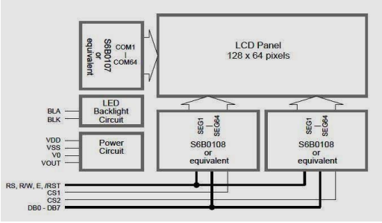
Block diagram for the LCD screen
LCD Display
Liquid crystal display(LCD) are passive display technology.By manipulating this light ,they display images using very little power.This has made LCDs the preferred technology whenever Low power consumption and compact size are critical. This LCD is used for display the value of all parameter at control panel room.
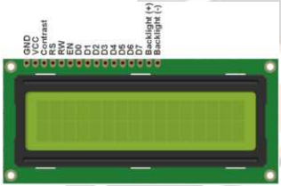

RGB LED
The 5050 LED strip SMD is employed for indication purpose. In this there can be many colour combinations which can be used for different situations. For example, different colour for different authorities will help in easy recognition of leaders and groups during outage inside the coal mines.

5.1.8 Node MCU
Node MCU is the call of a specification for a collection of high degree communique protocols the use of small, lowstrength virtual radios primarily based at the popular for wi-fi non-public place networks (WPANs), including wi-fi headphones connecting with mobile phones thru short-variety radio. The generation is supposed to be less complicated and less expensive than other WPANs, together with Bluetooth. node MCU is targeted at radiofrequency.And range is 30meters. (RF) applications that require a low statistics charge, lengthy battery lifestyles, and relaxed networking.
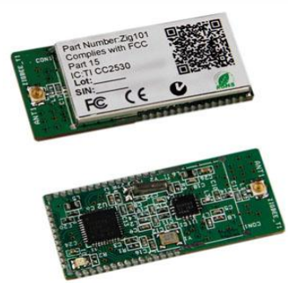

5.2 Temperature and Humidity Sensor
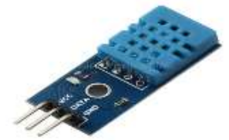
As per requirement of the coal mine or the condition of the coal mine there is balance between temperature and humidity so we are selecting DHT11 .The DHT11 is a basic, ultra low-cost digital temperature and humidity sensor. It uses a capacitive humidity sensor and a thermistor to measure the surrounding air, and spits out a digital signal on the data pin (no analog input pins needed). It‟s fairly simple to use. The only real downside of this sensor is you can only get new data from it once every 2 seconds, so when using our library, sensor readings can be up to 2 seconds old.

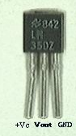
The LM35 series are precision blanketed-circuit temperature sensors, whose output voltage is linearly proportional to the Celsius (Centigrade) temperature. The LM35 due to this has a bonus has a bonus over linearoutput to attain reachable Centigrade scaling.The LM35 does now not require any out of doors calibration or trimming to offer popular accuracies of ±1⁄four°C at room temperature and ±three⁄four°C over a complete −55 to +150°C temperature variety. Low price is confident through trimming and calibration on the wafer stage. The LM35’s low output impedance, linear output, and particular inherent calibration make interfacing to readout or manipulate circuitry specially easy.It can be used with single strength additives, or with plus and minus elements. As it attracts handiest 60 μA from its supply, it has very low self-heating, plenty much less than zero.1°C in however air.

TECHNICAL DETAILS
- Low cost
- to 5V power and I/O
- 2.5mA max current use during conversion (while requesting data)
- Good for 20-80% humidity readings with 5% accuracy
- Good for 0-50°C temperature readings ±2°C accuracy.

Vibration Sensor

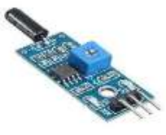
SW-18010P
SW-18010P series are spring type, no directional vibration sensor trigger switch, any angle can trigger. Switch is open circuit OFF-state, when it is static, when external force to touch and corresponding vibration, or movement speed achieve adequate (partial) centrifugal force, conductive pick feet will produce instant conductivity is instant ON-state, when external force disappear, switch back to open circuit OFF-state .Switch have the identification P at the bottom, for completely airtight; In the normal, switch life can reach 20,0000 cycles lifespan. This series Switches have trigger high sensitivity Apply to security devices toys electronic scales productswhen external force to touch and corresponding vibration, or movement speed achieve adequate (partial) centrifugal force, conductive pick feet will produce instant conductivity is instant ON-state.
TECHNICAL DETAILS
- Voltage: <12v
- Current:<50Ma
- Operating lifespan :above 50000 hour

5.3 Arduino Uno
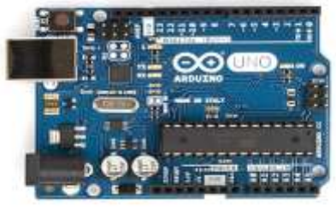
Arduino Uno is a microcontroller board.It has 14 digital input/output pins(of which 6 can be used as PWM outputs), 6 analog inputs, a 16 MHz quartz crystal, a USB connection, a power jack, an ICSP header and a reset button. It contains everything needed to support the microcontroller; simply connect it to a computer with a USB cable or power it with a AC-to-DC adapter or battery to get started. The Arduino Uno can be powered via the USB connection or with an external power supply. The power source is selected automatically. The board can operate on an external supply of 6 to 20 volts. We are using the 12V supply for Arduino. The Arduino Uno has a number of facilities for communicating with a computer, another Arduino, or other microcontrollers.The Arduino software includes a serial monitor which allows simple textual data to be sent to and from the Arduino board. The RX and TX LEDs on the board will flash when data is being transmitted via the USBto-serial chip and USB connection to the computer (but not for serial communication on pins 0 and 1). A Software Serial library allows for serial communication on any of the Uno‟s digital pins.Arduino is programmed by using the software „Arduino‟.The main function of Arduino in our project is to receive the signal from sensors and send the signal to Xbee.
5.4 Xbee Trans-Receiver

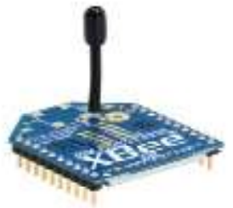

While considering that we have to give signal so the communication is essential. So for better communication we are wireless network and transmitting and receiving signal by using Xbee.This are the advance way for communication which give very fast communication rather than wired communication. Now we are selected XBEE 2mw wire antenna series 2 improve on the power output and data protocol. Series 2 allow you to create complex mesh network based on Xbee mesh firmware. These modules allows a very reliable and simple communication between Arduino, computer system really with serial port .Point to point and multipoint network are supported.
X-Bee is a remote correspondence attempted to the node MCU standard. X-Bee is a microcontroller made by Digi which uses the node MCU tradition. Digi X-Bee is the brand name of a gathering of shape factor culminate radio modules from Digi International. The primary X-Bee radios were displayed under the Stream stamp in 2005 and relied upon the IEEE 802.15.4-2003 standard planned for point-to-point and star trades at over-the-air baud rates of 250 K bit/s. X-Bee interfacing module is used to interface X-Bee remote module to any change board easily because of clear dispatch affiliation. It has locally accessible 3.3V low drop voltage controller and LED markers for RSSI, Associate and Power. Relationship with RX, TX, VIN and GND of the X-bumble bee Adaptor module are available particularly on the relimate. It can be particularly connected with headway sheets by methods for relimate connector.
TECHNICAL DETAILS
- 3.3v @ 40mA
- 250kbps max data rate
- 2mw output
- 400ft(120m ) Range
- 8digital I/O pins
- Built-in antenna
LED Light

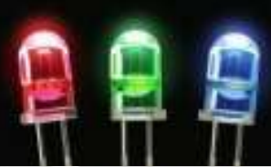

A light emmiting diode (LED) is essential a PN junction semiconductor diode that emites light when current is applied .It is the solid state device that controls current without heated elements and is therefore very reliable. LEDs are highely monocromatic,emmiting a pure colour in a narrow frequency range. LEDs are made up from galliumbased crystal that contain one or more additional materials such as phospherous to produce a distinct colour.
TECHNICAL DETAILS
- Light output - 1400 Lumen
- Beam angle- 150 degree
- CRI-80
- Starting time- <0.5

Buzzer
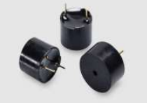
This buzzer is used in our project is that to indicate the dangerous conditions occur in the coal mine. The buzzer exhibits the reverse piezoelectric effect.The normal piezoelectric effect is generating electricity from sequencing a crystal. The buzzer is also called beeper is an audio signaling device. Which may be mechanical, electromechanical, or piezoelectric, Typical use of buzzers and beepers include alarm device ,timer etc.

5.5 SOFTWARE DESIGN
In this proposed contrivance, as we tend to used LPC2148 we wish to use following software package instrumentation to program for it.
1. Keil4 Vision
2. Flash Magic
The Keil4 Vision an IDE for Embedded c program language period. In this IDE, we preference to import the utilities and libraries constant with the controller. This IDE may be very extra with out problem and in customer great way to follow, assemblers, and debuggers in it. It simplifies the way of embedded simulation and trying entering into conjunction with Hex file era. The flash magic is programming software. The C/C++ software written in IDE could be processed into Hex record i.E. In Hex layout. By the use of hex report we have a tendency to products the code into microcontroller and carry out utility.
System software design mainly includes upper computer software and lower computer, the monitoring part of upper computer is developed in Visual C++, lower computer software is programed in C language under Jennic CodeBolcks compiler and debugger. CodeBolcks supports the functions of codes auto-completion, project management, and visually debugging. Operating system used by embedded software is Basic Operting System[10]. Lower computer software is generally composed of the following parts: main module, communication module, data acquisition modules, node MCU sending module, central node service module etc.. Main program module calls other modules to complete the business logic operations; Communication module establishes a data link between nodes; Data acquisition module collects data; node MCU module packages and sends the digital; Central node service module uploads data to the server, packs data and sends it to monitoring center in accordance with RS485 communication protocol.
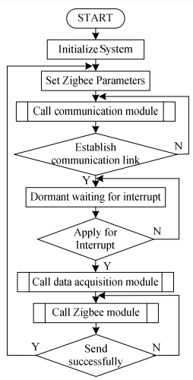
A. Embedded C Programming
Embedded c is a set of language extension for the C Programming language by the C Standards committee to address commonality issues that exist between C extensions for different embedded systems. Historically embedded C programming requires nonstandard extensions to the C language in order to support exotic features such as fixedpoint arithmetic, multiple distinct memory banks, and basic I/O operations.
B. Labview Software
Lab VIEW is an integrated development environment design specifically for engineers and scientist. Native to lab VIEW is a graphical programming language that uses a data flow model instead of sequential lines of text code, empowering us to write functional code using visual layout that resembles our thought process.

The helmet section has a sensor network which includes the sensors like- gas sensor for hazardous gas detection, in our case; it detects carbon monoxide concentration, an Infrared (IR) sensor to detect the removal of helmet by the miner. Pressure sensor is used to detect the fall of an object on the miners head and humidity sensor to check the humidity of the mining environment. Data processing module (ARM7 LPC2148) collects the sensed data and alerts the particular miner who has encountered the hazardous event. Data is transmitted through the wireless node with the help of node MCU module. To inform the other miner that his coworker is encountering a dangerous situation, he will be given alert through the node MCU wireless transmission by flashing a helmet light for few times. Through the wireless transmission, data is also sent to the ground monitoring station, where it uploads data to the cloud for graphical visualization and also it generates alert message to the authorized personnel regarding the detected hazardous event.
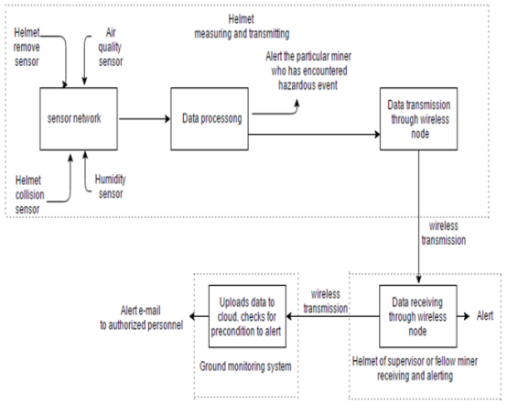
Air Quality Sensor
In coal mines, air pollution is primarily caused by the discharge of particulate matter (atmospheric pollutant) and a gas consists of methane (CH4), sulphur dioxide (SO2), and nitrogen oxides (NO2), in addition to carbon monoxide (CO). When humans are exposed to these toxic gases, it could cause negative response on their well-being. These uneven proportions of air deterioration gases and suspended particulate matter; surges respiratory disorder like asthma, cardiovascular problems, and chronic bronchitis. In this project the concentration of CO is measured using MQ7 sensor, it is a digital sensor, it only produces binary values as outputs, i.e. 1 indicates CO gas is detected and 0 indicates CO gas not detected.
Air Pollution Sensor
Air pollution from coal mines is mainly due to emissions of unmistakable matter and gases insert methane (CH4), sulphar dioxide (SO2), and oxides of nitrogen (NO2), as well as carbon monoxide (CO). From different studies, it is well known that when human being comes in contact these chemicals/pollutants it could have adverse effect on their health. MQ-2 gas sensor is used to detect hazardous gases, it has high flammable to Propane, Butane and LPG, also response to Natural gas. The sensor could be used to determine feedback different combustible gas, abnormally Methane, it is with low cost and advisable for different function.
Helmet Removal Sensor
To recognize whether a mine worker has removed his protective helmet or not, a helmet removal technique based on infrared ray sensor is used. An Infrared sensor is laid out to transmit a continual signal from one end, if the signal is obstructed, then it means that the miner is wearing a helmet else he is not wearing it. For detecting the removal of the helmet a few different approaches were considered. The comparison, advantage, and disadvantage of the proposed approaches in the literature was reported in [1]-[10]. For this study, the IR beam-based helmet remove sensor technique was considered better among other available techniques such as a switch, analogue distance sensor, and digital distance sensor. The IR beam can be designed to use low amounts of power. An off-the-shelf IR distance detector was used for this application. The IR sensor was designed to send a constant signal from the one side of the helmet to the other side with thecircuit.
Collision Sensor
In order to detect strike of on object on miners head and its severity, a pressure sensor is used. Pressure is nothing but force applied on an object per unit area, according to brain and neck injury criteria 25 psi (pound per square inch) of pressure on head causes moderate injury and 34 psi of pressure causes severe injury for head. In this project, MPS-2000 pressure sensor is used to detect pressure, which is UART and 8 bit data output sensor.
Wireless Transmission
In order to communicate among various nodes node MCU module is used. The connectivity of node MCU to ARM 7 microcontroller (helmet section) and to Raspberry PI module (monitoring section). A node MCU module is used in our implementation because its signal band has the capability to penetrate through walls and it works okay in mines. With node MCU we can also build a larger mesh network, access points and routers can also be realized. Wi-Fi is frequently used in mines for communicating, however it needs cabling all over the mine to build routers, that can be impaired. node MCU based devices can be constructed to work in various network topologies being star, cluster tree, mesh and light mesh, are most frequently used topologies.
node MCU was created to be a low power, low data rate and a lowcost device. node MCU has all the same benefits as a Wi-Fi system. A node MCU module is also more useful for construct larger mesh networks than Bluetooth and is therefore the better option when routers and access points cannot be completed. Based on the situation, other transmission technologies like wifi and lifi is used to get better results.

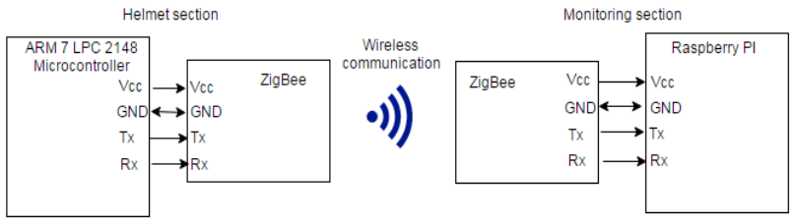

CC2500 RF module is used in this project for wireless communication between helmet section and reporting section. It provides a simple to use radio frequency communication at 2.4 GHz. A baud rate of 9600 is used to transmit and receive data and this RF module does not require no extra coding and any extra hardware to work in half duplex mode i.e. communications in both direction are possible, but just one at same time.
Data Processing Unit
The project is mainly divided into two sections; helmet section and monitoring section, ARM7 LPC2148 microcontroller (see Annexure) is used as a data processing unit in helmet section, it is a 32 bit 12MHz and 64 pin microcontroller. ARM 7 is a Reduced Instruction set Computing (RISC) based architecture, it means that it require significantly fewer transistor than the typical processor in average computers. This approach reduces the cost, heat dissipation and power usage. The LPC2148 incorporates 512 KB flash memory system both for code and data storage. It also has a SRAM data memory of 32 Kbytes and 10 bit analog to digital converter. The code for helmet section is written in embedded C language using keil μVision3 IDE. Later on building the source code, .hex file will be automatically generated in the project folder. .hex file will be used to burn the controller LPC2148. Flash magic is a tool used for burning the .hex files to LPC2148 microcontroller. From now onwards whenever the microcontroller is started, it gets loaded with the code which is dumped. In monitoring section Raspberry pi is used as a controller, which runs on Raspbian operating system. The receiving end of the node MCU is connected to Raspberry pi controller; the data is received through node MCU in the form of serial communication. The received sensor data is directly uploaded to ThingSpeak cloud for graphical visualization. This section also consists of an automatic alert e-mail generation system, where an automatic e-mail will be generated and sent to authorized personnel if the sensor values are out of the specified range.
Alerting unit
Since the underground is very dark sites, the workers will be provided with a protective helmet with an inherent light in it. Considering the normal working condition in the underground mines, alerting the user about the hazardous event is a tough process. Alerting the miners about hazardous event with an alarm or speaker would not work as they will be working with machinery that generates loud noise. So the idea is to use an existing mining light on the helmet to alert the miner by blinking it for few times. By this way one can easily identify the location of the miner who is experiencing a dangerous event. Monitoring section also contains alerting unit, where a python code is written to generate and deliver an automatic e-mail to authorized personnel if the sensed sensor values are out of specified range.
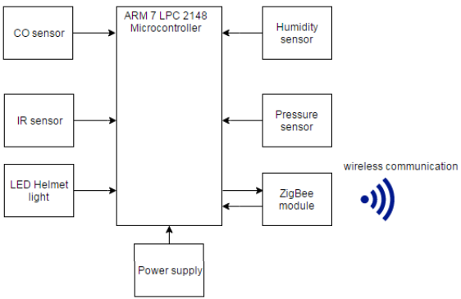
The helmet section of the design. Here in this section, it consists of four sensors carbon monoxide sensor, humidity sensor, IR sensor and pressure sensor. These sensors senses environment for data. The sensed data will be received by ARM 7 LPC 2148 microcontroller, microcontroller converts sensed data into digital format with the help of 10 bit ADC. It matches data from 0 to 1023. The matched data will be converted into string and is sent wirelessly to monitoring section.
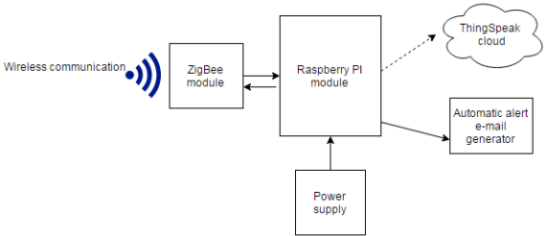

It consists of node MCU module, Raspberry pi controller. The data from the helmet section is received wirelessly by node MCU module. This data is collected by Raspberry pi controller and the data will be uploaded to ThingSpeak cloud for graphical representation. Simultaneously the data will be monitored by raspberry pi module and if it finds that the sensed data is out of specified range, then an automatic alert e-mail is generated and will be delivered to authorized personnel.

CHAPTER 6
RESULT & DISCUSSION
CONCLUSION
The proposed system has been successfully tested and has shown quick response to the hazardous parameters variation. We can conclude that this system will greatly help in reducing future casualties caused by sudden changes in these parameters and help make the work safer. The compact and efficient design ensures the practical implementation of the system. The system was tested for following predetermined range. However, depending on the environment of various coal mines, it can be changed according to the requirements using easy software editing.
FUTURE SCOPE
In the present work, it has been used to sense and monitor various hazardous parameters particular to an underground coal mine which can warn the workers and send the data to ground station via RF for help. However this technique can further be extended for other applications as well.
Some of the other applications of this smart system are:
- Health monitoring of underground coal mine workers.
- Last Location detection via RF with pings at predefined locations.
- Send help signal using RF if any emergency arrives

REFERENCE

[1] Pranoti Anandrao Salankar, Sheeja S. Suresh, “Zigbee Based Underground Mines Parameter Monitoring System for Rescue and Protection” . IOSR Journal of VLSI and Signal Processing (IOSR-JVSP) Volume 4, Issue 4, Ver. I (JulAug. 2014), PP 32-36 eISSN: 2319 – 4200, pISSN No. : 2319 – 4197

[2] CHENG Qiang, sun ji_ping, zhangzhe, zhang IEEE paper on “Zigbee based intelligent helmet for coal miners”, February [2009] CSIE2009.653

[3] Tanmoymaity, parthasarathidas, mithumukherjee, “Rescue and protection system for underground mine workers based on zigbee” vol.2 no.2 [June_December,2012] int.jr.of advanced computer eng. & architecture.

[4] A. Geetha, “Intelligent Helmet for Coal Miners with Voice over Zigbee and Environmental Monitoring” MiddleEast Journal of Scientific Research 20 (7): 825-827, 2014 ISSN 1990- 9233- 2014

[5] Shirish Gaidhane1, Mahendra Dhame, Rizwana Qureshi, “Smart Helmet for Coal Miners using Zigbee Technology” Imperial Journal of Interdisciplinary Research (IJIR) Vol-2, Issue6, 2016

[6] S. Wei, L. Li-li, “Multi-parameter Monitoring System for Coal Mine based on Wireless Sensor Network Technology”, Proc. International IEEE Conference on Industrial Mechatronics and Automation, pp 225-27, 2009.

[7] S. Jin-ling, G. Heng-wei, S. Yu-jun, “Research on Transceiver System of WSN Based on VMIMO Underground Coal Mines”, Proc. International Conference on Communications and Mobile Computing, pp 374-378, 2010.

[8] X. Ma, Y. Miao, Z. Zhao, H. Zhang, J. Zhang, “A novel approach to Coal and Gas Outburst Prediction Based on Multi-sensor Information Fusion”, Proc. IEEE international conference on automation and logistics, pp 1613-18, China 2008.

[9] Tanmoy Maity, Partha Sarathi Das, Mithu Mukherjee, "A Wireless Surveillance and Safety System for Mine Workers based on Zigbee", First International Conference on Recent Advances in Information Technology, RAIT, 2012.

[10]G. Ahalya et al “Development Of Coal Mine Safety System Using Wireless Sensor Networks”[IJESAT] [International Journal of Engineering Science & Advanced Technology] Volume-3, Issue-3, 74-78 ISSN: 2250-3676

[11]Y.P. Zhang, G. X. Zheng, J. H. Sheng, “Radio Propagation at 900 MHz in Underground Coal Mines”, IEEE transactions on antennas and propagation, vol.49(5), pp. 752-62, 2001.

[12] Wei Yang, Ying Huang, "Wireless Sensor Network Based Coal Mine Wireless and Integrated Security Monitoring Information System", Proceedings of the Sixth International Conference on Networking (ICN'07), IEEE, 2007.

