FUZZY LOGIC CONTROL FOR SOLAR PV FED MODULAR MULTILEVEL INVERTER TOWARDS MARINE WATER PUMPING APPLICATION

ABSTRACT- This paper presents the plan and execution of Modular Multilevel Inverter (MMI) to control the Induction Motor (IM) drive utilizing astute strategies towards marine water siphoning applications. The proposed inverter is of eleven levels and can handle the speed of an IM drive which is taken care of from sun oriented photovoltaics. It is assessed that the energy consumed by siphoning plans in an installed transport is almost half of the complete energy. Taking into account this reality, this paper examines and approves the proposed control plan with diminished intricacy planned for marine water siphoning framework utilizing an acceptance engine (IM) drive and MMI. The investigation of inverter is done with Proportional-Integral (PI) and Fuzzy Logic (FL) based regulators for working on the presentation. A similar examination has been made concerning better strength as far as pinnacle overshoot, settling season of the regulator and Total Harmonic Distortion (THD) of the inverter. Recreations are attempted in MATLAB/Simulink and the nitty gritty exploratory execution is led with Field Programmable Gate Array (FPGA). The outcomes hence acquired are used to examine the regulator execution, further developed inverter yield voltage, dependable enlistment engine speed control and power quality improvement by decrease of sounds. The oddity of the proposed control plot is the plan and mix of MMI, IM drive and canny regulator only for marine water siphoning applications.

INTRODUCTION

In around the world, significant endeavors been taken by the oceanic and transportation businesses to crumble the degree of air outflows and energy utilization. The discouragement of contamination in the marine climate and unintentional causes are totally trailed by specific guidelines which are outlined by International Convention for the Prevention of Pollution from Ships association (MARPOL). Because of environmental change and worldwide ozone harming substance emanations, the transportation contribute around 3% of worldwide CO2 discharges from diesel motors associated with marine areas. The marine delivery diesel motors discharges 2.8% of Carbon dioxide (CO2), 15% of Nitrogen Oxides (NOX), 13% of Sulfur Oxides (SOx) which are the main gases required to contaminate the environment. The United Nations Framework Convention on Climate Change (UNFCCC) and the International Maritime Organization (IMO) completely explored and outlined the guidelines and guidelines for the decrease of CO2 outflows by the delivery business. Notwithstanding the developing worldwide energy emergency brought about by the consumption of regular energy sources, it likewise include by and large in the emanation of unsafe poisons in air and water. The use of diesel motors in the boat transmits ozone harming substance and CO2 outflows are steadily expanded, and it arrived at 8% in the year 2020. To beat the issues looked because of ecological contamination in the boat business, an insurgency advanced towards the execution of sunlight based ability to give clean power from environmentally friendly power energy sources. Inspite of an always expanding worldwide interest for electrical power inferable from the expanding overall populace, the general longing for sun based energy alongside further developed power nature of an inverter are the need of great importance. The exhaustion of customary energy sources causes the developing worldwide energy emergency. In any case, it likewise brings about the nursery impact prompting an Earth-wide temperature boost. The temperature of the earth surface is relied upon to increment by 3◦C to 6 ◦C inside the finish of this century. Sun based power is normally the most ideal decision for the vast majority of the rural and marine applications as it requires lesser measure of upkeep, offer commotion free tasks because of the shortfall of moving parts and consumes less space at housetops in the boat. The sun based photovoltaic's based energy framework is executed in transport which conveys the expected power joining an original strategy to diminish discharges to expand the sustainable power productivity and furthermore to liven up the solidness of force.
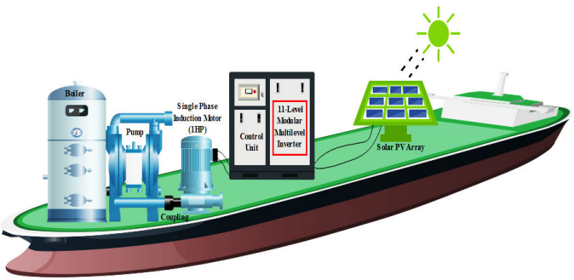
The sun based energy source is incorporated with power electronic converter and inverter to interact diverse high power loads. As of late, a wide scope of investigation in the advanced boat is locked in with relationship of environmentally friendly power coordinated power converters. The two basic issues happened in power converter are voltage diversion and recurrence deviations which prompts music mutilations. The siphoning frameworks in the boat consume around 70% of in general electrical energy. In transport power gadgets, converter is a significant square utilized for the impetus of engine drives frameworks yet endures a great deal with the mishap on sounds. The proposed work explores the new advancements in measured inverter, which is utilized to further develop power quality in the boat by diminishing music with help of an astute regulator.

PROBLEM STATEMENT :

The fluffy rationale regulator defeats the issue of vacillation of MPP around the working point in bother and perception technique (P&O) talked about. Regardless of this benefit, it represents a difficult issue in keeping a consistent result voltage conveyed to the buyers and furthermore fulfilling the framework association codes. The sizes of the DC voltages at MPP are closer to one another for PV modules having different illumination or temperature. Furthermore, it is liberated from the voltage adjusting issue since it doesn't contain DC connect capacitors. Then again, the different DC sources can be supplanted either by independent sustainable power sources with discrete converters or by single environmentally friendly power sources with multioutput converters where the voltage adjusting is the central issue.

LITERATURE REVIEW

H.LAN, Y.BAI, S. WEN, D.C.YU, Y.-Y.HONG, J.DAI, AND P.CHENG
“MODELING AND STABILITY ANALYSIS OF HYBRID PV/DIESEL/ESS IN SHIP POWER SYSTEM”
Due the worry about genuine natural contamination and fossil energy utilization, bringing sun oriented age into transport power frameworks has drawn more noteworthy consideration. In any case, the infiltration of sun based energy will bring about transport power framework precariousness brought about by the vulnerabilities of the sunlight based light. Dissimilar to ashore, the power produced by photovoltaic (PV) modules on the shipboard changes as the boat rolls. In this paper, a fast flywheel energy capacity framework (FESS) is displayed to smooth the PV power changes and further develop the power quality on an enormous oil big hauler which contains a PV age framework, a diesel generator, a FESS, and different kinds of boat loads.

R.KUMAR AND B.SINGH,
“SINGLE STAGE SOLAR PV FED BRUSHLESS DC MOTOR DRIVEN WATER PUMP”
To improve the sun based photovoltaic (PV) created power utilizing a most extreme power point following (MPPT) strategy, a DC-DC change stage is typically expected in sun based PV took care of water siphoning which is driven by a brushless DC (BLDC) engine. This power transformation stage prompts an expanded expense, size, intricacy and decreased productivity. As a one of a kind arrangement, this business locales a solitary stage sun powered PV energy transformation framework taking care of a BLDC engine siphon, which takes out the DC-DC change stage. A straightforward control method fit for working the sun oriented PV exhibit at its pinnacle power utilizing a typical voltage source inverter (VSI), is proposed for BLDC engine control.

C.-L.SU, W.-L.CHUNG, AND K.-T.YU,
“AN ENERGY-SAVINGS EVALUATION METHOD FOR VARIABLE-FREQUENCY-DRIVE APPLICATIONS ON SHIP CENTRAL COOLING SYSTEMS”
Variable-recurrence drive (VFD) applications are continuously being perceived by sea businesses as perhaps the best apparatuses for energy saving. Huge energy advantage can be acknowledged from VFD-driven focal seawater cooling frameworks in light of the fact that the encompassing seawater temperature fluctuates incredibly as boats travel through various ocean regions. Prior to settling on a choice with regards to which drive to pick, data about the genuine energy and cost reserve funds is required. A basic and quick strategy that can really decide the energy investment funds for intently assessing the financial aspects for their application is fundamental. This paper targets introducing a quick technique for working out energy investment funds that would come about because of introducing VFDs on the seawater cooling siphons on ships. The boat fundamental motor cooling framework and route climate qualities, including related marine gear, pipe assignment, encompassing seawater temperature, and so forth, are considered.

SYSTEM ARCHITECTURE :

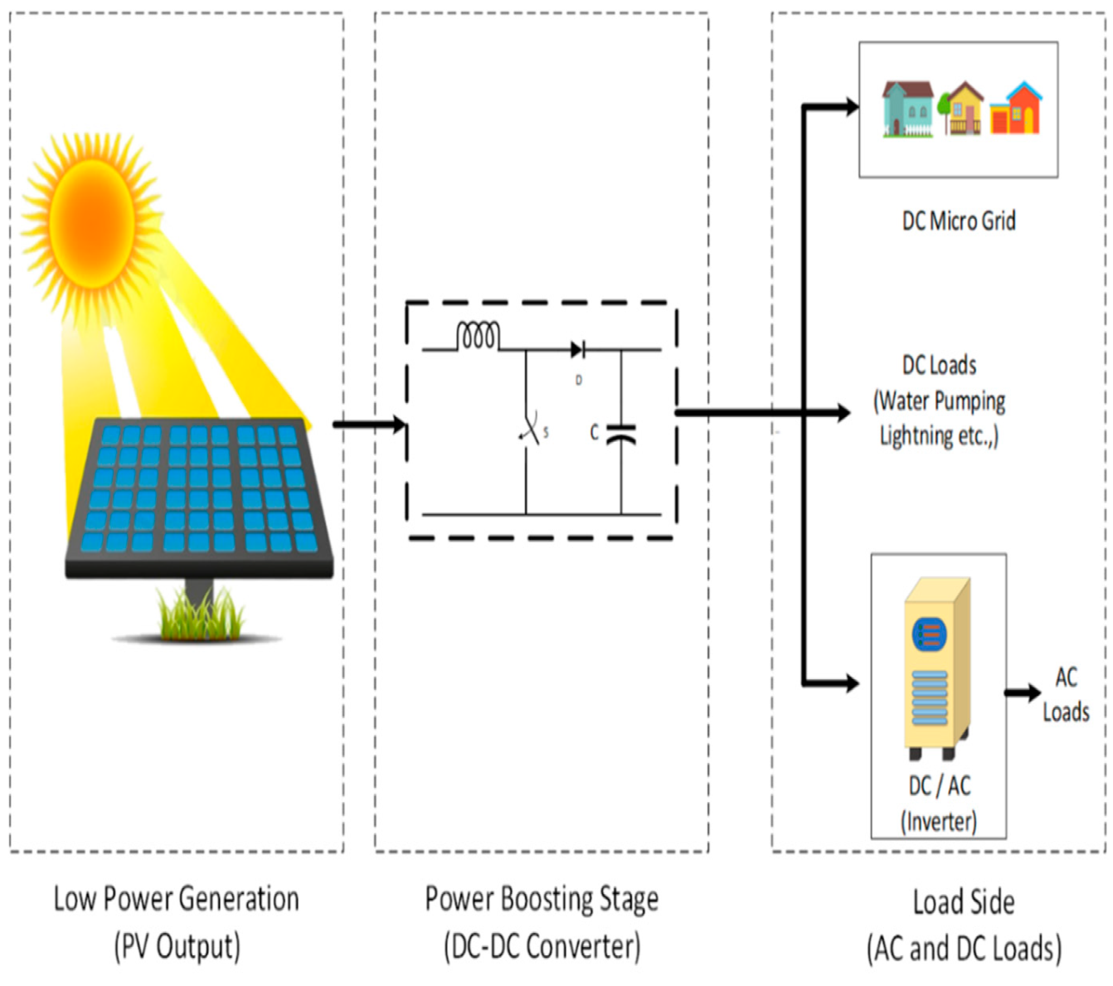

EXISTING SYSTEM

They planned a half breed framework with one inverter and the presentation was contrasted and the current methods.It has extremely viable procedures for convoluted and uncertain cycles where there doesn't exist any numerical model.The proposed strategy comprises of subbing the hysteresis regulators and the look-into table by fluffy rationale exchanging vector determination scheme.The primary benefits of Fuzzy rationale regulator are adjusted to the nonlinear control order and not in view of the model of the enlistment machine.

PROPOSED METHODOLOGY
Thusly, the proposed framework associated PV power change framework creates seven-level result voltage and a sinusoidal result current which is inphase with the utility voltage and is taken care of into the matrix. This paper proposes a sun oriented power age framework to change over the dc energy produced by a sun based cell exhibit into ac energy that is taken care of into the utility. The proposed sun based power age framework is made out of a dc-dc power converter and a seven-level inverter.

CONCLUSION :

The importance of the proposed work is to give top caliber of information capacity to the inverter drive relating to marine water siphoning applications. A sun oriented PV took care of MMI for speed control of acceptance engine drive has been inspected at consistent state and dynamic practices to explore its appropriateness for water siphoning framework planned for the marine applications. The sun powered PV exhibit is associated with the proposed inverter when is then taken care of to an acceptance engine. The engine speed is detected and criticism is given to the regulator for producing ideal PWM beats for the inverter switches. The engine is turned over steadily and the speed is expanded to accomplish reference speed with help of PI and FL based regulators. The exhibition of PI and FL regulators for a practical activity is confirmed and results are thought about in both reenactment and analysis. The outcomes guarantee that the FL based regulator gives quick settling time and diminished music when contrasted and the PI regulator. The fundamental effect of the proposed control conspire is to lessen the consistent state blunder of the enlistment engine speed control and break down sounds at the result voltage of particular staggered inverter. On considering the quantity of parts expected for the proposed MMI, the Table 3 shows the relative examination on the quantity of semiconductor switches expected for the plan of MMI alongside those inverters accessible in the writing. The source, converter, burden, regulator and network are the significant parts of a DC microgrid.

REFERENCES

[1] H. Lan, Y. Bai, S. Wen, D. C. Yu, Y.-Y. Hong, J. Dai, and P. Cheng, ‘‘Modeling and stability analysis of hybrid PV/diesel/ESS in ship power system,’’ Inventions, vol. 1, no. 5, pp. 1–16, 2016.

[2] S. G. Jayasinghe, L. Meegahapola, N. Fernando, Z. Jin, and J. M. Guerrero, ‘‘Review of ship microgrids: System architectures, storage technologies and power quality aspects,’’ Inventions, vol. 2, no. 4, pp. 1–19, 2017.

[3] R. Kumar and B. Singh, ‘‘Single stage solar PV fed brushless DC motor driven water pump,’’ IEEE J. Emerg. Sel. Topics Power Electron., vol. 5, no. 3, pp. 1337–1385, Sep. 2017.

[4] S. Shukla and B. Singh, ‘‘Single-stage PV array fed speed sensorless vector control of induction motor drive for water pumping,’’ IEEE Trans. Ind. Appl., vol. 54, no. 4, pp. 3575–3585, Jul./Aug. 2018.

[5] C.-L. Su, W.-L. Chung, and K.-T. Yu, ‘‘An energy-savings evaluation method for variable-frequency-drive applications on ship central cooling systems,’’ IEEE Trans. Ind. Appl., vol. 50, no. 2, pp. 1286–1297, Mar./Apr. 2014.

[6] B. Singh, U. Sharma, and S. Kumar, ‘‘Standalone photovoltaic water pumping system using induction motor drive with reduced sensors,’’ IEEE Trans. Ind. Appl., vol. 54, no. 4, pp. 3645–3655, Jul./Aug. 2018.

[7] A. Dolatabadi and B. Mohammadi-Ivatloo, ‘‘Stochastic risk-constrained optimal sizing for hybrid power system of merchant marine vessels,’’ IEEE Trans. Ind. Informat., vol. 14, no. 12, pp. 5509–5517, Dec. 2018.

[8] H.-L. Tsai, ‘‘Design and evaluation of a photovoltaic/thermal-assisted heat pump water heating system,’’ Energies, vol. 7, no. 5, pp. 3319–3338, May 2014.

[9] M. G. Yu, Y. Nam, Y. Yu, and J. Seo, ‘‘Study on the system design of a solar assisted ground heat pump system using dynamic simulation,’’ Energies, vol. 9, no. 4, pp. 1–17, 2016.

[10] S. V. Giannoutsos and S. N. Manias, ‘‘A systematic power-quality assessment and harmonic filter design methodology for variable-frequency drive application in marine vessels,’’ IEEE Trans. Ind. Appl., vol. 51, no. 2, pp. 1909–1919, Mar. 2015.

