FUZZY LOGIC CONTROL FOR SOLAR PV FED MODULAR MULTILEVEL INVERTER TOWARDS MARINE WATER PUMPING APPLICATION

ABSTRACT

This paper presents the design and implementation of Modular Multilevel Inverter (MMI) to control the Induction Motor (IM) drive using intelligent techniques towards marine water pumping applications. The proposed inverter is of eleven levels and has the ability to control the speed of an IM drive which is fed from solar photovoltaics. It is estimated that the energy consumed by pumping schemes in an onboard ship is nearly 50% of the total energy. Considering this fact, this paper investigates and validates the proposed control design with reduced complexity intended for marine water pumping system employing an induction motor (IM) drive and MMI. The analysis of inverter is carried out with Proportional-Integral (PI) and Fuzzy Logic (FL) based controllers for improving the performance. A comparative analysis has been made with respect to better robustness in terms of peak overshoot, settling time of the controller and Total Harmonic Distortion (THD) of the inverter. Simulations are undertaken in MATLAB/Simulink and the detailed experimental implementation is conducted with Field Programmable Gate Array (FPGA). The results thus obtained are utilized to analyze the controller performance, improved inverter output voltage, reliable induction motor speed control and power quality improvement by reduction of harmonics. The novelty of the proposed control scheme is the design and integration of MMI, IM drive and intelligent controller exclusively for marine water pumping applications.

TABLE OF CONTENT
CHAPTER NO |  | TITLES | PAGE NO
 |  | ABSTRACT | ii
1 | 1.1 | INTRODUCTION | 1
 | 1.2 | CONTROL TOPOLOGY FOR MMI | 5
 | 1.3 | PV ARRAY | 10
 | 1.4 | FUZZY MPPT | 10
 | 1.5 | SEVEN LEVEL INVERTER TOPOLOGY | 12
 | 1.6 | CONTROL BLOCKS | 14
 | 1.7 | VOLTAGE REGULATION CONTROLLERS | 17
 | 1.8 | CONTROLLER MODELLING | 19
 | 1.9 | MPPT ALGORITHM | 23
 | 1.10 | CONTROL STRATEGY FOR THE STUDIED SYSTEM | 23
 | 1.11 | MULTILEVEL INVERTERS(MLIs) | 26
2 |  | LITERATURE SURVEY | 32
3 |  | METHODOLOGY | 37
 | 3.1 | EXISTING SYSTEM | 37
 |  | 3.1.1 EXISTING SYSTEM FLOW | 37
 | 3.2 | PROPOSED SYSTEM | 38
 | 3.3 | BLOCK DIAGRAM | 38
4 |  | PROJECT IMPLEMENTATION | 39
5 |  | RESULT | 40
6 |  | CONCLUSION | 44
 |  | REFERENCES | 45

CHAPTER 1

INTRODUCTION
In worldwide, considerable efforts been taken by the maritime and shipping industries to deteriorate the level of atmospheric emissions and energy consumption. The deterrence of pollution in the marine environment and accidental causes are strictly followed by certain rules which are framed by International Convention for the Prevention of Pollution from Ships organization (MARPOL). Due to climate change and global greenhouse gas emissions, the shipping contribute about 3% of global CO2 emissions from diesel engines involved in marine sectors. The marine shipping diesel engines emits 2.8% of Carbon dioxide (CO2), 15% of Nitrogen Oxides (NOX), 13% of Sulphur Oxides (SOx) which are the most significant gases involved to pollute the atmosphere. The United Nations Framework Convention on Climate Change (UNFCCC) and the International Maritime Organization (IMO) thoroughly investigated and framed the rules and regulations for the reduction of CO2 emissions by the shipping industry. In addition to the growing global energy crisis caused by the depletion of conventional energy sources, it also involve to a great extent in the emission of harmful pollutants in air and water. The usage of diesel engines in the ship emits greenhouse gas and CO2 emissions are gradually increased, and it reached 8% in the year 2020. To overcome the problems faced due to environmental pollution in the ship industry, a revolution progressed towards the implementation of solar power to provide clean power from green energy sources. Inspite of an ever-increasing global demand for electrical power owing to the increasing worldwide population, the overall desire for solar energy along with improved power quality of an inverter are the need of the hour. The depletion of conventional energy sources causes the growing global energy crisis. However, it also results in the greenhouse effect leading to global warming. The temperature of the earth surface is expected to increase by 3◦C to 6 ◦C within the end of this century. Solar power is usually the best choice for most of the suburban and marine applications as it requires lesser amount of maintenance, offer noise free operations due to the absence of moving parts and occupies less space at rooftops in the ship. The solar photovoltaic’s based energy system is implemented in ship which delivers the required power incorporating a novel technique to decrease emissions to augment the renewable energy efficiency and also to perk up the stability of power.
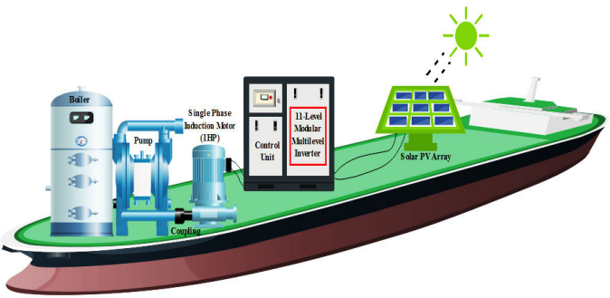

The solar energy source is integrated with power electronic converter and inverter to interface multifarious high power loads. Recently, a wide range of exploration in the modern ship is engaged with association of renewable energy integrated power converters. The two critical issues occurred in power converter are voltage digression and frequency deviations which leads to harmonics distortions. The pumping systems in the ship consume approximately 70% of overall electrical energy. In ship power electronics, converter is a major block used for the propulsion of motor drives systems but suffers a lot with the setback on harmonics. The proposed work investigates the recent developments in modular inverter, which is used to improve power quality in the ship by reducing harmonics with aid of an intelligent controller. The paper presents a novel symmetric multilevel module established on cascade category which does not require the necessity of any additional circuit to create negative voltage levels. A solar fed eleven level inverter with intelligent control techniques aimed to attain improved performance parameters for marine applications. The inverter is used to power the variable frequency drive of the seawater cooling pump mounted on the ship. The performance of the multilevel inverter fed IM drive is examined with PI and FLC based controllers. The proportional - integral (PI) controller is used in the majority of the speed control applications due to its better maximum peak overshoot and stability. The FLC is the simplest of all the intelligent controllers for induction motor speed control applications. The water is continuously pumped from morning to evening in the ship. Hence, the starting current and fixed voltage of an induction motor is to be maintained appropriately by controlling the inverter.
Conventional DC motors have commutation problems. To overcome the drawback of DC motor, induction motor is highly preferred in the ship. The seawater pumps adequately and satisfies the needs for the proper cooling of the fresh water. The proposed research work deals with single phase IM drive for marine water pumping, which is implemented with MMI topology in sustained control methods. The real-time implementation of speed control is governed by maximum solar power extraction in the atmospheric conditions. Besides, the switching frequency is gradually varied from the inverter is to control the speed of an induction motor. This is achieved by the optimized Pulse Width Modulation (PWM), which is generated with aid of modulating signal generated for a FL controller in enhancing the power quality. The simulation study involves the design of solar PV fed MMI powering an IM drive with PI and FL based controllers to enhance the overall performance of the system. The prototype model is developed with SPARTAN3E500 FPGA controller which generates the necessary pulses for both inverter and converter involved in the system.
The contributions made in the paper are illustrated as below:
- Investigating the performance of PI and FL based controllers to IM drive system for marine water pumping.
- Implementation of MMI fed IM drive in real time using SPARTAN3E500 FPGA controller.
- Comparative analysis of FL and PI based controllers towards the performance improvement in improving power quality.
The most considerable of these types are the diode clamped multi-level inverter (DCMI), the flying capacitor multi-level inverter (FCMI), the cascaded HBridge multi-level inverter (CHBMI), the magnetic coupled and the full bridge with cascaded transformers inverters. More recently, various novel topologies for seven-level inverters have been proposed. For example, a single-phase seven-level grid-connected inverter has been developed for a PV system.
The control structure of the grid-connected PV system is composed of two structure control
- The MPPT control, whose main property is to extract the maximum power from the PV generator,
- The inverter control,(i.e.) the main goal:
i. To control the active and regulate the reactive power injected into the grid.
ii. To control the DC bus voltage.
iii. To ensure high quality of the injected power.
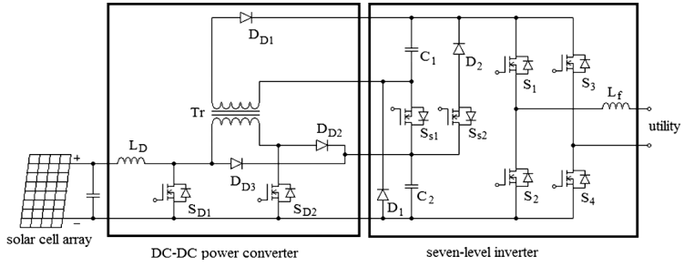
1.2 CONTROL TOPOLOGY FOR MMI
The structure of the solar PV fed IM drive for marine water pumping system employing an MMI. The proposed topology is to control the MMI using the PI and FL based controllers. The switching schemes of an inverter are governed by PWM with aid of intelligent control techniques to operate multilevel inverter and control the speed of an induction motor. The v/f control scheme is employed by varying the voltage, frequency along with the reference in Alternate Phase Opposition Disposition (APOD) under the category of multicarrier PWM methods. The five different triangular carrier waveforms (each out phase of 1800 ) are compared with the one sinusoidal reference waveform to generate the required PWM pulses as shown in Figure 4. The logic control and rule based techniques for both the controllers intend to generate the modulating signal which is then compared with the carrier to generate the dynamic pulses required for the inverter switches. The performance of IM with PI and Fuzzy controllers at constant and variable loads in open loop and closed loop operation are analyzed. The following sections describe the design and implementation of PI and FL based controllers in improving the performance of an IM drive operating along with MMI.
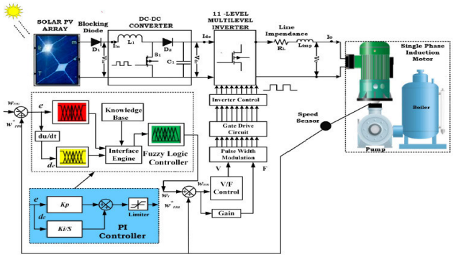
A. PI CONTROLLER BASED SPEED CONTROL
The PI based controller is generally implemented with any of the three different methods such as trial and error, evolutionary techniques based searching, Cohen Coon, Lambda tuning and Ziegler Nichols. In comparison of various methods for PI controller tuning, trial and error method is nominated due to its several benefits in detecting the gain parameters and better performance in motor drive applications.Typically, the comparator compares the actual (ωrm) and reference (ωrm∗) speed and the error (ωe(n)) thus obtained is used for tuning the parameters Kp and Ki . The error equation (ωe(n)) is given by, ωe(n) = ωrm − ωrm ∗ (16) 1ωe(n) = ω ∗ e −ωre(n−1) (17) The trial and error method mainly focused on two essential parameters in calculating the proportional and integral gain for motor drive applications. The numerical value of Kp and Ki attained from trial error method are 50 and 2, respectively. The objective of the PI controller is to minimize the error to enhance the driving performance.
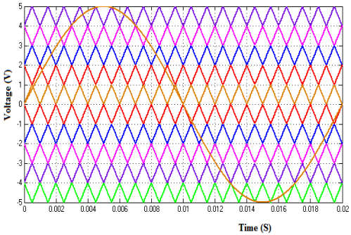
The objective of the closed loop PI controller has the superior performance while controlling the speed of an induction motor at constant torque. The proposed inverter (S1, S2, S3, S4, and S5) and (Q1, Q2, Q3, and Q4) switches are controlled by the v/f method. The switches S1 to S5 controls and operates the inverter while the other switches Q1 to Q4 convert the polarity changes of the inverter. The output of the inverter with constant v/f is fed into IM drive.
The open and closed control operation with PI controller has some limitations such as the rotor speed is slightly modified which is less than synchronous speed, stator current exceeds the rated current and slip speed cannot be maintained. These drawbacks of a PI controller mainly occur with fluctuating operative conditions. This limitation of the PI controller is overcome by FLC.
B. FUZZY LOGIC CONTROLLER
Fuzzy logic controller is a most efficient tool which is used to enhance the electrical apparatus through its fastness to evaluate the speed controller incorporating human thinking and rule based protocols. Generally, three methods are available for the control of induction motors namely,
- voltage/ frequency method,
- flux control Method and
- Vector control method.
In comparison with the speed control methods, closed loop v/f control method is characterized as best due to its simplicity and good accuracy. The proposed FL controller is intended to solve the two important main tasks:
- estimating induction motor speed and
- reducing error in speed using the rules based system and also deteriorating the harmonics.
The FL controller is designed with two inputs and one output. The error and change in error speed are considered as input and the modulating signal is taken as the output.
FL controller mainly follows the four necessary steps, such as:
- Analog fuzzifier converts input into fuzzy variables
- Stores fuzzy rules
- Inference and associated rules
- Defuzzifier converts the fuzzy variables into actual target
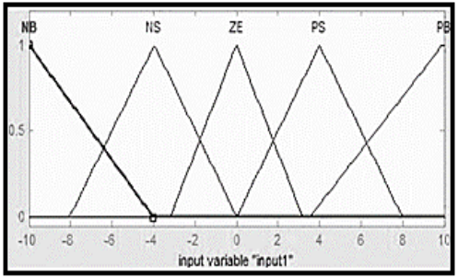
The input to the fuzzy operator has two or more relationship values from fuzzifier input variables. The output is a single truth value. If input 1 is declared to indicate the error means it while the input 2 indicates the changing error.
The linguistic variables contain eight fuzzy subsets in which five subsets are used which are described as follows:
(1) Negative error speed Big (NB)
(2) Negative error speed Small (NS)
(3) Positive error speed Small (PS)
(4) Positive error speed Big (PB) and
(5) Zero error speed (ZE)
If suppose the output is NS, it values up to 0.3416 such that the entire rule based membership functions work along with it. The output of the NB is 0.1, PB is 1, PS is 0.66 and ZE is 0.5 as illustrated in Figure 5. The input linguistic values range are NB = −1600, −10, −4, NS = −8.06, −3.96, 0.02646, ZE = −3.2, 0, 3.2, PS = 0, 4, 8 and PB = 3.52, 9.92,1550.
The 11 level MMI has 9 semiconductor switches (S1-S5) switches which are connected in parallel to (Q1-Q4) H bridge switches. The bipolar triangular and sine wave is compared to generate the PWM based upon the fuzzy rules. The pulses for S1 –S5 are inverter control pulses and Q1 to Q4 are level control pulses. FLC structure is fully designed by switching pattern of the inverter using switching pulse generator. The input fuzzification membership is designed (IN1-IN6). with switching magnitude range of (−1, 0, 1). Positive range from 0 to 1 represents the first quarter cycle (0◦ -90◦ ) and second quarter cycle (90◦ -180◦ ) respectively. Similarly, the negative range from −1 to 0 represents the third quarter cycle (180◦ -270◦ ) and fourth quarter cycle (270◦ -360◦ ). Later, in defuzzification, six membership functions are developed based on fuzzy rules to obtain the desired output.
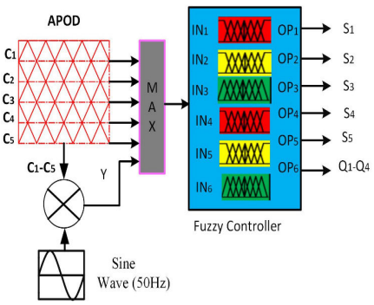
The paper illustrates the design and development of two controllers for water pumping application. The voltage and frequency are used to control the inverter. The speed of induction motor is controlled by v/f method.
1.3 PV ARRAY
The PV array used in the proposed system is KC200GT and it is simulated using a model based on Marcelo Gradella Villalva et al, (2009). In this model, a PV cell is represented by a current source in parallel with a diode and a series resistance.
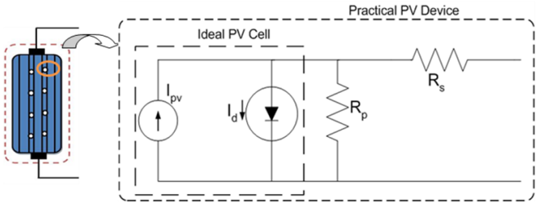
But practically the PV array comprised with many PV cells connected in series and parallel connection.
1.4 FUZZY MPPT
Conventional methods of MPPT are based on load line adjustment under varying atmospheric and load conditions. However, these uncertainties make MPPT less suitable for rapidly changing environmental conditions or parameter variations. The fuzzy logic controller overcomes the problem of fluctuation of MPP around the operating point in perturbation and observation method (P&O) discussed Shiqiong Zhou et al (2010). Fuzzy logic controllers (FLCs) are coming up in industrial processes owing to their heuristic nature associated with simplicity and effectiveness for both linear and nonlinear systems. Fuzzy Logic has also been implemented in Ravi et al (2011). The control inputs to the FLC are voltage error and change of errors, while the output is the change of control signal for PWM generator. Use of FLCs for the PV systems will relieve the burden involved in the design of controller parameters. In addition to this, these controllers will improve the tracking performance as compared with conventional controllers. The operation of this technique is explained in the block diagram. The use of fuzzy logic control has become popular over the last decade because it can deal with imprecise inputs, does not need an accurate mathematical model and can handle nonlinearity. The fuzzy logic consists of three stages: fuzzification, inference system and defuzzification. Fuzzification comprises the process of transforming numerical crisp inputs into linguistic variables based on the degree of membership to certain sets. Membership functions, like the ones in are used to associate a grade to each linguistic term.
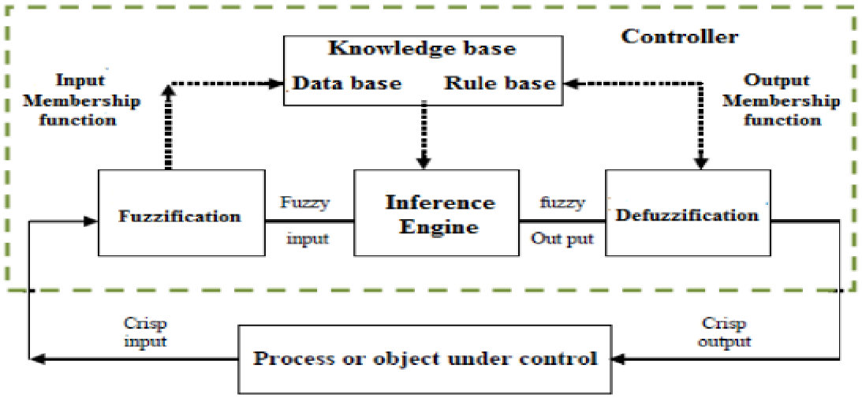
The number of membership functions used depends on the accuracy of the controller, but it usually varies between 5 and 7 discussed Esram et al 2007& S. Jain et al 2007. In Five fuzzy levels are used: NB (Negative Big), NS (Negative Small), ZE (Zero), PS (Positive Small), and PB (Positive Big). The values a, b and c are based on the range values of the numerical variable. In some cases the membership functions are chosen less symmetric or even optimized for the application for better accuracy. In this work the fuzzy inference rule is carried out by using Mamdani’s method. In accordance with, if the power (Ppv) increased, the operating point should be increased as well. FLC uses change in PV array Power (ΔPin) and change in PV array voltage (ΔVin) corresponding to the two sampling time instants to determine the duty cycle of converter.
1.5 SEVEN LEVEL INVERTER TOPOLOGY
In, the seven-level inverter is composed of a capacitor selection circuit and a full-bridge power converter, which are connected in cascade. The function of the seven-level inverter can be separated into the positive half cycle and the negative half cycle of the utility. For ease of analysis, the power electronic switches and diodes are assumed to be ideal, while the voltages of both capacitors C1 and C2 in the capacitor selection circuit are constant and equal to Vdc /3 and 2Vdc /3, respectively. Since the output current of the solar power generation system will be controlled to be sinusoidal and in phase with the utility voltage, the output current of the sevenlevel inverter is also positive in the positive half cycle of the utility. The operation of the seven-level inverter in the positive half cycle of the utility can be further divided into four modes.
Mode 1: At this mode, the output voltage of the seven-level inverter is directly equal to the output voltage of the capacitor selection circuit, which means the output voltage of the sevenlevel inverter is Vdc/3.The operation is shown in Fig.. Both the capacitor selection switches SS1 and SS2 are OFF, so C1 is discharged through D1 and the output voltage of the capacitor selection circuit is Vdc/3. S1 and S4 of the full-bridge power converter are ON.
Mode 2: The operation of mode 2. In the capacitor selection circuit, SS1 is OFF and SS2 is ON, so C2 is discharged through SS2 and D2 and the output voltage of the capacitor selection circuit is 2Vdc/3. S1 and S4 of the fullbridge power converter are ON. At this point, the output voltage of the seven-level inverter is 2Vdc/3.
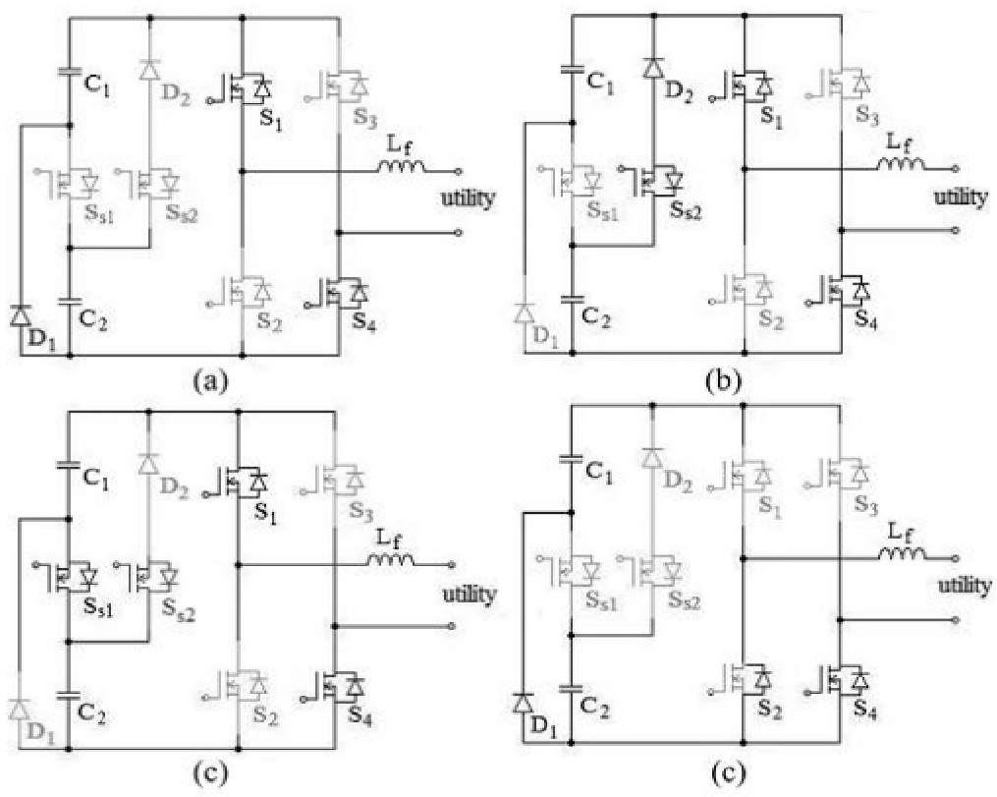
Mode 3: In this mode the capacitor selection circuit, SS1 is ON. Since D2 has a reverse bias when SS1 is ON, the state of SS2 cannot affect the current flow. Hence, SS2 may be ON or OFF, to keep away from switching of SS2. Both C1 and C2 are discharged in series and the output voltage of the capacitor selection circuit is Vdc. S1 and S4 of the full-bridge power converter are ON. At this point, the output voltage of the seven-level inverter is Vdc.
Mode 4: The operation of mode. Both SS1 and SS2 of the capacitor selection circuit are OFF. The output voltage of the capacitor selection circuit is Vdc/3. Only S4 of the full-bridge power converter is ON. Since the output current of the seven-level inverter is positive and passes through the filter inductor, it forces the anti-parallel diode of S2 to be switched ON for continuous conduction of the filter inductor current. At this point, the output voltage of the sevenlevel inverter is zero. Therefore, in the positive half cycle, the output voltage of the seven-level inverter has four levels: Vdc ,2Vdc/3,Vdc/3 and 0. In the negative half cycle, the output current of the seven-level inverter is negative. The operation of the seven-level inverter can also be further divided into four modes.
The seven-level inverter is controlled by the current-mode control, and pulse-width modulation (PWM) is use to generate the control signals for the power electronic switches. The output voltage of the seven-level inverter must be switched in two levels, according to the utility voltage. One level of the output voltage is higher than the utility voltage in order to increase the filter inductor current, and the other level of the output voltage is lower than the utility voltage, in order to decrease the filter inductor current. In this way, the output current of the seven-level.
1.6 CONTROL BLOCKS
A. DC-DC power converter
The control block diagram for the DC–DC power converter. The output of solar cell array is fed as a input to DC-DC power converter. The MPPT function is degraded if the output voltage of solar cell array contains a ripple voltage. Therefore, the ripple voltages in C1 and C2 must be blocked by the DC–DC power converter to provide improved MPPT.
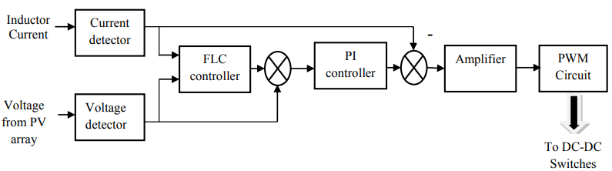
Accordingly, dual control loops, an outer voltage control loop and an inner current control loop, are used to control the dc– dc power converter. Since the output voltages of the DC-DC power converter comprises the voltages of C1andC2, which are controlled by the seven-level inverter, the outer voltage control loop is used to regulate the output voltage of the solar cell array. The inner current control loop controls the inductor current so that it approaches a constant current and blocks the ripple voltages inC1 and C2. The output voltage of the solar cell array and the inductor current are detected and sent to a MPPT controller to determine the desired output voltage for the solar cell array. Then the detected output voltage and the desired output voltage of the solar cell array are sent to a subtractor and the difference is sent to a PI controller.
The output of the PI controller is the reference signal of the inner current control loop. The reference signal and the detected inductor current are sent to a subtractor and the difference is sent to an amplifier to complete the inner current control loop. The output of the amplifier is sent to the PWM circuit. The PWM circuit generates a set of complementary signals that control the power electronic switches of the DC– DC power converter.
B. Inverter control
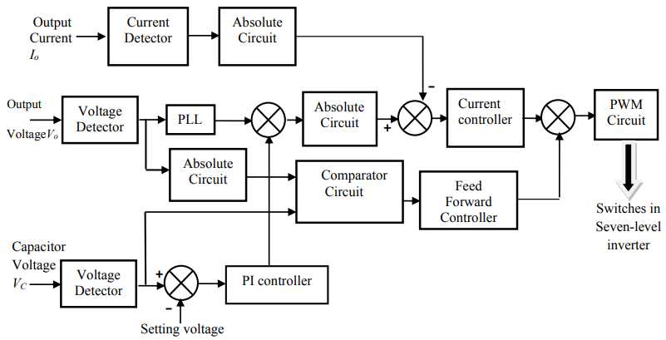
The control object of the seven-level inverter is its output current, which should be sinusoidal and in phase with the utility voltage. The utility voltage is detected by a voltage detector, and then sent to a phase-lock loop (PLL) circuit in order to generate a sinusoidal signal with unity amplitude. The voltage of capacitorC2 is detected and then compared with a setting voltage. The compared result is sent to a PI controller.
Then, the outputs of the PLL circuit and the PI controller are sent to a multiplier to produce the reference signal, while the output current of the seven-level inverter is detected by a current detector. The reference signal and the detected output current are sent to absolute circuits and then sent to a subtractor, and the output of the subtractor is sent to a current controller. The detected utility voltage is also sent to an absolute circuit and then sent to a comparator circuit, where the absolute utility voltage is compared with both half and whole of the detected voltage of capacitor C2, in order to determine the range of the operating voltage. The comparator circuit has three output signals, which correspond to the operation voltage ranges, (0,Vdc/3), (Vdc/3, 2Vdc/3), and (2Vdc/3,Vdc.
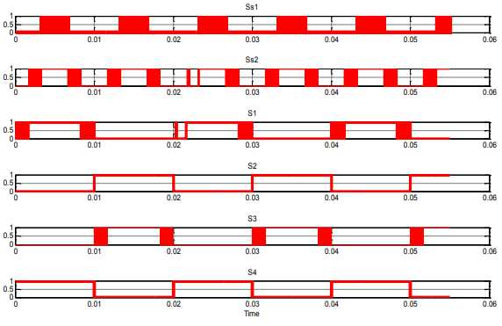
Then, the output of the current controller and the feed-forward signal are summed and sent to a PWM circuit to produce the PWM signal. The detected utility voltage is also compared with zero, in order to obtain a square signal that is synchronized with the utility voltage. Finally, the PWM signal, the square signal and the outputs of the compared circuit are sent to the switching signal processing circuit to generate the control signals for the power electronic switches of the seven-level inverter.
1.7 VOLTAGE REGULATION CONTROLLERS
In alternating circuits (AC) the load across the terminals need to be constant or adjustable. As the inverter in the solar power PV feeds into the terminal, the output voltage from the inverter needs to be controlled to meet the load in the AC circuits. Therefore, it is indispensable to ensure that deviations in the input DC voltage need to be compensated. This can be achieved on both DC and AC side with aid of controllers. PWM control can also be used for controlling the output voltage, which requires no external peripheral components. Unlike the conventional PWM schemes, modified PWM with advanced control topology is required to reduce the overall THD in improving the power quality. Besides, line and load regulation schemes to maintain the constant voltage can be performed whose expressions are given in Equations (1) and (2). However, these schemes are quite applicable to low power DC circuits. Line regulation = (1Vout/Vout) 1Vin × 100% (1) Load regulation = VNOLOAD−VFULLLOAD VFULLLLOAD ×100% (2) Capacitor voltage balancing is extensively considered for maintaining the balanced DC input voltage for the multilevel inverters. But these methods are useful for DCMLI (Diode Clamped) and FCMLI (Flying Capacitor) topologies which prevents the wide acceptance of these inverters in practical applications. The major advantage of CMLI is that it has no unbalanced problems since isolated DC source (solar PV array) is fed in each DC link.
In spite of this advantage, it poses a serious problem in maintaining a constant output voltage delivered to the consumers and also satisfying the grid connection codes. The magnitudes of the DC voltages at MPP are nearer to each other for PV modules possessing different irradiation or temperature. The usual variation is less than 15% and hence a suitable controller is required for the output voltage to be controlled at inverter end before it is fed to the consumers. The power quality improvement in inverters can be enhanced by many techniques. One way is to improve the power conversion with cascading the inverters, which results in lowering switching losses and improving power quality. The resultant inverter power is then converted into high-voltage at a lower frequency and a reverse of low-voltage at a higher frequency by cascading the inverters.
The renewable energy systems led to distributed generation systems coming into the picture with numerous households adopting to host solar power or micro-CHP and other technologies to sustain energy. As a result, the utility networks had to impose stricter standards to ensure power quality and protection from islanding and adapt to newer control strategies for reducing harmonics. In a bid to further reduce harmonic components in multilevel cascaded voltage source converters a new technique using Selective Harmonic Elimination Pulse Width Modulation (SHE-PWM) was tested on 3kVA prototype with an efficiency of 96%.
The medium or high power inverters often use optimal pulse width modulators as a contrivance for reducing the switching frequency leading to minimize the selective harmonic orders. Most of the selective harmonic algorithms are complex and based on linear equations resulting in inconsistencies.
In, a novel cascaded MLI using H-bridges was presented which involves reduced number of input DC sources and power switches with lesser blocking voltages. The mentioned features reduced the complexity and cost incurred for developing the inverter. In an effort to reduce the harmonics in a multilevel single phase transformerless grid connected system reference proposed a new model of synthesizing upto 9 voltage levels for improving the common mode leakage current and regulating voltage in the flying capacitor. The doubling of the output voltage level can improve the power quality in the inverter systems. This strategy was tested by Chattopadhyay et al. proposing a double level network (LDN) based multilevel inverter for reduction in inverter switching frequency. The topology uses a symmetrical H-bridge cascading while offering performance as equal to the asymmetrical system. The usage of three arm H-bridges greatly perk up the power quality while simultaneously decreasing the switching frequency, cost and size of the power filter. In grid-tied PV systems, the use of inverters as interface go ahead to stability and safety issues while also leading lower efficiency.
The shunt controller is proposed to reactive power absorption and delivering for voltage stability maintenance. An improvised model was adapted by Parija et al. using a dual extractor third order signal integrator. The model was tested on weak grids using the integrated system (WEGS (Wind energy generation system) + PV) with an outlook to enhance the fundamental components of load current and grid voltage by separating them for synchronization with the grid. This technique safeguards the entire system while mitigating various power quality issues like THD (Total Harmonic Distortion) and DC injection.
1.8 CONTROLLER MODELLING
The inverter operations are identical and analogous to a generator or a synchronous machine to a grid and most renewable energy resources like solar PV are connected to a DS (Distribution System). Since the power generated in a PV varies due to the irradiation absorption on the panel, the rated voltage can vary anywhere from −20% to +20% during the day. With the use of power electronic circuits, it is possible to ensure a stabilized DC voltage in the PV. Since transmission of grid voltage is in AC, the stabilized DC voltage is then inverted to AC. In line with this, the proposed experiment uses a suitable inverter with a maximum variation of 1% to ensure accuracy for a 48V, 7A solar panel with a ±20% variation.
A. FUZZY LOGIC CONTROLLER
The inherent characteristics of fuzzy logic are the values state has to be either 1 (ON) or 0 (OFF). The fuzzy logic varies from the Boolean logic due to its ability to accept two or more values between the true and false. Unlike the Boolean logic it accepts only true or false. Fuzzy logic helps in obtaining fixed conclusions from ambiguous, vague and imprecise information. The structure of the Fuzzy Logic Controller (FLC) used for performing VR in a solar PV fed cascaded H bridge multilevel inverter is exposed. Here, the output voltage (Vo) obtained from a fifteen level inverter output is then compared with the reference voltage (Vref), which is the preferred voltage to be achieved for the inverter in accordance with the grid requirements. The subsequent error, e = Vref − Vo and the rate of error change de/dt serves as input attributes for the FLC. The FLC consists of five major block set. They are fuzzifier, defuzzifier, inference system, rule base and database. Fuzzification in membership functions converts input data into degrees of membership. The commanding signal (or control signal) Cs obtained by the FLC is then contrasted with Vef to generate the modulating signal Ms required for PWM (pulse width modulation) generation, thereby afford the suitable gating signals to the semiconductor switches in the inverter power circuit.
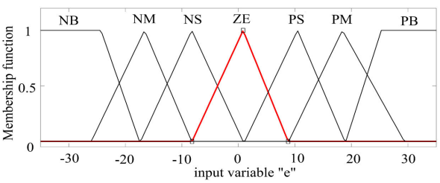

The fuzzy logic output is the reference signal formed from a membership function. The rule table with two inputs (error and its derivative signal) and one output (reference signal) is framed as a rule matrix. The fuzzy value is then converted to crisp value using a defuzzification procedure. The method adopted for the conversion is Centre of Gravity (COG). The 3-D visualization of input error and its derivative with output reference signal are exposed.
B. PI-BASED CONTROLLER
As similar to the FLC, the role of PI (Proportional-Integral) controller is to maintain the output voltage of the inverter constant in accordance with the grid requirements. The PID controller has been widely used in all types of feedback system. While the rules formulation and MF parameterization is the major task in FLC, in PI based controller, the tuning of controller gains is the major task to meet the required objective.
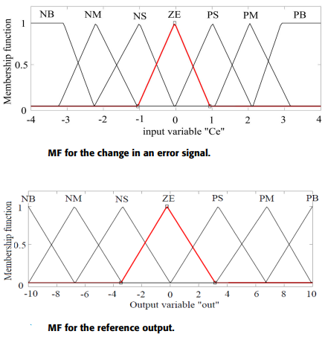
The PI controller gain is tuned for various error signals concerning the variable irradiance. The PI controller generates reference signal for the various error signal received due to the variations in the input solar PV.The PI controller gain is tuned for various error signals concerning variations in irradiance. The PI controller generates reference signal for the various error signal generated due to the variations in the solar PV. The PI controller is tuned manually for different error values for output voltage regulation by considering the real time solar data for the geographical region.
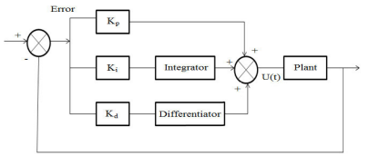
C. ARTIFICIAL NEURAL NETWORK BASED CONTROLLER
Neural networks collectively perform functions and by the units parallelly, rather than there being a clear delineation of subtasks to which various units are assigned. Pertaining to the input-output dataset, the neural networks based controller provides the required voltage regulation. The voltage error values are calculated using this equation Verror = Vref − Vactual. These error values are used to train the ANN. For the appropriate values of error signals the ANN can provide the optimal switching angles for the inverter circuit to maintain the constant voltage at its output end.
The training procedure of ANN consists of the following steps:
- Provide the input-output data set,
- Calculate the weights and
- Update the weights based on the input changes.
The neural network is trained for various samples at different intervals to process the error signal.

1.9 MPPT algorithm
Variable step size P&O algorithm
For best operating, the PV panel must be functioned at their maximum power point. Several Maximum Power Point Tracking (MPPT) algorithms are available in the literature, each one has its designations and particularizations. Acceptable performance is obtained using conventional MPPT methods based on fixed step, but they are slow and present oscillations around the MPP and the results are not satisfactory during sudden change of climatic conditions. A fast follow-up can be realized by increasing step, but we have oscillations in steady state. Many contributions have been introduced using a variable step, where the algorithm automatically changes the step size. In this paper we used the variable step size P&O in order to find a compromise between rapidity and precision of the system.
1.10 Control strategy for the studied system
Direct torque control of induction motor
The direct Torque Control (DTC) strategy was introduced by Takahashi in 1984 and proposed by Depenbrock in 1985 for the control applications of induction motors. This type of control is characterized by its fast dynamic response, simple implementation and robustness to the rotor parameter variation without the need for a complex field orientation block and inner current regulation loop. The basic principle in DTC for induction motors is to directly select stator voltage vectors, which makes the flux rotate and produce the desired torque. The stator flux (φ*) and torque references (Cem ∗ ) are compared with the corresponding estimated values. The torque error is the input of a three-level hysteresis comparator, where the error stator flux magnitude is the input of a two-level hysteresis comparator. The stator flux space is composed of six sectors of 60◦. The outputs of the flux hysteresis band, torque hysteresis band and flux sector are used to select the switching vector of voltage source inverter (VSI). Switching Table allows to determine the VSI switching vector as illustrated. The VSI is composed of six actives witching states and two zero switching states.
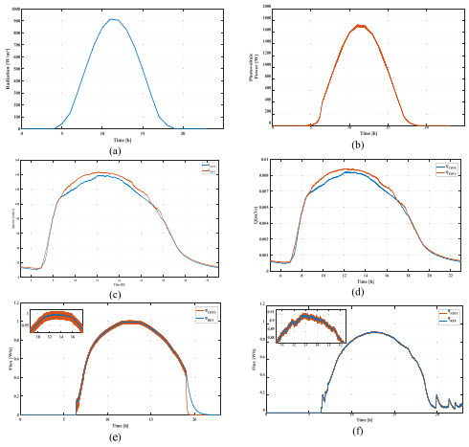
DTC base on fuzzy logic controller
A fuzzy approach is proposed to improve the DTC, the fuzzy logic controller is used to determine the desired inverter vector state. The proposed diagram of the fuzzy logic DTC of induction motor. The FLC is composed of tree inputs which are torque error, the stator error, the stator flux angle and one output.
An FLC generally consists of four principal steps
A fuzzifier
The analog inputs are converted into fuzzy variables which are produced by using membership functions (MF), the fuzzy system performance is described using a fuzzy rule base that stores fuzzy rules. An approximative reasoning will be done by associating input variable with fuzzy rules using a fuzzy inference engine. During the defuzzification step, the FLC ’s fuzzy output is converted to a crisp value for the actual system input. The shape of the membership function, the fuzzy reasoning rules and the defuzzification method influence the response of the FLC. In order to make the stator flux variations medium, the stator flux error is composed into three linguistic variables: negative (N), zero (Z) and positive (P). The (N) and (P) variables are represented by two symmetric trapezoidal membership functions and Z by an equidistant isosceles triangular. To make the torque error variations smaller, the torque error is divided into five linguistic variables: negative large (NL) negative small (NS) zero (Z) positive small (PS) and positive large (PL). The torque error membership function is represented by three equidistant isosceles triangular and two symmetric trapezoidal. The stator flux angle is divided into six sectors, for more precision, the universe of discourse is divided into 12 fuzzy sets. The stator flux angle membership function is represented by twelve equidistant isosceles triangular of 60◦ wide and an overlap of 30◦ with neighborhood fuzzy sets which each fuzzy set works for an angle of 30◦ . Fig. 8 shows the output variable of the fuzzy controller which is composed of into seven switching states (one zero8 switching state and six active switching states).
Fuzzy control rules
The optimal switching state is given by fuzzy rules. The fuzzy rules are established using expert knowledge and intuition in order to govern the behavior of the fuzzy controller. Stator flux angle, torque error and flux error: these elements are based on to determine the sector of stator flux. In order to get to the reference values of the motor torque and flux, the switching state has to be chosen.
Fuzzy inferences
In this work, the inference method is developed using Mamdani’s procedure based on min–max decision (Gdaim et al., 2014). µAi(eϕ), µBi(eT ) and µCi(θ) represent the membership values of torque error, flux error and stator flux angle. αi is the weighting factor for ith rule and it can be written as Eq. (23): αi = min(µAi(eϕ), µBi(eT ), µCi(θ)) (23) µ ′ Vi(V) = max(αi, µVi(V)) (24)

Defuzzifier
This operation converts the fuzzy values back into a numerical value at the out-put, which are one zero voltage (V0 or V7) and six non-zero voltage vectors . For this step, the max method is used and expressed by the Eq. (25). By this method, the value of fuzzy output which has the maximum possibility distribution is used as control output. µ ′ Vout (V) = max180 i=1 max(µ ′ Vi(V)) (25) In this proposed system, a 1880 W is extracted from CSUN 235-60P modules (Table 7) in order to feed the centrifugal pump. the extracted power is higher than the motor rating because some losses are existing into the PV system. For this, our pumping system is composed of 8 modules which must be connected in series.

1.11 Multilevel Inverters (MLIs)
These days, MLIs are being deployed in power systems because of their ability to meet the demand in power quality and power rating, as well as their reduced level of harmonic distortion and electromagnetic interference. There are several advantages of an MLI over the traditional two-level inverters where high switching frequency PWM is used. MLIs are currently being considered as an industrial solution for high power quality and dynamic performance demanding systems, spanning through a power range of 1 to 30 MW. Hence, MLIs are ideal for use in high voltage applications because they can generate low THD output voltage waveforms and can generate higher voltages with a limited device rating . The sources of sustainable energy, such as PV cells, fuel cells, and wind can broadly interact with a multilevel converter system. Mostly, the type of control algorithm utilized in the PWM of MLIs determine their operations, efficiency, power ratings, and application. Several studies have proposed various MLI topologies over the last few decades. The classification of the MLIs into two main groups based on the number of employed DC sources in their topology. Until now, the most commonly used topologies in the industries are the neutral point clamped (NPC) or diode clamped, the flying capacitor (FC), and the cascaded H-bridge (CHB).
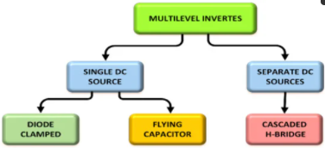

Cascaded H-Bridges MLI
The CHB-MLIs are produced from the serial connection of numerous single-phase H-bridge inverters with separate DC sources (SDCS). Each H-bridge consists of four unidirectional power switches and one DC source. Each inverter level is programmed to produce three voltage outputs (+Vdc, 0, and −Vdc) via the connection of the DC source to the AC output; the desired output is achieved by connecting the four switches (S1–S4) in different manners. Switching the S1 and S4 switches to the ON position generates the +Vdc output, but when S2 and S3 are in the ON position, −Vdc output is produced. To produce the 0 output voltage, either S1 and S2 or S3 and S4 must be in the ON position. A serial connection of the AC outputs of the full-bridge inverter is made in such a way that the generated voltage waveform will represent the sum of the outputs of all the inverters. In a cascade inverter, is used to represent the number of output phase voltage levels, with s being the number of different DC sources. This topology requires a smaller number of components when compared to DCMLI and FCMLI because it does not have clamping diodes and clamping capacitors. In addition to that, it is free from the voltage balancing problem because it does not contain DC link capacitors. On the other hand, the multiple DC sources can be replaced either by separate renewable energy sources with separate converters or by single renewable energy sources with multioutput converters where the voltage balancing is the major concern.
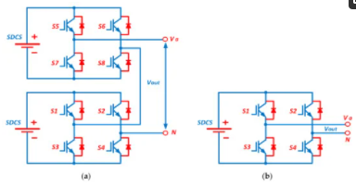

Proposals have been made for the use of multilevel cascaded inverters in applications for static var generation, as well as their usage as an interface with RES; they have also been proposed for use in battery-powered applications. A cascade inverter can also be used for static var compensation via direct connection in series with the electric system. They are suitable for the hooking of RES to the AC grid as they need separate DC sources when used in fuel cells and photovoltaics. They have also been proposed to be used in electric vehicles as the main traction drive because in such applications several batteries or ultracapacitors serve as SDCSs. The structure of this topology is flexible and can be used in different number of inverter levels. The generation of the different output voltages is achievable via the application of different ratios of the DC sources and reducing the inner voltage levels-related switching redundancy. Transformer-dependent CHBMLIs are developed to reduce the need for independent DC sources; it is like the CHBMLI structure but differs by the serial connection of the output voltage of the isolation transformer.

Flying Capacitor MLI
There are close similarities in the topologies of the FCMLI and DCMLI just that the FCMLI relies on the use of floating capacitors rather than clamping diodes. For the FCMLI, the magnitude of the voltage steps in the output waveform is a direct function of the voltage variation occurring in the adjacent capacitors. The FCMLI topology for the ‘m’ level inverter is comprised of [Math Processing Error] DC link capacitors count. is a schematic of the 3-level FCMLI topology which contains four unidirectional power switches and a flying capacitor, in addition to a DC supply with two capacitors for obtaining voltage levels (Vdc/2, 0, −Vdc/2). Switches S1 and S2 must be in the ON position to generate the positive polarity output voltage while S3 and S4 are switched ON for the negative polarity output voltage. Switches S1 and S3 or S2 and S4 are turned on to generate the 0 level output voltage. In the FCMLI, the voltage synthesis is more flexible compared to that of a DCMLI. When there are more than five levels, the problem of voltage balancing can be addressed by making a proper selection of the switching combination. One major advantage of this topology is that the reactive and active power can be controlled while its major drawback is in the use of several capacitors, which makes the system expensive and difficult to assemble. Furthermore, the switching frequency losses in such arrangements are high in real power transmission.
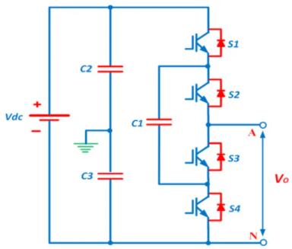

Diode Clamped MLI
This type of inverter, also called a neutral point clamped inverter (NPC), was invented in 1981 by depicts the DCMLI topology, which is used to generate an output voltage with three levels. The configuration for this topology contains four unidirectional power switches, two diodes, and two capacitors. The clamping diodes are connected in series to share the blocking voltage. In this topology, the output voltage is of three levels, which are Vdc/2, 0, and −Vdc/2; Vdc/2 is generated by keeping S1 and S2 switches ON while S3 and S4 are switched to ON to generate −Vdc/2. Switches S2 and S3 are turned on to produce the 0 level voltage. During the passage of the equivalent voltage through the DC link capacitors, it is expected that each active switching device has voltage stress that is clamped to the voltage of each capacitor through diode clamping . In a real application, the blocking voltage is shared by serially connecting the clamping diodes. Then, only a voltage level of dc is required to be blocked by each active device. For reverse voltage blocking, the voltage ratings of the clamping diodes must vary. If operating the DCMLI under the PWM technique, the major issue with the design in high voltage applications is the diode reverse recovery of these clamping diodes.
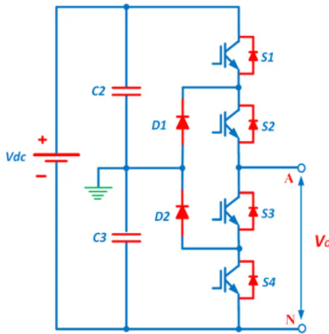
The DCMLI, in comparison to the other multilevel converter topologies, has a greater industrial application due to its high-power delivery capability, simplicity, and efficiency. It has found application in Static VAR Compensators (SVC), high voltage system interconnections, and variable speed motor drives. The need for a capacitance is annulled in the DCMLI converter as the components share a common DC bus. Hence, it can be used in high voltage back-to-back interconnection, adjustable speed drives, and other back-to-back topologies. However, the problems of this converter include difficulty in single inverter real power flow due to discharging or overcharging of the DC level without adequate control, as well as the issue of balancing and stabilizing the capacitor DC voltage in the DC link.

CHAPTER 2

LITERATURE SURVEY

1. “MODELING AND STABILITY ANALYSIS OF HYBRID PV/DIESEL/ESS IN SHIP POWER SYSTEM” H.LAN, Y.BAI, S. WEN, D.C.YU, Y.-Y.HONG, J.DAI, AND P.CHENG
Due the concern about serious environmental pollution and fossil energy consumption, introducing solar generation into ship power systems has drawn greater attention. However, the penetration of solar energy will result in ship power system instability caused by the uncertainties of the solar irradiation. Unlike on land, the power generated by photovoltaic (PV) modules on the shipboard changes as the ship rolls. In this paper, a high-speed flywheel energy storage system (FESS) is modeled to smooth the PV power fluctuations and improve the power quality on a large oil tanker which contains a PV generation system, a diesel generator, a FESS, and various types of ship loads.
The FESS stores mechanical energy in a rotating flywheel and this energy can be converted back to the electrical energy by means of an electrical machine. Similarly, the the flywheel transforms the electrical energy into mechanical energy through versa the electrical machine. FESSs are suitable for numerous charge and discharge cycles (hundred of thousands), which are used for the short-time application (seconds to minutes) in medium to high power systems (kW to MW). Compared with the ultracapacitor and superconducting magnetic energy storage technologies, FESSs have a higher energy density and efficiency.

DRAWBACKS
- The impacts of the integration of PV generation and FESS into the ship power system in three cases are studied and compared to demonstrate the effectiveness of the proposed control method.
- The output power from the shipboard PV generation system varies with the movement of the ship so the impact of ship rolling is also considered.

2.“SINGLE STAGE SOLAR PV FED BRUSHLESS DC MOTOR DRIVEN WATER PUMP” R.KUMAR AND B.SINGH,
In order to optimize the solar photovoltaic (PV) generated power using a maximum power point tracking (MPPT) technique, a DC-DC conversion stage is usually required in solar PV fed water pumping which is driven by a brushless DC (BLDC) motor. This power conversion stage leads to an increased cost, size, complexity and reduced efficiency. As a unique solution, this work addresses a single stage solar PV energy conversion system feeding a BLDC motor-pump, which eliminates the DC-DC conversion stage. A simple control technique capable of operating the solar PV array at its peak power using a common voltage source inverter (VSI), is proposed for BLDC motor control.
The speed control is performed through a variable voltage at the DC bus of voltage source inverter (VSI). However, a bulky capacitor is required at the DC link due to adopting a fundamental frequency operation of VSI. A Z-source inverter (ZSI) replaces the DC-DC converter in, other components of remaining unchanged, asserting a single stage solution. However, the sensing of motor phase currents and DC bus voltage is still required. On the way of sensor reduction, recently, the position sensor-free BLDC motor drive has been reported in for the same application. However, those utility models are based on a twostage power conversion.
DRAWBACKS
- A unique solution of the aforementioned problems, the present work proposes a single stage solar energy conversion system which completely eliminates the DC-DC conversion stage.

3.“SINGLE-STAGE PV ARRAY FED SPEED SENSORLESS VECTOR CONTROL OF INDUCTION MOTOR DRIVE FOR WATER PUMPING” S.SHUKLA AND B.SINGH,
This paper deals with a single stage solar powered speed sensorless vector controlled induction motor drive for water pumping system, which is superior to conventional motor drive. The speed is estimated through estimated stator flux. The proposed system includes solar photovoltaic (PV) array, a threephase voltage source inverter (VSI) and a motor-pump assembly.
The smooth starting of the motor is attained by vector control of an induction motor.
In the modern era of development, renewable resources of energy, are being advocated by many countries to meet the increasing demand of electrical energy due to rapid depletion of non-renewable resource. Solar PV based energy generation, has come up as an important alternative for many purposes. The irrigation sector is one of the major sectors where solar PV power is extensively used for water pumping . Solar PV water pumping has been initially realized using the DC motor. However, with all due virtues associated with the induction motor in terms of mechanical simplicity, ruggedness, reliability, low cost, higher efficiency and lower maintenance than the DC motors, it has replaced DC motors.

DRAWBACKS
- This algorithm is developed to overcome some drawbacks of perturb and observe (P&O) algorithm.
4.“AN ENERGY-SAVINGS EVALUATION METHOD FOR VARIABLE-FREQUENCY-DRIVE APPLICATIONS ON SHIP CENTRAL COOLING SYSTEMS” C.-L.SU, W.-L.CHUNG, AND K.-T.YU,
Variable-frequency-drive (VFD) applications are gradually being recognized by maritime industries as one of the most effective tools for energy savings. Significant energy benefit can be realized from VFD-driven central seawater cooling systems because the ambient seawater temperature varies greatly as ships travel through different sea areas. Before making a decision about which drive to choose, information about the actual energy and cost savings is needed. A simple and fast method that is able to effectively determine the energy savings for closely estimating the economics for their application is essential. This paper aims at presenting a fast method for calculating energy savings that would result from installing VFDs on the seawater cooling pumps on ships. The ship main engine cooling system and navigation environment characteristics, including related marine equipment, pipe allocation, ambient seawater temperature, etc., are taken into account.
The existing onboard pumping systems requiring flow control make use of bypass lines or throttling valves. The most efficient of these is pump-speed control. When a pump’s speed is reduced, less energy is imparted to the fluid and less energy needs to be throttled or bypassed. Speed can be controlled in a number of ways with variable-frequency drives (VFDs) or adjustable-speed drives (ASDs). This kind of drives is particularly appropriate for the seawater cooling pumps on ships because the seawater temperature varies greatly as ships travel through different sea areas. In this pump-speed adjustment scheme, the function of the thermostat valve is directly transferred to the VFD-driven seawater pumps; thus, the energy efficiency is enhanced effectively.
DRAWBACKS
- The control signal issued by the PLC is delivered to the VFD to vary the running frequency of the pump to adjust the pumped seawater flow in order to keep a constant temperature (typically 36 ◦C) in the discharged fresh water according to the measurements from the temperature and pressure sensors.

5.“DESIGN AND EVALUATION OF A PHOTOVALTAIC/THERMAL-ASSISTED HEAT PUMP WATER HEATING SYSTEM” H.-L.TSAI
This paper presents the design, modelling and performance evaluation of a photovoltaic/thermal-assisted heat pump water heating (PVTA-HPWH) system. The cooling effect of a refrigerant simultaneously enhances the PVT efficiency and effectively improves the coefficient of performance (COP) of the HPWH system. The proposed model was built in the MATLAB/Simulink environment by considering the reciprocal energy exchange between a PVT evaporator and a HPWH system.
With increasing attention being paid to the issue of global warming and the soaring cost of fuel, energy-efficient and environment-friendly heating and cooling applications ranging from domestic and commercial to industrial sectors are a promising development. With the characteristics of ubiquity, abundance, and sustainability, solar energy is currently considered the most sustainable resource among the various renewable energy alternatives with the growing increase of environmental awareness. Photovoltaic/thermal (PVT) solar collectors that simultaneously produce electricity and heat are currently considered the most efficient devices to harness the available solar energy.

DRAWBACKS
- Most residential water heating systems are equipped with conventional water heaters that utilize fossil fuels or electricity to generate heat and thus have a negative impact on the environment and offer low-efficiency energy conversion.

CHAPTER 3

METHODOLOGY

EXISTING SYSTEM
They designed a hybrid system with one inverter and the performance was compared with the existing methods.It has very effective techniques for complicated and imprecise processes where there does not exist any mathematical model.The proposed method consists of substituting the hysteresis controllers and the look-up table by fuzzy logic switching vector selection scheme.The main advantages of Fuzzy logic controller are adapted to the nonlinear control command and not based on the model of the induction machine.
    - EXISTING SYSTEM FLOW

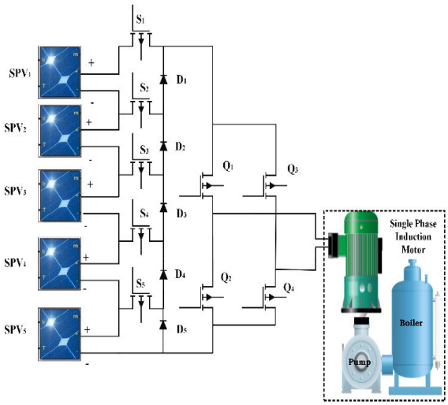
FIGURE3.1 SYSTEM FLOW
  - PROPOSED SYSTEM
In this way, the proposed grid connected PV power conversion system generates seven-level output voltage and a sinusoidal output current which is inphase with the utility voltage and is fed into the grid. This paper proposes a solar power generation system to convert the dc energy generated by a solar cell array into ac energy that is fed into the utility. The proposed solar power generation system is composed of a dc–dc power converter and a seven-level inverter.

  - BLOCK DIAGRAM
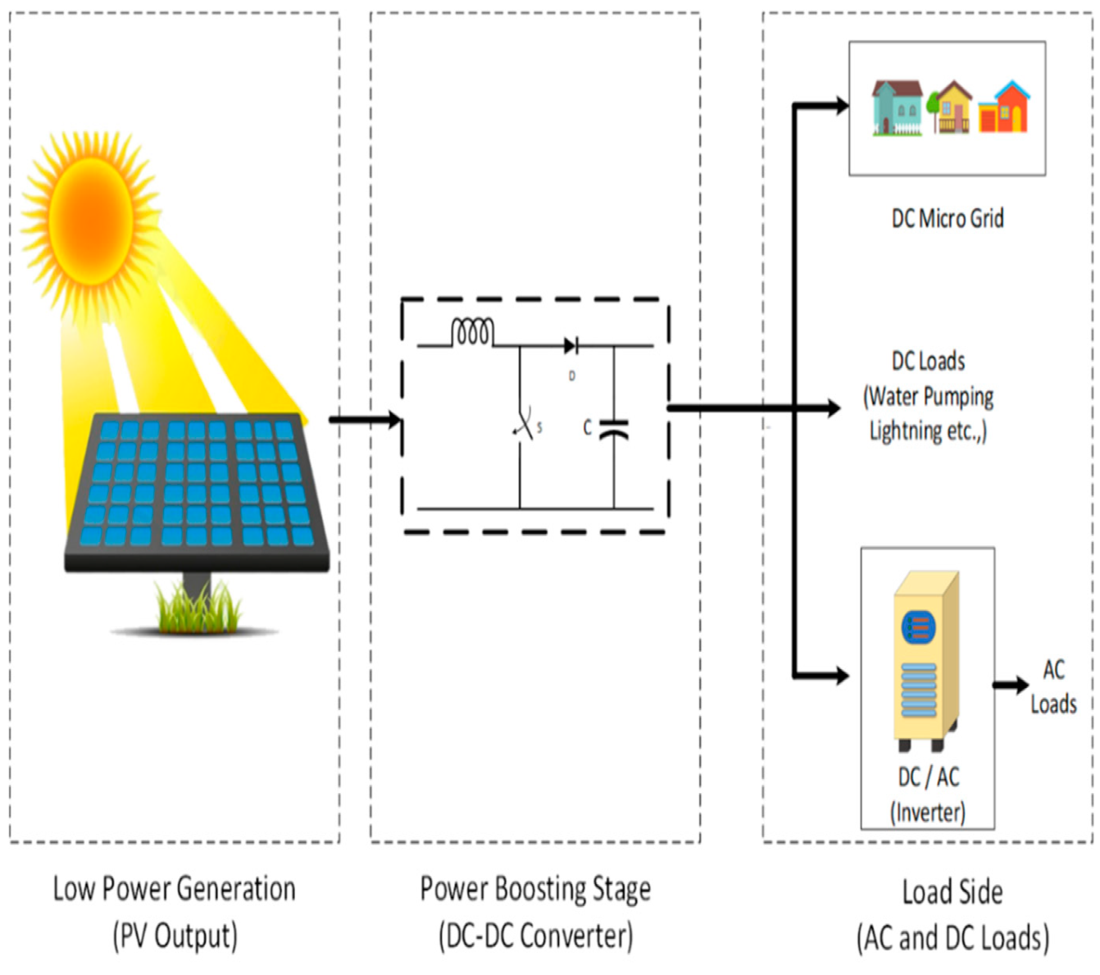
FIGURE3.2 BLOCK DIAGRAM

CHAPTER 4

PROJECT IMPLEMENTATION

4.1 HARDWARE FEATURES
- Node MCU
- 4 GB RAM
- 500 GB Hard disk
- GPS receiver
- Jumper Wires
- GPS antenna
- Accelerometer

4.2 SOFTWARE FEATURES
- Language: Java J2SE and JDK DE, Eclipse MARS.1
- Operating System: Windows 10
- Database required: MySQL
- Apache Tomcat Server
- Arduino 16.9

CHAPTER 5

RESULT
The simulation model is developed in MATLAB/Simulink 2013 to perform the performance comparison between PI and FL based controllers. The analysis for harmonics reduction under open and closed loop operation is also undertaken.
A. SPEED TRACKING PERFORMANCE AND HARMONICS ANALYSIS OF INVERTER
The IM drive connected with the pump is desired to reach the speed from 0 to 1000 rpm. To reach the desired speed, the parameters such as overshoot, undershoot and steady-state error are higher in PI when compared to FLC. Both controllers are examined at the reference speed of 1000 rpm. It is noted that FLC based IM drive system reaches the desired speed with the minimum time period. The simulation result with PI controller is point outs the motor starting at 0s and the motor speed is settled nearly 2 sec with the set speed of 1000 rpm. Using the FL controller, motor starts at 0s and settles at 0.5sec. The results are compared with respect to optimal gains, and faster setting time. By analyzing the power quality, the Total Harmonic Distortion (THD) with PI controller is 10.44% and with FL controller is 5.67% as respectively. The FLC for motor fed MMI provides a good response under the tracking of speed reference and also lower THD.

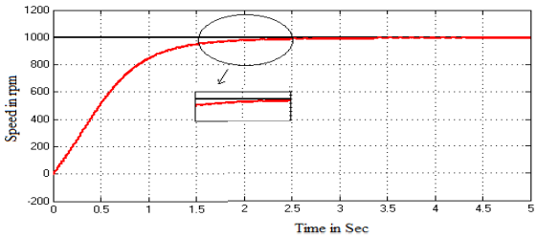
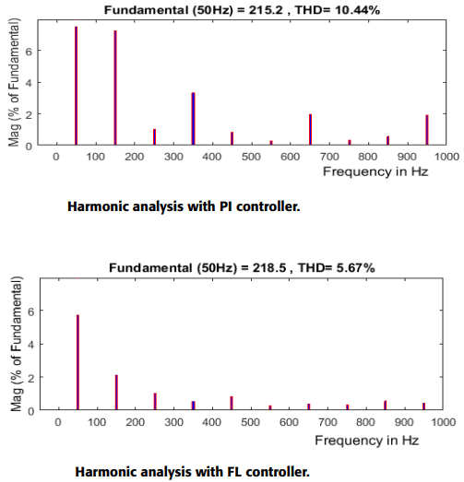
The proposed IM drive is integrated with the water pump system for the marine application.
The several DC links are featured in multilevel converters for making the independent control of possible voltage and MPP tracking at each string. A solar fed 15 level inverterwithout VR is an open-loop system. The panels with different irradiance level are designed and connected to each separate stages of CMLI. For the fifteen levels, seven cascaded H-bridges are connected in series. For the pulse generation, a reference and carrier signal is compared. The reference sinusoidal and the triangular carrier are compared for generating a pulse signal. The bipolar PDPWM technique is adopted for the pulse generation. For one leg, triangular wave and positive sinusoidal signal are compared, for the other leg triangular wave and negative sinusoidal signal are compared for pulse sequence. Figure 7 shows the modelling of PV panel with variations in the irradiance levels depicting the alteration in an inverter output voltage. Figure 8 depicts output voltage waveform obtained due to the variations in irradiance and partially shaded conditions of solar PV modules. This causes the uneven distribution of output voltage which results in a voltage imbalance situation. By adopting VR techniques, these uneven changes can be compensated.
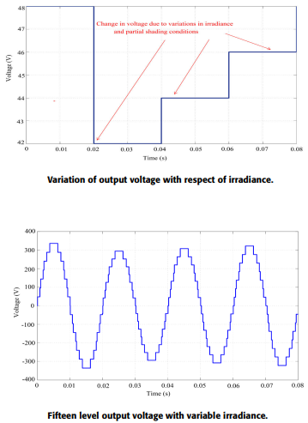

A. FIFTEEN LEVEL INVERTER WITH PI-BASED CONTROLLER
The DC input of CMLI changes according to the irradiance. The measured voltage value of solar fed CML1 across the load is evaluated with the desired signal. The error signal is obtained and applied as the input to PI based controller. The gain values, Kp = 0.04 and Ki = 0.5 is used for the PI based controller. The control signal from the PI controller output is further mixed with the reference signal to obtain the overall revised signal required for pulse generation. On receiving the required pulse signal, the regulated output voltage thus obtained.
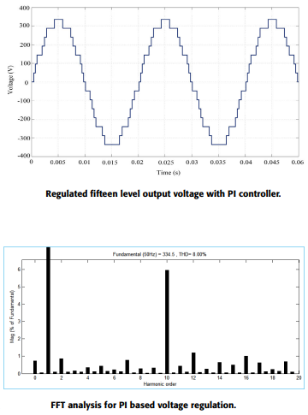

B. ANN BASED CONTROLLER FOR FIFTEEN LEVEL INVERTER
The specifications considered for the voltage regulation in solar fed 15 level inverter using ANN. The regulated output voltage and the corresponding FFT analysis.
C. FIFTEEN LEVEL INVERTER WITH FUZZY LOGIC CONTROLLER
The decision and pattern making is achieved by using Fuzzy inference. The error and derivate error signal are the two inputs signals and framed as membership function. Triangular membership function is used in the controller. The membership function produces a modulating output signal for the PWM generator. The error and derivative error each have 7 membership functions. Nearly 49 rules are framed and used for the better voltage regulation. The regulated output voltage is exposed in Figure 13 and the corresponding FFT analysis.
CHAPTER 6

CONCLUSION
The relevance of the proposed work is to provide high quality of input power to the inverter drive pertaining to marine water pumping applications. A solar PV fed MMI for speed control of induction motor drive has been examined at steady state and dynamic behaviors to investigate its suitability for water pumping system intended for the marine applications. The solar PV array is connected with the proposed inverter when is then fed to an induction motor. The motor speed is sensed and feedback is given to the controller for generating optimal PWM pulses for the inverter switches. The motor is started gradually and the speed is increased to achieve reference speed with aid of PI and FL based controllers. The performance of PI and FL controllers for a feasible operation is verified and results are compared in both simulation and experiment. The results ensure that the FL based controller provides fast settling time and reduced harmonics when compared with the PI controller. The main impact of the proposed control scheme is to reduce the steady-state error of the induction motor speed control and deteriorate harmonics at the output voltage of modular multilevel inverter. On considering the number of components required for the proposed MMI, the Table 3 illustrates the comparative analysis on the number of semiconductor switches required for the design of MMI along with those inverters available in the literature. The source, converter, load, controller and grid are the major components of a DC microgrid. A microgrid is normally referred as a standalone autonomous system to generate power by the community and for the community regions. In the proposed system, the entire component cited for DC microgrid is present and performs its function effectively. The appropriate estimation of power generated and power used is the future scope.

REFERENCES

[1] H. Lan, Y. Bai, S. Wen, D. C. Yu, Y.-Y. Hong, J. Dai, and P. Cheng, ‘‘Modeling and stability analysis of hybrid PV/diesel/ESS in ship power system,’’ Inventions, vol. 1, no. 5, pp. 1–16, 2016.

[2] S. G. Jayasinghe, L. Meegahapola, N. Fernando, Z. Jin, and J. M. Guerrero, ‘‘Review of ship microgrids: System architectures, storage technologies and power quality aspects,’’ Inventions, vol. 2, no. 4, pp. 1–19, 2017.

[3] R. Kumar and B. Singh, ‘‘Single stage solar PV fed brushless DC motor driven water pump,’’ IEEE J. Emerg. Sel. Topics Power Electron., vol. 5, no. 3, pp. 1337–1385, Sep. 2017.

[4] S. Shukla and B. Singh, ‘‘Single-stage PV array fed speed sensorless vector control of induction motor drive for water pumping,’’ IEEE Trans. Ind. Appl., vol. 54, no. 4, pp. 3575–3585, Jul./Aug. 2018.

[5] C.-L. Su, W.-L. Chung, and K.-T. Yu, ‘‘An energy-savings evaluation method for variable-frequency-drive applications on ship central cooling systems,’’ IEEE Trans. Ind. Appl., vol. 50, no. 2, pp. 1286–1297, Mar./Apr. 2014.

[6] B. Singh, U. Sharma, and S. Kumar, ‘‘Standalone photovoltaic water pumping system using induction motor drive with reduced sensors,’’ IEEE Trans. Ind. Appl., vol. 54, no. 4, pp. 3645–3655, Jul./Aug. 2018.

[7] A. Dolatabadi and B. Mohammadi-Ivatloo, ‘‘Stochastic risk-constrained optimal sizing for hybrid power system of merchant marine vessels,’’ IEEE Trans. Ind. Informat., vol. 14, no. 12, pp. 5509–5517, Dec. 2018.

[8] H.-L. Tsai, ‘‘Design and evaluation of a photovoltaic/thermal-assisted heat pump water heating system,’’ Energies, vol. 7, no. 5, pp. 3319–3338, May 2014.

[9] M. G. Yu, Y. Nam, Y. Yu, and J. Seo, ‘‘Study on the system design of a solar assisted ground heat pump system using dynamic simulation,’’ Energies, vol. 9, no. 4, pp. 1–17, 2016.

[10] S. V. Giannoutsos and S. N. Manias, ‘‘A systematic power-quality assessment and harmonic filter design methodology for variable-frequency drive application in marine vessels,’’ IEEE Trans. Ind. Appl., vol. 51, no. 2, pp. 1909–1919, Mar. 2015.

[11] C. Gnanavel and S. A. Alexander, ‘‘Experimental validation of an eleven level symmetrical inverter using genetic algorithm and queen bee assisted genetic algorithm for solar photovoltaic applications,’’ J. Circuits, Syst. Comput., vol. 27, no. 13, pp. 1–23, 2018.

[12] R. Thangaraj, T. R. Chelliah, M. Pant, A. Abraham, and C. Grosan, ‘‘Optimal gain tuning of PI speed controller in induction motor drives using particle swarm optimization,’’ Log. J. IGPL, vol. 19, no. 2, pp. 343–356, Apr. 2011.

[13] M. S. Zaky and M. K. Metwaly, ‘‘A performance investigation of a four-switch three-phase inverter-fed IM drives at low speeds using fuzzy logic and PI controllers,’’ IEEE Trans. Power Electron., vol. 32, no. 5, pp. 3741–3753, May 2017.

[14] R. E. Geneidy, K. Otto, P. Ahtila, P. Kujala, K. Sillanpää, and T. Mäki-Jouppila, ‘‘Increasing energy efficiency in passenger ships by novel energy conservation measures,’’ J. Mar. Eng. Technol., vol. 17, no. 2, pp. 85–98, May 2018.

[15] A. A. Stonier, ‘‘Design and development of high performance solar photovoltaic inverter with advanced modulation techniques to improve power quality,’’ Int. J. Electron., vol. 104, no. 2, pp. 174–189, Feb. 2017.

[16] K. Vanchinathan and K. R. Valluvan, ‘‘A Metaheuristic optimization approach for tuning of fractional-order PID controller for speed control of sensorless BLDC motor,’’ J. Circuits, Syst. Comput., vol. 27, no. 8, Jul. 2018, Art. no. 1850123.

[17] M. Paramasivan, M. M. Paulraj, and S. Balasubramanian, ‘‘Assorted carrier-variable frequency-random PWM scheme for voltage source inverter,’’ IET Power Electron., vol. 10, no. 14, pp. 1993–2001, Nov. 2017.

[18] E. Babaei, S. Laali, and Z. Bayat, ‘‘A single-phase cascaded multilevel inverter based on a new basic unit with reduced number of power switches,’’ IEEE Trans. Ind. Electron., vol. 62, no. 2, pp. 922–929, Feb. 2015.

[19] R. S. Alishah, S. H. Hosseini, E. Babaei, and M. Sabahi, ‘‘Optimal Design of New Cascaded Switch-Ladder Multilevel Inverter Structure,’’ IEEE Trans. Ind. Electron., vol. 64, no. 3, pp. 2072–2081, Mar. 2017.

[20] H. N. Avanaki, R. Barzegarkhoo, E. Zamiri, Y. Yang, and F. Blaabjerg, ‘‘Reduced switch-count structure for symmetric multilevel inverters with a novel switched-DC-source submodule,’’ IET Power Electron., vol. 12, no. 2, pp. 311–321, Feb. 2019.

