DESIGN AND FABRICATION OF FOUR WAY HACKSAW MACHINE

ABSTRACT

Objective of the project is to fabricate a motorized high speed 4-way hacksaw machine and to automate and to modify the conventional power hacksaw machine in order to achieve high productivity of work-pieces than the power hacksaw machine using cam mechanism. The operator need not measure the length of the work-piece that is to be cut and to load and unload the work-piece from the vice each time after a piece has been cut. This machine is built with the 4 hacksaw machines such that tall the machines are operated simultaneously with the help of a motor and cam mechanism.

TABLE OF CONTENTS

CHAPTER NO |  | TITLES | PAGE NO
 |  | ABSTRACT | ii
1 | 1.1 | INTRODUCTION | 1
 | 1.2 | PROCESS | 2
 | 1.3 | OBJECTIVE | 11
 | 1.4 | DESIGN PARAMETERS | 12
 | 1.5 | DESIGN &FABRICATION | 15
 | 1.6 | TYPES OF HACKSAW | 16
2 |  | LITERATURE REVIEW | 19
 | 2.1 | EXISTING SYSTEM | 25
 |  | 2.1.1 Disadvantage of existing system | 25
 | 2.2 | PROPOSED SYSTEM | 25
 |  | 2.2.1 Advantage of proposed system | 26
3 |  | SYSTEM SPECIFICATIONS | 27
 | 3.1 | HARDWARE REQUIREMENT | 27
 | 3.2 | SOFTWARE REQUIREMENT | 27
 | 3.3 | DESCRIPTION OF THE HACKSAW MACHINE | 33
4 |  | PROJECT DESCRIPTION | 36
 | 4.1 | PROBLEM DEFINITION | 36
 | 4.2 | OVERVIEW OF THE PROJECT | 36
 | 4.3 | MODULES DESCRIPTION | 37
 | 4.4 | DATA FLOW DIAGRAM | 39
 | 4.5 | E-R DIAGRAM | 40
5 |  | TESTING AND IMPLEMENTION | 41
 | 5.1 | TESTING | 41
 |  | 5.1.1 Unit testing | 41
 |  | 5.1.2 Block box testing | 41
 | 5.2 | SYSTEM IMPLEMENTATION | 41
6 |  | RESULT AND DISCUSSION | 42
7 |  | CONCLUSION AND FUTURE ENHANCEMENTS | 43
 |  | REFERENCES | 45

CHAPTER-1

1.1 Introduction
The hacksaw is a metal cutting machine tool designed to cut multiple metals simultaneously by applying cam mechanism. The machine is exclusively intended for mass production and they represent the faster and more efficient way to cut a metal. Hacksaws are used to cut thin and soft metals. The operation of the unit is simplified to a few simple operations involving a motor and a cam mechanism. There are numerous types of cutting machines in Engineering field, which are used to fulfil the requirements. We are interested to introduce multiple hacksaw cutting operation in Hacksaw machine. The main function of this hacksaw machine is to cut thin and soft metals by motor power.
This is an era of automation where it is broadly defined as replacement of manual effort by mechanical power in all degrees of automation. The operation remains an essential part of the system although with changing demands on physical input as the degree of mechanization is increased.
Degrees of automation are of two types, viz.
- Full automation.
- Semi automation.
In semi automation a combination of manual effort and mechanical power is required whereas in full automation human participation is very negligible.
There are many business programs in which spherical bar or square bars are required to be operated on unique machines to make device additives such as Shafts, Bolts, Screws and many others. These desires increasingly range of pieces to be reduced for mass manufacturing of those components. 4-way hacksaw blade machine is basically a reducing tool, which cut in 4 guidelines at a same time.
A hacksaw is a fine –toothed noticed, originally and mainly for slicing metallic. They also can reduce diverse different materials, which include plastic, wood and metallic and many others. This paper proposes the prototype model of 4-manner hacksaw gadget that's capable of reduce four portions simultaneously without any jerk and minimum vibrations. The prototype model implies conversion of rotary movement into the reciprocating movement for correct working of hacksaw. This prototype version overcomes the restrictions of conventional hacksaw machines that can cut unmarried piece at a time. it is able to reduce steel bars of different materials at identical time and might be helpful in lots of industries due its compatibility, reliability and performance.
In present condition many electrically operated powers hacksaw machines of various groups with exceptional specs are to be had for the use in shop ground. those machines are so precious that they can cut steel bars with minimal time made up of different materials but they have got one and foremost downside that those are capable of cut unmarried piece of bar at a time. For industries to acquire the mass production, it's miles important to cut metal bars with high charge. So, it's miles not possible to depend upon traditional unmarried frame power hacksaw machines and want the development in generation and design of such machines. 4 manner hacksaw machines over comes all of the obstacles and downside of traditional hacksaw machines. it's also helpful for small scale industries due to its easy operating and working conditions together with its compatibility, performance and cheap rate.
1.2 PROCESS
Manufacturing processes are the steps through which raw materials are transformed into a final product. The manufacturing process begins with the creation of the materials from which the design is made. These materials are then modified through manufacturing processes to become the required part. Manufacturing processes can include treating (such as heat treating or coating), machining, or reshaping the material. The manufacturing process also includes tests and checks for quality assurance during or after the manufacturing, and planning the production process prior to manufacturing.
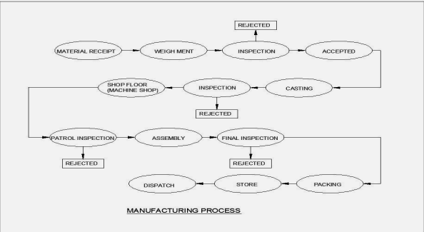

A. Mild Steel
Mild steel is a kind of carbon steel with a low measure of carbon – it is entirely known as "low carbon steel." Although ranges differ contingent upon the source, the measure of carbon ordinarily found in mellow steel is 0.05% to 0.25% by weight, while higher carbon steels are normally depicted as having a carbon content from 0.30% to 2.0%. In the event that any more carbon than that is included, the steel would be delegated solid metal. Mellow steel isn't composite steel and in this manner does not contain a lot of different components other than press; you won't discover huge measures of chromium, molybdenum, or other alloying components in mild steel. Since its carbon and alloying component content are generally low, there are a few properties it has that separate it from higher carbon and composite steels. Less carbon implies that mild steel is regularly more bendable, machinable, and weldable than high carbon and different steels, in any case, it likewise implies it is almost difficult to solidify and fortify through warming and extinguishing. The low carbon content likewise implies it has next to no carbon and other alloying components to square disengagements in its gem structure, by and large bringing about less elasticity than high carbon and compound steels. mild steel additionally has a high sum iron and ferrite, making it attractive.
B. Manufacturing
Mild steel is made like how other carbon steels are made. A typical way this is done includes a blend of iron metal and coal. Once the coal and iron mineral are separated from the earth, they are softened together in an impact heater. Once dissolved, the blend is moved to another heater to consume off any polluting influences that they may have, and also to make some other changes in accordance with the mild steel's synthetic organization. Following that, the steel is permitted to cement into a rectangular shape. This piece of mellow steel is then more often than not conveyed down to the coveted size utilizing forms called hot rolling or cool illustration, despite the fact that there are different techniques that can likewise be utilized.
C. Application
Here are some examples of where it is used in the world:
- Structural steel
- Signs
- Automobiles
- Furniture
- Decorations
- Wire
- Fencing
- Nails
Metal Cutting:
Metal cutting or machining is the process of by removing unwanted material from a block of metal in the form of chips. Cutting processes work by causing fracture of the material that is processed. Usually, the portion that is fractured away is in small sized pieces, called chips. Common cutting processes include sawing, shaping (or planning), broaching, drilling, grinding, turning and milling. Although the actual machines, tools and processes for cutting look very different from each other, the basic mechanism for causing the fracture can be understood by just a simple model called for orthogonal cutting. In all machining processes, the work piece is a shape that can entirely cover the final part shape. The objective is to cut away the excess material and obtain the final part.
This cutting usually requires to be completed in several steps – in each step, the part is held in a fixture, and the exposed portion can be accessed by the tool to machine in that portion. Common fixtures include vise, clamps, 3-jaw or 4-jaw chucks, etc. Each position of holding the part is called a setup. One or more cutting operation may be performed, using one or more cutting tools, in each setup. To switch from one setup to the next, we must release the part from the previous fixture, change the fixture on the machine, clamp the part in the new position on the new fixture, set the coordinates of the machine tool with respect to the new location of the part, and finally start the machining operations for this setup.
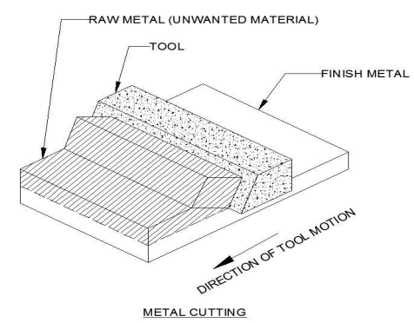
Therefore, setup changes are time-consuming and expensive, and so we should try to do the entire cutting process in a minimum number of setups; the task of determining the sequence of the individual operations, grouping them into (a minimum number of) setups, and determination of the fixture used for each setup, is called process planning.
These notes will be organized in three sections:
(i) Introduction to the processes,
(ii) The orthogonal cutting model and tool life optimization and
(iii) Process planning and machining planning for milling.
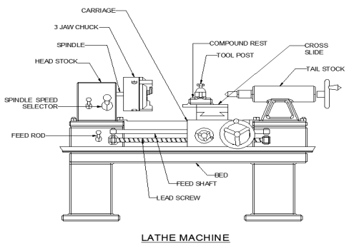
Sawing:
Cold saws are saws that make use of a circular saw blade to cut through various types of metal, including sheet metal. The name of the saw has to do with the action that takes place during the cutting process, which manages to keep both the metal and the blade from becoming too hot. A cold saw is powered with electricity and is usually a stationary type of saw machine rather than a portable type of saw.

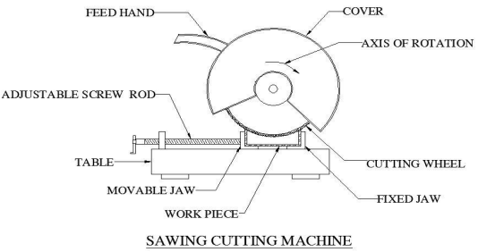
The circular saw blades used with a cold saw are often constructed of high speed steel. Steel blades of this type are resistant to wear even under daily usage. The end result is that it is possible to complete a number of cutting projects before there is a need to replace the blade. High speed steel blades are especially useful when the saws are used for cutting through thicker sections of metal. Along with the high speed steel blades, a cold saw may also be equipped with a blade that is tipped with tungsten carbide. This type of blade construction also helps to resist wear and tear. One major difference is that tungsten tipped blades can be re-sharpened from time to time, extending the life of the blade. This type of blade is a good fit for use with sheet metal and other metallic components that are relatively thin in design. Gadget for cutting up bars of material or for removing shapes in plates of crude material. The cutting gadgets of sawing machines may be thin metallic plates with teeth on their edges, thin metal sharp edges or versatile gatherings with teeth on one edge, or thin pulverizing wheels. The apparatuses may utilize any of three activities in sawing: bona fide cutting, pulverizing, or crushing made condensing. The power hacksaw machine gives a tight brace to section the work and means for reacting a U-shaped packaging on which is mounted a straight steel hacksaw edge that cuts while moving one route so to speak. The saw pushes down on the work amid the cutting stroke however is raised clear of the work amid the arrival stroke. The band saw utilizes an interminable adaptable steel band with teeth on one edge; the band is carried on two huge measurement turning wheels mounted on parallel tomahawks some separation separated. Band saws that cut vertically are especially reasonable for removing shapes in thin, level plates from workpieces that lie on flat tables. Cool sawing machines with toothed plate cutters are utilized broadly in steel-moving factories and in places where vast amounts of bars are cut. A V-molded clipping tight clamp empowers packs of bars to be cinched and cut at one time. Grinding sawing machines are utilized to a great extent for cutting off steel auxiliary shapes, for example, I pillars, channels, and points. The cutting wheels, with or without teeth, pivot at such high speeds that the warmth from the rubbing of contact is adequate to expel the metal by liquefying it. Grating cut off saws, thin elastic or Bakelite-fortified rough wheels that are worked at high fringe speeds, are especially reasonable for cutting off thin tubes and solidified steel bars.

TYPES OF SAWING:
A. Power Hacksawing
The basic forward and backward movement of the cutting edge made the hacksaw one of the principal kinds of sawing machines intended for control. The straightforwardness in the sharp edge movement has kept the cost of the saw machine generally less expensive than different kinds of sawing machines. The low introductory cost combined with the adaptability and versatility, has empowered the hacksaw to stay well known in industry. In hacksawing, a solitary sharp edge is tensioned in the bow, and responded forward and backward finished the work piece. The cutting activity is accomplished just amid half of the cycle of task. Amid the second 50% of the cycle, the arrival stroke, the sharp edge is lifted clear of the work piece, giving a spasmodic cutting activity, which is thought to be one of the disadvantages of the task. In spite of this inconvenience, when contrasted with the consistent cutting activity of the band saw, hacksaws remain similarly or much more famous elective machines. Likewise with numerous other fundamental procedures, hacksawing is an attempted and tried strategy, solid, reliably precise, fast and simple to repair, is less subject to remedy cutting edge strain and more averse to run-out. Besides control hacksaws can be left unattended for significant lots when cutting substantial distance across bar and require least administrator aptitude. Edge substitution is moderately shabby and straightforward.
B. Band Sawing
Band sawing, unlike hacksawing, is a continuous cutting operation. An endless blade, the band, is tensioned between two shrouded, rotating wheels, and part of the band is exposed to carry out the cutting operation of the work piece. The band travels in a continuous motion, with the teeth fed against the work piece. Whilst earlier metal sawing bands were wide (over 25 mm), and were used strictly for cut off methods, narrow blades, introduced about 50 years ago brought contouring capabilities. Furthermore, due to the small throat clearance of the early band saws, they were limited in use by the basic design, thus the length of the work piece could only be as long as the machine throat. However modern machines have been modified to give adequate throat clearance, by intentionally twisting the blade so that the toothed faces in line with the machine throat. As with hacksaw machines, band saws can be divided into two broad categories. A general purpose band saw having gravity fed system, controlled by a dash-pot and using a25 mm (1 inch) deep blade, is the most popular machine available. This machine is suitable for general fabrication work and accurate cutting of solid bars. This type of machine is limited to about 175 mm (7 inches) diameter for mild steel. In order to meet the present day requirements for high-volume production, cutting all grades of steel and to introduce high accuracy and reliability, it has been necessary for the band saw machine manufacturers to incorporate in the design not only heavy duty construction having capacities up to 450 mm (18 inches) diameters but also innovations in the hydraulic power downfeed, to allow the cutting of difficult alloys., such as mnemonics and titanium.
C. Circular Sawing
Roundabout saws have a constant cutting activity; utilize sharp edges having numerous teeth, and an extensive scope of rotational velocities. This activity is like a processing task. The machines accessible range from the prior, economical, hand-stacked models to the specific vast, control stacked write and join material taking care of gadgets for semi and after that completely programmed task. Present day generation roundabout saws are worked with a few substitute essential feed components i.e. level, vertical, shaking head and varieties of these. The decision of the most appropriate kind of machine relies upon the specific application and the size and state of segment. With vertical feed, the pivoting edge ventures downwards in a straight line to draw in the work piece. On machines intended for even feed the cutting edge is sustained into the work piece from the back. A third fundamental encouraging plan is a turn movement or shaking head framework, this is as proficient as a vertical feed framework and is a tough course of action. The seat or floor mounted manual-feed round observed, when introduced together with a general obligation band saw or hacksawing a little workshop, gives an entire slicing office to the little fabricator. Completely programmed round saws, having highlights, for example, dial-in segment length, in process checking, decision of stacking magazines, and so on are broadly utilized where top notch creation is required and frequently give the generation build a troublesome decision to make between roundabout sawing and band sawing.
Welding:
Welding is a process for joining similar metals. Welding joins metals by melting and fusing 1, the base metals being joined and 2, the filler metal applied. Welding employs pinpointed, localized heat input. Most welding involves ferrous-based metals such as steel and stainless steel.Weld joints are usually stronger than or as strong as the base metals being joined.

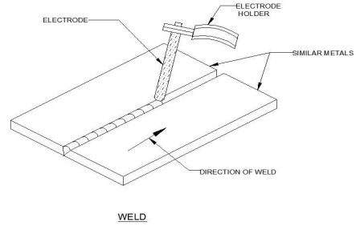
Welding is used for making permanent joints. It is used in the manufacture of automobile bodies, aircraft frames, railway wagons, machine frames, structural works, tanks, furniture, boilers, general repair work and ship building.

1.3 OBJECTIVE:
- The main objective of this project is to reduce the human effort for machining various materials.
- The basic principles of power driven hacksaw or four way hacksaw is Scotch Yoke Mechanism.
- The objective of this project is to save man power and time in cutting materials in order to achieve high productivity.
- By using scotch yoke Mechanism we can operate four hacksaw at same time.
- To take into account the issue of rivalry in mechanical industry the requirement for computerization is evaluate by all the business.
- To recognize the key arrangement roads thought to be fitting to address the difficulty of reasonable assembling and bundling industry for what's to come.
- To give other option to ventures pointing toward decreasing human exertion and change in material taking care of framework by actualizing mechanization.
- Reasonable and down to earth mechanization answers for the future mechanical condition.
1.4 DESIGN PARAMETERS
The basic design process consists of various design parameters like application of scientific principles, technical information and imagination for development of new or improvised machine with maximum economy and efficiency. Hence it is necessary to adopt careful and safe design approach.
The entire design of machine consist of two parts
- System design
- Mechanical Design
1. System Design
System design mainly focus on various physical constraints and ergonomics like space requirements, arrangements of various components on main frame of machine, man +machine interactions, number of controls and its positions, safety measures, ease of maintenance, scope for improvement, total weight of machine and many more. The detached design is done for designed parts and various distinctions obtained are then compared to next highest dimensions which are easily available in market. This amplifies the way of simple assembly as well as post production servicing work of machine for easy maintenance. The various tolerances on the works parts must be specified. In system design we mainly focus on the following parameters
A. System Selection Based on Physical Constraints
Before selecting any machine it must be checked whether it is going to be installed and used in a small scale industry or large scale industry. This machine is to be used by small scale industry, so space is the major constraint for this machine. The system needs to be very compact so that it can be installed to the corner of room for its easy operations. The mechanical design has direct norms for the system design. Hence the major job is to control the various physical parameters, so that the number of distinctions obtained after mechanical design can be well fitted.
B. Arrangement of Various Components
The various components of machine should be laid in such that their easy removal or servicing is possible. Each and every component should be easily seen none should be hidden to the operator of machine. So due to the space constraint every possible space is utilized while doing component arrangements
C. Components of System
Components of system should be compact enough so that it can be easily assembled and set inside the machine. All the moving parts of machine should be well closed and compact.
D. Man machine Interaction
The machine should be very much friendly to the operator because operating is an important factor of design. Anatomical and psychological principles are used to solve various problems arising from Man + Machine relationships Following are some of the topics which are related to Man +Machine relationship
E. Height of Machine from Ground
Height of the machine is very important design consideration for easy working and comfort of operator. The height of the machine should be properly decided so that operator may not get tired during operation. The machine should be slightly higher than the waist level of operator and also suitable clearance should be provided from ground level for cleaning purpose.
F. Weight of Machine
High weighted machine is not desirable because of transportation and breakdown problems. The entire weight of machine depends on selection of material for components and its dimensions. so it is very important to select components of lighter material available as per design specification.
2. Mechanical Design
Mechanical design is very important phase from design point of view because the whole success of project depends on the proper design analysis of problem. During this phase many preliminary alternatives are eliminated and designer should have adequate knowledge about the physical properties of material, deformation, failure, load stresses, various theories and wear analysis. Designer should be able to identify the various external and internal forces acting on machine parts It is required to estimate these forces accurately by using proper design equations. Selection of factor of safety is very important step in design of working dimensions of machine elements. The required correction in theoretical stress values needs to be made depending upon kind of loads, shape of parts, and service requirements. Selection of various materials for machine should be made according to the condition of loading, shapes of products, environment conditions & desirable properties of material.
a. Acquiring data from the user
The Automated Hacksaw machine acquires two inputs from such as number of pieces to be cut and length of each piece from the operator through a keypad and an LCD display. The operator may reset the data during any stage before pressing the machine start push button.
b. Sequence of operation
After entering correct data and pressing the start button, the conveyor will feed the work-piece in to the chuck to the required length and gets stopped by the microcontroller. As mentioned earlier, the conveyor motor will get stopped by the microcontroller when the IR sensor has sent the necessary number of pulses to the microcontroller in relation to the user specified length of the work-piece. When the teeth of the rotating disc attached to the conveyor roller pass before the IR sensor, the IR sensor provides a pulse to the controller. The rotation of disc from one tooth to the next teeth means that the corresponding linear movement is one centimeter. Then the solenoid DCV will make the chuck cylinder to extend and hence hold the work-piece in position and ready for cutting. At the same time, the self-weight gets rested on the work-piece with the blade pressing against the work-piece. Then the AC motor is turned on by the signal from controller, which initiates the cutting process. When a single piece has been cut, a limit switch gets turned on by the self-weight, which makes the microcontroller to start the whole process again until it has finished cutting the quantity of pieces as specified by the operator.

1.5 DESIGN &FABRICATION
First we designed the idea of machine structure, base, alignment of the three operations using Autodesk inventor professional. Since the machine should bear a human weight and have to sustain huge vibrations due to the operations drilling and grinding, we have designed a robust and strong base for the machine. We arranged the three operations in three directions at perpendicular angles. One main base frame is provided with the pedal, two chain drives and three sprockets. Main base frame is designed such that it resembles a bicycle frame. It gives the bicycle feel while pedaling as the dimensions are taken from an actual cycle. The design of this machine has two components. They are: Pedaling Equipment and Cutting Equipment.

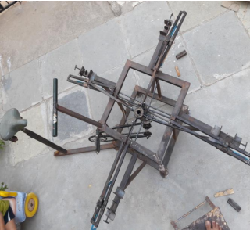

FABRICATION:
We fabricated the machine with four operations of cutting. Everything in the fabrication was done in an ordinary workshop. We used electric arc welding in fabricating the machine with tungsten as electrode. We used cast iron frames to fabricate the base design. In order to increase the angular velocity, we have used two chain drives. The specifications of sprockets are as follows
- Sprocket I: Diameter 18 cm, Teeth 44
- Sprocket II: Diameter 8 cm, Teeth 17
Total Obtained Gear Ratio by two chain drives = 2.25
i.e. for one revolution of pedal we are getting 2.5 revolutions. If we can consider 60 revolutions per minute as maximum capacity of a human, we can easily get 150 revolutions per minute. The Cutting Equipments are arranged to the four sides of the output shaft. The Cutting Equipment is connected to the output shaft using Bevel gears which are aligned at right angle. The power form the output shaft is transferred to another shaft to which a disc is attached using bevel gears.
1.6 Types of hacksaw
- Manual
- Hand hacksaw
- Jig saw
- Pedal hacksaw
- Automatic
- Power hacksaw
- Lathe machine and much more.
Manual
a. Hand hacksaw
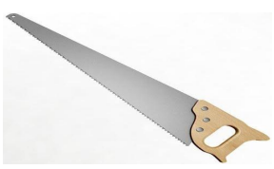

A saw is a tool consisting of a tough blade, wire or chain with a hard toothed edge. It is used to cut through material, very often wood, though sometimes metal or stone. The cut is made by placing the toothed edge against the material and moving it forcefully forth and less forcefully back or continue forward.
b. Pedal hacksaw

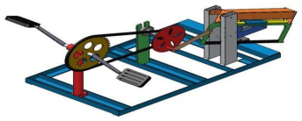

Pedal power is converted into mechanical work. This circular motion of the pedal crank is converted into reciprocating or sometime oscillatory motion to drive hacksaw blade. General hacksaw is operated by manually, hydraulically, electrically motor or pulley commonly used in industries and workshop.

Automatic
a.Power hacksaw

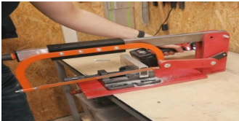

Power hacksaws are used to cut large sizes (selection) of metals such as steel. The heavy „arm‟ moves backwards and forwards, cutting on the backwards stroke. The metal to be cut is held in a machine vice which is an integral part of the base. Turning the handle tightens or loosens the vice.

CHAPTER 2

LITERATURE REVIEW

1. “THEORETICAL ANALYSIS OF MULTI-WAY POWER HACKSAW MACHINE” PROF.KSHIRSAGAR PRASHANT R EN ALL,
In his studies paper stated that it consist of unmarried segment vertical electric powered motor rigidly placed on the center of metal foundation furnished. The shaft of motor rotates at ninety-100 rpm with the energy 2HP. The circular disc is mounted at the shaft of motor with the assist of key and key slot association. In his research paper stated that it consist of single phase vertical electric motor rigidly placed at the center of metallic foundation provided. The shaft of motor rotates at 90-100 rpm with the power 2HP. The circular disc is mounted on the shaft of motor with the help of key and key slot arrangement.
In present condition many electrically operated power hacksaw machines of different companies with different specifications are available for the use in shop floor. These machines are so precise that they can cut metal bars with minimum time made up of different materials but they have one and major disadvantage that those are able to cut single piece of bar at a time. For industries to achieve the mass production, it is necessary to cut metal bars with high rate. So it is impossible to depend upon conventional single frame power hacksaw machines and need the improvement in technology and design of such machines. With the help of this multi-way power hacksaw machine the four metal bars can be cut simultaneously to get high speed cutting rate and to achieve mass production for maximum profit in related companies. As this machine overcomes all the limitations and drawbacks of conventional hacksaw machines, it is also helpful for small scale industries due to its simple working and operating conditions along with its compatibility, efficiency and affordable price.

DRAWBACKS
- To overcome problems in conventional hack saw machines, due to high efficiency, easy to operate and affordable price the proposed model of multi-way power hacksaw machine is helpful and completes allthe expectations needed in the mini industries.

2.“THEORETICAL ANALYSIS OF FOUR WAY HACKSAW BLADE MACHINE” RISHI ANAND, KHOMESH, SHRAWAN KUMAR, PROF.ALOK VERMA
In this paper offers the idea of four-way hacksaw blade gadget in particular accomplished for production based industries. Industries are essentially intended for manufacturing of beneficial goods and offerings at low production value, machinery cost and occasional inventory cost. know-how approximately evolved a model of a machine reach could be capable of acting distinctive operation simultaneously, and it must be economically green. these machines can be used in remote places wherein power is normal. it is designed as a portable one which can be used for slicing in various locations. it may be used for running on materials like skinny metals, timber. Four way hacksaw blade machine is basically a cutting device, which cut in four directions at a same time .A hacksaw is a fine –toothed saw, originally and principally for cutting metal .
They can also cut various other materials, such as plastic, wood and steel etc. In present condition many electrically operated power hacksaw machines of different companies with different specifications are available for the use in shop floor. These machines are so precious that they can cut metal bars with minimum time made up of different materials but they have one and major disadvantage that those are able to cut single piece of bar at a time. For industries to achieve the mass production, it is necessary to cut metal bars with high rate. So, it is impossible to depend upon conventional single frame power hacksaw machines and need the improvement in technology and design of such machines.
DRAWBACKS
- To achieve this we need to minimize idle time and machine time per unit.
- The four way hacksaw blade machine improves those factors by reducing time per unit to increase the production.

3.“DESIGN AND FABRICATION OF AUTOMATED HACKSAW MACHINE” D.V.SABARINANDA, V.SIDDHARTHA, B.SUSHIL KRISHNANA, T.MOHANRAJ,
The objective of this work is to automate the conventional power hacksaw machine in order to achieve high productivity of work-pieces than the power hacksaw machine using Microcontroller. The automated machine acquires two inputs from the user namely the number of pieces to be cut and the length of each piece that is required to be cut. The inputs are given by the user with the help of a keypad and an LCD display, which will help the user to verify the data given by him. The operator need not measure the length of the work-piece that is to be cut and to load and unload the work-piece from the chuck each time after a piece has been cut. After acquiring the two inputs from the user, the machine automatically feeds the given length of work-piece in to a chuck and starts to cut till the given number of work-pieces has been cut.
The machine feeds the work-piece with the help of a conveyor, which is driven by a DC motor and an IR sensor ensures that the feeding stops when the specified length has been reached. A pneumatic cylinder is used for holding the work-piece when cutting operation is done. An AC motor is used to bring about the reciprocating motion required for cutting the work-pieces. There is a self-weight attached with the reciprocating mechanism to provide the necessary downward force required for penetration of hacksaw blade in to the work-piece.
Power hacksaws are used to cut large sections of metal or plastic shafts and rods. Cutting of solid shafts or rods of diameters more than fifteen millimeters is a very hard work with a normal hand held hacksaw. Therefore power hacksaw machine was invented during 1920s in the United States to carry out the difficult and time consuming work. This power hacksaw machine shown in figure 1 is considered as an automatic machine because the operator need not be there to provide the reciprocating motion and downward force on the work-piece in order to cut it.
DRAWBACKS
- The power hacksaw machines, which are operated by human operators as aforementioned, have the demerit of unloading and loading the work-piece many times.
- It will be difficult for the operator if he has been assigned to cut a huge quantity of motor shafts and he has to measure the lengths each time for cutting.

4.“DESIGN AND FABRICATION OF HUMAN POWERED MULTI-PURPOSE MACHINE” RAKESH AMBADE, AMIT SARTABLE, MEGHRAJ AREKAR, VAIBHAV KHACHANE, PRAJAKTA GAWALI
This paper presents the concept of Human Powered Multi-Purpose Machine mainly carried out for production based industries. Industries are basically meant for Production of useful goods and services at low production cost, machinery cost and low inventory cost. Today in this world every task have been made quicker and fast due to technology advancement but this advancement also demands huge investments and expenditure, every industry desires to make high productivity rate maintaining the quality and standard of the product at low average cost. We have developed a conceptual model of a machine which would be capable of performing different operation simultaneously, and it should be economically efficient .This machine can be used in remote places where electricity is irregular or insufficient. It is designed as a portable one which can be used for cutting in various places. It can be used for operating on materials like thin metals,wood and p.v.c.The material can be cut without any external energy like fuel or current. Since machine uses no electric power and fuel, this is very cheap.Energy is the most vital aspect in the development of modern technological civilization.
In an industry a considerable portion of investment is being made for machinery installation. So in this paper we have a proposed a machine which can perform operations like drilling, sawing, grinding, some lathe operations at different working centers simultaneously which implies that industrialist have not to pay for machine performing above tasks individually for operating operation simultaneously. Economics of manufacturing: According to some economists, manufacturing is a wealth-producing sector of an economy, whereas a service sector tends to be wealth-consuming. Emerging technologies have provided some new growth in advanced manufacturing employment opportunities in the Manufacturing Belt in the United States. Manufacturing provides important material support for national infrastructure and for national defense.
DRAWBACKS
- Current machines are costly.
- This machines requires electric supply or fuels for working.
- The unit operating by means of electricity has limited applications in the rural area.

.5.“ MATERIAL SELECTION AND TESTING OF HACKSAW BLADE BASED ON MECHANICAL PROPERTIES” PROF.NITINCHANDRA R.PATEL, MOHAMMAD A.VASANWALA, BALKRUSHNA B.JANI, MITESHKUMAR D.RATHWA, RAVI A.THAKKAR
Testing of different material blades like High Carbon Steel, Low Alloy Steel, Bi-metallic blade, High speed Steel blades for their hardness, Cutting time performance, Wear Resistance, Tensile Strength and performance under buckling. Experiment of Rockwell Hardness tester for getting Hardness Number on C-Scale for all different types of blades, so their relative hardness of teeth of different blade blades can be compared. For Cutting Performance test, Cutting of same diameter (25mm) job of different materials like Aluminium, Brass, Copper by all blades and their cutting time is noted and compared. For Wear Resistance ability, Profiles of blades-before and after cutting are developed with the help of profile projector and compared.
A hacksaw is a fine-tooth saw with a blade under tension in a frame, used for cutting materials such as metal. Handheld hacksaws consist of a metal frame with a handle, and pins for attaching a narrow disposable blade. A screw or other mechanism is used to put the thin blade under tension. Hacksaw blade cutting is conventional machining process which works on the principle of metal cutting. Where harder material which is tooth of the blades cuts the relatively softer material as per need.A power hacksaw (or electric hacksaw) is a type of hacksaw that is powered by electric motor. Most power hacksaws are stationary machines but some portable models do exist. Stationary models usually have a mechanism to lift up the saw blade on the return stroke and some have a coolant pump to prevent the saw blade from overheating. The saw or saw blade is the one of the most important component of a sawing machine. Saws are characterized by their material, tooth form, teeth set, tooth spacing and size. The geometry of the teeth is singular to that of the single point tools. The straight tooth form is suitable for finer pitches whereas the undercut face tooth forms are used for coarser pitches. Undercut tooth form is better from design point of view, because the cutting edges are backed up by more metal. It is very difficult to have this tooth form if teeth are very small in size.For the maximum efficiency for cutting process, hacksaw blade is fixed at 30◦ inclined to the work piece.
DRAWBACKS
- The high carbon steel experiences minimum wear on tooth for cutting the aluminium, gun metal etc.

2.1 EXISTING SYSTEM
- The problem of cutting-off material to size is common to practically every industry.
- Preliminary investigations by the author have revealed that existing blade testing methods were not independent of the machine characteristics, which could contribute to one of the reasons for the inconsistency in the test data.
- Whilst these alternative processes are frequently, quicker than power hacksawing, their costs are in many applications higher.
- Whilst the impact of these alternative processes on the application of power hacksawing cannot be denied there remains a significant field of application for power hacksawing which is likely to remain unchallenged.
- A factor of prime interest to manufacturers is that, if the costs of power hacksawing can be reduced by developing the blade and the saw machine, the potential field of application will be widened.
2.1.1 Disadvantages of existing system
- More number of moving parts.
- Must be handled with care.
- The loading and unloading of the work pieces must be done manually.
2.2 PROPOSED SYSTEM
- This project consists of single phase vertical electric motor rigidly placed at the centre of metallic foundation provided. The shaft of gearbox rotates at 80- 90 rpm with the motor power 1 HP.
- The circular disc is mounted on the shaft of the motor with the help of key and key slot arrangement.
- The eccentric point on the plane of the disc is provided such that the desired cutting stroke is achieved. One end of each connecting rod is pivoted at this eccentric point by the use of the suitable bearing. Another end of each rod is connected to the hacksaw blade fame with the help of a universal joint to get vertical and horizontal Degree of Freedom of rotation for the proper cutting operation.
- The hacksaw frame slides on the guideways provided. When the motor is ON and disc starts rotating, due to the reciprocating motion of hacksaw frame the metal rod is cut which is firmly fixed in a vice.
2.2.1 Advantages of proposed system

- Simple in construction.
- Easy to fabricate.
- The components used for the fabrication of the are easily available.
- Repairing and replacing is not a difficult task.
- Multiple work pieces can be cut simultaneously.
- The time taken for cutting operation is less.
- Increased productivity.

CHAPTER 3

SYSTEM SPCIFICATION

3.1 HARDWARE REQUIREMENTS:
- DC motor,
- Battery,
- Bearing with bearing cap,
- Cam mechanism,
- Frame,
- Machine vice,
- Shaft.
3.2 SOFTWARE REQUIREMENTS:
- Operating system : Windows XP/7.

- Coding Language : JAVA/J2EE

- IDE : Netbeans 7.4

- Database : MYSQL

COMPONENTS USED
The components used in this project are discussed below.
A. Electric Motor
There are two electric motors in this proposed machine, a DC motor for driving the conveyor through a chain drive and an AC motor for providing the reciprocating motion of Hacksaw blade by means of a simple crank mechanism.
B. DC Motor
The conveyor roller is coupled to the dc motor through a chain drive and is driven when the microcontroller sends a signal to it. The conveyor runs till the specified length of work-piece is fed in to the chuck. This is achieved with the help of an IR sensor and a toothed disc attached to the conveyor shaft, which together function as an Encoder.
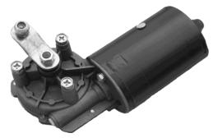

C. AC Motor
The reciprocating motion of the Hacksaw blade, which is where the cutting process takes place, is produced with the help of an AC motor, which operates by a simple crank mechanism to convert rotary motion in to reciprocating motion.
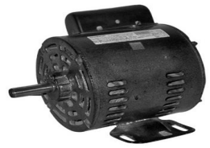
The AC motor is turned on after the work-piece has been firmly fit in the pneumatic chuck. The Torque of motor is increased by transmission of power to a pulley by belt transmission.
D. Double acting pneumatic cylinders
There are two pneumatic cylinders used in this machine. One serves the purpose of a chuck so as to hold the workpiece for arresting the work-piece motions while cutting process takes place and another cylinder is for lifting and lowering of self-weight. The pneumatic cylinder used as chuck shown in figure 4 does the same function of vice in a Power hacksaw machine. It is controlled by a solenoid actuated DCV. The cylinder extends to hold the work-piece when a signal from microcontroller energizes the solenoid DCV.
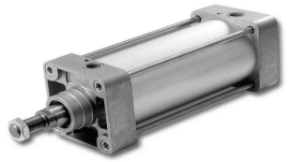
E. Weight-lifting cylinder
The weight-lifting pneumatic cylinder serves the purpose of lifting and lowering of the self-weight. Initially, the cylinder will be in extended condition. When cutting process takes place, it retracts so as to make the hacksaw blade rest on the work-piece. It is also controlled by a solenoid actuated DCV. The cylinder retracts to rest the blade on work-piece when a signal from microcontroller energizes the solenoid DCV.
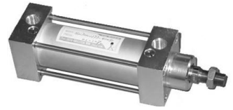

F. 5/2 Solenoid actuated spring return DCV
The DCV shown in figure 6 serves the purpose of controlling the two pneumatic cylinders according to the signal received from the microcontroller. The DCV has a solenoid operating at 12 Volt. The normally open port of the DCV is connected to the extension port weight-lifting cylinder so as to keep the self-weight in a lifted condition. The normally closed port of the DCV is connected to the extension port of chuck cylinder so that when the solenoid is actuated by the signal from the controller, it extends and holds the work-piece tightly.
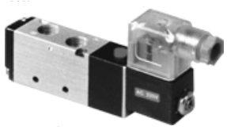

G. Microcontroller AT89C51and LCD Display
The microcontroller AT89C51 belongs to the family of 8 bit microcontrollers manufactured by Atmel. It plays the most important part in controlling the electric motors and pneumatic cylinders in the programmed sequence perfectly. AT89C51 has four input and output ports constituting a total of 32 individual inputs and output pins. These controllers are widely used for the purpose of automation because of they are easy to program and sufficient for most of the smaller applications. LCD display shown in figure 8 is used to view the inputs such as number of pieces to be cut, length of each piece to be cut, that the user specifies through keypad. The LCD prompts the user to enter his data.
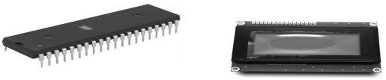

H. Keypad
A 4 X 3 keypad shown in figure 9 is used by the operating person to specify the number of pieces to be cut and length of each piece. The controller receives the inputs and displays it on LCD and also uses it for performing the cutting process. The Star key is used as a Reset button and Hash key is used as Enter key. The operator will be able to give the length of each piece to be cut only in terms of centimeter and there shall be no decimal points in the length.
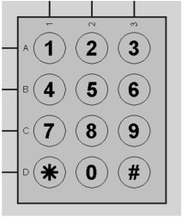

I. IR Sensor and toothed disc
The IR sensor along with a rotating disc shown in figure 10 attached to the conveyor roller, serves the function of an encoder. Each time a tooth passes before the IR sensor, it sends a positive pulse to the microcontroller, and it uses its counter to count the number of pulses. When it has received two pulses from IR sensor, it means that the work-piece has been moved one centimeter in to the chuck. So, the IR sensor is the key element in making the automated hacksaw machine to feed the work-piece to the required length in to the chuck. There is a provision for calibration of the IR sensor on its module itself, which is used for adjusting the sensitivity level of the sensor. The adjusting is actually done by a potentiometer connected to a comparator IC or an operational amplifier.
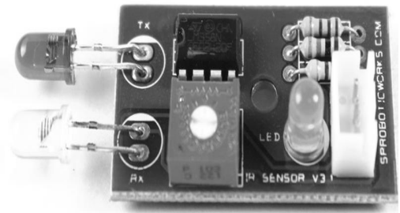

3.3 DESCRIPTION OF THE HACKSAW MACHINE
A. Proteus Simulation
The simulation of electronic circuit using Proteus software. A 4x3 matrix keyboard is used for providing the human interface with the machine. Since the LCD display control pins such as RS and EN pins are connected to the port three of the microcontroller, whereas the RW pin is directly grounded. There has to be an external pull-up resistor in series with each of the pins connected to port zero because port zero has no in-built pull-up resistors. Since the output current of microcontroller will not be enough for driving the relay circuit, a IC for driving these relays called ULN2003 is connected with the output pins of microcontroller. But, there is a common problem encountered in relay circuits due to the reason that when current passes through a coil, an EMF will be generated in opposite direction to that of the applied current, and tends to oppose the applied current. So, this problem must be rectified by providing a diode connected in reverse bias to the applied current. This causes the EMF developed to flow to the positive terminal of the relay rather than allowing the EMF to oppose the supplied current. So, the relay circuit consists of an IC called the ULN2003, four relays and four diodes connected in reverse bias to the terminals of each of the four relays.
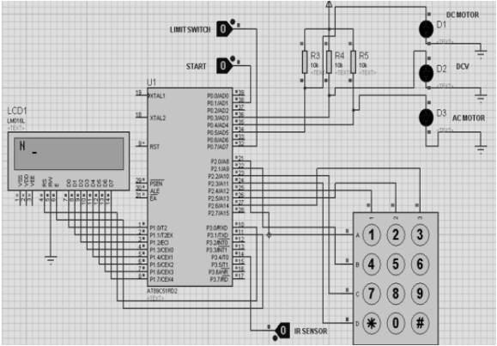

B. Description of the Project setup
There are three main parts in the Automated Hacksaw machine namely the conveyor, base and self-weight attached with the hacksaw blade.
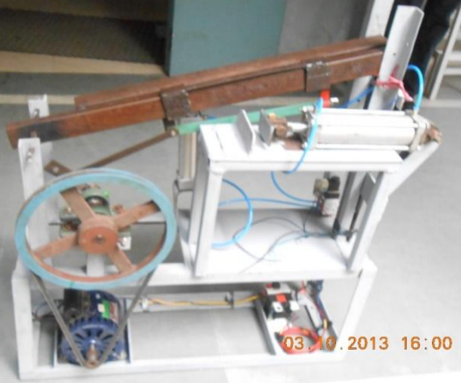
The DC motor is located on the conveyor setup along with the IR sensor and toothed disc, which are connected to the microcontroller. The base setup consists of the AC motor and the setup which consists of the pneumatic chuck. On the side of the AC motor, there are two upward projecting structures in between which the self-weight mechanism is pivoted. The Hacksaw blade can be adjusted along its length so as to be stiff while cutting by means of a threaded screw arrangement at the free end of the self-weight mechanism. the photographic view of mechanical setup.

CHAPTER 4

PROJECT DESCRIPTION

4.1 PROBLEM DEFINITION
To done cutting of different materials with higher rating and improvement in accuracy , efficiency on account of minimization of machine idle time. As the machine overcomes all the limitations and drawbacks of conventional hacksaw machine, it is also helpful for s mall scale industries. It can operate in four different direction at same time, this model will be helpful in all kinds of limitation of traditional hacksaw machine.
The conventional hacksaw machines are operated by human operators. But it has the drawback of unloading and loading different work pieces again and again. Industry focuses on higher production rate with less power consumption. In order to achieve this, we need to minimize the idle time on the floor. This can be achieved by using proposed machine at the place of conventional machine in order to cut different metal/ wooden/PVC bars with high rate of accuracy and lower idle time.
4.2 OVERVIEW OF THE PROJECT
In current industrial process, material cutting with single hacksaw blade is done in both pneumatic and electrically operated hacksaw machine. Industry focuses on the high production rate with less consumptio n of resources. To achieve this we need to minimize idle time per unit. This four way hacksaw machine those factor by reducing time per unit to increase the production. This work is design to overcome the stress attached to hand cutting of engineering material by turning it into less effort to produce uniform cutting.

4.3 MODULES DESCRIPTION
4.3.1 MODULES
A module allows you to logically organize your Python code. Grouping related code into a module makes the code easier to understand and use. A module is a Python object with arbitrarily named attributes that you can bind and reference.
Simply, a module is a file consisting of Python code. A module can define functions, classes and variables. A module can also include runnable code.
A Python statement can access variables in a local namespace and in the global namespace. If a local and a global variable have the same name, the local variable shadows the global variable.
Each function has its own local namespace. Class methods follow the same scoping rule as ordinary functions.
Python makes educated guesses on whether variables are local or global. It assumes that any variable assigned a value in a function is local.
Therefore, in order to assign a value to a global variable within a function, you must first use the global statement.
The statement global VarName tells Python that VarName is a global variable. Python stops searching the local namespace for the variable.
For example, we define a variable Money in the global namespace. Within the function Money, we assign Money a value, therefore Python assumes Money as a local variable. However, we accessed the value of the local variable Money before setting it, so an UnboundLocalError is the result. Uncommenting the global statement fixes the problem.
Python is a high-level, interpreted, interactive and object-oriented scripting language. Python is designed to be highly readable. It uses English keywords frequently where as other languages use punctuation, and it has fewer syntactical constructions than other languages.
Python is a MUST for students and working professionals to become a great Software Engineer specially when they are working in Web Development Domain. I will list down some of the key advantages of learning Python:
- Python is Interpreted − Python is processed at runtime by the interpreter. You do not need to compile your program before executing it. This is similar to PERL and PHP.
- Python is Interactive − You can actually sit at a Python prompt and interact with the interpreter directly to write your programs.
- Python is Object-Oriented − Python supports Object-Oriented style or technique of programming that encapsulates code within objects.
- Python is a Beginner's Language − Python is a great language for the beginner-level programmers and supports the development of a wide range of applications from simple text processing to WWW browsers to games.
Following are important characteristics of Python Programming −
- It supports functional and structured programming methods as well as OOP.
- It can be used as a scripting language or can be compiled to byte-code for building large applications.
- It provides very high-level dynamic data types and supports dynamic type checking.
- It supports automatic garbage collection.
- It can be easily integrated with C, C++, COM, ActiveX, CORBA, and Java.

4.4 DATA FLOW DIAGRAM

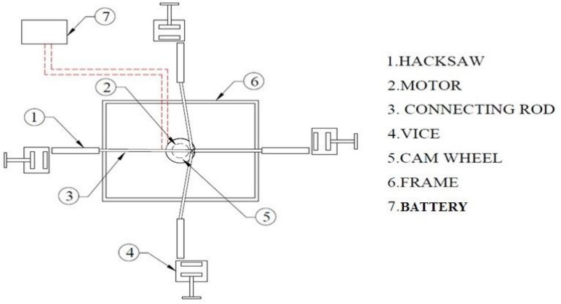

4.5 E-R DIAGRAM

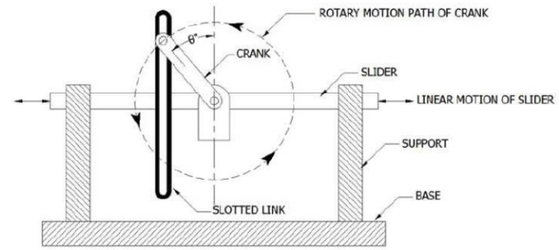

CHAPTER 5

TESTING AND IMPLEMENTATION
  - TESTING
Implementation is the stage of the project when the theoretical design is turned into a working system. This is the final and important phase in the system life cycle It is actually the process of converting the new system into a operational one.

5.1.1 Unit Testing

Unit testing comprises the set of tests performed by an individual programmer prior to integration of the unit into a larger system. The module interface is tested to ensure that information properly flows into and out of the program unit. The local data structure is examined to ensure that data stored temporarily maintains its integrity during all steps in an algorithm’s execution. Boundary conditions are tested to ensure that the module operates properly at boundaries established to limit or restrict processing. All independent paths through the control structure are tested. All error-handling paths are tested.

5.1.2 Block Box Testing
Black-box testing is a method of software testing that examines the functionality of an application without peering into its internal structures or workings. This method of test can be applied virtually to every level of software testing: unit, integration, system and acceptance. It is sometimes referred to as specification-based testing.

5.2 SYSTEM IMPLEMENTATION
Implementation is the stage of the project when the theoretical design is turned into a working system. This is the final and important phase in the system life cycle It is actually the process of converting the new system into a operational one.
CHAPTER 6

RESULT AND DISCUSSION

As per the above discussion we conclude that to overcome problems in conventional hacksaw machine due to high efficiency, easy to operate. The proposed model of multi way hacksaw is helpful and complete all the expectations needed in the mini industries. As a result benefits would be achieved such as longer tool life, easy chip flow and higher machining quality in the machining process. The selection of cutting fluid should be carefully carried out to obtain optimum result in machining process. Various factors are affecting the selection of cutting fluid type in machining operation such a type of work piece and the method of machining process.
The machine was tested for three different materials (wood and plastic pipes and iron pieces). The ideal mechanical advantage is 0.5, power output is 5.72KW and efficiency is 76.9% makes it very adequate and efficient as a useful machine for exercise and as a cutting machined compared to the existing ones.
Design and fabrication of pedal power hack saw is completed. This project can be applicable to cut small round, square bars. Application is depended on the selection of hacksaw blade as well as RPM required. This is used to cut metal sheets, wooden blocks and PVC pipes. This can also be machined at small scale industries and at workshops. This plays a key role in excising purpose also which gives mental relief .So this project can be used in workshops, seminars for the cutting of various processes. According to the productivity it can also be used in small scale industries for cutting of thin sheet of metals since its cost is relatively accessible.

CHAPTER 7

CONCLUSION AND FUTURE ENHANCEMENTS

7.1 CONCLUSION:

A strong multidiscipline team with a good engineering base is necessary for the Development and refinement of advanced computer programming, editing techniques, diagnostic Software, algorithms for the dynamic exchange of informational different levels of hierarchy. This project work has provided us an excellent opportunity and experience, to use our limited knowledge. We gained a lot of practical knowledge regarding, planning, purchasing, assembling and machining while doing this project work. We are proud that we have completed the work with the limited time successfully. The “FABRICATION OF FOUR WAY HACKSAW MACHINE” is working with satisfactory conditions. We are able to understand the difficulties in maintaining the tolerances and also quality. We have done to our ability and skill making maximum use of available facilities. In conclusion remarks of our project work. Thus we have developed a “FOUR WAY HACK SAW MACHINE”. By using more techniques, they can be modified and developed according to the applications.

7.2 FUTURE ENHANCEMENTS

Future scope of proposed research work to increase the production rate, cuts the metal bars easily. It can withstand the vibrations, no hazards from jerk, no special training required to operate it.

The machine can be fully automated by using Micro-controller.

In fully automated machine the operator need not measure the length of the work piece.

The inputs can be given by the operator with the help of a keypad and LCD display.

Automatic lifting up mechanism for frame when cutting operation is finished to introduce next potion of bar for cutting.

REFERENCES

[1] Prof. Kshirsagar Prashant R en all, “Theoretical Analysis of Multi-Way Power Hacksaw Machine,” International Journal of Research in Advent Technology, Vol.3, No.4, April 2015 E-ISSN: 2321-9637

[2] Rishi Anand,Khomesh,Shrawan Kumar,Prof. Alok Verma,” Theoretical Analysis Of Four Way Hacksaw Blade Machine”, International Journal of Advance Research and Innovative Ideas in Education, ISSN(O)-2395-4396, Vol2 ,Issue-2 ,April2016

[3] Prof. Nitinchandra R. Patel, Mohammad A. Vasanwala, Balkrushna B.Jani, Miteshkumar D. Rathwa, Ravi A. Thakkar,” Material Selection and Testing of Hacksaw Blade Based on Mechanical properties”, International Journal of Innovative Research in Science, Engineering and Technology, ISSN: 2319-8753, volume 2, Issue6, June 2013.

[4] D.V.Sabarinanda, V.Siddhartha, B. Sushil Krishnana, T.Mohanraj , “Design and Fabrication of Automated Hacksaw Machine”, International Journal of Innovative Research in Science, Engineering and Tech nology, ISSN (Online):2319-8753, volume 3, April 2014.

[5] Rakesh Ambade,Amit Sartabe,Meghraj Arekar,Vaibhav Khachane,Prajakta Gawali ,” Design & Fabrication of Human Powered Multi-Purpose Machine”, International Journal of Advanced Technology in Engine ering and Science,ISSN(Online):2348-7550,Volume No 03,Special Issue No.01,April 2015.

[6] Kshirsagar Prashant R, Rathod Nayan,Rahate Prashant P,Halaye Prashant P ,”Theoretical Analysis of Multi-way Power Hacksaw Machine”,International Journal of Research in Advent Technology,E-ISSN:2321- 9637,Vol.3,No.4,April2015.

[7] Muhammad Ali Mazidi, Janice Gillispie Mazidi, and Rolin D. McKinlay ‘The 8051 Micro Controller and Embedded Systems’, 2nd Edition, Pearson Education Inc. 2008

[8] http://www.ssiproject.com/mechanical_project.php?cool=160/ mechanical/production projects

