CREATING DESKTOP SPEECH RECOGNISATION USING PYTHON PROGRAMMING

ABSTRACT

As a personal assistant, this project is built with AI technologies, Artificial intelligence technologies are beginning to be actively used in human life, this is facilitated by the appearance and wide dissemination of the Internet of Things (IOT). Autonomous devices are becoming smarter in their way to interact with both a human and themselves. The advancement in technology over time has been unmeasurable. In such an era of advancement if people are still struggling to interact with their machine using various input devices then its not worth it. For this reason, many voice assistants were developed and are still being improved for better performance and efficiency. The main task of a voice assistant is to minimize the use of input devices like keyboard, mouse, touch pens, etc. This will reduce both the hardware cost and space taken by it.

TABLE OF CONTENTS

CHAPTER NO |  | TITLES | PAGE NO
 |  | ABSTRACT | ii
1 | 1.1 | INTRODUCTION | 1
 | 1.2 | OBJECTIVE | 2
 | 1.3 | INTELLIGENCE VOICE ASSISTANT TECHNOLOGIES | 2
 | 1.4 | DEVELOPMENT OF INTELLIGENT VOICE ASSISTANT FOR A SPECIFIC PROBLEMS OF INTERACTION | 3
 | 1.5 | METHODOLOGY | 10
 | 1.6 | SALIENT FEATURES | 16
2 |  | LITERATURE REVIEW | 18
 | 2.1 | EXISTING SYSTEM | 24
 | 2.2 | PROPOSED SYSTEM | 24
3 |  | SYSTEM SPECIFICATIONS | 26
 | 3.1 | HARDWARE REQUIREMENT | 26
 | 3.2 | SOFTWARE REQUIREMENT | 26
4 |  | PROJECT DESCRIPTION | 27
 | 4.1 | PROBLEM DEFINITION | 27
 | 4.2 | MODULES DESCRIPTION | 27
 | 4.3 | DATA FLOW DIAGRAM | 36
 | 4.4 | E-R DIAGRAM | 38
5 |  | TESTING AND IMPLEMENTION | 39
 | 5.1 | TESTING | 39
 |  | 5.1.1 Unit testing | 39
 |  | 5.1.2 Block box testing | 39
 | 5.2 | SYSTEM IMPLEMENTATION | 39
6 |  | RESULT AND DISCUSSION | 40
7 |  | CONCLUSION AND FUTURE ENHANCEMENTS | 42
 |  | REFERENCES | 43

CHAPTER-1

1.1 Introduction
The development of artificial intelligence (AI) systems that are able to organize a natural human-machine interaction (through voice, communication, gestures, facial expressions, etc.) are gaining in popularity. One of the most studied and popular was the direction of interaction, based on the understanding of the machine by the machine of the natural human language. It is no longer a human learns to communicate with a machine, but a machine learns to communicate with a human, exploring his actions, habits, behavior and trying to become his personalized assistant. The work on creating and improving such personalized assistants has been going on for a long time.
These systems are constantly improving and improving, go beyond personal computers and have already firmly established themselves in various mobile devices and gadgets. One of the most popular voice assistants are Siri, from Apple, Amazon Echo, which responds to the name of Alex from Amazon. These types of virtual assistants are very useful for old age, blind & physically challenged people, children, etc. by making sure that the interaction with the machine is not a challenge anymore for people. Even blind people who couldn’t see the machine can interact with it using their voice.
The understanding and executing commands are reached a new level like the virtual assistant of the iron man named Jarvis. This is although fictional yet this is what that can be achieved using virtual assistants. All you need to do is give a command to the assistant and the rest will be performed by the assistant. With the help of voice-activated virtual assistants, there will be no need to write long codes to perform a task, the system will do so for us. The machine will work in three modes- supervised, unsupervised or reinforcement learning depending upon the usage for which the assistant is developed.

1.2 OBJECTIVE:
- Based on findings and requirement, Following objectives are set for this work.
- Proposed System will provide the facility of developing a code through voice instructions.
- System will be able to save Python the recognized code by voice instructions.
- System will provide the compile the developed code through voice instructions.
- System will be able to compare the keywords with database.
- It will provide the way to get the recognized keywords on the editor.
- It will provide the facility to execute the developed code through voice instructions
1.3 INTELLIGENCE VOICE ASSISTANT TECHNOLOGIES
Each company-developer of the intelligent assistant applies his own specific methods and approaches for development, which in turn affects the final product. One assistant can synthesize speech more qualitatively, another can more accurately and without additional explanations and corrections perform tasks, others are able to perform a narrower range of tasks, but most accurately and as the user wants. Obviously, there is no universal assistant who would perform all tasks equally well. The set of characteristics that an assistant has depends entirely on which area the developer has paid more attention. Since all systems are based on machine learning methods and use for their creation huge amounts of data collected from various sources and then trained on them, an important role is played by the source of this data, be it search systems, various information sources or social networks. The amount of information from different sources determines the nature of the assistant, which can result as a result. Despite the different approaches to learning, different algorithms and techniques, the principle of building such systems remains approximately the same. Figure 1 shows the technologies that are used to create intelligent systems of interaction with a human by his natural language. The main technologies are voice activation, automatic speech recognition, Teach-To-Speech, voice biometrics, dialog manager, natural language understanding and named entity recognition.

1.4 DEVELOPMENT OF INTELLIGENT VOICE ASSISTANT FOR A SPECIFIC PROBLEMS OF INTERACTION
To work with voice recognition, it is advisable to use existing systems. For example, the PocketSphinx project. In the developed system, it was he who was chosen, as the main means of voice recognition. PocketSphinx is a tool for automatic voice recognition [9], which works well on various low-power embedded systems, such as Raspberry Pi, and it is also cross-platform, which is the reason for choosing this framework [8]. To generate the voice, the most used Festival engine was chosen, which runs on Linux operating systems and has quite good characteristics of voice generation. The next stage, on which the intellectual work of the voice assistant is carried out, is the creation of a system for recognizing the natural language of a person, i.e. recognition of intentions. For the system that can understand the user, we used training intellectual algorithms based on machine learning methods. But before you teach the system to understand the user, you need to perform several stages of data preparation. Since in our case the output characteristics can be a set of different classes (that is, n-best hypotheses of the user's intentions, the task will be a multi-class classification task where one label can contain labels from different classes. For example, as a response can return "on; light; bathroom", where each part of the answer belongs to one of several classes. Collecting the necessary data is the most important process that will allow you to most accurately predict the results. In Fig. 4 shows the process of preparing data for training. In our work, we created a specialized system for managing a smart home. Considering this, the given examples of data sets will correspond to the training of the model for such systems. For any other tasks, the principle will remain unchanged, only the data sets will change.
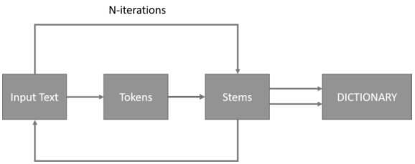

To collect data, you need to create a table of synonyms and different variants of pronunciation of keywords, according to which the system will be able to build forecasts. Words and synonyms are indicated in the format in which they are commonly used in colloquial speech.
The next step is to build a vocabulary from which a training sample is created. Since most of the machine learning algorithms operate on numeric data, we must match each word in the dictionary with a unique number within the dictionary. It is also advisable to reduce the size of the dictionary with the help of stamping. On large volumes of data and different variants of pronunciation, this method allows one to reduce the number of different words by an order of magnitude. This ultimately leads to a reduction in data and will improve the quality of recognition.
SUBJECTIVE EVALUATION
Systems
In the subjective evaluation, a Finnish-to-English S2ST system was used. To focus on the impacts of machine translation and speech synthesis, the correct sentences were used as the input of the machine translation component instead of the speech recognition results. The system developed in was used as the machine translation component of our S2ST system. This system is HiFST: a hierarchical phrase-based system implemented with weighted finite-state transducers. 865,732 parallel sentences from the EuroParl corpus were used as training data, and 3,000 parallel sentences from the same corpus was used as development data. When the system was evaluated on 3,000 sentences in, it obtained 28.9 on the BLEU-4 measure. As the speech synthesis component, an HMM-based speech synthesis system (HTS) was used. 8,129 sentences uttered by one male speaker were used for training acoustic models. Speech signals were sampled at a rate of 16 kHz and windowed by an F0-adaptive Gaussian window with a 5 ms shift. Feature vectors comprised 138-dimensions: 39-dimension STRAIGHT mel-cepstral coefficients (plus the zero-th coefficient), log F0, 5 band-filtered aperiodicity measures, and their dynamic and acceleration coefficients. We used 5-state left-to-right context-dependent multi-stream MSDHSMMs. Each state had a single Gaussian. Festival was used for deriving full-context labels from the text; the labels include phoneme, part of speech (POS), into national phrase boundaries, pitch accent, and boundary tones. The test data comprised 100 sentences from EuroParl corpus not included in the machine translation training data. The machine translation component output the 20-best translations for each input sentence, resulting in 2,000 translated sentences. To these, we added reference translations to give a total of 2,100 sentences to use in the evaluation. Table 1 shows an example of top 5-best translated sentences.
Evaluation procedure
In, speech synthesis was evaluated. Evaluators listened to synthesized speech and assigned scores for naturalness (TTS). We asked evaluators to assign a score without considering the correctness of grammar or content. In, speech-to-speech translation was evaluated. Evaluators listened to synthesized speech, then typed in the sentence; we measured their word error rate (WER). After this, evaluators assigned scores for “Adequacy” and “Fluency” of the typed-in sentence (S2ST-Adequacy and S2ST-Fluency). Here, “Adequacy” indicates how much of the information from the reference translation sentence was expressed in the sentence and “Fluency” indicates that how fluent the sentence was. These definitions were provided to the evaluators. “Adequacy” and “Fluency” measures do not need bilingual evaluators; they can be evaluated by monolingual target language listeners. These measures are widely used in machine translation evaluations, e.g., conducted by NIST and IWSLT. In, machine translation was evaluated. Evaluators didn’t listen to synthesized speech. They read translated sentences and assigned scores of “Adequacy” and “Fluency” for each sentence (MTAdequacy and MT-Fluency). TTS, S2ST-Adequacy, S2ST-Fluency, MT-Adequacy, and MT-Adequacy were evaluated on five-point mean opinion score (MOS) scales. Evaluators assigned scores to 42 test sentences in each section. 150 people participated in the evaluation.
Impact of MT and WER on S2ST
First, we analyzed the impact of the translated sentences and the intelligibility of synthesized speech on S2ST. WER averaged across all test samples was 6.49%. The correlation coefficients between MT-Adequacy and S2ST-Adequacy and between MT-Fluency and S2ST-Fluency were strong (0.61 and 0.68, respectively). The correlation coefficient between WER and S2ST-Adequacy was −0.21, and the correlation coefficient between WER and S2STFluency was −0.20. These are only weak correlations. The impact of the translated sentences on S2ST is larger than the impact of the intelligibility of the synthesized speech, although this does affect the performance of S2ST.
Impact of MT on TTS and WER
Next, we analyzed the impact of the translated sentences on the naturalness and intelligibility of synthesized speech. The correlation coefficients between TTS and MT scores, and the correlation coefficients between WER and MT scores. MT-Fluency score has a stronger correlation with both TTS score and WER than MT-Adequacy score. That is, the naturalness and intelligibility of synthesized speech were more affected by the fluency of the translated sentences than by the content of them. Therefore, next we focused on the relationship between the fluency of the translation output and the synthesized speech. boxplots of TTS score divided into four groups by MT-Fluency score. In this figure, the red and green lines represent the median and average scores of the groups, respectively. This figure illustrates that the median and average scores of TTS are slightly improved by increasing MT-Fluency score.
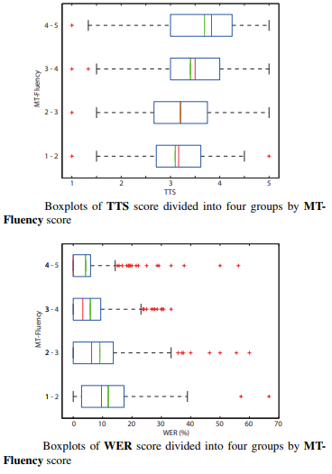
This is presumed to be because the speech synthesis text processor (Festival, in our case) often produced incorrect full-context labels due to the errors in syntactic analysis of disfluent and ungrammatical translated sentences. In addition, the psychological effect called “Llewelyn reaction” appears to affect the results. The “Llewelyn reaction” is that evaluators perceive lower speech quality when the sentences are less fluent or the content of the sentences is less natural, even if the actual quality of synthesized speech is same. Therefore, we conclude that the speech synthesis component will tend to generate more natural speech as the translated sentences become more fluent. The boxplots of WER divided into four groups by MT-Fluency score. From this figure, it can be seen that the median and average scores of WER improve and the variance of boxplots shrinks, with increasing MT-Fluency score. This is presumed to be because evaluators can predict the next word when the translated sentence does not include unusual words or phrases, in addition to the naturalness of synthesized speech being better when the sentences were more fluent, as previously described. Therefore, the intelligibility of synthesized speech is improved as the translated sentences become more fluent, even though all sentences are synthesized by the same system.
Correlation between MT Fluency and N-gram scores
We have shown that the naturalness and intelligibility of the synthesized speech are strongly affected by the fluency of sentences. It is well known in the field of machine translation that the fluency of translated sentences can be improved by using long-span word-level N-grams. Therefore, we computed the correlation coefficient between MT-Fluency and word N-gram scores. The word N-gram models we used were created using the SRILM toolkit, from the same English sentences used for training the machine translation component. Kneser-Ney smoothing was employed.

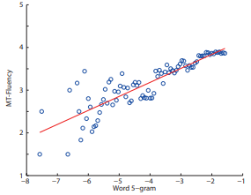
The word 5-gram gave the strongest correlation coefficient of 0.44. Although there were weak correlations between MT-Fluency and word N-gram scores on raw data, it was difficult to find strong correlation coefficients. Therefore, MT-Fluency scores were divided into 200 bins according to the word 5-gram score and subsequently average MT-Fluency scores for each bin were computed. In Figure 3, the averaged MT-Fluency scores and word 5-gram scores are shown, and the regression line is illustrated by the red line. Now, the correlation coefficient is 0.87. This result indicates that the word 5-gram score is an appropriate feature for measuring the average perceived fluency of translated sentences.
Correlation between TTS and N-gram scores
P.563 is an objective measure for predicting the quality of natural speech in telecommunication applications. However, we found no correlation between TTS score and P.563. So, we looked for correlations with other objective measures. It is well known that speech synthesis systems generally produce better quality speech when the input sentence is in-domain (i.e., similar to sentences found in the training data). Therefore, we computed the correlation coefficient between TTS and phoneme N-gram score of the sentence being synthesized; the N-gram score is a measure of the coverage provided by the training data for that particular sentence.

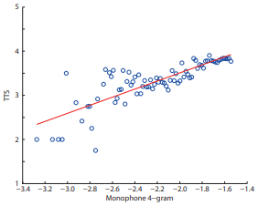
The phoneme N-gram model was estimated from the English sentences used for training the speech synthesizer. The correlation coefficients of TTS and phoneme N-gram scores; the 4-gram model gave the strongest correlation coefficient of 0.20. The bin-averaged TTS and phoneme 4-gram scores. Now, the correlation coefficient is 0.81. Although the correlation between TTS and phoneme N-gram scores was weak on the raw data, there is a strong correlation between bin-averaged TTS and phoneme N-gram scores. This result suggests that the phoneme 4-gram score is a good predictor of the expected naturalness of synthesized speech.The ability to predict average naturalness of synthetic speech before generating the speech could be used in other applications, such as sentence selection (as in this work, or in natural language generation with speech output), voice selection before generating speech. We hope to investigate this further in the future.
1.5 METHODOLOGY
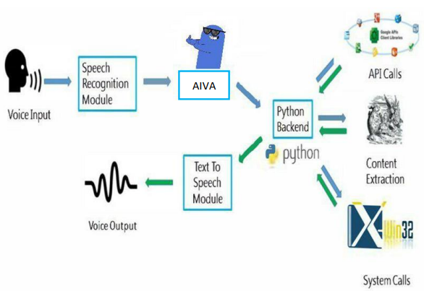

A. Speech Recognition
The system uses Google’s online speech recognition system for converting speech input to text. The speech input Users can obtain texts from the special corpora organized on the computer network server at the information center from the microphone is temporarily stored in the system which is then sent to Google cloud for speech recognition. The equivalent text is then received and fed to the central processor.

B. Python Backend
The python backend get the output from the speech recognition module and then identifies whether the command or the speech output is an API Call, Context Extraction, and System Call. The output is then send back to the python backend to give the required output to the user.
C. API Calls
API stands for Application Programming Interface. An API is a software intermediary that allows two applications to talk to each other. In other words, an API is the messenger that delivers your request to the provider that you're requesting it from and then delivers the response back to you.
D. Context Extraction
Context extraction (CE) is the task of automatically extracting structured information from unstructured and/or semi-structured machine-readable documents. In most of the cases this activity concerns processing human language texts by means of natural language processing (NLP). Recent activities in multimedia document processing like automatic annotation and content extraction out of images/audio/video could be seen as context extraction TEST RESULTS.
E. System Calls
In computing, a system call is the programmatic way in which a computer program requests a service from the kernel of the operating system it is executed on. This may include hardware-related services (for example, accessing a hard disk drive), creation and execution of new processes, and communication with integral kernel services such as process scheduling. System calls provide an essential interface between a process and the operating system.
F. Text-To-Speech
Text-to-Speech (TTS) refers to the ability of computers to read text aloud. A TTS Engine converts written text to a phonemic representation, then converts the phonemic representation to waveforms that can be output as sound. TTS engines with different languages, dialects and specialized vocabularies are available through third-party publishers.
The main purpose of the project is to develop a personal virtual assistant which will make the task easy for the user. The proposed work is divided into different submodules. It is majorly categorized into three modules namely automatic speech recognition, Drowsiness detection, and opening of a class interface according to the timetable of a student. Apart from it the Virtual assistant also performs multiple features for making the user task be completed with ease. AI-based Virtual Assistant has been implemented using python libraries, selenium, and the google speech recognition API. Python 3.7 or above, Spyder IDE or Visual studio code or pycharm, have been used for the development of the assistant.
A. Working of Automatic Speech Recognition
Automatic Speech Recognition primarily known as ASR is the main principle behind AI-based Voice Assistant operation. [4]ASR programs, initially record the speech and then convert it into different wave files. At first, we import the speech recognition tools. In this we have different organizer classes out of which Google() class will be used. Input speech would be taken with the help of a microphone by using the pyaudio package. Google() recognizer will help in translating the speech into corresponding text.
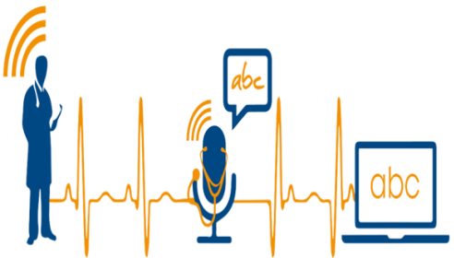

B. Drowsiness detection Analysis
The drowsiness detection approach is typically based on two crucial computer vision techniques namely Facial Landmark Detection and Eye Aspect Ratio[5]. the system for the first time detects the user's face, when the Eye Aspect Ratio indicates that the user's eyes are open, the system plays the movie which the user wants to watch. The app keeps track of the user's feature rating, if it shows that the eyes are closed, it will automatically pause the current movie playback. Besides, if the user leaves the screen and the system does not detect any face the current movie will be paused. The position of the eye is checked using the Eye Aspect Ratio(EAR), where the immediate state of an eye of a user is calculated using the points in the (x,y) plane. It checks for 20 consecutive frames and if it finds the eye ratio less than 0.25 then it generates an alarm.
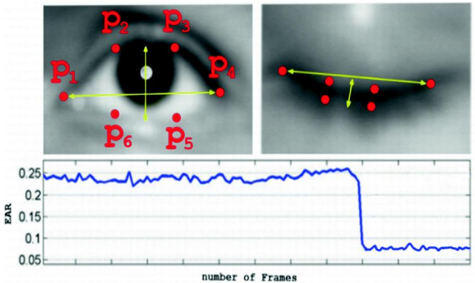

C. Opening class interface Analysis
It works on the principle of automation of chrome. From the automation tool, Selenium web drivers are imported which are used to access and control the web i.e chrome. From the chrome, a search box is opened where the credentials and keys of the college portal will be given. After that, the login credentials of the class platform are shared. Based on the path and according to the time the feature will work. When there is a class according to the timetable embedded in the system, it will open the class interface for joining the class and move the cursor to the join class button
D. Acoustic Analysis
All the data recorded gets processed by artificial intelligence without any human interaction. All the waveforms which are generated while speaking gets transmitted to the decoder which in turn converts these speech waveforms to corresponding texts. It tells us about what are words which have been pronounced.
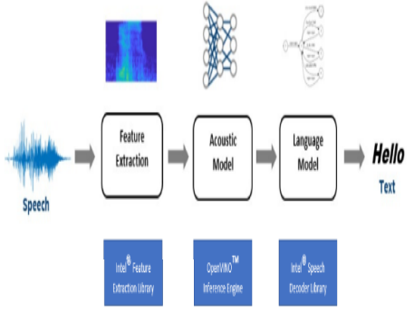

E. Drowsiness detection Analysis
The drowsiness detection approach is typically based on two crucial computer vision techniques namely Facial Landmark Detection and Eye Aspect Ratio[5]. the system for the first time detects the user's face, when the Eye Aspect Ratio indicates that the user's eyes are open, the system plays the movie which the user wants to watch. The app keeps track of the user's feature rating, if it shows that the eyes are closed, it will automatically pause the current movie playback. Besides, if the user leaves the screen and the system does not detect any face the current movie will be paused. The position of the eye is checked using the Eye Aspect Ratio(EAR), where the immediate state of an eye of a user is calculated using the points in the (x,y) plane. It checks for 20 consecutive frames and if it finds the eye ratio less than 0.25 then it generates an alarm.
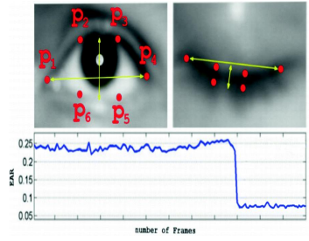
F. Opening class interface Analysis
It works on the principle of automation of chrome. From the automation tool, Selenium web drivers are imported which are used to access and control the web i.e chrome. From the chrome, a search box is opened where the credentials and keys of the college portal will be given. After that, the login credentials of the class platform are shared. Based on the path and according to the time the feature will work. When there is a class according to the timetable embedded in the system, it will open the class interface for joining the class and move the cursor to the join class button.
G. Acoustic Analysis
All the data recorded gets processed by artificial intelligence without any human interaction. All the waveforms which are generated while speaking gets transmitted to the decoder which in turn converts these speech waveforms to corresponding texts. It tells us about what are words which have been pronounced.
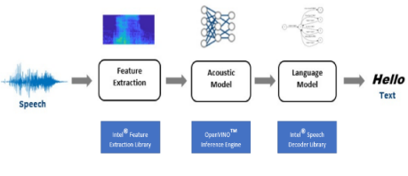
1.6 SALIENT FEATURES
A. QUERIES FROM THE WEB
Making queries is an essential part of one’s life, and nothing changes even for a developer working on Windows. We have addressed the essential part of a netizen’s life by enabling our voice assistant to search the web. It supports a plethora of search engines like Google, Bing and Yahoo and displays the result by scraping the searched queries.
B. ACCESSING YOUTUBE VIDEOS
Videos have remained as a main source of entertainment, one of the most prioritized tasks of virtual assistants. They are equally important for entertainment as well as educational purposes as most teaching and research activities in present times are done through YouTube. This helps in making the learning process more practical and out of the four walls of the classroom.
C. WEATHER REPORT
Getting live weather conditions about a place remains an important task of virtual assistants. It helps the user charter the course of their action. It addresses this issue with the help of Python.
D. RETRIEVE IMAGES
Users could get images directly through the user interface. The images are derived from the entire web code received from Google images. These are formatted according to use and displayed in a compact manner in the user interface.

E. DICTIONARY MEANING
One of the usages of the web is to find word meaning and its usage in our day-to-day life. Instead of going through the bulky books, our users can simply search for it using the voice assistant and get the meaning within a fraction of seconds.
F. MEDICINE DETAILS
One of the important issues our software addresses is of healthcare, and medicine in general. The user can query either the medicine or the symptoms. The former lets you know the complete details of the medicine, like indications, contradictions, trade or brand names, dosage, the process of consumption, warning and precautions, storage conditions, etc. On the other hand, the symptom feature lets you query about the symptoms while it lists various diseases one is likely to be affected along with their medicine. This is helpful for people who are quite busy with their life and find trouble visiting the doctor immediately, thus relying on the web to find the best result for short term cause.
G. SET REMINDERS
One of the main features of a voice assistant is to set a reminder for the user accordingly. It is no different when it comes to this feature. The user can set reminders to be notified about a task at a particular time. This will help users, especially developers to schedule their time and resources easily. All the user has to do is to input Set reminder to the assistant.
H. SEND E-MAILS
Integrating mailing features to eases the job of mailing, which otherwise would have to be done by opening the concerned email address. Here, you do not need to go for another tab to do one of the major tasks of your day-to-day affairs. The user can send emails to the desired receiver.

CHAPTER 2

LITERATURE REVIEW

1. “AN ANALYSIS OF MACHINE TRANSLATION AND SPEECH SYNTHESIS IN SPEECH-TO-SPEECH TRANSLATION SYSTEM” KEI HASHIMOTO, JUNICHI
YAMAGISHI, WILLIAM BYRNE, SIMON KING, KEIICHI TOKUDA,
This paper provides an analysis of the impacts of machine translation and speech synthesis on speech-to-speech translation systems. The speech-to-speech translation system consists of three components: speech recognition, machine translation and speech synthesis. Many techniques for integration of speech recognition and machine translation have been proposed. However, speech synthesis has not yet been considered. Therefore, in this paper, we focus on machine translation and speech synthesis, and report a subjective evaluation to analyze the impact of each component. In speech-to-speech translation (S2ST), the source language speech is translated into target language speech. A S2ST system can help to overcome the language barrier, and is essential for providing more natural interaction. A S2ST system consists of three components: speech recognition, machine translation and speech synthesis. In the simplest S2ST system, only the single-best output of one component is used as input to the next component. Therefore, errors of the previous component strongly affect the performance of the next component. Due to errors in speech recognition, the machine translation component cannot achieve the same level of translation performance as achieved for correct text input. To overcome this problem, many techniques for integration of speech recognition and machine translation have been proposed, such as. In these, the impact of speech recognition errors on machine translation is alleviated by using N-best list or word lattice output from the speech recognition component as input to the machine translation component. Consequently, these approaches can improve the performance of S2ST significantly. In addition, we found that long-span word N-gram scores correlate well with the perceived fluency of sentences and that phoneme N-gram scores correlate well with the perceived naturalness of synthesized speech.
DRAWBACKS
- While personalization is an important area of research, this paper focuses on the impact of the machine translation and speech synthesis components on endto-end performance of an S2ST system.

2.“STUDY OF VOICE CONTROLLED PERSONAL ASSISTANT DEVICE” ABHAYDEKATE, CHAITANYAKULKARNI, ROHANKILLEDAR,
In the Modern Era of fast moving technology we can do things which we never thought we could do before but, to achieve and accomplish these thoughts there is a need for a platform which can automate all our tasks with ease and comfort. Thus we need to develop a Personal Assistant having brilliant powers of deduction and the ability to interact with the surroundings just by one of the materialistic form of human interaction i.e. HUMAN VOICE. The Hardware device captures the audio request through microphone and processes the request so that the device can respond to the individual using in-built speaker module. There is an unbelievable change rather advancement in technology over the last few years. Believe it or not, in today’s world you can interact with your machine. What is interacting with a machine? Obviously giving it some input, but what if the input is not in the conventional way of typing, rather it is your own Voice. What if you are talking to the machine, giving it commands and wanting the machine to interact with you like your assistant? What if the machine is not giving you answers just by showing you the best results but also by advising you with a better alternative. An easy access to machine with voice commands is the revolutionary way of humansystem interaction. To achieve this, we need to use speech to text API for understanding the input. Many companies like Google, Amazon and Apple are trying to achieve this in generalized form. Isn’t it amazing that you can set reminders by just saying remind me to.... Or set alarm with wake me up at .. Understanding the importance of this we have decided to make a system that can be placed anywhere in vicinity and you can ask it to help you do anything for you just by speaking with it.

DRAWBACKS
- The designed system not only monitors the sensor data like temperature, gas, light, motion sensors but also actuates a process according to the requirement.
3.“VOICE ASSISTANT APPLICATION FOR A COLLEGE WEBSITE” DENY NANCY, SUMITHRA PRAVEEN, ANUSHRIASAI, M.GANGE, R.S ABISREE,
We are still far away from understanding the genuine capability of speech recognition technology. This applies both to the refinement of the innovation itself and to its coordination into our lives. The current digital assistants can decipher discourse great, yet they are not the conversational interfaces that the innovation suppliers need them to be. Besides, speech recognition stays constrained to few items. Voice recognition technology was around some time before Apple's Siri appeared in 2011. At the Seattle World's fair in 1962, IBM presented a device called Shoebox.It was the size of a shoebox and could perform scientific functions and perceive 16 spoken words as well as digits 0-9.Mozilla are working on foundations for open, public voice services. The key here is voice. A voice associate is an advanced accomplice that makes use of voice confirmation, talk mix, and everyday language getting geared up (nlp) to offer an enterprise by means of a selected application. Improvement is unremittingly progressing and changing over, and the voice associate market will develop close-with the aid of it. In april 2015, the exam company gartner anticipated that earlier than the of completing of 2020, 50 percentage of affiliation with improvement might be through "talks" with sharp machines, huge amounts of them by means ofstrategiesfor voice. The quantity of humans using voice assistants is depended upon to make bigger. As shown by means of method for the voice bot exquisite speaker buyer adoption file 2018, legitimate around 10% of folks who don't guarantee an energetic speaker plan to look for one. At the off chance that this ultimate parts regular, the purchaser base of great speaker customers will grow 50 price, which implies that a fourth of developed americaa long way and gigantic will guarantee an excited speaker.

DRAWBACKS
- It collaborates with versatile functionalities like SMS, Calls, and so on. Aides in ascertaining maths issues in only a couple of moments.
4.“AI BASED VOICE ASSISTANT USING PYTHON” DEEPAK SHENDE, RIAUMAHIYA, MONIKA RAGHORTE, AISHWARYABHISIKAR, ANUPBHANGE,
Artificial intelligence technologies are beginning to be actively used in human life, this is facilitated by the appearance and wide dissemination of the Internet of Things (IOT). Autonomous devices are becoming smarter in their way to interact with both a human and themselves. New capacities lead to creation of various systems for integration of smart things into Social Networks of the Internet of Things. One of the relevant trends in artificial intelligence is the technology of recognizing the natural language of a human. New insights in this topic can lead to new means of natural human-machine interaction, in which the machine would learn how to understand human’s language, adjusting and interacting in it. One of such tools is voice assistant, which can be integrated into many other intelligent systems. In this paper, the principles of the functioning of voice assistants are described, its main shortcomings and limitations are given. The method of creating a local voice assistant without using cloud services is described, which allows to significantly expand the applicability of such devices in the future. the development of artificial intelligence (AI) systems that are able to organize a natural human-machine interaction (through voice, communication, gestures, facial expressions, etc.) are gaining in popularity. One of the most studied and popular was the direction of interaction, based on the understanding of the machine by the machine of the natural human language. It is no longer a human learns to communicate with a machine, but a machine learns to communicate with a human, exploring his actions, habits, behavior and trying to become his personalized assistant. The work on creating and improving such personalized assistants has been going on for a long time. These systems are constantly improving and improving, go beyond personal computers and have already firmly established themselves in various mobile devices and gadgets.
DRAWBACKS
- It not only works on human commands but also give responses to the user on the basis of query being asked or the words spoken by the user such as opening tasks and operations.
.5.“SMART PYTHON CODING THROUGH VOICE RECOGNITION” M.A. JAWALE, A.B. PAWAR, D.N. KYATANAVAR,
Many artificial intelligence applications developed using programming languages like Python, R and so on. Each language comes with its own programming structure and syntactical forms. Programmers are broadly classified into three categories namely, novice users, knowledge intermittent and expert one. For novice users, it is always a challenge to write a code without typographic errors though users know theoretical knowledge of Programming language, its structure and syntax as well as logic of program. Therefore, this paper explores use of voice recognition technique in the field of programming, specifically for writing program with Python programming language. In experimental analysis, it found helpful for new Python programmers and provide new learning curve for programmers wherein beginner can experience hassle free program writing. Programming involves human efforts, hardware and due to manual typing through keyboard, there are many chances to meet an error while typing. As programming is important for students and innovation, as manual typing is time, consuming there is a need for an advanced system, which would reduce programmer’s effort and promote smart work. The system, which we are going to develop, is easier than this manual typing of code. We are going to recognize the voice of user through the microphone and those keywords will be matched with the stored keywords if they are matched then that will be displayed on editor and that is the code or programme in a specific language, which can be further compiled and executed through the voice instructions of user. In the first phase of proposed system, we made use database for the keywords comparison and further in the second phase, we will be going from machine learning concept in which the next keyword will be recognized by using the previous keyword by using the machine learning algorithm and will be printed on the editor will be compiled and executed through user voice instructions.
DRAWBACKS
- We addressed the problem of user while developing a computer program.
- To avoid the problems we are designing a system in which the computer program can developed through the voice.

2.1 EXISTING SYSTEM
- Desktop personal assistant is built with AI technologies, here Jarvis assists the end-user with day-to-day activities like general human conversation, searching queries in various search engines like Google, searching for videos in youtube, retrieving images, files in local drive, play songs in desktop by the use of imported modules like pyttsx3 is an offline module that is used for text to speech conversion in python, Date Time module is imported to support the functionality of date and time.web browser, Wikipedia, Google those are imported to fetch the user result.
- The user statements/commands are analysed with the help of Artificial intelligence to give an optimal solution.

2.2 PROPOSED SYSTEM
The proposed system will have the following functionality:
- The system will keep listening for commands and the time for listening is variable which can be changed according to user requirements.
- If the system is not able to gather information from the user input it will keep asking again to repeat till the desired no. of times .
- The system can have both male and female voices according to user requirements.
- Features supported in the current version include playing music, emails, texts, search on Wikipedia, opening anything on the web browser, etc.
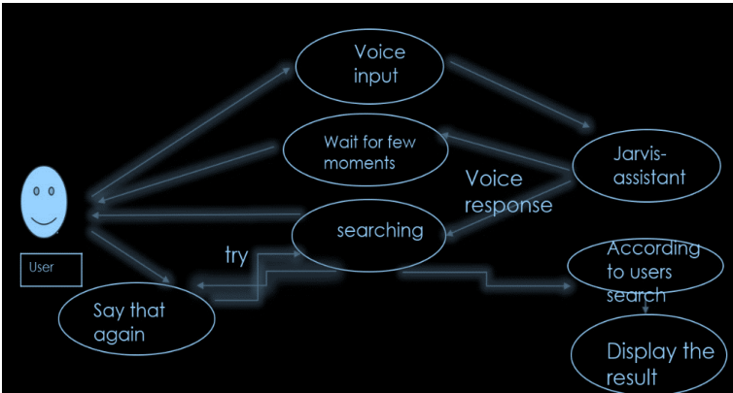

CHAPTER 3

SYSTEM SPCIFICATION

3.1 HARDWARE REQUIREMENTS:
- Keyboard
- Mouse
- Hard disk 500GB
- Ram 4 Gb
3.2 SOFTWARE REQUIREMENTS:
- Operating system : Windows XP/7.

- Coding Language : JAVA/J2EE

- IDE : Netbeans 7.4

- Database : MYSQL

CHAPTER 4

PROJECT DESCRIPTION

4.1 PROBLEM DEFINITION
We are all well aware about Cortana, Siri, Google Assistant and many other virtual assistants which are designed to aid the tasks of users in Windows, Android and iOS platforms. But to our surprise, there’s no such complete virtual assistant available for Core Windows platform consisting of 70% of the users. So, this is actually a major problem for users where there could be internet instability, server problems and places where internet is not accessible.
4.2 MODULES DESCRIPTION
4.2.1 MODULES
STEP1: (import packages for this program):
- Import pyttxs3
- Import datetime
- Import speech_recognition as sr
- Import Wikipedia
- From googlesearch import search
- From youtube_search import youtubesearch
- Import urlib.request
- Import os
- Import webbrowser
PIP INSTALLATION IN THIS PROGRAM WHICH IS ESSENTIAL:
- PIP INSTALL PYLINT
- PIP INSTALL PYTTSX3
- PIP INSTALL SPEECH RECOGNITION
- PIP INSTALL WIKIPEDIA
- PIP INSTALL GOOGLE
- PIP INSTALL YOUTUBE-SEARCH
- PIP INSTALL WEBBROWSER
Step2:Definition of functions
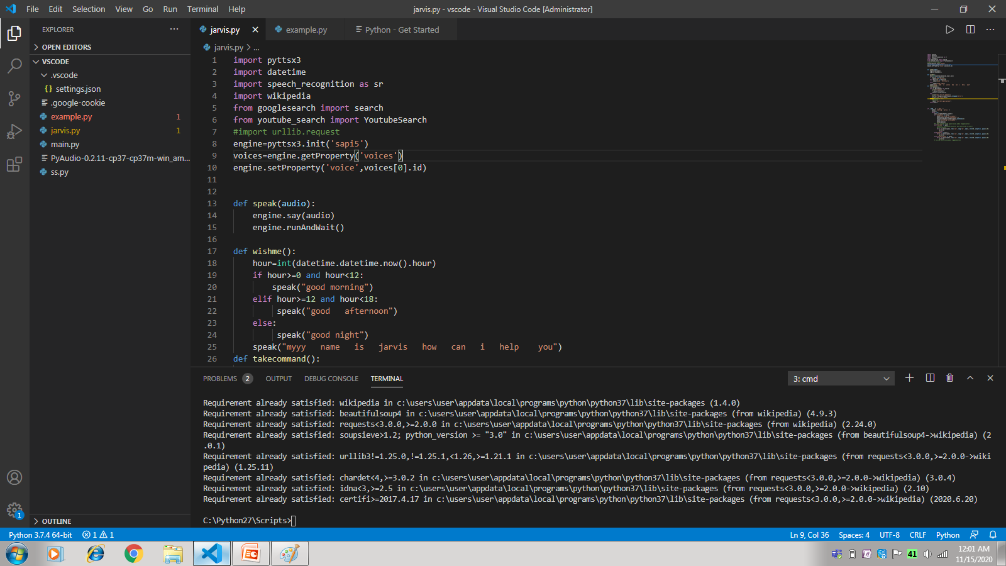

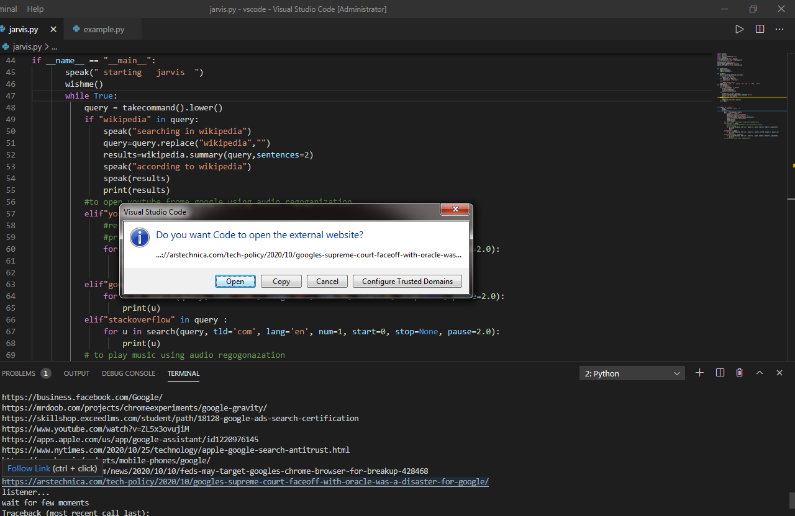
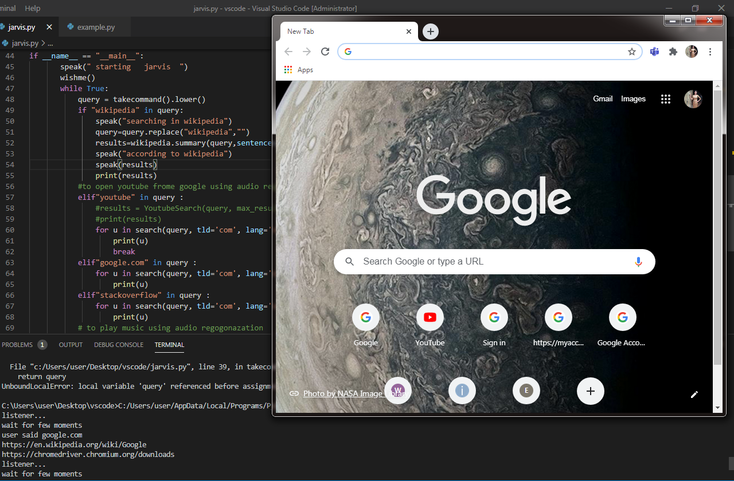

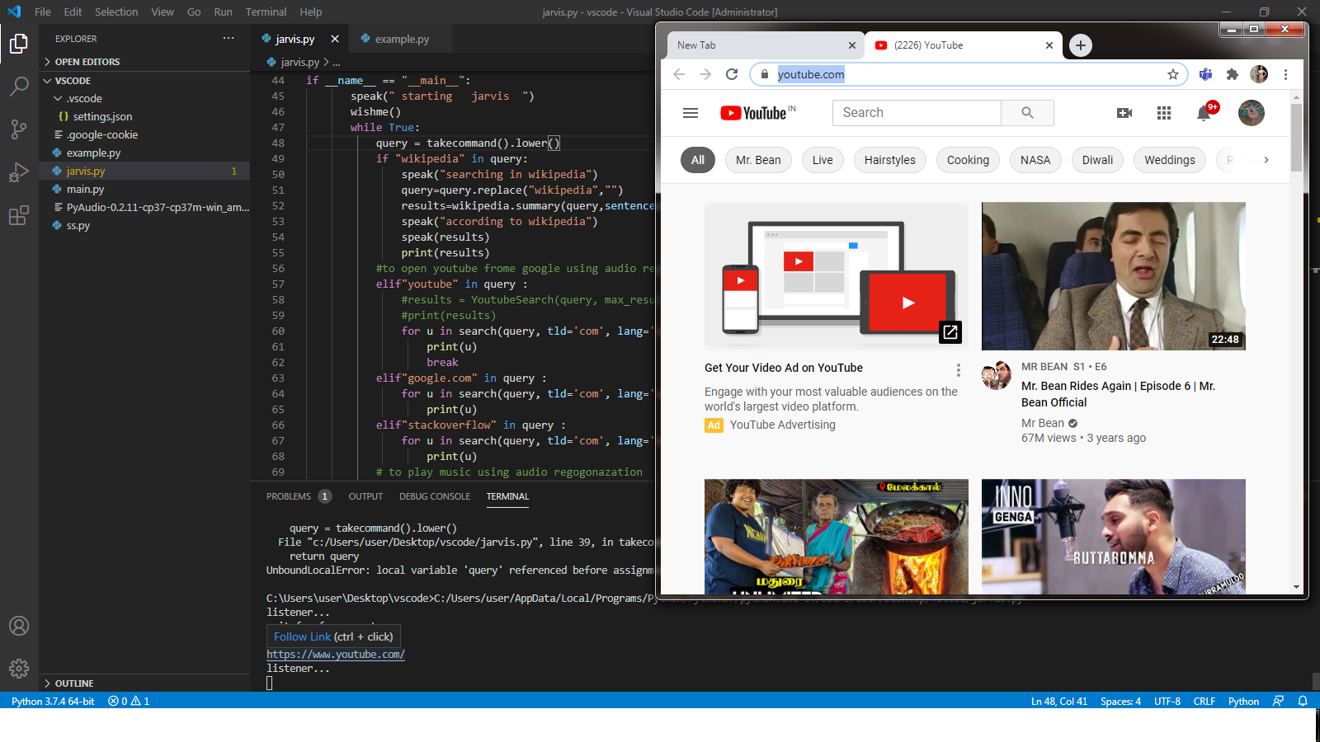

A. Subprocess:-
This module is used for getting system subprocess details which are used in various commands i.e Shutdown, Sleep, etc. This module comes built-in with Python
B. WolframAlpha:-
It is used to compute expert-level answers of any command using Wolfram’s algorithms, knowledgebase and AI technology.
C. Pyttsx3:-
Pyttsx3 is a text-to-speech conversion library in Python. It works offline and is compatible with python like Python 2 and 3 works without internet connection or delay. The text-to-speech features for this pyttsx3 module are based on python languages installed in your operating system. It is a very easy to use tool which converts the entered text into speech.
The pyttsx3 is an offline module that is used for text to speech conversion in Python and it is supported by both Python 2 & 3. The run and wait functionality is also in this module only. It determines how much time the system will wait for another input or in other words the time interval between inputs. This is a free module available in the python community which can be installed using the pip command just like other modules.
D. JSON:-
JSON stands for JavaScript Object Notation. JSON is a lightweight format for storing and transporting data. JSON is often used when data is sent from a server to a web page. JSON is "self-describing" and easy to understand
E. Speech recognition:-
Speech recognition means that when humans are speaking, a machine understands it. In our project we are using Google Speech API in Python to make software which is used to run machines on command. We need to install the Pyaudio python package for recognize the voice commands. Pyaudio can be installed by using pip install Pyaudio command.
F. gTTS:-
Google’s text-to-speech packages, gTTS converts your audio questions command to text. The response from the look-up function that you write for fetching answer to the question or command is converted in an audio form by gTTS. This package interface with Google Translate’s API.
G. Datetime:-
Datetime package is used to showing Date and Time. This datetime module comes built-in with Python. The DateTime module is imported to support the functionality of the date and time. For example, the user wants to know the current date and time or the user wants to schedule a task at a certain time. In short this module supports classes to manipulate date and time and perform operations according to it only. This is an essential module, especially in tasks where we want to keep a track of time. This module is very small in size and helps to control the size of our program. If the modules are too large or heavy then the system will lag and give slow responses.
H. Wikipedia:-
We all know Wikipedia is a great and huge source of knowledge just like GeeksforGeeks or any other sources we have used the Wikipedia module in our project to get more information from Wikipedia or to perform a Wikipedia search. To install this Wikipedia module use pip install wikipedia. Wikipedia is a library in python which it possible for the virtual assistant to process the queries regarding Wikipedia and display the results to users. This is an online library and needs an internet connection to fetch the results. The no. of lines that the user wants to get as a result can be set manually.
I. web browser:-
To perform Web Search. This module comes built-in with Python. This module allows the system to display web-based information to users. For example, the user wants to open any website and he gives input as “Open Google”. The input is processed using the web browser module and the user gets a browser with google opened in it. The browser which will be used is the default set web browser.
J. OS:-
The OS module in Python provides functions for interacting with the operating system. OS comes under Python’s standard utility modules. This module provides a portable way of using operating system dependent functionality. OS Module provides an operating system dependent functionalities. If we want to perform operations on files like reading, writing, or manipulate paths, all these types of functionalities are available in an OS module. All the operations available raise an error “OSError” in case of any error like invalid names, paths, or arguments which may be incorrect or correct but just no accepted by the operating system.
K. Winshell:-
The winshell module is a light wrapper around the Windows shell functionality. It includes helpful functions for accessing special folders, for using the shell’s file copy, rename & delete functionality, and a certain amount of support for structured storage. winshell is tested on all versions of Python from 2.4 to 3.2 (2.5+ for context management).

L. Pyjokes:-
Pyjokes is used for collection Python Jokes over the Internet. Pyjokes is add in our project because it adds jokes in our project . It is very interesting. Pyjokes is the one line joke which makes our project interesting.
M. Pyaudio:-
PyAudio is a set of Python bindings for PortAudio, a cross-platform C++ library interfacing with audio drivers.
N. Smtplib:-
The smtplib is a Python library for sending emails using the Simple Mail Transfer Protocol (SMTP). The smtplib is a built-in module in python; do not need to install it. It abstracts away all the complexities of SMTP. It provides a Simple Mail Transfer Protocol (SMTP) client implementation. Python has this module for in the standard library for working with emails & email servers. The SMTPLIB defines an object known as “SMTP client session object” which is used to send mails by the user. There are 3 steps involved - initialize, sendmail(), quit. When the optional parameters which are host and port, are provided connect method is called with these arguments during the first step which is initialization.
O. Ctypes:-
Ctypes is a built-in powerful Python feature to create and manipulate C data types in Python, it is enables you not only for call functions in dynamically linked libraries but also used for low-level memory manipulation. It allows wrapping these libraries in pure Python.
P. Requests:-
Requests module allows u to send http requests using python. Requests is used for making GET and POST requests. It abstracts the complexities of making requests behind a beautiful, simple API.
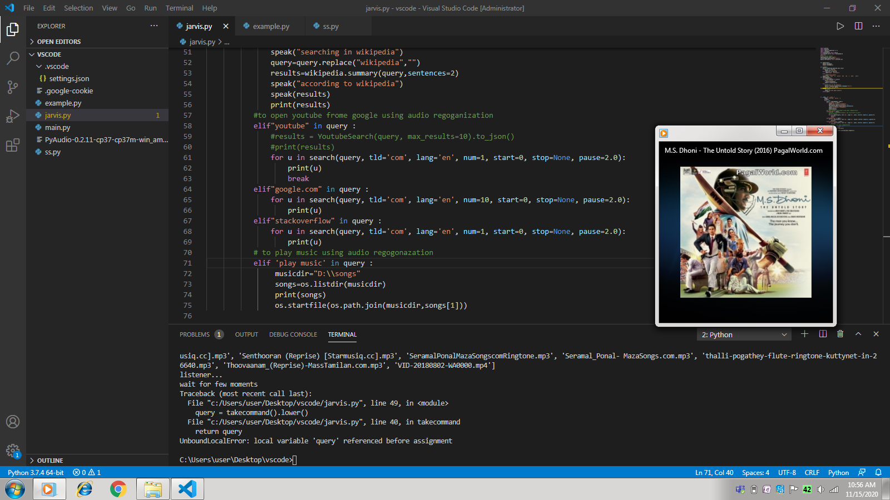
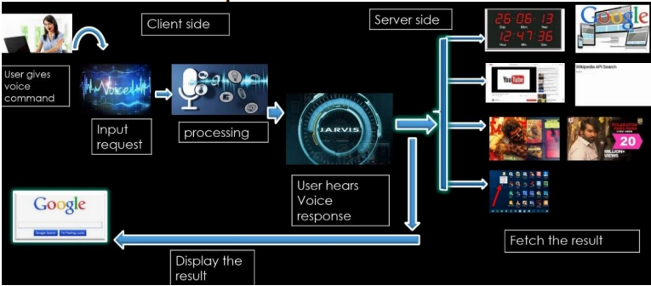

4.3 DATA FLOW DIAGRAM
A. DFD Level 0 (Context Level Diagram)

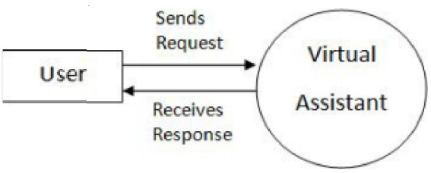

B. DFD Level 1
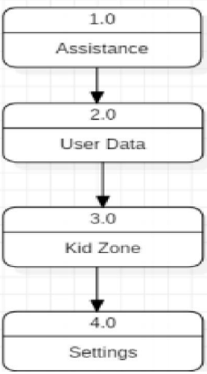

C. DFD Level 2

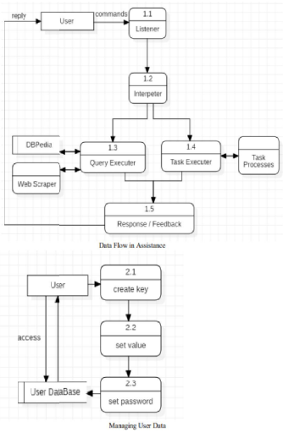

Component Diagram

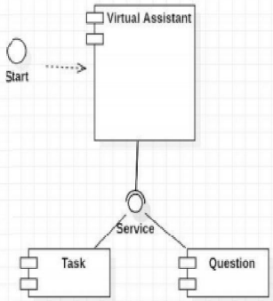

4.4 E-R DIAGRAM

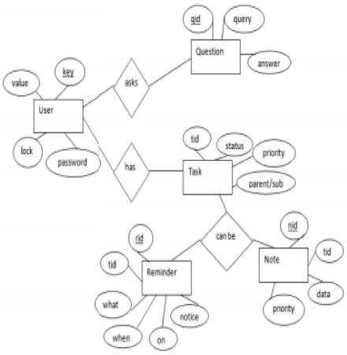

CHAPTER 5

TESTING AND IMPLEMENTATION
  - TESTING
Implementation is the stage of the project when the theoretical design is turned into a working system. This is the final and important phase in the system life cycle It is actually the process of converting the new system into a operational one.

5.1.1 Unit Testing

Unit testing comprises the set of tests performed by an individual programmer prior to integration of the unit into a larger system. The module interface is tested to ensure that information properly flows into and out of the program unit. The local data structure is examined to ensure that data stored temporarily maintains its integrity during all steps in an algorithm’s execution. Boundary conditions are tested to ensure that the module operates properly at boundaries established to limit or restrict processing. All independent paths through the control structure are tested. All error-handling paths are tested.

5.1.2 Block Box Testing
Black-box testing is a method of software testing that examines the functionality of an application without peering into its internal structures or workings. This method of test can be applied virtually to every level of software testing: unit, integration, system and acceptance. It is sometimes referred to as specification-based testing.

5.2 SYSTEM IMPLEMENTATION
Implementation is the stage of the project when the theoretical design is turned into a working system. This is the final and important phase in the system life cycle It is actually the process of converting the new system into a operational one.

CHAPTER 6

RESULT AND DISCUSSION

Virtual assistant is a less time consuming. Virtual assistant is a software that understands verbal or written commands and complete task assigned by client. Virtual assistant use natural language processing (NLP) to match user voice or text input with executable commands. With the help of virtual assistant you able to run your machine like laptop or PC’s on your own command. It is the fast process, therefore it saves time. Virtual assistant is working for you at set times, so always available to you and able to adapt to changing needs quickly. Virtual assistant will be available to you and, should their workload enable, help others too, such as family and colleagues

Test Case Design
A. Test Case 1
Test Title: Response Time
Test ID: T 1
Test Priority: High
Test Objective: To make sure that the system respond back time is efficient.
Description: Time is very critical in a voice-based system.
As we are not typing inputs, we are speaking them. The system must also reply in a moment. User must get instant response of the query made.
B. Test Case 2
Test Title: Accuracy
Test ID: T 2
Test Priority: High
Test Objective: To assure that answers retrieved by system are accurate as per gathered data.
Description: A virtual assistant system is mainly used to get precise answers to any question asked.
Getting answer in a moment is of no use if the answer is not correct. Accuracy is of utmost importance in a virtual assistant system
C. Test Case 3
Test Title: Approximation
Test ID: T 3
Test priority: Moderate
Test Objective: To check approximate answers about calculations.
Description: There are times when mathematical calculation requires approximate value. For example, if someone asks for value of PI the system must respond with approximate value and not the accurate value. Getting exact value in such cases is undesirable.
Note: There might include a few more test cases and these test cases are also subject to change with the final software development.

CHAPTER 7

CONCLUSION AND FUTURE ENHANCEMENTS

7.1 CONCLUSION:

In this paper, we discussed the design and implementation of a Digital Assistance. The project is built using open source software modules with visual studio backing which can accommodate any updates in the near future. The modular nature of this project makes it more flexible and easy to add additional features without disturbing current system functionalities. This examination speaks to an initial phase in investigating the potential job of remote helpers in programming improvement ventures finished by virtual groups. This project will be help for visually impaired and physically challenge people. Instead, we will see a fragmented marketplace emerge. It will be a market where you are might into using default AI providers depending on the hardware purchase. This will lead to consumer friction and third party solutions to remove incumbent solution.

7.2 FUTURE ENHANCEMENTS

The virtual assistants which are currently available are fast and responsive but we still have to go a long way. The understanding and reliability of the current systems need to be improved a lot. The assistants available nowadays are still not reliable in critical scenarios. The future of these assistants will have the virtual assistants incorporated with Artificial Intelligence which includes Machine Learning, Neural Networks, etc. and IoT. With the incorporation of these technologies, we will be able to achieve new heights. What the virtual assistants can achieve is much beyond what we have achieved till now. Most of us have seen Jarvis, that is a virtual assistant developed by iron man which is although fictional but this has set new standards of what we can achieve using voice-activated virtual assistants.

REFERENCES

[1] Subhas mani Kaushal,megha Mishra(IRJET)volume:07 Issue:09|sep 2020

[2] Dhiraj Pratap singh,Deepika Sherawat,Sonia school of computer science and engineering,Galgotias University volume 26,Issue 6,2020.

[3] Kei Hashimoto, Junichi Yamagishi, William Byrne, Simon King, Keiichi Tokuda, “An analysis of machine translation and speech synthesis in speech-to-speech translation system” proceedings of 5108978-1-4577-0539- 7/11/$26.00 ©2011 IEEE.

[4] B. Marr, The Amazing Ways Google Uses Deep Learning AI.

[5] Cortana Intelligence, Google Assistant, Apple Siri.

[6] Hill, J., Ford, W.R. and Farreras, I.G., 2015. Real conversations with artificial intelligence: A comparison between human– human online conversations and human–chatbot conversations. Computers in Human Behavior, 49, pp.245-250.

[7]AbhayDekate, ChaitanyaKulkarni, RohanKilledar, “Study of Voice Controlled Personal Assistant Device”, International Journal of Computer Trends and Technology (IJCTT) – Volume 42 Number 1 – December 2016.

[8] Deny Nancy, Sumithra Praveen, AnushriaSai, M.Ganga, R.S. Abisree, “Voice Assistant Application for a college Website”, nternational Journal of Recent Technology and Engineering (IJRTE) ISSN: 2277-3878, Volume-7, Issue-6S5, April 2019.

[9] Deepak Shende, RiaUmahiya, Monika Raghorte, AishwaryaBhisikar, AnupBhange, “AI Based Voice Assistant Using Python”, Journal of Emerging Technologies and Innovative Research (JETIR), February 2019, Volume 6, Issue 2,

[10] M. A. Jawale, A. B. Pawar, D. N. Kyatanavar, “Smart Python Coding through Voice Recognition”, International Journal of Innovative Technology and Exploring Engineering (IJITEE) ISSN: 2278-3075, Volume-8 Issue-10, August 2019.

[11] TusharGharge, ChintanChitroda, NishitBhagat, KathapriyaGiri, “AI-Smart Assistant”, International Research Journal of Engineering andTechnology (IRJET), Volume: 06 Issue: 01, January 2019. 10. VetonKëpuska, “Next-Generation of Virtual Personal Assistants (Microsoft Cortana, Apple Siri, Amazon Alexa and Google

[12] Rishabh Shah, Siddhant Lahoti, Prof. Lavanya. K, “An Intelligent Chatbot using Natural Language Processing”. International Journal of Engineering Research, Vol. 6, pp. 281-286, 1 May 2017.

