CMOS TRANS-CONDUCTANCE LNA INTEGRATION OF VITAL SIGN PROCESSING RECIEVER WITH CLUTTER ELIMINATION USING SC CHEBYSHEV LPF

ABSTRACT

This brief describes a critical signal processing circuit without any automatic signal processing or ultra-wideband (UWB) pulse-based radar algorithm for simultaneous dc/near-dc exclusion and out-of-band interference removal. As a secure and balanced pseudo resistor applied under a servo feedback mechanism in a critical signal receiver of the sensing radar, it was proposed that an inherent self-balancing MOS diode (SBMD) operate as a High-Pass Filter (HPF) with an ultra-low corner frequency below 0.5 Hz to suppress undesired clutters of reflected signals and input dc-offset voltages from underlying circuit offsets. A third-order switched-capacitor (SC) Chebyshev low-pass Filter (LPF) with trans-conductance low-noise amplifier (LNA) and leap-frog topology was embraced as the next step to remove out-band noise, create an integrated band-pass response vital-sign transmission circuit and incorporate it into a radar module to verify its viability. This study was finally established at 130 nm and 45 nm CMOS Technology in Tanner EDA.

TABLE OF CONTENT
CHAPTER NO |  | TITLES | PAGE NO
 |  | ABSTRACT | iii
1 | 1.1 | INTRODUCTION | 1
 | 1.2 | PROBLEM STATEMENT | 3
 | 1.3 | OBJECTIVE OF THE WORK | 4
 | 1.4 | SCOPE OF THE WORK | 4
 | 1.5 | VITAL SIGN DETECTION | 5
 | 1.6 | 915 MHz CW DOPPLER RADAR SENSOR | 8
 |  | 1.6.1 Radar Architecture | 8
 |  | 1.6.2 Path-Loss Calculation | 9
 |  | 1.6.3 The PSIL Radar | 11
 | 1.7 | CLUTTER EFFECT AND CANCELLATION TECHNIQUE | 12
 | 1.8 | DIGITAL SIGNAL PROCESSING ALGORITHM | 15
 |  | 1.8.1 Arc-Fitting Algorithm | 17
 |  | 1.8.2 Dynamic CDC Removal and Arc Position Adjustment | 20
2 |  | LITERATURE SURVEY | 24
3 |  | METHODOLOGY | 30
 | 3.1 | EXISTING SYSTEM | 30
 | 3.2 | PROPOSED SYSTEM | 32
 | 3.3 | BLOCK DIAGRAM | 33
4 |  | PROJECT IMPLEMENTATION | 34
 | 4.1 | THE VITAL-SIGN PROCESSING RECEIVER | 34
 | 4.2 | IMPLEMENTATION OF RADAR SENSOR | 40
 |  | 4.2.1 Fractal-Slot Patch Antenna | 40
 |  | 4.2.2 Two-Stage LNA | 43
 |  | 4.2.3 915 MHz Radar Sensor Module | 46
5 |  | RESULT | 47
6 |  | CONCLUSION | 51
 |  | REFERENCES | 52

LIST OF FIGURES

FIGURE NO | TITLE | PAGE NO
1 | THE PSIL RADAR | 11
2 | DIGITAL SIGNAL PROCESSING ALGORITHM | 16
3 | DYNAMIC CDC REMOVAL | 21
4 | DYNAMIC ARC ROTATION | 22
5 | PROPOSED SYSTEM | 33
6 | 915 MHz RADAR SENSOR MODULE | 46
7 | RESULTS | 47

CHAPTER 1
INTRODUCTION
  - INTRODUCTION
Vital signal detection based on noncontact and direct conversion Doppler radar is of great importance for long-term physiological monitoring. However, the dc offset caused by clutter signals and circuit imbalances is a crucial issue which often deteriorates the sensitivity of receiving physiological data. There are several ways to solve this dc-offset issue. The first one is to adopt arctangent demodulation in a quadrature radar architecture to eliminate the clutters and sensing blind zones, but at the same time, such demodulation increases the circuit complexity and occupies a fairly large area. In the second way, a conventional calibration technique with equal amplitude but out-of-phase clutter signals has been widely used to execute compensation. Nevertheless, a clutter canceller with an adjustable phase-shifter and a programmable gain amplifier (PGA) implemented in the RF front-end circuit raised certain concerns regarding the uncertainty of incoming RF signals and a complicated system. The third way is to apply a dual-tuning voltage-controlled oscillator (VCO) in a self-injection locked mode to detect the vital signs with dc-offset elimination instead of using the precalibration process. An adaptive dc compensation circuit in the analog receiver is another means to directly handle the down-converted information and feed the demodulator with the required compensation voltages to calibrate the dc offset. A servo loop feedback configuration can also be used to form a high-pass response and prevent any dc residue. However, to preserve the desired vital signs, an ultralowcorner frequency is required which is really difficult to obtain because of an unrealizable high feedback resistance or capacitance. An MOS diode operating in a subthreshold region as a pseudo resistor with ultrahigh resistance is commonly used in the feedback path of a biomedical instrument amplifier (IA) for input bias. However, the limited dynamic range and high sensitivity of the pseudo resistor reduce its stability and applicability when the variations in process, voltage, and temperature (PVT) occur. The input and output swing variations (Vgs/Vgd) imposed at the two terminals of a conventional MOS diode in a subthreshold region as a pseudo resistor can deviate the desired resistance. A stable bias scheme at the gate of an MOS diode against the process variation is also required. Furthermore, with respect to system integration, the dc offset not only exists in the reflected pulses but also in each subcircuit mismatched offset of a receiving chain, which should all be rejected. This is because a small input offset may saturate the following stages in the processing circuit due to its high-gain property (60–80 dB), and hence, degrade the sensitivity of detection. The mechanism of eliminating intrinsic input-referred offsets due to circuit imbalances in the receiver chain is generally considered for the stability of the entire radar system.
In this brief, an alternative way is first proposed to efficiently suppress the clutter signals using an intrinsic self-balanced MOS diode (SBMD) technique as a pseudo resistor with ultrahigh resistance applied at the servo feedback loop to push the high-pass corner close to dc. We adopted three-stage servo feedback loops with dc-offset canceling (DCOC) and distributed them in several subblocks of the receiving chain to further reject any interferer near the dc, clutters, and concurrent intrinsic input-referred offsets. A third-order switched-capacitor (SC) low-pass filter (LPF) was also incorporated into the vital-sign receiver to form a low-pass response. Both the clutters and out-band noises were rejected, which greatly benefited the detection of physiological parameters of a direct conversion radar without digital-assisted calibration of the dc offset.
There have been growing research activities on physiological sign detection techniques based on microwave Doppler radars for health-assistance devices, sleep apnea syndrome alarms, and life detectors for earthquake rescue. The vibration of the chest wall due to cardiopulmonary activity modulates the phase of the signal reflected off the subject. Doppler radars extract the information of the respiration and heartbeat rates from the phase variation of the reflected signal. Early studies on the continuous-wave (CW) radars for vital-sign detection have used phase-locked oscillators due to better phase noise. The development of range correlation theory makes free-running oscillators applicable only for short range vital-sign monitoring because the signal-to-noise ratio (SNR) degrades rapidly with increasing detection distance. Moreover, the flicker noises from the mixers in the conventional Doppler radar receiver further degrade the detection sensitivity. The dc offset due to the clutter and circuit imperfections is a critical issue for conventional CW radars since it saturates and desensitizes the receiver. Various clutter cancellation and dc offset calibration techniques have been reported with complex RF front-end and digital signal processing (DSP) hardware,. In, a heterodyne receiver has been presented to reduce the dc offset from local oscillator leakage. However, the coupling from transmitter to receiver results in interferences at the same IF frequency could not be removed. Moreover, the residual phase noise from additional local oscillator degrades the detection sensitivity. A Doppler radar using a self-injection-locked (SIL) oscillator has been proposed to achieve a high SNR gain in the vital-signal bandwidth. However, it suffers from uncontrolled frequency drift which causes electromagnetic interference (EMI) issues in practical applications.However, the dc offset problems caused by the clutter and circuit imperfections were not addressed in regard to the reliable detection. In this paper, we present a simple and hardware efficient method to eliminate the dc offset using a dual-tuning VCO and avoiding the complex clutter cancellation circuits. Analysis based on the classic injection locking equation shows that the dc offset can be eliminated without any frequency drift and sensitivity degradation.
1.2 PROBLEM STATEMENT
- The first one is to adopt arctangent demodulation in a quadrature radar architecture to eliminate the clutters and sensing blind zones, but at the same time, such demodulation increases the circuit complexity and occupies a fairly large area.
- In the second way, a conventional calibration technique with equal amplitude but out-of-phase clutter signals has been widely used to execute compensation. Nevertheless, a clutter canceller with an adjustable phase-shifter and a programmable gain amplifier (PGA) implemented in the RF front-end circuit raised certain concerns regarding the uncertainty of incoming RF signals and a complicated system.
- The third way is to apply a dual-tuning voltage-controlled oscillator (VCO) in a self-injection locked mode to detect the vital signs with dc-offset elimination instead of using the pre-calibration process. However, to preserve the desired vital signs, an ultra low corner frequency is required which is really difficult to obtain because of an unrealizable high feedback resistance or capacitance. The mechanism of eliminating intrinsic input-referred offsets due to circuit imbalances in the receiver chain is generally considered for the stability of the entire radar system.
- The above methods are used in order to eliminate the clutter and create an integrated band-pass response vital-sign transmission circuit and incorporate it into a radar module to verify its viability.
  - OBJECTIVE OF THE WORK
- To Design the Third Order SC Chebyshev LPF (Low pass Filter) using Trans-conductance LNA (Low Noise Amplifier) at 130 nm and 45 nm CMOS Technology and proved the comparisons of Area and Power Consumptions.
.
  - SCOPE OF THE WORK
  - To reduce the logic area and power consumptions
  - To reduce the Dc-offset and reduce the noise
  - Increase the stability in Radar system

1.5 VITAL SIGN DETECTION
The range and phase information acquired in the preceding step are combined to retrieve vital signals for multiple subjects. The phase information is extracted from the FFT data, whose frequency is fixed at the beat frequency acquired by the MUSIC algorithm.The vital signal of the pth target can then be expressed as follows: xp(τ) = Sb (fb,p , τ) = ρpTm exp j 4π fcRp(τ) c + N ∑ n=1 n6=p ρnTm exp j 4π fcRn(τ) c sinc h Tm fb,p − fb,n i . (3) In Equation (3), the first term shows the body movement of the pth target, while the second term describes the mutual interference from other subjects. The second term is a function of the sinc function; thus, its influence increases if two subjects approach each other, especially for the situation within the resolution limit. To reduce the effect of mutual interference, the integration of several cm is performed in consideration of the property of the sinc function. For the ease of calculation, it is assumed that the total number of subjects is two and the RCSs of two subjects are identical. Because the human body is an electromagnetically dispersed target, the reflectivity ρ is proportional to 1/R. Equation (2) can be expressed as follows: Sb (f , τ) = α1(f) y1(τ) + α2(f) y2(τ) (4) where α1(f) = sinc [Tm (f − fb,1)] R1 , α2(f) = sinc [Tm (f − fb,2)] R2 , y1(τ) = exp j 4π fcR1(τ) c , y2(τ) = exp j 4π fcR2(τ) c . (5) The effect of mutual interference depends on the ratio of coefficients α1 and α2 at each position. Thus, the mutual interference to signal ratio is α2/α1 at the position of R1 and α1/α2 at the position of R2. As the two subjects approach each other, the mutual interference increases, and each ratio of the coefficients also increases accordingly. Especially in the case of two adjacent subjects within the resolution limit, the vital sign is erroneously detected due to the mutual interference. Therefore, the ratio of coefficients should be reduced to detect the vital signs properly. With the range integration, the vital signals of each subject can be formulated as follows:    I1(τ) = R fb,1 fb,1−∆f Sb (f , τ) d f = y1(τ)y11 + y2(τ)y12 I2(τ) = R fb,2+∆f fb,2 Sb (f , τ) d f = y1(τ)y21 + y2(τ)y22 (6) where y11 = Z fb,1 fb,1−∆f α1(f)d f , y12 = Z fb,1 fb,1−∆f α2(f)d f , y21 = Z fb,2+∆f fb,2 α1(f)d f , y22 = Z fb,2+∆f fb,2 α2(f)d f . (7) Thus, the mutual interference to signal ratio is y12/y11 at the position of R1 and y21/y22 at the position of R2. Figure 2 shows the mutual interference to signal ratio on each subject with varying the range difference. Despite the occurrence of some position estimation error, the vital signal of the front subject is robust to the mutual interference because of its relatively larger amplitude. On the other hand, the vital sign of the rear subject is susceptible to mutual interference. Thus, it is necessary to consider a method for removing the effect of mutual interference to the rear subject. Assuming that the vital signs are correctly detected regardless of the mutual interference in a situation where range difference is larger than the resolution limit of 60 cm, the threshold value can be determined to be 0.45. The influence of the mutual interference is investigated based on the threshold value, as shown in Figure 3. When the error of the position estimation is −10 cm, a wider coverage area eliminates more mutual interference. However, when the error of the position estimation is 10 cm, a wider coverage area deteriorates the situation. According to the threshold value of the ratio, it is optimal to set the integration area to approximately 30 cm. When the integration area of 30 cm is applied, the mutual interference to signal ratio is less than the threshold value even in situation where the range difference is 40 cm, which can be called detection limit. On the other hand, the detection limit without range integration is 60 cm. This shows that the range integration is effective to eliminate the mutual interference for two adjacent subjects.
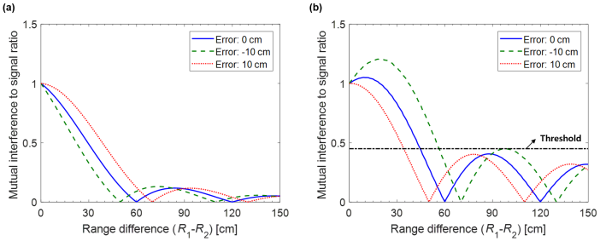
Influence of the mutual interference with varying range difference and position estimation error: (a) front subject (y12/y11); and (b) rear subject (y21/y22)
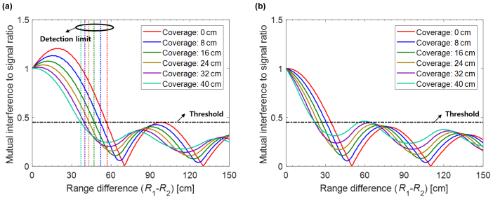
Effect of the range integration for the rear subject (y21/y22): (a) position estimation error: −10 cm; and (b) position estimation error: 10 cm
Furthermore, some errors may arise in the data extracted from only one point, where the local maximum is displayed in the result of the MUSIC algorithm, because the human body is an electromagnetically disperse target. Therefore, the range integration not only corrects the errors in tracking vital signs, but also isolates vital signs from each other due to the characteristics of the sinc function, especially for adjacent subjects within the radar resolution limit. Before the vital sign detection, the phase information is extracted from the output of the range integration at each position. Using the characteristics of the complex value, the arctangent demodulation is used for the extraction of the phase information.
1.6 915 MHz CW DOPPLER RADAR SENSOR
1.6.1 Radar Architecture
A block diagram of the detection of vital signs using a CW Doppler radar sensor. Transmitted signal T(t), generated by the free-running oscillator, is expressed as (1)where At represents the magnitude of the transmitted signal, f0 represents the operating frequency of the radar sensor, t represents time, and represents the phase noise of the oscillator. Because of the Doppler shift generated by the respiration and heartbeat of the subject, received signal R(t) can be expressed as a phase-modulated signal.
(2)where Ar represents the magnitude of the received signal, d0 represents the distance from sensor to subject, [Math Processing Error] represents wavelength corresponding to operating frequency, c represents the velocity of the EM waves in free space, and x(t) and y(t) represent the time-varying displacements caused by respiration and heartbeat, respectively; x(t) and y(t), due to vital signs, are significantly smaller than the wavelength corresponding to the operating frequency. The received signal and the local oscillator (LO) signal, coupled with the transmitted signal, are downconverted by a frequency mixer and a low-pass filter into the baseband signal.
(3)where AB represents the magnitude of the baseband signal. Phase variation θ over the distance from sensor to subject is given as 4πd0/λ, and residual phase noise Δφ is given by [Math Processing Error]. It is assumed that residual phase noise can be neglected when the LO and received signals are generated by the same oscillator due to the range correlation effect. If θ is an odd multiple of π/2, baseband signal B(t) can be represented with small-angle approximation of the sine function.
(4)When θ approaches an even multiple of π/2, it is difficult to distinguish vital signs at the baseband output of the radar sensor due to the null-point problem. A radar sensor with a single output channel has limited operation owing to distance dependence, but this problem can be solved by using a quadrature receiver or the demodulation method. For a 915 MHz radar sensor with a single output channel, the null-point problem can be avoided by adjusting the distance from the sensor to the subject and implementing a simple hardware configuration.
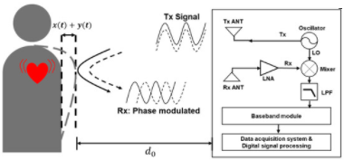
The continuous-wave (CW) Doppler radar sensor for vital-sign detection
1.6.2 Path-Loss Calculation
In the human body, the region from the skin to the heart, which is a measurement target of the radar sensor, has a multilayer structure with various dielectric properties. These properties vary with respect to EM wave frequency, and depend on personal characteristics, such as age, gender, and race. The layer constituting the inside of the human body was defined according to biological information obtained from a well-examined male cadaver. Based on previous studies, the EM properties of human-body tissue at 915 MHz and 2.45 GHz were calculated, as presented in respectively. Properties are shown only for human-body layers in the region from the radar sensor to the heart, which is the main observation target. Properties related to energy loss of EM waves in each layer differed according to frequency, whereas other properties did not show significant differences. Calculation results showed that conductivity and attenuation at 915 MHz were lower than those at 2.45 GHz. These results agree with the well-known fact that. at the same transmitted power, EM waves can more deeply penetrate inside the body when operating frequency is reduced.
Permeability was assumed to be 1 in all types of tissue, and multiple reflections in each layer were neglected in the calculation. For the same output power of 0 dBm, signal attenuation at the chest surface was calculated to be approximately equal to −3.9 dB and −4 dB at 915 MHz and 2.45 GHz, respectively. Signal levels reflected by the heart were calculated to be −27.35 dB at 915 MHz and −34.33 dB at 2.45 GHz. It is considered that the signal received by the radar sensor operating at 915 MHz contained more information regarding the movement of the heart, because the signal reflected by the heart is 7 dB higher. The attenuation level given by path-loss calculation may vary depending on human-body characteristics or human-body layer modeling. However, calculations clearly indicate the tendency of path-loss reduction for EM waves with the reduction of the frequency. The same tendency of EM waves passing through the human body was reported for different frequency bands.
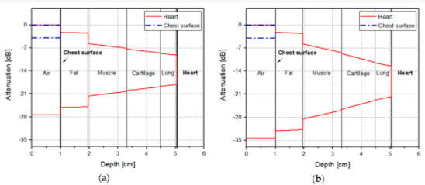
Path loss in human-body layers depending on frequency: (a) 915 MHz and (b) 2.45 GHz
1.6.3 THE PSIL RADAR
The system block diagram of the proposed Doppler radar based on the PSIL oscillator with the path-diversity switch. The dual-tuning VCO has the fine tuning voltage controlled by the PLL to extract the Doppler phase modulated signal and the coarse tuning voltage is set by the control circuit to eliminate the dc offset. The received Doppler signal is injected into the VCO through the circulator to form an SIL loop. Then, the SIL loop is phase locked by the PLL to stabilize the output frequency and reduce the in-band phase noise. The Doppler injection signal results in an output phase perturbation of the VCO which is detected by the phase frequency detector (PFD). The charge pump (CP) circuit and the loop filter transform the output of the PFD into a voltage for tuning the intrinsic oscillation frequency of the VCO.
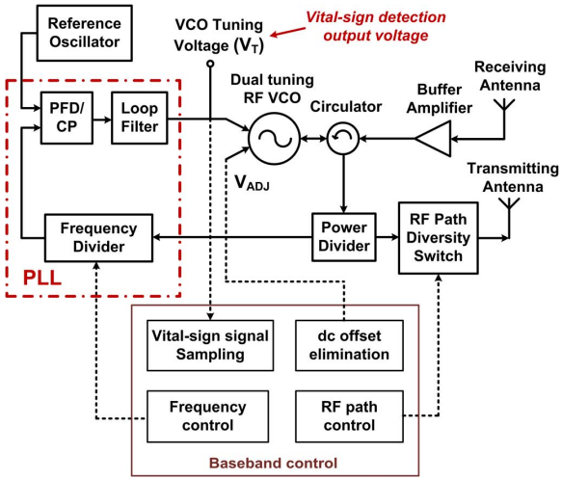
Figure 1.6.3 System block diagram of the PSIL Doppler radar with path-diversity switch
The VCO fine tuning voltage controlled by the PLL is the vital-sign output voltage that reflects the phase variation of the Doppler signal. The path-diversity switch transmitter periodically alters the transmission path to eliminate the null points and reduce the average transmitted power. The steady-state analysis provides comprehensive derivation for the operation of the PSIL oscillator since the vital-sign signal is slowly varying.
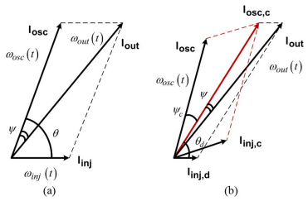
This equation of the PSIL radar indicates that the reflected signal from the stationary object results in a variation on the VCO tuning voltage controlled by the PLL with respect to the locking range and the phase difference between and . In the proposed architecture, is the output voltage containing the Doppler information. The output voltage variation is periodic with respect to the distance of the stationary object away from radar since accounts for the round-trip phase delay. The period is a half free-space wavelength. Furthermore, the VCO gain can be used to increase the detection sensitivity without high-gain signal amplification.
1.7 CLUTTER EFFECT AND CANCELLATION TECHNIQUE
A. Detection Sensitivity Under Clutter Injection
The clutters, including the coupling between the antennas, circuit reflections, and stationary reflecting and scattering objects within the detection range, degrade the detection sensitivity in the conventional Doppler radars. The proposed PSIL radar can maintain the detection sensitivity with strong clutter. The vector diagram of the PSIL oscillator with both the strong clutter signal and the weak Doppler signal . The signal is the sum of and , representing the effective VCO oscillation signal under clutter injection. The phase difference between and stands for the round-trip delay of the signal reflected from the target.
The variation of the VCO tuning voltage causes a different output signal when clutter injection exists. Since the VCO gain stands for the change of the resonant frequency with respect to the tuning voltage, the clutter effect can be regarded as a variation to the VCO gain.
The detection sensitivity is proportional to the square root of the ratio of the injection power to the intrinsic oscillation power. The PSIL radar retains the property of the SIL radar [10] that the sensing distance can grow four times longer by doubling the operating frequency. It is also inversely proportional to the quality factor and the VCO gain. The detection sensitivity can be further tuned by adjusting the VCO gain or adding a variable gain amplifier in the receiver chain.
B. DC Offset Elimination Technique Using Dual-Tuning VCO
The dc offset in the mixer-based conventional Doppler radars requires complex cancellation and calibration circuits in both the RF front-end and baseband. This paper presents a simple and hardware efficient technique to eliminate the dc offset using the dual-tuning VCO. For nominal operation of the PSIL radar, the fine tuning voltage controlled by the PLL is used to extract the vital-sign signal with a small to obtain high detection sensitivity. However, the PSIL radar with high detection sensitivity produces considerably large dc offset when the clutter reflection signal is injected into the VCO. The radar may fail to detect small cardiopulmonary activity under strong clutter injection because the dc offset may saturate the sampling circuit. It is intuitive that the dc offset can be mitigated by tuning the PLL synthesized frequency to shift the output voltage back to the desired dc level. This frequency tuning technique can be applied against the dc offset problem in the PSIL radar. However, the frequency tuning technique has an undetermined bandwidth since the operating frequency is forced to vary in different clutter environments. Moreover, the voltage tuning step cannot be well controlled since it is also affected by the clutter injection, as shown in (5). The frequency change causes a variation of , resulting in the shift of the dc offset. In this paper, the dc offset can be easily eliminated by adjusting the coarse VCO tuning voltage , which is controlled by the dc offset elimination circuit.
Typically the VCO gain value of is larger than that of to simultaneously obtain larger frequency channel selection range and high detection sensitivity. This ensures that the dc offset can be always eliminated even if saturates the sampling circuit. It is noted that the detection sensitivity is not affected by since after dc offset elimination, is a fixed constant value under the specified operating condition. Compared to the conventional dc offset cancellation architectures, the proposed technique is simple and hardware efficient without any bulky RF attenuators, phase shifters, and complex DSP clutter cancellation algorithms.
PATH DIVERSITY TRANSMISSION
The CW radars suffer from the null detection problem that exists at every multiple of a quarter free-space wavelength distance. The PSIL radar also has the null detection problem since it has a zero power spectral SNR gain and fails to detect the physiological movement. In this paper, we propose a single channel receiver topology to eliminate the null points using the path-diversity transmission. The two signal paths have a difference of a 90 phase shift. From, the detection sensitivity of the first path is proportional to while that of the second path with additional 90 phase shift is proportional to . The two SIL paths are periodically switched to ensure that when one is in the null point, the other will be in the optimal point.
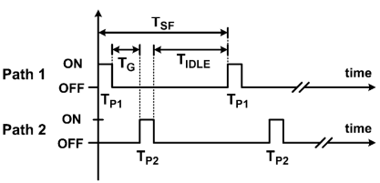
Control timing diagram of the path-diversity switch
Another advantage of the path-diversity transmission is to reduce the average transmitted power by repetitively enabling the signal transmission within short pulse durations for the concern of human electromagnetic energy exposure. The control timing diagram is shown in Fig. 6. The period of a sensing period is denoted as . There are two pulses with duration and in a sensing period to alternately switch on the two SIL paths. The path control is synchronized with the receiver sampling circuit. A guard time interval mitigates the noise from the transition between the SIL loops. The vital-sign output voltage is sampled only when stable SIL loops are established. The average transmitted power can be reduced while the detection sensitivity is not affected since the vital-sign signal has a slow time-varying waveform. The steady-state vital-sign output voltages of each SIL path including the clutter effects can be obtained. The dc offsets can be then removed using the proposed dual-tuning VCO technique. The settling time of the transition from an idle state to an SIL steady state is determined by both the injection locking stabilization time and the PLL settling time for correcting the phase error introduced by the injection signals. The time constant of the injection locking stabilization process is the inverse of the locking range under weak injection condition. The other dominant factor of the settling time is the PLL settling time, which is related to the damping factor and the natural frequency of a typical second-order PLL. The PLL settling time can be determined by designing the loop filter and the supply current of the CP circuit. It is noted that the divider modulus of PLL is not altered and the output frequency is stable. The required settling time is less than 0.2 ms at a natural frequency of several kilohertz. For accurate detection of the cardiopulmonary activity, must be designed by the Nyquist criterion. The detection pulses, and , must be designed to obtain steady-state SIL operations.
1.8 DIGITAL SIGNAL PROCESSING ALGORITHM
The algorithm was developed to be implemented with a CW radar operating at 5.8 GHz, considering the inherent issues that arise during its handling. The block diagram presented in Figure 6 sums up the algorithm working principle.
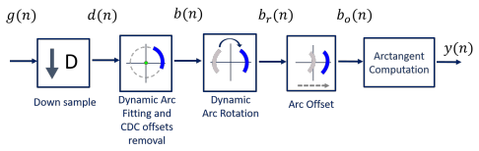
Figure 1.8 DSP algorithm for extraction of vital signs
Usually, signals are acquired by quadrature receivers in CW radars, with a high sampling rate due to front-end restrictions. The front-end output consists of a complex baseband signal g(n), which was acquired with a sampling rate equal to 100 kHz. Firstly, this signal is down sampled, since vital signs are low-pass signals. In our case, the decimated signal d(n) presents a sampling rate equal to 100 Hz, embracing both respiratory and heart signal characteristics. Afterwards, the CDC offsets are estimated using our novel arc fitting method, and subsequently removed from the decimated signal d(n), resulting in signal b(n). In this stage, two concerns were noted:
- The CDC offsets should be correctly estimated, with r >> 0;
- The CDC changes should be tracked and accounted for, which can be accomplished by estimating the offset values dynamically over time through a windowing approach.
After the CDC removal, the arcs can be located in any position in the complex plane. All arcs are rotated accordingly to oscillate around the 0 ◦ value, resulting in signal br(n). One should note the advantages that the arc rotation stage provides: first, it prevents the oscillation around the π value and avoids the wraps occurrence. Secondly, its rotation for a specific angle eases an automatic implementation. Furthermore, it also eases the computation of the vital signs rate. Since y(n) is a phase signal, the location of the arc in other quadrants would increase the magnitude of the spectral component in 0 Hz. After the rotation step, the average angle is approximately 0 ◦ , which enables the automatic computation of the vital signs rate through the identification of the spectral component with higher magnitude. The arc rotation is also performed dynamically, and this procedure is also detailed in Section 2.2. Then, and as one will see later, if the implementation of the algorithm fails to remove the CDC offsets successfully, there will be samples crossing the origin. In those cases, a small offset can be added to push them away, resulting in signal bo(n). Finally, the vital signs information can be correctly extracted using the arctangent method, thus obtaining signal y(n). In this case, we applied this method to complex signals, using the angle function from MATLAB.
1.8.1 Arc-Fitting Algorithm
In order to remove the CDC offsets in bio-radar signals, the literature usually presents fitting algorithms that aim to search for a circle that fits the radar complex samples, finding its radius and center coordinates, which are used afterwards to remove the CDC offsets. Least Squares Fitting (LSF) is a common example of this approach. Moreover, in cases where the data are well distributed, the literature suggests that the Gauss–Newton method with the Levenberg–Marquardt correction (LM) is an LSF -robust solver, which is quite stable, reliable, and fast-converging. It uses a cost function and identifies the possible solutions by finding the parameters that lead to minimization of the cost function. For instance, in, a circle fitting method is implemented to remove the CDC offsets using a cost function minimization. The center coordinates are identified when the radius variance is minimized. Nonetheless, both LM and methods require an optimization stage, which consumes an unknown process time to achieve the desired solutions. Additionally, algorithms based on LSF are sensitive to outliers and hence might not be effective in cases where the data are noisy or lack in resolution, which is a common case in the bio-radar context, as demonstrated previously. Other impairment of the circle-fitting methods usage for bio-radar CDC removal relies on the dependence of the circle radius as an optimization parameter. Badly formed arcs with low lengths and wide thicknesses can drive the algorithm to provide center solutions within the radar signal samples, as demonstrated. The algorithm is forced to search for a circle that fits all points, assigning the radius that enables this fitting. In these situations, the cost-function’s minimum zone is located within the radar data points, which correspond to the center of such circle. For instance, presents a case where the considered optimization starting point was the radar signal mean value, which was already located in a minimum zone. Under these circumstances, it was impossible to find a proper center point outside the data samples, even if the number of iterations is increased or the boundary conditions are wider.
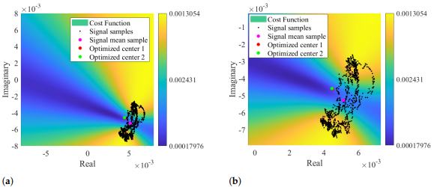
Color map of the cost function result using signal mean value as optimization starting point: (a) Representation of the optimized solution, (b) Zoomed visualization of the optimized solution.
By taking as prior knowledge that the radar samples are disposed according to an arc rather than a circle, it is possible to set the searching zone already outside the signal samples, since the minimum zone extends on the arc’s forward area. In this sense, we developed a novel arc-fitting method that aims to determine the most appropriate center of the arc formed by the radar samples. This new method, from now on referred to as Optimized Cost (OC), is also based in a cost-function minimization. The searching area is limited to the arc sideways zones, avoiding the center solutions within the radar samples.
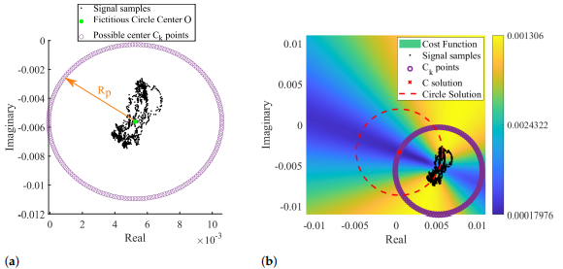
The novel arc fitting method: (a) definition of the possible Ck solutions, (b) cost function result with the selected C solution

One should note that the OC algorithm presents three limitations. First of all, the S minimum zones can occur in both arc sides, i.e., inside and outside its concavity, as can be observed in Figure 8b with the location of the dark blue zones. The next sub-section explains the dynamic implementation of this algorithm to accommodate CDC changes over time. Such implementation requires the CDC estimation of overlapped windows in order to provide a progressive and coherent CDC estimation over time. When signals are especially weak, successive windows might present C solutions at opposite sides of the arc, as depicted.
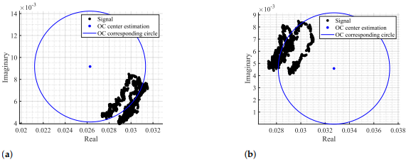
Center estimations in opposite arc sides in consecutive windows, using as an example: (a) the window nº 74, (b) the window nº 75
In order to avoid this issue, the distance between the current window center C and the last acceptable window center Ci−1 was included as a new cost in the cost function. Therefore, Equation (3) should be re-written as Equation (6): S = n ∑ i=1 (|C − Pi | − r) 2 + α|C − Ci−1 | 2 , (6) where α represents a weight and Ci−1 is the last acceptable center estimation. The center Ci−1 is selected and updated if it is located far from the radar samples P. This new term reduces estimate transitions in successive windows by giving to α a fair value, keeping in mind that lower α values allow more transitions and higher α values avoid necessary transitions, when the arc orientation changes. In this case, the α term was set to 1. The second limitation regards the vital signs’ amplitude, after performing the arctangent method. The searching area is set outside the radar sample points by giving a considerable value to the AW scale factor. This value must be selected while keeping in mind that it should always provide estimates outside the radar data samples. However, a special care should be given, since larger AW values push the arc away from the complex plane origin, reducing the angle variation range. Therefore, higher amplitude vital signs are obtained if the arc is located close to the origin, but its amplitude can slightly decrease if they are too distant. This also means that the final signal amplitude might not be the original one. The amplitude variation over the original signal can indicate changes in the subject’s psychophysiological state. Therefore, one should use the same AW for all signal windows in order to try to preserve the maximum possible eventual signal amplitude variations. Finally, as mentioned previously, in order implement this algorithm, the radar samples must be disposed according to an arc, which is only valid when low-frequency carriers are being used. Higher carriers induce full circles instead of arcs, and in these cases, the traditional circle-fitting algorithms are indeed more appropriate.
1.8.2 Dynamic CDC Removal and Arc Position Adjustment
As seen previously, long-term monitoring periods could embrace CDC offset changes over time, not only due to any eventual subject body motion, but mostly due to changes in the scenario disposition during the monitoring period. Thus, the DSP algorithm should encompass such changes dynamically as their occur in order to preserve the arc information. The CDC offsets can be removed and compensated over time by performing the arc fitting with a windowing approach, enabling an implementation for both offline signal processing (which is the case of this work) or in a real-time application (with the proper adjustments to maximize the algorithms’ performance). The implementation of the dynamic CDC removal is depicted in Figure 10a. The decimated signal d(n) is divided into windows with 1000 samples length and with 50% overlap while moving forward. This window length was selected considering our sampling frequency (equal to 100 Hz after downsampling) and the possible respiratory rates across the population. Healthy subjects generally breathe at a rate around 0.2 Hz (12 breaths/min), but it is also possible to reach lower values such as 0.1 Hz (6 breaths/min). Under these circumstances, 10 seconds is required to obtain a full arc, leading to a minimum of 1000 samples and thus always guaranteeing that a complete arc is obtained.
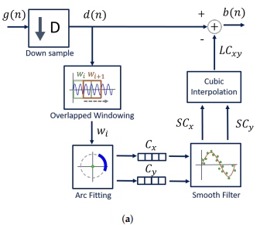
Figure 8.2 Dynamic CDC removal

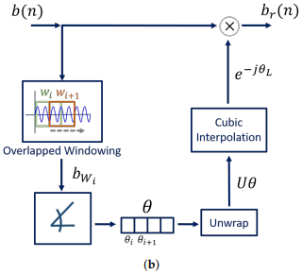
Figure 8.3 Dynamic arc rotation
The arc fitting method is applied to each window wi , and the center C coordinates are stored in two vectors, one for the real coordinates Cx and other for the imaginary ones Cy. As we will see later, our proposed method is relatively stable, when comparing with other well-known fitting methods. Nonetheless, after inspecting all signal windows, a smooth filter was applied to the each vector in order to prevent outliers.Then, the vectors are interpolated using the shapepreserving piecewise cubic interpolation, resulting in the vectors LCx and LCy, which form the complex number LCxy. The cubic interpolation was selected for providing a smooth interpolated vector and for having a good approximation behavior on the vector extremes [32]. Finally, the interpolated vector is subtracted from the decimated signal d(n), resulting in signal b(n) (from Figure 6). After removing the CDC component, the arc position in relation to the complex plane should be adjusted in order to avoid wraps that can occur when the arc is located between the second and the third quadrants, crossing the π value. The CDC change over time also affects the arc orientation in relation to the origin. Therefore, this rotation step must also be implemented dynamically over time by dividing the signal in windows again. This procedure is depicted in Figure 10b. The goal is to rotate all window arcs until they oscillate around the 0 ◦ angle. This is performed by computing, for each window, the necessary angle required to rotate the arc. This is accomplished using Equation (7): θi = arg(∑bWi (n)). (7) where θi is the necessary angle to rotate the arc bWi (n) from window i. Similarly to the CDC offsets’ window estimations, an angle vector θ is created with all θi values. The θ vector is unwrapped and interpolated using the same interpolation used for the CDC offsets. Then, the full signal is evenly rotated by applying Equation (8), resulting in signal br(n): br(n) = b(n) × e −jθL , (8) where b(n) is the full signal without CDC offsets and θL is the angle vector, unwrapped and interpolated. After properly centering the arc around the origin, weaker signals might require an additional step. The implementation of Equation (6) in the arc-fitting stage decreases the number of estimation transitions, but does not solve them all. When there are transitions in successive iterations, it affects the overall estimation in that signal portion by considering the mean of those consecutive values, and the arc is pushed to the origin after the CDC offsets’ removal. In these cases, it is necessary to shift the arc position slightly away from the complex origin. For this purpose, a small offset can be added to the full complex signal, resulting in signal bo(n). This offset can also be computed automatically: when the final arc is centered in the origin, there are samples with a negative values on the real component. Therefore, the signal with an offset can be obtained by applying Equation (9): bo(n) = br(n) + min(Re{br(n)}). (9) where min(Re{br(n)}) denotes the minimal value of the real component of br(n) signal.

CHAPTER 2
LITERATURE REVIEW
1. “Arctangent demodulation with DC offset compensation in quadrature Doppler radar receiver systems” B.-K. Park, O. Boric-Lubecke, and V. M. Lubecke,
Direct-conversion microwave Doppler radar can be used to detect cardiopulmonary activity at a distance. One challenge for such detection in single channel receivers is demodulation sensitivity to target position, which can be overcome by using a quadrature receiver. This paper presents a mathematical analysis and experimental results demonstrating the effectiveness of arctangent demodulation in quadrature receivers. A particular challenge in this technique is the presence of dc offset resulting from receiver imperfections and clutter reflections, in addition to dc information related to target position and associated phase. These dc components can be large compared to the ac motion-related signal, and thus, cannot simply be included in digitization without adversely affecting resolution. Presented here is a method for calibrating the dc offset while preserving the dc information and capturing the motion-related signal with maximum resolution. These functions can be a promising tool for health care, emergency, military, or security applications if reliable and robust sensing can be provided. One challenge in providing robust sensing is detection sensitivity to target position due to the periodic phase relationship between the received signal and local oscillator (LO), resulting in “optimum” and “null” extreme target positions. A quadrature Doppler radar receiver with channel selection has been proposed to alleviate this problem. This method selects the better of the quadrature (I and Q) channel outputs, and is thus limited to the accuracy of a single channel. This paper will present relevant quadrature receiver theory, followed by experimental results demonstrating expected signal distortion in “null” cases. Arctangent demodulation will then be introduced as a means of overcoming this issue, thus providing a more robust sensing system. Before arctangent demodulation can be performed, quadrature channel imbalance and dc offset issues must be addressed. Both of these issues are well known in direct conversion receivers for radar and communications applications.

2. “A fully integrated 60-GHz CMOS direct-conversion Doppler radar RF sensor with clutter canceller for single-antenna noncontact human vital-signs detection” H.-C. Kuo et al.,
This paper presents a 60-GHz CMOS direct-conversion Doppler radar RF sensor with a clutter canceller for single-antenna noncontact human vital-signs detection. A high isolation quasi-circulator (QC) is designed to reduce the transmitting (Tx) power leakage (to the receiver). The clutter canceller performs cancellation for the Tx leakage power (from the QC) and the stationary background reflection clutter to enhance the detection sensitivity of weak vital signals. The integration of the 60-GHz RF sensor consists of the voltage-controlled oscillator, divided-by-2 frequency divider, power amplifier, QC, clutter canceller (consisting of variable-gain amplifier and 360 phase shifter), low-noise amplifier, in-phase/quadrature-phase sub-harmonic mixer, and three couplers. It can avoid error detections caused by disconnection of electrode wires, reduce the inconvenience of long-term wearing of traditional electrocardiography (ECG) equipment, protect the privacy of the patient (without taking off clothes), and provide real-time monitoring of the life of burnt people (or those who cannot use an electrode) to medical personnel. In order to pursue the high-performance low-cost low-power radar sensor chip, extensive goal efforts to develop a fully integrated vital-signs Doppler radar RF sensor chip have been conducted and reported. From reported state-of-the-art chips, most works used 1.6-, 2.4-, or 5.8-GHz band, and the Ka-band. Moreover, the 60-GHz millimeter-wave (MMW) frequency band for vitalsigns Doppler radar application has also been investigated. A 60-GHz MMW life detection system (MLDS) prototype constructed by using V-band MMW waveguide components has been reported. Furthermore, the 60-GHz CMOS Doppler radar sensor chip with two- or single-antenna noncontact vital signs detection are reported. Sensitivity is always one of the critical issues in the radar system. The radar RF transceiver front-end architecture plays an important role in reducing the noise, increasing detection sensitivity, and extending the vital-signs sensing range.

3.“Phase–and self-injection-locked radar for detecting vital signs with efficient elimination of DC offsets and null points” P.-H. Wu et al.,
A phase- and self-injection-locked radar is presented for robust vital-sign detection. The dc offset from the clutter is eliminated by using a dual-tuning voltage-controlled oscillator without complex clutter cancellation techniques. Phase noise analysis shows that the proposed radar has the advantages of both phase-locked oscillators and self-injection-locked oscillators to achieve high power spectral signal-to-noise ratio. Path-diversity transmission is employed to eliminate null points and reduce average transmitted power The dc offset due to the clutter and circuit imperfections is a critical issue for conventional CW radars since it saturates and desensitizes the receiver. Various clutter cancellation and dc offset calibration techniques have been reported with complex RF front-end and digital signal processing (DSP) hardware. In, a heterodyne receiver has been presented to reduce the dc offset from local oscillator leakage. However, the coupling from transmitter to receiver results in interferences at the same IF frequency could not be removed. Moreover, the residual phase noise from additional local oscillator degrades the detection sensitivity. A Doppler radar using a self-injection-locked (SIL) oscillator has been proposed to achieve a high SNR gain in the vital-signal bandwidth [10]. However, it suffers from uncontrolled frequency drift which causes electromagnetic interference (EMI) issues in practical applications. The null detection problem encountered at every quarter wavelength distance from the radar to the subject is another critical issue for reliable vital-sign detection. The quadrature demodulation architecture is the most prevailing solution while the extra flicker noise contributed by the mixers degrades the detection accuracy. Double-sideband and two-tone transmission systems require multiple signal sources with frequency tuning algorithm to find the optimal detection point when the subject changes its position. Arctangent demodulation method combines the in-phase and quadrature baseband signals into a single channel to eliminate the null points. However, it requires complicated calibrations on the dc offsets for accurate demodulation. Complex signal reconstruction approach is less sensitive to the dc offset while the clutter reflection inevitably degrades the detection sensitivity in the mixer-based receiver. Millimeter wave radars have been developed with shorter wavelength to avoid the null detection problem. However, the design is still challenging with respect to robustness, power consumption, and cost. Radar with passive harmonic tag has been proposed to isolate the target from clutter for improving the SNR.

4. “Vital signal radar with adaptive compensation circuits to effectively eliminate DC offsets” Z.-P. Yang and Y.-C. Chiang,
A new type of vital signal radar with adaptive dc compensation circuits that can automatically eliminate the dc offsets caused by clutter signals without software controlled units is presented. The theoretical analysis of the dc compensation circuits, which are connected to the outputs of a direct conversion mixer will be described. A 2.5-GHz experimental prototype was fabricated on a printed circuit board substrate to verify the proposed adaptively compensated radar. All circuits are realized by commercially available devices. Measurements show very good agreement with theoretical prediction. The radar can be used with only a single antenna connected to the proposed module and have successfully detected clearly heartbeat and respiration signals at any distance within the detectable range by incorporating phase-shifting technique. VITAL signal detection radars have been widely investigated for various biomedical applications, such as heartbeat and respiration monitoring and disaster survivor rescuing. Many studies have been reported in this area. To successfully detect vital signals, the radar should have the capability to eliminate the dc offsets caused by clutter signals and null points in the detection path. The structures of quadrature Doppler radars are commonly adopted to solve the problem of null points in the detection path by acquiring vital signals in either I or Q channel. Therefore, two channels of data acquisition (DAQ) modules are needed to implement the system. Recently, a new feature of vital signal detection radar is proposed to overcome the null point problem. The idea is to switch between two different receiving paths with quadrature phase difference such that only one DAQ channel is required to detect vital signals at various distances between the target and the radar. Besides adopting the dualpath feature to solve the problem of null points, the radar in also uses dual-tuning VCO in an injection locked structure to detect vital signals and eliminate the dc offsets caused by clutter signals, which include the signals reflected from the environment and the target, and that caused by circuit imperfections.

5. “On the design of a programmablegain amplifier with built-In compact DC-Offset cancellers for very lowvoltage WLAN systems” P.-I. Mak, S.-P. U, and R. P. Martins,
A switched-current-resistor (SCR) technique minimizes the bandwidth variation and the transient in gain tuning by stabilizing, concurrently, the PGA’s feedback factor and quiescent-operating point. Another technique, inside-opamp dc-offset canceller (DOC), embeds inside the PGA’s opamp a subthreshold-biased – integrator for extracting its output dc-offset, while negatively feeding the correction (current) signal back to the opamp at an inherent low-impedance node. This paper, on the other hand, is focused on the design of a low-voltage (LV) embedded programmable-gain amplifier (PGA) with dc-offset cancellation for a receiver targeting the IEEE 802.11a/b/g wireless local-area network (WLAN) applications. Two novel circuit techniques, namely switched current resistor (SCR) and inside-opamp dc-offset canceller (DOC), are proposed. These, in conjunction, not only enable the PGA to operate robustly under LV constraints, but also enhance the design efficiency and operation of the entire receiver as mentioned below. With a zero-intermediate-frequency (IF) or low-IF receiver architecture, the signal levels arriving at the baseband are scaled to around the 0-dBm range for analog-to-digital conversion. The dynamic-range requirement from the antenna to the baseband is approximately 0 to 80 dB, with the majority of this gain achieved in the baseband. If the radio front-end offers typically a 0- to 30-dB gain range, the baseband channel-selection filter and PGA have to provide another 0 to 50 dB of controllable gain. In practice, although a cascade use of multiple PGAs can attain such a high gain range, the PGA has to feature an excess bandwidth (BW), roughly 10 wider than that of the channel-selection filter to ensure stable selectivity against gain. Leaks of a high-performance opamp structure underneath a LV supply, however, will highly complicate the implementation.

CHAPTER-3
METHODOLOGY
3.1 EXISTING SYSTEM
The CW radars suffer from the null detection problem that exists at every multiple of a quarter free-space wavelength distance. In this paper, we propose a single channel receiver topology to eliminate the null points using the path-diversity transmission. The conventional FFT method and the proposed feature extraction method for two separation distances between two targets to evaluate the performance of the proposed algorithm for the vital sign detection of multiple targets: one closer than the theoretical range resolution and the other greater. No external noise or clutter was assumed to exist, but path loss was considered. This tracking involves the association of detections with existing tracks or creating new tracks with detections that cannot be associated with any existing track, smoothing/filtering of all the tracks, estimating the speed and heading of the targets, predicting the new position, and providing estimates on the errors in these predictions. Several mechanisms exist which handle data loss, such as Open-Loop Estimation (OLE) and Compensated Closedloop Estimation (CCLE). In the following sub-sections, these algorithms are briefly elaborated with associated shortcomings.
Open-Loop Estimation
It is a very simpler scheme devised for data loss and has been employed in numerous application. The basic mechanism of OLE is discussed as follows: For a discrete-time LTI system, with dynamics xk+1|k Axk|k + Buk + ωk yk+1|k ϑk+1( ) H xk+1 + θk+1 the standard Kalman filtering estimates xk+1|k in two steps namely prediction-cycle and update-cycle. Contrary to the standard Kalman filter, the OLE is summarized in Algorithm 1. OLE is a fast algorithm for signal recovery, however, it may cause divergence in case of adequate data loss and sudden crusts and troughs may appear in recovered signal. Further, it may be difficult to reach the steady state after resumption of the original signal. Due to these limitations, series-based algorithms are proposed in the next section to predict the missing part of the signal.
Series-Based Algorithms
The compensated closed-loop scheme has efficiently reconstructed the missing data and promising estimation results have been achieved. The recent achievements obtained through this model can be seen in Khan et al. (2013) and Khan et al. (2010). Data loss occurred in series which may have any trend are more expected to be recovered through Autoregressive (AR) series. These series include AR, MA, and ARMA to name but a few. Human vital signal possess a periodic trend, therefore it can be recovered through AR series.

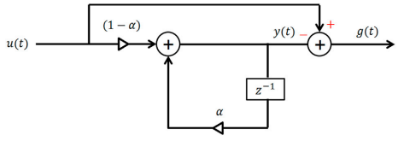
Algorithm for removing clutters

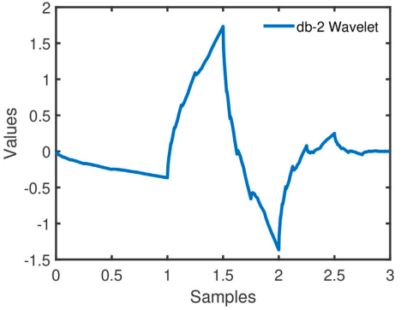

3.2 PROPOSED SYSTEM
Phase noise analysis shows that the proposed radar has the advantages of both phase-locked oscillators and self-injection-locked oscillators to achieve high power spectral signal-to-noise ratio. A Doppler radar using a self-injection-locked (SIL) oscillator has been proposed to achieve a high SNR gain in the vital-signal bandwidth. However, the design is still challenging with respect to robustness, power consumption, and cost. Radar with passive harmonic tag has been proposed to isolate the target from clutter for improving the SNR. Single channel receivers using the dynamic phase variation technique have been proposed to find the optimal detection point with complicated algorithm. The dc offsets can be then removed using the proposed dual-tuning VCO technique. The present study proposes a novel vital-sign sensing algorithm for clear target identification and accurate vital sign estimation using a single 24 GHz FMCW Doppler radar based on FCC regulation. The proposed algorithm approaches the problem from three perspectives: (1) clear target identification; (2) elimination of mutual interference, especially in the case of two adjacent subjects within range resolution limit; and (3) vital sign retrieval with minimal ambient noise. For this purpose, with the proposed method, phase information is formed by the fast Fourier transform (FFT) method, while range information is obtained by the parametric spectral estimation method, which provides accurate and high-resolution results. The physiological signals are extracted from the combined two types of information. The mutual interference is eliminated by range integration.

3.3 BLOCK DIAGRAM

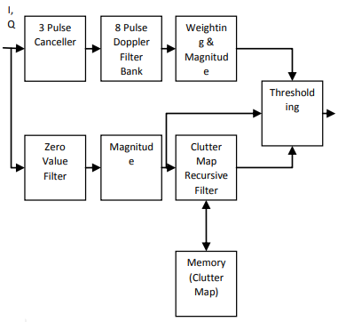
Figure 3.2 proposed system

CHAPTER-4
PROJECT IMPLEMENTATION
4.1 THE VITAL-SIGN PROCESSING RECEIVER
The architecture of an analog processing circuit for removing the in-band clutter signals and the out-of-band noises is shown by Fig. 2. The receiver comprised a preamplifier, two PGAs, and a third SC Chebyshev LPF. Under the aforementioned radar receiving system consideration, three-stage servo feedback loops are used by the preamplifier and the two following PGAs to eliminate the input dc offsets due to circuit imbalances.
A. Servo Feedback Loop With DCOC
A preamplifier with a servo-loop feedback topology, as shown in Fig. 2, was the first stage of an analog processing circuit that would realize an ultralow high-pass corner frequency lower than 0.5 Hz. For a servo-loop feedback configuration, the multiplication of R2,A/B ·C2,A/B determined the high-pass corner frequency point, while the feedback gain in terms of R1,A/B was represented as dc residue rejection. Accordingly, the intrinsic SBMD was used as a pseudo resistor to achieve an ultralow high-pass frequency response. A single-transistor pMOS operating in a cutoff region behaved like natural back-to-back diodes directly from the source–bulk and bulk– drain junctions of an MOSFET, thereby resulting in extremely large resistance (Tera-ohms) while simultaneously enabling a full-swing differential signal between the terminals (VD and VS) due to the extended diode breakdown voltage from V + B to V − B ,an equivalent structure exhibiting a well-matched configuration.
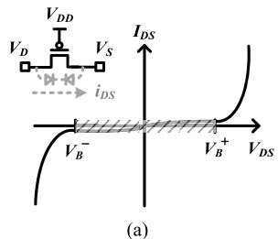
- I–V characteristic curve of the SBMD device
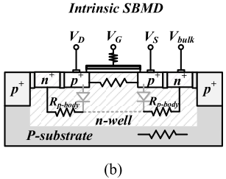
(b) Its equivalent structure
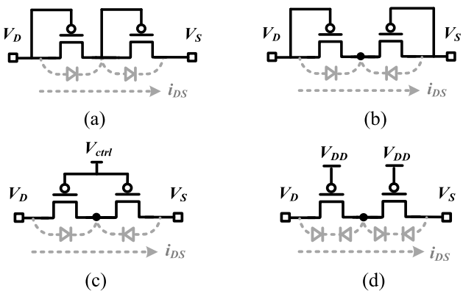
Pseudo resistor structures are composed of (a) two series of MOS diodes, (b) back-to-back diodes, (c) tunable back-to-back diodes in a subthreshold region, and (d) proposed intrinsic balanced diodes in a cutoff region.
To further investigate the differences between the proposed SBMD operating in a cutoff region and the conventional two diode-connected MOSFETs operating in a weak-inversion region, A pseudo resistor, implemented by the two series of MOS diodes to replace the required high resistance in the servo feedback loop. Although the dynamic range was extended up to 2VB, only a one-side operation limited its application. For a high-swing design topology, a pair of back-to-back diodes and a tunable structure of a pseudo resistor, controlled by the voltage (Vctrl) that operates in the weak inversion, are presented. However, these types of pseudo resistors are easily subject to suffering from PVT variations. Thus, two balanced SBMDs in a cutoff region have been proposed. To verify the validity of this brief, The simulated incremental resistance of each pseudo resistor type, where V = |VD − VS|. The results demonstrated that the intrinsic balanced SBMDs presented an obvious matched response and provided better linearity for a large output swing drop across the pseudo resistor, which will be a great benefit to the feedback configuration due to the discrepancy between the input and output swings in particular at the high-gain stage. Furthermore, with regard to the application of a pseudo resistor at a later stage of an analog receiver to remove the input-referred dc offsets from mismatched differential topology, the matched SBMD exhibited its superiority in a wider dynamic range and better stability in comparison to other pseudo resistors. It is worth noting that the tunable back to-back diodes in the sub threshold region also exhibited a broad characteristic of linearity between two terminals, but not really a balanced behavior on resistance variation. A precisely controlled voltage was also required to maintain stability. Thus, several servo feedback loops with the pMOS-based SBMDs in the cutoff region were used to create an ultralow high-pass response.
B. Third-Order SC Chebyshev LPF
For suppressing the out-of-band noises, the third-order SC Chebyshev LPF, as, helped improve the overall SNR.
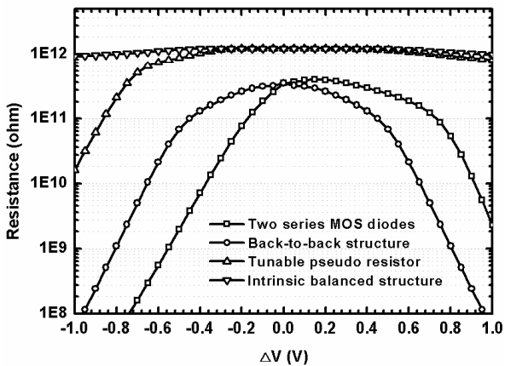
Equivalent resistance variations in four pseudo resistor types
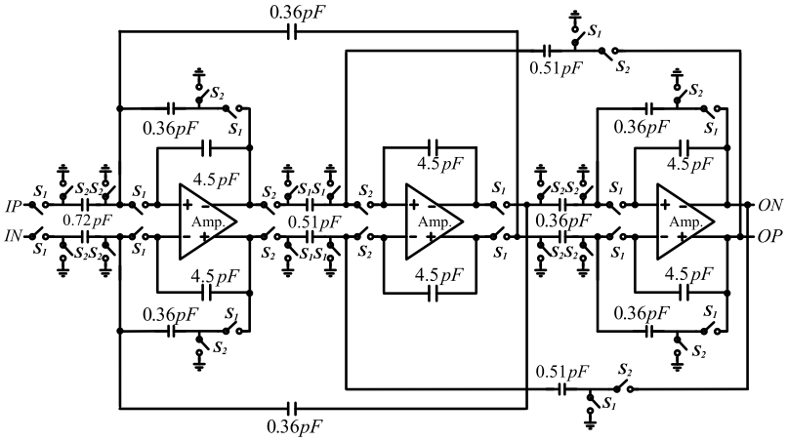
Schematic of the third-order SC Chebyshev LPF
The leap-frog configuration of the LPF was adopted to achieve high stability and low-impact PVT variations. The bandwidth could be adjusted from 50 Hz to 20 kHz, determined by the sampling rate of the SC LPF using interval sample-and-hold (S/H) clocks ( fBW = fS/H/50). The measured full-band frequency response of the entire analog-receiving chip which exhibited band pass behavior to deal with the physiological data. The measured pass band ripple was less than 0.5 dB. Moreover, we observed that a high-pass frequency roll-off less than 0.5 Hz can be achieved when the SBMD structure was applied to the servo feedback path. With regard to the vitalsign application, the chest movement of respiration is a reciprocal behavior with an amplitude motion of approximately 5 mm. The heartbeat movement commonly ranges from 0.2 to 2 mm. Therefore, we expected that the strength of the detected respiration would be much higher than that of the detected heartbeat signal. Although the breath signal (commonly at 0.2 –0.5 Hz) is indeed suppressed by the in-band rejection around 5-dB reduction, the impact on the suppression of the low-frequency breath signal can be alleviated by an obvious chest movement compared with the heartbeat.
The main architecture was the same as that in, except for an on-chip vital-sign processing receiver with the DCOC mechanism in our case. For real-time physiological monitoring, a periodical sequence of nanosecond sensing pulses with a repetition frequency of 2 MHz was radiated in the transmission mode by controlling the T/R and Ref. switches. The behavior of chest movement was obtained by correlating the phase delay based on the echoes. The matched receiver with DCOC also played an important role in effectively rejecting the unwanted signals. The demodulated signals were amplified and filtered by the proposed on-chip vital-sign processing receiver, which also executed an ultralow high-pass corner frequency roll-off less than 0.5 Hz for canceling in-band dc/near-dc clutters with a view to increasing the signal-to-noise ratio (SNR).
Operational Mechanism in Pulse-Based Radar for Vital-Sign Channel Construction With DCOC
For vital-sign monitoring, the probing pulses experienced an individual’s chest and heart beat with steady physiological data.

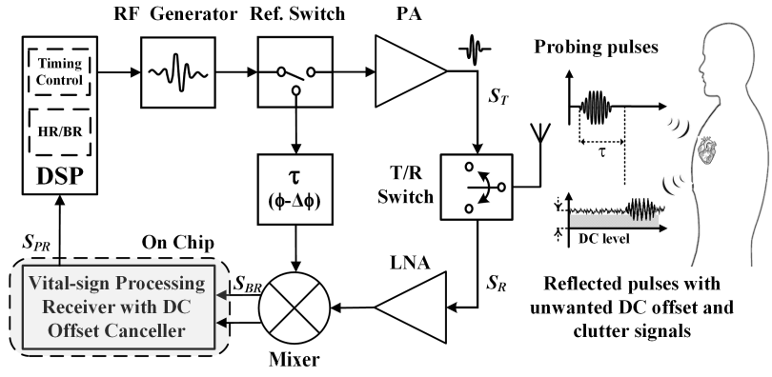
A pulse-based radar system with dc offset and clutter elimination
These reflected pulses with a fixed phase delay (φ − φ) were directly demodulated to baseband by a down-converted mixer. Thus, two inputs of the mixer coming from the local oscillator (LO) and reflected pulses are supposed to be in phase for vital-sign demodulation. This is conceptually true when the nominal distance (Ro) between the radiated antenna and the investigated subject is fixed and can be given as Ro = (1/2)C ·τ , where C is the spreading rate of the electromagnetic wave and τ is the propagation delay time. However, for practical applications, the receiving pulses back to the sensing radar comprise the clutter signals and dc offsets in particular with slow-time movements, which are all demodulated into the vital-sign processing channel. These undesired interferences cause irregular phase perturbations and deteriorate the radar sensitivity. Therefore, the pulse sensing behavior cannot be properly characterized. One, thus, first considers a short-pulse transmitting signal ST (t) in the frequency domain given by the Fourier transform ST ( f ) = pd /2 −pd /2 sT (t)e−j2π f t dt e−jπ f pd (1) where sT (t) is a pulse of the sinusoidal wave of amplitude (vT ), frequency ( fo), and pulse duration (pd ). Moreover, pd can be further represented by N cycles at the resonance frequency of the RF oscillator for an ultrashort pulse (pd = N/ fo). Hence, the magnitude of a spectrum with a short transmitting pulse can be derived as ST ( f ) = vT π fo sin(Nπ( f/ fo)) 1 − ( f/ fo)2 · e−jπ f pd . (2) One can characterize the reflected pulses suffering from the phase fluctuation captured by the correlated radar receiver SR( f,ϕ) = m · ST ( f )e−j(ϕo+ϕ(t)+ϕc(t)) + rdc(ϕ) (3) where m is the degradation factor of the receiving amplitude, rdc(ϕ) is the dc-offset contribution, and ϕ(t) and ϕc(t) are the effective phase shifts, attributed to the reciprocal movement and clutter signals, respectively. Thus, the overall instantaneous phase value ((t)) based on an initial phase delay (ϕo(t)) with a fixed distance (Ro) can be expressed as (t) = ϕ(t) + ϕc = 2ωo R(t) C = 2ωo λ (Vbsin(2π fbt) + Vhsin(2π fh t) + rc(t)) (4) where R(t) is the time-variant position variations at a fixed Ro, rc(t) is the clutter signal in slow-time displacement, and λ is the wavelength of the oscillations filling the probing signal. Hence, the down-converted signals can be further derived as SBR( f, ϕ) = ABR( f )sin(π f pd)e−j(t) + rdc(ϕ). (5) It was observed that the term in the bracket of (t) consists of the regular vital signs of the respiration and heartbeat, respectively, represented by the sinusoidal waves of amplitude (Vb and Vh), frequency ( fb and fh ), along with the clutters.
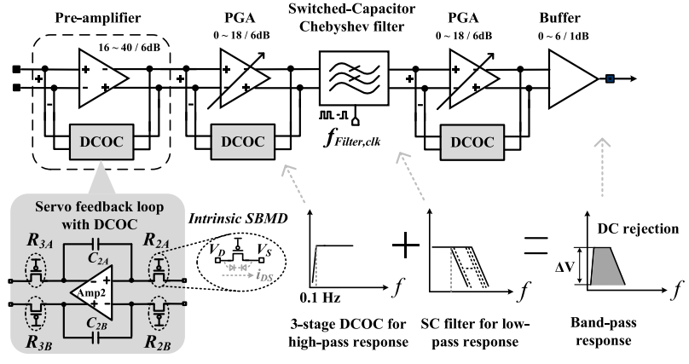
The vital-sign processing chip and operational mechanism of bandpass behavior
Therefore, the vitalsign processing receiver was used to suppress these undesired phase fluctuations and to preserve the physiological parameters. The servoloop feedback with DCOC applied to the receiving circuit served the purpose of blocking dc component rdc(ϕ), slow-time clutters rc(t), random movement at relatively low frequency, innate circuit input offsets, and out-of-band interferences. Therefore, the processed reflected pulse can be further expressed as SPR( f, ϕ)= APR( f )sin(π f pd)e−j 2ωo λ Vbsin(2π fbt) e−j 2ωo λ Vhsin(2π fht) (6) where APR( f ) is the amplitude of the receiving pulses. It was noted that a person’s respiration and heartbeat can be described as a sinusoidal form with stable phase variation. For implementation, (2ωo/λ)Vbsin(2π fbt) and (2ωo/λ)Vhsin(2π fht) were first determined by performing the vital-sign processing with DCOC. The frequencies at dc/near-dc and out-band interferences do not receive any signals.
4.2 IMPLEMENTATION OF RADAR SENSOR

4.2.1 Fractal-Slot Patch Antenna
The reduction of antenna size is required for miniaturizing the 915 MHz radar sensor for vital-sign detection, because antenna size is proportional to the wavelength of the operating signal. There are small surface-mounted-device-type products fabricated on high-permittivity ceramic substrates that operate in the frequency band below 1 GHz, but conventional linearly polarized antennas have a limit in detecting various movements related to respiration and the heart. A patch antenna for a 915 MHz radar sensor on an FR4 substrate was designed via the size-reduction method using a fractal slot because of the easy design and fabrication of the desired characteristics. Circular polarization was implemented in the proposed antenna with a truncated edge at the diagonal patch. Antenna size can be reduced by designing the resonance frequency with an arbitrary shape inside the patch because the operating frequency of the antenna is inversely proportional to the effective path length of the EM wave. However, as patch size decreases owing to the implementation of the arbitrary shape, the radiation efficiency of the antenna decreases. A fractal-slot patch antenna that can increase path length with a small pattern is advantageous for implementing a miniaturized antenna while maintaining antenna performance. The proposed fractal slot is inserted in the center of the patch antenna with three Koch snowflake patterns, for increasing the surface current path on the patch. The ANSYS HFSS 3D EM simulator was used to design the shape with optimal parameters to obtain a long resonance wavelength for the patch. The optimized shape from the simulation was tilted by 40°, which is similar to the truncated angle of the patch (45°). The proposed antenna with a fractal slot on an FR4 substrate with a permittivity of 4.4 and a thickness of 1 mm has a patch length of 70.4 mm, which is 6 mm (7.9%) smaller than that of a conventional patch antenna. Physical size was also reduced by 15.2% compared with a conventional patch antenna with the same operating frequency, The proposed antenna was simulated to have a return loss of 26 dB at 915 MHz, a −10 dB bandwidth of 17 MHz (from 907 MHz to 924 MHz), a half-power beam width of 108°, and a radiation efficiency of 12%. The simulated performances and radiation patterns were similar to those of a conventional antenna despite size reduction. The antenna gain of the proposed antenna was −5.8 dB, which is smaller than that of a conventional antenna of −4.1 dB because of the decrease of radiation efficiency in the proposed antenna. The maximum return loss of the antenna was measured at 905 MHz and was downshifted by 10 MHz from the desired frequency owing to the fabrication tolerance of the printed circuit board (PCB).
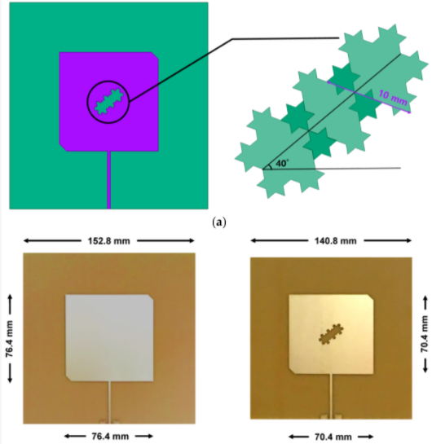

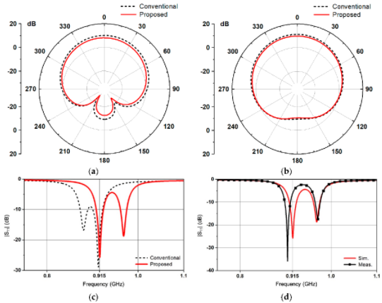
Performances of the conventional antenna and proposed antenna with the fractal-slot: (a) simulated E-plane radiation patterns at 915 MHz; (b) simulated H-plane radiation patterns at 915 MHz; (c) simulated S₁₁ in magnitude; (d) simulated and measured magnitudes of S₁₁ of the proposed antenna.

4.2.2 Two-Stage LNA
The proposed design can reduce the size of the patch antenna in the 915 MHz band, but measured return loss was 6 dB at the desired center frequency of 915 MHz. Because the low return loss can degrade signal sensitivity, the proposed radar sensor was implemented with an LNA connected to the antenna for impedance matching. The wideband LNA is proposed to improve the sensitivity of the radar sensor and impedance matching with the antenna. The proposed LNA is a two-stage inverter-based amplifier with resistive feedback. Inverter-type LNA achieves wideband input- and output-impedance matching using feedback resistors, according to the size of the n- and p-type metal-oxide semiconductor transistors. However, impedance mismatching may be generated to obtain the desired voltage gain in the inverter-based LNA, because the transconductances and output resistances of the transistors affect the wideband input and output matching characteristics and the voltage gain. Impedance mismatch can be compensated by adding capacitance C_{x} a, between the first and second stages in the proposed LNA. Additional capacitance C_{x} can not only increase the degree of freedom in the inverter-based LNA design without increasing the noise figure but also be useful for achieving impedance matching with the proposed fractal-slot antenna. Capacitance characteristics at the input of the LNA can be designed to compensate for the inductance characteristics of the antenna, because the input capacitance of the first stage, which depends on the size of the transistors, can be adjusted by changing capacitance C_{x}.
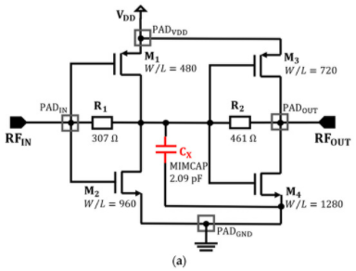

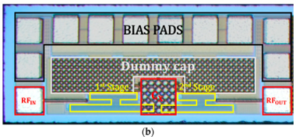
Proposed two-stage low-noise amplifier (LNA) in the radar sensor: (a) schematic of the LNA including external bond-wire inductances, and discrete and pad capacitances; (b) photograph of the fabricated LNA.
The proposed LNA was fabricated using TSMC (Taiwan Semiconductor Manufacturing Company) 0.25 μm mixed-signal CMOS process technology with one polylayer and five metal layers. b. The chip area of the LNA is 0.23 mm², and external bond-wire inductors and discrete capacitors were used for input and output matching. Simulation results show that the LNA obtains both a voltage gain of ≥20 dB, and wideband input and output matching via interstage capacitance C_{x}. As indicated by the simulated results, at 915 MHz, input and output matching were improved by the capacitance C_{x} without any significant effect on the noise figure and the voltage gain of the LNA. Input P1dB was simulated to be −15.7 dBm; thus, it can be predicted that the linearity of the LNA would not affect the operation of the radar sensor compared with the received power based on path-loss calculation.
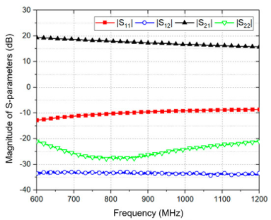
The magnitudes of the measured S-parameters of the proposed LNA
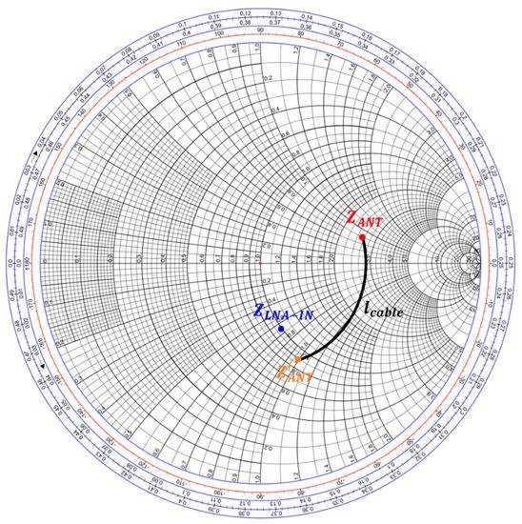

Input impedances of the proposed antenna and LNA at 915 MHz

Degradation in the measured voltage gain and input matching was caused by the difference in bond-wire inductance between simulation and implementation. The magnitude of the input reflection coefficient was degraded; however, the Smith chart in that impedance Z_{ANT} of the antenna was matched with input impedance Z_{LNA} of the LNA using a radiofrequency cable with a characteristic impedance of 50 Ω and a length l_{cable} of 200 mm. The return loss of the antenna connected to the LNA was calculated to be 12.8 dB.

4.2.3 915 MHz Radar Sensor Module
The front-end module of the 915 MHz CW radar sensor was implemented on an FR4 PCB with a thickness of 1 mm. Signals of 915 MHz with an output power of 9 dBm were generated at the voltage-controlled oscillator (VCO) and divided into LO and Tx paths by a power divider with an insertion loss of 0.4 dB. The maximum output power of the transmitted signal was less than 3 dBm because of the input return loss of the proposed antenna and the intrinsic loss of the connectors. Additionally, the reflected signal was received by the proposed antenna and amplified using the chip-on-board LNA with a voltage gain of 17 dB at 915 MHz. The received signal was downconverted to the baseband signal by a passive mixer with a conversion gain of −7.54 dB and a low-pass filter with a cutoff frequency of 80 MHz. The board size of the front-end module is 50 × 35 mm.
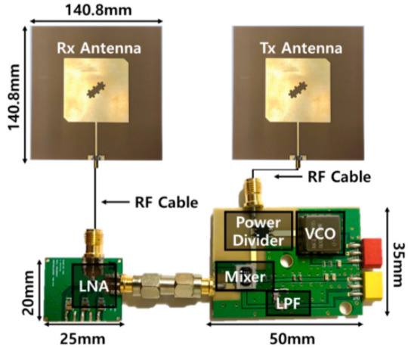
Figure 4.2.3 Photograph of the 915-MHz CW Doppler radar sensor including front-end module, LNA module, and two antennas with a fractal-slot

CHAPTER-5
RESULT
In this brief, an ultra wideband (UWB) pulse sensing radar system was implemented for vital-sign application on a standard FR4 printed circuit board (PCB) with an integrated analog processing chip using a TSMC 0.18-μm CMOS technology. The photographs of the testing radar board and the receiving chip, as displayed, had physical sizes of 10 × 5 cm2 and 2.9 × 0.75 mm2, respectively. The power consumption of the processing chip was only 150 μW. Moreover, a high-pass cutoff frequency lower than 0.5 Hz was obtained due to the servo feedback loop with the SBMD technique. The vital-sign receiver with the DCOC mechanism provided a measured passband channel gain of 82 dB to deal with the physiological information.

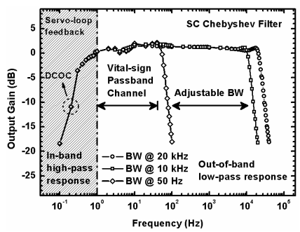
Measured channel response of an analog receiving circuit with a servo feedback loop for DCOC

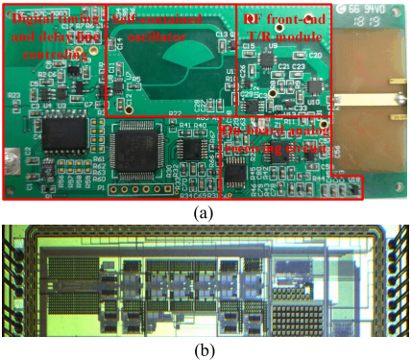
(a) implemented pulse-based radar system and (b) vital-sign analog processing chip
For vital-sign measurement of the radar system, only one 2 × 2 patch antenna unit radiated continuous short pulses (5 ns) with repetition frequency at 2 MHz to an investigated subject and received reflective waves to observe the sensing data. We first tested the pulse based radar by sensing a vibrating loudspeaker bass attached to a metal plate as an ideal simulator at a fixed noncontact distance of 10 cm from the antenna. The signal generator generated a 0.3-Hz sinusoidal signal which was straightforwardly fed into the loudspeaker to simulate the ideal respiration rate. A stable and periodic signal at 0.3 Hz was detected by the radar sensor. In addition, to investigate the dc-offset issue, the breathing simulator stopped the signal source. At the same time, the probing pulses first experienced a static metal plate and then they were reflected back to the sensor. The demodulator down-converted the RF signals with the frequency same as that of the correlated pulse, which caused a severe dc offset at the input of the receiver. Due to the proposed vital-sign processing circuit implemented by the ac-coupled topology with capacitive amplification, the dc offsets coming from the reflected echoes, mismatched demodulator, or LO leakage to the RF port were all blocked at the input of the vital-sign receiver. In addition, the subcircuit input offset of the receiver was rejected by the servo feedback loops with the SBMD structure so as to preserve the vital signs. The lower panel of demonstrates the concept of the dc-offset rejection, measured at the receiver output.
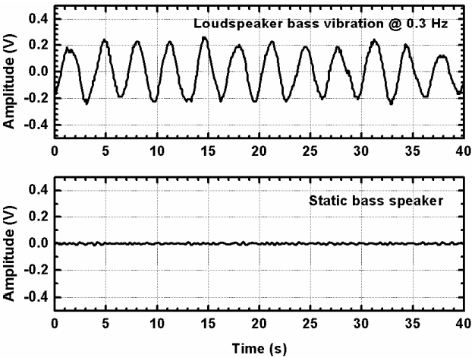
Measured output signals from the vibrating and static loudspeaker bass with a metal plate
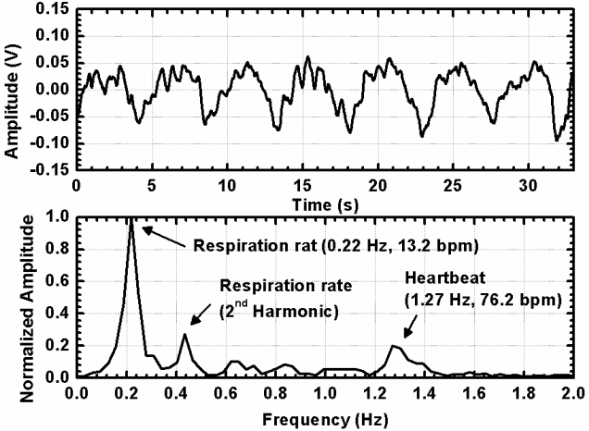
Measured vital signs of breathing and heartbeat signals in time and frequency spectrum
The radar was subsequently applied to detect the physiological information by simultaneously sensing the chest and heartbeat movements with only a radiated power of −35.2 dBm for a short-range detection (30 cm). Fig. 10 shows the measured raw data without any extra calibration in software or digital signal processing. The upper panel presents the measured output signal of the heartbeat and chest displacement, while the lower panel depicts its frequency spectrum. It was observed that the vital signs with periodical behavior were clear at around 0.22 Hz (13.2 bpm) and 1.27 Hz (76.2 bpm), respectively. The second harmonic of the breathing rate could also be identified by the radar. Table I lists the results of reported prior work with the solutions of the dc offset. It was worth noting that there exists a tradeoff between the radiated power and the sensing distance. Although a short-range sensing with a low radiated power was adopted in a pulse-based radar, the concept of the dc-offset elimination can be compatible with other radars.

CHAPTER-6
CONCLUSION
This brief proposed an alternative way to reject the clutter signals of the vital-sign radar. A vital-sign processing receiver with a servo feedback loop was developed to perform a high-pass response. An intrinsic SBMD structure was further applied at the servo feedback path to realize a high-pass corner close to dc for suppressing the in-band dc offset. Meanwhile, the third-order SC Chebyshev LPF with variable bandwidth was also used to remove the outband interferences. Consequently, instead of using extra digital signal processing, the radar featured the dc/near-dc rejection in the analog vital-sign receiver, which automatically performed clutter signals’ reduction. To demonstrate the concept and its feasibility, a pulsebased radar with a clutter elimination circuit for short-range detection was designed, measured, and analyzed.

REFERENCES
[1] B.-K. Park, O. Boric-Lubecke, and V. M. Lubecke, “Arctangent demodulation with DC offset compensation in quadrature Doppler radar receiver systems,” IEEE Trans. Microw. Theory Techn., vol. 55, no. 5, pp. 1073–1079, May 2007.

[2] H.-C. Kuo et al., “A fully integrated 60-GHz CMOS direct-conversion Doppler radar RF sensor with clutter canceller for single-antenna noncontact human vital-signs detection,” IEEE Trans. Microw. Theory Techn., vol. 64, no. 4, pp. 1018–1028, Apr. 2016.

[3] P.-H. Wu et al., “Phase–and self-injection-locked radar for detecting vital signs with efficient elimination of DC offsets and null points,” IEEE Trans. Microw. Theory Techn., vol. 61, no. 1, pp. 685–695, Jan. 2013.

[4] Z.-P. Yang and Y.-C. Chiang, “Vital signal radar with adaptive compensation circuits to effectively eliminate DC offsets,” IEEE Microw. Wireless Compon. Lett., vol. 28, no. 1, pp. 88–90, Jan. 2018.

[5] P.-I. Mak, S.-P.U, and R.P. Martins, “On the design of a programmable gain amplifier with built-In compact DC-Offset cancellers for very low voltage WLAN systems,” IEEE Trans. Circuits Syst. I, Reg. Papers, vol. 55, no. 2, pp. 496–509, Mar. 2008.

[6] A. M. Sodagar, G. E. Perlin, Y. Yao, K. Najafi, and K. D. Wise, “An implantable 64-channel wireless microsystem for single-unit neural recording,” IEEE J. Solid-State Circuits, vol. 44, no. 9, pp. 2591–2604, Sep. 2009.

[7] R. R. Harrison and C. Charles, “A low-power low-noise CMOS amplifier for neural recording applications,” IEEE J. Solid-State Circuits, vol. 38, no. 6, pp. 958–965, Jun. 2003.

[8] R. Puddu et al., “A precision Pseudo Resistor bias scheme for the design of very large time constant filters,” IEEE Trans. Circuits Syst. II, Exp. Briefs, vol. 64, no. 7, pp. 762–766, Jul. 2017.

[9] W.-P. Hung, C.-H. Chang, and T.-H. Lee, “Real-time and noncontact impulse radio radar system for μm movement accuracy and vital-sign monitoring applications,” IEEE Sensors J., vol. 17, no. 8, pp. 2349–2358, Apr. 2017.

[10] D. Zito et al., “SoC CMOS UWB pulse radar sensor for contactless respiratory rate monitoring,” IEEE Trans. Biomed. Circuits Syst., vol. 5, no. 6, pp. 503–511, Dec. 2010.

[11] C. Gu et al., “Accurate respiration measurement using DC-coupled continuous-wave radar sensor for motion-adaptive cancer radiotherapy,” IEEE Trans. Biomed. Eng., vol. 59, no. 11, pp. 3117–3123, Nov. 2012.

