BATTERY CHARGING AND DISCHARGE CONTROL OF A HYBRID ENERGY SYSTEM USING MICROCONTROLLER

ABSTRACT
This study aims to control charging and discharging the battery for hybrid energy systems. The control system works by selecting the right energy source to supply voltage to the load. And also this control system can regulate charging and discharging the battery automatically. The voltage source consists of two energy, namely from the battery and DC source. The control system that has been designed has the ability to choose the right DC source when the battery capacity is less than 80%. This system also has a good ability to choose a battery source when the battery reaches 100% capacity and the DC source has a voltage drop of more than 20%. This control system is equipped with excessive electric current protection so that the security level is high.

CHAPTER – I
INTRODUCTION
Renewable energy such as solar radiation as an energy source to reduce the energy crisis . Energy from photovoltaic panels can be used to charge the battery. The battery charge control regulates the flow of electricity from the photovoltaic panel to the battery or DC load. Battery energy storage systems (BESS) is the most common energy storage that can be integrated into grid connected PV system . Solar PV energy systems are used to convert the trapped solar light into electricity. The various power sources that are available may be invarious forms such as the utility grid, renewable power sources such as solar panel and DC energy storage units such as batteries. Multiple energy sources are integrated in the microgrid to have for a reliable energy supply. Batteries are everywhere, from power storage device in solar photovoltaic. Among them, lithiumion (Li-ion) batteries have become the most promising technology for energy storage due to their high energy density and high efficiency. The energy management strategy should be determined among the renewables, energy storage and grid. Batteries are used as power storage device in solar photovoltaic (PV) systems. They supply power when there is no solar power generation in the absence of sunlight. The size of energy storage can be done using two types of batteries, namely Lead-acid Lithium-ion batteries and batteries. but it needs to be considered because there is a big difference between the minimum cost between a lead-acid battery and a Li-ion battery. Battery has the advantages of high energy density, but with low power density, short cycle life, slow charging and discharging speed, and many other shortcomings. Control of these hybrid batteries within the same system is more challenging compared to conventional battery management systems which mainly deal with the homogeneous battery system. State of Charge is an important parameter of the Battery Management System. It is an indication of the remaining battery capacity. It is very important to have an accurate estimate of the State of Charge, to avoid over charging and over discharging of Lithium ion batteries. Battery management systems (BMS) to improve range prediction accuracy. Lithium-ion cells also have a consistent maximum charge and discharge rate capability over the complete 0-100% SOC range. Existing charging techniques for lithium-ion batteries use a largely open-loop approach where the charge profile is pre-decided based on a priori knowledge of cell parameters. The “constant-current and constant-voltage” charging mode is a widely used charging profile, in which a battery is charged with a constant current until a voltage limit is reached and then a constant-amplitude voltage is applied until the current reduces to a certain value, to charge the battery as fully as possible. Charging the battery causes temperature rising. A battery charger have to more intelligent and conscious of battery health and bring a positive impact on user satisfaction. Battery charger have to meet the range of requirements, particularly in current ripples in battery float charge mode. There are many factors that affect SOC, such as battery voltage, temperature, current, battery history, battery chemistry and so on. Ambient temperature is a significant factor that influences the accuracy of SOC estimation. The SOC estimation can be improved by accurately calculating OCV using the proposed internalimpedance extraction from the battery. Charging systems of battery electric current from the PV source with pulse charging technique is done to distribute high electric current to the battery without causing damage. Charging time can be done using different sources, the duration of battery charging varies greatly depending on the AC source. The batteries for photovoltaic systems need accurate, intuitive, and comprehensive electrical battery model which can sense the battery response under dynamic conditions. This study discussed ways to improve the management system on battery charging and discharging. Automatic settings for selecting energy sources are also considered. A control system that has been built to overcome the problem of battery charging to avoid overcharging. The system designed is equipped with current and voltage sensors that can monitor current battery drainage. This system is equipped with protection against reverse electrical currents which can cause damage to the battery and the panel.
Due to the high economic cost generated by the replacement of a BESS, a charge control method and control strategy is required to protect the battery from overcharging and over discharging.
The charge control method’s efficiency will depend on the amount of current used for the charging process, the level of the oscillations in the charging current, the charging voltage levels, the charging time, and the fluctuations in the temperature during the charging. Moreover, there are battery parameters that due to their complexity, cannot be obtained by using conventional control methods.
New research trends in energy storage include Li-ion batteries, especially those of lithium iron phosphate (LiFePO₄) batteries. This technology has greater advantages in energy density, voltage, useful life, and speed in loading and unloading compared to lead-acid technology. However, nowadays, most renewable facilities include lead-acid batteries and they demand new control methods to improve the useful life of the system. This paper will focus only on control methods applied to lead-acid batteries.Regarding battery management systems, the research was focused on fuzzy logic control (FLC) and model predictive control (MPC), due to their leading roles in battery control. Where the power input can be supplied by the grid, a photovoltaic system or wind power system is not required.

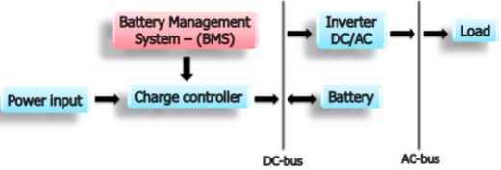
Figure 1.1 Battery control scheme
Fuzzy logic control (FLC) and model predictive control (MPC) have been proven to have higher performance than traditional charging control methods in terms of energy management, thus improving charging time, charging efficiency, states of charge (SOC), and battery life expectancy. The strategies used, goals, and results reached with these controls are detailed and useful. In general terms, the input variables used in an FLC and MPC are battery voltage and temperature, SOC, energy prices, photovoltaic system power, and weather forecast, among others. The current, ESS power, and grid power are used as output variables.
OBJECTIVE
- To improve the energy utilization rate of solar and wind energy and hence decrease of dependency on power grid
- Reduction of uncertainty about energy produced by renewable sources
- Improve the battery operations by implementing efficient battery management system.
- The objective is to utilize as much energy as possible from various renewable sources, including solar and wind.
- The objective of the proposed project is to increase the utility factor of the renewable sources such as PV and Wind turbines attached to the system.
- Development of new real time Energy Management System (EMS) to improve energy utilization rate of solar and wind energy.
- Design and implementation of cyber-physical controller based on improved minority game algorithm for real –time EMS of micro grid.
- Design and implementation of efficient battery management system so as to keep the batteries within safe limits during charging and discharging and also to prolong the life of batteries.

SCOPE OF THE PROJECT
- The renewable technologies have a vast scope in terms of research and development. However there are certain obstacles in terms of their efficiency and optimal use.
- The renewable energy sources, such as solar PV and FCs, need modern technology to harness more amount of useful power from them. The less efficiency of solar is major disadvantage in encouraging its use.
- The manufacturing cost of renewable energy sources need to be reduced because the high money cost leads to an increased payback time.
- It should be ensured that there should be least amount of power loss in the power electronic devices.
- The storage technologies need to increase their lifecycle through modern technologies.
- These stand alone systems are less preferable to load fluctuations. Large variation in load might even lead to entire system collapse.

CHAPTER 2
LITERATURE SURVEY

1. Aspects Regarding Solar Battery Charge Controllers
Energy produced by photovoltaic technology is clean and renewable. The actual problem is that currently the price of photovoltaic systems is relatively high. Research in this field is now focused on improving the efficiency of electricity production using photovoltaic technology. For this each component of a photovoltaic system must enroll on this course. Solar battery chargers are an important component of photovoltaic systems that could bring significant efficiency improvements through technology. The paper proposes a study on the types of solar battery chargers from the simplest to the most cutting edge technology, chargers searching for the MPP (maximum power point). An MPPT (Maximum Power Point Tracking) charger plays an important role in photovoltaic systems because it maximizes the power output of the photovoltaic panel array for different levels of irradiation and panel temperature leading to more energy harvested. Solar energy is one of the most promising renewable energy sources. One of the great advantages is its versatility. Photovoltaic systems can provide clean energy to small or large application, home or industrial, stand alone, grid connected or hybrid. Photovoltaic panels are manufactured using one of four different types of technologies: hybrid, monocrystalline, polycrystalline and amorphous. Each of these technologies has different characteristics. There are three main factors regarding these characteristics: how the panel operates in all light conditions, how much area is required for a specific power output and its cost. Battery charge controllers regulate the flow of electricity from the photovoltaic panels to the battery or DC load. The controller keeps the battery charged without overcharging it when there is abundant solar irradiation available. Batteries are used as a storage medium. The batteries store the energy produced by the solar panels for use over night or during the day, when the solar modules are not generating enough energy to cover the load requirements. Photovoltaic systems require deep-cycle batteries, to provide energy for long periods of time. These are usually lead-acid batteries, designed to charge and discharge up to 80% of capacity for many times.

2. Analysis of an energy storage sizing for grid-connected photovoltaic system
This paper present on the analysis of an energy storage sizing for a small grid-connected PV system. This project is to study the proper sizing of energy storage (battery) in a grid-connected PV system for consumers whom purchase and sell electricity from and to the utility grid. The goal is to minimize the total cost of the operation for a consumer with a PV system with a battery storage system. This is to make sure that minimizing the total annual operating cost while maintaining an efficient system. Battery energy storage systems (BESS) is the most common energy storage that can be integrated into grid connected PV system. Battery is used to store energy when the PV power is not available. By adding battery storage to Grid-connected PV system, it will increase load consumption and reduce the dependence on the grid. A battery system must have the capacity to supply consistent power when the PV system is generating less power output. Since the battery is being made out of chemicals, the way of they utilized the battery will affect its performance, lifetime and cost. Having battery for energy storage in PV system means the power is guaranteed even in cloudy days. Thus, choosing the batteries in PV system have to meet the demand of the load. The ultimate advantage of Li-ion battery is higher charge and discharge rate. Thus, it will increase the product efficiency. Thus, it will be beneficial to compare the sizing of the Li-ion and lead acid battery. Based on the end results, it will be a significant reason to compare the same PV system with different type of battery. To make the simulation looks appropriate with different grid price at different time. The Time-ofuse (TOU) data is used. Time of use or TOU is the isolation of energy rates based on time of the energy being consumed. TOU is a way for utility providers attempt to reduce demand during peak periods by enforcing tariff structures that impose an increased rate in typical peak period usage. This type of battery is mainly used for deep cycle with deep discharge applications like in sail boats and electrical vehicles.

3. Efficiency enhancement of solar PV powered micro-integrated high frequency isolated vehicle battery charging converter
This Paper proposes a method to improve the efficiency of charging the battery used in autonomous electric vehicle powered by foldable roof-mounted solar photovoltaic (PV) generation system. The conventional vehicle battery charging application from solar PV consists of a boost converter in the frontend followed by a full bridge converter with discrete switches. Here an attempt is made on the total scheme with a micro integrated package to have better conversion efficiency with high power density. The total system is controlled digitally incorporating zero voltage transition (ZVT) in the full bridge conversion. These areas can generate power on their own using renewable resources such as solar PV energy systems. This solar PV, if mounted on vehicles it can produce its energy indigenously and provided storage systems enable its usage at times of demand. The efficiency of the solar PV energy system exclusively depends on the PV panels, converters and the Maximum Power Point Tracking system. The efficiency of a single PV cell is very low. The efficiency of hard switching converters is low. So they can be replaced by the soft switching converters that have very less losses and high efficiency. Use of good and efficient MPPT algorithm also improves the system efficiency. It is possible to achieve the maximum efficiency with a single stage conversion. Yet, a two stage conversion is implemented in this scheme in order to provide the isolation between the source and the load. Hence, a galvanic isolation by means of high frequency transformer is provided and the entire scheme is now managed using analog based control systems. The present scenario in DC-DC Converters is to switch at high frequencies, in the range of a few MHz, with a scope to achieve high power densities. Boost Converter is implemented in the scheme in order to boost the voltage from the solar PV energy systems. The boost converter with the duty ratio, D > 0.5, it provides the desired voltage, targeted for the application. Full bridge converter is used as a second stage converter from DC to AC with a fixed duty ratio of 0.5, such that it converts the DC to AC with minimized losses through ZVT scheme implemented in Phase Shifted FBC operation modes.

4. An Optimal Design and Analysis of A Hybrid Power Charging Station for Electric Vehicles Considering Uncertainties
The charging problem becomes prominent with the increasing number of electric vehicles. It is necessary to built charging station (CS), like the gasoline station, to satisfy the recharging and be convenient for the drivers. In this paper, a new type of charging station integrated with renewable energy source was studied. A hierarchical energy management strategy oriented to real-time application was proposed to handle the uncertainties. To determine the optimal size of the CS by considering multiobjective including economic, environment and battery energy storage system degradation, Monte Carlo simulation was adopted to solve the problem with many uncertainties. And large progress in lithium-ion battery propels the development of EVs. However, it is challenging that the growing number of EVs means huge charging demand and will definitely aggravate the power grid load. Traditional approach is to build more power plants for extra electric power, which is costly and brings environmental problems. Integration with renewable energy sources such as solar and wind power is an efficient way to moderate the problem. Thus, it is necessary to research on establishing a proper electric vehicle charging station with hybrid energy source. Several papers have investigated the optimal planning or sizing of EV charging station with renewable energy source. In the size of the battery storage was optimized through minimizing the total energy cost. It employed two typical irradiance scenarios and specified delivery EV charging patterns. Optimal design of an electric vehicle charging station considering various renewable energy sources with the goal of minimizing the total monetary cost was analyzed. The decision variables were the size of the PV array, size of each diesel generator, number of battery energy storage system units, and grid purchase/sell. But there was little instruction about the internal operated energy management strategy. In, a dynamic programming algorithm was utilized for EV charging scheduling after determining the solar power and vehicle charging demand and compared with a uncontrolled method by evaluating the economics and carbon tax. We can find that those studies treated the charging demand as fixed value to input the decision model, which neglected the uncertainties in reality.

5. Design of Batteries Charging by Charge Management Concepts on Photovoltaic Standalone System
Charging systems of battery electric current from the PV source with pulse charging technique is done to distribute high electric current to the battery without causing damage to the functionality and performance of the battery through a process to vary the pulse width. Techniques vary the pulse width is done by adjusting the duration of the charging current through the control of electronic switches, the advantage of this technique is there a time lag (break) for the battery in the process of stabilizing the electrode, besides the rate of temperature increase is small when charging process. The Charge management concept is the charging process of three battery units independently, when one battery is in full condition, the system will disconnect the charging line and two other units keep to do the battery charging process without being influenced by the change of battery. Batteries are the electrical energy storage component that is portable. Today the use of batteries is important because of the nature of the battery that has high mobility. Moreover, by the development of battery technology that gave birth to the battery can be recharged making it possible to use it repeatedly. The converter has an important role in the regulation of batteries for renewable energy. Lithium ion batteries and lithium iron are often used in large power applications, one battery type lead acid battery (LAB) are still preferred and popular used due to its reliability and cost. Research on the photovoltaic pulsed charge using the concept of charge management is done to distribute high electric current to the battery without causing damage to the functionality and performance of the battery, charging high current pulses can overcome the sulfation on battery electrode, a negative electrode mainly because the battery is charged and discharged with a high current pulse. Pulse current charging is an effective way to delay the crystallization process and minimize development PbO2 layer during the charging cycle and increase the life cycle of LAB in charge condition. There are two types of DC-DC converters used in the system, the first is the type of sepic converter to maximize the power output of PV at the maximum point and the second type is a boost converter which serves to raise the value of the voltage for the burp charging process. Concepts of charge management applied in this study serves to keep power balancing of PV in order to keep a continuous supply of energy at the point of maximum, By using three units of the battery, the power output of PV will be stored and nothing is wasted, the process of setting the charging current to the battery performed individually in different time intervals, when one battery fully charged, the power output of PV can be stored on the other battery unit.

CHAPTER 3

EXISTING SYSTEM

- Due to the existence of uncontrolled stochastic uncertainties, it is difficult to implement an optimal approach to manage the output power ratio between the PV, BESS and utility grid.
- In this paper, the energy production from PV and BESS is prioritized to use for charging demand over grid energy.
- When the output power of PV system is enough to the EV charging demand, the excess power of PV system will be stored a certain amount of energy in the BESS for future use.
- If the charging demand is higher than the available power of PV, BESS will operating in the discharge mode to make up the difference amount of power.
- The main objective of the PMS actions is the control of the battery state-of-charge, which is estimated by using an accurate algorithm developed for this purpose: this feature represents one key aspect of the developed system compared to existing ones, as it allows limiting in an effective way the number of startup and shutdown maneuvers of the FC.
- The estimation of the battery state-of-charge is also a crucial parameter for the management of the energy flows in a standalone system equipped with multiple power supply and electrochemical batteries.
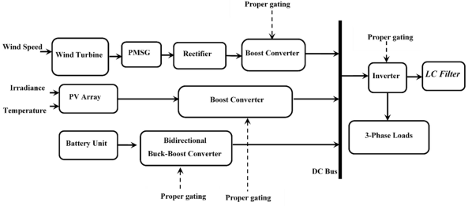
BLOCK DIAGRAM OF EXISTING SYSTEM

DISADVANTAGES
- Hybrid transportation systems, unlike those in pure electric vehicles, cannot effectively utilize regenerative energy during braking.
- Low power density and fast degradation of the cells in the battery under high charging currents
- Even when using the battery management systems that directly control the charging and discharging rate, cell’s state of charge (SOC), voltage and temperature, the lifetime of the common electric vehicle batteries does not exceed 4–5 years.
- The electrical vehicles are less economical as the battery is the most expensive part of electric vehicle.

CHAPTER 4
PROPOSED SYSTEM
- A decentralized charging scheduling was proposed in, where utility company broadcasts the price and EVs choose their own charging profiles, instead of being instructed by a centralized infrastructure, to achieve the objective of valley filling.
- Recognizing the emerging need for planning EVCS to satisfy the increasing charging demand from EVs, in this paper a framework was proposed to optimize the size of EVCS incorporating many uncertainties.
- Various energy management approaches have been proposed in the literature in order to handle the characteristics of different power generators and storage systems.
- The proposed real-time EMS is formulated based on optimization model for cluster of prosumers such that cooperative operation with other prosumers in the neighbourhood achieves balanced distribution and hence improved utilization rate.
- The proposed method helps the battery of EV to operate in a safer zone.

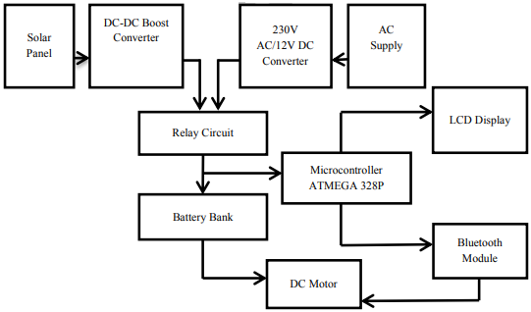
BLOCK DIAGRAM OF PROPOSED SYSTEM

ADVANTAGES

- The main issue is to avoid grid interruptions when several EVs are simultaneously plugged into the system during very short period of time can be solved by implementing this technique.
- It is envisaged that more sophisticated energy management system is required to manage the charging stations for large number of EVs. So by implementing this technique it is possible to overcome this problem up to some extent.
- The proposed technique optimizes the EV charging based on the availability of the PV power, real time electricity demand and tariff structures.
- This system leads to the safe charging of the battery that needs to be maintained to ensure long life of the EV batteries.
- Maintenance cost will be negligible when compared to IC Engine vehicles.

CHAPTER 5

BLOCK DIAGRAM

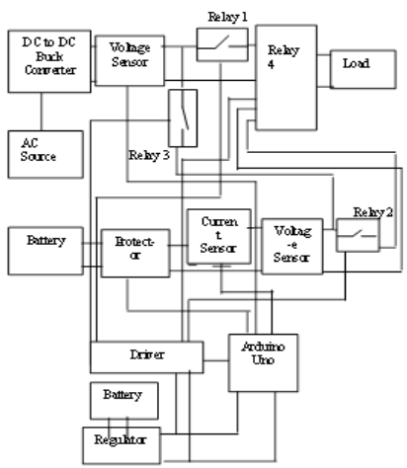
Block diagram of the battery charging for hybrid energy

5.1 System Design-Hardware
Control system for battery charging are designed based on the block diagram. Protector in this design consist of a fuse and diodes. The protection circuit is used to protect the system from overload condition. Beside that when the battery voltage is greater than the solar module it is likely that the battery will send its voltage back to the solar module. This is where the blocking diode functions to protect the battery.
5.2 System Design-Software
Software that has been created using the Arduino IDE 1.6.4 software. Designing software based on flowchat which has been designed based on Arduino Mega 2560. To be able to upload software, a connection must be made to the Arduino port. The following is an explanation of the flowchart.
- The control system always prioritizes the DC source rather than the battery when the DC source reaches the voltage that has been set and when the DC source is below that which has been set then selects the battery and displays it on the LCD screen.
- The control system selects all switches off to load if all voltage sources are below 80%
- The control system charges when the battery capacity is below 80% and will stop charging when the battery capacity is 100% and displays this status on the LCD screen.
- The control system disconnects if there is an overload and displays this status on the LCD screen.
- The control system calculates the power load to the load and displays this status on the LCD screen.
- The control system calculates and estimates the remaining battery time and displays this status on the LCD screen.
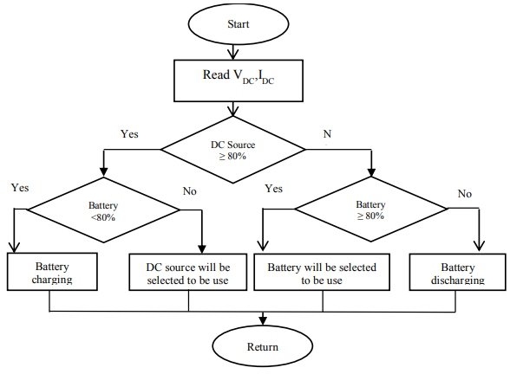
The Flow chart for the battery charging control program

CHAPTER 6
TRADITIONAL CHARGING CONTROL METHODS
The main goal of charging control methods is to increase the SOC. However, specifications such as battery performance, charging time, battery protection from overcharging or over discharging, and increase of life are very important too.
As the battery charging process is nonlinear, different methods have been developed to effectively control battery charging. Control methods commonly used in battery charging are: constant current (CC), constant voltage (CV), two-step charging (i.e., CC–CV), pulse charging (PC), reflex charging or negative pulse charging (NPC), trickle charge or taper-current (TC), and float charge (FC).
Constant Current (CC)
This method consists of charging the battery with a constant current. This method limits the current to prevent over-current of the initial charge. The voltage value will depend on the charging current, and one advantage is easy calculation of the charging time and the SOC. As voltage is not usually controlled, this can cause battery overcharging and a temperature rise, resulting in battery life degradation.
Constant Voltage (CV)
This method is commonly used to charge the battery by applying a constant voltage on its terminals. During the initial stage of charging, the charge current is high. As the battery voltage reaches the charger’s voltage set limit, the charge current decreases. This type of control is used in applications that require extended charging periods to reach full charge. As it requires a long charging time, it can cause temperature rises and degradation of the battery life.
Constant Current–Constant Voltage (CC–CV)
This charging method is also known as the two-step method, because it combines both CC and CV. CC is applied at the initial charging stage until the battery voltage reaches an overcharged stage or a predefined voltage. At a second stage, the charging method switches to CV to maintain the battery voltage, so that it avoids overvoltage. Previous research has shown that the CC–CV charging method is the most efficient for battery charging, regardless of the battery type, and also that it is the most used control method. However, its charging speed and efficiency are very low. Moreover, the CC–CV is not suitable for rapid charging, because the CV charging stage prolongs the charging time, causing battery temperature rises and battery lifecycle reductions.
Pulse Charging (PC)
This charging method consists of periodically applying a pulsed current to the battery. Batteries are completely discharged and recharged periodically in what is called an equalizing charge. This will allow the battery voltage to become more stable. In this charging method, is important to take into account the charging frequency, the pulse peak, and pulse width, because they are related to the capacity and the charging time. This method can reduce the polarization to prevent the battery temperature rise. The weak point of this charging method is its complexity.
Reflex Charging or Negative Pulse Charging (NPC)
This is an improvement of the PC. The concept of applying reflex charging started with the patents by W. Burkett & J. Bigbee and W. Burkett & R. Jackson in 1971. NPC follows this charging sequence: a positive charging pulse, a rest period (not charging), and a discharge pulse (burp). This method could eliminate polarization so that the temperature rise is decreased. However, it also may reduce the charge efficiency.
Trickle Charge or Taper-Current (TC)
This method consists of providing the battery with a continuous CC charge at a low (about C/100) rate. It is designed to compensate for the self-discharge of the battery. This method can charge the battery up to 100% by using a very small charge current. This is typically used for starting, lighting, or ignition (SLI) battery applications, but it is not suitable for batteries that are susceptible to being damaged by overcharging.
Float Charge (FC)
This method involves a CV charge set to a value just sufficient to finish the battery charge or to maintain the full charge of the battery. This method is used for stationary batteries, mainly lead-acid batteries. These traditional charging control methods have been incorporated in commercial inverters such as Victron Energy and the Sunny Island solar technology, among others. The latter controls the charge of the battery in three phases: CC (I phase/bulk phase), CV phase (absorption phase/Vo phase), and float charge/V phase.
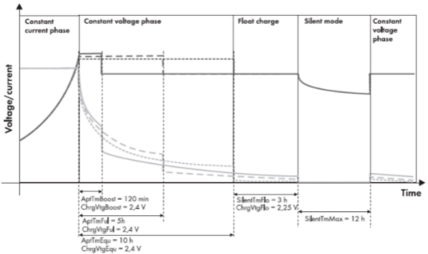
Figure 6.1 An absorbent glass mat (AGM) battery
6.1 SOLAR BATTERY CHARGERS
All solar battery charge controllers, no matter of what technology they use, have the same key function: they regulates the flow of energy from the solar modules to the battery bank. Charge controllers prevent batteries from overcharging reducing the risk of damage to the battery. The charge controller should monitor the charging state of the batteries and disconnect the photovoltaic modules when the batteries are fully charged. Also the charge controller prevents the overvoltages, which can affect the battery performance and severely shorten its life. Besides the main function, the charge controller can have also complementary functions, such as low voltage disconnect, data logging, temperature compensation function for safe and complete charging, parallel setup, excess energy management, adjustable battery type. Charge regulation technology had evolved a lot in the last decades. There are four general types of charge controllers, categorized by the method used to regulate the charge from the solar modules to the batteries:
- shunt type charge controllers
- series type charge controllers
- PWM (pulse width modulation) charge controllers
- MPPT charge controllers.
- Shunt type charge controllers are the first type of chargers developed and are the simplest ones still on the market today. They short circuit the energy from the solar panel when the battery reaches the full charge. In general, shunt type charge controllers are low cost and reliable, with simple design and suitable for small off grid photovoltaic systems. Shunt type charge controllers can only be used on photovoltaic systems because of the photovoltaic panels property to not be affected if they are short circuited. Photovoltaic devices are current limited by their nature, so we can be short circuit them with no risk.
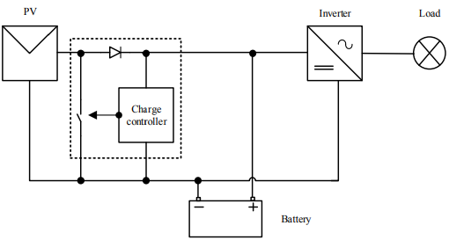
Shunt type charge controller
Shunt interrupting charge controllers can be used on all battery types, but the way they regulates the power to the batteries may not be always optimal for all battery types. The manufactures of gelled and AGM (Absorbed Glass Mat) batteries recommend the constant voltage, PWM or linear charge controllers.
- Series type charge controllers are very similar to shunt type charge controllers, instead of short circuiting the solar panel output they open the circuit, interrupting the path to the batteries. For disconnecting the circuit, this type of controllers use a relay or a solid state switch. After the batteries reach a set voltage value, the solar module is disconnected from the batteries. When the battery state of charge goes down, the switch is reset and the panel is once again connected to the batteries.
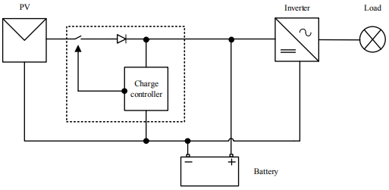
Series type charge controller
For these two types of charge controllers, an OFF and ON voltage values have to be set. Similar to the shunt interrupting charge controllers, the series interrupting design are recommended to be used with flooded batteries rather than VRLA (valve-regulated leadacid battery) types, due to the way the power is applied to the battery.
- Pulse width modulation charge controllers simulates a variable charging current, given by variable power output of the solar panel or by the battery state of charge, switching a series element at a high frequency for variable periods.
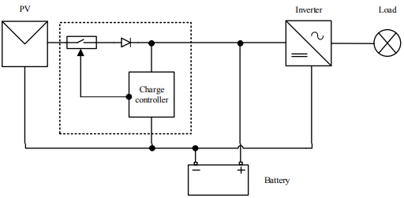
Pulse width modulation type charge controller
The charge controller pulses the full charging current and varies the width of the pulses to regulate the charge current. When the battery is partially charged, the current pulse is ON all the time. To lower the current as the battery voltage rises, the pulse width is decreased. The PWM charge controller is essentially a high switching speed, interrupting type charge controller. The PWM charge controllers allow greater control over how a battery approaches the fully charged state and generates less heat.
- Maximum power point tracking charge controllers are usually DC-DC converters, as a matching interface between the solar panel and the battery. The main function of a MPPT controller is to adjust the panel output in order to transfer maximum energy to the batteries. This offers a high efficiency over a wide range of operating points.
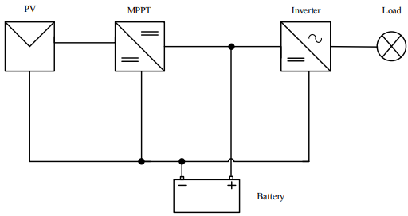
MPPT type charge controller
6.2 MAXIMUM POWER POINT TRACKING SOLAR BATTERY CHARGERS
The electric power generated by PV systems changes continuously with weather conditions which varies over the day and also with seasons. Generally, the voltage-current curve for a PV array is not linear so a specific point on the curve namely maximum power point needs to be tracked in order to operate the charging of the batteries at maximum efficiency and produces maximum output power. At a given solar irradiation level and solar panel temperature, the output of the module is at its maximum at a particular operation point called the maximum power point. This operation point varies over a wide range. Instantaneous shading conditions and ageing of photovoltaic cells also affect this maximum power operating point. Also the load electrical characteristics may also vary in time. Because the MPPT charge controller always operates at the maximum power point of the solar panel, over the life time of the photovoltaic system, more energy is harvested. With a maximum power point tracking charge controller we can use higher voltage solar systems, the cross section of connections wire decreases and with this the cost and the power losses. There are some different methods to track the maximum power point of the output of a solar panel. These methods differ in many aspects such as complexity, sensors required, cost and efficiency.
Some of these methods are described as it follows:
- constant voltage
- open circuit voltage
- short circuit current
- perturb and observe
- incremental conductance
- neural networks
- fuzzy logic.
Constant voltage algorithm is the simplest MPPT control method. The operating point of the PV array is kept near the MPP by regulating the photovoltaic module voltage and matching it to a fixed reference voltage. The voltage reference value is set equal to the maximum power point voltage of the photovoltaic module or to another calculated voltage value. This method assumes that individual solar irradiation and temperature variations on the solar systems are insignificant, and that the constant reference voltage is an adequate approximation of the true maximum power point. Therefore, the operation is never exactly at the true maximum power point.
Open Circuit Voltage method uses the technical characteristics of the solar panel, in this case the value of open circuit voltage to determine the maximum point voltage. Once the system obtains the Voc, the value of Vmp is calculated with the formula: Vmp=k · Voc, (1) where k is the fill factor.
Short Circuit Current method uses the value of short circuit current Isc to estimate the maximum point current Imp with the following formula: Imp=k · Isc, (2) This method uses a short load pulse to generate a short circuit condition. During the short circuit pulse, the input voltage will go to zero, so the power conversion circuit must be powered from some other source. The k values are typically close to 0.9 to 0.98, .
Perturb and observe (P&O). This method, named also hill climbing, consist of the introducing a small perturbation in the system. If the power output of the panel increases then the perturbation is continued in the same direction. After the peak power is reached, in the next step the power output decreases and the perturbation is reversed. When the steady state is reached the algorithm oscillates around the peak point. In order to keep the power variation small the perturbation size is kept very small, as well. The algorithm is developed in such a manner that it sets a reference voltage of the module corresponding to the peak voltage of the module.
Incremental conductance (IC). Perturb and observe algorithm have the disadvantage of not being able to track the maximum power point under fast varying solar irradiation such as clouds shading. This disadvantage is eliminated by incremental conductance algorithm. In this method, voltage changes in the solar panel are measured to predict the effect of a voltage change. More computational power is required, but the controller can track changing conditions very fast.
Fuzzy logic controllers have the advantages of working with imprecise inputs, not needing an accurate mathematical model, and handling nonlinearity.

CHAPTER 7
BATTERY CHARGING/DISCHARGING MANAGEMENT
A microcontroller was used in to control the hybrid energy system and the charge -discharge of the battery storages. The architecture of the developed system and explains the system operation. First, the system reads the VDC and IDC of the connected Direct Current (DC) sources. Then, if the DC sources are equal to or greater than 80% of the VDC, IDC, all the switches connecting to the connected LOAD are switched OFF. The DC sources are used to charge the battery storages if their capacity is less than 80%, otherwise, the battery storage will be connected to the LOAD for discharging. The system RETURNS to the start process and continuously checks on the available VDC, IDC from the DC sources.
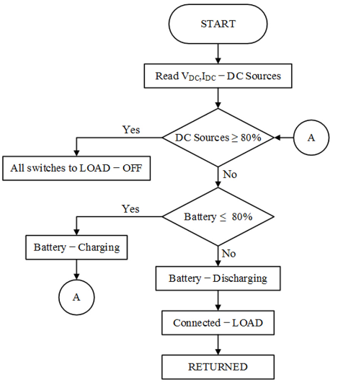
Figure 7.1 Microcontroller embedded algorithm-battery charging-discharging

In a similar research,an intelligent algorithm based on ANFIS was developed to simultaneously perform two different tasks: to protect the connected battery against overcharging and deep discharging. The ANFIS algorithm that has been developed in this research measures the Vpv, Ipv, SoC of the battery storage and Volt Direct Current (Vdc). This measurement is vital to find the Maximum Power Point (MPP) from the resources and control the battery storage charging - discharging. Figure 2 presents the algorithm process that controls the battery storage charging - discharging based on the power condition (Pc), battery SoC minimum (SoCmin) and battery SoC maximum (SoCmax). When the measured Vpv and Ipv input from the photovoltaic panel is equal to the maximum, the photovoltaic power is compared with the initial Pc before starting the charging process. Based on the calculation, when the photovoltaic panel power (Ppv) is equal to maximum photovoltaic power (Pmax), then the Ppv is equal to Pc. Otherwise, the ANFIS algorithm keeps searching for Pmax.
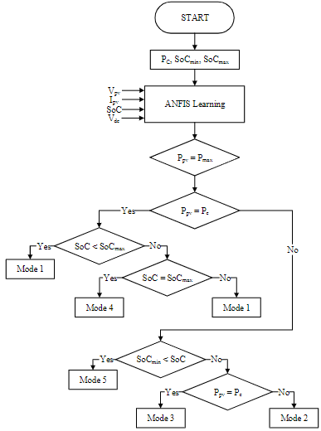
ANFIS algorithm – battery charging-discharging based on SoC
The battery storage charging-discharging process according to the battery SoC conditions. Based on the process, three different operation modes are controlled by three relays that act as switches. During Mode 1, the logic state for R1 and R2 relay switches equals to 1. The power generated from the photovoltaic generator (Ppv) is greater than zero, sufficient to source the connected load and batteries. During Mode 2, the logic state for R2 and R3 relay switches equals to 1. During this mode, the power generated by the photovoltaic generator is insufficient (0 < Ppv < Pc). In this case, the battery power is utilized to satisfy the additional required power demand, this mode is also known as battery compensation mode. During Mode 3, the logic state for the R3relay switch is equal to 1. The energy stored in the batteries is fed to the connected load. During this operation mode, the photovoltaic generator is unavailable to produce power, Ppv <0. During Mode 4, the logic state for the R2 relay switch is equal to 1. The photovoltaic generator, Ppv = Pc and the batteries are fully charged. Therefore, in this mode it is required to disconnect the batteries from being overcharged. During Mode 5, none of the relay switches is equal to 1. This condition shows that the photovoltaic generator Ppv is equal to zero, and the batteries' SoC is equal to SoCmin. Therefore, both the available recourses are disconnected from the connected load.
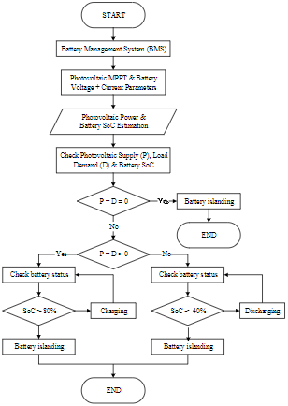
Entire system and battery charging-discharging operation
In another similar recent research, the intelligent power control shown in Figure 3 was developed to improve battery reliability and operational life. The power control operates in two control modes: 1) MPPT mode and 2) Battery Management System (BMS) mode. The SoC estimation technique incorporates the Back-Propagation Neural Network (BPNN) algorithm, which manages the battery’s charging - discharging and islanding approaches, which helps prolong the battery's lifespan. The developed system is divided into stages of operation. Firstly, the available photovoltaic power, battery’s voltage, and current information are collected. In the second stage, the photovoltaic power supply is compared with the load demand. If the photovoltaic power supply and load demand are zero, then the battery is connected to islanding mode. If the photovoltaic power supply is higher than the load demand, the battery SoC status is checked. If the battery SoC is more than 80%, then the battery is connected to the islanding mode. Otherwise, if the battery SoC is between 40% to 80%, then the battery is connected for charging. If the battery SoC is less than 40%, battery discharging is not allowed, and the battery is connected to islanding mode.
7.1PROPOSED CHARGING/DISCHARGING MANAGEMENT CONTROLLERS
The most recent battery storage charging - discharging methods, mechanisms, or techniques. The battery storage charging - discharging process starts to operate when the connected DC source is equal to or greater than 80% of the generated DC input. Otherwise, the proposed process is deactivated from all the connected loads. Therefore, if the DC is equal to or more than 80%, the proposed system checks on the battery SoC. If the battery SoC is above 80% and the DC source is equal to or more than 80%, only the battery source is connected to the discharging and connected load. Therefore, the developed system functionality is restricted and dependent on the DC source supply. If the battery source is sufficient, the system should be connected to the load. The battery storage charging - discharging the overall proposed process simultaneously sensing and measuring the voltage, current, battery SoC, and direct current battery voltage. This information is used to calculate either the solar photovoltaic system power output or to analyze the total power condition. The proposed process operates fully only when the solar photovoltaic system power output is equal to the maximum power required and the power condition. The proposed system operates entirely when these conditions are satisfied. Otherwise, the system strictly follows the five mode conditions that have been explained in Section II. Furthermore, the proposed system can only operate unidirectionally, and the initial conditions need to be met for the battery energy storages to operate. The presented battery storage charging – discharging, operates when the photovoltaic power supply and load demand are equal to zero and the battery is connected into islanding condition. When the photovoltaic power supply is more than the load demand, only the battery status is checked for either charging - discharging or islanding. The proposed process shows that the battery can only operate when the battery’s SoC is consistently above 80%, which also explains that the system needs to be installed at a location where solar irradiance is always available. The proposed system also shows that the functional period of the battery is only limited to 20%, which explains why the system needs to be installed at a location where continuous solar irradiance is available. The study of three different processes of battery storage charging - discharging shows that each proposed process has its own methodology, operationality, and functionality.
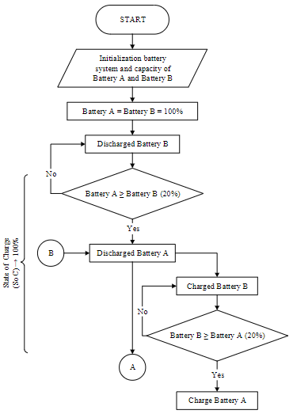
Hierarchical SoC battery charging-discharging: Battery SoC = 100%

The hierarchical SoC battery starts to charge/discharge when the battery' SoCs are between 60% and 80%. When battery A is being discharged, as shown in Figure 4, when the measured SoC is less or equal to battery B (20%), then discharging is switched to battery B, otherwise, it remains. Suppose the measured battery A SoC is less or equal to battery B (20%). In that case, battery B will be connected to the discharging process while battery A to the charging process, only if the charging source is available. The charging of battery A will continue until the battery A's SoC is more or equal than the 20% of discharging battery B's SoC. Additionally, if the measured battery A SoC is more than or equal to 20% of battery B at 60% SoC condition, the discharging of battery B will be switched to battery A. Battery B will be connected for the charging process when a charging source is available. During the battery B charging, the SoC of battery B will be continuously measured and compared with the SoC of battery A. If the SoC of battery B more or equal to the SoC of battery A (20%), discharging will be switched to battery B, otherwise, it remains. Figure 6 (Part C) occurs when both batteries' SoC is equal to 40%. The halt condition is required to prevent the battery from fully discharge, which will cause damage to the batteries. Therefore, the discharging process of the batteries is halted when both SoCs are equal to 40%. At the same time, battery A will also be connected to any available charging source to start charging until the SoC of both batteries is at least 60%. When both batteries' SoC is at 60%, then the hierarchical SoC battery charging/discharging methodology process is activated.
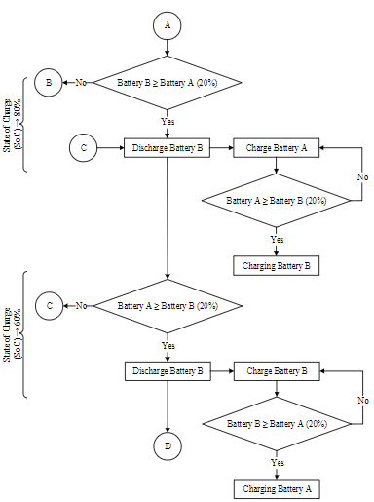
Hierarchical SoC battery charging-discharging: SoC battery equal to 60% or 80%

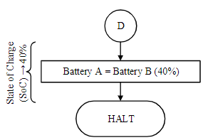
Hierarchical SoC battery charging-discharging: SoC battery equal to 40%

7.2 BATTERY MANAGEMENT SYSTEMS
Because the process of battery charging and discharging is complex, it required the design of a robust supervisory control over the classic controller. FLC and MPC are especially suitable for battery charging management because they do not require a precise knowledge of mathematical system models and they have high flexibility.

7.2.1 Fuzzy Logic Control (FLC)
In 1965, Lotfi Zadeh first proposed fuzzy theory. Between the applications of fuzzy logic, fuzzy control (FC) has been one of the fields where fuzzy techniques have obtained a greater amount of successful results working with complex nonlinear systems or even nonanalytic ones. FLC is composed by a knowledge base where its parameters can be determined without an exact model of the system.

Fuzzy Logic Control of Energy Storage Systems in Stand-Alone Applications
A FLC method was developed by Bandara et al. to charge a lead-acid battery. The FLC charges the battery at two stages. At the first stage, they use a high current that allows them to reach 70% of their total battery capacity. At the second stage, the voltage of the battery is maintained at a constant value, while the current decreases exponentially. Rahim et al. described a battery charger with a digital signal processor which included FLC as a control algorithm. This approach produced a higher charging current and it supported higher input supplies. Thus, the charging time could be reduced.
Huang et al. used a single crystal processor as the basic controller and a digital signal processor (DSP) to get the voltages, current, and temperature of the batteries. This approach allowed them to lower the battery temperature by about four degrees. Kim et al. proposed a fuzzy proportional integral derivate (PID) controller to improve performance of the frequency control of an islanded microgrid. The control strategy consisted of first, controlling the BESS, and secondly, controlling the energy management system. The control is composed of FLC and a conventional proportional integral (PI) controller, connected in series. The gains of the conventional PI controller and fuzzy PID controller were determined by the particle swarm optimization (PSO) algorithm. The simulation showed that using the proposed controller, the performance was improved compared to a conventional PI.
Welch et al. showed that using particle swarm optimization (PSO), the optimized FLC performed with 26.13% decreased energy usage compared to unoptimized FLC. The charge strategy was improved about 5.22% in relation to a previous study. Fu-shun et al. observed that using a PIC6014 microcontroller as the control core in the design of the FLC, the battery charge time is reduced by two hours compared to the three-stage control method. According to Swathika et al., using an FLC, the battery voltage can be controlled more efficiently than with a traditional controller. Also, the integral square error (ISE), integral absolute error (IAE), and settling time can be reduced considerably in comparison to a PI control. Safari et al. developed an optimized FLC based on the particle swarm optimization (PSO) algorithm. In the control design, they took into account the operation and maintenance costs and the loss of power supply probability. The results of the simulation showed that optimized FLC reduces fluctuations in batteries’ SOC, extending battery life expectancy. Moreover, it can lower operational and maintenance costs and loss of power supply probability by 57% and 33%, respectively, and average SOC can be increased by 6.18%. Also, it reduces the capacity investment cost by up to 18% of autonomous hybrid green power system (HGPS) equipment. Improving what was presented. Berrazouane et al. adopt the idea of an optimized FLC, but contrary to, use cuckoo search (CS) to adjust the shape of the FLC system membership functions to achieve a better performance, instead of using a conventional FLC or an optimized FLC based on the PSO algorithm. Compared to the FLC based on PSO, the proposed control reduced the loss of power supply probability, excess energy, and levelized cost of energy.

Fuzzy Logic Control of Energy Storage Systems in Grid-Connected Applications
Yin et al. divided the charging process into two stages. At the first stage, they implemented a FLC to determine the start charging time and to prevent overcharging or insufficient battery charging. At the second stage, they used the normal charging method. However, during the simulation, the temperature was not taken into account in the inner loop of the control unit.
Contrary to, Haoran et al. took into account the SOC of the BESS as an input to the FLC, where FLC adjusts the active power output of the BESS and the microgrid active power flow. Arcos-Aviles et al. divided their strategy into two stages: at the first stage, minimizing the power peaks and fluctuations in the grid’s power profile and maintaining the lead-acid battery SOC above 70%; at the second stage, performing an offline optimization process based on a set of evaluation quality criteria. With that strategy, the proposed control reduced the maximum and minimum grid power by 61% and 15%, respectively; and 53% and 4%, respectively, if compared to the FLC based on the microgrid’s net power trend. The strategy proposed by Derrouazin et al. led to optimal use of available energy resources beyond a threshold to withstand the load demand, giving priority to the highest power source, while enough of the available energy was routed directly to the battery through a charging/discharging regulator system. This allowed them improve energy efficiency by about 7% compared with the classical FLC. Paliwal et al. revealed that incorporating battery charging efficiency as a battery SOC function offers a more practical approach to system planning. In this research, the authors go on to conclude that assuming a constant value of efficiency may lead to an impediment that allows them to ensure optimal system performance, because the charging efficiency obtained will be greater or less than the constant assumed value affecting the charging power drawn by the energy storage system. Teo et al. designed a control based on the fuzzy inference system (FIS) to determine the charging/discharging rate and current SOC of an energy storage system where power quality (PQ), power variation range (PVR), and battery dynamic range (BDR) were used as quality indices. The maximum and minimum power of the grid was reduced. Hussain et al. proposed a control strategy where the controller decides the mode of BESS operation: subservient mode, resilient mode, or emergency mode. In subservient mode, the battery energy storage system is controlled by the energy management system, and the resilient mode minimizes the operational cost of the microgrid. The goal of the emergency mode operation was to reduce the load shedding during the emergency period. Regarding the latter, load shedding can be reduced by 92%.

7.2.2 Model Predictive Control (MPC)
Model predictive control (MPC) is a control method which provides the sequence of optimal control variables over a finite time horizon by solving an optimization problem. Therefore, it is widely used in many fields.

Model Predictive Control of Energy Storage Systems in Stand-Alone Applications
Perez et al. designed a control that anticipates the future saturations of the ESS. The MPC allowed the system to reduce its power production during the first hours . To obtain the optimal performance of the battery, Pezeshki et al. focused on two goals: energy operational cost and smooth charging. Based on a nonlinear model predictive control (NMPC), Dizqah et al. developed an energy management strategy that commands the energy flow through a standalone direct current (DC) microgrid. The NMPC solves an optimal control problem, finding the optimum values for the pitch angle. The control had three main goals: voltage level regulation, battery management system (BMS), and proportional reactive power sharing . While Morstyn et al. used a convex formulation of the DC microgrid dynamic optimal power flow problem, the proposal was based on a constant voltage-current model and linear power flow approximations. Simulations were made on a real-time digital simulator (RTDS) which used nonlinear battery models and switching converter models. The convex MPC provides an environment for generating reasonable approximated values based on the microgrid operating state, allowing reduction of the computation time by a factor of 1000. Including additional constraints to the MPC to keep the battery voltage below the upper threshold voltage level provided by the manufacturer leads to the MPC decreasing the charging current. However, this generates a slower charging in comparison with the traditional MPC. Zeng et al. proposed to combine a MPC and a hierarchical optimization to increase output of the renewable energy system generation and to decrease fluctuations between the intraday schedules and day-ahead schedule. Li et al. presented a MPC to mitigate wind power intermittency. The proposed control took into account two features: the smoothness in wind power scheduling and the efficiency loss of the BESS.

Model Predictive Control of Energy Storage Systems in Grid-Connected Applications
A control system based on MPC was proposed by Khalid et al. for primary frequency regulation of the BESS to keep a reliable operation. Through a frequency predictor, they optimized the performance of the controller using multi-step-ahead predictions. They presented two scenarios: the first scenario where the BESS operation was adjusted between 40% and 80%; and a second one where the BESS was adjusted between 10% and 50%. In the first case, the maximum battery SOC was reached at ~17 min, while the minimum battery SOC was reached at ~70 min. In the second case, the maximum battery SOC was reached at ~80 min, while the minimum battery SOC was reached at ~12 min.
Ferrarini et al. developed a MPC to store the energy necessary for a building, delivering it when the building load requires it instead of buying from the grid. They designed two MPC controls: the building MPC and the battery MPC. The goal of the building MPC was to optimize the temperature control. Additionally, the battery MPC had the main goal of minimizing the power flow at the point of common coupling (PCC). The PCC power flow was successfully maintained at around 50% until the battery reached a SOC of 90%. Wang et al. used a MPC to optimize and distribute the prosperity energy storage project in New Mexico (PNM). The storage system was divided into two BESS units: a large and slow-moving unit for energy shifting and arbitrage and a small rapid-charging unit for smoothing . The first goal was to provide energy arbitrage and to smooth the intermittent output from the photovoltaic (PV) array. The second goal was to reduce the excessive charge/discharge cycles of the BESS units. A MPC and an EMS based on optimal generation scheduling (OGS) were combined to optimize the short-term operation of the microgrid. The OGS was used to compare the expected power produced by the renewable generators with the expected load demanded over a period of days. Also, it defined the scheduling and evolution of the SOC of the ESSs for a few hours, minimizing the operating cost of the overall microgrid. The MPC aims for real-time control in order to guarantee the microgrid stability. A stochastic approach was implemented to forecast weather and load uncertainties. OGS and MPC working simultaneously can reduce computational load, as achieved.
Matthiss et al. used a MPC to maintain high levels of self-consumption, reduce the peak feed-in power to improve grid compatibility, and to minimize energy costs. In this case, four battery charge algorithms were implemented: charge at the earliest opportunity, linear delayed charging, peak shaving, and a model predictive control (MPC). Additionally, energy pricing was used as an additional parameter of the optimization process. The results show that using a MPC, wind energy is improved by 35% and the energy costs could be reduced about 25%.

CHAPTER 8
RESULTS
In this section, there are 3 parts of the design result, hardware, software, and test result.
8.1 Hardware
The hardware that has been designed is based on the block diagram in Figure 1. The battery charging control hardware consists of Arduino Mega 2560 as a microcontroller, regulator circuit, electric current sensor, voltage sensor, protection circuit, relay, and DC to DC Buck Converter. DC to DC Buck Converter as a device to increase (Boost) or reduce (Buck) DC voltage. Buck DC to DC converter is for troubleshooting unstable voltages. The voltage sensor uses a module that can read voltage values ranging from 0 to up to 25 volts and requires a supply of 5 DC volt. The current sensor that has been used in this system is INA 219. The INA219 sensor is a bi-directional system sensor using a shunt resistor. Relay driver is an electronic component that functions as an auxil-iary switch to move the load. Relay drivers are used to drive switches for electric current control. Relay drivers used amounted to 4 of them to set the source of the solar panel, regulate the battery source, regulate battery charging and the selection of voltage sources. The regulator uses IC 7805. Regulators are used to regulate the source voltage of a Li-Ion battery that has a voltage of 9 volts dc to a working voltage of 5 volts dc. The regulator circuit is used to provide power supply to the relay driver circuit. The realization of hardware development.
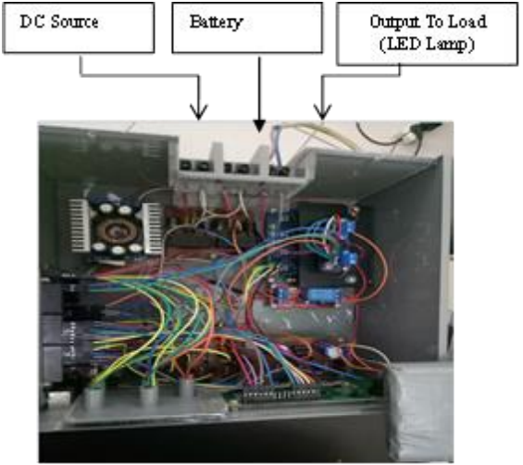
Picture of hardware from developing result a battery charging control system
8.2 Selection of Voltage Sources Test
Tests are carried out with the battery is set at 12.60 volt and the DC source is varied. In the control system always prioritizes DC sources or switch A when more than 12 V and the selector will selects the source from the battery (switch B) when the DC source is less than 12 V.
8.3. Minimum Battery Capacity Test
Testing aims to get system performance. Minimum battery capacity the allowable for supply of loads is 80%. The test results show the system can work automatically disconnecting the battery to the load when the capacity is below 80%. In relationship between percent of battery capacity and battery voltage. and for more detailed data can be seen . In the position of the switch NC or normally close means that the battery is connected to the load. While on the position switch NO or normally open means that the battery is not connected to the load.
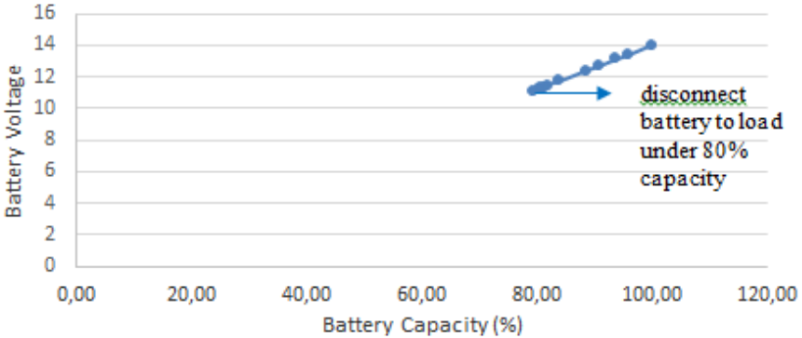
Relationship between percent of battery capacity and battery voltage
Relay 2 is the battery connecting switch to the load. When the battery capacity is below 80%, relay 2 is off. When relay 2 is off, the battery is charging. The voltage requirement to the load is supplied by DC source. In the results that when the battery voltage is smaller than 11.1 volts or the battery condition is under 80%, relay 2 will cut the electric current to the load. In row 11 the battery voltage is less than 11.1 volts so relay 2 normally opens (NO). In the results that when the battery voltage is smaller than 11.1 volts or the battery condition is under 80%, relay 2 will cut the electric current to the load. In row 11 the battery voltage is less than 11.1 volts so relay 2 normally opens (NO).
8.4. Charging and Discharging Battery Test
Charging and discharging battery test are carried out to determine the work of the system designed. In the stage of charging the battery. The battery is charged based on DC source capacity. If the DC source is more than 0.9 amperes, it can charge the battery. Relay 3 is a switch connecting the DC source to the battery. In that when DC source is 0.2 volts, 0.10 volts and 0.12 volts it cannot charge the battery. In order for the DC source to recharge it must be more than 0.9 volts.
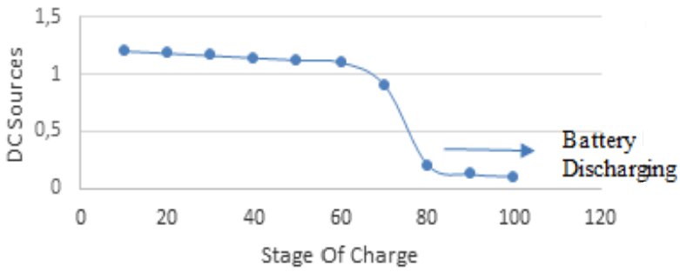
Relationship between DC source and stage of charge
8.5. Protection of Overload
In this research an over current protection system performance test was also carried out. The purpose of this protection system is to protect the panel and load due to over current from the battery and DC source. Testing on short circuit safety uses detection from current sensor 1. When the current sensor reads the current value of more than 5 amperes, the system will disconnect the current from the DC source and the battery source.
8.6. Calculation of Electric Power
Electric power is obtained by multiplying the electric current and voltage. The average power flowing to the load can be known. The maximum power that can be flowed is 50 Watt DC. Tests are carried out with LED light loads.
8.7. Duration Time of the Battery
The remaining time is the duration of time the battery will run out of energy. In this study using battery with 14 V 5Ah. If the average electric current used is 5 A, the battery usage time is 1 hour. In the more electric current the battery uses, the battery energy will also run out faster.
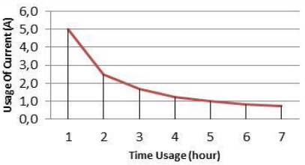
Relationship between usage current and time duration battery
In the estimation of the duration of time based on the use of electric current batteries usage. A battery with 5 Ah means that the average current used in 1 hour is 5 amperes. If use an average electric current of 0.7 amperes, the duration of the battery reaches 7 hours.

CHAPTER 9
CONCLUSION
Based on the results of testing and analysis that has been carried out the charge controller battery can work well even with low cost materials. The battery charge controller can choose the right energy form DC source when the voltage more than 12 V and the battery voltage less than 12.60 volts. And also when the DC source is less than 12 V and the battery voltage is 12.60 volts, the system selects the battery source. The control system can also work well when the battery voltage < 11.1 volts than relay 2 will cut the electric current to the load. The DC source cannot charge the battery if the voltage is less than 80%. In order for a DC source to charge the battery it needs more than 80% voltage. This BCR protection system also works well. When the sensor reads a current value of more than 5 amperes, the system will disconnect the current from the DC source and battery source.

CHAPTER 10
REFERENCES
[1] Răzvan Florin Pantelimon, Maricel Adam, MihaiAndruşcă, CătălinPancu, “Aspects Regarding Solar Battery Charge Controllers” The 8th International Symposium On Advanced Topics In Electrical Engineering May, 2013.

[2] Aimie Nazmin Azmi, Norhafiz Salim, Aziah Khamis, ”Analysis of an energy storage sizing for grid-connected photovoltaic system,” Indonesian Journal of Electrical Engineering and Computer Science (IJEECS), vol. 16, no. 1, pp. 17~24, October 2019

[3] Jawahar M, Jayasankar V, Karthik Kumar K, Edward Rajan S,”Efficiency enhancement of solar PV powered micro-integrated high frequency isolated vehicle battery charging converter,” International Journal of Power Electronics and Drive System (IJPEDS), vol. 10, no. 2, June 2019

[4] D Sattianadan, K Saravanan, S. Murugan, N. Hari, P. Venkadesh, ”Implementation of quasi-z source inverter for grid connected PV based charging station of electric vehicle,” International Journal of Power Electronics and Drive System (IJPEDS), vol. 10, no. 1, March 2019

[5] M. Reyasudin Basir Khan, Jagadeesh Pasupuleti, Jabbar Al-Fattah, Mehrdad Tahmasebi, ”Energy management system for PV-Battery microgrid based on model predictive control,”Indonesian Journal of Electrical Engineering and Computer Science (IJEECS), vol. 15, no. 1, pp. 20~25, July 2019

[6] Raffaele Romagnoli, Luis D. Couto, Marco M. Nicotra, Michel Kinnaert, EmanueleGarone, ” ComputationallyEfficient Constrained Control of the State-of-Charge of a Li-ion Battery Cell,” IEEE 56th Annual Conference on Decision and Control (CDC), December 2017.

[7] Taoyong Li, Jing Zhang, Yuanxing Zhang, Linru Jiang, Bin Li, Dongxiang Yan, Chengbin Ma,”An Optimal Design and Analysis of A Hybrid Power Charging Station for Electric Vehicles Considering Uncertainties,” IECON 2018 - 44th Annual Conference of the IEEE Industrial Electronics Society, 2018

[8] Quan Ouyang; Jian Chen; JianZheng; Huazhen Fang,” Optimal Multi-Objective Charging for Lithium-Ion Battery Packs: A Hierarchical Control Approach,” IEEE Transactions On Industrial Informatics, pp: 1–1, 2018

[9] Joydip Jana, HiranmaySamanta, Konika Das Bhattacharya, HiranmaySaha, “A Four Stage Battery Charge Controller Working on a Novel Maximum Power Point Tracking Based Algorithm for Solar PV System”, 21st Century Energy Needs - Materials, Systems and Applications (ICTFCEN), pp. 1–4, 2016

[10] Victor Herrera, AitorMilo, Haizea Gaztañaga, Ion Etxeberria Otadui, Igor Villarreal, Haritza Camblong,” Adaptive energy management strategy and optimal sizing applied on a battery-supercapacitor based tramway,”Applied Energy, vol. 169, pp. 831-845, May 2016

[11] Ting-Long Pan,Hong-ShuWan,Zhi-Cheng Ji,”Stand-alone wind power system with battery/super capacitor hybrid energy storage,” International Journal of Sustainable Engineering, 2014

[12] Nilanjan Mukherjee, Dipankar De,” A New State-of-Charge Control Derivation Method for Hybrid Battery Type Integration,” IEEE Transactions on Energy Conversion, Vol. 32, No. 3, 2017

[13] Mahesh S. Chitnis, Sachin P. Pandit, Mr. M. N. Shaikh, “Electric Vehicle Li-Ion Battery State of Charge Estimation using, ”Artificial Neural Network. Proceedings of the International Conference on Inventive Research in Computing Applications, IEEE, 2018

[14] Shady Gadoue, Kuan-Wen Chen, Paul Mitcheson, Vladimir Yufit, Nigel Brandon,” Electrochemical Impedance Spectroscopy State of Charge Measurement for Batteries using Power Converter Modulation,” The 9th International Renewable Energy Congress,IEEE, 2018

[15] Mahesh Padmanabh, Manoj Madhukar Desai,”Performance and Dynamic Charge Acceptance estimation of different Lithium-Ion batteries for Electric and Hybrid Electric Vehicles,” 2017 IEEE Transportation Electrification Conference (ITEC-India), IEEE, 2017

[16] Lalit Patnaik, A. V. J. S. Praneeth, Sheldon S. Williamson,”A Closed-loop Constant-temperature Constant-voltage Charging Technique to Reduce Charge Time of Lithium-ion Batteries,” IEEE Transactions On Industrial Electronics, vol. 66, Issue: 2, 2019

[17] Jung-Hoon Ahn, Byoung Kuk Lee, “High Efficiency Adaptive-Current Charging Strategy for Electric-Vehicles Considering Variation of Internal Resistance of Lithium-ion Battery,” IEEE Transactions on Power Electronics, vol. 34, Issue. 4, 2019

[18] Chien-Wu Lan, Shih-Sung Lin, Sih-Yan Syue, Hao-Yen Hsu, Tien-Cheng Huang, Kuang-Hsiung Tan,”Development of an Intelligent Lithium-Ion Battery-Charging Management System for Electric Vehicle,”Proceedings of the 2017 IEEE International Conference on Applied System Innovation,2017

[19] Quan Ouyang; Jian Chen; JianZheng; Huazhen Fang,” Optimal Multi-Objective Charging for Lithium-Ion Battery Packs: A Hierarchical Control Approach” IEEE Transactions On Industrial Informatics, pp: 1–1, 2018

[20] Aleksandr D.Kupchinov, Nickolay N. Smotrov, Yury P.Gusev,”The Compatibility Verification of Batteries and Battery Chargers to Ripples in Battery Float Charge Mode,” IEEE Conference of Russian Young Researchers in Electrical and Electronic Engineering,2018

[21] Shuxiang Song, Zhenhan Wei1,Haiying Xia, Mingcan Cen,Chaobo Cai, ”State-of-charge (SOC) estimation using T-S Fuzzy Neural Network for Lithium Iron Phosphate Battery” 26th International Conference on Systems Engineering (ICSEng), IEEE, 2018

[22] Jun-ichi Nagata, Kenichi Kawasaki and Hiroyuki Nakamoto,”A Battery Management System Adapted for an Energy Harvester with a Low-Power State of Charge Monitoring Method and a 24 Microwatt Intermittently Enabled Coulomb Counter,”IEEE Applied Power Electronics Conference and Exposition (APEC), 2018

[23] Budi Amri, Soedibyo, ”Design of Batteries Charging by Charge Management Concepts on Photovoltaic Standalone System,” IEEE, International Seminar on Application for Technology of Information and Communication, 2016

[24] Gilfred Allen Madrigal, Kristin Gail Cuevas, Vivien Hora, Kristine Mae Jimenez, John Niño Manato, Mary Joy Porlaje, BenedictoFortaleza,”Fuzzy logic-based maximum power point tracking solar battery charge controller with backup stand-by AC generator,” Indonesian Journal of Electrical Engineering and Computer Science (IJEECS),vol. 16, No. 1, pp. 136~146,2019

[25] B V Rajanna, MalliguntaKiran Kumar,”Dynamic model development for lead acid storage battery,”Indonesian Journal of Electrical Engineering and Computer Science (IJEECS),vol.15, no. 2, pp. 609~619,2019

