BANK LOCKER SECURITY SYSTEM BASED ON GSM AND RFID

ABSTRACT

This paper presents the development and implementation of " bank locker security system basedon RFID and GSM technology" which can be organized in bank, secured offices and homes.In this system only authenticperson can be recovered money from bank locker. We have im plemented a bank locker security system based on RFID and GSM technology containing door locking system using RFID and GSM which can activate, authenticate, and validate the user and unlock the door in real time for bank locker secure access. The main advantage of using passive RFID and GSM is more secure than other systems. This system consists of microcontroller, RFID reader, GSM modem, keyboard, and LCD, in this system The RFID reader reads the id number from passive tag and send to the microcontroller, if the id number is valid then microcontroller send the SMS request to the authenticated person mobile number, for the original password to open the bank locker, if the person send the password to the microcontroller, which will verify the passwords entered by the key board and received from authenticated mobile phone. if these two passwords are matched the locker will be opened otherwise it will be remain in locked position, This system is more secure than other systems because two passwords required for verification. This system also creates a log containing check-in and check out of each user along with basicinformation of use.

CHAPTER 1

INTRODUCTION

In this present age, safety has becomes an essential issue for most of the people especially in the rural and urban areas.Some people will try to cheat or steal the property which may endanger the safety of money in the bank, house, and office. To overcome the security threat, a most of people will install bunch of locks or alarm system.
There are many types of alarm systems available in the market which utilizes different types of sensor. The sensor can detect different types of changes occur in the surrounding and the changes will be processed to be given out a alert according to the pre-set value. By the same time this system may not be good for all the time.
In this paper we have implemented safety of the money in the bank locker, house, and office (treasury) by using RFID and GSM technology which will be more secure than other systems. Radio-frequency identification (RFID)based access-control system allows only authorized persons to open the bank locker with GSM technology. Basically, an RFID system consists of an antenna or coil, a transceiver (with decoder) and a transponder (RF tag) electronically programmed with unique information.
There are many different types of RFID systems in the market. These are categorized on the basis of their frequency ranges. Some of the most commonly used RFID kits are low-frequency (30- 500 kHz), mid-frequency (900 kHz-1500MHz) and highfrequency (2.4-2.5GHz).
The passive tags are lighter and less expensive than the active tags [2]. Global system formobile communication (GSM) is a globally accepted standard for digital cellular communication. GSM is a common European mobile telephone standard for a mobile cellular radio system operating at 900 MHz In the current work, SIM300 GSM module is used. The SIM300 module is a Triband GSM/GPRS solution in a compact plug in modulefeaturing an industry-standard interface. It delivers voice, and fax in a small form factor with low power consumption in this paper we have designed and implemented a bank locker security system based on RFID and GSM technology. In this system only authentic person can be recovered moneyfrom bank locker with two password protection method.
1.2 RFID Fundamentals
Basically, an RFID system consists of an antenna or coil, a transceiver (with decoder) and a transponder (RF tag) electronically programmed with unique information. There are many differenttypes of RFID systems in the market. These are categorized on the basis of their frequency ranges. Some of the most commonly used RFID kits are low-frequency (30-500 kHz), mid-frequency (900 kHz-1500MHz) and high-frequency (2.4-2.5GHz).Basically, an RFID system consists of three components: an antenna or coil, a transceiver (with decoder) and a transponder (RF tag) electronically programmed with unique information. AnRFID readeris a device that is used to interrogate anRFID tag. The reader has an antenna that emits radio waves; the tag responds by sending back its data. AnRFID tagis a microchip combined with an antenna in a compact package; the packaging is structured to allow the RFID tag to be attached to an object to be tracked. "RFID" stands for Radio Frequency Identification. The tag's antenna picks up signals from anRFID reader or scannerand then returns the signal, usually with some additional data (like a unique serial number or other customized information). Apassive tagis anRFID tagthat does not contain a battery; the power is supplied by the reader. When radio waves from the reader are encountered by a passive RFID tag, the coiled antenna within the tag forms a magnetic field. The tag draws power from it, energizing the circuits in the tag. The tag then sends the information encoded in the tag's memory. The RX and TX pins of RFID reader connected to Tx and Rx pins of AT89C51 Microcontroller respectively. Then the reader senses the data from the Tag and transmitsthe sensed data to microcontroller via serial port.
1.2.1 How RFID Works:
A Radio-Frequency Identification system has three parts:
- A scanning antenna
- A transceiver with a decoder to interpret the data
- A transponder -the RFID tag -that has been programmed with information.
The scanning antenna puts out radio-frequency signals in a relatively short range. The RF radiation does two things:
- It provides a means of communicating with the transponder (the RFID tag) AND
- It provides the RFID tag with the energy to communicate (in the case of passive RFID tags).
This is an absolutely key part of the technology; RFID tags do not need to contain batteries, and can therefore remain usable for very long periods of time (maybe decades). The scanning antennas can be permanently affixed to a surface; handheld antennas are also available. They can take whatever shape you need; for example, you could build them into a door frame to accept data from persons or objects passing through. When an RFID tag passes through the field of the scanning antenna, it detects the activation signal from the antenna. That "wakes up" the RFID chip, and it transmits the information on its microchip to be picked up by the scanning antenna. In addition, the RFID tag may be of one of two types. Active RFID tags have their own power source; the advantage of these tags is that the reader can be much farther away and still get the signal. Even though some of these devices are built to have up to a 10 year life span, they have limited life spans. Passive RFID tags, however, do not require batteries, and can be much smaller and have a virtually unlimited life span. RFID tags can be read in a wide variety of circumstances, where barcodes or other optically read technologies are useless.
- The tag need not be on the surface of the object (and is therefore not subject to wear)
- The read time is typically less than 100 milliseconds
- Large numbers of tags can be read at once rather than item by item
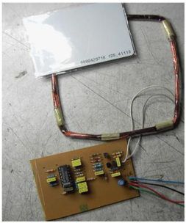

RFID READER

1.2.2 SIM 900:
The SIM900 is a complete Quad-band GSM/GPRS solution in a SMT module which can be embedded in the customer applications. Featuring an industry-standard interface, the SIM900 deliversGSM/GPRS 850/900/1800/1900MHz performance for voice, SMS, Data, and Fax in a small form factor and with low power consumption. With a tiny configuration of 24mm x 24mm x 3 mm, SIM900 can fit almost all the space requirements in your M2MApplication, especially for slim and compact demand of design.
- SIM900 is designed with a very powerful single-chip processor integrating
- AMR926EJ-S core
- Quad -band GSM/GPRS module with a size of 24mmx24mmx3mm
- SMT type suit for customer application
- An embedded Powerful TCP/IP protocol stack
- Based upon mature and field-proven platform, backed up by our support
- service, from definition to design and production
General Features:
- Quad-Band 850/ 900/ 1800/ 1900 MHz
- GPRS multi-slot class 10/8
- GPRS mobile station class B
- Compliant to GSM phase 2/2+
- Weight: 3.4g
- Control via AT commands (GSM07.07, 07.05 and SIMCOM enhanced AT Commands)
- SIM application toolkit
- Supply voltage range 3.4 ... 4.5 V
- Low power consumption.
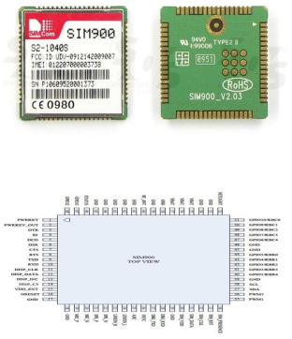
SIM 900

1.2.3 AT89C51:
The AT89C51 is a low-power, high-performance CMOS 8-bit microcomputer with 4KBytes of Flash programmable and erasable read only memory (PEROM). The deviceis manufactured using Atmel’s high-density non-volatile memory technology and iscompatible with the industry-standard MCS-51 instruction set and pin out. The on-chipFlash allows the program memory to be reprogrammed in-system or by a conventional.
Non-volatile memory programmer. By combining a versatile 8-bit CPU with Flashon a monolithic chip, the Atmel AT89C51 is a powerful microcomputer which providesa highly-flexible and cost-effective solution to many embedded control applications.

Features:
- Compatible with MCS-51™ Products
- 4K Bytes of In-System Reprogrammable Flash Memory
- Endurance: 1,000 Write/Erase Cycles
- Fully Static Operation: 0 Hz to 24 MHz
- Three-level Program Memory Lock
- 128 x 8-bit Internal RAM
- 32 Programmable I/O Lines
- Two 16-bit Timer/Counters
- Six Interrupt Sources
- Programmable Serial Channel
- Low-power Idle and Power-down Modes.
The AT89C51 provides the following standard features: 4Kbytes of Flash, 128 bytes of RAM, 32 I/O lines, two 16-bit timer/counters, a five vector two-level interrupt architecture, a full duplex serial port, on-chip oscillator and clock circuitry. In addition, the AT89C51 is designed with static logicfor operation down to zero frequency and supports two software selectable power saving modes. The Idle Mode stops the CPU while allowing the RAM, timer/counters, serial port and interrupt system to continue functioning. The Power-down Mode saves the RAM contents but freezes the oscillator disabling all other chip functions until the next hardware reset. The AT89C51 is normally shipped with the on-chip Flash memory array in the erased state (that is, contents = FFH) and ready to be programmed. The programming interface accepts either a high-voltage (12-volt) or a low-voltage (VCC) program enable signal. The low-voltage programming mode provides a convenient way to program the AT89C51 inside the user’s system, while the high-voltage programming mode is compatible with conventional third party Flash or EPROM programmers.
TheAT89C51 is shipped with either the high-voltage or low-voltage programming mode enabled. The respective top-side marking and device signature codes are listed in the following table. The AT89C51 code memory array is programmed byte-by-byte in either programming mode.

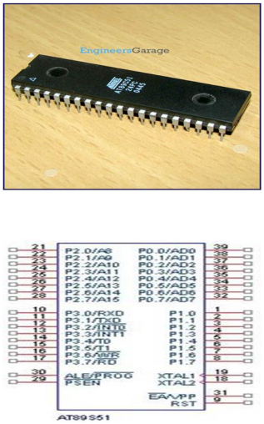
AT89C51
1.3 GLOBAL SYSTEM FOR MOBILE COMMUNICATIO (GSM):
A GSM modem is one of the wireless modem that is devised to work with a GSM wireless network. It works with the same frequency of GSM wireless network.it is an important part of the GSM network Now a day’sGSM based cell phones are more preferred than CDMA phones, Hence let us see its operation andits features. The GSM wireless modem works in the way like a dial –up modem. The main difference between the GSM modem and dial –up modem is that a dial-up modem sends and receives data through a fixed telephone line while a GSM wireless modem sends and receives data through radio wave propagation.A GSM modem can be external device, A pc card or a PCMCIA card. A GSM modem can be connected to a computer using a serial cable or USB cable.it works similar to a GSM mobile phone, and also a GSM modem requires SIM card for operation .It can be used for internet purpose also depending on various subscriptions to the service provider. There are so many features and operations that can be perform using GSM modem.The GSM modem is specialized type of modem which accept a SIM card operate on a subscriber’s mobile number over a network, just like a cellular phone. Basically, it is a cell phone without display. Modem SIM900 is a triband GSM/GPRS engine that work on EGSM 900 MHz, DCS 1800 MHz and PCS 1900 MHz frequencies. GSM is RS232 logic level compatible. i.e. it takes -3 volt to -15 volt as logic high and +3 volt to +15 volt as logic low. MAX 232 is used to convert TTL into RS232 logic level converter used between the microcontroller and GSM board. The signal at pin 11 of the microcontroller is send to the GSM modem thorough pin 11 of MAX232. This signal is received at pin 2 (RX) of the GSM modem. The GSM modem transmit the signal from pin 3 (TX) to the microcontroller through MAX232, which is received at pin 10 of IC1.
1.3.1 Features of GSM:
- Single supply voltage 3.2 volt-4.5 volt.
- Typical power consumption in sleep mode 2.5mA.
- SIM900 tri-band.
- MT, MO, CB, text and PDU mode, SMS storage: SIM card.
- Supported SIM card: 1.8v, 3v.
- Support wide range of frequencies (from 850 MHz to 1900 MHz for different classifications of GSM networks).
- Supports integration with RS232 cable.
- Can be interface to system using USB cables.
- Very less weight in few grams.
- Provided with SIM holder and SMA antenna connecter.
- Programmable with AT commands.

1.3.2 Operation that can be performusing GSM modem:
- We can read, write and delete messages.
- We can start sending SMS messages.
- We can reply to SMS messages.
- We can monitor signal strength in particular locality.
- We can monitor the charging statusand also the charge level in the battery.
- We can read, write and search phone-book entries.
- We can use it in various projects for different purpose.

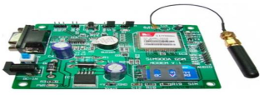
GSM NETWORK

1.4 RFID READER (EM-18)
Radio frequency Identification (RFID) is a wireless identification technology that uses radio waves to identify the presence of RFID tags. Just like Bar code reader, RFID technology is used for identification of people, object etc. presence. In barcode technology, we need to optically scan the barcode by keeping it in front of reader, whereas in RFID technology we just need to bring RFID tags in range of readers. Also, barcodes can get damaged or unreadable, which is not in the case for most of the RFID. RFID is used in many applications like attendance system in which every person will have their separate RFID tag which will help identify person and their attendance. RFID is used in many companies to provide access to their authorized employees. It is also helpful to keep track of goods and in automated toll collection system on highway by embedding Tag (having unique ID) on them. RFID based system has two basic elements.
1.4.1 RFID Tag:
RFID tag includes microchip with radio antenna mounted on substrate which carries 12 Byte unique Identification number.
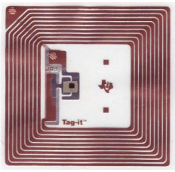
RFID Tag Inside

RFID Reader:
It is used to read unique ID from RFID tags. Whenever RFID tags comes in range, RFID reader reads its unique ID and transmits it serially to the microcontroller or PC. RFID reader has transceiver and an antenna mounted on it. It is mostly fixed in stationary position.
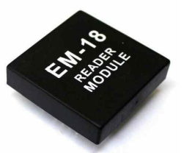
EM18 RFID Reader Module
1.4.2 NODE MCU
The Node MCU (Node Micro Controller Unit) is an open source software and hardware development environment that is built around a very inexpensive System-on-a-Chip (SoC) called the ESP8266. The ESP8266, designed and manufactured by Espressif Systems, contains all crucial elements of the modern computer: CPU, RAM, networking (WIFI), and even a modern operating system and SDK. That makes it an excellent choice for IoT projects of all kinds. However, as a chip, the ESP8266 is also hard to access and use. You have to solder wires, with the appropriate analog voltage, to its PINs for the simplest tasks such as powering it on or sending a keystroke to the “computer” on the chip. And, you have to program it in low-level machine instructions that can be interpreted by the chip hardware. While this level of integration is not a problem when the ESP8266 is used as an embedded controller chip in massproduced electronics, it is a huge burden for hobbyists, hackers, or students who want to experiment with it in their own IoT projects. Borrowing a page from the successful playbooks of Arduino or a Raspberry Pi, the Node MCU project aims to simplify ESP8266 development.
It has two key components.
- An open source ESP8266 firmware that is built on top of the chip manufacturer’s proprietary SDK. The firmware provides a simple programming environment based on eLua (embedded Lua), which is a very simple and fast scripting language with an established developer community. For new comers, the Lua scripting language is easy to learn.
- A DEVKIT board that incorporates the ESP8266 chip on a standard circuit board. The board has a built-in USB port that is already wired up with the chip, a hardware reset button, WIFI antenna, LED lights, and standard-sized GPIO (General Purpose Input Output) pins that can plug into a bread board.
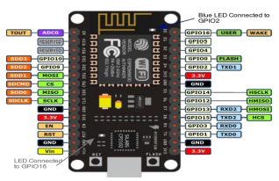
Node MCU
The Node MCU DEVKIT board that comes preloaded with the firmware can be purchased for $8 USD a piece, which makes it a very economical device for prototyping and even for production use.

1.5 PROBLEM DEFINITION

Bank lockers are plays important role in today’s life and it is considered the safest place to store jewelry, documents, stock certificates and etc. The traditional methods used for most of banks rely on manual lock and PIN number/ password which are not fully secure. In manual lock systems, whenever a customer uses the locker, he/she should assist by the bank staff. This may lead to waste of time for both the customer and the staff. The major drawback of such manual locker systems are lack of security because the key can be duplicated. This would lead to theft of the entire valuable possessions in the bank lockers. The password, Personal Identification Number (PIN) or smart cards are used for personal identification to access lockers. Anyhow, the smart cards can be stolen, the password and PIN numbers can be forgotten or might be guessed. Still many banks struggle to prevent illegal access, intrusions and stopping secret information disclosure. These all become problems of traditional bank lockers and leads to bank robberies. The safety of this lockers need to be ensured and verified through the strong authentication mechanisms in order to restrict the unauthorized access

1.6 OBJECTIVES

The focus of this project is to develop a locker system based on two-factor authentication. The objective of the project as follows:
- Develop a locker system that can replace the current traditional methods such as manual lock, PIN number and password.
- Improve the security with automate locker system based on two-factor authentication.
- Making the bank customers feel safe about their possessions in the safe.
- Eliminating the need to remember multiple passwords, PINs and not carry identity proof and keys.
- Eliminate the frauds which are done by smart larceners.
- Provide user friendly and easier system to banks to do their jobs efficiently.
- Save the time by the process of withdrawal of possessions faster and ultimately make the services pleasant for the bank customers.
- Successfully verifyan OTP which is generated by an Android App and identify the user accessing the locker using his/her OTP No.
- Verify a user accessing the locker by using fingerprinting.
- Analyze malicious users and generate a ‘blacklist’ with unacceptable fingerprints of user are able to use the locker. Identify invalide users and create a ‘white list’ with the fingerprints of users that gives permission to access the locker.
Banks offer lockers to people as and when needed. Both public and private banks provide this facility to people in need for a small annual fee. A bank locker has several advantages, some of the best are listed below:
- Softy
- Easy Access
- Available at any bank
- Anyone can use
- Easy nomination available
The fingerprint based bank locker security system is an advanced version of the traditional bank locker system which uses keys. Keys can now be easily copied and made by thieves. In addition, the keys need to be taken care of and they can also be lost through some neglect.The fingerprint based bank locker security system can solve all of these problems. The fingerprint-based bank locker system is more secure and it is easy to use and maintain. Here there is no need for key handling and hence you don't have to worry about losing keys.The system uses fingerprint recognition to read the fingerprints and first stores the registered fingerprints in the bank locker register. The next time when a person scans his/her finger, the sensor reads it and compares it to previous recordings. If a match is now found with the existing fingerprints, it sends the match signal to the microcontroller and the controller displays this data on the LCD screen. The controller also operates the driver motor to open the locker to authorized customers. The locker remains closed for unauthorized customers.

1.7 METHODOLOGY

The face detection algorithm contains different methodology of detecting the face. The algorithm used is AdaBoost algorithm. AdaBoost, short for Adaptive Boosting, is a machine learning meta-algorithm formulated by Yoav Freundand Robert Schapire, who won the 2003Gödel Prize for their work. It can be used in conjunction with many other types of learning algorithms to improve performance. The output of the other learning algorithms ('weak learners') is combined into a weighted sum that represents the final output of the boosted classifier. AdaBoost is adaptive in the sense that subsequent weak learners are tweaked in favor of those instances misclassified by previous classifiers. AdaBoost is sensitive to noisy data and outliers. In some problems it can be less susceptible to the over fitting problem than other learning algorithms. The individual learners can be weak, but as long as the performance of each one is slightly better than random guessing, the final model can be proven to converge to a strong learner.
A. AdaBoost refers to a particular method of training a boosted classifier. A boost classifier is a classifier in the form where eachis a weak learner that takes an object as input and returns a value indicating the class of the object. For example, in the two class problem, the sign of the weak learner output identifies the predicted object class and the absolute value gives the confidence in that classification. Similarly, the classifier is positive if the sample is in the positive class and negative otherwise. Each weak learner produces an output hypothesis, for each sample in the training set. At each iteration, a weak learner is selected and assigned a coefficient such that the sum training error of the resulting-stage boost classifier is minimized. Hereis the boosted classifier that has been built up to the previous stage of training,is some error function and is the weak learner that is being considered for addition to the final classifier. The system will work is as follows.
B. When the instruction from the controller it will directly through the MATLAB software. Where it check the user face.
C. Before it check the valid user the MATLAB is trained in such a way that it can store the 15 images of each user. Then it will compare the user with these 15 set of images
D. If it matches then the instruction will send back to controller where controller can do some specific task as mentioned aboe
E. If it not match the controller will do some specific task to block the locker.
This project provides a highly secure, valid and easy to operate for both the customer’s who has a locker in a Bank and the head of the branch who responsible for all the operations connected to the safety lockers. Our work does tripple verification process by user fingerprint, legitimate login credentials and OTP for authorized user. When a user wants to access the locker he/she request the login page from sever, the severthen returns the login page. The user sends the login credentials, if login credentials verification is passed then system request to give an fingerprint of user. Then the obtain fingerprint is analyzed and matched with original one. There are two lists in our database; the ‘whitelist’ is the list which consist of acceptable fingerprints of legitimate users and the ‘blacklist’ is a list of illegal fingerprints which for,who tried to approach the locker. The whitelisted user with their acceptable fingerprints can only access the locker after OTP No. verification. The blacklisted client along with their fingerprints are not permitted to use the locker although their User Name and Password are correct. The Android App which generate an One Time Password(OTP) which consist of an random code and send it to the correct users registered mobile number through message, That code is entered by the user into the webpage and thus authorized person is verified. If the user is notable to verify any of this stages then that user is added in blacklist and he is not capable to access the locker at all. Then that blacklisted users information is given to that of authorized person. The authorized user can add the users in blacklist if he wants and trusted third party device can access the locker after verification by legitimate user.
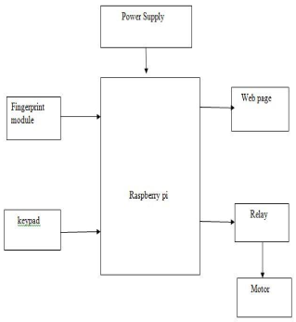
There are two types of fingerprint processing: fingerprint registration and fingerprint comparison. When logging in, users have to enter the fingerprint twice. The system processes the finger image, creates a finger image template based on the processing result, and stores the template. During the comparison, the user holds his finger on the optical sensor and the system displays the fingerprint template and compares this finger with the template already in the "finger" library for a 1: 1 comparison system that the machine uses corresponds to compares the recorded original fingerprint with the clearly defined template, which is sorted in the module, for 1: N match or for the search system, which searches the entire finger library for the matching fingerprint of the user. In both cases, the system returns the match result as a success or failure.
1.7.1 Fingerprint template
The first step is to collect the fingerprint with another or special recognition device. This process is known as registration. In this step the fingerprint is taken for confirmation or authentication. Images that we have taken that are f The digital artwork can be saved directly as an image or as a biometric algorithm. With this biometric algorithm, various data points in the digital print template are clearly studied and stored, which is the actual fingerprint. The algorithm software measures 40 or more data points for each fingerprint and then stores these measurements while the data is organized or encrypted into a digital certificate for future authentication. If we represent the fingerprint in mathematical form, but the actual fingerprint is not used to prove a person's name or identity, a higher level of reliability can be clearly understood.
1.7.2 FINGERPRINT MATCHING
Fingerprint Matching or Matching Techniques can have two types of categories, the first one is based on details and the other one is based on correlations. The minutiaebased technique first finds the minutiae points and then plans their associated position and places them on the finger. When we match the features for the minutiae extraction, you need some kind of processes including orientation calculation, image segmentation, image enhancement, edge and brightness extraction, minutiae extraction, and filtering before the match can be performed. The correlation-based approach is able to solve some of the difficulties of the minute-based approach. Correlation-based techniques require the exact position of a corner or center of an object or a registration point and are overloaded by translation and rotation from the image.
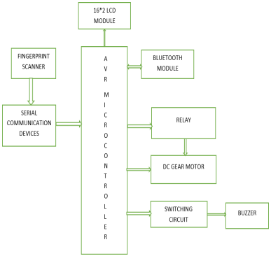

1.8 Limitation of this project
The limitations of this project are identified through the initial system analysis, development environment and based on the equipment’s specifications as follows:
- Limited time, high commitment and limited technical source and support.
- Noise in fingerprint sensed data and spoof of attack.
- The continuous power supply needed for the system in order to work lifetime.
- The system only focusing on two-factor authentication and alerting. The physical security is not concerned.
1.9 COMPONENTS REQUIRED
1.9.1 FINGERPRINT SENSOR
The sensor is a solid-type fingerprint sensor that reliably captures fingerprint information. It is designed to be combine into devices for added security and convenience. The sensor offers a reliable, fast and easy-to-use alternative to passwords, PINs and other forms of user authentication.
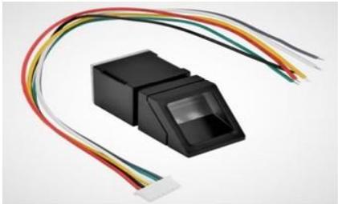
Fingerprint Sensor
1.9.2 AVR MICROCONTROLLER
The AVR microcontroller is the heart of the project. The C language is employed to do the programming. This is a modified 8-bit RISC single-chip microcontroller in Harvard design, which was developed by Atmel in 1996. The AVR was one amongst the primary microcontroller families to use on-chip non-volatile storage for program storage, instead of one-time programmable ROM, EPROM, or programmable EEPROM utilized by other microcontrollers at the time.
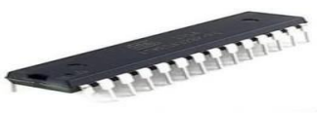
AVR Microcontroller

1.9.3 ANDROID
Android is popular with technology companies who need an inexpensive, customizable, out-of-the-box operating system for high-tech devices. Android's openness has encouraged a large community of developers and enthusiasts to use open-source code as the basis for community-based projects, add new features for power users, or bring Android to devices that are officially released with other operating systems.
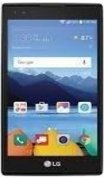
Android

1.9.4 BLUETOOTH



Bluetooth
Bluetooth is a popular wireless technology for exchanging information over short distances from constant and cellular devices and for building personal space networks. It was invented in 1994 by the telecommunications provider Ericsson and was originally designed as a wireless alternative to RS232 data cables. You can connect a variety of devices to troubleshoot sync problems.
1.9.5 SERIAL COMMUNICATION DEVICE
In telecommunications and computing, serial communication is the process in which data is sent bit by bit sequentially over a communication channel or computer bus, as opposed to parallel communication, in which multiple bits are sent as a whole on one connection. with several parallel channels. Serial communication is used for all long-distance communication and most computer networks where the cost of cables and timing issues make parallel communication impractical.
1.9.6 POWER SUPPLY
The input to the circuit is applied by the regulated power supply. The AC input voltage, i.e. 230 V from the mains, is reduced to 12 V by the transformer and fed to a rectifier. The voltage from the rectifier is a pulsating DC voltage. In order to obtain a direct voltage, the rectifier output voltage is fed to a filter to remove any alternating current components even after rectification. This voltage is fed to a voltage regulator to obtain a pure constant DC voltage.
1.9.7 CRYSTALOSCILLATOR
Crystal oscillators are devices capable of utilizing mechanical resonance of a vibrating crystal made of a piezoelectric material to produce an electrical signal at a precise frequency. This frequency can be used to keep track of time in order to provide a stable clock signal for our AVR microcontroller. The most commonly used Piezoelectric Resonator is quartz crystal, hence the oscillator circuitry that contained this is called as crystal oscillators.
1.9.8 STEP DOWN TRANSFORMER
Step-down transformers are created to reduce the electrical voltage. Its primary voltage is greater than its secondary voltage. This kind of transformer lowers the voltage applied to it. These transformers reduce the electrical voltage from a level or a phase configuration in general to a lower level.
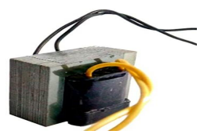
Step Down Transformer
1.9.9 RECTIFIER
A rectifier is an electrical device which is capable to convert alternating current (AC) which can periodically reverse its direction into direct current (DC),which flows in only one direction. The process is called as rectification and it has different forms including vacuum tube diodes, mercury arc valves, selenium-copper oxide rectifiers, semiconductor diodes, silicon controlled rectifiers, and other silicon based semiconductor devices.
1.9.10 FILTER
Electronic filters are analog circuits that does signal processing functions especially to remove undesirable frequency components from the signal in order to enhance the desired ones, or both. Linear filters are the most common electronic filter regardless of other aspects of their design.
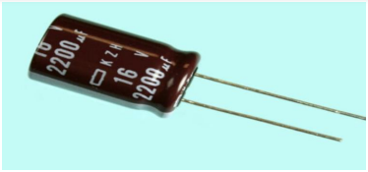
Filter

1.9.11 REGULATOR
A regulator is a device that can maintain a particular characteristic. It is responsible for managing or preserving a wide range of values in a machine. The quantifiable property of any device is closely managed by specified conditions or an advance value. It may be a fixed value or a variable one based on a predetermined formula.
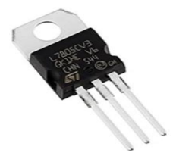
Regulator

CHAPTER 2

LITERATURE REVIEW

1. GYANENDRA K VERMA, PAWAN TRIPATHI, “A DIGITAL SECURITY SYSTEM WITH DOOR LOCK SYSTEM USING RFID TECHNOLOGY”
RFID, Radio Frequency Identification is an inexpensive technology, can be implemented for several applications such as security, asset tracking, people tracking, inventory detection, access control applications. The main objective of this paper is to design and implement a digital security system which can deploy in secured zone where only authentic person can be entered. We implemented a security system containing door locking system using passive type of RFID which can activate, authenticate, and validate the user and unlock the door in real time for secure access. The advantage of using passive RFID is that it functions without a battery and passive tags are lighter and are less expensive than the active tags. A centralized system manages the controlling, transaction and operation task. The door locking system functions in real time as the door open quickly when user put their tag in contact of reader.
A digital door locking system is also implemented and governed by RFID reader which authenticate and validate the user and open the door automatically. It also keeps the record of check-in and check-out of the user. It’s very important to authenticate the user before entering into a secure space and RFID provide this solution. The system enables user to check-in and check-out under fast, secure and convenient conditions. The system include door locking system which open when the user put their tag in contact with reader and the user information matched with the information already stored in database. The RFID controls the opening and closing of the door. In this study we utilize RFID technology to provide solution for secure access of a space while keeping record of the user. We used passive type of rfid here. The passive types of rfid are battery-less and they obtain power to operate from reader. The major advantages of passive rfid are its cost effective and small in size. Due to above advantages, it is widely use by inventory tracking technology.
In this study, we proposed a security system contains door locking system using passive type of rfid. The system is implemented in three spaces using central database system. The secure space located on same or different part of buildings. The system used hardware as well as software. The hardware components are RFID reader, tags, USB connections and connecting cables etc.
The RFID tag is detected when touched or come in the range of few millimeters from reader. The tag is automatically detected by RFID reader in every mille second and reader sent the information containing by tag to the central control though serial port. The central controls already have information of different users registered with system. The signal information coming from RFID reader is matched with the stored information in local as well as central control. When the information matched with the stored information, system displays the information.
The information contains details of user as name, id no, category, check-in time, check-out time, date and photo as well. All the coming information of RFID tag gets stored by central control server. System can also generate report of a single user as well as multiple users according to the date, time. Once the tag user authentication is performed, system generates a control signal through parallel port. This control signal goes to a control circuit.

2. KUMAR CHATURVEDULA.U.P, “RFID BASED EMBEDDED SYSTEM FOR VEHICLE TRACKING AND PREVENTION OF ROAD ACCIDENTS”
In the era of embedded systems time and efficiency are a matter of priority . RFID (Radio Frequency Identification) emerges as one of the converging technologies and transportation plays an important role in urbanization, RFID is one of the key catalyst playing a significant role in it. RFID plays major role in auto ID applications like RFID contact less smart cards used by bus riders, in Super market, Textiles and logistics chain management. This paper aims to understand the benefits of RFID technology possibilities to reduce the accidents on Indian roads. The Global System for Mobile Communications (GSM) has been a great success in providing both voice and low speed data services. The Enhanced Circuit Switched Data on GSM (ECSD) is one of the major evolutionary steps to serve real time high speed data services.
This fast paced World is with number of transport related problems. RFID technology can be effectively used to solve some of them. Some of the problems that require immediate attention are accident risk management, environment alert, traffic rule violation control, vehicle theft identification and traffic signal management. RFID tags are placed on the road giving area information and environment alerts (such as school zone, industry, market, bridge etc.). One RFID is placed in vehicle with owner info, RC book, insurance details, service details etc. to send vehicle identification to traffic information database. RFID reader will be placed with embedded controller in vehicle, Toll Gates, Parking areas and also in traffic signal areas We used GSM module with embedded unit in the moving vehicle to transmit accident information to different points.
Whenever vehicle meets with an accident, the system reads area information from RFID tags placed on the road and transfers this information to embedded module. The details are transmitted to the specific numbers stored in database (Police station, Owner and Hospital). Additionally, vibration sensor activates air bags such that severe accident to the driver driving the vehicle can be avoided and transmits this emergency situation to owner, police control office and hospital through SMS . Whenever the vehicle crosses the particular road area, the data from Vehicle tag is read and based on the location, an SMS regarding location of the vehicle will be sent to the owner. Vibration/Impact sensors are added to trigger our system, when the vehicle is met with accident. Special zone information can be programmed in active tag and this information is transmitted to RFID reader connected with vehicle embedded kit, it alarms driver about the zone.
This project can also extended with small changes for Toll gate control, traffic signal control, traffic rules violation control, parking management, vehicle theft and special zone alert using the latest RFID technology. It is proposed as a low cost optimized solution using RFID and GSM mobile technology. This is in line with the developed countries like USA, England, German and Japan, where RFID, GPS and GSM technologies are widely used for traffic management. But in India we have not implemented any automated system for transport management due to prohibitive cost. Keeping this in mind I have proposed this system at low cost.

3. ISLAM, N.S. WASI-UR-RAHMAN, M. “AN INTELLIGENT SMS BASED REMOTE WATER METERING SYSTEM”
The Integrated Prepaid Water Meter System is a technology for prepaid billing ofwater along with sufficient monitoring ofthe water meter readings automatically from a remote place without any human intervention. This system promises fast and accurate billing of water as well as prevents any misuse ofit. In this paper, a technique having adequate security support, for prepaid billing ofwater using Short Message Service (SMS) has been illustrated. Existing Global System for Mobile communications (GSM) networks have been used for sending and receiving SMS.
The conventional billing system for water is that an assigned person visits each house and reads the meter readings manually. Then the collected meter readings are used for bill calculation. This manual process can become very time consuming and tiresome. It can cause human error and can open an opportunity for corruption done by the human meter readers as well as illegal users. Sometimes users disconnect the water supply line from the water meter and collect water directly from the supply line. Due to the absence of automatic monitoring system with the existing water meter, the water supply authority is unable to detect the illegal users and this leads to wastage and illegal use of water to a great extent. Thus the billing system can become in-accurate and inefficient.
The recent advances in the field of information technology have made the exchange of information fast, secured and accurate. The digital revolution caused rapid drop of cost of digital devices such as computers and telecommunication devices. Communication networks like the internet, GSM networks etc. are available in almost all the countries of the world. In the work presented here, a technique has been developed for prepaid billing of water. In this system, water is supplied to a house only when its corresponding meter is recharged with some credit.
A remote server of the water supply authority reads the meter readings automatically using the existing GSM networks for cellular phones and as soon as the credit of the meter expires, water supply is halted. The central server can also halt water supply if any kind ofsecurity breach is detected. The meters send the meter readings like remaining credits, amount of water used, security breach information etc. by SMS to a central server.
The SMS based data collection can be done very quickly and efficiently. As there is no human intervention in the entire process, there is no chance of human error and corruption. Also, unwanted weather conditions like heavy snow, rain, storm, etc. will not hamper on collecting data as long as the GSM networks are stable. By applying complex encryption algorithms on the data SMS, data security can be ensured. Though, the development cost of the SMS based remote meter will be higher than conventional meter, the water supplier will revenue more in the successive months because it will eliminate the possibility of corruption done by the customers and employees and it can be a prolific solution to stop wastage and illegal use of water. Moreover, it can eliminate the bill preparation and paying overhead.

4. MOHD HELMY ABD WAHAB, SITI ZARINA MOHD MUJI, FAZLIZA MD. NAZIR, “INTEGRATED BILLING SYSTEM THROUGH GSM NETWORK”
In this project an automatic meter reading system is designed using GSM Technology. The embedded micro controller is interfaced with the GSM Module. This setup is fitted in home. The energy meter is attached to the micro controller. This controller reads the data from the meter output and transfers that data to GSM Module through the serial port. The embedded micro controller has the knowledge of sending message to the system through the GSM module. Another system is placed in EB office, which is the authority office.
When they send “unit request” to the microcontroller which is placed in home. Then the unit value is sent to the EB office PC through GSM module. According to the readings, the authority officer will send the information about the bill to the customer. If the customer doesn’t pay bill on-time, the power supply to the corresponding home power unit is cut, by sending the command through to the microcontroller. Once the payment of bill is done the power supply is given to the customer. Power management concept is introduced, in which during the restriction mode only limited amount of power supply can be used by the customer
The system consists of a microcontroller, GSM module, buzzer, LCD display and a relay switch. The system’s microcontroller continuously reads the energy meter and the GSM transmitter transmits the information wirelessly to the GSM receiver which is connected to the computer at the EB Office. If the user pays the bill on time the power supply will be provided to the user without any interrupt. If the user fails to pay the bill the power supply to the user will be cut. Power management system is introduced in which during normal mode user can consume the amount of power he/she requires, but during t h e restriction mode only limited amount of power supply is given to the customer. The service provider for energy still uses conventional methods for getting the energy consumed by individual customer.
This system automatically reads the energy consumed and sends it to the service provider using the existing short message service (SMS). The billing process of electricity consumption which we are using at present is very long process and requires lot of man power. For overcoming all the difficulties present in this system we are introducing fully automated billing process. Two GSM modems are used one connected to electric meter and another connected to PC present in office of electricity board. The PC is the computer which consists of all database such as meter reading, bill amount, due amount, last date for bill payment. GSM modem consists of SIM cards possessing unique number. User interface consists of LCD which displays the power consumed and amount of bill to be paid. User also consists of a mobile phone through which bill details can be communicated to the consumer. Bill can be paid just by recharging through the mobile.
In the power management concept, two modes are being used, one is the normal mode and the other is the restricted mode. During normal mode, the customer can consume the power as much as it is required. During the power demand, the authority officer will select the restricted mode which limits the power supply to the each customer’s house and sends the message to each customer’s microcontroller via GSM. By receiving this message, the microcontroller alerts the customer with an alarm and controls the usage of power. If the customer tends to consume more power, then the controller automatically disconnects the whole power supply to that particular customer’s house. The reconnection is made only after paying the fine to the government.

5. CARELIN FELIX AND I. JACOB RAGLEND, “HOME AUTOMATION USING GSM”
Home automation makes it possible for electrical appliances (such as lighting systems, washing machines, and refrigerators) to be easily accessed and effectively controlled. The key reasons behind home automation are making peoples’ lives easy, driven more by technology and effectively managed. Among others, home automation systems available are either based on Bluetooth technology, ZigBee technology, Infrared Remote (IR) controller, or Radio Frequency (RF) technology. Though these systems are good, unfortunately, they are only effective for short distances (100 meters maximum) automation within a particular locality. This posed a big challenge/risk of electrical disaster (such as fire outbreak) to people outside their vicinities that mistakenly left their appliances ON/OFF, as the case may be, and could also lead to energy wastage for appliances left connected to the mains for a period longer than required. Hence, the need for an effective means of remotely controlling home appliances beyond ones’ vicinity. However, this paper proposed a GSM based home automation system as a means to address the aforementioned issues. The system uses SMS to send commands in order to remotely turn on and off electrical devices.
Automating a home makes it possible for electrical appliances (such as lighting systems, washing machines, and refrigerators) to be easily accessed and effectively controlled. Another name used for home automation is smart home as used in the report of. The authors describe it as a home, furnished with electrical appliances, and accessed remotely with the help of an internet or a smartphone. The key reasons behind home automation are making peoples’ lives easy, driven more by technology and effectively managed. Today, home automation is an emerging new technology utilised by both the public and the private domains to ease peoples’ standard of living and also end unanticipated casualties.
In this paper, the development of a GSM-based home automation system is presented. The system enables one remotely control electrical appliances requiring 220/240V 50Hz power source (such as refrigerators and water heaters) from anywhere in the world. This is achieved by simply sending an SMS command to a dedicated SIM card embedded in the system.

CHAPTER 3

PROPOSED SYSTEM

In this project work, the RFID reader reads the data from tag and send to the microcontroller, if the card is authentic then microcontroller show the account holder name and number. Then the account holder needs to enter the password, if the password is authentic then microcontroller sends the SMS to account holder mobile number. Then account holder enters the password to the microcontroller through mobile phone using GSM. The microcontroller compares the passwords entered by keyboard and received SMS. If these passwords match, the microcontroller provides necessary control signal to open the bank locker. This method is simple and more reliable than other system.
A. RFID
RFID" means Radio Frequency Identification. An RFID reader is a device that is used for examining an RFID tag. The reader emits radio waves as the tag responds by reversing their data back. An RFID tag is a microchip merged with an antenna. This package is built to allow the RFID tag that is attached to an object to be traced. The RFID tag's antenna collects the signal from an RFID reader and then returns the signal to the RFID reader, generally by providing some additional data. RFID tag is a submissive tag that does not contain a battery where the reader imparts power. When radio waves from the reader are experienced by a submissive RFID tag, the coiled antenna within the tag forms a magnetic field.The tag drives power from it, exciting the circuits in the tag. The tag then sends the information ciphered in the tag's memory. The receiver and transmitter pins of RFID reader connected to transmitter and receiver pins of ATMEGA2560 Microcontroller eventually. Then, the reader senses the information from the tag and sends the sensed information to microcontroller via serial port.

B. GSM
The GSM modem is a special type of modem. GSM accepts a SIM card that works on a subscriber’s mobile number over a network, just like a mobile phone. GSM is basically a mobile phone without display. Modem sim800 is a tri-band GSM/GPRS engine that works on EGSM900MHz, DCS1800MHz and PCS1900MHz frequencies. GSM Modem is RS232-logic level compatible. It takes negative voltage (-3v to -15v) as logic high and positive voltage (+3v to +15) as logic low. Conversion of TTL into RS232 logic level translator between the microcontroller and GSM board is done by MAX232. The microcontroller signal at pin 11 is sent to the GSM modem through pin 11 of MAX232. Then the signal of pin 11 is received at pin2 (RX) of the GSM modem. The GSM modem transmits the signal from pin3 (TX) to the microcontroller through MAX232, which is received at pin 10 of IC1.
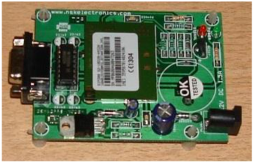
GSM Modem
Features of GSM:
- Single supply voltage 3.2v-4.5v
- Typical power consumption in SLEEP Mode: 2.5mA.SIM300 tri-band
- MT,MO,CB, text and PDU mode, SMS storage: SIM card
- Supported SIM Card :1.8V,3V
3.1 FINGERPRINT MODULE
Fingerprints are one of several forms of biometrics, used to recognize persons andverify their identity. The analysis of fingerprints for identical purposes generally requires the similarity of several features of the print pattern. This is a fingerprint sensor module with TTL UART interface. The user can store the finger print data inthe module and can configure it in 1:1 or 1: N mode for identifying the someone. The finger print module can directly interface with 3v3 or 5v Microcontroller.
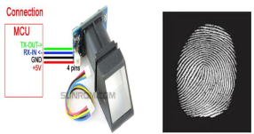

Finger print module

Features:
- Power DC: 3.6V-6.0V
- Interface: UART(TTL logical level)/ USB 1.1
- Working current : 100Ma
- Peak Current: 150mA
- Matching Mode: 1:1 and 1:N
- Character file size: 256 bytes
- Image acquiring time : <0.5s
- Template size : 512 bytes
- Storage capacity: 120

3.2 ARM:
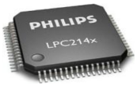
LPC2148IC

It is a 16/32-bit ARM7TDMI-S microcontroller in a tiny LQFP64package. It has 8 kB to 40 kB of on-chip static RAM and 32 kB to 512 kB of on-chip. It offers high performance small size low power. It is having two UART pin UART0 AND UART1 from UART0 interface through pc using serial cable.
3.3 LCD:
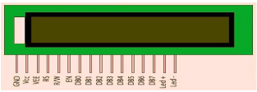
LCD Display
The board which we used is shipped with 16*2 character LCD display. LCD is used to display message access granted and access denied. In LCD has16 characters per line by 2 lines and 20 characters per line by 2 lines, respectively. When lockers will be open and close.LCD display is used for the displaying the message or to open and clse the door and also display the enter the password etc.
3.4 DC Motor :
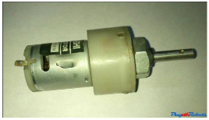
DC motor

This direct current motors series, whose power range goes from 45Watt to 1500 Watt .Using L293D and L298 are dual H-bridge motor driver ICs. We can control the rotation of two motors in both clockwise and anti-clockwise direction. DC motors areused to physically drive the application as per the requirement of system. The dc motor works on 12V.To drive a dc motor, we need a dc motor driver called L293D.

3.5 BLOCK DIAGRAM

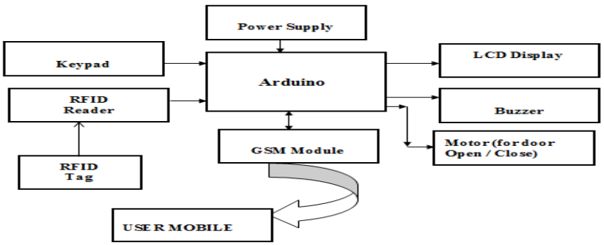

The block diagram of Bank locker system based on RFID and GSM technology is shown in the figure 1. It consists of the power supply section, keyboard, RFID Reader, ATMEGA2560 microcontroller, MAX232driver, GSM modem and LCD. The GSM board has a valid SIM card with sufficient recharge amount to make outgoing calls. The circuit is powered by regulated +5v dc.
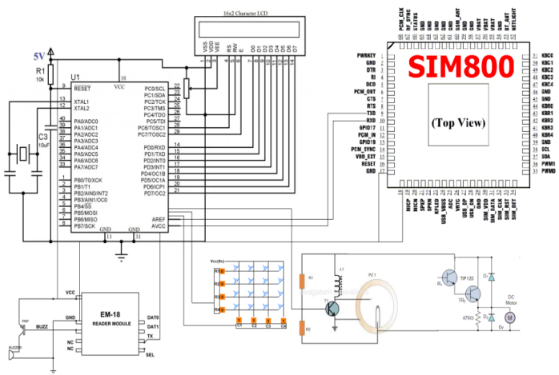
CIRUIT DIAGRAM OF PROPOSED SYSTEM
In this paper, first RFID Reader read the customer RFID tag number then OTP Password sends to registered mobile number using GSM Module and also PIN and OTP number is entered using the matrix keypad , everything is correct the door is opened , otherwise buzzer is enabled and message sends to customer. The Figure 2 of proposed system is achieved by designing an embedded system, which consists of embedded controller, Keypad, RFID module (Radio Frequency Identification) and GSM module. Embedded controller used here is ATMEGA 2560 micro controller. Keypad is used to enter password. GSM module provides communication between user mobile and bank.Here keypad is interfaced I/O lines of micro controller RFID module and GSM module are interfaced with serial port of micro controller.User who wants to do access the bank locker provided with Individual RFID tag. When user accesses the banking they show their RFID Tag. RFID reader reads the information from the tag. The micro controller is programmed to receive the RFID tag data from RFID reader and compares this data with already stored authorized data in micro controller. If it matches, it sends a password (OTP) to user’s mobile phone. Then user enters the password through the keypad. Finally micro controller sends the details to user mobile through GSM module.If password is incorrect buzzed is enabled and message send to customer.
3.5.1 ARDUINO SOFTWARE
The software program is written in embedded C and compiled using Arduino IDE. After compiler operation the hex code is generated and stored in the computer. The hex code of the program is burnt into the AT2650.The version used is Arduino IDE 1.8.8 lunched in 2018. AT mega 2560 is running at a frequency of 16 MHz with an auto-reset. It has improved level of automatic port re-selection after upload. The MacOSX added a touch bar support and does not exit theapplication after closing last window.
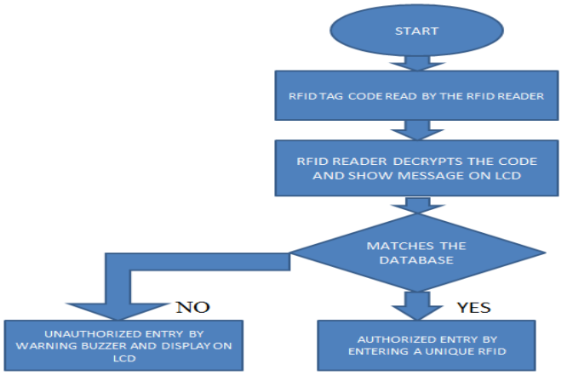

Flow chart of the proposed system

D.ALGORITHM
- Start the program
- The LCD display is on
- The RFID reader reads the code from the RFID tag
- Then the 4 digit OTP is entered using the keypad
- If the OTP is correct then it further asks to enter the password
- If both the OTP and password is matched then the DC motor is on indicating that locker can be opened
- If any one of them is wrong or mismatched buzzer is on which indicates unauthorized entry
A.The Scope of this Study Which Needsfor the Completion of this Project Involves the Following Criteria
- Architecture of LPC2148 knowledge
- ARM7 programming in C language.
- The study of modem functions which involvesAT commands.
- The circuitry and devices that is needed to construct the devices and establish the necessary communication.
3.5.2 HARDWARE DESIGN
Hardware of this system contains sensors, LPC2148 microcontroller, Buzzer, In system programmer(ISP)and relays to control the functional programs of this project. The outputs of all the sensors are connected to ADC.IR is connected either at window or atdoor.The entry to bank at night timesistreated as theft or unauthorized entry andbuzzer will be turned ONand an SMS is sent as (IR DOOR BREAK).If there is any unauthorized entryinto the bank,PIR detects the body temperature and movementsof that person and the buzzer will be turned ONand an SMS will be sent through GSM.In case of fireor any gas leakage, smoke sensor detects the change in density of air and responds in the same way as the IR and PIR do that is it sends the SMS and turns on the buzzer.

A. Design and Implementation
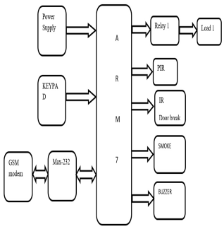
Block diagram

- Microcontroller Unit:

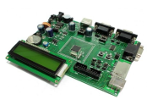

ARM7 development board
The LPC2141/42/44/46/48 microcontrolleris based on the 16-bit/32-bit ARM7TDMI-S CPU withanreal-time emulation and an embedded trace support, that combinesmicrocontrollerwith embeddedhigh speed flash memory ranges from 32 kB to 512 kB. A 128-bit widememory interfacesand anunique accelerator architecture enable 32-bit code execution atthe maximum clock rate. For critical code size applications, the alternative 16-bit Thumbmode reduces the code by more than 3% with minimum performance penalty.Due to their tiny size and low power consumption, LPC2141/42/44/46/48 isan uniquefor applications where miniaturization ofa key requirement, such as access control andpoint-of-sale. Serial communications interface ranges from a USB 2.0 Full-speed device,multiple UARTs, SPI, SSP to I2C-bus and on-chip SRAM of 8 kB to 40 kB, make thesedevices very well suited for communication gatewayand protocol converters, softmodems, voice recognition and low end imaging, providing both large buffer size and highpower processesing. Various 32-bit timers, single or dual 10-bit ADC(s), 10-bit DAC, PWMchannels and 45 fast GPIO lines with up to nine edge or level sensitive external interrupt pins make these microcontrollers suitable for industrial control and medical systems.
B.Sensors Used in the System
1)Infrared Sensor:
Infrared (IR) sensors are used to detect the intruder. They are used at doors and at windows. The IR pair that is IR transmitter and IR receiver detects the obstacle within the range of 5-6 feet.
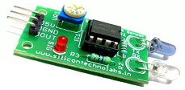
IR sensor

2) PIR Sensor:
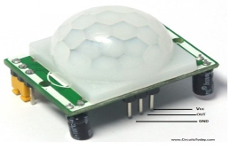
PIR sensor
A PIR-based motion detectoris used to sense movement of a people, animals, or other objects. This is commonly used in burglar alarms and automatically-activated lighting systems. This is commonly called as an"PIR", or sometimes "PID", for "passive infrared detector". Instead of infrared or laser transmitters and receivers, PIR (Passive Infrared Radial) sensors are used in this circuit. The sensor is basically a pyro-electric device. When the device is exposed to infrared radiation, it generates an electric charge. The device is made up of crystalline material. According to the generated, which is measured by an on-board amplifier. It instead accepts the incoming in change in the amount of infrared striking the element, there will be a changes in a voltage rared radiation passively.
3)Smoke Sensor:
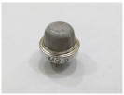
Smoke sensor(MQ-2)
MQ-2 gas sensor has high sensitivity to LPG, Propane and Hydrogen,also be used to Methane and other combustible steam, it is with low cost and suitable for different applications used for detectingthe gas and smoke before getting caught to fire. Sends an alert message to the subscriber.
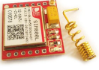
GSM module

3.5.3 SOFTWARE DESIGN
The LPC2148 is programmed with KeilμVision3. It is window-based software platform that combines a robust and modern editor with a project manager and makes facility tools for development. It integrates all toolsto develop embedded applications including a C/C++ compilers, macro assembler, linker/locator, and a HEX file generator, keil helps expedite the development process of the embedded application by providing the IDE (Integrated Development Environment). KEIL is used to create an source files; automatically compile, link and covert using options set with an easy to use user interface and finally simulates or performs debugging on the hardware with access to C variables and memory. This IDE i.e. KEIL greatly simplifies the process of creating and testing of an embedded applications. The user of KEIL centers on projects. A project is a list of all the source files required to build a single application, all the tool options which specify exactly how to build an application, and if required how the application should be simulated. It would be very tedious to set these options up every time the application is being built; therefore they are stored in a project file. The KeilμVision4 platform put forward the options for assembly language and high level programming language. C language being the most convenient language to access different port pins of LPC2148,we programmed thisalgorithm to control the GSM module and sensors through host controller LPC2148 in C language.

3.5.4 SOFTWARE IMPLIMENTATION
The software program is written in c or assembly language and compile using Keil software. After compiler operation the hex code is created and stored in the computer. The hex code of the program is burnt into the LPC2148 by using Top win Universal programmer. The architecture of the ARM7 is more suitable and easily accessible for present code software like as Keil. Keil version web pack is user friendly software tool, which is having many superior developed programs. The program can be downloading into device easily by using parallel ports.

CHAPTER 4

RESULTS AND DISCUSSION

The proposed systems are tested on the model of smart bank .The sensors based security system detects the motion and sends message to the subscriber or bank security. The system is very simple and easy to use. There are various parameters which can be adjusted in this software. Streaming of videos is also possible with this software. The developed GSM based security system gives good response to the sensor and sends SMS when it detects the fire or temperature is increased above desired level or detection of intrusion at thedoors or atwindows. The time taken by the system to deliver the SMS is dependent on the coverage area or range of the specified mobile network. If the mobile is in the range of the system then the SMS is delivered in 25-30 seconds.
The test results are divided into three phase. One is voice from the authorized user and same face, second is the voice is authorized but face is not matched and the third is the voice is unauthorized.
A.When Voice is Matched
In this phase, the voice is given by the authorized user and the face will be authorized. It will ask the user for user input. If the user input will match go to face active. If face will match then the locker will open to display the message as “locker open take care.
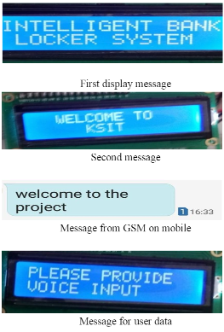

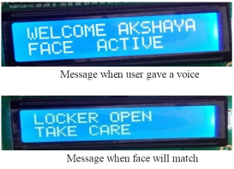

B. When Voice is Matched but Face is not Matched
The initial step is similar to the first procedure but here the user voice will be authorized but the face will mismatch. In this situation the GSM module send the message to the user will it allow or block. If the user will send the message allow then the system will access the locker else it will block it.

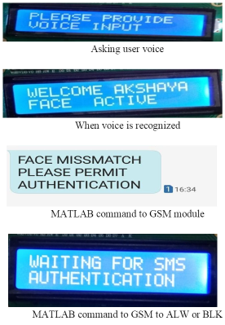

1) If it is allowed

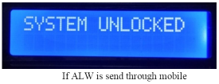

2) If it is blocked:

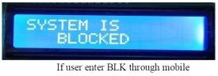

C. When Voice is not Matched
In this procedure when the voice will not matched then the GSM module send it will be an wrong password on to the LCD display.
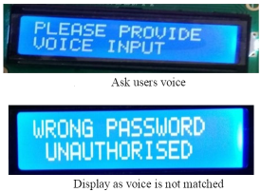

CHAPTER 5

CONCLUSION

Better scheduling or route planning can enable you handle larger jobs loads within a particular time. Main motto of the accident alert system project is to decrease the chances of losing life in such accident which we can’t stop from occurring. Whenever accident is alerted the paramedics are reached toVehicle tracking system makes better fleet management and which in turn brings large profits. the particular location to increase the chances of life.

REFERENCES

[1]. Parvathy A, Venkata Rohit Raj, Venumadhav, Manikanta, “RFID Based Exam Hall Maintenance System’’, IJCA Special Issue on “Artificial Intelligence Techniques - Novel Approaches & Practical Applications” AIT, 2011
[2]. Gyanendra K Verma, Pawan Tripathi, “A Digital Security System with Door Lock System Using RFID Technology”, International Journal of Computer Applications (IJCA) (0975 – 8887), Volume 5– No.11, August 2010
[3]. Kumar Chaturvedula .U.P, “RFID Based Embedded System for Vehicle Tracking and Prevention of Road Accidents”, International Journal of Engineering Research & Technology (IJERT) , Vol. 1 Issue 6, August 2012, ISSN: 2278-0181
[4]. Islam, N.S. Wasi-ur-Rahman, M. “An intelligent SMSbased remote Water Metering System”. 12th International Conference on Computers and Information Technology, 2009, 21-23 Dec. 2009, Dhaka, Bangladesh.
[5]. Mohd Helmy Abd Wahab, Siti Zarina Mohd Muji, Fazliza Md. Nazir. “Integrated Billing System through GSM Network”. In Proceeding of 3rd International Conference on Robotics, Vision, Information and Signal Processing 2007 (ROVISP2007), Penang, 28 – 30 November 2007
[6]. Mohd Helmy Abd Wahab, Azhar Ismail, Ayob Johari and Herdawatie Abdul Kadir. “SMS-Based Electrical Meter Reading”. In Proceeding of InternationalConference on Rural Information and Communication Technology 2009 (r-ICT), 17 – 18 June 2009, Bandung, Indonesia
[7]. Malik Sikandar Hayat Khiyal, Aihab Khan, and Erum Shehzadi. “ SMS Based Wireless Home Appliance Control System (HACS) for Automating Appliances and Security”, Issues in Informing Science and Information Technology. Vol. 9. pp. 887 – 894. 2009.
[8]. Al-Ali, A.R. Rousan, M.A. Mohandes, M. “GSM-Based Wireless Home Appliances Monitoring & Control System”, Proceedings of International Conference on Information and Communication Technologies: From Theory to Applications, pp 237-238, 2004.
[9]. Md. Wasi-ur-Rahman, Mohammad Tanvir Rahman, Tareq Hasan Khan and S.M. Lutful Kabir, “Design of an Intelligent SMS based Remote Metering System”, Proceedings of the IEEE International Conference on Information and Automation, 2009, pp. 1040- 1043.
[10]. Carelin Felix and I. Jacob Raglend, “Home Automation Using GSM”, Proceedings of 2011 International Conference on Signal Processing, Communication, Computing and Networking Technologies, pp. 15-19, 2011.
[11]. Ahmad A.W., Jan N., Iqbal S. and Lee C., “Implementation of ZigBee-GSM based home security monitoring and remote control system”, IEEE 54th International Midwest Symposium on Circuits and Systems (MWSCAS), 2011, pp. 1-4.
[12]. Pravada P. Wankhade1 and Prof. S.O. Dahad2, “Real Time Vehicle Locking and Tracking System using GSM and GPS Technology-An Anti-theft System”, International Journal of Technology And Engineering System(IJTES):Jan –March 2011- Vol.2.No.3.

