AN IMPROVED THREE STAGES CASCADING PASSIVITY-BASED CONTROL OF GRID-CONNECTED LCL CONVERTER IN UNBALANCED WEAK GRID CONDITION

ABSTRACT
This paper proposes an improved three-stages cascading passivity-based control (PBC) for a grid -connected LCL converter in unbalanced weak grid condition. In general, the traditional double-loop control based on positive and negative sequence transformations is used in grid-connected converter control in unbalanced weak grid condition. However, it is time consuming for second harmonic filtering, and positive and negative sequence currents need to be controlled separately. The PBC has strong robustness to interference, and the line voltage based PBC can deal with the voltage unbalance effectively and easily without negative sequence transformation. But the traditional PBC needs six variables and three damping coefficients for the grid-connected LCL converter in unbalanced grid condition, and it has the disadvantage of difficult implementation. The improved PBC can realize the same control effect with three-stages cascading PBCs of two variables and one damping coefficient, and it has the advantages of easy implementation, good performance and high stability. First, the modeling and controller design are detailed described. Then the SIMULINK simulation results demonstrate the benefits of the improved control strategy. Finally, a grid-connected LCL converter prototype of 5kW is built and the experimental results verify the correctness and effectivity of the improved three-stages PBC strategy.

TABLE OF CONTENT
CHAPTER NO |  | TITLES | PAGE NO
 |  | ABSTRACT | ii
1 | 1.1 | INTRODUCTION | 1
 | 1.2 | EQUIVALENT TOPOLOGY ANALYSIS | 3
 | 1.3 | MATHEMATICAL MODEL OF GRID-CONNECTED LCL CONVERTER | 4
 | 1.4 | PASSIVITY BASED CONTROL OF GRID-CONNECTED LCL CONVERTER | 5
 | 1.5 | DESIGN OF HYBRID NON LINEAR CONTROLLER | 8
 |  | 1.5.1 Design of ADRC Controller | 9
 |  | 1.5.2 Design of PBC Controller | 10
 |  | 1.5.3 Input Current Zero-Crossing Distortion Elimination | 11
 | 1.6 | GRID-VOLTAGE FEEDFORWARD CONTROL | 12
 | 1.7 | TIME DELAY CAUSED BY THE LPF AND DIGITAL CONTROL | 15
 | 1.8 | TIME-DELAY COMPENSATION FOR GRID-VOLTAGE FEEDFORWARD CONTROL | 17
2 |  | LITERATURE SURVEY | 21
3 |  | METHODOLOGY | 28
 | 3.1 | EXISTING SYSTEM | 28
 |  | - EXISTING SYSTEM FLOW | 28
 | 3.2 | PROPOSED SYSTEM | 29
 | 3.3 | BLOCK DIAGRAM | 29
4 |  | PROJECT IMPLEMENTATION | 30
5 |  | RESULT | 34
6 |  | CONCLUSION | 43
 |  | REFERENCES | 44

CHAPTER 1

INTRODUCTION

A grid-connected converter is a connector between AC power grid and DC power supply or DC load. Thus, it plays a significant role of power injection from distributed energy source to AC grid, such as PV and wind power energy source. However, compared with traditional energy source, the grid-connected converter’s voltages, which are based on pulse width modulation (PWM), are pulse waves with multiple harmonics, and some measures must be taken to reduce and even eliminate these harmonics.
A low-pass passive filter is normally used to eliminate harmonics and improve power quality of the grid-connected converter. Compared with a L-type filter, a LCL-type filter has the advantages of smaller inductor, lower cost and higher harmonic elimination rate, but a LCL-type filter also has the risk of resonance, especially in weak grid condition.
A weak grid does widely exist, especially in remote microgrid formed by distributed energy source. Particularly, there are usually long distant transmission line and multi-stages transformers between the micro-grid and the power grid. As a result, the grid often suffers from high grid impedance and low short circuit capacity, and these form the characteristics of weak grid. In addition, there also has high probability of unbalance voltages, because of high grid impedance and three-phases unbalance loads or single-phase loads.
In a weak grid, the point of common coupling (PCC) voltages have non negligible impedance and unbalance voltages with multiple harmonics. Furthermore the ‘polluted’ voltages and internal impedance influence the grid-connected LCL converter’s operation, cause resonance, and even destroy its stability. Thus, some measures must be taken to deal with the possible resonance and instability of the grid-connect LCL converter in unbalanced weak grid.
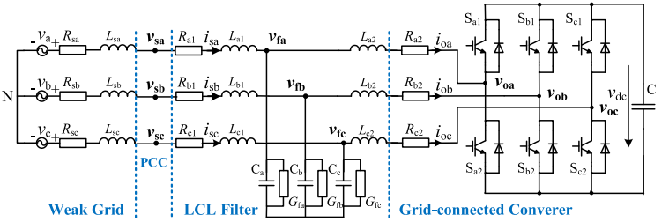
To avoid LCL filter resonance, passive damping (PD) and active damping (AD) are often used. The PD is easily applied with a paralleled or a series connected damping resistor to damp the resonant frequency, but it increases power loss and decreases power efficiency. Compared with PD, AD is lossless and costless. However, AD needs capacitor currents or capacitor voltages feedback. The capacitor currents-based AD needs high-precision current sensor and controller, the capacitor voltages-based AD needs high bandwidth switching devices and digital differentiator, which often results in amplifies noises. In the grid-connected converter studies, the linear control strategies, which includes PI control, PR control, and so on, are early used. However, the linear converter cannot achieve accurate control, and it is also difficult to achieve global stable control. So more and more nonlinear control strategies are applied to the grid-connected converter, such as the predictive control (PRC) . Obviously, nonlinear control strategy is one of the most promising techniques to reduce or even remove the oscillation, and to achieve the high robustness of the system. However, nonlinear control strategies are mostly difficult to realize the real time control with complex modelling and a large amount of computation. In the weak grid studies, a robust current control is used to improve the converter’s stability , a grid impedance estimation based adaptive control is used to maintain the converter’s stable operation in, a quasi-proportional resonance feedforward control is used to enhance the converter’s robust ability, a small-signal disturbance compensation control is used to mitigate the weak grid’s influence , a novel grid voltage feed forward control is used to suppress the effect of grid voltage harmonics, all these studies greatly improve the performance of the converter in weak grid. However, the studies are mainly based on traditional nonlinear control, some complex models are needed, and a large amount of computation are also needed in practical application. In view of these studies, a valid nonlinear control strategy, which has fewer parameters, simple design, easy application and good performance, should be conducted to improve the grid connected LCL converter’s performance in unbalanced weak grid condition. The passivity-based control (PBC), which was proposed by R. Ortega and M. Spong in 1989, can be stable globally in nonlinear system and has the advantages of simple design and easy implementation, and it has been used in power conversion system, rectifier, PV, STATCOM and other grid-connected LCL converter . Obviously, all these studies promote electrical applications of PBC. However, there are often many state variables and damping parameters in traditional PBC, and it is difficult to adjust these parameters in practical application. The major contribution of this paper is to propose an improved three-stages cascading PBC, a traditional PBC with six-variables is decomposed to three cascading PBCs with two-variables, and each PBC has only one parameter, which makes it easy to use in practical application.
1.2 EQUIVALENT TOPOLOGY ANALYSIS
The converter is made up of three parts: The part I is a three-phases two-levels converter, and Ra2, Rb2 and Rc2 are used to simulate its conducting and switching losses, and the currents and voltages are ioa, iob, ioc, voa, vob and voc, respectively. The part II is a LCLtype low-pass filter. Ra1, Rb1 and Rc1 are used to simulate the series losses related with currents, and Gfa, Gfb and Gfc are used to simulate the paralle1 losses related with voltages, and the LCL filter voltages are vfa, vfb and vfc, respectively. The part III is a weak grid source. Rsa, Rsb, Rsc, Lsa, Lsb and Lsc are used to simulate the internal resistors and inductors, respectively. va, vb and vc are the power source voltages, and vsa, vsb and vsc are PCC voltages.
According to Kirchhoff voltage law (KVL) and Kirchhoff current law (KCL), the converter voltages and currents differential equations can be expressed as follow, (Lsi + Li1) disi dt + (Rsi + Ri1)isi + vfi = vi, i = a,b,c Li2 dioi dt + Ri2ioi − vfi = −voi, i = a,b,c Ci dvfi dt − isi + ioi + Gfivfi = 0, i = a,b,c (1) where isi and ioi are grid currents and converter currents, vfi are filter voltages, vi are power source voltages, and voi are converter voltages, respectively.
1.3 MATHEMATICAL MODEL OF GRID-CONNECTED LCL CONVERTER
A. MODEL IN ABC COORDINATES
Considering that a three-phases three-lines converter meets isa + isb + isc = 0 and ioa + iob + ioc = 0 all the time, it can be derived that, where Ls1 = Ls + L1, Rs1 = Rs + R1, vab, vbc, vca, vfab, vfbc, vfca voab, vobc and voca are line voltages of power source, LCL filter and converter, respectively.
B. MODEL IN DQ COORDINATES
The synchronous rotation coordinate is adopted, and the dq voltages and currents are shown as where isd, isq, iod and ioq are dq coordinate currents, vd, vq, vod, voq, vfd and vfq are dq coordinate voltages, T1 and T2 are transform matrices from abc coordinate to dq coordinate. Then, the mathematical model of the weak grid-connected LCL converter in EL form is naturally achieved. M • X +JX + RX = V, (12) where M is a positive definite symmetric coefficient matrix, that is MT = M. J is an anti-symmetric coefficient matrix, that is J T= −J. R is a positive coefficient matrix, that is R T= R. And it satisfies R > 0, which means that the converter has dissipative character. X is the state vector, and V is the input vector.
C. PASSIVITY OF LCL CONVERTER
It is assumed that the storage energy function is It can be seen that H(X) is a positive semi-definite function and Q(X) is a positive definite function, and if the output variables Y is set as X, the energy supply rate X TV is valid to any input variable V, that is to say that the weak grid-connected LCL converter is strictly passive according to the passivity theory.
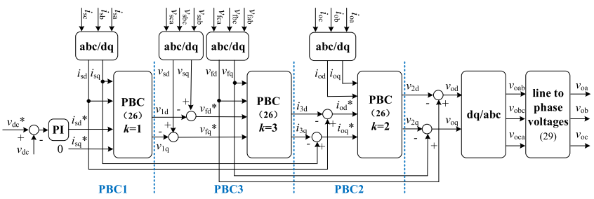
1.4 PASSIVITY BASED CONTROL OF GRID-CONNECTED LCL CONVERTER
A. TRADITIONAL PBC CONTROL
Considering that the PCC voltage is measured in the application, vsd, vsq, L1 and R1 are used instead of vd, vq, Ls1 and Rs1 in (12), where vsd and vsq are dq coordinate PCC voltages. Assuming X ∗ = (i ∗ sd i ∗ sqi ∗ odi ∗ oq v ∗ fdv ∗ fq) T is the control goal, the error vector is Xe = X–X ∗ . In order to accelerate X converge to X ∗ , a damping injecting matrix Rd= diag{r11 r11r22r22g33 g33} is used, where r11, r22 and g33 are positive constants. And the model with state vector X can be further descripted with error vector Xe as M • Xe +(R + Rd)Xe = V−(M • X ∗+JX + RX∗ − RdXe). (20) Therefore, the traditional PBC controller can be selected as V = M • X ∗+JX + RX∗ − RdXe. (21) The traditional PBC control has six state variables, six input variables and three damping parameters, and it is often difficult to adjust these parameters in practical application.
B. IMPROVED PBC CONTROL
To simplify the traditional PBC control, it can be further decomposed to three-stages cascading PBCs by selecting appropriate state variables and input variables. According to (12), we can get three mathematical models in EL form as MkX˙ k + JkXk + RkXk = Vk , k = 1,2,3, (22) It can be seen that there are two state variables, two input variables and one damping coefficient in each PBC controller. In addition, the output of PBC1 is related to the reference of PBC3, and the output of PBC3 is related to the reference of PBC2, so these three PBC controllers are cascading connected as shown in Fig.2. At the meantime, the grid currents are only used in PBC1 controller, filter voltages are only used in PBC3 controller, converter currents are only used in PBC2 controller, and it means that the grid currents, filter voltages and converter currents are decoupled in the improved PBC control strategy.
C. STATE VECTOR REFERENCE
The grid current object is X ∗ 1 = (i ∗ sd, i ∗ sq) T , where i ∗ sd can be decided by the DC voltage PI controller, that is i ∗ sd = (kp + ki s )(v ∗ dc − vdc), (27) where kp and ki are proportional and integral coefficients, v ∗ dc and vdc are dc voltage reference and value, and the grid current reference i ∗ sq can be set according to requirement. And the objects X ∗ 2 and X ∗ 3 can be decided as    X3 ∗ = vsd vsqT − √ 3V1, X2 ∗ = isd isq T − √ 3V3, (28) where V1 can be get from the PBC1 control result, and V3 can be get from the PBC3 control result.
D. CONVERTER VOLTAGES REFERENCE
According to the improved control strategy, the three-stages cascading PBC’s output are vod and voq, then we can further get the converter’s line and phase voltages and a SPWM or SVM pulse modulation mode can be selected to generate pulses to drive switches Sa1-Sc2.
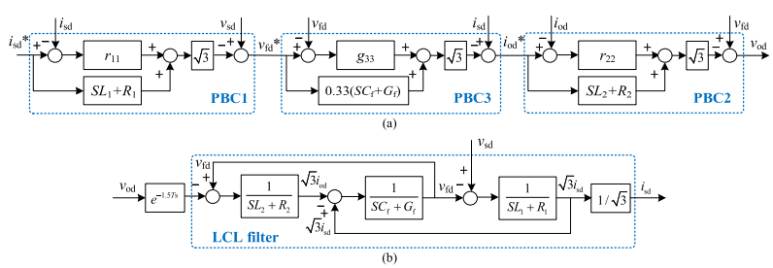

E. STABILITY ANALYSIS
The stability analysis of the improved three-stages cascading passivity-based control of grid-connected LCL converter is carried out, and the control diagram.The open loop transfer function of the improved PBC control LCL converter can be obtained as GCON = isd i ∗ sd = S 3N3 + S2N2 + SN1 + N0 S 4M4 + S 3M3 + S2M2 + SM1 + M0 , (30) According to the open-loop transfer function shown in equation (30), the Bode diagram of the three-stages cascading PBC control strategy can be obtained in Fig.4. It shows that the phase margin and magnitude margin are 54.1◦ and 11.6dB, respectively, and the system is stable.
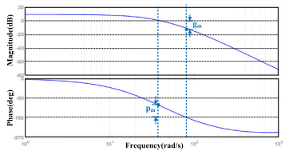
1.5 Design of Hybrid Nonlinear Controller
In this paper, a hybrid nonlinear control strategy for three-phase bridgeless rectifier is proposed. The outer loop voltage ADRC controller and the inner loop current PBC controller are designed respectively. The function of this hybrid nonlinear controller is to ensure the sinusoidal currents input, unity power factor, quick response of DC-link voltage as well as the strong anti-interference ability of the rectifier. These control objectives are reflected in the mathematical model when the components of three-phase input currents in the dq0 coordinate id, iq can be stable at the desired value i * d, i * q under the condition of unbalanced three-phase input voltages and existing external interference. In addition, the DC-link voltage of each phase can be stable at the desired value u * dc, namely x * = [i * d i * q u * dc] T = [i * d 0 u * dc] T . According to the judgment of passivity about three-phase voltage source PWM rectifier, the three-phase bridgeless rectifier is strict passive [23], and a PBC controller can be designed for it. Traditionally, it is very often to design a PI controller to regulate the outer loop voltage of the rectifier, and then achieve the desired value i * d of inner loop current. Nevertheless, the three-phase bridgeless rectifier is a truly complex nonlinear system. As for the traditional PI controller, it is a linear controller based on error elimination, and the actual output and desired output are mainly considered without the influence between the other factors of the system. In this way, the controller can only ensure the system stable at a static working point, so it is sometimes difficult to ensure the stability of the system in a large scale, and the anti-interference ability is weak. In order to overcome the weakness of the traditional linear PI controller, a ADRC controller is designed to regulate the outer loop voltage of the three-phase bridgeless rectifier. ADRC is an advanced nonlinear control technology. It can treat all the uncertain factors of the system, namely the internal and external disturbance, as an unknown disturbance. It can then estimate the disturbance in real time. Above all, the ADRC controller can make the system obtain the better ability of dynamics and anti-interference.

1.5.1 Design of ADRC Controller
The ADRC controller is a nonlinear controller which is improved by traditional linear PI controller. It is completely independent of the specific mathematical model of the controlled object and only needs a general description of the controlled object. The ADRC controller mainly includes three parts: the tracking differentiator (TD), the extended state observer (ESO), the nonlinear state error feedback (NLSEF). In order to simplify the design of the controller, the first-order ADRC is adopted in this paper. The detailed design process of each part in the controller is as follows:
1. Design of TD
First-order TD is as follows: • v1 = −m sinsgn(v1 − ku∗ dc, n) (8) The tracking differentiator is composed of nonlinear saturation function sinsgn [25], where: sinsgn(A, n) =    1, A > n sin πA 2n , |A| ≤ n −1, A < −n (9) The tracking signal of DC-link voltage can be obtained by the above first-order tracking differentiator. The parameter m in Formula (8) determines the tracking accuracy of the tracking differentiator.
2. Design of ESO
Second-order ESO is as follows:    e = z1 − udc • z1 = z2 − β1 f al(e, α1, δ1) • z2 = −β2 f al(e, α2, δ2) + bi∗ d (10) where the fal function [25] is as follows: f al(e, α, δ) = |e| α sign(e), |e| > b e b α , |e| ≤ b (11) The tracking signal of system’s output voltage and estimation of total disturbance z2 can be obtained by the second-order ESO. In Formula (10), the β1, β2 are the parameters which are selected properly for the observer. Through regulating the parameters α, δ in the nonlinear fal function, the filtering effectiveness of ESO on the system as well as the adaptability to the uncertainty and disturbance of the system’s mathematical model can be enhanced.

3. Design of NLSEF
NLSEF is as follows:    e1 = v1 − z1 uo = β3 f al(e, α3, δ3) i ∗ d = uo − z2/b (12) The NLSEF calculates the control quantity uo of the ADRC controller according to the e1 between the tracking differentiator and the output of ESO, and then obtained the final desired value i * d of inner loop currents through the comprehensive of total disturbance compensation quantity z2/b. The ADRC controller replaces the PI controller to maintain the DC-link voltage stability and provide the desired value i * d of inner loop currents. The outer loop voltage control scheme based on ADRC.
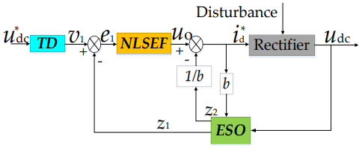

1.5.2 Design of PBC Controller
According to the EL mathematical model of the three-phase bridgeless rectifier above, the inner loop current PBC controller is designed. Let the energy storage function H(x) and the error energy function He(x). The purpose of the PBC controller is to make the system converge to the desired equilibrium point as soon as possible, that is, x * = [id * iq * udc * ] T = [id * 0 udc * ] T . If the derivate of the error energy function He = x T eMxe holds, then the convergence of at the desired equilibrium point x * of system can be realized, that is, x→x * . In order to accelerate the convergence of error energy function, it is necessary to inject virtual damping Ra into the system. The virtual damping term after injecting virtual damping into the system is Rd = (Ra + R). Rd is the system damping matrix after injecting virtual damping. R is the system inherent damping matrix. Then, according to the relationship between the switch functions Sj (j = a, b, c) and dj (j = a, b, c), the driving signal of power switches in each phase is obtained.
1.5.3 Input Current Zero-Crossing Distortion Elimination
Obviously, the unidirectional rectifier has the problem of input current zero-crossing distortion in essence. In order to eliminate the zero-crossing distortion, this paper adopted the method, through controlling the voltage uON between the neutral point of the rectifier input terminal and three-phase power supply to eliminate the zero-crossing distortion, which was described in detail in [13]. This paper will briefly discuss this method as follows: Step 1: Assuming the zero-crossing distortion is not existing, following the changing law of voltage uaN, ubN, ucN and then obtain the desired value uaN * , ubN * , ucN * . Step 2: Judge whether the input current in Phase x (x = a, b, c) is flowing into the zero-crossing distortion region or not. The judging criterion is defined as the Formula (23). i ∗ x × u ∗ xN ≤ 0 (23) Step 3: If the input current in Phase x (x = a, b, c) is out of the zero-crossing distortion region, let the desired voltage uaN * , ubN * , ucN * are equal to the desired voltage uaO * , ubO * , ucO * . Step 4: If the input current in Phase x (x = a, b, c) is flowing into the the zero-crossing distortion region, control the corresponding voltage uxO of input terminal to 0 and control the other voltages uxO of input terminals to make their fundamental component follow the changing law of uxN * , so as to achieve the elimination of input current zero-crossing distortion. The whole adjustment process can be expressed by the following formula:    u ∗ aO = u ∗ aN − u ∗ xN u ∗ bO = u ∗ bN − u ∗ xN u ∗ cO = u ∗ cN − u ∗ xN (24) Above all, the overall control scheme of the three-phase bridgeless rectifier.
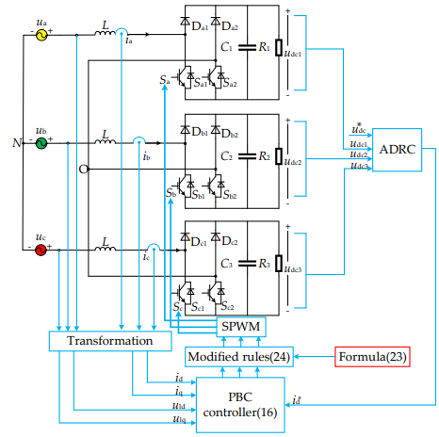
1.6 GRID-VOLTAGE FEEDFORWARD CONTROL
A. Principle of Grid-Voltage Feedforward Control
The grid-side current control of a voltage source converter is realized by the control of the amplitude and phase of the converter output voltage at the AC side. The current is generated by this voltage and the grid voltage on the two terminals of the filter reactor. Therefore, the active and reactive components of the grid-side current can be controlled by regulating the converter output voltage. In addition, the DC voltage control can be realized by adjusting the active current. Fig. 1 shows a schematic diagram of the L-filtered static var generator system used in this study. The active component reference of the grid-side current is the output of the DC voltage regulator in the form of PI, and the reactive component reference is obtained from the load current calculation or manual setting. Then the reference current in the natural coordinate can be determined by a coordinate transformation from the active and reactive components, and the converter output voltage is given by the current regulator output according to the error between the reference and the output current. Owing to the ability to track a sinusoidal reference with zero steady-state error, a PR regulator is used in the inner current loop for the fundamental output current control of the converter. For a convenient analysis, the converter output voltage at the AC side can be divided into two components. One is the synchronous voltage, which has the same amplitude and phase as the grid voltage and generates zero grid-side current. The other is the voltage difference between the grid voltage and converter output voltage, which generates grid-side current through an L-filter. If the grid voltage feedforward is unused, i.e., the path denoted by fω in Fig. 1 is removed, both of the components are generated by the current regulator. However, if a grid voltage feedforward path exists, the current regulator only outputs the second component, which generates the grid-side current. Hence, the dynamic performance of the system can be remarkably improved as illustrated in the following subsections.
B. Improvement of the Startup Performance Owing to Grid-Voltage Feed forward Control
From the above analysis, the current regulator must generate a synchronous voltage component to counteract the influence of the grid voltage on the converter output current when the grid voltage feedforward is not adopted. In the startup stage of the converter, it takes some time for the current regulator to generate this component. Therefore, a current shock and a DC voltage overshoot usually occur, as shown in Fig. 2(a), where ig, ug and Udc are the grid current, the grid voltage in one cycle and the DC voltage, respectively. The grid voltage is positive in the time interval T1, and the DC voltage is lower than its reference value at the beginning of the startup stage. As a result, a positive ig is generated from the DC regulator to charge the capacitor, and an obvious voltage overshoot occurs near the end of T1. Owing to this overshoot and the negative grid voltage during T2, the DC voltage regulator still generates a positive ig to discharge the capacitor to regulate the voltage towards its reference value.
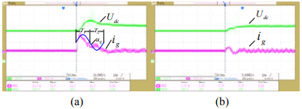
When the feedforward control is adopted, the synchronous component is directly added into the output of the current regulator without the requirements of the regulating process. Accordingly, the shock in the startup stage can be greatly reduced and the DC voltage overshoot can be eliminated. With the same control parameters used in Fig. 2(a), the startup performance of the converter with the grid voltage feedforward control. It shows a prominent improvement.
C. The Suppression Ability of the Feed forward Control on the Influence of Grid-Voltage Distortion
Using Kirchoff’s laws on the main circuit shown in Fig.1, a differential equation of the physical quantities can be given by: L o g LL di u u Ri L dt (1)+ =− Using Laplace transformation, the converter output current can be expressed in the s-domain as: () () ( ) o g L L Us Us I s R Ls (2)+ = − Based on (2), a control diagram of the grid-connected converter with the voltage feedforward control is shown in Fig. 3, where GF(s), GPWM(s), Gc(s) and GL(s) are the transfer functions of the LPF in the grid-voltage filtering circuit, the PWM control, the current regulator, and the L-filter. The path f in the figure is the grid-voltage feedforward path. From (2), the transfer function of the L-filter can be written as: G s (3)+ =R Ls If a PR controller is used in the inner current loop, its transfer function can be expressed as [26]: 2 2 0 2 ( ) 2 r c c p c K s Gs K s s ω ω ω + = (4)+ + where, Kp is the proportional gain mainly affecting the response speed of the system, ω0 is the resonant frequency, ωc is the resonance bandwidth, and Kr is the resonance gain at πthe resonant frequency. In this study, Kp=2, Kr=80, ω0=100 are used.πand ωc=4.
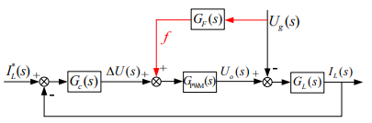
In the ideal condition of GPWM(s) =1 and GF(s) =1, the right-hand side term of the above equation is zero. That is, the influence of the grid background voltage harmonics on the converter’s output current can be completely eliminated by the grid voltage feedforward control.
1.7 TIME DELAY CAUSED BY THE LPF AND DIGITAL CONTROL
The principle of the suppression of the grid-voltage distortion for the feed forward control is that the converter quickly outputs a voltage which is exactly equal to the distorted grid voltage. Therefore, the distorted grid voltage is completely counteracted by this voltage, and the influence of the grid voltage distortion on the grid-side current can be avoided. However, if a delay exists between the feed forward voltage and the real grid voltage, the compensation precision of the grid-voltage disturbances will be decreased, and the suppression ability of the feed forward control on harmonic voltages will be weakened. The delay between the feed forward voltage and the real grid voltage may be caused by a large number of factors in practice. Among them, the LPF in the voltage filtering circuits and the digital control are two major factors.
A. Time Delay Caused by an Analog Filter
In the control system for a grid-connected converter, the LPF is usually designed to filter noise and to ensure the accuracy of the sampling signals. Due to the approximately linear phase-shift characteristics below the cut-off frequency, the phase lag caused by a LPF can be treated as a pure time delay. Both the frequency responses of the LPF described by and the corresponding pure time delay function obtained for comparison. Obviously, the LPF can be equivalent to a pure time delay function below the cut-off frequency.
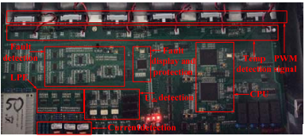
B. Time Delay Caused by the Digital Control
With the rapid development of digital signal processing technology, digital control has become mainstream technology for grid-connected converters. Compared with analog control, digital control has higher reliability, is smaller in volume, lower in energy consumption and higher in flexibility.
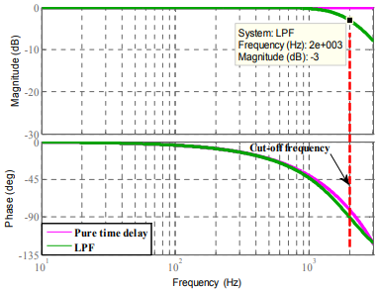

Largely owing to such advantages, it is convenient to realize complex and intelligent algorithms to achieve higher performance of converters. However, it also brings some drawbacks. Just take the PWM technology widely used in converter control as an example. One of these drawbacks is the maximal duty-cycle limitation due to sampling and computation. As a result, the one-step-delay control method is usually used for the converter control. This produces some delays between the calculation of the output-voltage reference of the converter and the updating of the PWM comparison value. The updating frequency is related to the loading mode of the PWM module in the digital signal processor (DSP). The PWM comparison value usually updates only at the peak or the trough of the carrier wave. That is to say, it updates once in a switching cycle. If it updates at the peak and the trough of the carrier wave, this is twice in a switching cycle. Whether it updates once or twice in a switching cycle, the delay always exists. The mechanism for the delay caused by the PWM updating is illustrated in Fig. 6 when the comparison value updates once in a switching cycle (only updated at the trough of the carrier wave). Provided that the DSP is interrupted at n moment, the u(n-1)ΔPWM comparison value corresponding to uf(n-1)+ and obtained in the previous period will be updated u areΔimmediately (the meaning of the symbols uf and shown in Fig. 1). In the present period, the grid voltage uf (n) is sampled, and from Fig. 1, the output-voltage reference of the converter can be determined by the sum of uf (n) and u(n). However, the corresponding PWM comparison valueΔ makes no contribution in the current switching cycle. It will not be loaded until the DSP is interrupted again in the next switching cycle. From the above, it is obvious that the loading mode of the PWM comparison value produces a switching cycle delay.
1.8 TIME-DELAY COMPENSATION FOR GRID-VOLTAGE FEEDFORWARD CONTROL
In order to analyze the time delay in the feedforward path, the control diagram shown in Fig. 3 is equivalently converted into Fig. 7(a). Obviously, the total delay between the feedforward voltage and the real grid voltage is the sum of the delay caused by the LPF and the digital control, which can be expressed as (13). PWM () () () mT ss Gs G sGs e D F (13)=⋅ = − where, m is defined as the leading correction factor in the base of a switching cycle Ts. In view of the analyses in III.A and III.B and the PWM loading mode used in the following study, the value of m can be given by: 1.5 LPF s T m T + = (14) In order to compensate the delay in the feedforward path, a leading correction function Gp(s) for the feedforward voltage is proposed to be embedded in the feedforward path.
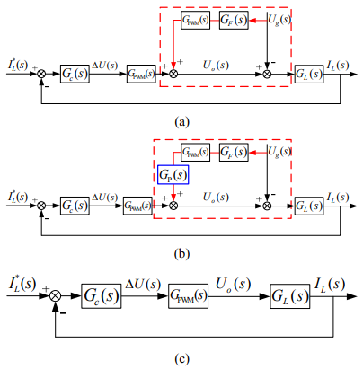
When the leading correction algorithm described by (15) can be realized with the leading correction factor obtained from (14), the delay in the feedforward path is fully compensated, and the grid-side current is not affected by grid voltage distortion. However, it should be noticed that the leading correction factor m should be an integer in practice due to the discreteness of the digital control period, while it is usually a decimal according to (14). The integer m is called the leading step in the following study. Since the AD conversion and the PWM reversal cannot be completed immediately, the optimal leading step should be the smallest integer that is greater than or equal to the number calculated from (14) in practice.
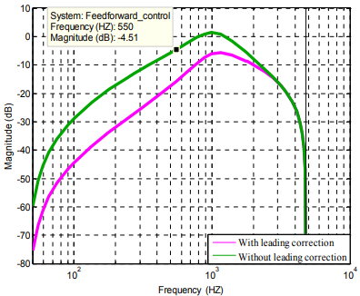
When the leading correction of the feedforward voltage is not used, Gp(z) =1 should be selected. Substituting discrete transfer functions into (19), the frequency responses of the grid-side current versus the grid voltage can be obtained.
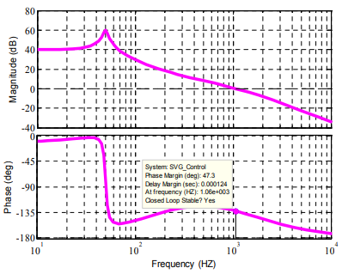
The amplitude-frequency characteristics at the integer harmonic frequencies both with and without the leading correction algorithm. That without the leading correction of the feedforward voltage, the amplitudes at lower integer frequencies such as the 3rd and 5th harmonics are relatively lower. However, the amplitude at the frequency of the 11th harmonic is only about -4.5dB, which reflects the low suppression ability on grid-voltage harmonic. Thus, it can be concluded that owing to the delay caused by the LPF and the digital control, the performance of the feedforward control on reducing the effect of the grid voltage harmonics on the grid-side current is poor, especially at the relatively higher harmonic frequencies. Even the harmonics near 1000 Hz will be enlarged. It also shows that the amplitude-frequency characteristics at integer harmonics shift down when the leading correction is adopted. This illustrates the improved suppression ability of the control system on grid voltage harmonics with the leading correction.

CHAPTER 2

LITERATURE SURVEY

1. “STEP-BY-STEP CONTROLLER DESIGN FOR LCL-TYPE GRID-CONNECTED INVERTER WITH CAPACITOR-CURRENT-FEEDBACK ACTIVE-DAMPING” C.BAO, X.WANG, W.LI, D.PAN, AND K.WENG
Distributed power generation systems use power electronics converters as interface for connection to grid. The connection through an LCL filter offers certain advantages, but it brings also the disadvantage of having a resonance frequency. Power electronic converter control is challenging due to filter resonance peak. In this paper a three level ultra-efficient converter called T-Type converter is connected to grid through an LCL filter and its injected current is controlled by PR controller. The resonance peak of the filter is also damped using filter capacitor current feedback.
Global warming caused by fossil fuels has led to important role of renewable energy resources in today’s energy production. However, bulk production of renewable energy is not always economical and have drawbacks e.g. transmission losses. Therefore distributed power generation (DPG) systems which can produce required amount of energy near to consumption area became more popular in recent years. DPG systems need power electronics converter to connect the grid/consumer. T-Type inverter is an ultra-efficient converter which can be used for this application. The output of this inverter consists of three levels, therefore, to meet harmonic standards like an output filter is needed. Among different filter types, LCL filter has superior performance at high frequencies in comparison with L an LC filters and it is not as complicated as high order filters.
One of the troubling constraints of LCL filter is the resonance phenomenon which can cause stability problems. So damping is required to suppress filter resonance. Passive damping methods require resistance connection either in parallel or series with filter capacitor, but this resistance leads to power loss which is not desirable. Active damping methods use control approaches to achieve the same goal. The feedforward gain of the grid voltage effect point and its regarding gain is vague as the PR controller can’t track voltage and current error in the same point.
In this paper a step by step design procedure is presented to design PR controllers’ parameters as well as filter capacitor current feedback coefficient. Complexity and ambiguity of mentioned previous works has been tried to be revised.
DRAWBACKS
- Design and tuning of PR controller are issues that designers face while applying LCL filter with such controller.
- In this paper a space vector modulation method which is proposed is used to tackle this issue.
2.“OVERVIEW OF CONTROL AND GRID SYNCHRONIZATION FOR DISTRIBUTED POWER GENERATION SYSTEMS” F.BLAABJERG, R.TEODORESCU, M.LISERRE, AND A.V.TIMBUS,
Renewable energy sources like wind, sun, and hydro are seen as a reliable alternative to the traditional energy sources such as oil, natural gas, or coal. Distributed power generation systems (DPGSs) based on renewable energy sources experience a large development worldwide, with Germany, Denmark, Japan, and USA as leaders in the development in this field. Due to the increasing number of DPGSs connected to the utility network, new and stricter standards in respect to power quality, safe running, and islanding protection are issued. As a consequence, the control of distributed generation systems should be improved to meet the requirements for grid interconnection. This paper gives an overview of the structures for the DPGS based on fuel cell, photovoltaic, and wind turbines.
Moreover, the day-by-day increasing demand for energy can create problems for the power distributors, like grid instability and even outages. The necessity of producing more energy combined with the interest in clean technologies yields in an increased development of power distribution systems using renewable energy.
Besides their low efficiency, the controllability of the distributed power generation systems (DPGSs) based on both wind and sun are their main drawback. As a consequence, their connection to the utility network can lead to grid instability or even failure, if these systems are not properly controlled. Moreover, the standards for interconnecting these systems to the utility network are stressing more and more the capability of the DPGS to run over short grid disturbances.
In this case, both synchronization algorithm and current controller play a major role. Therefore, the control strategies applied to distributed systems become of high interest. This paper gives an overview of the main DPGS structures, PV and fuel cell (FC) systems being first discussed. A classification of WT systems with regard to the use of power electronics follows. This is continued by a discussion of control structures for grid-side converter and the possibilities of implementation in different reference frames.
DRAWBACKS
- The current loop is responsible for power quality issues and current protection; thus, harmonic compensation and dynamics are the important properties of the current controller.
- As a consequence, more stringent demands for interconnecting the DPGS to the grid are issued.
3.“ASSESSMENT OF VOLTAGE UNBALANCE” A.VON JOUANNE AND B.BANERJEE
This paper endeavors to present a comprehensive summary of the causes and effects of voltage unbalance and to discuss related standards, definitions and mitigation techniques. Several causes of voltage unbalance on the power system and in industrial facilities are presented as well as the resulting adverse effects on the system and on equipment such as induction motors and power electronic converters and drives. Standards addressing voltage unbalance are discussed and clarified, and several mitigation techniques are suggested to correct voltage unbalance problems.
A major cause of voltage unbalance is the uneven distribution of single-phase loads, that can be continuously changing across a three-phase power system. Example problem areas can be rural electric power systems with long distribution lines, as well as large urban power systems where heavy single-phase demands, such as lighting loads, are imposed by large commercial facilities. Single-phase traction and electric transit and railroad systems can also cause considerable unbalance on the utility three-phase system unless proper design steps are taken. Additional causes of power system voltage unbalance can be asymmetrical transformer winding impedances, open wye and open delta transformer banks, asymmetrical transmission impedances possibly caused by incomplete transposition of transmission lines, and blown fuses on three-phase capacitor banks.
The balancing problem becomes particularly difficult to compensate for when the unbalance is continually varying as with large industrial loads such as arc furnaces. In addition, when energy-saving schemes such as adjustable speed drives (ASDs) are employed, the customer load can vary continuously with large hourly variations. When a large number of single-phase ASDs are employed, this can result in continuously varying unbalanced loads. ASDs are also nonlinear loads, with most topologies containing a diode rectifier front-end that draws very nonsinusoidal currents leading to harmonic distortion. The combination of ASDs, with the proliferation of singlephase nonlinear switch-mode power supply based loads such as computers, can lead to unbalanced levels of distortion between phases which can also make the balancing process more challenging.
DRAWBACKS
- Motor unbalance can be due to a problem in manufacturing such as unequal number of turns in the windings, a misaligned rotor or an asymmetric stator.
- Standards addressing voltage unbalance were discussed and clarified, and several mitigation techniques were suggested to correct voltage unbalance problems.
4.“DESIGN AND CONTROL OF AN LCL FILTER-BASED THREE-PHASE ACTIVE RECTIFIER” M.LISERRE, F.BLAABJERG, AND S.HANSEN,
This paper proposes a step-by-step procedure for designing the LCL filter of a front-end three-phase active rectifier. The primary goal is to reduce the switching frequency ripple at a reasonable cost, while at the same time achieving a high-performance front-end rectifier (as characterized by a rapid dynamic response and good stability margin). An example LCL filter design is reported and a filter has been built and tested using the values obtained from this design. The experimental results demonstrate the performance of the design procedure both for the LCL filter and for the rectifier controller. The system is stable and the grid current harmonic content is low both in the low- and high-frequency ranges. Moreover, the good agreement that was obtained between simulation and experimental results validates the proposed approach.
The voltage-source converter (VSC) may be used as an active rectifier, with the advantages of its potential for full control of both dc-link voltage and power factor, and its ability to work in rectifying and regenerating mode. Moreover, the use of pulse wdith modulation (PWM) in conjunction with closed-loop current control allows a sinusoidal input current to be achieved with a total harmonic distortion (THD) below 5%, even if grid voltage or current sensors are not used. However, typical power device switching frequencies of between 2–15 kHz can cause high-order harmonics that can disturb other sensitive loads/equipment on the grid, and can also produce losses. To reduce the current harmonics around the switching frequency a high value of input inductance should be used. However, for applications above several kilowatts, it becomes quite expensive to realize higher value filter reactors.
A further issue for a VSC is high-frequency electromagnetic interference (EMI) (differential mode and common mode), which needs specific filters in frequency ranges above 150 kHz and rated at lower power levels. Of course, an LCL filter that is effective in the reduction of switching frequency harmonics may also be effective for differential mode EMI if the filter inductors are built using chokes that can mitigate high frequency (using ferrite cores, for example). Similarly, for common-mode EMI, a commonmode inductor could be included in the differential-mode filter as suggested. However, conducted EMI is a very complex problem: depending on the frequency range it needs different solutions and specifically designed filters. Hence, even if filter integration is feasible in some cases, the use of one filter over a wide frequency range is often too expensive since the same reactive element must be designed to work over different frequency ranges and at different power levels.
DRAWBACKS
- The resonant frequency should be in a range between ten times the line frequency and one-half of the switching frequency, to avoid resonance problems in the lower and upper parts of the harmonic spectrum.
- It can be seen that the dc voltage dynamic response is slowed down compared to simulation because of the dc filter that is used to reduce measurement ripple to avoid problems in the control loops.
.5.“BASIC CRITERIA IN DESIGNING LCL FILTERS FOR GRID CONNECTED CONVERTERS” H.KARSHENAS AND H.SAGHAFI,
Many of these resources use renewable energies, and many of them provide electrical energy in the form of dc voltage source. Consequently, the connection of such resources to the utility grid needs a dc/ac conversion stage. Voltage Source Converters (VSC) are widely used for this application as they have a mature technology. These converters are usually connected to the utility grid through a simple L filter to reduce the current harmonics injected to the grid. However, higher order filters, like LCL filters, can provide better harmonic attenuation and reduce the filter size at the same time. This paper is concerned with the subject of grid connected converters via LCL filter topology.
Energy crisis and the threatening increase of greenhouse gases have naturally caused more attention to the use of renewable energy resources in modem distribution networks. The dispersed nature of these resources, sometimes called Distributed Resources (DR), along with other technical and economical issues has consequently brought the subject of Distributed Generation (DG) into consideration. Many types of distributed resources produce electrical energy in the form of dc voltage source. Well known examples are photovoltaic (PV) and fuel cells. Furthermore, in some other type of DR, although the generated electrical energy is in the form ac, it is preferred to perform energy exchange through an acldclac conversion stage for the incompatibility of the generated voltage and/or frequency with that of grid. Examples of this type are micro-turbines, in which the electrical energy is generated via high speed permanent magnet generators with the frequency around a few kilohertz, or in some types of wind turbines in which technical characteristics of the system do not allow direct connection of the generator to the utility grid. As a result, with currently available technologies, many DRs need a dclac conversion stage for energy transfer to the grid. Apparently, static dclac converters are the best alternative for this task and thus widely used in such applications.
DRAWBACKS
- Their size does not have great impact on system size, cost and reliability as compared to other components.
- Therefore, despite better harmonic attenuation of an LCL filter, a designer is faced with more complicated design problem in an LCL filter as compared to simple L filter.

CHAPTER 3

METHODOLOGY

EXISTING SYSTEM
An unbalanced grid does exist because of the asymmetry of power grid parameters, the access of nonlinear loads and power grid faults. In order to overcome the drawback of existing control strategies for the three-phase cascaded bridgeless rectifier, taking one bridgeless model in each phase of three-phase cascaded bridgeless multilevel converter.The main advantage of the proposed control scheme with respect to the similar existing one is the simultaneous control of the negative-sequence perturbation and positive-sequence current by means of a single unified controller.
    - EXISTING SYSTEM FLOW

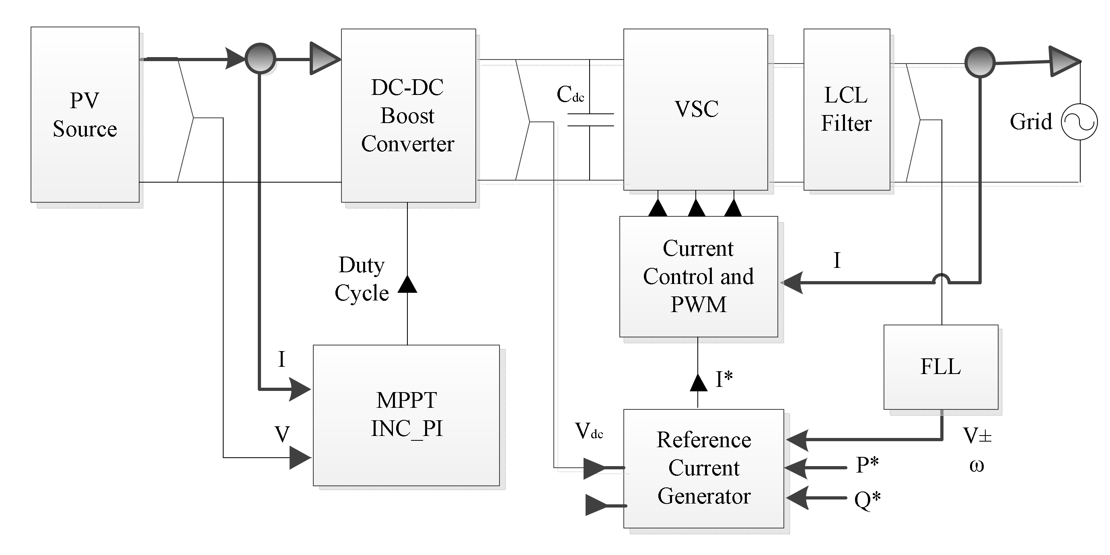
FIGURE3.1 SYSTEM FLOW

  - PROPOSED SYSTEM
In this proposed control strategy, using line voltages and line currents as state variables, the mathematical model of rectifier has been established without considering the positive and negative sequence components of the above variables. The proposed method does not require a phase-locked loop (PLL), it employs an observer to estimate positive- and negative-sequence components of the grid voltage.The proposed controller first determines the double-frequency current references and then uses a sixth-order two-input two-output proportional-integral-resonance (PIR) structure, which is optimally designed.
3.3 BLOCK DIAGRAM

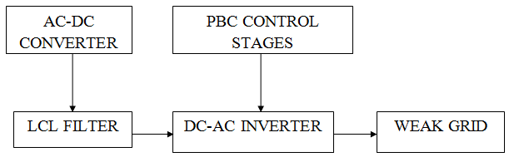
FIGURE3.2 BLOCK DIAGRAM

CHAPTER 4

PROJECT IMPLEMENTATION

4.1 HARDWARE FEATURES

- AC-DC Converter
- PBC control stages
- Weak grid
- LCL filter
- DC-AC inverter

4.2 SOFTWARE FEATURES
- Operating system : Windows 10.
- Coding Language : Asp.Net
- IDE : .Net Framwork
- Database : Mssql

The performance of the proposed control strategy has been evaluated through a MATLAB-based simulation. The semiconductor models are based on the ABB 35L4510 4.5kV 4 kA Integrated Gate Commutated Thyristor (IGCT) and the ABB 10H4520 fast recovery diode. The LCL-filter parameters are L = Lg = 600 µH, both with a series resistance R = Rg = 5 mΩ, whilst the filter capacitor is C = 1 mF. The resulting resonant frequency is ω1 = 1290 rads−1 (205 Hz). The Lfilter parameters are L = 1.2 mH, with a series resistance R = 10 mΩ, meaning that the overall resistance and inductance of the filter is the same for both cases. This also means that the losses in the LCL- and L-filters are approximately equal. The per-unit system, which is used in all simulations, is established from foundation values of Vbase = p 2/3Vg = 2449 V, Pbase = 8 MVA and fbase = 50 Hz. A summary of nominal ratings and per-unit (p.u.) parameters. All MPDCC simulations have been run with a sampling time of 25 µs and with the cost function penalising switching losses. Exact (model-based) extension has been used. The neutral point bound width δNP = 0.03 p.u. and the virtual resistance Rv4 = 0.7 p.u. For both the LCL- and L- filters the fundamental converter current references are set to deliver 1 p.u. real power and 0 p.u. reactive power to the grid. B. Steady-State Performance Evaluation Figs. 5 and 6 show the grid current, grid current spectrum, neutral point potential, and switching pattern, for MPDCC with an LCL- and L-filter, respectively. In both cases, the bound width δi = 0.1 p.u. and the switching horizon Ns = ’eSE’. For the LCL-filter, the resulting average device switching frequency is 548 Hz, average device switching losses are 33.9 kW, and grid current TDD is 2.13%. As shown in Fig. 5(b), the AD strategy is very effective in suppressing the resonant frequency ω1 from the grid current. For the Lfilter, the switching frequency is 262 Hz, the switching losses are 17.1 kW, and the grid current TDD is 7.10%.

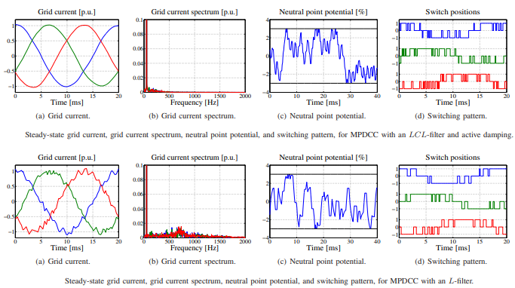

The substantial discrepancy in switching frequency and losses is caused by the fact that the dynamics of the controlled (converter-side) current of the LCL-filter are much faster than those of the L-filter. For the LCL-filter, the inductance through which the converter-side current flows is only half that of the L-filter, and as a result the switching frequency is roughly double that of the L-filter. As shown in Figs. 5(c) and 6(c), the ability of the controller to balance the neutral-point potential is not affected by the introduction of the LCL-filter. The increase in switching losses is offset by the considerable increase in harmonic attenuation offered by the LCLfilter, which results in a much lower grid current TDD. The trade-off between switching losses and grid current TDD is therefore a very important consideration and forms the basis of comparison between MPDCC with an LCL- and L-filter. Fig. 7 provides trade-off curves showing grid-current TDD (ig,TDD) against average device switching losses (Psw). The comparison is made for switching losses of between 20 and 30 kW, and up to a grid current TDD of 5%, which is the maximum allowable grid current TDD according to the IEEE Standard 519 on harmonic limits. The data points are generated by varying the width of the current bound, δi , and a hyperbolic trendline is subsequently fitted. Fig. 7(a) shows the trendlines for MPDCC with Ns = ’eSE’. It is apparent that the performance of MPDCC with an LCLfilter is superior to that with an L-filter at most values of Psw. It is only below Psw = 22 kW that the performance of the L-filter is better than that of the LCL-filter, at which point the TDD for both cases approaches 5%. The trendlines with the switching horizon extended to ’eSESE’ are shown in Fig. 7(b). Once again, the performance with an LCL-filter is superior to that with an L-filter when the switching losses are above roughly 22 kW. It is interesting to note that with the LCL-filter, the performance with Ns = ’eSESE’ does not improve greatly over Ns = ’eSE’, whilst with the L-filter, there is a substantial improvement. This means that for Ns = ’eSESE’ the improvement offered by the LCL-filter over the L-filter is not as significant as with the shorter horizon. Fig. 7(c) shows the trendlines with the switching horizon further extended to ’eSSESE’. With this horizon, the performance of MPDCC with an LCL-filter is considerably better than with an L-filter. At Psw = 20 kW, the LCL-filter offers a grid current TDD of around 4.2%, compared to around 4.8% for the L-filter, whilst at Psw = 30 kW, the LCL-filter offers a TDD of less than 2%, compared to around 3% for the L-filter. The simulation results validate the effectiveness of the modified MPDCC strategy for use with an LCL output filter. At all of the switching horizons examined - ’eSE’, ’eSESE’, and ’eSSESE’ - the modified strategy has been shown to outperform conventional MPDCC with an L-filter across a range of operating points. With switching horizons of ’eSE’ and ’eSESE’, the modified strategy performs worse than conventional MPDCC when the switching losses are below about 22 kW. However, this could potentially be corrected by further optimising the LCL-filter design. Moreover, modifications to the AD strategy, for instance the formulation of the damping quantity in (20), could also improve performance.

CHAPTER 5

RESULT

To verify the improved three-stages cascading PBC of grid connected LCL converter in unbalanced weak grid condition, SIMULINK simulations in different weak grid conditions are carried out, the main circuit parameters, and the control coefficients.
A. STRONG GRID SIMULATION
A strong grid is simulated by the power source whose internal resistance and inductance are all zeros. In Fig.5(a), the DC voltage stays at the reference value at the first. At the time t4, a 50 resistor is put in the DC capacitor, and the currents track the active current step rapidly, whose response time is less than 5ms. In Fig.5 (b), at the time t5, t6, t7 and t8, the reactive current reference is set as 20A, 0A, −20A and 20A, respectively, and the currents also track the reactive current references step rapidly, whose response time is also less than 5ms all the time. The currents’ total harmonic distortion (THD) is less than 2.39% in the strong grid simulation process.

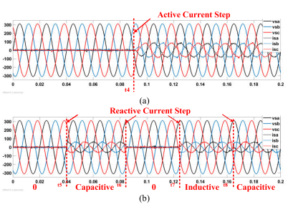

B. WEAK GRID SIMULATION
In the simulation, the power source internal resistance and inductance are used to simulate weak grid. In Fig.6 (a), the power sources are perfect sinusoidal waves at the first, and the converter outputs 20A capacitive current. At the time t9, the internal resistance and inductance are set as 0.5 and 10mH, respectively. The PCC voltages waves deteriorate with total harmonic distortion (THD) of 7.59%, but the currents are still sinusoidal balanced waves with same amplitudes, and the currents’ THD is 3.83%. At the time t10, the reference current is set as −20A inductive current, the PCC voltages decrease, however the currents track the reactive current step with same sinusoidal balanced waves and same amplitudes.

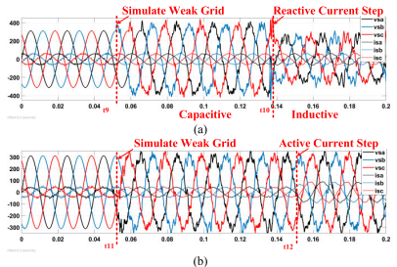
The power sources are perfect sinusoidal waves with 100 resistor load at the first. At the time t11, the power source internal resistance and inductance are set as 0.5 and 10mH, respectively, and the PCC voltages waves deteriorate with many harmonics. However, the currents are still perfect sinusoidal balanced waves with same amplitude. At the time t12, another 100 resistor load is put in, the currents are still perfect sinusoidal balanced waves with twice amplitude.
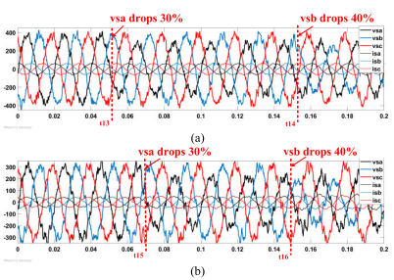
PCC voltages and currents waveforms in unbalanced weak grid simulation. (a) In reactive power state. (b) In active power state.

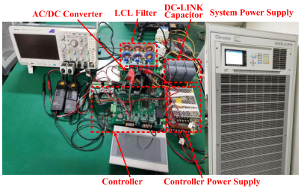
The downsized LCL prototype

C. UNBALANCED WEAK GRID SIMULATION
The power sources are balanced weak grid at the first, and the converter outputs -20A reactive current. At the time t13 and t14, vsa and vsb drop by 30% and 40%, respectively, the currents are still sinusoidal balanced waves with same amplitude all the time in unbalanced weak grid condition. In, the power sources are balanced weak grid at the first, and the converter’s load is 100 resistor. Similarly, at the time t15 and t16, vsa and vsb drop by 30% and 40%, respectively, the currents are still sinusoidal balanced waves with same amplitude all the time in unbalanced weak grid condition. Through the simulations, we can conclude that in whatever strong grid, weak grid or unbalanced weak grid, in whatever active or reactive power state, the improved three-stages PBC can stabilize the system, response to control command rapidly, and the currents are balanced sinusoidal waves all the time.
Main Parameters of System
To verify the effectiveness of the hybrid nonlinear control strategy proposed and the designed nonlinear controller in this paper, a three-phase bridgeless rectifier simulation model is built by using the power electronics module in Matlab/Simulink for verification. The main circuit parameters of the prototype are set. At the same time, it is compared with the traditional linear control strategies, such as PI + proportional resonance (PR).
Set the main circuit parameters and control coefficients of prototype. Simulated the prototype under the condition of grid voltages imbalance . The AC side input voltages and currents under the control strategy proposed in this paper. Moreover, in order to verify the sensitivity of the control strategy to the phase difference of three-phase grid voltage, the phase angle of phase-b is −100 degrees and the phase of phase-c is 130 degree. It can be seen from that the proposed strategy can ensure the AC side three-phase input currents sinusoidal and realize the unity power factor under the condition of grid voltages imbalance. To better verify that the control strategy in this paper can cope with worse grid voltage quality, it is proposed to inject 10% of the 3rd, 5th and 7th harmonic voltages into Phase a and Phase b, respectively, on the basis of the above three-phase unbalanced grid voltages. The grid voltages and three-phase input currents on the AC side after harmonic injection.
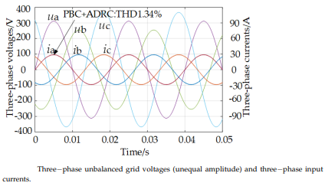
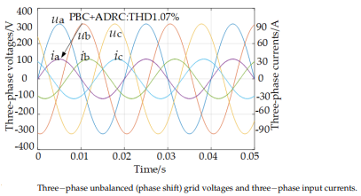

The response curves of DC-link output voltages udc1, udc2 and udc3 during steady-state operation of three-phase Y-connected bridgeless rectifier the DC-link voltages can track the desired value well. At the same time, the DC-link voltages response curves of the three-phase basically coincide, which proves that the balance between the three phases can be realized under the hybrid PBC and ADRC.
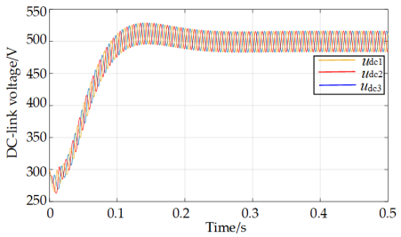
To verify the advantages of hybrid nonlinear control of PBC and ADRC, the Figure 8 is a comparison with the DC-link output voltage response curves under the traditional PI + PR control strategy. Under the PI + PR control strategy, the voltage responses between three phases are not balanced well. Beyond that, voltage fluctuations under PI + PR control are greater than the PBC + ADRC control. Although traditional PI + PR control can stabilize the DC-link voltages at the desired value, under the hybrid PBC and ADRC, the DC-link voltage response is closer to the desired value udc * , and the voltage difference between the three phases is smaller. The comparison of DC-link voltage response curves in Figure 8. Figure 9 compares the three-phase input currents of AC side under two different control strategies. The three-phase input currents of hybrid PBC and ADRC, PI + PR control strategy are 1.34% and 4.61%, respectively. Proving that the hybrid PBC and ADRC control strategy makes the rectifier have lower current harmonics. In addition, it can be seen that through adding the modified rules, the input current zero-crossing distortion is eliminated very well.

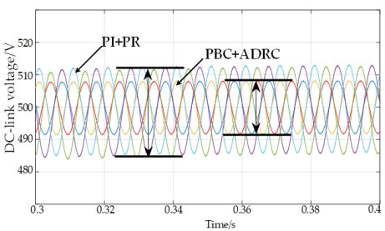
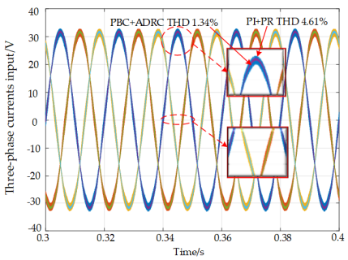
To test the anti-interference ability of the rectifier under the hybrid PBC and ADRC control strategy, load disturbance is injected into the rectifier at the time of 0.3 s, that is, the DC-link load RL changes from 50 Ω to 25 Ω, the disturbance lasts for 0.4 s, the disturbance disappears at the time of 0.7 s, and the DC-link load RL returns to 50 Ω. The Figure 10 is the response curves of the DC-link voltage udc1 of the rectifier when the load changes suddenly. It can be seen from the response curve that the rectifier can quickly sense the load disturbance and stabilize the DC-link voltage at the desired value. At the same time, it also compares the DC-link voltage response under load disturbance of PI + PR control strategy. As can be seen from Figure 10, under the PI + PR control strategy, the DC-link voltage drop is greater when the load changes, and the voltage recovery time is relatively long. It is further proved that the rectifier has better anti-interference performance under the control strategy of hybrid PBC and ADRC.
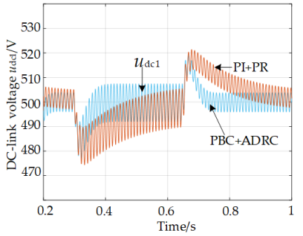

DC-link voltage responses under load disturbance under different control strategies.
This paper has studied the hybrid nonlinear control strategy of three-phase Y-connected bridgeless rectifier under the condition of power grid imbalance. The working principle of the three-phase Y-connected bridgeless rectifier is analyzed and the EL mathematical model is established. A hybrid nonlinear control strategy using voltage outer loop ADRC controller and current inner loop PBC controller are designed. With the control strategy, there is no requirement to consider the positive and negative sequence components of the voltages and the currents. The detection and processing of voltages and currents are simplified. Only the real-time values of grid voltages and AC side input currents can ensure that three-phase Y-connected bridgeless rectifier can maintain excellent steady-state and dynamic characteristics under the condition of power grid imbalance. A simulation model is constructed by Matlab/Simulink power electronics module to verify the proposed control strategy. At the same time, compared with the PI + PR controller, it also proves that the superiority of the control strategy proposed in this paper. It has important guiding significance for the application of three-phase Y-connected bridgeless rectifier in engineering. In order to further study the nonlinear control of the rectifier, some other nonlinear control methods, such as model predictive control and sliding mode control, can be considered in the future work. In addition, their advantages and disadvantages can be compared and summarized. Moreover, the parameter tuning of nonlinear controller and the power density of the system need to be further studied and optimized.

CHAPTER 6

CONCLUSION
In this paper, an improved three-stages cascading PBC strategy of a grid-connected LCL converter is proposed, and theory analysis, controller design, SIMULINK simulation and prototype experiment are studied respectively. The simulations and prototype experiments in strong grid, weak grid and unbalanced grid are carried out respectively, and the results show that the converter currents are balanced sinusoidal waves all the time with good static and dynamic characteristics. Compared with traditional PBC, the improved three-stages cascading PBC has the advantages of easy implementation because of state variables decomposition and cascading control.

REFERENCES

[1] C. Bao, X. Ruan, X. Wang, W. Li, D. Pan, and K. Weng, ‘‘Step-by-step controller design for LCL-type grid-connected inverter with capacitor– current-feedback active-damping,’’ IEEE Trans. Power Electron., vol. 29, no. 3, pp. 1239–1253, Mar. 2014.
[2] F. Blaabjerg, R. Teodorescu, M. Liserre, and A. V. Timbus, ‘‘Overview of control and grid synchronization for distributed power generation systems,’’ IEEE Trans. Ind. Electron., vol. 53, no. 5, pp. 1398–1409, Oct. 2006.
[3] R. N. Beres, X. Wang, M. Liserre, F. Blaabjerg, and C. L. Bak, ‘‘A review of passive power filters for three-phase grid-connected voltage-source converters,’’ IEEE J. Emerg. Sel. Topics Power Electron., vol. 4, no. 1, pp. 54–69, Mar. 2016.
[4] R. Beres, X. Wang, F. Blaabjerg, C. L. Bak, and M. Liserre, ‘‘A review of passive filters for grid-connected voltage source converters,’’ in Proc. IEEE Appl. Power Electron. Conf. Expo., Mar. 2014, pp. 2208–2215.
[5] M. Liserre, F. Blaabjerg, and S. Hansen, ‘‘Design and control of an LCLfilter-based three-phase active rectifier,’’ IEEE Trans. Ind. Appl., vol. 41, no. 5, pp. 1281–1291, Sep./Oct. 2005.
[6] H. Karshenas and H. Saghafi, ‘‘Basic criteria in designing LCL filters for grid connected converters,’’ in Proc. IEEE Int. Symp. Ind. Electron., Jul. 2006, pp. 1996–2000.
[7] S. Sang, N. Gao, X. Cai, and R. Li, ‘‘A novel power-voltage control strategy for the grid-tied inverter to raise the rated power injection level in a weak grid,’’ IEEE J. Emerg. Sel. Topics Power Electron., vol. 6, no. 1, pp. 219–232, Mar. 2018.
[8] A. von Jouanne and B. Banerjee, ‘‘Assessment of voltage unbalance,’’ IEEE Trans. Power Del., vol. 16, no. 4, pp. 782–790, Oct. 2001.
[9] C. Yoon, X. Wang, F. M. Faria da Silva, C. L. Bak, and F. Blaabjerg, ‘‘Harmonic stability assessment for multi-paralleled, grid-connected inverters,’’ in Proc. Int. Power Electron. Appl. Conf. Expo., Nov. 2014, pp. 1098–1103.
[10] X. Wang, F. Blaabjerg, and P. C. Loh, ‘‘Proportional derivative based stabilizing control of paralleled grid converters with cables in renewable power plants,’’ in Proc. Energy Convers. Cong. Expo., 2014, pp. 4917–4924.
[11] R. Pena-Alzola, M. Liserre, F. Blaabjerg, M. Ordonez, and Y. Yang, ‘‘LCLfilter design for robust active damping in grid-connected converters,’’ IEEE Trans. Ind. Informat., vol. 10, no. 4, pp. 2192–2203, Nov. 2014.
[12] J. Roldan-Perez, E. J. Bueno, R. Pena-Alzola, and A. Rodriguez-Cabero, ‘‘All-pass-filter-based active damping for VSCs with LCL filters connected to weak grids,’’ IEEE Trans. Power Electron., vol. 33, no. 11, pp. 9890–9901, Nov. 2018.
[13] P. Cortes, M. P. Kazmierkowski, R. M. Kennel, D. E. Quevedo, and J. Rodriguez, ‘‘Predictive control in power electronics and drives,’’ IEEE Trans. Ind. Electron., vol. 55, no. 12, pp. 4312–4324, Dec. 2008.
[14] P. Lin, C. Zhang, P. Wang, X. Li, J. Xiao, P. Tu, and C. F. Hoong, ‘‘A global robust output regulation method for grid-connected inverter with LCL filter in weak grid condition,’’ in Proc. 12th IEEE Conf. Ind. Electron. Appl. (ICIEA), Jun. 2017, pp. 1646–1651.
[15] J. Xu, Q. Qian, and S. Xie, ‘‘Adaptive control method for enhancing the stability of grid-connected inverters under very weak grid condition,’’ Proc. Appl. Power Electron. Conf. Expo. (APEC), 2018, pp. 1141–1146.
[16] X. Chang, C. Lv, Q. Wang, W. Qin, M. Zhang, Y. Liu, and R. Fan, ‘‘Robust voltage resonance feedforward control strategy for LCL-type grid-connected inverters under weak grid condition,’’ in Proc. Asian Conf. Energy, Power Transp. Electrific. (ACEPT), Oct. 2018, pp. 1–6.
[17] D. Zhu, S. Zhou, X. Zou, Y. Kang, and K. Zou, ‘‘Phase-locked loop smallsignal disturbance compensation control for three-phase LCL-type gridconnected converter under weak grid,’’ in Proc. Energy Conv. Congr. Expo. (ECCE), 2018, pp. 3108–3112.
[18] T. Liu, X. Hao, X. Yang, M. Zhao, and L. Xiong, ‘‘A novel grid voltage feed forward control strategy for three-phase grid-connected VSI with LCCL filter,’’ Proc. Intl. Sympo. Ind. Electron., May 2012, pp. 86–91.
[19] A. F. Cupertino, L. P. Carlette, F. Perez, J. T. Resende, S. I. Seleme, and H. A. Pereira, ‘‘Use of control based on passivity to mitigate the harmonic distortion level of inverters,’’ in Proc. IEEE PES Conf. Innov. Smart Grid Technol. (ISGT Latin America), Apr. 2013, pp. 1–7.
[20] D. Biel and J. M. A. Scherpen, ‘‘Passivity-based control of active and reactive power in single-phase PV inverters,’’ in Proc. Int. Symp. Ind. Electron. (ISIE), Edinburgh, Scotland, Jun. 2017, pp. 999–1004.

