A HIGH-EFFICIENCY SEPIC BASED DC-DC CONVERTER DESIGN BY ROBUST PID CONTROLLER

ABSTRACT
This work addresses the problem of instability occurring in the voltage control mode of a non-minimum phase Quasi Resonant High Gain, High-Efficiency Single Ended Primary Inductor Converter -based DC-DC converter with continuous input current. To solve this instability issue in the presence of uncertainties and the external disturbances, quantitative feedback theory (QFT) is adapted to systematically design a robust proportional integral derivative (PID) controller, which is realized using only sensed output voltage as feedback. The advantages of the proposed PID design using the QFT are: (i) it eliminates the burden of tedious and ad-hoc tuning of PID gains using the conventional PID design approaches, (ii) current measurement is not required, (iii) disturbance dynamics (input voltage and load current variations) are included in the design stage itself, which further enhances the disturbance rejection performance of the output voltage. Due to soft-switching operation in all switching components, the power dissipations in the converter are significantly alleviated. Thus, the proposed SEPIC can provide high voltage gain whilst achieving a high efficiency.

CHAPTER – I
INTRODUCTION
Power electronics is a field rich in non-linear dynamics. Chaos is an apparently disordered deterministic behavior, which is an universal phenomenon that is present in many systems in all areas of science. A rich variety of bifurcations and chaos are present, if the switching action is governed by feedback control as in regulated power supplies. Many literature reports the presence of bifurcations in buck, boost, buck-boost and cuk converter topologies. Positive output Luo converters are a series of new step up dc-dc converters derived from buck-boost converters. It can step up and step down the voltage with high power density, high power efficiency and the topology of the converter is also very simple. These converters are widely used in computer peripheral equipment and industrial applications, especially for high voltage projects. In this paper, an attempt is made to study the bifurcation in a positive output elementary luo converter. The averaging approach is one of the most widely adopted modeling strategies for switching converters that yields a simple model. Hence it is proposed to perform the analysis by considering the converter operating in a hysteretic current controlled mode.
The major conventional energy sources like fossil fuel are fast depleting in nature in addition to the major environmental threat like increased greenhouse gas emission and other damages. Hence moving to renewable energy source is the ideal choice for the future of the nation because it reduces the environmental issues offered by fossil fuel conventional sources of energy. The major renewable sources of energy are solar, wind, biomass, fuel cell, tidal, geothermal etc. The economy of the nation due to agriculture depends on the effective irrigation techniques. Energy availability and energy cost for water pumps are the major issues faced by farmers. In this paper a solar powered water pumping system which lowers the operating and maintenance cost of water pumps is the research topic. The solar water pumps needs a dc-dc converter and dc-ac inverter for efficient transfer of power from solar PV to induction motor water pump. The most commonly available step up dc-dc converter has limitations on output voltages and energy efficiency due to parasitic elements. A dc-dc IGBT based Luo converter which utilizes the voltage lift feature of electronic circuits is used as the dc-dc converter topology in this work. There are many other topologies available as super lift, self lift etc but all these topologies comprises of many switching devices. Hence they are not suitable for a cost effective efficient open loop water pumping system. Luo converter with reduced components topology with only one semiconductor switch helps to reduce the output current ripples, losses and energy efficient system. Negative output Luo converters are similar to conventional buck boost converter except for the fact that they have a smooth current curve. The converter is modeled to work in continuous conduction mode (CCM). As the output of the converter is ripple free extra circuitry such as filters, polarity sensors are not required. The output voltage obtained from Luo converter is fed to three phase voltage source inverter circuit and the output of inverter is fed to induction motor connected to the centrifugal pump for water pumping. Induction motor is used to run the pump attached to the shaft. The induction motor is selected because they are rigid, rugged and more efficient than dc motors. Simulation is carried out with solar panel, Luo converter, inverter and induction motor. The detailed simulation analysis and hardwire results from prototype of water pumping system with Luo converter and DC motor is carried out and discussed in this paper.
The present era is the era of the industrial revolution, which began with the invention of motor. Various types of motors have been developed over time, but these motors are generally classified into two main categories, namely, AC motor and DC motor. There exists a set of DC motors that can be used on different devices. However, generally two types of DC motors are set up in industrial applications. In the first type, the magnetic flux is generated by the current through the field coil of static pole structure and in the second type, permanent magnet supplies the required air gap flux. A BLDC motor is a special type of DC motor that does not apply a brush for transport, instead an electronic process system is used for this purpose. The BLDC motor is usually a synchronous motor composed of a trapezoidal back EMF waveform and a permanent magnet. The current trend shows that high performance BLDC motor technologies are widely used for global industrial applications and variable speed drives in electric vehicles. In fact, these types of motors depend on its control circuit. In fact, these types of motors rely on its control circuit and still developing a high performance circuit is a challenging task for researchers. A basic control system for the BLDC motor. The structure of the BLDC motor tuning control project selection, modelling simulation and so on. The design structure of a BLDC motor is a complex task and depends on many issues such as project selection, modeling, simulation, etc. In terms of the rapidity framework of the BLDC motor, a host of modern control solutions have been proposed. The key features of a conventional PID controller algorithm are it is easily adjustable, steady operation and its simple design, which making it widely used for controlling system. For practical reason, common speed control structure is applied in the PID controller. The mathematical model and speed control of the BLDC motor have been proposed and validated using fuzzy logic and PID controller. Most of the cases a different finding is seen in terms of practical utility experiences where the volatility of well-structured prototype, different units of nonlinear, low variability have been at work. For tuning a PID controller parameters are not that simple, hence, getting the optimal position under the examined circumstances is challenging. This study proposes a PID controller through modifying some changes thereto which, may increase the regulation speed of BLDC motor. In this case parameters can be tuned at the actual moment under PID controller operation. In the sake of better functioning of the PID controller scheme requires input and membership function enhancement. At the same time, a set of values are applied for the PID controller’s constant coefficients, Kp, Ki and Kd. By employing these values, the proposed modified controller would be restructured to any adjusting dimension. The purpose of this study is to show the dynamic response to the rapid tuning results of the proposed modified PID controller; which can help to control the speed of the motor and to maintain constant speed during load changes. Thus, the PID regulator can increase the overall performance of the BLDC motor. The simulation results showed that the functions of the PID controller could be provided with a better control performance.
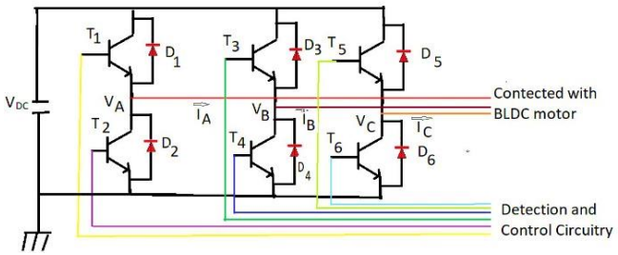
The fossil fuel which is mostly considered as the main source of power and it should be exhausted in the next few years, so we need to generate alternative power from a non-renewable energy source. In recent years many research works have been done on the electrical application of PV energy as an alternative energy source of non-renewable energy source. Today the PV energy plays an important role in the whole world and they have various range of application like solar power used in the space program for satellite, electrical power generation. Also rapid increment in demand of electricity and change in the environment condition due to a high amount of use fossil fuel energy such as global warming so need cheaper and substance having fewer carbon emissions so the huge effort has been given by the researcher to grow up the new technology for energy resource to its increased in a few years. That is why the algorithm of maximum power point tracking has been developed . PV array does not have any rotating part in the system also there is no noise production also maintenances should below. In the PV system direct conversion of solar energy into electrical energy, no of a solar cell are connected together to form a solar array or solar module but the drawback of PV system is installation cost is high also efficiency is low of PV system so this drawback is overcome by maximum power point tracking. In this system, the interleaved boost converter is used. IBC has various advantages like low ripple content, efficiency it should high also switching loss will be low. high power application IBC is used. In this work, the solar PV system is used to drive BLDC motor because the relevance of BLDC motor has been increased day by day in industrial sector of the whole world. Solar is one of the alternative energy sources since the overall cost of required for implementing is higher. They are mostly employed for high power applications.
OBJECTIVE
- The conventional step-up DC-DC converters such as boost and SEPIC converters with a simple structure are theoretically able to provide a high voltage gain for the RES.
- For this purpose, to increase the voltage gain ratio of the conventional DC-DC converters, some effective voltage boosting strategies such as Voltage Lift (VL), Voltage Multipliers (VM), Switched-Capacitors/Inductors (SC/SI), and also Cascading Techniques (CT) are applied .
- Although these modified converters can achieve a high voltage gain, using a large number of passive components and operating in hard-switching condition, which limits the efficiency severely.
- The disturbance rejection capability of DC-DC converters can be improved by considering the disturbance dynamics in the controller design stage itself.

SCOPE OF THE PROJECT
- In this work, a computationally simple robust PID controller is designed using QFT to control the output voltage of a sepic DC-DC boost converter under voltage mode control.
- The controller design for the disturbance rejection is formulated by including the disturbance dynamics of boost type sepic dc-dc converter in the design stage itself.
- The proposed robust PID controller exhibits improvement in the output voltage response in the presence of uncertainty and external disturbances.

CHAPTER 2
LITERATURE SURVEY

1. A Modified SEPIC Converter with High Static Gain for Renewable Applications
A high step-up DC-DC converter based on the modified SEPIC converter is presented in this paper. The proposed topology presents low switch voltage and high efficiency for low input voltage and high output voltage applications. Two alternatives with and without magnetic coupling are analyzed. The magnetic coupling allows to increase the static gain with a reduced switch voltage. High static gain DC-DC converters are nowadays an important research focus due to the crescent demand of this technology for some applications as renewable energy sources, fuel-cells, embedded systems, portable electronic equipments, uninterrupted power supply, battery powered systems and others applications supplied by low DC voltage energy sources. High step-up ratio is necessary when some loads operate with and DC or AC peak voltage higher than ten times the input source voltage. Many techniques were developed in order to increase the static gain of the non-isolated structure for the implementation of high efficiency and high power density solutions. A review of the main techniques proposed is presented in. The main characteristics desired in the applications considered are a static gain equal or higher than ten times, low switch voltage, low input current ripple, reduced weight and volume and high efficiency. New alternatives for high and very high step-up ratio applications are proposed and are based on a new DC-DC non-isolated topology called Modified SEPIC converter that presents a static gain close to the double of the classical boost converter. The proposed converter allows the inclusion of an auxiliary winding for the implementation of the magnetic coupling technique.
2. High Gain Soft Switched DC-DC Converter for Renewable Applications
In this paper, high gain soft switched DC-DC converter is proposed. It consists of two switches, coupled inductor, three diodes and five capacitors. An active snubber circuit, where an auxiliary switch is included, helps to achieve zero voltage switching (ZVS) of switch. Soft switching is also achieved for auxiliary switch. The leakage energy of the coupled inductor is reused at output by using auxiliary switch which helps to increase voltage gain. All the diodes are turned-off with zero current switching (ZCS) condition which reduces reverse recovery losses in diodes. The active clamp also reduces the voltage stress across the devices, thus facilitating the use of low rated devices reducing the cost and improves the overall efficiency.
3. Coupled inductor based high gain current-fed DC-DC bridge converters
High boost DC-DC converters find wide variety of application in industry such as solar photovoltaic systems, fuel cell systems, UPS, micro-grids to name a few. Low component count, continuous input current, high boost operation at nonextreme duty ratio, etc. are some of the desirable features of a high gain DC-DC converter. In this paper two coupled inductor based novel high gain DC-DC converters are presented which are derived from current-fed DC-DC bridge converter. The proposed converters require only one capacitor and one coupled inductor in its structure. While both the converters present a linear gain – turns-ratio characteristics, one of the converters presents a unique feature of very small turns-ratio range of the coupled inductor. In this paper, two novel high gain DC-DC converters are presented. The proposed converters are derived from currentfed DC-DC bridge converter and utilize coupled inductor to achieve very high conversion ratio. One of the proposed converters presents a unique feature that the coupled inductor turns-ratio varies from 0 to 1 in order to achieve very high gain. This enables the converter to use lower winding turn thus increasing efficiency. The proposed converters use only one capacitor and a coupled inductor in its structure thus reducing the space and weight of the system.
4. Experimental Evaluation of Internal Model Control Scheme on a DC–DC Boost Converter Exhibiting Non minimum Phase Behavior
In this work, an internal model controller (IMC) with two-degree-of-freedom has been implemented as a voltage mode controller for the output voltage regulation of a boost type dc-dc converter that exhibits non-minimum phase behaviour due to occurrence of a RHP zero. The IMC structure provides an alternate parameterization of the conventional feedback controller and is comparatively simple to tune to achieve satisfactory servo and regulatory behaviour that are close to the performance limits set by the RHP zero. An internal model controller was designed using a linear model developed in the neighbourhood of a nominal operating point for the converter. To assess the efficacy of the IMC scheme, simulation studies and experimental evaluations were carried. In majority of the problems investigated, the IMC was found to perform significantly better than a PID designed using the conventional approach. Most commonly used controller is PID and tuning a PID to deal with the difficulties arising from the non-minimum phase dynamics is not a straightforward task. Also, a conventional PID controller is designed either to meet the regulatory specifications or the tracking performance. In fact, most of the available approaches that employ the conventional feedback control structure have this limitation.
5. Identification and Robust Control of a Quadratic DC/DC Boost Converter by Hammerstein Model
This paper deals with the theoretical framework definition and the experimental application of the Hammerstein (HM) identification and related robust control technique to a quadratic DC-DC single switch boost converter. A set of 4th order transfer functions has been identified with the Hammerstein approach, on the basis of a PRBS (Pseudo Random Binary Sequence) excitation signal. The set of identified transfer functions has been then used to design a suitable robust control technique, able to properly deals with converter’s parameters uncertainty and load variation. As a matter of fact, some sources as photovoltaic (PV) cells and fuel cells (FC) exhibit low voltages compared to those required by the input of the inverter stage; for this reason, among power DC/DC converters, boost topologies have attracted attention thanks to their inherent capacity to perform the Maximum Power Point Tracking (MPPT). On the other hand, the classic one-switch boost converter reveals its limits for elevate values of boosting, since a high duty cycle is needed. Anyway, it often cannot be adopted because of both the minimum off time of the switch and the influence of the parasitic parameters.

CHAPTER 3

EXISTING SYSTEM

A DC-to-DC converter is a device that accepts a DC input voltage at one level and converts it to a DC output voltage of another level. Among the DC-DC converters, the SEPIC has unique features like a non-inverted output voltage, and its output is greater than, less than, or equal to its input voltage. The system behavior is completely determined by the coefficients k1 , k2 , k3 and k4 which must be selected so as to satisfy the existing condition and to ensure stability and a fast response, even under large supply and load variations. In order to improve the dynamic performance of the SEPIC, a Sliding Mode Controller (SMC) is developed. There is still exists room for the development of a controller to improve the performance of the SEPIC. A sliding mode controller for the SEPIC is proposed in this paper in order to ensure the stability under any operating conditions, better static and dynamic performances under input voltage disturbances, load changes and component variations. The performance of the SMC is evaluated in terms of output voltage regulation under different operating conditions such as startup transients, line variations, load variations, steady state conditions and component variations. The performance of the SMC versus a PI controller is evaluated in a simulation in terms of robustness and stability.

CHAPTER 4
PROPOSED SYSTEM

A. Circuit diagram
The configuration of the proposed single diode model of the solar panel fed water pumping system employing negative output Luo converter is presented

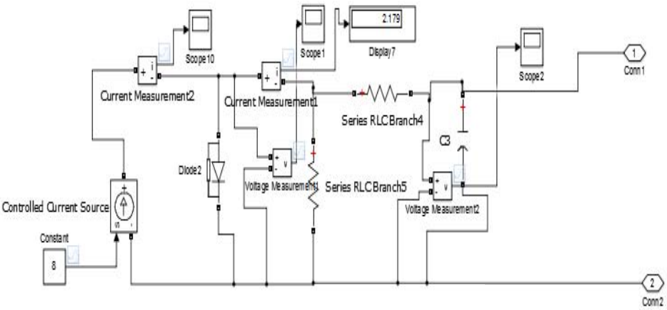
Fig. 1. Circuit diagram of single diode model

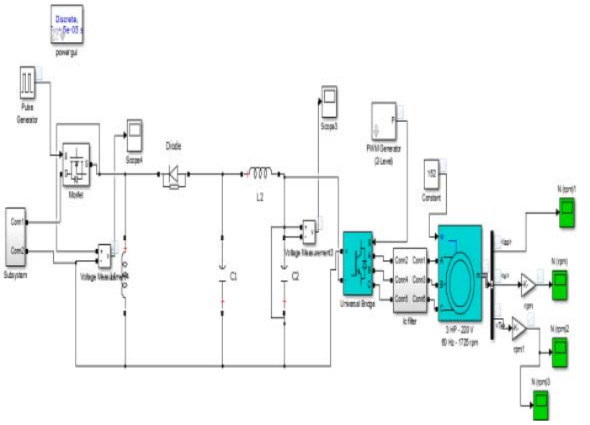
Fig. 2. Circuit diagram of the set up

The system consists of a PV panel supplying the water pumping system, using a negative output Luo converter as a DC-DC converter, a three phase VSI inverter which supplies power to the motor-pump system, a three phase induction motor and centrifugal pump coupled to the shaft of the motor.
The different section of the water pumping system such as PV panel, negative output Luo converter and motorpump system are designed in such a way that the system becomes reliable and performs efficiently irrespective of any environmental condition. Every section is designed at all possible test conditions (1000W/m2 , 250 C). First an induction motor of 4kW,1500rpm at 415V and then according to the requirement a SPV array of slightly more than 4kW peak power rating, is selected. PV panel with higher capacity is proposed based on the practical condition wherein there are loses at different section of the given system.
B. Design of the proposed single diode model
The PV array with a rating of Pmpp=4 kW is designed for the proposed water pumping system. Solar world PV model Tata Power Solar Systems TL300LBZ is selected to realize the required PV array. The specification of the module is given below in Table 1.Luo converter belongs to the buck boost converter category, hence to produce a highly efficient converter a duty ratio of 0.6 is chosen. The output voltage of Luo converter is 800V. When given 800V as input to the inverter we get a RMS voltage valued 415V which would drive the induction motor.
C. Design of Luo Converter
The outline of Luo converter includes determination of the input inductor L1, intermediate capacitor C1, an output inductor L2 and an output capacitor C. The converter elements are designed for a duty ratio of 0.6 such that the converter always works in continuous conduction mode. A switching frequency of fsw=20 kHz is selected to design the elements.

CHAPTER 5

BLOCK DIAGRAM

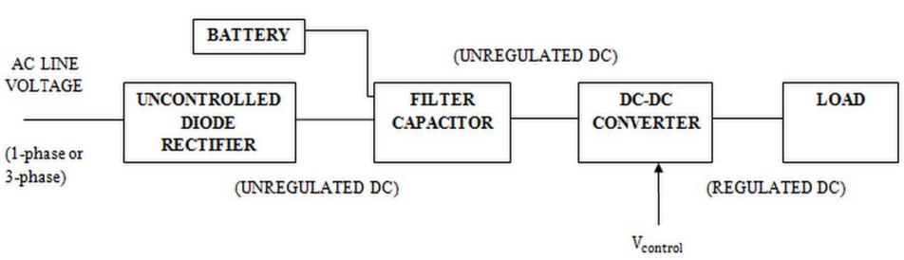

Block diagram of dc-dc converter

CHAPTER 6
SEPIC CONVERTER
SEPIC CONVERTER
A SEPIC is a type of DC-DC converter which converts input voltage to an output voltage which can be more, less, or same. The switch of the SEPIC is controlled by varying the duty cycle. This enables close and open conditions. A SEPIC is like a buck-boost converter. However, it has the unique feature of giving a non-inverted output. This means that the output is always the same polarity as the input. A series capacitor is used to couple the energy from the input to the output. The SEPIC can respond quickly to a short-circuit condition, and it works as a true shutdown mode when the switch is turned off and its output drops to 0V following a fairly hefty transient dump of charge. The SEPIC is useful in applications in which the voltage can be above or below that of the regulator's intended output. The SEPIC transfers energy through the switching operation between the capacitors and the inductors. This is done in order to convert from one voltage to another. The amount of energy is controlled by switch S, which is a transistor such as a MOSFET, IGBT, etc. MOSFET offer a much higher input impedance and a lower voltage stress and do not require biasing resistors. In addition, MOSFET switching can be controlled by differences in voltage rather than a current. There are various modeling methods available such as the signal flow graph, the state space average and the small signal model.

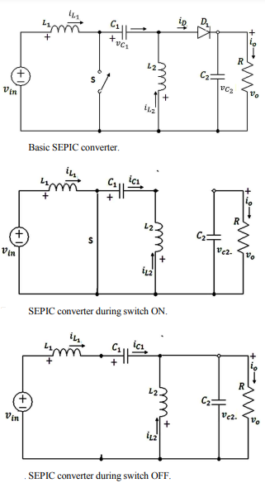
In the proposed controller, the state space averaging method is adopted. This Control method with a SMC for the SEPIC converter is to resolve the problems previously pointed. Therefore, it is proposed to design a SEPIC operated in a CCM.
A. SEPIC and its Mathematical Model
A power circuit diagram of the SEPIC. It includes a DC input supply voltage in v , capacitors C1 and C2 inductors L1 and L2 a switch S (MOSFET), a diode D1 and a load resistance R. It is assumed that the components are ideal and that the SEPIC operates in the CCM. Fig. 2 and Fig. 3 show the modes of operation of the SEPIC. In Fig. 2, when switch S is closed, the diode is reverse biased and open, inductor L1 is occupied by the source voltage vin, while the L2 charges capacitor C1 , and the polarity of the inductor current and capacitor. The current L1 i increases at a rate of: , t dT L v dt diL in = 0 £ £ 1 1 (1) 1 in c v = v (1a) Where c1 v is the voltage across capacitor C1. In Fig. 3, when the switch is open, diode D1 is forward biased and closed, inductor L1 charges capacitor C1 , inductor L2 discharges and C2 is charging. At this time, the equation can be obtained as: L1 in i = i (2) L Da o i i i a = = 2 (3) where Da i is the average current of diode D1 , and o i is the output current. When the SEPIC is operating in the CCM [8], [9], the voltage conversion ratio of the SEPIC can be obtained from the volt second balance of inductor L1 in one switching period as expressed by: d d v v in o - = 1 (4) where d is the duty cycle, and vo is the output voltage of the SEPIC converter.
B. Mathematical Modeling of the SEPIC
In this paper the state space representation is applied. It gives several advantages when compared with other methods. These are its ability to handle the system easily with multiple inputs and outputs. The system model includes the internal state variables as well as the output variable. The model directly provides a time-domain solution, which ultimately is the thing of interest. The form of the solution is the same as that for a single 1st-order differential equation. The effect of the initial conditions can be easily incorporated into the solution and the matrix modeling is very efficient from a computational standpoint for computer implementation.
6.1 DESIGN OF A SMC FOR THE SEPIC
A. Basic Requirement of a SMC
Sensing of all of the state variables and the generation of suitable references for all of them are the basic requirements of a SMC. According to the principles of SMC, the capacitor voltages 1c v and 2 c v are made to follow their references as dependably as possible. It is difficult to measure the inductor current reference since it usually depends on the load power demand supply voltage and the load voltage. To overcome this problem in implementation, the state variable error for the inductor current ( ) L L ref L L ref i i ,i i 1 1 2 2 - - can be obtained from the feedback variables L1 i and L2 i by means of a high-pass filter under the assumption that their low-frequency component is automatically adapted to the actual operation of the converter. As such, it is found that only the high-frequency component of this variable is needed for control. The system order will be increased due to the high pass filter which can heavily alter the SEPIC converter dynamics. In order to avoid this problem, the cutoff frequency of the high-pass filter must be suitably lower than the switching frequency to pass the ripple. However, it should be more able to tolerate the quick response of the SEPIC converter. In the design of the converter, some assumptions are made and three factors such as ideal power switches, a power supply free of DC ripple and a converter operating at a high-switching frequency are considered. To have a good response in the output voltage and current of the SEPIC, a sliding surface equation in the state space, which is expressed by a linear combination of state-variable errors ε (the respective differences between the feedback reference current/voltage and the feedback actual current/voltage) has to be chosen optimally. The complete control arrangement of the SEPIC.
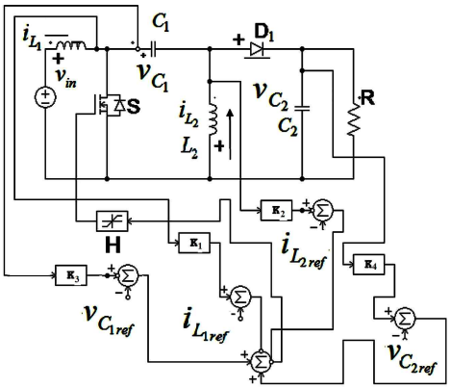
Principle scheme of SMC for SEPIC converter

B. Selection of the Control Parameters
Once the SEPIC parameters are selected, the inductances L1 and L2 are designed from specified input and output current ripples, capacitors C1 and C2 are designed so as to limit the output voltage ripple in the case of fast and large load variations, and the maximum switching frequency is selected based on the proposed converter ratings and switch type. The system behavior is completely determined by the coefficients k1 , k2 , k3 and k4 which must be selected so as to satisfy the existing condition and to ensure stability and a fast response, even under large supply and load variations.
C. Switching Frequency
A practical system cannot switch at an infinite frequency. The operating range of the average switching frequency of the hysteresis relay varies from 50 kHz to 450 kHz. From this operating range, the optimum value of the chosen average switching frequency is 100 kHz and its corresponding band is 0.5.
D. Duty Cycle
The duty cycle d is defined by the ratio between the conduction time of switch s and the switch period time. It is important to determine the circuit parameters and coefficients of k1 , k2 , k3 and k4 that agree with the desirable values for a maximum inductor current ripple, a maximum capacitor ripple, a maximum switching frequency, stability, and a fast response under any operating conditions.
6.2 NEED OF DC-DC CONVERTER:
DC-DC converters are mainly used when we require to convert DC electrical power effectively from one voltage level to another. They are highly efficient because unlike AC, DC cannot be simply stepped up or down using a transformer. In many ways, a DCDC converter is the DC equivalent to a transformer. The basic intention behind any converter is to get a energy level with variations as per requirement along with minimum energy losses and easy control. The important thing to remember about any DC converters is similar to a transformer; they just vary the input energy into different levels of impedances. That is nothing but stepping up and stepping down of voltage levels. So whatever be the output voltage level, the output power all comes from the input; there is no energy manufactured inside the converter. Some energy is probably used up by the converter circuitry and components while doing their job. They provide fast dynamic response, good acceleration and proper position control along with high efficiency. The input of these converters are nothing but an unregulated dc voltage which are obtained by rectifying line voltage and therefore it will produce fluctuations due to change in magnitude of line voltage. Switching mode type dc to dc converters are mainly used to transform unregulated dc input into an controlled dc output for a given voltage level. The static conservation principles for these switching converters are one of the main reasons for their 0 increase in the number of applications in electrical systems.
6.3 CLASSIFICATION OF DC-DC CONVERTERS:
The frequent switching operations of dc converters results in the circuit components being connected together periodically change in its configuration. These converters can be synthesized based on topological variations, inductors, and capacitors.
In order to obtain reliability for dc converters, there are two main rules:
(a) Inductor has the capacity to store energy by means of current and also has the property of not allowing sudden changes in current. Hence it should be placed such that mode of operation should not be discontinuous.
(b)Capacitor has the function to store energy by virtue of voltage across it and this voltage won’t change suddenly. So it should be placed in such a way that capacitor voltage does not become discontinuous during operation.
Based on above mentioned rules and as per applications, dc converters can be classified as follows:
- Step Down or Buck converter
- Step Up or Boost converter
- Buck-Boost converter
- Cuk converter
- Fly-back converter

STEP DOWN CONVERTER:
In this converter the average output voltage is less than the input voltage. During switch on, inductor charges rapidly and the same energy is dissipated to load. Filter capacitors used are to be of large value under steady state analysis so as to get constant instantaneous output.
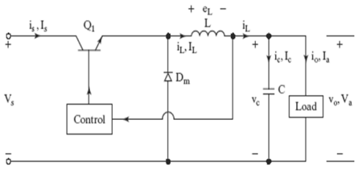
Step down Converter

STEP UP CONVERTER:
In this chopper the load voltage is greater than the source voltage. When switch is on, diode is reversed biased thereby isolating output voltage. The input supplies energy to inductor during on condition. When the switch is off, the output terminal receives energy from inductor as well as input source. For the case of steady state analysis, the output filter capacitor is assumed to be of a very large value to ensure constant output voltage.
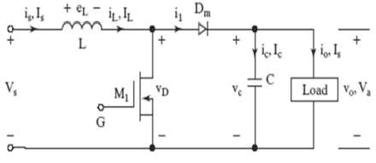
Step up Converter

BUCK-BOOST CONVERTER:
The important purpose of this chopper is in the case of regulated dc power supply, that is where a negative polarity output may be required with respect to common terminal of input voltage and output may be of either higher or lower than the input voltage. It’s a combination of both step up and step down converter. When switch is closed, the input stores energy in inductor and dissipates when switch is in open condition. No input is supplied during this time interval and output is assumed across capacitor.
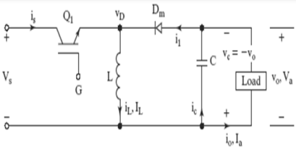
Buck-Boost Converter

CUK CONVERTER:
This circuitry is obtained by using the duality principle on the circuit of buck-boost converter. It provides a negative polarity regulated output voltage with respect to the input terminal voltage.

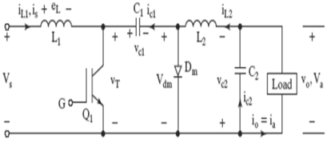
Cuk Converter
FLY-BACK CONVERTER:
This converter is similar to buck-boost but uses transformer instead of single inductor to store energy. When current flows from supply to the primary winding, energy is stored in the magnetic field of transformer. Then when switch is turned off, the transformer tries to maintain the current flow through primary winding by suddenly reversing the voltage across it and thus generating a “fly-back” pulse of back-EMF.
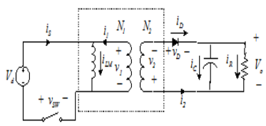
Flyback Converter

6.4 COMPARISION OF DC-DC CONVERTERS:
The above mentioned dc choppers can transfer energy only in one direction as they have the tendency to produce only unidirectional current and voltage. Only a full bridge converter can have a bidirectional power flow both in form of current and voltage. Hence they operate in all four quadrants.
From the following data some assumptions are taken, they are as follows:
- The average current is at rated value which the desired maximum value. Also ripple present in inductor current is negligible. Hence continuous conduction mode is attained.
- The output voltage is at its rated value with negligible ripple content present in the voltage.
- The input voltage is allowed to vary.
Therefore, the duty ratio of the switch must be controlled in order to hold output voltage level constant. Hence besides the full bridge converter, all other converters operate in single quadrant thereby allowing unidirectional power flow.
SWITCHING TECHNIQUES:
The average output voltage can be controlled by frequent opening and closing of switch. Here one or more switches can be used to attain the required output. This can be attained by varying the duty cycle periodically. For this purpose some control strategies are used, they are as follows:
- Constant frequency system
In this, the on time is varied but chopping the frequency is kept constant. Varying the time period means varying the pulse width. So this strategy is called pulse width modulation.
- Variable frequency system
Here chopping frequency is varied and either on time or off time is kept constant. This method of controlling is called frequency modulation.

Frequency modulation technique has some advantages compared to pulse width modulation.
They are as follows:
- Varying chopping frequency for large signals to get a controlled output is difficult. This makes the filter design for this circuit complex.
- The control of duty cycle for frequency variation would be wide. This may result in interference with other signals.
- Large off time may lead to discontinuous mode of operation.
6.5 DC-DC BOOST CONVERTER:
The growing applications of DC-DC boost converters in continuous conduction mode (CCM) have become prevalent in automotive, battery charging applications and so on, whose performance highly depends on the deployed control scheme . The main objective is to always provide constant output voltage across the load despite input voltage and load variations. However, the control strategies for these converters are not robust against model uncertainties as well as the external disturbances. Thus, the closed-loop operation requires a robust control, which not only rejects the disturbance but also handles variations in the system parameters satisfactorily. Current mode control (CMC) exhibit current loop instability for a duty ratio > 50% regardless of the DC-DC converter. In voltage mode control (VMC), there is no duty ratio restriction. However, VMC operation provides a sluggish dynamic response for boost converters due to the presence of a right half plane (RHP) zero, thereby restricting the closed-loop bandwidth. Hence, operating the non-minimum phase (NMP) boost converter close to the performance limits set by RHP zero is a challenging control task under VMC operation.
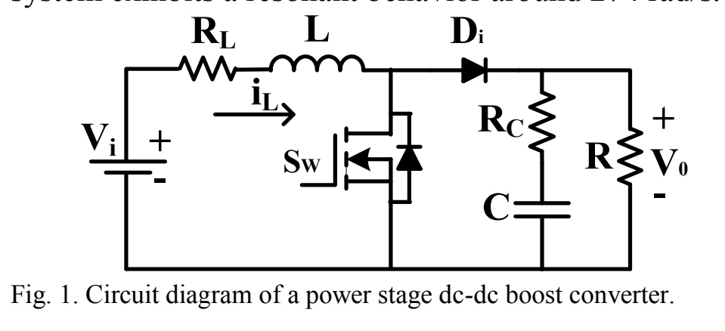

APPLICATION FOR NMP DC-DC BOOST CONVERTER
- This section deals with the application of QFT design procedure outlined in section II to design a robust PID.controller for a boost converter.
- The circuit diagram of a power stage boost circuit is shown in Fig. 1. The CCM operated DC-DC boost converter parameters are: L = 3.1 mH, RL = 0.3 Ω, and C =1930 μF, Rc=0.08 Ω.
- The nominal load resistance is Rn= 90 Ω. Switching frequency is 25 kHz. The input voltage, Vi = 10 V and the output voltage, Vo = 15 V. From [2, 6], the plant model is given as:
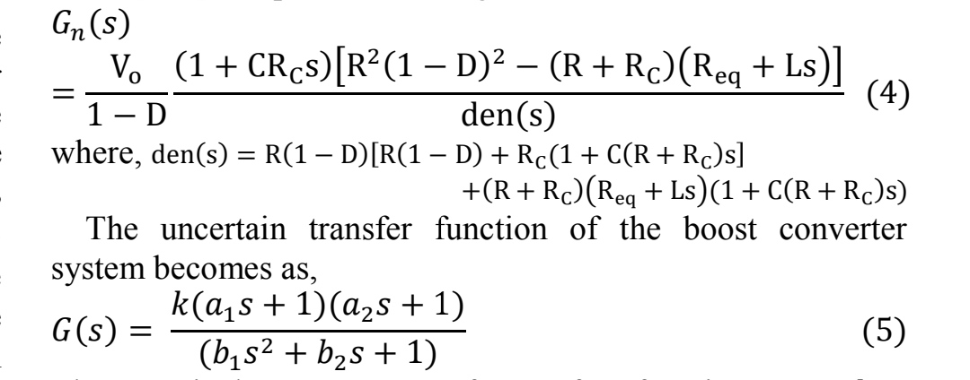

- The nominal parameters of transfer function are,
𝑘 =22.0617, a1=1.5440 × 10−4,a2=−7.8287 × 10−5, 𝑏2 =1.8847 × 10−3, 𝑏1 = 1.3345 × 10−5, With an uncertainty of about 10% [20-23], k ∈ [19.85, 24.27], a1 ∈ [1.3896,1.6984] ×10−4, a2 ∈ [-7.04583,-8.61157] × 10−5,
b1 ∈ [1.20105, 1.46795] × 10−5, b2 ∈ [1.67,2.073] × 10−3.
- The converter system exhibits a resonant behavior around 274 rad/s.

DESIGN SPECIFICATION OF DISTRIBUTION REJECTION PROBLEMS:

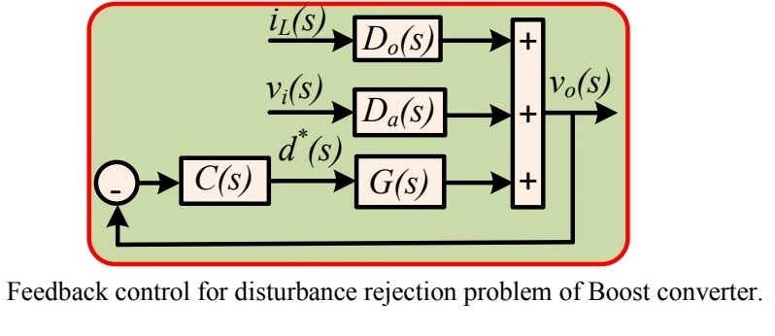
ADVANTAGEG OF TRANSFER FUNCTION OF BOOST CONVERTER:
- It performs step-up or step-down of voltage using minimum components.
- It offers lower operating duty cycle.
- It offers high efficiency across wide input and output voltage ranges.
- It is less expensive compare to most of the converters.

6.6 QRHGHE SEPIC based DC-DC CONVERTER:
The converter is composed of a CI with turns ratios of n, a single power switch (S), an input inductor (Lin), four diodes (D1-D3 and Do), and five capacitors (C1-C4 and Co). Series interconnection between the input inductor and input DC voltage source leads to low input current ripple, which improves the RESs performance. Moreover, the current waveform of the switch and the diode D3 change in sinusoidal form because of a QR operation among the leakage inductance of the CI, C1, C3, and C4. This also helps to reduce the switch turn-off and the reverse recovery losses.
To simplify the converter analysis in Continues Conduction Mode (CCM) condition, the following assumptions are considered:
- All switching components of the converter are ideal without parasitic components.
- All capacitors are large enough so that their voltages are constant.
- The CI is modeled by a parallel magnetizing inductor (LM) and a series leakage inductor (Lk) seen from the primary side with a turns ratio of n=n2/n1.
- The input and magnetizing inductors are considered to be large enough so their current ripple is negligible.
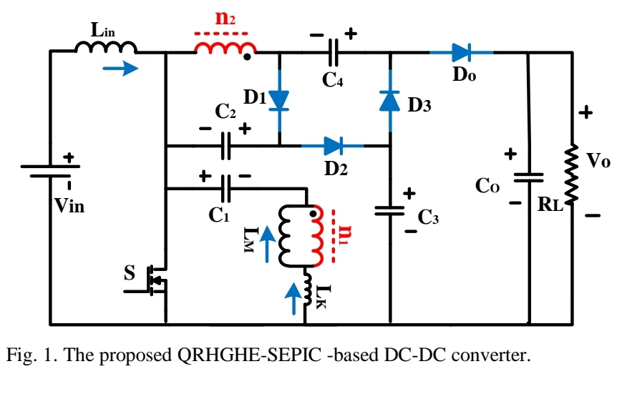

DISADVANTAGES
- Like the buck–boost converter, the SEPIC has a pulsating output current.
- The similar Ćuk converter does not have this disadvantage, but it can only have negative output polarity, unless the isolated Ćuk converter is used.
- Since the SEPIC converter transfers all its energy via the series capacitor, a capacitor with high capacitance and current handling capability is required.
- The fourth-order nature of the converter also makes the SEPIC converter difficult to control, making it only suitable for very slow varying applications.

APPLICATIONS
- Battery-operated equipments and
- handheld devices.
- NiMH chargers.
- LED lighting applications

6.7 OPERATION OF SEMI-SEPIC CONVERTER
The schematic of the proposed semi-SEPIC DC/DC converter is shown in Fig.1 which is similar to the traditional SEPIC converter except with the modification that the impedance network replaces the intermediate inductor present in the traditional SEPIC converter . The converter consists an input inductor (L), an intermediate capacitor (C2), an output diode (D2), an output capacitor (C), a controllable switch (S) and an impedance network consisting of a diode (D1), one capacitor (C1) and the coupled inductor with the turns ratio n = NP /Ns.
Since the CCM mode of the operation is considered, the following assumptions are made:
- All the components are assumed to be ideal.
- All the capacitors are large enough and the voltage across them is held constant.
- The current across the inductor is always continuous and positive.
- The coupling coefficient of the transformer is assumed to be one which means it has zero leakage inductance.
- The switch is open for time interval (1-D)T andclosed for the time DT having T as the switching period.
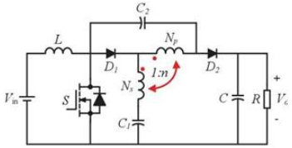
Schematic of the semi-SEPIC converter
The operation of the semi-SEPIC DC/DC converter in the continuous conduction mode (CCM) with the above assumptions is as follows: When the switch is ON, both the diodes D1 and D2 are reverse biased as shown in Fig.2(a) and the input inductor L is charged by the input source. As the diode D2 is off the output load is isolated from the input source, the load R is powered by the output capacitor C. By considering the Fig.2(a) we can write: VS = Where VS is the secondary side inductance voltage, VC1 is the voltage across the capacitor C1 and VC2 is the voltage across the capacitor C2. When the switch is OFF, both the diodes D1 and D2 are forward biased as shown in Fig.2(b) and the energy stored in the input inductor L is released to the load. The current in the inductor decreases as the output capacitor C is charged. Now from the Fig.2(b) we can write: VS = Where VO is the output voltage. By applying the volt second balance principle the voltages across C1, C2 and the output voltage can be obtained: DVin +(1 − D)(Vin − VC2 − VO )= 0 D + (1 - D) = 0 The voltage gains VC1, VC2 and V 0 are given as: Vc1 = Vin Vc2 = Vin V0 = Vin This proves that with the decrease in the turns ratio the gain of the converter increases and the duty cycle range of the converter can be varied in a wide range (0 < 1) between 0 and 1.
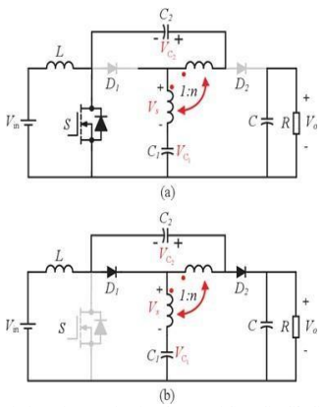
Equivalent circuits of the semi-SEPIC DC/DC converter (a) when the switch is ON (b) when the switch is OFF

6.8 CLOSED LOOP CONTROL WITH PID CONTROLLER

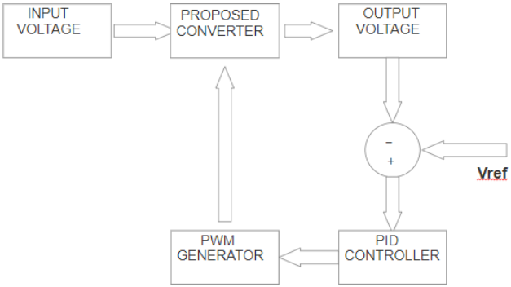
Block Diagram of closed loop control with PID controller

The system or procedure that regulates the characteristics of other systems for obtaining the desired results is called a control system. The closed loop system is considered to be the most important type of control system which uses the feedback mechanism to adjust the input signal. The closed loop control system uses the PID controller as the feedback mechanism.The output of the PID controller is delivered on the basis of the measured error and the three gains of the controller which are proportional gain Kp, integral gain Ki and derivative gain Kd. The closed loop control operation of the semi-SEPIC coupled inductor based DC/DC converter starts from obtaining the output voltage. T he output voltage obtained and the reference voltage are fed to the comparator where the output voltage is compared with the reference voltage and generates an error signal. The error signal generated is fed as input to the PID controller. Now by adjusting the control variable, the PID controller tries to decrease the error and a new value is determined at the end of the process. The output of the PID controller is fed to the PWM control as the reference signal. The basic principle behind the working of this converter is to control the switching of the MOSFET by creating a square pulse called duty cycle, which controls the output voltage. The duty cycle controls the switching of the MOSFET. The output of the PID controller fed as the reference signal to the PWM control is now compared with the triangular carrier signal which produces the square pulses. This signal obtained from the PWM generator is used to control the switching of MOSFET. The main characteristics of using this control scheme is the system has reduced errors, improved stability, increased sensitivity and reliable performance. The advantage of this scheme is the system will have the ability to automatically adjust the output voltage by controlling the duty cycle feeding back the output signal. Thus this scheme allows the converter to operate efficiently which gives the high voltage gain.

CHAPTER 7
BLDC MOTOR AND SPEED CONTROL SYSTEM
A. Speed Control System
A controller circuit is essential to operate and control the speed of a BLDC motor. There are many types of speed control system developed for controllers but the speed controllers have to modernize with the ages. However, they are generally classified as closed loop and open loop control systems, respectively. Closed loop techniques are used for high accuracy control system. a BLDC motor speed controller block diagram using two closed loop systems. In this case, the internal loop is used for tuning and sense the power supply polarity and the external loop is used to control the speed. The motor speed controller helps to adjust the voltage of the DC bus. To control the system, DC supply is required and its value depends on the motor speed (rpm) and its capacity. This system also requires a controller, in which case a PID controller is used that ultimately controls the inverter output voltage. A sensor is an integral part of a closed loop controller for controlling the speed of a motor. The primary function of the sensor is to convert the physical position and condition of the motor shaft into an equivalent electrical signal for the controller circuit. Typically, BLDC motor requires an AC-like voltage-waveform for its operation, so inverter circuit is used to convert the DC power supply voltage into an equivalent AC supply voltage for proper function.
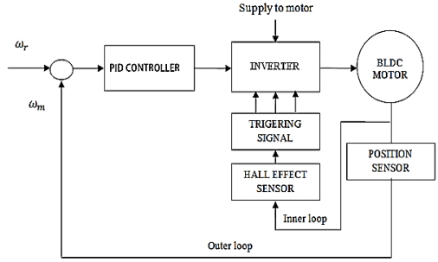
Block Diagram of BLDC Motor Speed Control

B. The Back Electro Motive Fource (BEMF)
Typically, a 3-phase BLDC motor uses six electronic switches (power transistors) to produce 3-phase voltage simultaneously to a full-bridge configuration power converter. The transistors have a rotor position, which will be defined as the switching sequence. Most of the cases motor starter is monitoring by using three hall sensor devices. The hall sensors provide the information to the decoder block for producing the sign of reference current signal vector to the back electromotive force (BEMF). To operate the motor in the opposite direction, the current is changed in reverse direction or the switching order of the controller is changed. The MATLAB simulation block diagram for generating the back EMF of the decoder sequences of the proposed 3-phase PID controller for the BLDC motor to rotate in the clockwise direction.
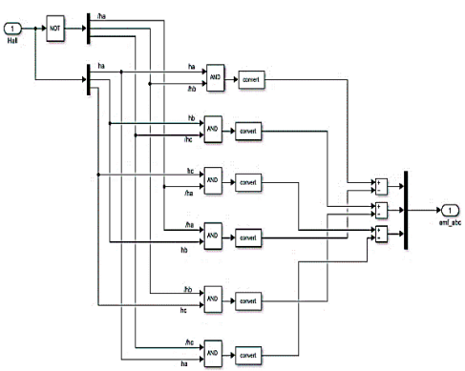
Back EMF of Decoder for MATLAB Drive

CHAPTER-8
PROPOSED PID CONTROLLER MODELING
For getting better performance of DC motors it is essential to use a controller circuit. For this purpose, a variety of controller circuits and algorithms are used. However, among them PID controller is the most suitable controller circuit for BLDC motor. The PID controller is mainly composed of three block of circuits and they are proportional, integral and derivative blocks. Each block of circuit is used to perform different mathematical operations as their name mentioned. The complete MATLAB design of the proposed controller for 3-phase brushless DC motor is shown in Fig. 5. The diagram clearly shows how the reference source, PID controller, driver circuit, sensors, converter circuit, inverter circuit, display scope and motor are interconnected. The foundational frequency transferring performance G(s) of the PID controller can be represented by (1) and (2), G(s) = Kp + Ki /s +Kd s (1) G(s) = (Kd s2 + Kp s + Ki)/s (2) Where, Kp = proportional gain coefficient, Ki = integral gain coefficient, Kd = derivative gain coefficient and s is the complex frequency. The time derivative output U(t) of the controller for control of the plant is equal to Kp times the magnitude of error pulse Kd times the derivative of time function error signal e(t) and Ki times the integral can be represented by (3). U(t) = Kp e(t) + Ki ∫e(t)dt + Kd de(t)/dt (3).
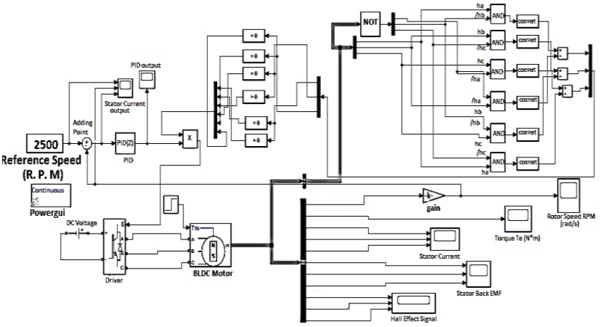
Complete MATLAB Design of Controller for BLDC Motor

Its applications are wide because of its ease and outstanding performance, in many cases its efficiency is more than 95%. Typically a closed-loop PID controller is used for industry application. The four key features are most interested in the response to the closed-loop step, they are, settling time, overshoot, steady-state error and response time.

CHAPTER 9
SIMULATION RESULTS
The configuration of the discussed PV array fed water pumping system shown in Fig.1 is simulated using MATLAB-Simulink and the performance of each stages are described briefly.
A. Simulation results of SPV array
The PV array voltage and the PV array current. PI controller is able to achieve optimised array power at any atmospheric conditions.

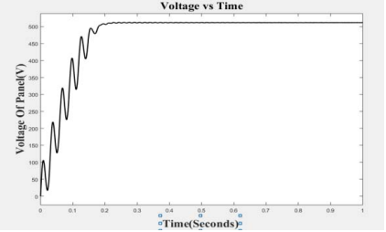
PV array output voltage
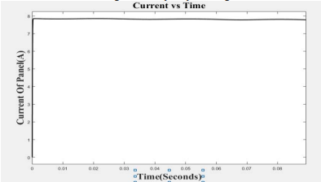
PV array output current waveform

B. Simulation results from Luo Converter
The current flowing through the inductor and the voltage across the capacitor in the Luo converter. The output waveforms clearly depict that the converter works in the CCM mode. Switching frequency of 20kHz is chosen to avoid the ripples.
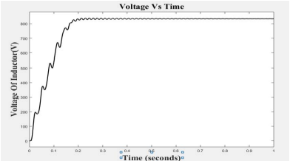
. Voltage across capacitor
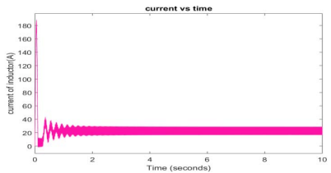
Current through the inductor

D. Performance of Induction motor
The output characteristics of the induction motor depicts that the motor is capable of running at any desired atmospheric condition and within its permissible of rated speed and its rated torque.
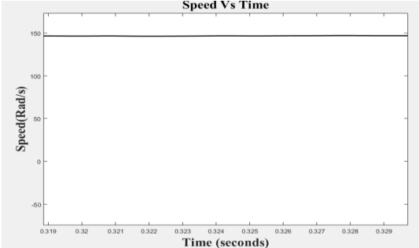
Speed characteristics
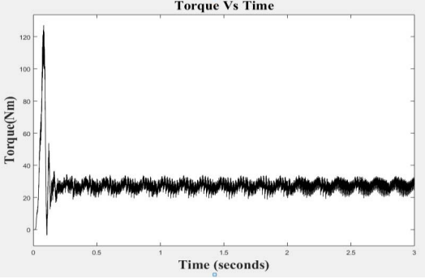
Torque characteristics
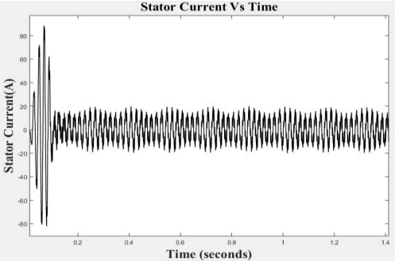
Stator current
CHAPTER 10
CONCLUSION
As we see modeled and simulated the solar power fed brushless DC motor. In which we can extract maximum power from a solar array with the help of P and O Algorithm. Interleaved boost converter is used in the system so that we can found that the IBC was helped reduced ripple content from the output as well as input side also it can reduce stress on switches. IBC suitable converter for high power renewable energy source. BLDC motor driven by solar energy and hence can be used in solar water pumping, E-BIKE also compressor. Closed loop Speed control Inverter fed BLDC Motor using PWM we can discuss in this paper. A feedback signal from motor indicates the speed and position of the motor which is utilized to generate the switching signal for the inverter.

CHAPTER 11
REFERENCES
[1] Radak Blange Chitralekha Mahanta Anup Kumar Gogoi “ MPPT of Solar Photovoltaic Cell Using Perturb & Observe and fuzzy Logic controller Algorithm for BuckBoost DC-DC Converter” Dept. of Electronics & Electrical Engineering Indian Institute of Technology Guwahati, Assam, India. 2015 IEEE

[2] . Shamsun Nahar and M. Basir Uddin.”Analysis the performance of interleaved boost converter” Dept of electrical and electronic engineering, Dhaka University of Engineering& Technology(DUET) Gazipur, Bangladesh

[3] Ashwin Chandwani, Abhay Kothari Department of Electrical Engineering Institute of Technology, Nirma University Ahmedabad, India and Department of Electrical Engineering Institute of Technology, Nirma University Ahmedabad. India “ Design, Simulation and Implementation of Maximum Power Point Tracking (MPPT) for Solar based Renewable Systems” 2016 International Conference on Electrical Power and Energy Systems (ICEPES).

[4] Santanu Mondal, Abhirup Nandi, Indranil Mallick, Chirantan Ghosh, Alapan Giri Department of Applied Electronics and Instrumentation Techno India Salt Lake Kolkata, India. “Performance Evaluation of Brushless DC Motor Drive for Three Different Types of MOSFET BasedDC-DC Converters ” DevIC March 2017.

[5] D. K. Sharma ,G. Purohit Advanced perturbation and observation(P&O) based maximum power point tracking (MPPT)of a solar photo-Voltaic System.

[6] Deepak.S.Suryawanshi, Sunita S. Khairnar “Perturb And Observe Based Mpptfor Solar Power Generation Connected To Ac Load” 2017 2nd IEEE International Conference On Recent Trends in Electronics Information & Communication Technology (RTEICT), May 19-20, 2017, India.

[7] Jubaer Ahmed , Member, IEEE and Zainal Salam , Member, IEEE “An Enhanced Adaptive P&O MPPT for Fast and Efficient Tracking Under Varying Environmental Conditions ” IEEE.

[8] Shamsun Nahar and M. Bashir Uddin, Dept. of Electrical and Electronics Engineering Dhaka University of Engineering & Technology Gazipur, Banglashesh “ Analysis the performance of interleaved boost converter” 4 th ICEEICT

[9] M.Poovizhi M.Senthil Kumaran P.Ragul L.Irene Priyadarshini “Investigation of mathematical modelling of brushless dc motor(BLDC) drives by using matlabsimulink”IEEE 2017

[10] Abhilash Nilkanth Jadhav1 Dr. V. A. Kulkarni2 1,2 “MPPT Techniques for PV Connected BLDC Motor Drives” (IJSRD/Vol. 7/Issue 03/2019/355).

[11] T.Nivethitha1, R.Anand 2 “ PV Connected BLDC Motor Drive by Employing P&O MPPT Controller” JIRSETVol. Special Issue 6, May 2015.

[12] H. Salim Hameed, “Brushless DC Motor Controller Design Using Matlab Applications,” 3rd Scientific Conference of Engineering Science (ISCES), 19 April 2018.

[13] M. Rajkumar, G. Ranjhitha, G. Pradeep and M. F. Kumar, “Fuzzy-based Speed Control of Brushless DC Motor feed electric vehicle,” IJISSET, 2017, vol. 3(3).

[14] M. Valan Rajkumar, G. Ranjhitha, M. Pradeep, M. Fasil PK and R. Sathish Kumar, “Fuzzy based Speed Control of Brushless DC Motor fed Electric Vehicle,” International Journal of Innovative Studies in Sciences and Engineering Technology (IJISSET), 2017, vol. 3(3).

[15] H. Manal and Jasim, “Tuning of a PID Controller by Bacterial Foraging Algorithm for Position Control of DC Servo Motor,” Iraqi Academic Scientific Journals, 2018, vol. 36.

[16] M. Singirala, D. Krishna and T. Anil Kumar, “Improving Performance Parameters of PMBLDC Motor using Fuzzy Sliding Mode Controller,” International Journal of Recent Technology and Engineering (IJRTE), 2019, vol. 8(4).

[17] M. Rafay Khan, A. Ahmed Khan and U. Ghazali, “Speed Control of DC Motor under Varying Load Using PID Controller,” International Journal of Engineering (IJE), 2015, vol. 9(3).

[18] T. Rahman, S. M. A. Motakabber, M. I. Ibrahimy and A. H. M. Zahirul Alam, “PLL-Based 3φ Inverter Circuit for Microgrid System Operated by Electrostatic Generator,” IIUM Engineering Journal, 2019, vol. 20(1), pp. 177-193.

[19] T. Rahman, S. M. A. Motakabber, M. I. Ibrahimy and Aliza ‘Aini, “A PWM Controller of a Full Bridge Single-phase Synchronous Inverter for Micro-grid System,” Journal of Physics: Conference Series, 2017, pp.1- 13.

[20] S. M. A. Motakabber, M. A. Mohd Ali and N. Amin, “Computer Aided Design of an Active Notch Filter for HF Band RFID,” FREQUENZ, 2010, vol. 64(1-2), pp. 23-25.

[21] K. Swapnil, J. Anjali, A. Mohan and D. Shantanu, “Modeling and control of a permanent-magnet brushless DC motor drive using a fractional-order proportional-integral-derivative controller,” Turkish Journal of Electrical Engineering and Computer Sciences, 2017, 25(5), pp. 4223-4241.

