Digital Media Marketing using Trend Analysis On Social Media

Abstract
Social Media has quickly gained prominence as it provides people with the opportunity to communicate and share posts and topics. Tremendous value lies in automated analysing and reasoning about such data in order to derive meaningful insights, which carries potential opportunities for businesses, users, and consumers. Many events in the world are accompanied by the Hash-Tag trends on social media. The whole idea behind this is to create such an application that would help in marketing of products and services over social media platforms. The technique is known as Social Media Marketing and is a sub-set of Digital Media Marketing. As of now there is no personalize engagement between marketers and clients. We aim to provide such data by Personal Engagement by providing a deep insight into the user's’ content and thus would generate quality data resulting in better customer base, high conversion and lower bounce rates.
INTRODUCTION
Everyone is coming online in today’s world so the services which one has to offer also have to come onboard in world of internet. The basic services which one offers are healthcare, shopping, ticket booking etc. All of these services need to reach the desire or targeted customer that would utilize them. Before Internet, Mass Communication was used to publicize or market any product /services. The only flaw in the previous system is that it hits every sector of society not the one particular targeted sector. To counter this flaw marketers decided to use the biggest platform in today’s world and the idea of digital media marketing came into existence. How does social media fits into the idea of Digital Media Marketing, digital media has many aspects such as E-Mail marketing, Digital ads and social media marketing etc.
Social Media has been the lifeline of every person in today’s digital world. Where there are people, there are potential customers, to engage with that potential customer base social media marketing is used. Google Plus, Tumblr and Twitter are the most used social media platforms from all. Since there are variety of people on every platform how to distinguish them as your potential customer that task is colossal task and that is where our proposed system will help digital marketers find the potential customer and get more from a campaign rather than just promoting anything to generate revenue.
The aims and Objective of the study
The essence of this study is to research how a company can seize the moment of using social media networks to create brand awareness and also explore its challenges to draw the attention of those companies venturing into social media networks to increase brand visibility. On the other hand, listening to the analysts and some scholars, the census is that the traditional ways of advertising i.e. newspapers, television, radio, etc., are no longer effective due to the rise of social media. This is however a debatable position even though social media in terms of reachability could potentially reach many people. Therefore the study also explores the already existing theoretical body of work that emergence of social media has led to the demise of traditional advertising channels.
COMPARISON BETWEEN EXISTING SYSTEM & PROPOSED SYSTEM
- Existing System
The concept of Digital Media Marketing has become very popular in the recent times mainly because of the increasing use of social media by more and more people day by day. With the growing usage of social media platforms, the digital media marketing importance has increased over the time. Hence, there are a number of marketing tools that helps the marketing agencies to target users and sell their products and services. There exists a number of applications that provides analysis of the social media usage.

A good example of such a system is Google Analytics, Facebook Insight and Audience Insights by Twitter. Google Analytics tracks down the activities of a website where as Facebook or Twitter Analytic Tool use social science and computer science together to show the valuable insights gathered from stakeholders and use the same for business development decisions. The available online platforms such as Google Trends provides a complete generalized analysis for the data of the social media platforms available. It shows how often a particular search-term is entered relative to the total search-volume across various regions of the world, and in various languages. The horizontal axis of the main graph represents time (starting from 2004), and the vertical is how often a term is searched for relative to the total number of searches, globally but it doesn’t provide how well a potential or existing customer has interacted with it.

- Proposed System
The proposed system aims at utilizing the data collected from the three of the most popular social media platforms that are Facebook, Twitter and Instagram[5]. The users would be classified into different categories based on the preferences. The sufficient data for classification is obtained from the APIs from all the three platforms. The data from all the three platforms is integrated and combined for a specific user.
The analysis is performed on the combined data that was generated for a user. The user is then accordingly classified on the basis of the analysis performed. The classification is done using the classifier algorithm. The categorized users could then be targeted for Marketing. This would lead to better results as the categorized users would be targeted for only those advertisements that match with their interests. A user may also be categorized into two or more categories as a user can have multiple interests.

Proposed System
provides better personal engagement and better group targeting. The Proposed System provides user grouping and classification. This divides the users based on the data into multiple classes or groups. However, a user might be classified into two or more classes as a user might have multiple interests. As a wide range of social media platforms are being used, there is user diversity. This resolves the issue of users targeted for a specific geographical area as users from all across the world would be covered. The Proposed System also provides a unique historical view of the data acquired and gathered from various social media platforms. This would be ensured by storing the classified user information in the database. This would also reduce the number of API calls that are made to fetch the data. Thus, a vast majority of users can be obtained for targeted marketing. The presence of multiple social media platforms ensures the abundance of data. This would provide a greater number of users as compared to an application that uses just one social media platform.

METHODOLOGY
Proposed system aims to help Digital Marketers, Organization or Freelancers to achieve their clients desired target goal in respect to digital marketing[4]. The main purpose is to create a personal engagement system which would be helpful in various different ways other than existing system. They would be having details of customer base they can target and excel by increasing the “Conversion Rate” (The percentage of people who are interacting with your website or any purchase having due to the campaign.), such that the yield from paid advertisement increases.
The conversion rate increases as the system maintains a copy of historic data that is updated on multiple instances to filter out the invalid data that is gathered over time. The data also would include local data along with global data to help targeting region based users. The ‘Generate Data’ request from the client would query the required responses from the APIs as well as the central database. This should satisfy the historic data need required for analytical purposes like historic analysis and trend analysis. It would also be able to respond to the instance requests as the data generated will have real-time accuracy.

ALGORITHM
The Multi-layer Perceptron (MLP) can be viewed as a logistic regression classifier where the input is first transformed using a learnt non-linear transformation . This transformation projects the input data into a space where it becomes linearly separable. This intermediate layer is referred to as a hidden layer. A single hidden layer is sufficient to make MLPs a universal approximator. There are substantial benefits to using many such hidden layers, i.e. the very premise of deep learning. It is a supervised learning algorithm that learns a function F by training on a dataset, where is the number of dimensions for input and is the number of dimensions for output. Given a set of features and a target , it can learn a nonlinear function approximator for either classification or regression. It is different from logistic regression, in that between the input and the output layer, there can be one or more non-linear layers, called hidden layers.
MLP trains on two arrays: array X of size (n_samples, n_features), which holds the training samples represented as floating point feature vectors; and array y of size (n_samples,), which holds the target values (class labels) for the training samples.
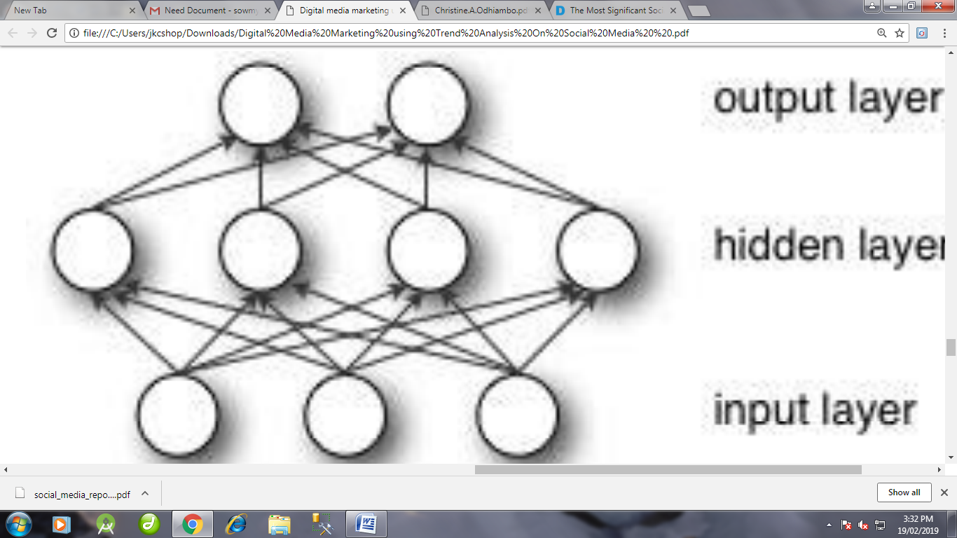

THE PROCESS OF COLLECTING SOCIAL MEDIA DATA

The process of collecting social media data, while seemingly simple on the surface, requires numerous competencies (Brooks, 2015; Driscoll & Walker, 2014; Felt, 2016), both technical and research design related. The process is made more complex as it involves a mixture of theory, data, and computational processes (see Goble 2008 for a bioinformatics perspective) filled with many “black-boxes” (Driscoll & Walker, 2014; Goble et al., 2008, p. 510). An algorithmic system underlies the multitude of interfaces users and programs use to consume and interact with information from social media platforms. These algorithmic systems (Ananny & Crawford, 2017) are an assemblage of “institutionally situated code, practices, and norms with the power to create, sustain, and signify relationships among people and data through minimally observable, semiautonomous action” (Ananny, 2015, p. 93).
To users and researchers outside of the platform, these algorithmic systems and databases seem like black boxes taking input from a user’s action and outputting posts without giving any details of how data is processed or changed. The lack of transparency only adds complexity to the research process since the impact of forces assembling and acting on data are unknown to us. The process often begins with the research design of a project, linking a set of research questions with the appropriate social media data.
After matching a research design and data source, a data collection plan must be developed and executed. It is important to use data collection methods that preserve elements of each social media post and their accompanying metadata that are essential to answering the researchers’ research question. Developing and executing this plan requires a deep understanding of the phenomena and social media site(s) under examination: that is to say the recipes used to “cook” (the collecting, cleaning, processing, and analysis of the data) (Bowker, 2013), and the technical skills to carry out the “cooking”. The amount of data collected ranges from a few hundred posts to larger datasets consisting of thousands or millions of information artifacts. Methods of collecting social media data range from manually copying and pasting content from social media web sites to large-scale automated data collection via complex scripts. Large or small, manual or programmatic, the processes of research design and social media data collection require a set of empirically informed principles to guide researchers through many choices that must be made throughout the 8 data collection process.
Literature focusing on this process is lacking and this dissertation contributes to this area. Social media datasets continue to present challenges for researchers after data collection. These datasets also push at the boundaries of traditional research methods (Hargittai & Sandvig, 2015; Karpf, 2012). Oftentimes researchers attempt to apply existing, more traditional methods in this space, but this approach may be problematic if researchers do so blindly without first adapting methods to the unique properties of social media datasets and platforms. For example, consider the application of stratified random sampling techniques traditionally used in survey techniques (de Leeuw, Hox, & Dillman, 2012; Lynch, 2008); how can this method be applied to social media data without a proper sampling frame or observed characteristics on which to determine which strata each account or individual falls? How do we account for representation (Miller et al., 2015), political power (Nahon, 2015), algorithmic and platform bias (Gillespie, 2010), presentation of self (Goffman, 1990), and the context within which these posts are generated (Seaver, 2015)? These are important questions to address in order to assess the validity of research using social media data.
A precursor to this In the rush to collect data, the implications of observing dynamic content at a particular (arbitrary) point in time and issues of preservation of social media posts and their accompanying linked metadata aren’t generally considered and rarely discussed in research publications. At its core, social media data is ephemeral – a term often used but rarely defined in research (see Bernstein, Monroy-Hernández, Harry, & André, 2011 for an example of use without a definition). When researchers use the term ephemeral in 9 the context of social media data it is often shorthand for instability; data is constantly changing, being updated, or deleted. As a result, it is difficult for two researchers to collect the same exact dataset in real-time and practically impossible for them to collect the same dataset retrospectively via a purchase of data from a reseller or by scraping (Burgess & Bruns, 2014).
Further, researchers are often forbidden from sharing full datasets by the Terms of Service (ToS) of many platforms. While some platforms, such as Twitter, allow for sharing of each post’s unique identification number; this still requires researchers to “rehydrate” or go back to the platform to recollect the most current post content and metadata, if available. The difficulty of collecting and/or sharing datasets makes it impossible to validate or replicate studies using social media data (Felt, 2016).

GAPS IN THE SOCIAL MEDIA LITERATURE
Few studies have focused on the dynamic nature of social media data itself; those that have primarily looked at specific tools or software interfaces for data collection (Driscoll & Walker, 2014; Felt, 2016; e.g. Gaffney & Puschmann, 2014; González-Bailón, Wang, Rivero, Borge-Holthoefer, & Moreno, 2014), and have not considered the impact of the ephemeral nature of social media data on the data collection process and resulting dataset. In this dissertation, I examine the impact of the ephemeral nature of social media data on research datasets — how posts, their accompanying metadata documenting the post, and linked content such as videos, images, and web pages change over time.
Our research community needs ways of acknowledging, understanding, stabilizing, and combating/addressing the ephemerality of social media datasets. 10 Without ways to measure the impact ephemerality has on datasets, researchers are unable to determine the subsequent impact on research designs and findings. If ephemerality does have an impact, how can researchers quantify and counteract or at least address it or understand the limitations of results? The first step in addressing these questions is to gather empirical data to measure the level of ephemerality over time within multiple social media based case studies at the post, metadata, and linked content levels.

THE DIMENSIONS OF LATENCY AND LEVEL OF AUTOMATION
In the social media research space, researchers are applying existing methods to the collection and analysis of social media data. In a content analysis of the abstracts of over 500 papers focusing on Twitter from 2007 to 2011, Williams et al. (2013) found that the analysis of tweets rather than Twitter users or the Twitter site itself was the most common focus of these papers. Building on this work, Zimmer and Proferes coded 382 studies focusing on Twitter for their primary data collection and analysis published between 2006 to 2012. They created a typology of Twitter research related to the 29 “disciplines and methods of analysis, amount of tweets and users under analysis, the methods used to collect Twitter data, and accounts of ethical considerations related to these projects” (2014). Their findings show the amount of research utilizing Twitter data has grown from two studies in 2007 to 145 studies in 2011, with a slight dip in 2012 of only 109 studies.

The fields of computer science, information science, and communications dominated. Content analysis of the text of the tweet itself was the dominant analysis with nearly two-thirds of all studies examined using this method with a majority of studies using Twitter APIs for data collection. Of the papers not using the Twitter API, manual capture or the use of a tool such as TwapperKeeper was popular. Similar work with papers focusing on Facebook as their data source found that content analysis of posts also dominated as the primary method for analysis (2016).

Based on the meta studies of social media research approaches and my experiences working with social media data, it is useful to think about the social media data collection process across two dimensions: 1) Latency (real-time vs. historical) and 2) Automation (manual vs. automated). Figure 2.5 shows data collection methods along a latency (or delay) continuum from the least (data collection in real-time) to the highest latency (data collection from a historical archive). In the middle are low latency (semireal-time) data collection methods enabling the collection of data in near real-time — seconds to minutes after a post has been created.
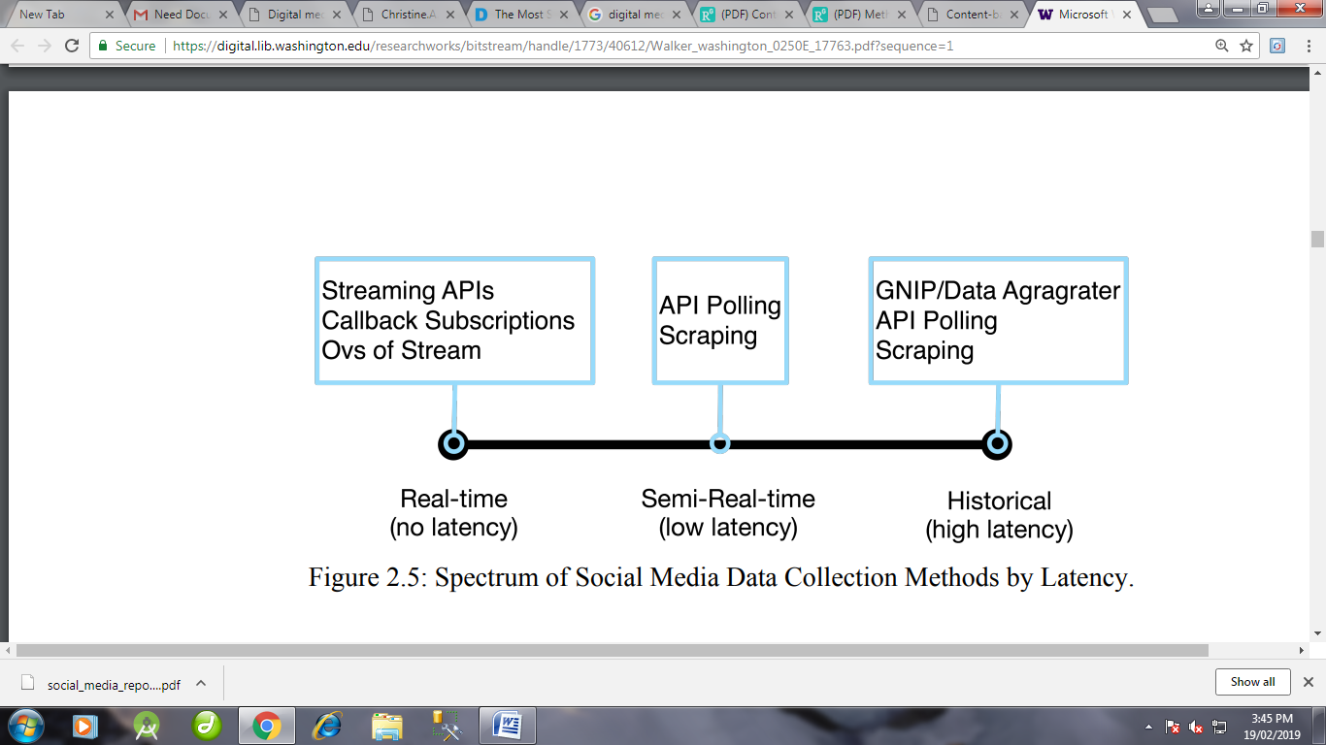

PROCESS THEORY

The research questions guiding this dissertation are concerned with the impact of choices made during the research process, specifically how and when the collection of social media data is performed, on the resulting datasets. Process theory “argues for a patterned sequence of events [focusing on] … questions of the order and sequence of events and about the effects of that order [to determine if more] preferable outcomes can be associated with particular sequences of activities” (Abbott, 1990). A sequence is an ‘ordered sample of things’ that can be temporal or spatial in nature with properties of a continuous or discrete variable. These become events when tied together into temporal sequences (Abbott, 1990).

Using process theory, a given set of sequence patterns can be examined to understand why they are the way there are or the effect of a certain set of sequence patterns. Examples of the former include: “Does education determine the characteristic sequence of career? Does the size of an organization determine the shape of the status rankings we find in it?” Examples of the latter include: [Are] “those promoted before acquiring certain kinds of expertise are helped or hindered in their ultimate career success”? I focus on the second of these questions — the effect of a certain set of sequences on a particular outcome.

CASE STUDY AND DATA DESCRIPTION

A case study approach was chosen to closely replicate the bounded, event/phenomena focus of the social science approach to research allowing the findings to apply to a wider range of research designs from a social science point of view. Case studies also work well when a “how” question is being asked about a set of contemporary events (Yin, 2014) — which in my case included a recent world-wide social movement, interactions between the public and West Coast Departments of Transportation, and a reality TV show. This approach also preserves the connection between the phenomenon and its context (Yin, 2014) while retaining the capacity to address a case study’s complexity (Simons, 2006). Each case study was chosen because it represents prototypical features of the types of data collection scenarios researchers experience. Examples of these dimensions include time-scale (short to long), population bounding (tight to lose), level of political contention (highly contentious to the everyday political context), and inclusion of links to media such as images and videos (high to low level of media and linking).

The range of case studies provide for a triangulation of different contexts — social movements, daily interactions with government, and a reality TV show — to examine the ephemerality of social media data within, between, and across cases. Different levels of case study analysis provide different types of insights — within case analysis informs researches in situations where their case studies/data match one or more of the prototypical dimensions of one of my case studies. Between-case analysis provides information about the impact of different prototypical dimensions on the ephemerality of 68 social media data sets. Across case analysis allowed me to generalize across twitter and to other social media platforms. For example, due to its nature as a social movement and the use of deletion as a protest tactic (Neumayer & Stald, 2014), the Occupy Wall Street case may exhibit a different level of ephemerality than the other cases.

As a result, the Occupy Wall Street case acts as a model for researchers working with politically contentious social media datasets, but may not be a good model for researchers working with non-political data. The other case studies counter this, for example the inclusion of popular culture and entertainment though the Drag Race case study, acts as a model for a variety of events/phenomena social sciences researchers encounter when working with social media data. Combined the three case studies allow for a more general understanding of ephemerality across the Twitter and to other social media platforms.

LIMITATIONS
The focus of this dissertation was to further describe and explore the problem space around the ephemerality of social media datasets specifically focusing on the reliability of posts and the authenticity of metadata surround those posts. Heavy reliance on descriptive statistics, the data collection environment, and case construction while providing new insights, also create a set of limitations:
• In the Occupy Wall Street case, data collection was limited to two time points (real-time and three years later). As a result, the most politically contentious case study was excluded from the majority of the within case study analyses
• Due to the daily granularity of nightly data collection, it is not possible to detect multiple changes occurring within each day or disambiguate missing posts due to API errors vs. changes in user privacy settings. It was not possible to collect data more often than once-a-day due to API request rate limits since checking the status of all Tweets in the larger case studies took 6-7 hours.
• While the difference between case studies were significant, it is not possible to determine which prototypical features has the highest impact on the ephemerality of each dataset.
• The descriptive and exploratory nature of this work limited the use of inferential statistics to determine causality.
• While Twitter shares many concepts, structures, metadata, and links (URLs); patterns of user activity within Twitter may differ from social media platforms, limiting my ability to generalize outside of Twitter. 116
• Between and during period of data collection, Twitter made changes to the affordances of the platform. For example, Twitter introduced the simplified replies and media attachments where the @mentions at the beginning of a tweet and URLs linking to media (photos, videos, and GIFs) at the end of a tweet do not count toward the 140-character limit.25 While none of the metadata fields analyzed in this dissertation were changed, changes in affordances may have impacted user behavior.

CONTRIBUTIONS

Returning to the guiding research questions of this work, the findings address the interaction between ephemerality and the process of data collection. This dissertation advances the field of information science by empirically investigating how the ephemeral nature of social media data, metadata, and linked content have significant and lasting effects on the reliability and authenticity of datasets used in research. Situating research design decisions, specifically choices made on how and when to observe data, within the frameworks of process theory and archival theory, this work brings the importance of methodological considerations to the forefront of studies of digital and social media. Key contributions of this work include:
• The introduction of a new framework detailing typical methodologies for sampling data from digital and social media platforms.
• Demonstrates through an empirical analysis of descriptive data related to the reliability and authenticity across three illustrative case studies, how the challenges of ephemerality of social media translate to consequences for research.
• A design and technical system for archiving links embedded in social media datasets during data collection.
• Guidelines and design considerations for social media-based research studies to aid in limiting and understanding the impact of ephemerality.
• Limitations of social media datasets and the importance of these limitations within the field of information science.

FUTURE WORK

This research addressed gaps in the current literature related to social media methods and data collection. Invitation of this problem space revealed directions for future work including:
• Integrating ongoing re-conceptualizing of the archival record to take into account the concept of non-fixed, event-oriented records. Seeing social media as a performance that cannot be separated from its creator (Anderson, 2013, p. 362).
• Examining the extent to which the changes in the reliability and authenticity due to latency in data collection impact the results of an analysis within the same research project — this could take the form of analyzing social media data addressing the same research question at different data collection latencies.
• While this work found that the prototypical features of a case study result in different patterns of inaccessibility, it was not possible to determine which have the most impact. Future research designs could further examine which prototypical features have the most impact.
• Conduct sensitivity testing and random modeling of inaccessibility to better determine the extent of impact within each case study.
• Addressing ethical questions surrounding ephemeral social media data sets — both from a research methods as well as a human-subjects angles.

CONCLUSION

The process of collecting social media data presents a number of challenges for researchers as we attempt to add rigor to the field. In this dissertation I developed the concept of ephemerality as it relates to social media data sets – quantifying the levels of reliability and authenticity within three cases studies observed over a 90 day to 3 year timeframe. To me, the most surprising results were the levels of change of user profile metadata with over 50% of users in the RuPual’s Drag Race case study changing their profile images and a large number of users completely rewriting their profile descriptions.

The empirical results lay the foundation for future work examining what impact latency in data collection and the resulting change in a social media data set have on findings. The results point to the need for researchers to more closely align the latency and methods of data collection with their research design. Some researchers may see these 119 results as a call to strengthen their data collection methods to prevent change and stabilize their data sets. Other researcher may see ephemerality as an inherent property of social media data itself. I do not have a normative stance on either view, but the results point to the importance of taking the impact of data set change into account when describing findings and limitations of research using social media data. These findings also point to the importance of more clearly describing our data collection procedures when publishing research so readers may evaluate findings in light of the research design choices that were made. Both of steps will go a long way to increasing the rigor of social media research.

The study commenced by giving the background of the study and what motivated the researcher to conduct the study on the topic of social media. We saw how social media is slowly becoming an important marketing tool which offers an companies‟ opportunity to engage with their markets and to learn about customers‟ needs, important segments and profile unlike main stream media i.e. radio or print channels. However, the implications are that this is an uncontrolled environment that business do not have control over and therefore it requires a robust social media strategy that also manages the comments posted by consumers whether positive or negative.

Even though they are becoming popular and effective marketing tools, Social network sites can pose a threat as well as an opportunity to companies as they can rapidly spread the views of dissatisfied customers‟ comments. Social networks and the Web offer small and large companies new and unique opportunities to engage with their customer and learn about customers‟ needs in real time like never before. Evidence presented suggests that the peer group online social network effect can potentially influence purchase decisions because of its viral nature. Social media alone cannot be effective without augmenting it with other traditional media channels like radio, newspaper, or TV even though it is widely reported that the effectiveness of traditional media and their use is sharply falling. In general it is worth having a social media strategy in place to manage the enormous challenges that social media brings.

The findings of the empirical framework coincided with the theoretical framework based on the research problems. The study shows how social media has become an important tool for marketing and creating brand awareness. In fact it is foreseen that in the near future there will be a paradigm shift from traditional advertising to social media platforms. The study also identified some challenges the company has faced using social media, unlike in the study where there have 69 been so many challenges reported. A personal observation made over a period of about two years now found out that it is the manufacturers or the service companies that suffer the brunt of the social network defamation of character most.

The reason why Itronic has few challenges with online communities can be attributed to the fact that the case company is a reseller and hence all the complaints about products would only be made to the manufacturer and not the reseller. It is agreeable that though social media is effective it cannot be used on its own without augmenting it with the traditional forms of advertising. This is a very interesting study and even though it is not fully researched, it is however worth replicating with a longitudinal data to fully determine whether social media networks are really effective as the finding of this study suggests. In social science data can be categorized into two types; data that are collected at more than one point in time (longitudinal) and data that are collected on one occasion. Therefore it would be important to collect the performance data in terms of sales figures and brand equity over a long time to determine whether social media networks are really effective than the traditional advertising channels such as radio and prints.

REFERENCES
AlexaBezjian.A, Calder.B and Lacobucci. D; New Media Interactive Advertising vs. Traditional Advertising, Journal of advertising research (July. August 1998)

Alexander.B and Levine.A, Storytelling; emergence of a New Genre (2008)

A.J. Veal: Research Methods for Leisure and tourism; A practical guide,3rd Ed. Prentice Hall(2006)

Barwise.P and Meehan.S: The one thing you must get right when building a brand (2010)

Butler.P and Peppard. J; Consumer purchasing on the internet: Processes and prospects (1998)

Burns.R.B; Introduction to research methods 4thEd (2000) Sage Publications Boyd.D.M and

Ellison.N.B: Social Network Sites: Definition, History, and Scholarship, Journal of Computer-Mediated Communication (2007)

Blaxter.L, Hughes.C, and Tight.M: How to research, (1997) Open university press. Blumberg.B, Donald R. Cooper, and Pamela S. Schindler: Research Methods 2nd European edition (2008)

Chaffey.D; E-Business and E-commerce Management, Second Edition (2004)

Charles, C. M. (1995). Introduction to educational research (2nd ed.). San Diego, Longman

Churchill.G.A, Jr. &Lacobucci.D: Marketing Research, methodological foundation, Tenth Edition (2009)

Creswell. J. W. & Miller. D. L. (2000): Determining validity in qualitative inquiry. Theory into Practice, 39(3), 124-131.

Evans.D; Social Media Marketing-an Hour A day (2008)

Evans.D with Jake McKee; Social Media Marketing, The Next generation of Business Engagement (2010)

Fauser.S.G, Wiedenhofer. J and Lorenz. M: Touchpoint social web:an explorative study about using the social web for influencing high involvement purchase decisions (Volume 9,Issue 1,2011)

Fournier.S and Avery.J: The uninvited brand; Business Horizon (2011) 54, 193- 207

Gay R,Charlesworth A and Esen R; Online marketing, a customer led approach (2007 B) Oxford University Press Inc, New York

Agarwal, S. D., Bennett, W. L., Johnson, C. N., & Walker, S. (2014). A Model of Crowd Enabled Organization: Theory and Methods for Understanding the Role of Twitter in the Occupy Protests. International Journal of Communication, 8, 27

Anderson, K. (2013). The footprint and the stepping foot: archival records, evidence, and time. Archival Science, 13(4), 349–371. http://doi.org/10.1007/s10502-012-9193-2

Driscoll, K., & Walker, S. (2014). Big Data, Big Questions Working Within a Black Box: Transparency in the Collection and Production of Big Twitter Data. International Journal of Communication, 8, 20.

Karpf, D. (2012). SOCIAL SCIENCE RESEARCH METHODS IN INTERNET TIME. Information, Communication & Society, 15(5), 639–661. http://doi.org/10.1080/1369118X.2012.665468

