ANDROID AND BLUETOOTH BASED VOICE CONTROLLED WIRELESS SMART HOME SYSTEM
Abstract :
In this paper, a design is proposed using IR and LDR sensor for automation of lights and fans using PIC with Internet of Things for smart homes. Nowadays we’re having automation of every little electrical device in our homes. Internet of Things is the concept of basically connecting any device with an on and off switch to the internet. IOT is more than smart homes and connected appliances; however, it scales up to include smart cities with connected sensors. Using IR sensors, the lights will automatically turn on and off according to the intensity of light. Temperature sensors will detect the room temperature and turn on and off fans. The security challenges being encountered in many places today require electronic means of controlling access to secured premises in addition to the available security personnel. Various technologies were used in different forms to solve these challenges. The Radio Frequency Identification (RFID) Based Access Control Security system with IOT technology presented in this work helps to prevent unauthorized access to controlled environments (secured premises).

OBJECTIVES:

The objectives of the system are:
1. To control home appliances by using voice commands.
2. To help the disabled and elderly people.

This project is an embedded one so there is a hardware as well as software part. It is
can also be used by non programming people easily and simple to use.

It can be used by two types of users:
1. Elderly people.
2. Disabled people.
Elderly and disabled people can use this system for controlling their home appliances
just by having an android application in their smart phones and passing voice
commands through android app and the hardware part has an Bluetooth device which
recognizes the voice command and operates on it. New features such as GPS or the
Internet can be used to receive the voice commands.

Introduction

Automation of the surrounding environment of a modern human being allows increasing his work efficiency and comfort. There has been a significant development in the area of an individual’s routine tasks and those can be automated. In the present times, we can find most of the people clinging to their mobile phones and smart devices throughout the day. Hence with the help of his companion – a mobile phone, some daily household tasks can be accomplished by personifying the use of the mobile phone. Analyzing the current smart phone market, novice mobile users are opting for Android based phones. It has become a second name for a mobile phone in layman terms. Home Automation System (HAS) has been designed for mobile phones having Android platform to automate an 8 bit Bluetooth interfaced microcontroller which controls a number of home appliances like lights, fans, bulbs and many more using on/off relay. This project presents the automated approach of controlling the devices in a household that could ease the tasks of using the traditional method of the switch. The most famous and efficient technology for short range wireless communication- Bluetooth is used here to automate the system. The HAS system for Android users is a step towards the ease of the

Today’s homes require sophistication control in its different gadgets which are basically electronic appliances. This has revolutionized the area of home automation with respect to an increased level of affordability and simplicity through the integration of home appliances with smart phone and tablet connectivity. Smart phones are already feature-perfect and can be made to communicate to any other devices in an ad hoc network with a connectivity options like Bluetooth. With the advent of mobile phones, Mobile applications development has seen a major outbreak. Utilizing the opportunity of automating tasks for a smart home, mobile phone commonly found in normal household can be joined in a temporary network inside a home with the electronic equipment. Android, by Google Inc. provides the platform for the development of the mobile applications for the Android devices. Home automation system is a mobile application developed using Android targeting its vast market which will be beneficial for the masses.

These days, the web need ended up a normal interface that a significant number of gadgets use in place will improve the everyday life about numerous individuals. Web aides us to get quick result for huge number of issues capable to interface starting with any of the remote spots which contributes with general expense decrease furthermore vitality utilization.Home mechanization might make portrayed as introduction for innovation organization in the home environment which provides straightforwardness which is more secure with its occupants. Towards utilizing the innovation of web for Things, those examinations Furthermore execution about home mechanization have got extra Normal. Different remote advances which has the capacity to help some sort of remote information transfer, sensing also management like Bluetooth, Wi-Fi and other cell division networks would be used to enter abundant levels for discernment inside the home. It might provide an interface with home mechanization itself, by means of mobile phone or alternately the internet.
There are several automatic identification technologies including barcode, magnetic stripe and Radio Frequency Identification (RFID) applied in security system. Radio-Frequency Identification (RFID) is an emerging technology and one of the most rapidly growing segments of today’s automatic identification data collection industry. RFID technology, offers superior performance over other automatic identification systems. Because it is not an optical technology like bar coding, no inherent line of sight is required between the reader and the tagged RFID object

CIRCUIT :
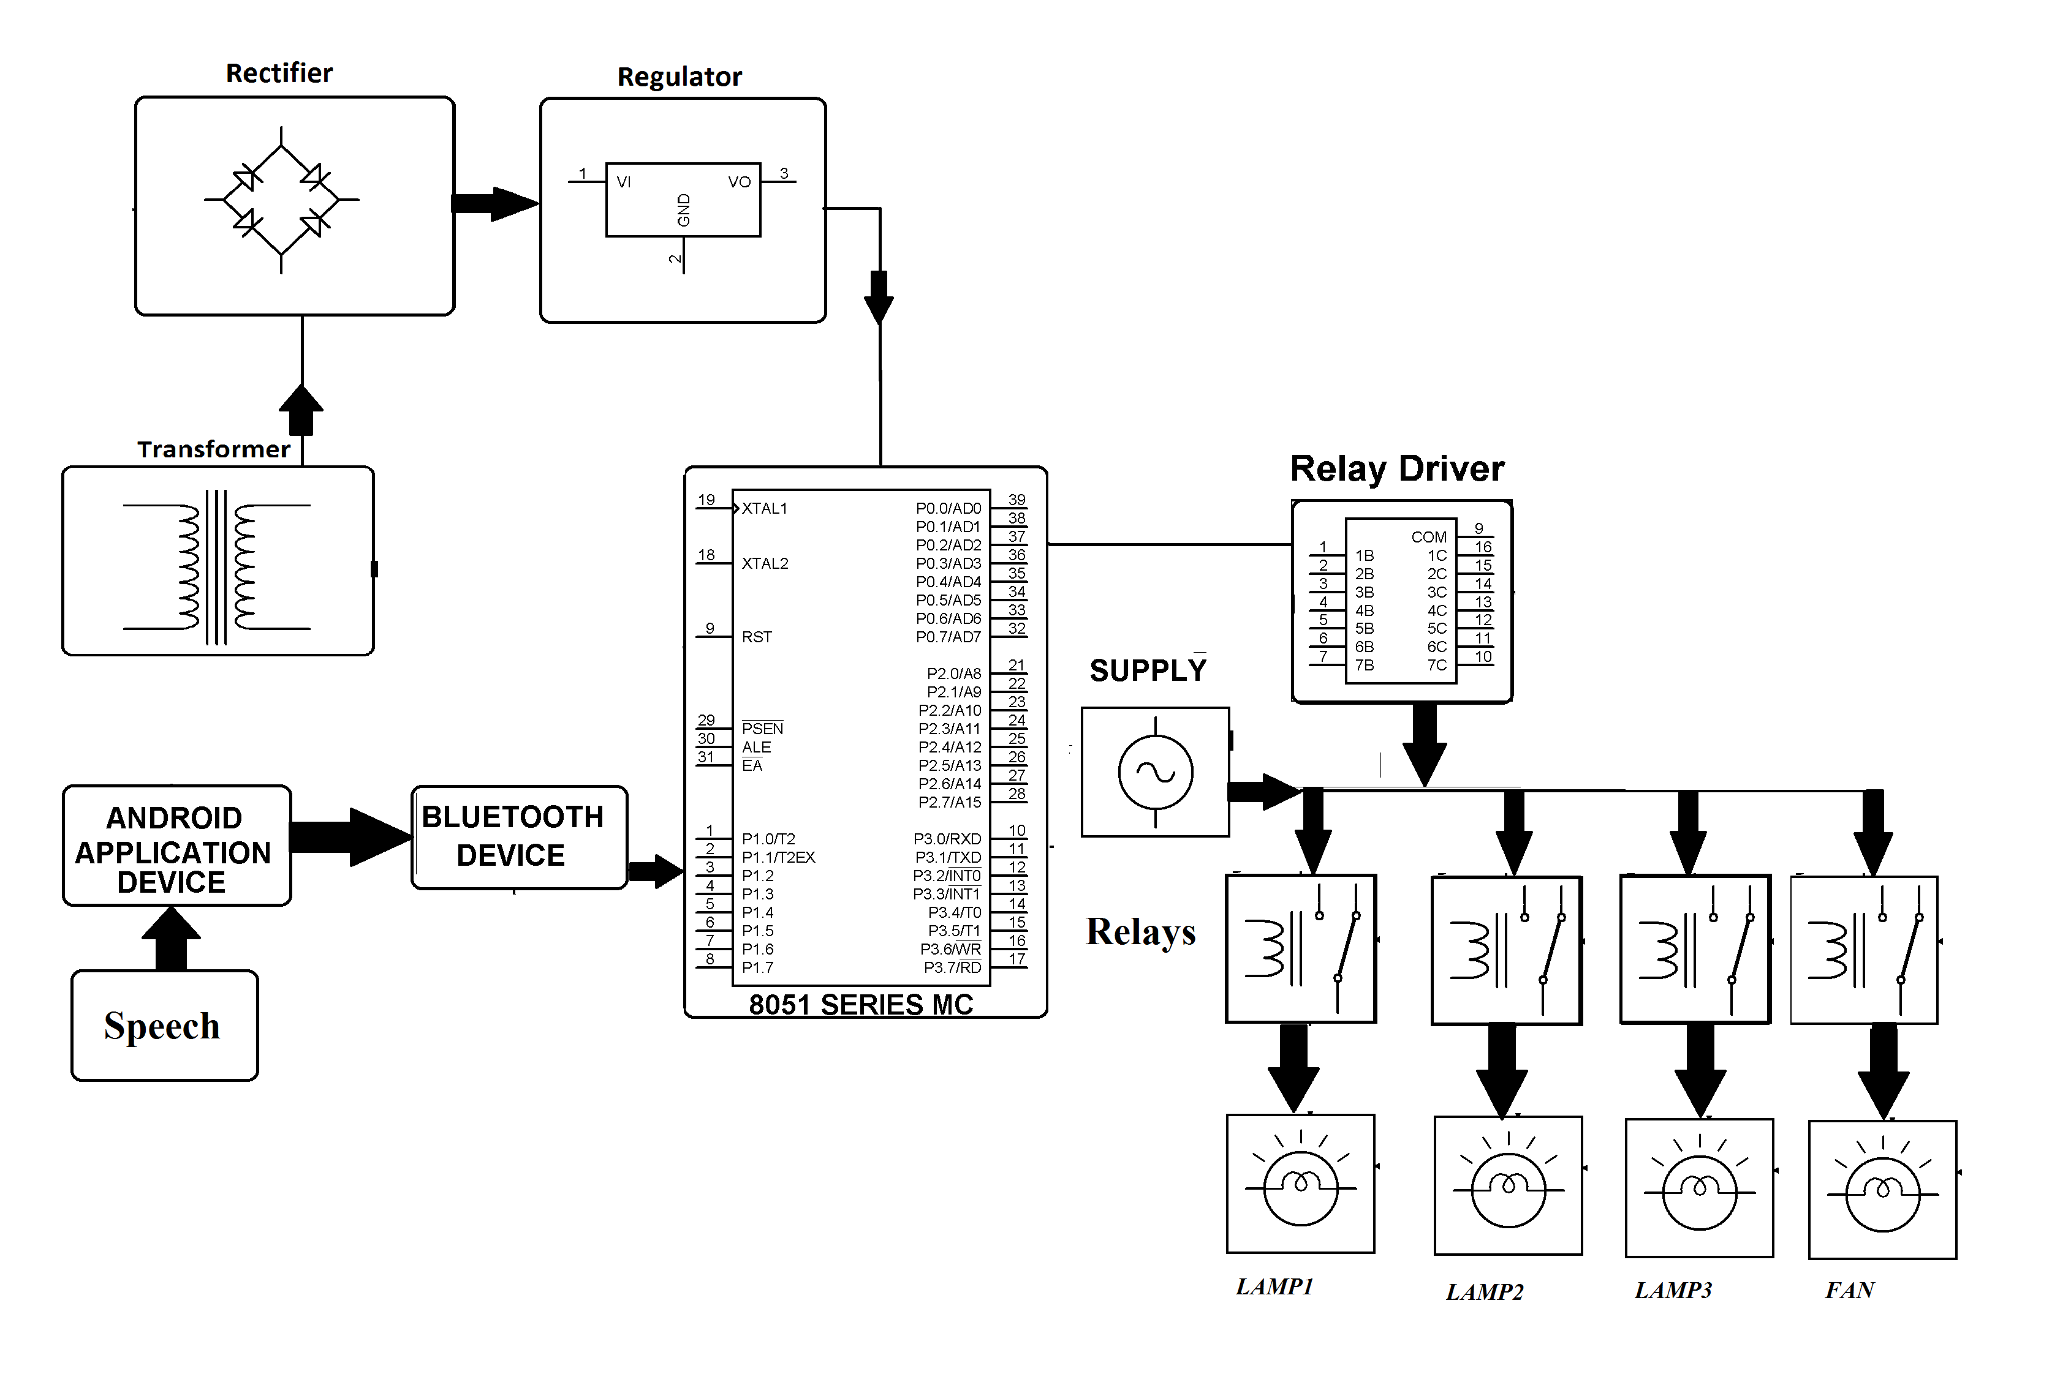
Internet of things

Internet of Things (IOT) includes theidea that those webs may be never again just a worldwide organizefor individuals to convey with each other utilizing computers, anyway it may be likewise a stage to gadgets will impart electronically with those universe around them. Those web for things additionally known as those web about Objects, alludes all the on a remote organize between objects, generally those organize will make remote Furthermore selfconfiguring, for example, family appliances. The expression “Internet about Things” need arrive at depict an amount about advances Also Look into controls that empower those web on connect under this present reality about physical Questions. The haul web for things might have been main utilized Eventually Tom's perusing Kevin Ashton over 1999. It alludes all the on particularly recognizable proof Questions (things) and their virtual representations for an Internet-like structure. IOT permits Questions on be sensed and regulated remotely over existingorganize infrastructure, making chances to more immediate joining the middle of the physical planet What's more machine based systems, what’s more bringing about moved forward efficiency, correctness and investment profit. IOT is utilized within a totally assortment of units for example, such that heart screening implants, biochip transponders ahead ranch animals, electric mollusks in seaside waters, automobiles for built-it sensors, DNA Investigation gadgets to Ecological checking. These devices collect useful data with the help of various existing technologies and then autonomously flow the data between other devices.

IOT could see as a gigantic organize comprisingabout networks for units What's more achinesassociated through an arrangement for middle of theroad innovations the place various advances inRFIDs, remote associations might go about asenablers about this connectivity. The clue may be that not just in PC and yoursmartphone might converse with each other, as wellas constantly on things around you. From joinedhomes What's more urban communities associated autos Furthermore machines will gadgetsthat track an individual’s conduct technique What'smore utilize the information gathered to new sort ofadministrations. gigantic organize comprisingabout networks for units What's more machinesassociated through an arrangement for middle of theroad innovations the place various advances in Ds, remote associations might go about as The clue may be that not just in PC and yoursmartphone might converse with each other, as wellas constantly on things around you. From joinedhomes What's more urban communities willassociated autos Furthermore machines will gadgetsthat track an individual’s conduct technique What'smore utilize the information gathered to new sort of administrations.

Iot applications
Some of the applications include wearables such as watch, traffic and water management in the smart watch, traffic and water management in smart Cities, internet connected cars, smart medical devices in connected with health, grocery shopping in smart retail, etc.
IMPLEMENTATION

PIC is a tool for making computers that can sense and control more of the physical world than your desktop computer. It's an open-source physical computing platform based on a simple microcontroller board, and a development environment for writing software for the board.PIC can be used to develop interactive objects, taking inputs from a variety of switches or sensors, and controlling a variety of lights, motors, and other physical outputs. PIC projects can be stand-alone, or they can communicate with software running on your computer (e.g. Flash, Processing, MaxMSP.) The boards can be assembled by hand or purchased preassembled; the opensource IDE can be downloaded for free.The PIC Is a microcontroller board based on the ATmega328. It has 14 digital input/output pins (of which 6 can be used as PWM outputs), 6 analog inputs, a 16 MHz ceramic resonator, a USB connection, a power jack, an ICSP header, and a reset button. It contains everything needed to support the microcontroller; simply connect it to a computer with a USB cable or power it with a AC-to-DC adapter or battery to get started.
Due to this insulating layer, DC current can not flow through the capacitor as it blocks it allowing instead a voltage to be present across the plates in the form of an electrical charge.
The conductive metal plates of a capacitor can be either square, circular or rectangular, or they can be of a cylindrical or spherical shape with the general shape, size and construction of a parallel plate capacitor depending on its application and voltage rating.
When used in a direct current or DC circuit, a capacitor charges up to its supply voltage but blocks the flow of current through it because the dielectric of a capacitor is non-conductive and basically an insulator. However, when a capacitor is connected to an alternating current or AC circuit, the flow of the current appears to pass straight through the capacitor with little or no resistance.
There are two types of electrical charge, positive charge in the form of Protons and negative charge in the form of Electrons. When a DC voltage is placed across a capacitor, the positive (+ve) charge quickly accumulates on one plate while a corresponding and opposite negative (-ve) charge accumulates on the other plate. For every particle of +ve charge that arrives at one plate a charge of the same sign will depart from the -ve plate.
Then the plates remain charge neutral and a potential difference due to this charge is established between the two plates. Once the capacitor reaches its steady state condition an electrical current is unable to flow through the capacitor itself and around the circuit due to the insulating properties of the dielectric used to separate the plates.
The flow of electrons onto the plates is known as the capacitors Charging Current which continues to flow until the voltage across both plates (and hence the capacitor) is equal to the applied voltage Vc. At this point the capacitor is said to be “fully charged” with electrons.
The strength or rate of this charging current is at its maximum value when the plates are fully discharged (initial condition) and slowly reduces in value to zero as the plates charge up to a potential difference across the capacitors plates equal to the source voltage.
The amount of potential difference present across the capacitor depends upon how much charge was deposited onto the plates by the work being done by the source voltage and also by how much capacitance the capacitor has and this is illustrated below.
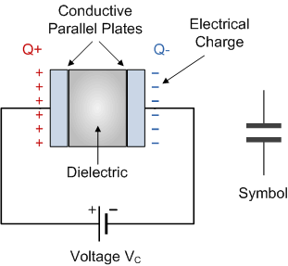
The parallel plate capacitor is the simplest form of capacitor. It can be constructed using two metal or metallised foil plates at a distance parallel to each other, with its capacitance value in Farads, being fixed by the surface area of the conductive plates and the distance of separation between them. Altering any two of these values alters the the value of its capacitance and this forms the basis of operation of the variable capacitors.
Also, because capacitors store the energy of the electrons in the form of an electrical charge on the plates the larger the plates and/or smaller their separation the greater will be the charge that the capacitor holds for any given voltage across its plates. In other words, larger plates, smaller distance, more capacitance.
By applying a voltage to a capacitor and measuring the charge on the plates, the ratio of the charge Q to the voltage V will give the capacitance value of the capacitor and is therefore given as: C = Q/V this equation can also be re-arranged to give the more familiar formula for the quantity of charge on the plates as: Q = C x V
Although we have said that the charge is stored on the plates of a capacitor, it is more correct to say that the energy within the charge is stored in an “electrostatic field” between the two plates. When an electric current flows into the capacitor, charging it up, the electrostatic field becomes more stronger as it stores more energy.
Likewise, as the current flows out of the capacitor, discharging it, the potential difference between the two plates decreases and the electrostatic field decreases as the energy moves out of the plates.
The property of a capacitor to store charge on its plates in the form of an electrostatic field is called the Capacitance of the capacitor. Not only that, but capacitance is also the property of a capacitor which resists the change of voltage across it.

The Capacitance of a Capacitor
Capacitance is the electrical property of a capacitor and is the measure of a capacitors ability to store an electrical charge onto its two plates with the unit of capacitance being the Farad (abbreviated to F) named after the British physicist Michael Faraday.
Capacitance is defined as being that a capacitor has the capacitance of One Farad when a charge of One Coulomb is stored on the plates by a voltage of One volt. Note that capacitance, C is always positive in value and has no negative units. However, the Farad is a very large unit of measurement to use on its own so sub-multiples of the Farad are generally used such as micro-farads, nano-farads and pico-farads, for example.

Voltage Rating of a Capacitor
All capacitors have a maximum voltage rating and when selecting a capacitor consideration must be given to the amount of voltage to be applied across the capacitor. The maximum amount of voltage that can be applied to the capacitor without damage to its dielectric material is generally given in the data sheets as: WV, (working voltage) or as WV DC, (DC working voltage).
If the voltage applied across the capacitor becomes too great, the dielectric will break down (known as electrical breakdown) and arcing will occur between the capacitor plates resulting in a short-circuit. The working voltage of the capacitor depends on the type of dielectric material being used and its thickness.
The DC working voltage of a capacitor is just that, the maximum DC voltage and NOT the maximum AC voltage as a capacitor with a DC voltage rating of 100 volts DC cannot be safely subjected to an alternating voltage of 100 volts. Since an alternating voltage has an r.m.s. value of 100 volts but a peak value of over 141 volts!.
Then a capacitor which is required to operate at 100 volts AC should have a working voltage of at least 200 volts. In practice, a capacitor should be selected so that its working voltage either DC or AC should be at least 50 percent greater than the highest effective voltage to be applied to it.
Another factor which affects the operation of a capacitor is Dielectric Leakage. Dielectric leakage occurs in a capacitor as the result of an unwanted leakage current which flows through the dielectric material.
Generally, it is assumed that the resistance of the dielectric is extremely high and a good insulator blocking the flow of DC current through the capacitor (as in a perfect capacitor) from one plate to the other.
However, if the dielectric material becomes damaged due excessive voltage or over temperature, the leakage current through the dielectric will become extremely high resulting in a rapid loss of charge on the plates and an overheating of the capacitor eventually resulting in premature failure of the capacitor. Then never use a capacitor in a circuit with higher voltages than the capacitor is rated for otherwise it may become hot and explode.

CONCLUTION :
The purpose of the system is to use mobile phone’s inbuilt Bluetooth facility for automation. Different hardware and software unit of the system are described. The complete application software has been designed using Android, using JAVA Language. The HAS furnishes a good paradigm for any Automation System based on Android Mobile Phone and Bluetooth.

