SIMULATION OF AUTONOMOUS FLIGHT CONTROL SYSTEM
CHAPTER 1
INTRODUCTION
  - OVERVIEW
AFCS seeks to automate all primary functions of the flight control architecture. With AFCS, a higher level of ease and flexibility can be given to commercial, military and drone pilots in the areas of flight, aerial maneuvering and warfare. The various systems demonstrated in the AFCS system will pave the way to automation.

Using various sensors like the accelerometer, GPS module, 3 Axis gyroscope, compass and an ultrasonic range finder, the primary guidance and navigation functions of the UAV can be automated. Additional stabilization controls should be programmed into the Raspberry Pi which is serving as the heart of the System which will provide additional security in case of any external failures.

This seeks to be an advanced system that unites all major functions of automated systems in existence and removing their dependency on a human pilot.
Additionally this projects seeks to further simplify the human effort needed to pilot a plane or even a small UAV by implementing a Direct Voice System that enables the UAV to be piloted without any physical contact by the controller and merely his voice input is enough to perform all programmed tasks with ease.

Using the derivative of the haversine formula and the trigonometric calculation, the need for a GPS module is eliminated all the while retaining almost all of the features with a minor tradeoff in accuracy. Using only the start coordinates and the end coordinates, the bearing, desired speed, and the accurate distance for travel can be calculated that perfectly emulates the functionality of a GPS system.

CHAPTER 2
SYSTEM ANALYSIS
2.1 EXISTING SYSTEM
` The ones in existence are merely passive control systems being implemented in 5th generation avionics architecture. Advancements in this field is undertaken by all leading manufacturers and designers like NASA with its Intelligent Flight Control System which incorporates Machine Learning into the system and MIT CSAIL autonomous drone system. However Direct Voice Input systems do not exist for UAVs and the IRS / INS systems share a similarity with the CSNS algorithm.
The topic of this project is still being researched as the accuracy, safety and efficiency of this product is not proven to be reliable. This is also a highly controversial topic as people misinterpret this as the birth of terminator and other fictional derivatives. Hence the existing systems are merely experimental models and none are close to being a human replacement.
Direct Voice Input systems do not exist as of now after losing favor in the year 2000 as the technology present then didn't offer a high level of accuracy especially for speech processing let alone DVI. Due to the high levels of error involved and the risks that followed, this system fell out of favor.
The Inertial Navigation / Reference system is currently in use by all commercial and military aeroplanes and guided missiles but never in an UAV. The normal INS or the IRS system uses the data from accelerometer to judge the missile or the plane’s speed and angular velocity, the compass derives the bearing and using the initial bearing a rough output of the real time current location can be calculated. However the total cost of the system is quite high which is why the GPS system seems a to be a better option when compared.

2.2 DISADVANTAGES OF EXISTING SYSTEM

PID controllers have slow response, overshoot, long adjustment also has limitations in optimality and robustness. PID controllers are mostly used to control a system so it is used in small UAVs. Accuracy and Stability are two important factors to achieve a target in small UAV.
Stability combinations is Kalman and PID controller. To solve unexpected condition such as the weather conditions, faults in telecommunication link and UAV subsystem failures etc. the fuzzy logic controller is best suited.

The current research work will be extended to the more tolerant design with interface specially focused to UAV inter and intra communications.

2.3 PROPOSED SYSTEM

The proposed AFCS system like the other systems being researched is only efficient and accurate to a certain level. But however it is also meant to be a technology demonstrator for the simplified autonomous system. The AFCS system will have most of the features of most autonomous flight control systems with simpler circuits and lower prices. The proposed AFCS system is meant to be the next level of Flight automation. This seeks to be an advanced system that unites all major functions of automated systems in existence and removing their dependency on a human pilot. This additionally seeks to increase the accuracy and efficiency of autonomous systems making flight much safer.

Along with the proposed autonomous system the DVI system will simplify radio control operations significantly and the CSNS system will also provide an accurate and viable alternative to the GPS module, while retaining all of it features.
The Direct Voice input will use an advanced speech processing system that is capable of approximately 80-90 % accuracy which is considerably higher than the system implemented in the 2000s in the F 22 program. This will enable a higher level of control flexibility and ease that will go a long way in redefining flight controls.
The CS Navigation system is also an upgrade over the preceding INS and the IRS system which shares a level of similarity.

This is accomplished as the only components that are required for AANS to function is the initial bearing, initial coordinates and the end coordinates after which AANS can calculate the next coordinate, required bearing change and the distance to the target location.

CHAPTER 5

RESULTS AND DISCUSSION

Testing and performance evaluation of the FCS has been performed on several platforms
The goal of flight testing was to evaluate the performance of the control system, and to tune it in order to increase that performance, addressing any problems discovered. All flight tests were performed with a human pilot who could, at any time, either fly the plane manually or allow the FCS to control the plane. During a flight, all of the FCS parameters discussed in the Controls section previously could be changed from the ground control station. Initial values for these were chosen by estimation based on the vehicle.

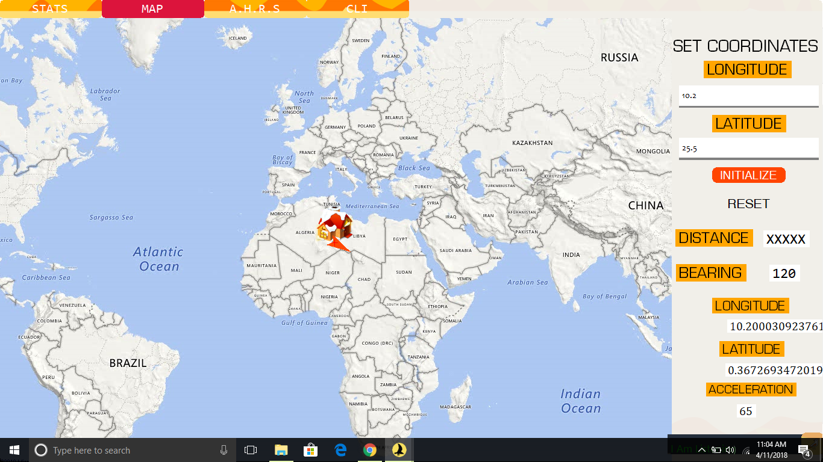

FIGURE 22

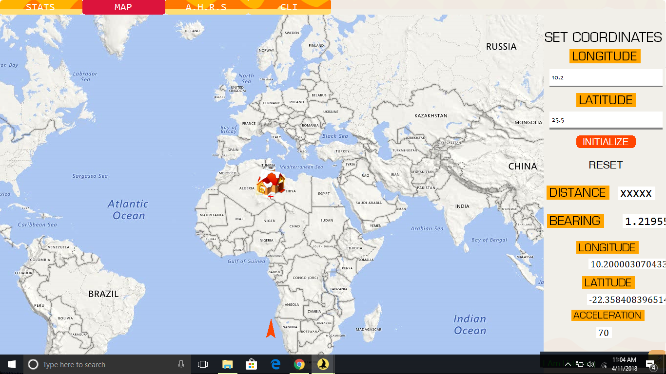
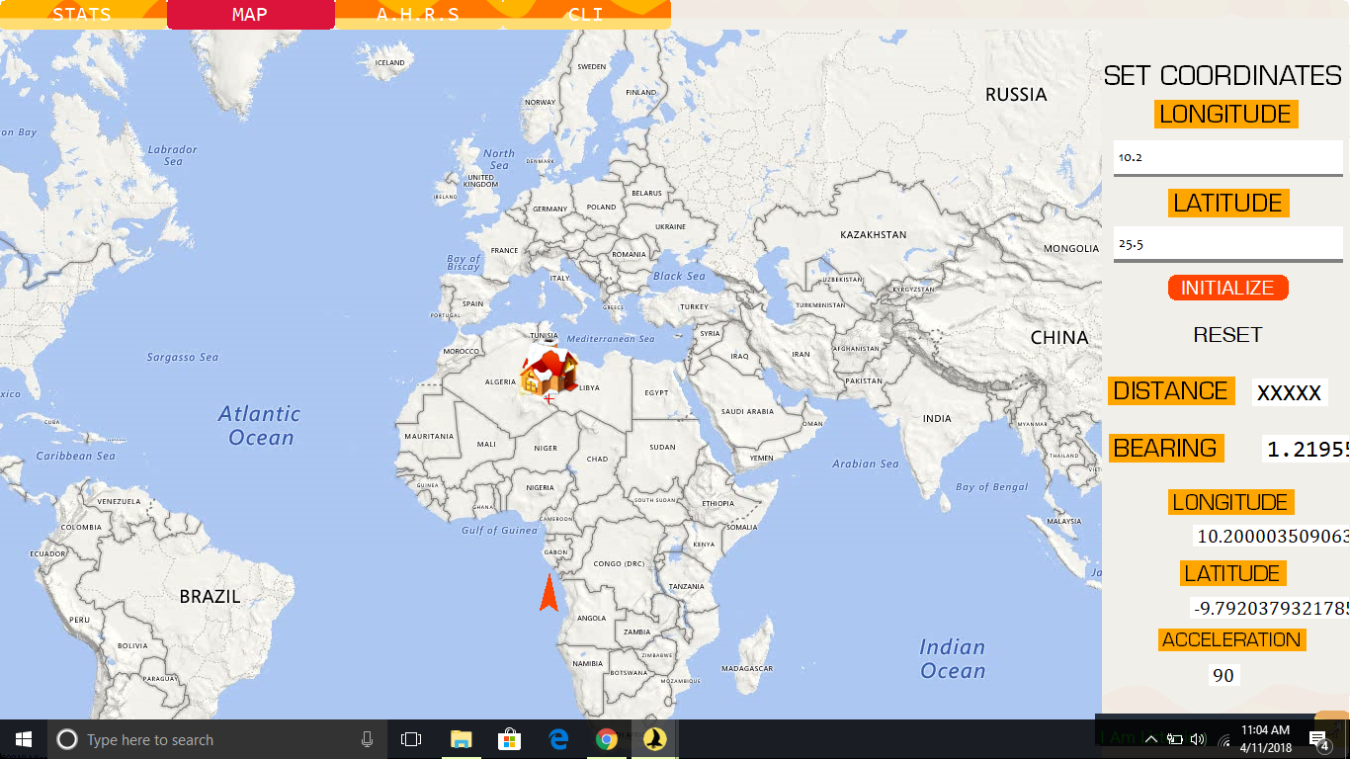
FIGURE 23

FIGURE 24
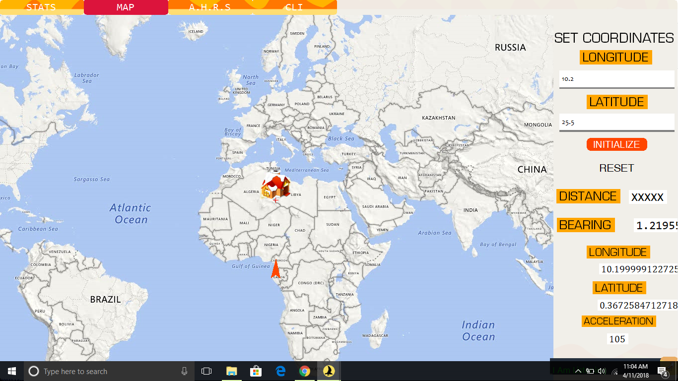
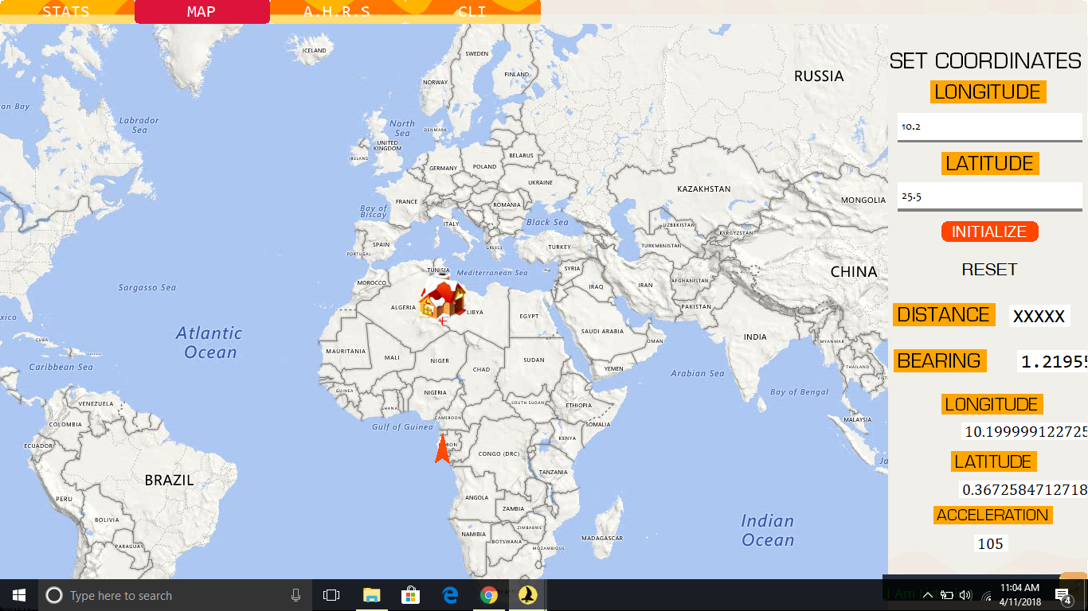
FIGURE 25
Figure 26

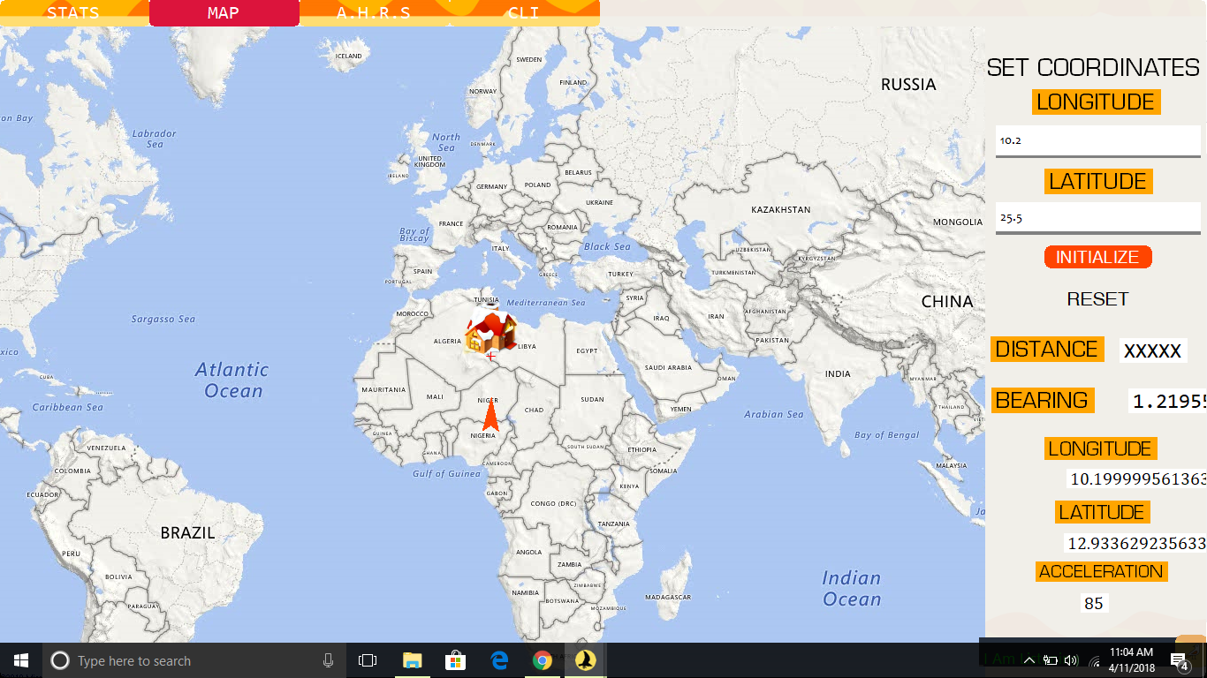
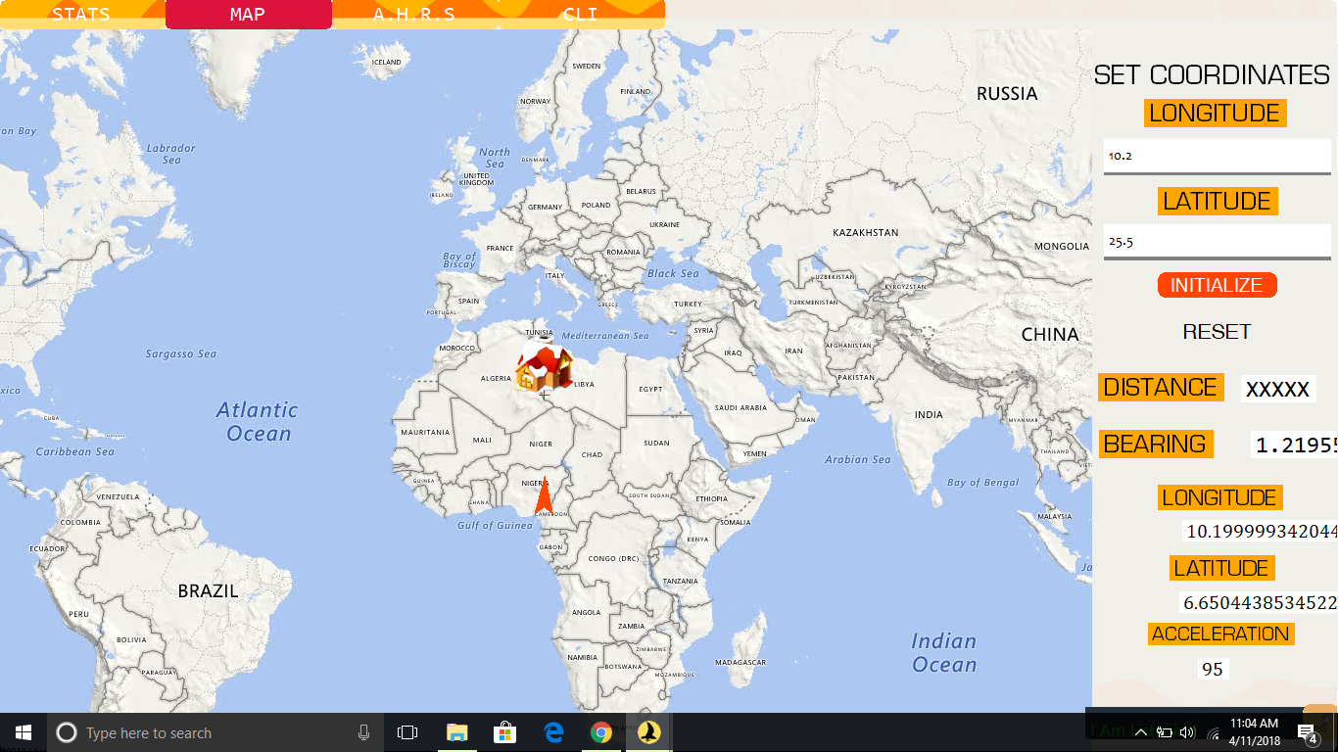
Figure 28
FIGURE 27

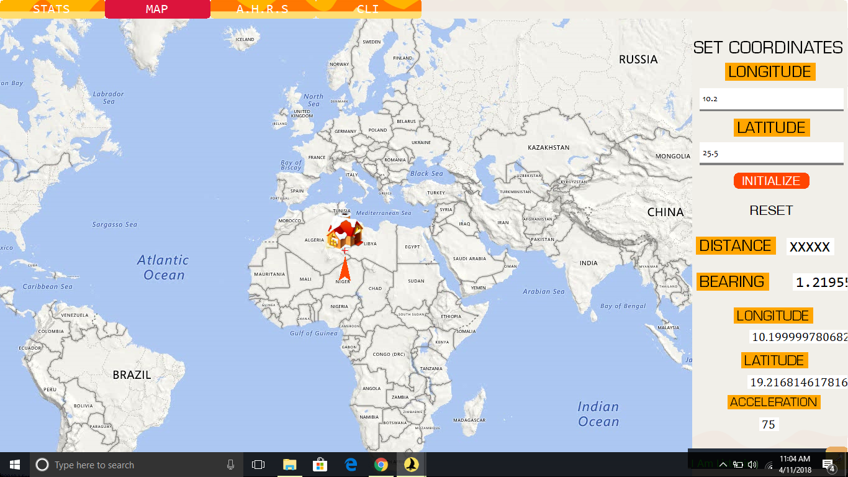

FIGURE 29

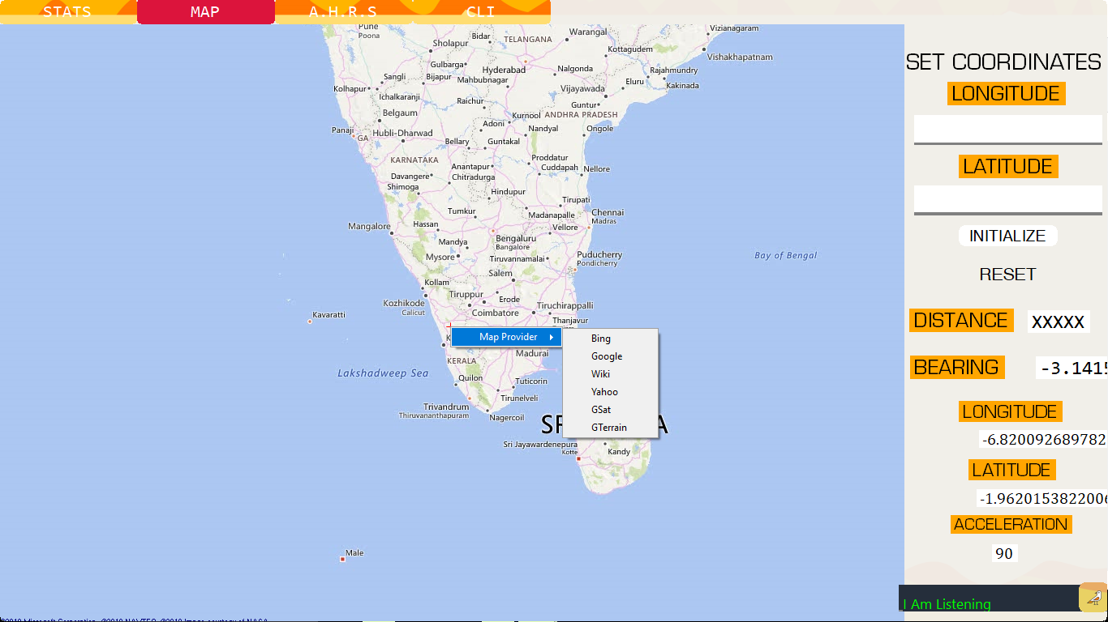
Figure 30

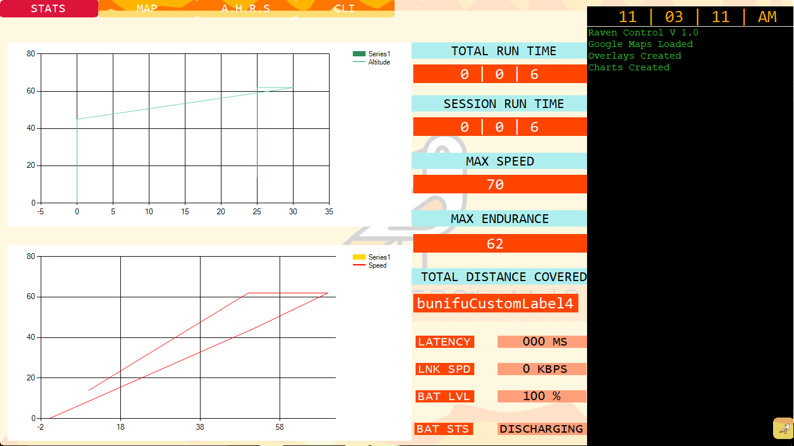
Figure 32
FIGURE 31
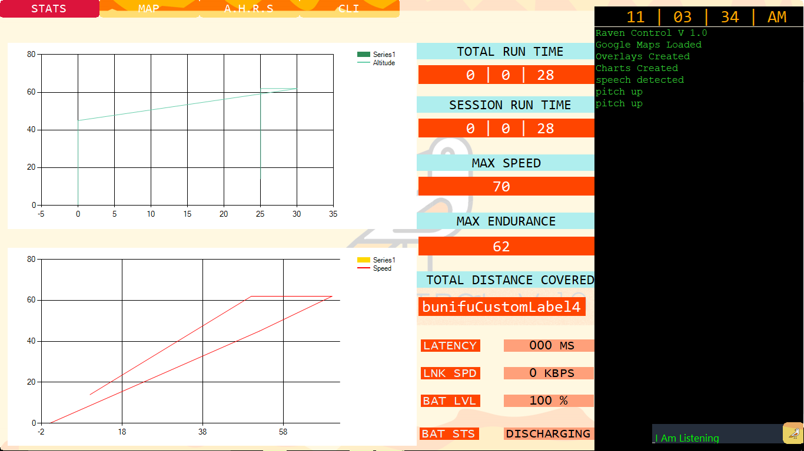
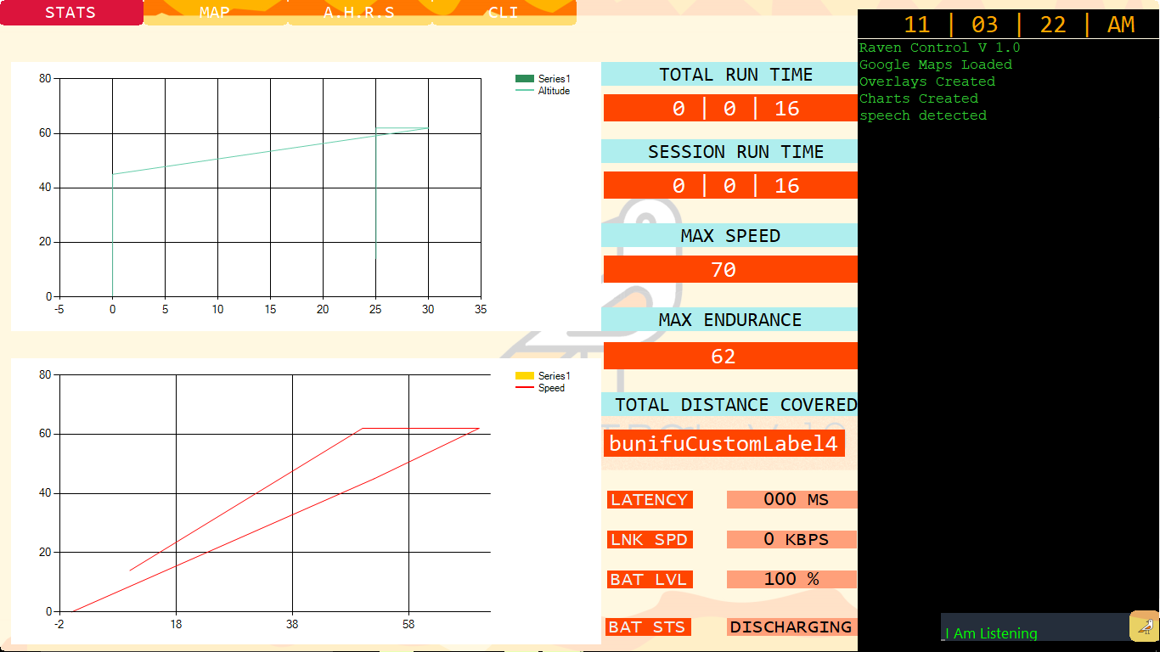
Figure 34
FIGURE 33
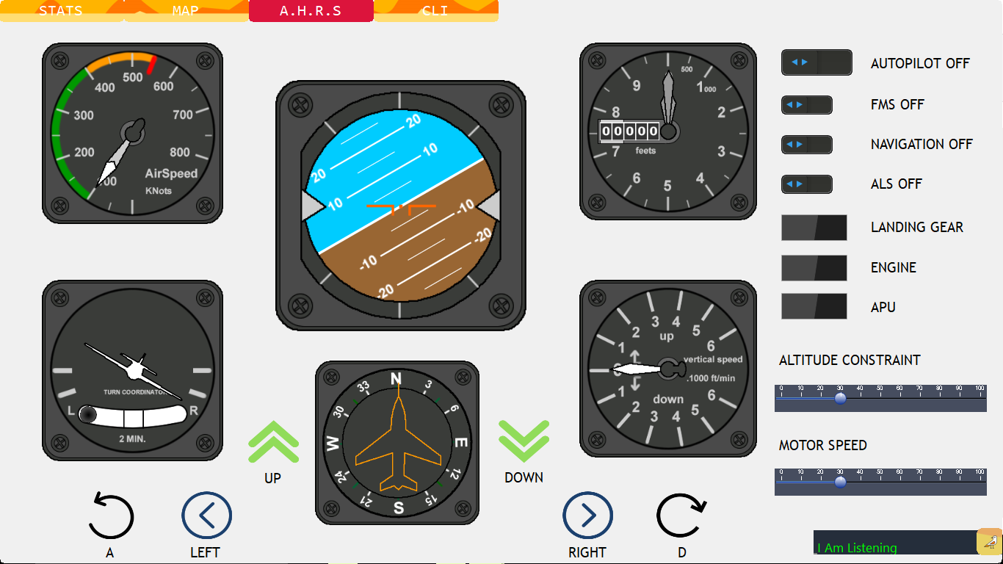
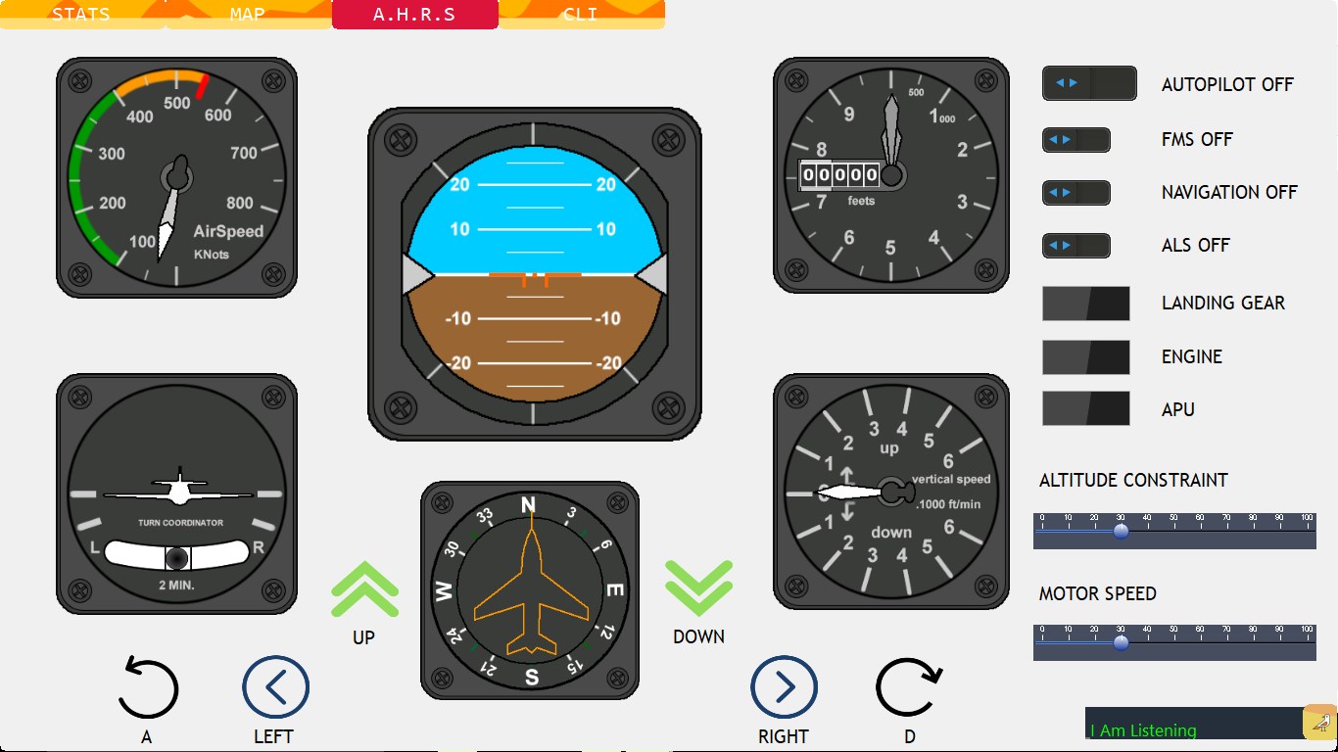
Figure 36
FIGURE 35
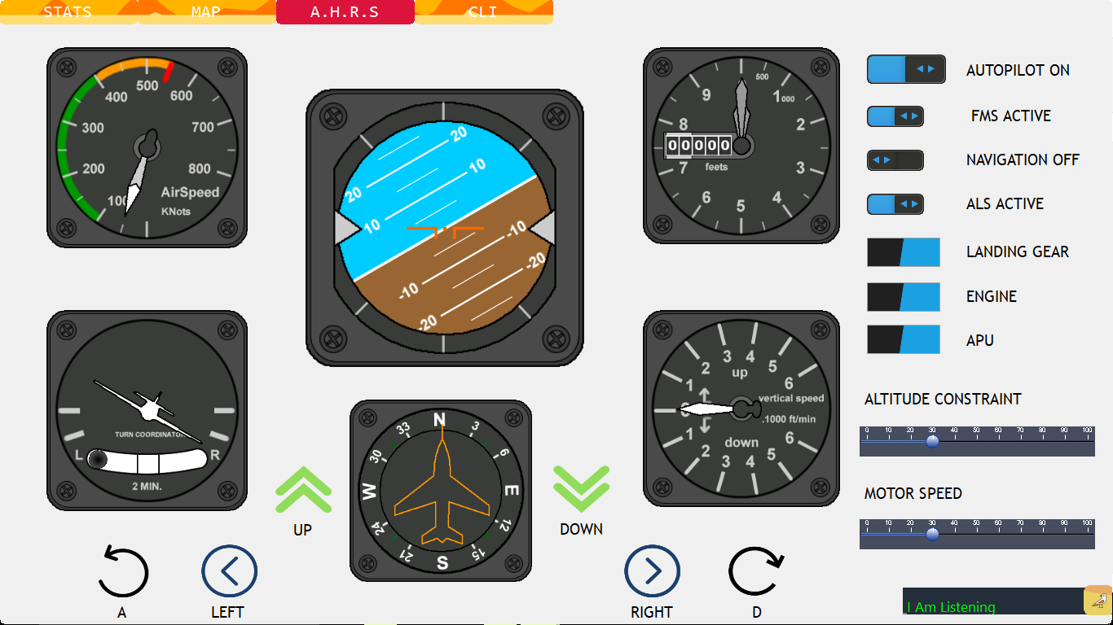
FIGURE 36
CHAPTER 6

CONCLUSION

Using various sensors like the accelerometer, GPS module, 3 Axis gyroscope, compass and an ultrasonic range finder, the primary guidance and navigation functions of the UAV can be automated. Additional stabilization controls should be programmed into the Raspberry Pi which is serving as the heart of the System which will provide additional security in case of any external failures.

This seeks to be an advanced system that unites all major functions of automated systems in existence and removing their dependency on a human pilot.

Additionally this projects seeks to further simplify the human effort needed to pilot a plane or even a small UAV by implementing a Direct Voice System that enables the UAV to be piloted without any physical contact by the controller and merely his voice input is enough to perform all programmed tasks with ease.

REFERENCES

- www.wikipedia.com
- www.CSAIL.MIT.EDU
- https://ocw.mit.edu/courses/aeronautics-and-astronautics/16-333-aircraft-stability-and-control-fall-2004/
- https://ieeexplore.ieee.org/document/7791971/

- https://ieeexplore.ieee.org/document/1171440/
- Design of autonomous flight control system for small-scale UAV, by ShuoWang and ZiyangZhen, IEEE DOI: 10.1109/CGNCC.2014.7007468
- An analytical review on FPGA based autonomous flight control system for small UAVs, by Banwari Lal Sharma ; Narendra Khatri ; Abhishek Sharma, IEEE DOI: 10.1109/ICEEOT.2016.7754907
- Longitudinal dynamic system modelling of a fixed-wing UAV towards autonomous flight control system development: A case study of BPPT wulung UAV platform, by Fadjar R. Triputra; Bambang R. Trilaksono; Rianto A. Sasongko; M. Dahsyat , IEEEE DOI: 10.1109/ICSEngT.2012.6339294
- Development of autonomous flight control system for 50m unmanned airship, by Sang-Jong Lee ; Seong-Pil Kim ; Tae-Sik Kim ; Hyoun-Kyoung Kim ; Hae-Chang Lee, IEEE DOI: 10.1109/ISSNIP.2004.1417504

