LABVIEW BASED ENGINE CONTROL UNIT USING RELAY
CHAPTER 1
INTRODUCTION

1.1 CONTROL UNIT
A control unit (CU) handles all processor control signals. It directs all input and output flow, fetches code for instructions from microprograms and directs other units and models by providing control and timing signals. A CU component is considered the processor brain because it issues orders to just about everything and ensures correct instruction execution.

A CU takes its input from the instruction and status registers. Its rules of operation, or microprogram, are encoded in a programmable logic array (PLA), random logic 0r read only memory.CU functions are as follows:
- Controls sequential instruction execution
- Interprets instructions
- Guides data flow through different computer areas
- Regulates and controls processor timing
- Sends and receives control signals from other computer devices
- Handles multiple tasks, such as fetching, decoding, execution handling and storing results

CUs are designed in two ways:
- Hardwired control: Design is based on a fixed architecture. The CU is made up of flip-flops, logic gates, digital circuits and encoder and decoder circuits that are wired in a specific and fixed way. When instruction set changes are required, wiring and circuit changes must be made. This is preferred in a reduced instruction set computing (RISC) architecture, which only has a small number of instructions.
- Microprogram control: Microprograms are stored in a special control memory and are based on flowcharts. They are replaceable and ideal because of their simplicity.
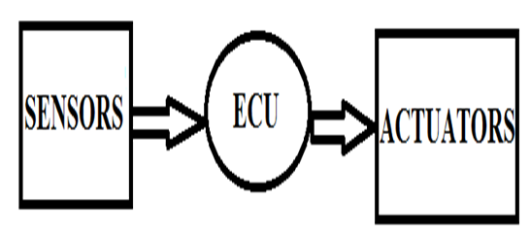
Fig. 1.1 Block Diagram Control Unit

CHAPTER 2
SYSTEM ANALYSIS
  - EXISTING SYSTEM
The ECU is an extremely reliable piece of hardware which has the capability to receive and process information hundreds of times per second. At the heart of the ECU is the microprocessor. It is the processing center of the ECU where input information is interpreted and output commands are issued. The process and output functions of the ECU can be divided into the following six areas:
- Fuel Injection Control
- ESA / VAST Spark Advance Control
- Idle Speed Control
- Self Diagnosis
- Related Engine and Emissions Control
- Failure Management (fail-safe and back-up)

Fuel, spark, and failure management functions will be covered individually in this chapter. Idle Speed Control, related engine systems, emissions control systems, and the self diagnosis system.

2.2 DISADVANTAG OF EXISTING SYSTEM
- Electronics control system have less reliability
- High cost.
- In Electronics control system have less speed when compare to control systems using DAQ
2.3 PROPOSED SYSTEM
It is one of the automotive based industrial projects. The project is mainly based upon the automotive testing purpose for ECU (Engine Control Unit) with different supply voltage such as 12V and 24 V. It is a newer innovation; it has never been existing in the market.
CHAPTER 4
SOFTWARE DESCRIPTION
4.1 SOFTWARE DESCRIPTION
4.1.1 Introduction to LabVIEW
The name LabVIEW is shortened form of its description: Laboratory Virtual Instrument Engineering Workbench. LabVIEW is a visual programming language: it is a system-design platform and development environment that was aimed at enabling all forms of system to be developed. It uses icon instead of using lines of text to create applications.
LabVIEW was developed by National Instruments as a workbench for controlling test instrumentation. However its application has spread well beyond just test instrumentations to the whole field of system design an operation. LabVIEW is a graphical structured dataflow Language sometimes referred to as “G” not to be confused with G-code.


Fig. 4.1 LabVIEW Logo
4.1.1.1 FRONT PANEL WINDOW
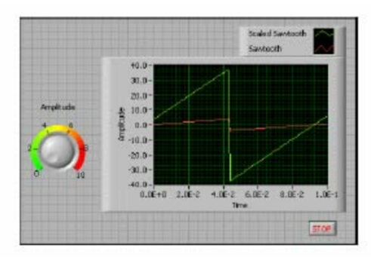
Fig. 4.2 Front panel of LabVIEW
The most advanced LabVIEW development systems offer the ability to build stand-alone applications. Furthermore, it is possible to create distributed applications, which communicate by a client-server model, and thus earlier to implement due to the inherently parallel nature of G.

4.5 INTERFACING TO DEVICES
LabVIEW includes extensive support for interfacing to devices, instruments, camera and other devices. User interface to hardware by either writing direct bus commands or using high-level, design-specific, drivers that provide native LabVIEW function node for controlling the device.
LabVIEW includes built-in support for NI hardware platforms such as CompactDAQ and CompactRIO, with large number of device-specific blocks for such hardware, the Measurements and Automation explorer (MAX) and virtual Instruments Software Architecture toolsets. National Instruments makes thousands of devices available for download on the NI Instruments Driver Network.
4.6 CODE COMPILING
LabVIEW includes a complier that produces native code for the CPU platform. This aids performance. The graphical code is translated into executed machine code by a complier The LabVIEW syntax is strictly enforced during the editing process and complied into the executable machine code when requested to run or upon saving. In the latter case, the executable and the source code are merged into the single file.
The executable runs with the help of LabVIEW run-time engine, which contains some pre-complied code to perform common tasks that are defined by the G language. The run time engine reduces compiling time and provides a consistent interface to various operating system, graphic system, hardware components, etc.
The run time environment makes the code portable across platforms. Generally, LabVIEW code can be slower than equivalent complied C code, although the differences often lie more with program optimization than inherent execution speed.

4.7 LARGE LIBRARIES
Many library with a large number of functions for data acquisition, signal generation, mathematic, statistics, signal conditioning, analysis, etc., along with numerous for functions such as integration, filters, and other specialized abilities usually associated with data capture from hardware sensors is enormous.
In addition, LabVIEW includes text-based programming components named Math script with added functions for signal processing, analysis, and mathematics. Math script can be integrated with graphical programming using script nodes and uses script nodes and uses a syntax that is compatible generally with MATLAB.

4.8 ECOSYSTEM
Due to the longevity and popularity of the LabVIEW language, and the ability for users to extend its functions, a large ecosystem of third party add-ons has developed via contribution from the community. This ecosystem is available on the LabVIEW Tools Network, which is a marketplace for both free and paid LabVIEW add-ons.

4.9 USER COMMUNITY
There is a Low-Cost LabVIEW student edition aimed at educational institutions for learning purposes. There is also an active community of LabVIEW users who communicate through several electronic mailing sites and internet forums.

4.10 A SIMPLE PROGRAM
Input a numeric data a from the Front panel and display the result b after multiplication: b=constant. a
4.10.1 Procedure
- Find and drag the Numeric control and numeric indicator respectively, to the from panel: View – controls palette- Modern- numeric- Numerical Control/numerical Indicator
- Find and drag multiply an Numeric Constants, respectively, into the Background Diagram: View – functional palette- Programming- Numeric Multiply/Numeric Constant
- Wire the associated icons: Clean up the wire properly after complete our code
- Running the code: Run the program after complete our code

4.11 APPLICATIONS
- Testing and Measurements
- Hardware control
- Signal processing
- Image processing

CHAPTER 5
RESULTS AND DISCUSSIONS
5.1 EXPERIMENTAL RESULTS
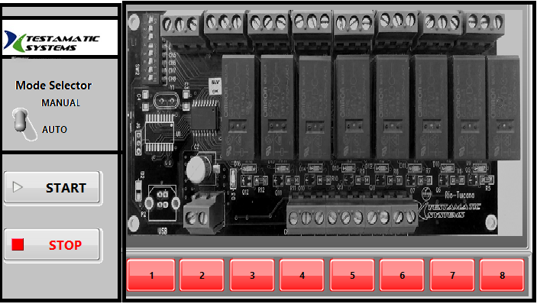
Fig. 5.1 Front Panel view of LabVIEW based Engine Control Unit using Relay
We use USB cable to interface the relay board with our personal computer. Initially, we must install the MCP2200 Driver kit for the connections. After install that kit, we must easily interface the relay board without any problem. The use of driver kit is to call the DLL library file for our applications.
5.2 RECOGNITION RESULT
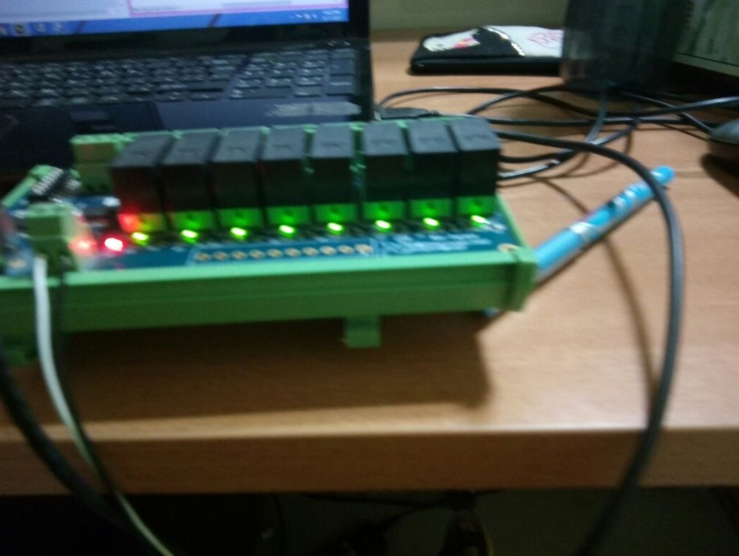
Fig. 5.2 Physical View of Relay Control Unit using LabVIEW
First, we select the mode Automatic or Manual mode. And the click the start button. If we press the Manual mode, whatever channel we want the switch on or off that channel will press in front panel according to that our relay board will also switch on or off. In Automatic mode, they will switch the channel one by one automatically after 3 seconds. That will simultaneously indicate in our front panel

CHAPTER 6
CONCLUSIONS & FUTURE ENHANCEMENTS
It is of high importance to make a report of the switching the relay for the application and for Engine Control Unit. In the real time, SSR will used in the industries because it has to control the high voltage circuit by low voltage circuit. It has no moving parts inside the relay. By using LabVIEW, it is easy to switching the relay channel for our requirements and also cost constraints.
6.1 CONCLUSION
This project has described the main areas where Hitachi is active in the field of environmentally friendly engine control systems. This performance of this control equipment and the associated control techniques have a large impact on fuel consumption, emissions and other aspects of engine performance.
6.2 FUTURE ENHANCEMENT
Our Comprehensive offering includes test solutions such as validation systems and automated test equipment (ATE) for today’s automotive instrument clusters and dashboards. Our Multimedia tester can simultaneously test multiple technologies such as video, audio, USB, Ethernet and wireless and provide support for all new-generations multimedia and broadcasting products. There are two types of test. They are DUT and UUT. In DUT. it is used in Radio, Infotainment systems - automotive HVAC control panels. In UUT, it is used to test data communication, display colors and backlight, Waveforms stimuli calibration.
APPENDICES
Certificate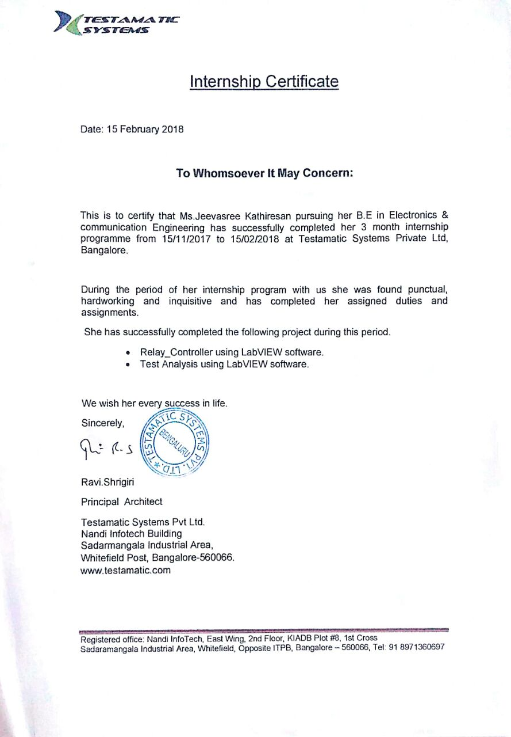
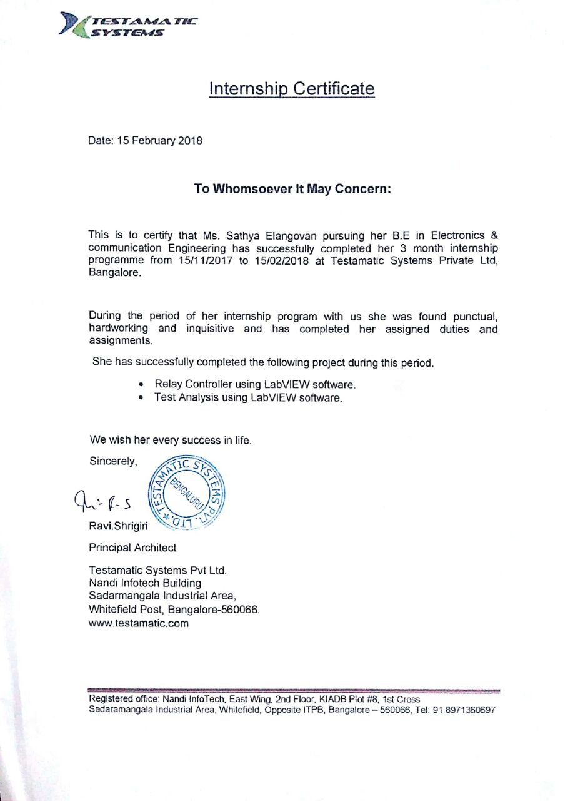

REFERENCES
- S.Yamaoka et al., “A Study of controlling the Auto-Ignition and Combustion in a Gasoline HCCI Engine,”SAE Paper 2004-01-0942, 2004.
- J.Ishii et al., “Reduction of CO2 Emissions for Automotive Systems,” Hitachi Review 57.pp. 184-191 (Sep.2008)
- M.Osuga et al., “New Direct Fuel Injection Engine Control Systems for Meeting Future Economy Requirements and Emission Standards,” Hitachi Review 53, pp.193-199(NOV, 2004).
- http://pdf1.alldatasheet.com/dataheet.pdf/view/348690/MICROCHIP/MCP2200.html and http://www.microchip.com.
- G. Gonzalez, J.A. Florez and S. Arab, “Development of the management strategies of the ECU for an internal combustion engine computer simulation”, Mechanical Systems and Signal Processing Vol22, 2008, PP 1356-1373.
- E.V Vijay, C.V.R. Rao, E.V. Kumar and G.N. Swamy, “Electronic control unit for an adaptive cursive control systems and engine management system in a vehicle using electronic fuel injection”, 2010 IEEE International Conference on Emerging Trends in Robotics Communication Technologies (INTERACT), INSPEC Accession Number: 11822592, Chennai, India, 3-5 Dec 2010, PP 143-146.

