WEB BASED REMOTE TEST SOLUTION

CHAPTER 1

INTRODUCTION
Users during research sessions, and the ability to probe into the deeper “why” right there in the moment, are key to build buy in from stakeholders. Sometimes, however, this just isn’t an option.You might have users who are geographically dispersed and you don’t have a travel budget. You might not have a lab in all the areas you’d need to test or the appropriate lab equipment. Sometimes you just simply don’t have the capacity or time to bring users into the lab and handle the logistics (directions, parking, feeding, etc.).This project neglect these issues and done the testing successfully.

1.1 OVERVIEW OF THE PROJECT
The testing has many types they differ from each other,in this project we can do the testing in different location from the testing equipments location.this system has three main blocks in that web client,server,testing client.the web client is user side location that client has the full control for the testing process the client use the resources as HTML files from the database given by the server.the server is the intermediate for both clients and it communicate with the database to share the resources the communication used in the project is socket communication it is event based duplex communication.and final block is testing client it do the execution of web clients command it runs by the python programming language.
One of the biggest benefits of remote testing is that it’s very flexible, this neglects the distance barrier for doing the test, and it can be very helpful on the vital situation in the case of lack equipments in the tester’s location means the testing can bedone by this proposed concept

CHAPTER 4

IMPLEMENTATION AND RESULTS

4.1 BLOCK DIAGRAM

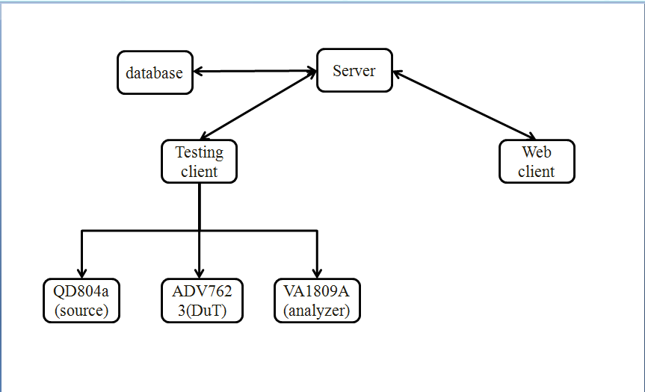Figure 4.1 block diagram

4.2 SERVER
A server is a computer program that provides services to other computer programs (and their users) in the same or other computers. The computer that a server program runs in is also frequently referred to as a server. That machine may be a dedicated server or used for other purposes as well.In the client/server programming model, a server program awaits and fulfills requests from client programs, which may be running in the same or other computers. A given application in a computer may function as a client with requests for services from other programs and also as a server of requests from other programs.
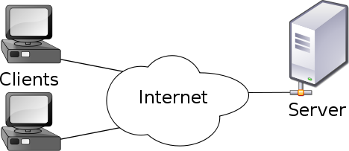

Figure 4.2.server

Here are a few types of servers, among a great number of other possibilities An application server is a program in a computer in a distributed network that provides the business logic for an application program. A proxy server is software that acts as an intermediary between an endpoint device, such as a computer, and another server from which a user or client is requesting a service. A mail server is an application that receives incoming e-mail from local users (people within the same domain) and remote senders and forwards outgoing e-mail for delivery. A file server is a computer responsible for the central storage and management of data files so that other computers on the same network can access them.A policy server is a security component of a policy-based network that provides authorization services and facilitates tracking and control of files.
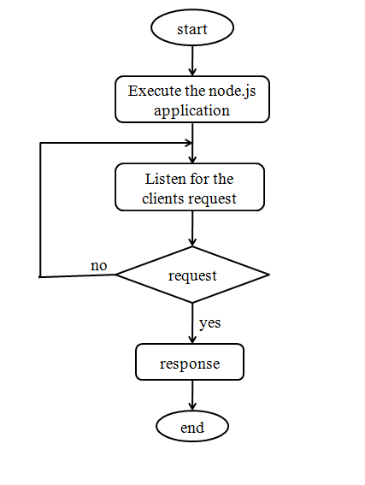
Figure 4.2 flow of server

Here the server made by the node.js IDE by the java script programming language.And the communication protocol is socket communication and it is event based duplex communication.The server listen for the event from both client and give the respective response to the clients.
4.3.2 TESTING CLIENT
The testing client is fully run by the python programming language.The testing client initially collect the all information about the device connected to its COM port and its baud rate. then it login with the server and waits for the commands to execute, when the testing command received from the server the testing client split the command for respective device and write the command via serial port and get the response from the device then it sends the data to the server. organized as key-value pairs. The key is a unique identifier of the data and the value is the data itself or a pointer to the data’s location. Standard database functions are all performed by JavaScript. OS-agnostic, device-independent Web standards allow databases to perform well for the widest variety of users.
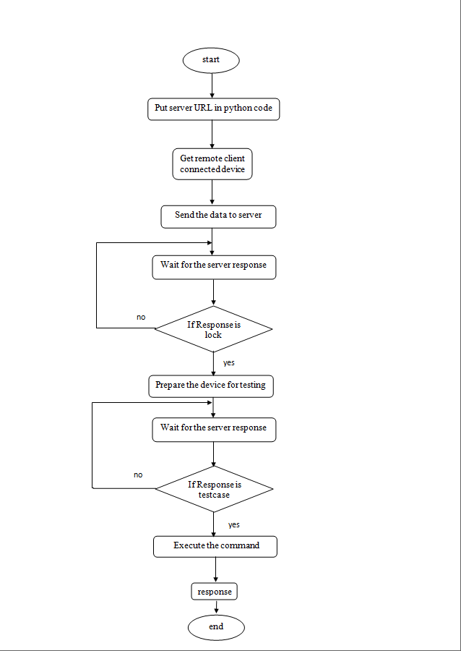

Figure .4.3.2 flow of testing client

4.4 DATABASE:
CouchDB is an open source NoSQL database based on common standards to facilitate Web accessibility and compatibility with a variety of devices.NoSQL databases are useful for very large sets of distributed data, especially for the large amounts of non-uniform data in various formats that is characteristic of big data. Data in CouchDB is stored in the JavaScript object notification (JSON) format, and organized as key-value pairs. The key is a unique identifier of the data and the value is the data itself or a pointer to the data’s location. Standard database functions are all performed by JavaScript. OS-agnostic, device-independent Web standards allow databases to perform well for the widest variety of users.
In couch DB the webclient’s html file and the testcases for the testing client are stored in has a document-oriented no SQL database architecture and is implemented in the concurrency-oriented language Erlang; the stored data in JSON format.
4.5 OUTCOME AND RESULT
The proposed system is run the node.js application in server,python application runs in testing client,at the time of URL put in the browser at web client.the testing client’s python application identifies the device name and its baudrate then it send the information.
To the server.the server send that to the web client.when the web client decides to execute the testcase means the server fetch the testcase from the database and it pass it to the tsting client,then the testing client execute the test commands and get the response from the devices that response are move to server and database.the testing result are stored in the data base in JSON format.
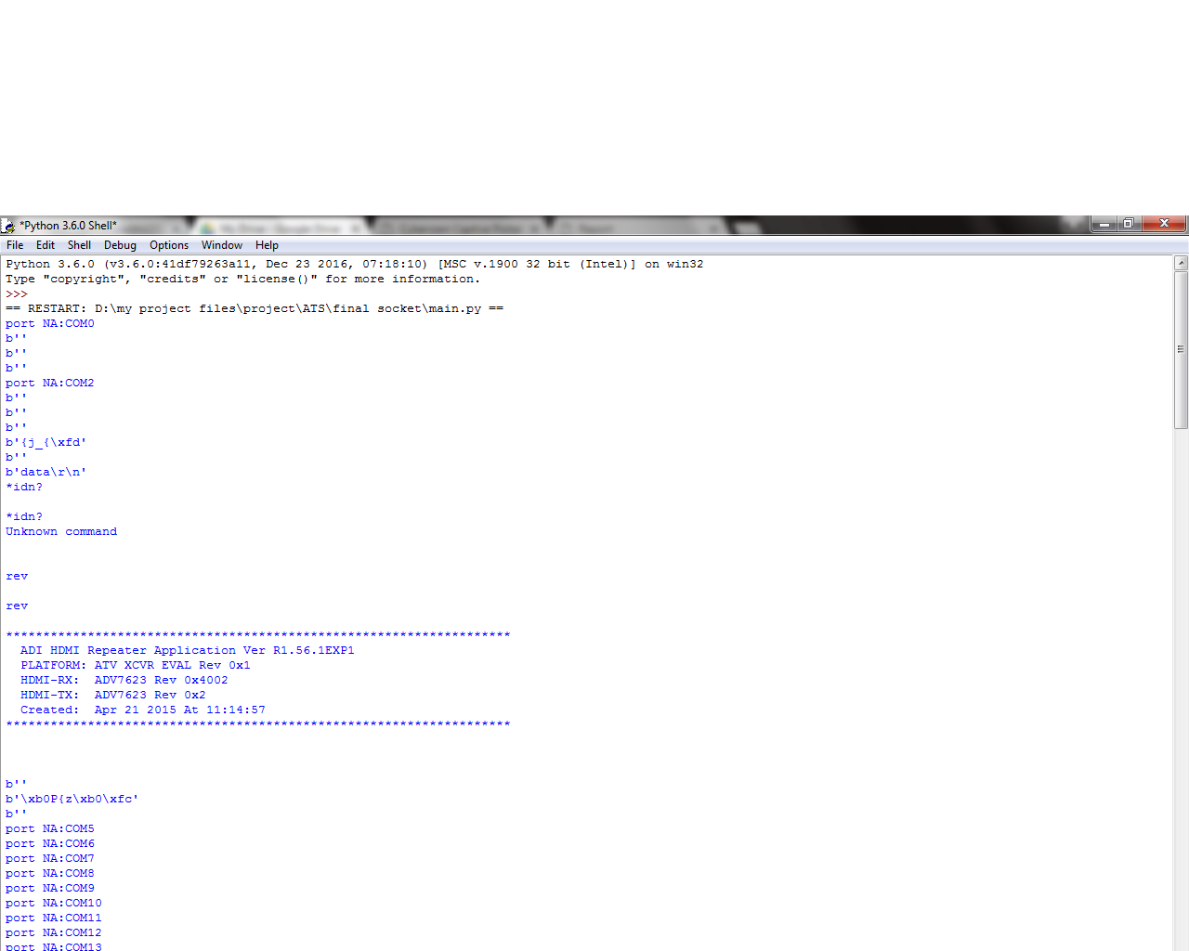
IN TESTING CLIENT
Step1:Python application detect the device name and respective baud rate

In database:
Stored testcases in DB
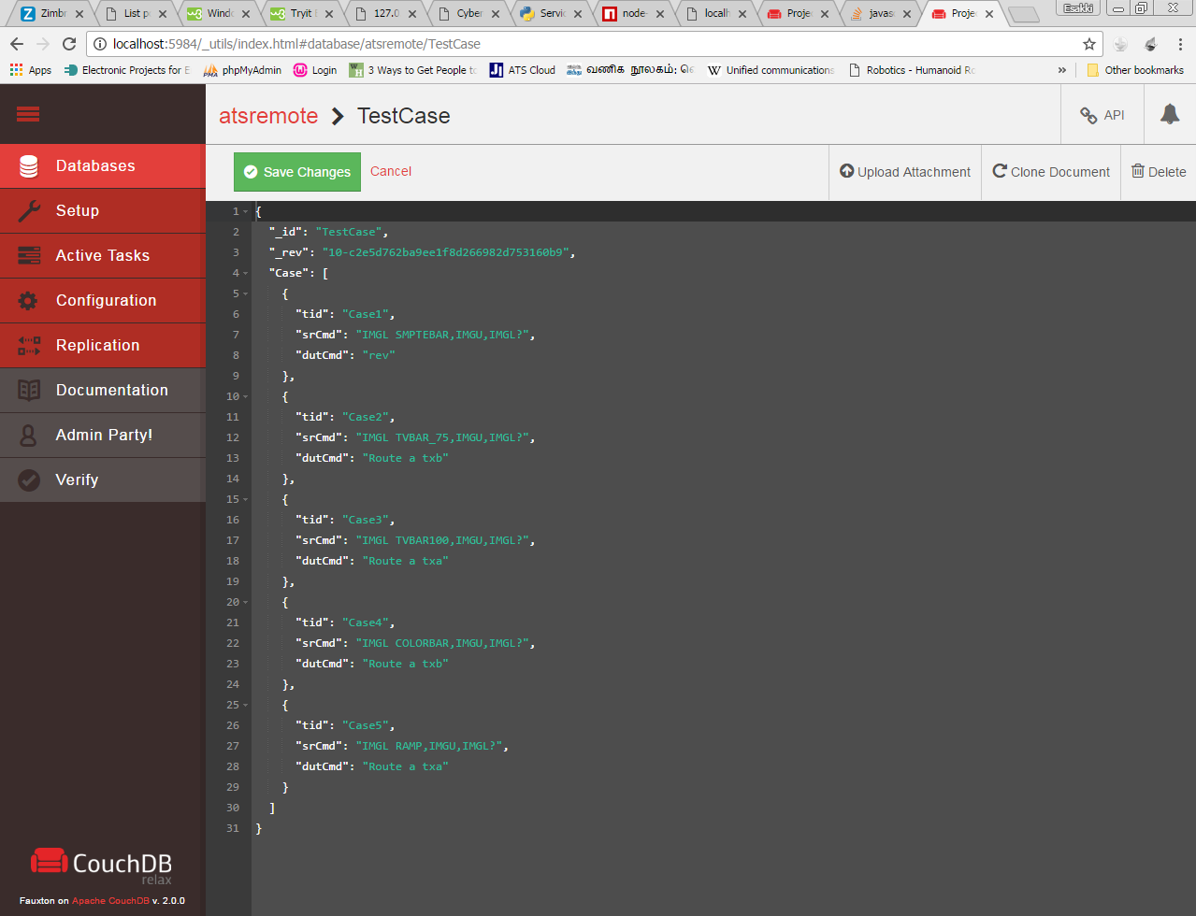
Fig.4.5.5 database view
Stored response from the testing client in DB
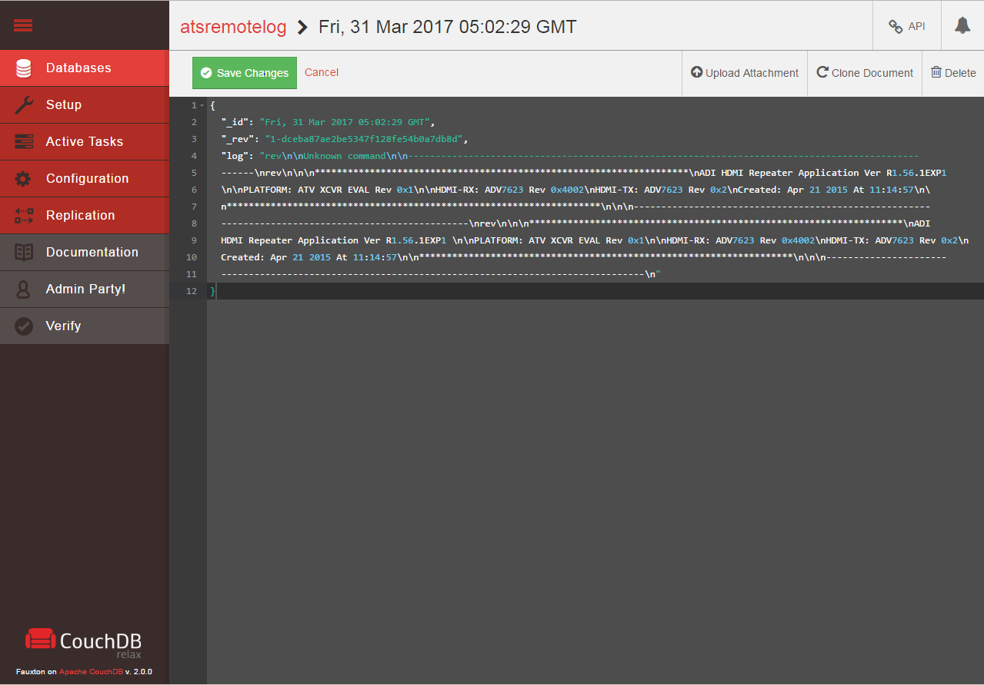
Fig.4.5.6 stored data in data base

CHAPTER 5

CONCLUSION

This project developed by those programming languages python, java script and markup languages HTML,CSS. Then the data storage is done by the couchDB database.

This system has script to automatically identify the device which is connected and its baudrate,if connected device unfortunately unplugged means the script detect and give the alert to the tester and researcher.

Under the proposed system we can test both audio and video signal,in the case that tester not need the equipment at his place to do the testing.he simply do the test via web to communicate with the equipments which is the tester want to test.the system reduces the distance barrier for the user and researcher at the testing process.

5.1 FUTURE SCOPE:

This project can implemented in different remote controllable systems.If the equipments availability is rare, more expensive and transporting the equipment is not possible means this project help in that situation.

5.2 REFERENCE
- Dennis G. Jerz (July 19, 2000). "Usability Testing: What Is It?". Jerz's Literacy Weblog.Retrieved June 29, 2016.
- Ardentia Technologies: Providing Cutting Edge Software Solutions and Comprehensive Testing Services Published by CIO Review, April 2016
- Kaner, Cem (November 17, 2006). "Exploratory Testing" . Florida Institute of Technology, Quality Assurance Institute Worldwide Annual Software Testing Conference, Orlando, FL. Retrieved November 22, 2014
- "Heuristic Evaluation". Usability First. Retrieved April 9, 2013.
- Bossavit, Laurent (2013-11-20). The Leprechauns of Software Engineering--How folklore turns into fact and what to do about it. Chapter 10: leanpub.
- Chalil Madathil, Kapil; Joel S. Greenstein (May 2011). "Synchronous remote usability testing: a new approach facilitated by virtual worlds". Proceedings of the 2011 annual conference on Human factors in computing systems.
- Computer. 32 (6): 113–114. Retrieved 2008-08-19.
- Leitner, A., Ciupa, I., Oriol, M., Meyer, B., Fiva, A., "Contract Driven Development Test Driven Development Writing Test Cases", Proceedings of ESEC/FSE'07: European Software Engineering Conference and the ACM SIGSOFT Symposium on the Foundations of Software Engineering 2007, (Dubrovnik, Croatia), September 2007
- Dabney Gough; Holly Phillips (2003-06-09). "Remote Online Usability Testing: Why, How, and When to Use It". Archived from the original on December 15, 2005.
- 9.Bach,James (June 1999). "Riskand Requirements-BasedTesting" (PDF).
- IEEE (1998). IEEE standard for software test documentation. New York: IEEE. ISBN 0-7381-1443-X.
- IEEE (1990). IEEE Standard Computer Dictionary: A Compilation of IEEE Standard Computer Glossaries. New York: IEEE. ISBN 1-55937-079-3.

