MULTIPLE SENSOR BASED FIRE WARNING AND MONITORING SYSTEM FOR WORKERS IN INDUSTRY

CHAPTER 1
INTRODUCTION
A key aspect of Multiple fire protection is to identify a developing multiple fire emergency in a timely manner, and to alert the industry Depending on the anticipated multiple fire scenario in industry, this project alert industry employees to a multiple fire condition and the need to evacuate. Another common function is the transmission of an alarm notification signal to the multiple fire department or other emergency response organization. This project may also shut down electrical, air handling equipment or special process operations, and this project may be used to initiate automatic suppression systems. This section will describe the basic aspects of fire detection and alarm systems. The flame consists of mixture of propane and butane which is highly flammable chemical. It is odorless gas due to which Ethanethiol is added as powerful odorant, so that leakage can be easily detected. Some people have low sense of smell, may or may not respond on low concentration of Fire. In such a case, some high security systems become an essential and help to protect from fire accidents. In this project, a fire detection system identifies any fire accidents and turns on the system like spinning the Exhaust fan, SMS, Call, Beep sound, LED Blink and provides a cost effective and highly accurate system.

In addition to all these challenges, the attendances of the workers are recorded manually by the tutor and therefore are prone to personal errors. There arises a need for a more efficient and effective method of solving this problem. A technology that can solve this problem and even do more is the RFID technology. RFID is an automated identification and data collection technology, that ensures more accurate and timely data entry. RFID is not actually a new technology; it only quickly gained more attention recently because of its current low cost and advances in other computing fields that open up more application areas. RFID combines radio frequency and microchip technologies to create a smart system that can be used to identify, monitor, secure and do object inventory.

CHAPTER 2
EXISTING SYSTEM
2.1 INTRODUCTION
In this 21st century but still we lag to stop the communicating problem involved in fire accidents. The loss of mankind and property through fire accidents is the most devastating thing that can ever happen .It can be more dangerous if the vehicle or the object is moving as the wind adds extra force to the fire leading to more damage. To minimize the damage, we present a fire detection system which uses a GSM modem and microcontroller in particular. The sensors which are fire and smoke sensitive detects the fire and smoke caused due to fire passes the signals to microcontroller and the microcontroller controls the all the hardware components attached to it effectively.

A fire detection circuit using both fire and smoke sensors for detection as well as GSM modem for communication is presented in this project. The design of simple hardware circuit enables every user to use industrial fire monitoring system. The major use of this system is to detect the fire in the industries. This GSM based industrial security system can be used to provide for security purpose. Now a days in big industries detecting the fire is difficult process. The system is capable of early detection of giving warning signal through GSM to save the property and human life.

2.2 WORKING MODEL OF EXISTING SYSTEM
In the existing system user can get remote indication through SMS and buzzer alarm only. It will not give any intimation about the employees working in the work yard In the existing system initially fire sensor detects the fire then a signal is sent to microcontroller. The microcontroller will process the signal and sent to GSM unit and Alarm unit. GSM is used to remote indicate the user to that fire is affected in the industry. The alarm is used to alert the employees when the fire is affected. Losses from the fire hazard can be reduced by responding to such system which is capable of sending warning signal during emergency situation through GSM. The system is equipped with fire sensor. Fire accidents are common industries the extent of damage caused by such accidents can be reduced if the fire extinguisher can be activated and fire fighting team can be call easily. The sensors which are fire and smoke sensitive detects the fire and smoke caused due to fire passes the signals to microcontroller and the microcontroller controls the all the hardware components attached to it effectively.
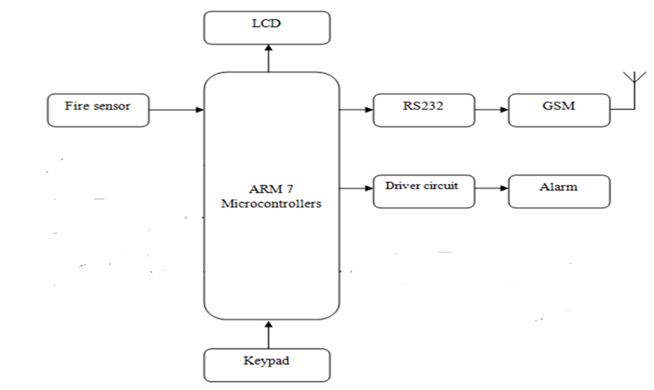
Fig. 2.1 Block diagram of existing fire detection system
ADVANTAGES
- Wired System
- RF Based Security system
- Web enabled Security system.
DISADVANTAGES
- Difficult to maintain
- Need internet access

CHAPTER 3
PROPOSED SYSTEM
3.1 INTRODUCTION
A key aspect of fire protection is to identify a developing fire emergency in a timely manner, and to alert the building's occupants and fire emergency organizations. This is the role of fire detection and alarm systems. Depending on the anticipated fire scenario, building and use type, number and type of occupants, and criticality of contents and mission, these systems can provide several main functions. First they provide a means to identify a developing fire through either manual or automatic methods and second, they alert building occupants to a fire condition and the need to evacuate. Another common function is the transmission of an alarm notification signal to the fire department or other emergency response organization. They may also shut down electrical, air handling equipment or special process operations, and they may be used to initiate automatic suppression systems. This section will describe the basic aspects of fire detection and alarm systems. It tough to find number of workers in the fire affected place and it also maintains attendance of employees.
3.2 WORKING MODEL OF PROPOSED SYSTEM
In this proposed method fire detector is implemented by using a fire sensor. User can get remote indication through SMS sent from the system and it also contains a data of number of employees present in the work ward and monitors an employee’s attendance using RFID tag. This SMS is sent from GSM modem which is connected to the ARM7 controller. Buzzer is turned on after fire detection so it acts as a fire detection alarm and Home Appliance EB Power Automatically OFF Condition Based Security Based Control System and Home Temperature Value through the GSM Modem based SMS Sent. Then another one Application RFID Tag Based maintains the Staff Attendance System using the ARM7 Controller Daily total Number Staff Absent or Present through the SMS Sent to the Owner Mobile. The both are Environmental Application using Control the Uno Controller Using ARM7 Controller System.

The IR sensor is used to count a person’s entering and leaving a work yard and RFID tag is given to each employee for monitoring the attendance. The user will get a remote indications SMS contains of Fire is detected and No of employees present in the work yard. The first step toward halting a fire is to properly identify the incident, raise the occupant alarm, and then notify emergency response professionals. This is often the function of the fire detection and alarm system Fire protection experts generally agree that automatic sprinklers represent one of the single, most significant aspects of a fire management program. Properly designed, installed, and maintained, these systems can overcome deficiencies in risk management, industry construction, and emergency response. In such a case, some high security systems become an essential and help to protect from fire accidents. In this project, a fire detection system identifies any fire accidents and turns on the system like spinning the Exhaust fan, SMS, Call, Beep sound, LED Blink and provides a cost effective and highly accurate system.
ADVANTAGES
- This project is easy to use and it gives remote indication to user.
- Security System
- Monitoring a workers
- High Speed Operation Using ARM 7 Processor
- Low Cost Compare with DSP Processor.
- APPLICATION
      - Industries
      - Home
      - Hospitals
BUZZER
A buzzer or beeper is a signaling device, usually electronic, typically used in automobiles, household appliances such as a microwave oven, or game shows. It most commonly consists of a number of switches or sensors connected to a control unit that determines if and which button was pushed or a preset time has lapsed, and usually illuminates a light on the appropriate button or control panel, and sounds a warning in the form of a continuous or intermittent buzzing or beeping sound. Initially this device was based on an electromechanical system which was identical to an electric bell without the metal gong Often these units were anchored to a wall or ceiling and used the ceiling or wall as a sounding board. Another implementation with some AC-connected devices was to implement a circuit to make the AC current into a noise loud enough to drive a loudspeaker and hook this circuit up to a cheap 8-ohm speaker. Nowadays, it is more popular to use a ceramic-based piezoelectric sounder like a Sonalert which makes a high-pitched tone. Usually these were hooked up to "driver" circuits which varied the pitch of the sound or pulsed the sound on and off.
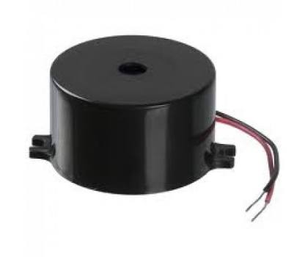
Fig. 4.15 Buzzer

CHAPTER 5
WORKING PRINCIPLE OF PROPOSED SYSTEM
It initially detects the fire through fire sensor. The fire sensor senses the flame. Generally sensor changes any form signals into electrical signal. The multiple fire sensor is used to identify the fire affected from different units of a industry The IR sensor is used to count the number of employees entering and leaving from the work yard. Two IR sensor unit is used for IN and OUT way.

The RFID tag is given to each employees with a employees data is fetched with the tag. It is used monitoring the workers attendance. The GSM modem is used to give remote indication to user when a fire is detected through SMS. The SMS consists of alert about a fire accident and number of person in ward yard. The Buzzer is used to alert a workers. The will give a sound when fire affected is the industry. The DC centrifugal pump is used to spill a water when is fire is affected to reduced the intensity of fire.

\
CHAPTER 6
OVER VIEW OF POWER SUPPLY
6.1 INTRODUCTION
The ac voltage, typically 220V RMS, is connected to a transformer, which steps that ac voltage down to the level of the desired dc output. A diode rectifier then provides a full-wave rectified voltage that is initially filtered by a simple capacitor filter to produce a dc voltage. This resulting dc voltage usually has some ripple or ac voltage variation. A regulator circuit removes the ripples and also remains the same dc value even if the input dc voltage varies, or the load connected to the output dc voltage changes. This voltage regulation is usually obtained using one of the popular voltage regulator IC units.
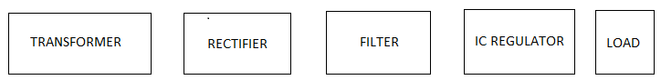
Fig. 6.1 Block Diagram of Power Supply
6.2 TRANSFORMER
The potential transformer will step down the power supply voltage (0-230V) to (0-6V) level. Then the secondary of the potential transformer will be connected to the precision rectifier, which is constructed with the help of op–amp. The advantages of using precision rectifier are it will give peak voltage output as DC, rest of the circuits will give only RMS output.
6.3 BRIDGE RECTIFIER
When four diodes are connected as shown in figure, the circuit is called as bridge rectifier. The input to the circuit is applied to the diagonally opposite corners of the network, and the output is taken from the remaining two corners. Let us assume that the transformer is working properly and there is a positive potential, at point A and a negative potential at point B. the positive potential at point A will forward bias D3 and reverse bias D4. The negative potential at point B will forward bias D1 and reverse D2. At this time D3 and D1 are forward biased and will allow current flow to pass through them; D4 and D2 are reverse biased and will block current flow. The path for current flow is from point B through D1, up through RL, through D3, through the secondary of the transformer back to point B. this path is indicated by the solid arrows. Waveforms (1) and (2) can be observed across D1 and D3. One-half cycle later the polarity across the secondary of the transformer reverse, forward biasing D2 and D4 and reverse biasing D1 and D3. Current flow will now be from point A through D4, up through RL, through D2, through the secondary of T1, and back to point A. This path is indicated by the broken arrows. Waveforms (3) and (4) can be observed across D2 and D4. The current flow through RL is always in the same direction. In flowing through RL this current develops a voltage corresponding to that shown waveform (5). Since current flows through the load (RL) during both half cycles of the applied voltage, this bridge rectifier is a full-wave rectifier.

One advantage of a bridge rectifier over a conventional full-wave rectifier is that with a given transformer the bridge rectifier produces a voltage output that is nearly twice that of the conventional full-wave circuit. This may be shown by assigning values to some of the components shown in views A and B. assume that the same transformer is used in both circuits. The peak voltage developed between points X and y is 1000 volts in both circuits. In the conventional full-wave circuit shown—in view A, the peak voltage from the center tap to either X or Y is 500 volts. Since only one diode can conduct at any instant, the maximum voltage that can be rectified at any instant is 500 volts.

The maximum voltage that appears across the load resistor is nearly-but never exceeds-500 v0lts, as result of the small voltage drop across the diode. In the bridge rectifier shown in view B, the maximum voltage that can be rectified is the full secondary voltage, which is 1000 volts. Therefore, the peak output voltage across the load resistor is nearly 1000 volts. With both circuits using the same transformer, the bridge rectifier circuit produces a higher output voltage than the conventional full-wave rectifier circuit.
Fig. 6.2 Diagram of Bridge Rectifier
6.4 IC VOLTAGE REGULATORS
Voltage regulators comprise a class of widely used ICs. Regulator IC units contain the circuitry for reference source, comparator amplifier, control device, and overload protection all in a single IC. IC units provide regulation of either a fixed positive voltage, a fixed negative voltage, or an adjustably set voltage. The regulators can be selected for operation with load currents from hundreds of milli amperes to tens of amperes, corresponding to power ratings from milli watts to tens of watts.
A fixed three-terminal voltage regulator has an unregulated dc input voltage, Vi, applied to one input terminal, a regulated dc output voltage, Vo, from a second terminal, with the third terminal connected to ground. The series 78 regulators provide fixed positive regulated voltages from 5 to 24 volts. Similarly, the series 79 regulators provide fixed negative regulated voltages from 5 to 24 volts.

CHAPTER 7
SOFTWARE TOOLS USED AND ITS FEATURES
Keil Software, world's leading developer of Embedded Systems Software, makes ANSI C compilers, macro assemblers, real-time kernels, debuggers, linkers, library managers, simulators, integrated environments, and evaluation boards for the 8051, 251, ARM7, and C16x/ST10 microcontroller families. Keil Software implemented the first C compiler designed from the ground-up specifically for the 8051 microcontroller.
ADVANTAGE
- Unlimited Breakpoint Capabilities including access, conditional, and execution breakpoints.
- Simulated peripherals fully synchronized with program execution.
- Power-down and idle modes are fully simulated.
- Full timing and execution analysis with Code Coverage, Trace, Timing Profile, Logic Analyzer.
- Input signal generation from a script language; synchronized with program execution (single-stepping).
- Simulation is timing accurate and in correct relation to peripherals.

CHAPTER 8
RESULTS AND OUTCOME
The proposed system detects the fire and sends a SMS to user. It count the number persons entering and leaving a work yard. The RFID reader reads the employees tag and monitoring a attendance well. The DC centrifugal pump spill the water when fire is detected. When fire detects the will turn OFF the of EB supply.

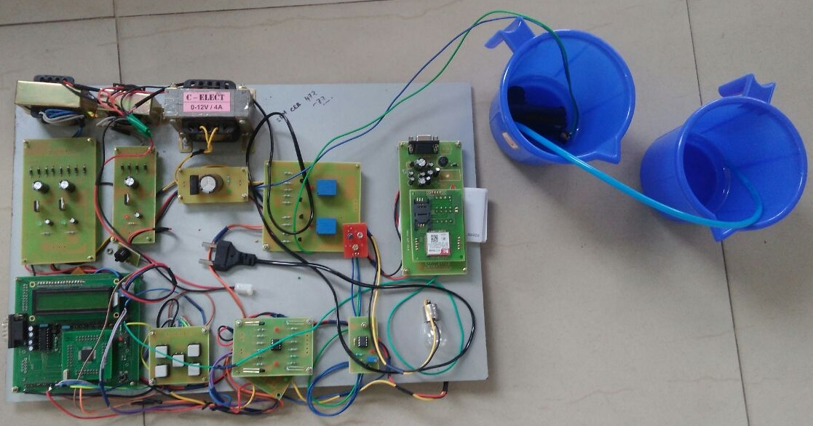
Fig. 8.1 Project Hardware

Fig. 8.2 Output of the Proposed System

CHAPTER 9
CONCLUSION
The most important fire protection options for most heritage applications. The successful application of fire detection is dependent upon careful design and installation of high quality components by capable engineers and contractors. A properly selected, designed and installed system will offer unexcelled reliability. Fire detection system components should be selected for compliance with the institution's objectives. Wet pipe systems offer the greatest degree of reliability and are the most appropriate system type for most heritage fire risks. With the exception of spaces subject to freezing conditions, dry pipe systems do not offer advantages over wet pipe systems in heritage buildings.

The fire was detected with the help of fire sensor and sends a signal to ARM7 Controller with the Help of GSM modem the SMS to the user. A new approach for RFID has many applications as can be utilized the versatility of RFID in implementing functional and automatic attendance recording system that allows employees to simply fill their attendance just by swiping or moving their ID cards over the RFID reader. The DC centrifugal pump will spray the water when a fire is detected the SMS based Both Environmental Application using this fire detection system and RFID Based Attendance system using GSM has both applications in various areas like home, industries, hotels, hospitals.

FUTURE SCOPE
In future this project can implement with GPS system for finding the exact location of employees. Image processing can be used for detecting fire intensity and monitoring employees presents in the employees.

REFERENCE
[1] R.Anandan, Mr.B.Karthik, Dr.T.V.U.Kiran Kumar (2013), “Wireless Home and Industrial Automation Security System Using GSM“, Journal of Global Research in Computer Science, Volume 4, No. 4.
[2] Prakash Kumar, Pradeep Kumar (2013), “Arduino Based Wireless Intrusion Detection Using IR Sensor and GSM”, A Monthly Journal of Computer Science and Information Technology, IJCSMC, Vol. 2, Issue. 5, pg.417 – 424.
[3] Vini Madan, S.R.N Reddy (May 2012), “GSM-Bluetooth based Remote Monitoring and Control System with Automatic Light Controller “ , International Journal of Computer Applications, Volume 46– No.1.
[4] Michael Anshel and Sarah Levitan (2007), “Reducing medical errors using secure RFID technology”, ACM SIGCSE Bulletin.
[5] Robert C. Yoder (2006), “Using RFID in the Classroom to Teach Information Systems Principles”, Journal of Computing Sciences in Colleges, Volume 21,
[6] Michael Anshel and Sarah Levitan (2007), “Reducing Medical Errors Using Secure RFID Technology”, ACM SIGCSE Bulletin,
[7] LAN-MAN Standards Committee of the IEEE Computer Society (1997), “Wireless LAN medium access control(MAC) and physical layer(PHY) specification”, IEEE, New York, IEEE Std 802.11-1997 edition,
[8] Chenebert, A.; Breckon, T.P.; Gaszczak (1781–1784 ), A. (September 2011). "A Non-temporal Texture Driven Approach to Real-time Fire Detection". Proc. International Conference on Image Processing (PDF). IEEE pp.

