A CLOUD-EDGE COLLABORATION FRAMEWORK FOR
COGNITIVE SERVICE

ABSTRACT
Cloud computing has significantly enhanced the growth of the Internet of Things (IoT) by ensuring and supporting the Quality of Service (QoS) of IoT applications. However, cloud services are still far from IoT devices. Notably, the transmission of IoT data experiences network issues, such as high latency. In this case, the cloud platforms cannot satisfy the IoT applications that require real-time response. Yet, the location of cloud services is one of the challenges encountered in the evolution of the IoT paradigm. Recently, edge cloud computing has been proposed to bring cloud services closer to the IoT end-users, becoming a promising paradigm whose pitfalls and challenges are not yet well understood. This paper aims at presenting the leading-edge computing concerning the movement of services from centralized cloud platforms to decentralized platforms, and examines the issues and challenges introduced by these highly distributed environments, to support engineers and researchers who might benefit from this transition.

CHAPTER-1
INTRODUCTION
The massive proliferation of personal computing devices is opening up new human-centered de-signs that blur the boundaries between humans and machines [1]. Now, the frontier for research on data management is related to the so-called edge computation and communication, consisting of an architecture of one or more collaborative multitude(s)of computing nodes that are positioned among edge networks with the access of cloud-based services. Such a mediating level is responsible for carrying out a substantial amount of data storage and processing to reduce the retrieval time and have more control over the data with respect to cloud-based services, and to consume fewer resources and energy to reduce the workload [2,3].The edge computing paradigm has multiple advantages. Firstly, the edge node can reduce the traffic load of backhaul by providing a certain amount computing capability, which is significant for applications such as online games that need to transmit 60 or even 120 frames per second. As an alternative solution, the server only sends parameters such as character position, timestamp and attribute changes (some common data), and leaves the edge node to compute and render the visual image. Secondly, as a result of the large number of edge nodes deployed in 5G and the big-data analysis based on user preference, the popular contents can be acquired in advance in the interconnecting edge devices, which are only one hop away from the user. However, edge computing is also faced with many challenges. Firstly, the operation and processing capabilities of an edge device are limited and can failto meet the demands on real-time service, data optimization, and application intelligence. Secondly, the intelligence of most typical edge-computing services is only embodied in the artificial intelligence (AI)-enabled data storage and processing on the edge. However, the intelligence is missing from the aspects of behavior feedback, automatic networking, load balance, and data-driven network optimization. Cognitive computing originates from cognitive scientific theory. Now, it makes machines achieve “brain-like” cognitive intelligence through an interactive cognition loop with machine, cyber space and humans. Compared to big-data analytics, it possesses the following features: 1) analysis of theexisting data and information in cyber space, to improve the intelligence of the machine; 2) themachine reinterprets and explains the information in the existingcyber space, and accordingly gen-erates new information; humans also participate in this process; 3) the cognition of the machine tothe human provides a more intelligent cognitive service. Its enabling paradigms (e.g., agent-based computing) had been researched and the related concrete applications based on cognitive Internetof Things (IoT) platforms and frameworks have been studied in [4–6].Nevertheless, the cognitive computing application mainly depends on the machine-learningmodel trained on the cloud, while the real-time inference requests are made by end edge devices,which so far have been the most common deployment mode of the cognitive service. The existingproblem of such a mode is the large latency in the network operation and the service delivery. However, if the cognitive service is deployed on the network edge, the latency of the network response to the user request will be greatly reduced, so the research of edge deployment for training and inference machine is rapidly increasing. Therefore, considering both the advantages and disadvantages of edge computing and cognitive computing, a new computing paradigm called Edge Cognitive Computing (ECC) is proposed, which combines edge computing and cognitive computing. Such a new architecture integrates communication, computation, storage and application on edge networks; it can achieve data and resource cognition by cognitive computing. Moreover, it can provide personalized services nearby, enabling the network to have a deeper, human-centered cognitive intelligence. The main contributions of this paper are as follows:
•We propose a new ECC architecture that deploys cognitive computing at the edge of the net-work to provide dynamic and elastic storage and computing services. In addition, the design issues of how to fuse these key technologies of cognitive computing and edge computing are illustrated in detail.
- We propose an ECC-based dynamic cognitive service-migration mechanism that considers both the elastic allocation of the cognitive computing services and the user mobility, to pro-vide a mobility-aware dynamic service-adjustment scheme.
- We develop an ECC-based test platform for dynamic service migration and evaluate it by means of several experiments, with the results showing that the proposed ECC can providedynamic services according to different user demands.
The remainder of the paper is organized as follows. Section II introduces the related work. Section III presents the proposed architecture for edge cognitive computing in detail. Section IV stipulates the related design issues. Section V introduces the dynamic cognitive service migration mechanism. Section VI demonstrates the ECC test platform for dynamic service migration. Finally,Section VII concludes the paper and reports some open issues.

As smart phones are gaining enormous popularity, more and more new mobile applications such as face recognition, natural language processing, interactive gaming, and augmented reality are emerging and attract great attention [1]–[3]. This kind of mobile applications are typically resource-hungry, demanding intensive computation and real-time responsiveness. Due to the physical size constraint, however, mobile devices are in general resource-constrained, having limited computation resources. The tension between resource-hungry applications and resource-constrained mobile devices hence poses a significant challenge for the future mobile platform development.
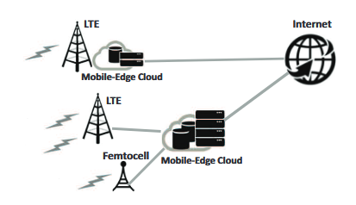

Mobile cloud computing is envisioned as a promising approach to address such a challenge. By offloading the computation via wireless access to the resource-rich cloudXu Chen and Zhi Zhou are with School of Data and Com-puter Science, Sun Yatsen University, Guangzhou, China. Emails:{chenxu35,zhouzhi9}@mail.sysu.edu.cn.Wenzhong Li and Sanglu Lu are with State Key Laboratory for NovelSoftware Technology, Nanjing University, Nanjing, China. Emails:{lwz,sanglu}@nju.edu.cn.Xiaoming Fu is with Institute of Computer Science, University of Goettin-gen, Goettingen, Germany. Email: goettingen.de.InternetFemtocellLTEMobile0Edge3CloudMobile0Edge3CloudLTEFig. 1. An illustration of mobile-edge cloud computing infrastructure, mobile cloud computing can augment the capabilities of mobile devices for resource-hungry applications. Currently, one common approach for mobile cloud computing is to offload the computation-intensive tasks to the remote public cloud infrastructure (e.g., Amazon EC2 and Windows Azure), in order to utilize the powerful computing and processing capabilities by the public clouds. As a matter of fact, the current public cloud architecture - built around static Internet-based installments of cloud resources not integrated with wireless networks - is already starting to show its limits in terms of computation-intensive mobile application support, since mobile users would experience long latency for data exchange with the public cloud through the wide area network(WAN), which risks to become the major impediment in satisfying the real-time interactive response requirement of mobile applications. To address this challenge, a novel mobile cloud computing paradigm, called mobile-edge cloud computing, has been proposed [4]. As illustrated in Figure 1, mobile-edge cloud computing can provide cloud-computing capabilities at the edge of pervasive radio access networks (e.g., 3G, 4G, WiMax,femtocells) in close proximity to mobile users. In this case, the need for fast interactive response can be met by fast and low-latency connection (e.g., via fiber transmission) to resource rich cloud computing infrastructures (called mobile-edge clouds) deployed by network operators (e.g., AT&Tand T-Mobile) within the network edge and backhaul/core networks. By endowing ubiquitous radio access networks with powerful computing capabilities, mobile-edge cloud computing is envisioned to provide pervasive and agile computation augmenting services for mobile users at anytime and anywhere cloud computing framework that can provide rich flexibility in meeting different mobile users’ demands. To this end, in this paper we propose a comprehensive framework consisting of a resource-efficient computation offloading mechanism for the users and a joint communication and computation (JCC) resource allocation mechanism for the network operator. Specifically, we first address the resource-efficient computation offloading problem, in order to reduce a user’s resource occupancy. We then study the admission control problem and design the pricing scheme for JCC resource allocation, by jointly taking into account the objective of system wide performance optimization as well as the practical constraints such as computational complexity for practical implementation and truthfulness for preventing manipulation.

The collaborative cloud-edge computing framework

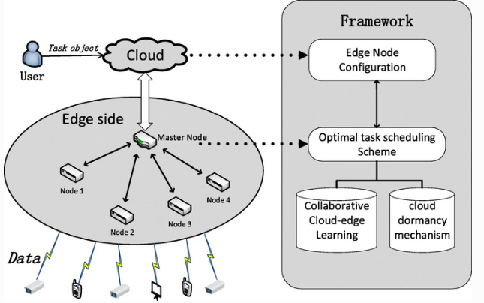

Edge-Cloud Collaboration Framework

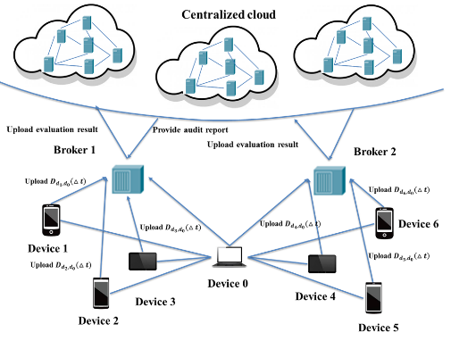
Architecture for the cloud-edge framework

Shows our trustworthy coordination architecture for the cloud-edge framework, which is consisted of three modules: the centralized cloud investigating module, the edge broker managing module and the edge trust material processing module. The edge trust material processing module is designed to deal with the raw history interaction data and extract trust features. With this design, most of the calculation tasks are undertaken by edge devices and the pressure on the communication networks could be improved effectively. Based on the trust features uploaded from edge devices in the management domain, the edge brokers could analyze the behaviors and performances of edge devices with low computing resources cost. After evaluating devices’ credibility, the edge brokers could distinguish malicious devices from normal ones and filter them. In addition, the evaluation results and trust features could be uploaded to the centralized cloud termly. With the uploaded evaluation results and features, the retrained convolution neural networks developed in the centralized cloud could distinguish the malicious edge devices rapidly and check the evaluation uploaded from edge brokers. Once the number of the malicious devices which cloud not be distinguished by edge brokers beyond the security limitation, the centralized cloud will return investigating reports to the edge brokers and awaken the related punishment factors deployed in them. So, the security strategies could be modified with the changing of edge network situation and the punishment factors could be weighted adaptively.

In this section, we present a trustworthy coordination architecture for the cloud-edge framework and discuss the popular malicious attack patterns in recent years. After computing these four trust features, the edge broker could learn one device’s credibility and filter the devices whose global trust value is beyond our security limitation. Then, trust evaluation results and four trust features will be uploaded to the centralized cloud.

EDGECOMPUTING
Withvirtuallyunlimitedcomputingpowerandstorageresources,cloudsareconceivedtobetheperfectplatformforlargescaledataanalytics,whilestorageefficienciesalsoprovideeasymanagementofdifferentapplications.However,withcloudbasedapplications,mostdatamustbesenttothedatacentersintheCloud.Duringtheexpansionoftheseapplications,thevolumeofdataincreasesandalargeamountofdatafromtheseapplications(e.g.,IoTdevices)aremovedtotheCloudcausingnetworkbottlenecksduetobandwidthconstraints.
Edge computing(e.g., Cloud let, MobileEdgeComputing,andfogcomputing isproposedtoovercometheproblemsfacedbycloudbasedapplications byoffloadingcomputingtaskstotheedgeofthecloudnetwork.Usinginstalledcomputingresourcesandintelligenceatthenetworkedgelayer,apromptresponsecanbedeliveredtoapplicationsandthetransmissionofredundantdatatoremotecloudsisavoided[28].Onemorefeatureofedgecomputingisitsdistributedmodeandsupportfordevicemobilityinsideheterogeneousnetwork.

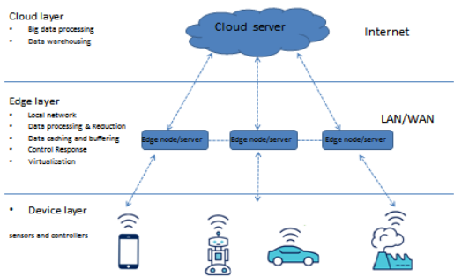
TheEdgecomputinglayerliesbetweencloudandendedgenetworkdevices;however,thereisnocommonlyagreeduponframeworktocapturethefunctionalityofthiscomputingparadigm.Recently,IBMandsomeresearchershaveproposedathree layer paradigmas the highlevel architectures, this is illustrated in.

EdgecomputingisintroducedforextendingtheCloudComputingparadigmtotheedgeofthenetworktosupportmanyofcloudapplication(IoT,M2M,andCPS).Manycharacteristicshavebeenfoundinedgecomputing,includinglowlatency,locationawareness,mobiliy,andwide spreadgeographicaldistribution,etc.ThesefeaturesmakeEdgecomputingsuitablefordifferentcloudapplications.

1.2 OBJECTIVES

