OPERATION AND PROTECTION OF INDUCTION MOTOR BY USING GSM TECHNOLOGY
CHAPTER 1
INTRODUCTION
In earlier days dc motors were frequently used for industrial applications. With the invention of AC induction motors that have higher performance attributes over DC motor, industrial automation are being widely done with it. An induction is an electric motor in which the electric current in the rotor, needed to produce torque is obtained by electromagnetic induction from the magnetic field of the stator winding. The main advantages of the IM are its reliability, low cost, and simplicity of construction with respect to currently used high performance motors but it is much more difficult to control.
Single phase and three phase induction machines are very popular in the industries because of their vast applications. Hence it becomes necessary to protect them against faults so as to ensure uninterrupted operation and functioning. Various parameter controlling and monitoring systems are present for other types of machine, but in case the of induction machine the controlling and monitoring systems are not extensively used due to high cost of installation and physical constraints. So as to overcome the limitations in monitoring and controlling, GSM Based System is used which makes it cost-effective and simple. Monitoring of voltage and current by employing GSM based system was a radical step towards automation. Different approaches have been developed, for induction motor control and parameter estimation, but only partial results were obtained. After going through this entire project it was concluded that the GSM based protection system of the induction motor is viable and can be safely implemented for the use of industrial automation.
1.2 PROPOSED SCHEME
Manual systems is used in the existing scheme and it is replaced by automation system. If there is any increase or decrease in voltage and current, the motor will be turn off. When problem occurs, it sends a message to the operator regarding to that failure with the help of GSM module.PIC microcontroller is used in this system. It acts as the heart of the kit.
1.3 EXISTING SCHEME
In Existing system induction motor has to be monitored and controlled by human to check whether the motor is running properly. In several cases running of motor may take even 24 hours, so monitoring of motor for 24 hours is impossible. In this existing scheme human monitorisation is must

3.9.2 Transistor as a switch

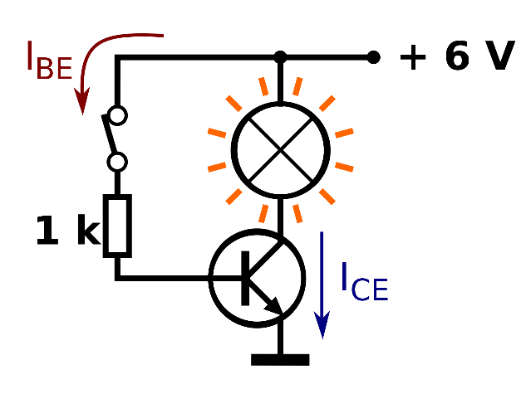
Figure 3.15 – Transistor switch
BJT used as an electronic switch, in grounded-emitter configuration. Transistors are commonly used as electronic switches, for both high power applications including switched-mode power supplies and low power applications such as logic gates.
If V_{CE} could fall to 0 (perfect closed switch) then Ic could go no higher than V_{CC} / R_{C}, even with higher base voltage and current. The transistor is then said to be saturated. Hence, values of input voltage can be chosen such that the output is either completely off, or completely on. The transistor is acting as a switch, and this type of operation is common in digital circuits where only "on" and "off" values are relevant.
3.9.3 amplifier
An electronic amplifier is a device for increasing the power of a signal. It does this by taking energy from a power supply and controlling the output to match the input signal shape but with a larger amplitude. In this sense, an amplifier may be considered as modulating the output of the power supply.
. As the open loop DC gain of an operational amplifier is extremely high we can afford to lose some of this gain by connecting a suitable resistor across the amplifier from the output terminal back to the inverting input terminal to both reduce and control the overall gain of the amplifier. This then produces and effect known commonly as Negative Feedback, and thus produces a very stable Operational Amplifier system.
Negative Feedback is the process of "feeding back" some of the output signal back to the input, but to make the feedback negative we must feed it back to the "Negative input" terminal using an external Feedback Resistor called Rf. This feedback connection between the output and the inverting input terminal produces a closed loop circuit to the amplifier resulting in the gain of the amplifier now being called its Closed-loop Gain.
3.10 KEYPAD
A numeric keypad, or numpad for short, is the small, palm-sized, seventeen key section of a computer keyboard, usually on the very far right. The numeric keypad features digits 0 to 9, addition (+), subtraction (-), multiplication (*) and division (/) symbols, a decimal point (.) and Num Lock and Enter keys. Laptop keyboards often do not have a numpad, but may provide numpad input by holding a modifier key (typically lapelled "Fn") and operating keys on the standard keyboard.
Figure 3.16 – Keypad
Numeric keypads usually operate in two modes: when Num Lock is off, keys 8, 6, 2, 4 act like an arrow keys and 7, 9, 3, 1 act like Home, PgUp, PgDn and End; when Num Lock is on, digits keys produce corresponding digits. These, however, differ from the numeric keys at the top of the keyboard in that, when combined with the Alt key on a PC, they are used to enter characters which may not be otherwise available.

Most settings are read in the following form
- Bits per second
- Number of data bits
- Parity
- Number of Stop bits3.12 PCB DESIGNING
Introduction
Design and Fabrication of Printed circuit boards .Printed circuit boards, or PCBs, form the core of electronic equipment domestic and industrial. Some of the areas where PCBs are intensively used are computers, process control, telecommunications and instrumentation.
Manufatcuring
The manufacturing process consists of two methods; print and etch, and print, plate and etch. The single sided PCBs are usually made using the print and etch method. The double sided plate through – hole (PTH) boards are made by the print plate and etch method. The production of multi-layer boards uses both the methods. The inner layers are printed and etch while the outer layers are produced by print, plate and etch after pressing the inner layers.
Panelisation
Here the schematic transformed in to the working positive/negative films. The circuit is repeated conveniently to accommodate economically as many circuits as possible in a panel, which can be operated in every sequence of subsequent steps in the PCB process. This is called penalization. For the PTH boards, the next operation is drilling.
Drilling
PCB drilling is a state of the art operation. Very small holes are drilled with high speed CNC drilling machines, giving a wall finish with less or no smear or epoxy, required for void free through hole plating.

Plating
The heart of the PCB manufacturing process. The holes drilled in the board are treated both mechanically and chemically before depositing the copper by the electro less copper platting process.
Etching
Once a multiplayer board is drilled and electro less copper deposited, the image available in the form of a film is transferred on to the outside by photo printing using a dry film printing process. The boards are then electrolytic plated on to the circuit pattern with copper and tin. The tin-plated deposit serves an etch resist when copper in the unwanted area is removed by the conveyor’s spray etching machines with chemical etch ants. The etching machines are attached to an automatic dosing equipment, which analyses and controls etch ants’ concentrations.
Soldermask
Since a PCB design may call for very close spacing between conductors, a solder mask has to be applied on the both sides of the circuitry to avoid the bridging of conductors. The solder mask ink is applied by screening. The ink is dried, exposed to UV, developed in a mild alkaline solution and finally cured by both UV and thermal energy.
Hot Air Levelling
After applying the solder mask, the circuit pads are soldered using the hot air leveling process. The bare bodies fluxed and dipped in to a molten solder bath. While removing the board from the solder bath, hot air is blown on both sides of the board through air knives in the machines, leaving the board soldered and leveled. This is one of the common finishes given to the boards.
3.13 SOFTWARE TOOLS
MPLAB IDE is an integrated development environment that provides development engineers with the flexibility to develop and debug firmware for various Microchip devices.MPLAB IDE is a Windows-based Integrated Development Environment for the Microchip Technology Incorporated PICmicrocontroller (MCU) and dsPIC digital signal controller (DSC) families. In the MPLAB IDE, you can:
- Create source code using the built-in editor.
- Assemble, compile and link source code using various language tools. An assembler, linker and librarian come with MPLAB IDE. C compilers are available from Microchip and other third party vendors.
- Debug the executable logic by watching program flow with a simulator, such as MPLAB SIM, or in real time with an emulator, such as MPLAB ICE. Third party emulators that work with MPLAB IDE are also available.
- Make timing measurements.
- View variables in Watch windows.
- Program firmware into devices with programmers such as PICSTART Plus or PRO MATE II.
MPLAB Simulator
MPLAB SIM is a discrete-event simulator for the PIC microcontroller (MCU) families. It is integrated into MPLAB IDE integrated development environment. The MPLAB SIM debugging tool is designed to model operation of Microchip Technology's PIC microcontrollers to assist users in debugging software for these devices.
IC Prog
The PRO MATE II is a Microchip microcontroller device programmer. Through interchangeable programming socket modules, PRO MATE II enables you to quickly and easily program the entire line of Microchip PIC microcontroller devices and many of the Microchip memory parts.
PRO MATE II may be used with MPLAB IDE running under supported Windows OS's (see Read me for PRO MATE II.txt for support list), with the command-line controller PROCMD or as a stand-alone programmer.
Compiler-High Tech C
A program written in the high level language called C; which will be converted into PICmicro MCU machine code by a compiler. Machine code is suitable for use by a PICmicro MCU or Microchip development system product like MPLAB IDE.
Pic Start Plus Programmer
The PIC start plus development system from microchip technology provides the product development engineer with a highly flexible low cost microcontroller design tool set for all microchip PIC micro devices. The PIC start plus development system includes PIC start plus development programmer and MPLAB IDE.
The PIC start plus programmer gives the product developer ability to program user software in to any of the supported microcontrollers. The PIC start plus software running under MPLAB provides for full interactive control over the programmer.
Advantages:
- Used to save lives.
- Low cast.

CHAPTER 4
RESULT AND OUTCOME
In our project Temperature sensor, current transformer and voltage transformer used to sense the motor condition.PIC16F877A has inbuilt ADC of 8-channel to which CH-0 is used for temperature, CH-1 is used for voltage sensing; CH-2 is current sensing. GSM can communicates with microcontroller as TXD of microcontroller is connected to RXD of GSM and RXD of microcontroller is connected to TXD of GSM . In case of three-phase supply when one of the phase is disconnected at the same instant of time motor stop its working and message will displayed on the LCD as well as user . Similarly , in case of temperature , when temperature is beyond 60 degree then it will stop its working and message will send as overheated.

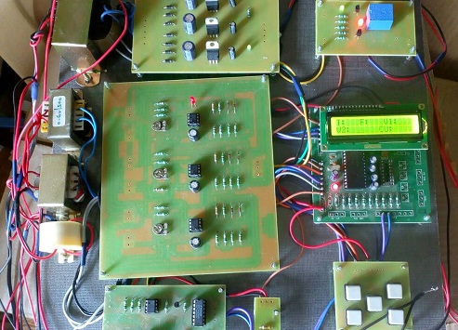
CASE 1 - In case of three-phase supply when one of the phase is disconnected at the same instant of time motor stop its working message will be displayed on the LCD as well as user.
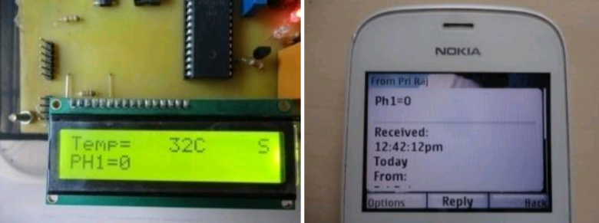
Result on LCD Result on user
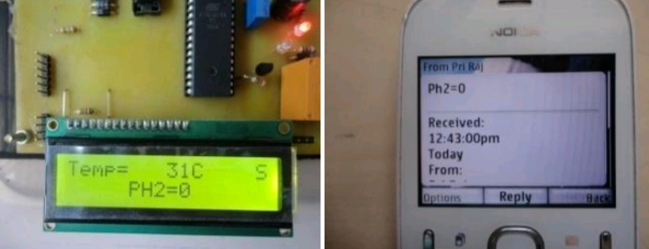
Result on LCD Result on user
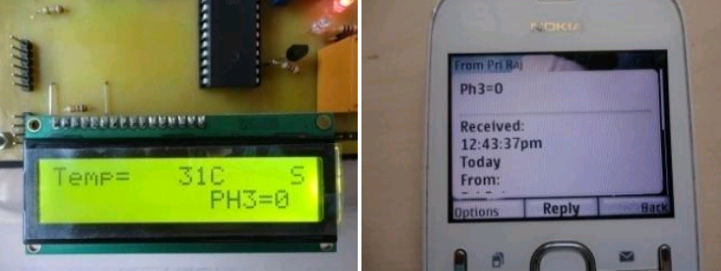
Result on LED Result on user
CASE 2 - Similarly, in case of temperature , when temperature is beyond 60 degree then it will stop its working and message will send as‖ overheated‖ on LCD screen as well as user .

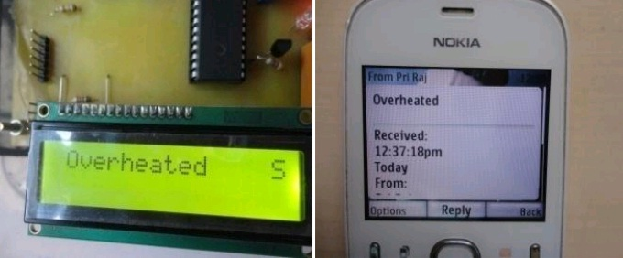
Result on LCD Result on user

CHAPTER 5
CONCLUSION
Here we conclude that ―OPERATION AND PROTECTION OF INDUCTION MOTOR BY USING GSM TECHONOLOGY is more advantages as compared to the other monitoring method .Here motor parameter is monitored through GSM modem from remote place, as a result manpower and time requirement will be less. This offers major benefit to both customer and companies in terms of efficiency, reliability, and cost saving that motor is fully protected.

referenceS
- Prof. R.R. Jadhav, Prathmesh P Pandit, Shubham D Pal, Vineet H. Risbud (May 2015) “Three Phase Motor Control Using GSM” - international journal of innovative research in electrical, electronics, instrumentation and control engineering vol. 3.
- Kamrul Hassan, Raziul Islam Siddiqui , Md. Takdirul Islam , Nahid Alam Siddique , Syed Mohammad Enam Uddin (April 2014) “GSM Based Automatic Motor Control and Protection System”-International Journal of Advancements in Research & Technology, Volume 2.
- Snehal Lande1, Pooja Jaiswal, Priyanka Rajgure (May-June 2012)“An analytical approach of Parametric Monitoring of Induction Motor Using GSM” IOSR Journal of Electronics and Communication Engineering (IOSRJECE) Volume 1.
- Gang Z, Shuguang L, (2010) “Study on electrical switching device junction temperature monitoring system based on Zigbee technology” International Conference on Computer Application and System Modeling (ICCASM), Taiyuan, China.
- Baran L,(2009) “A PLC based monitoring and control of power factor of a three phase induction motors”, MSc Thesis, Ghazi University, Institute of Science and Technology, Ankara.
- Ramazan bayindir, Mehmet Sen2 (2011) “A Parameter Monitoring System for Induction Motors Based on Zigbee Protocol” Ghazi University Journal of Science GU.
- P.E Elavenil , Dr.R.Kalaivani M.E (Embedded Systems) (February 2014) “Speed monitoring and protection of motor using zigbee communication”-International Journal of Scientific Research Engineering & Technology (IJSRET) Volume 2.
- Prof. M. S. Badmera1, Pradip M. Ambore, (June 2016)S “An Efficient Parameter Monitoring & Controlling System for Three Phase Induction Motor”-International Journal of Advanced Research in Electrical, Electronics and Instrumentation Engineering Vol. 5.
- Bayindir R, Sefa I, Colak I, Bektas A (2008) “Fault detection and protection of induction motors using sensors”- IEEE Trans Energy Convers.
- Reddy PN (2013) “Microcontroller based speed control of induction
motor using wireless technology”- Int J Emerg Sci Eng.
- Mhaisgawali ML (2012) “Induction motor speed control using PID
controller”- International journal Technology Science.
- Chabre M, Meoufel A, Bendaha Y (2011) "Speed control of induction
motor using genetic algorithm-based PID controller”- Acta Polytech
Hung.

