HOME AUTOMATION CONTROL
USING RASPBERRY PI

ABSTRACT
Home automation is the control of any electrical and electronic device in our home, whether we are there or not. Some products are available that allow us to control over the devices automatically using raspberry pi model either by remote control. This home automation system provide the user with remote control of various lights and appliances within their home. This system is designed to have low cost and expandable allowing a variety of devices to be controlled. Home automation and its benefits will focus on how this can be achieved through the use of the raspberry pi. It is meant to save the electric power and human energy. This project is made with the help of the microcontroller and Raspberry Pi.

CHAPTER
INTRODUCTION

1.1 GENERAL
Home automation is the control of any or all electrical devices in our home or office. There are many different types of home automation system available. These systems are typically designed and purchased for different purposes. In fact, one of the major problems in the area is that these different systems are neither interoperable nor interconnected. There are number of issues involve when designing a home automation system. It should also provide a user friendly interface on the host side, so that the devices can be easily setup, monitored and controlled. In smart home systems, the internet is also use to ensure remote control.
Smart homes are equipped with technologically advanced systems for various pre-programmed function such as lighting, controlling and many other operations. The system is proposed to create a smart environment by switching on and off the target devices by Wireless-Fidelity (Wi-Fi).
1.2. EXISTING SYSTEM
This existing system controlling the home appliance only The GSM based Control System by PIC microcontroller implements the emerging applications of the GSM Technology. Using GSM networks, a control system has been Existing that will act as an embedded system which can monitor and control appliances and other devices locally using built-in input and output peripherals.

Remotely the system allows the user to effectively monitor and control the house Appliances and equipment’s via the mobile phone set by sending commands in the form of SMS messages and receiving the appliances status Control the operation using PIC Controller.
1.2.1 BLOCK DIAGRAM OF EXISTING SYSTEM

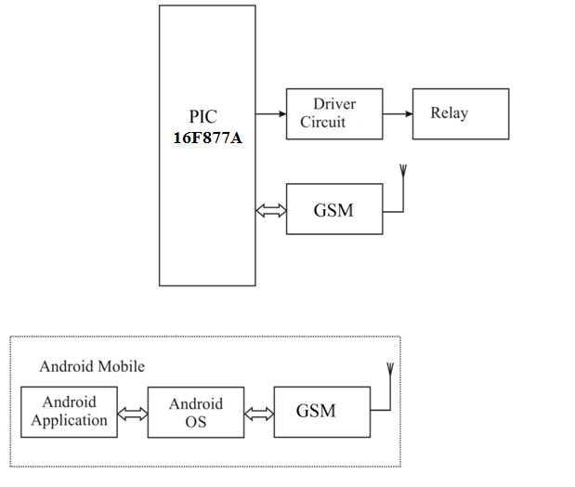
Fig 1.1 Block Diagram of existing system

1.3. PROPOSED SYSTEM
BLOCK DIAGRAM OF PROPOSED SYSTEM
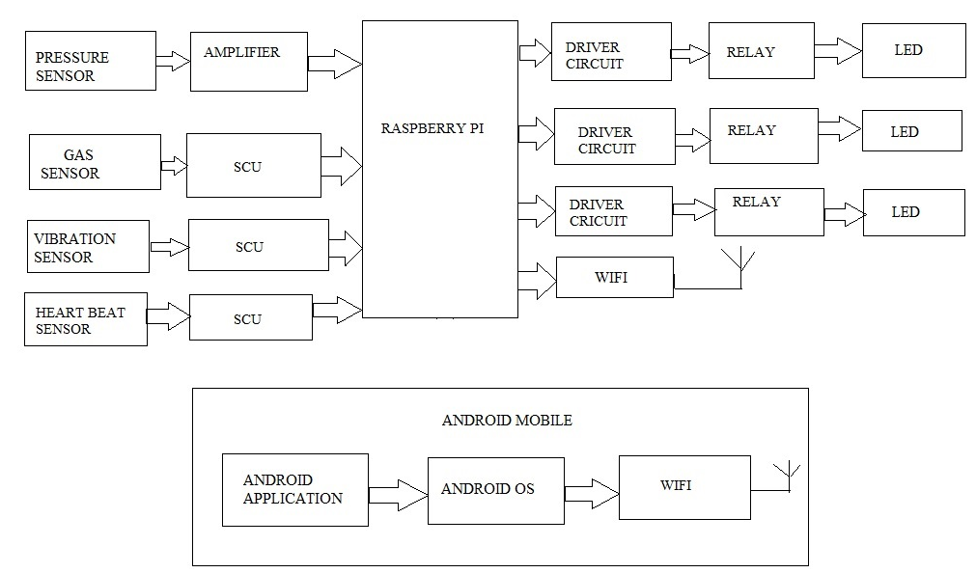

Fig 1.2 Block diagram of proposed system

SENSING MATERIALS
Two main groups of materials are used for vibration sensors: vibration ceramics and single crystal materials. The ceramic materials (such as PZT ceramic) have a vibration constant / sensitivity that is roughly two orders of magnitude higher than those of single crystal materials and can be produced by inexpensive sintering processes. The piezo effect in piezo ceramics is "trained", so unfortunately their high sensitivity degrades over time. The degradation is highly correlated with temperature. The less sensitive crystal materials (gallium phosphate, quartz, tourmaline) have a much higher – when carefully handled, almost infinite – long term stability
PIEZO ELECTRIC SENSOR:
A piezoelectric sensor is a device that uses the piezoelectric effect to measure pressure, acceleration, strain or force by converting them to an electrical signal.
PIEZO ELECTRIC EFFECT:
Piezoelectricity is the ability of crystals and certain ceramic materials to generate a voltage in response to applied mechanical stress. Piezoelectricity was discovered by Pierre Curie and the word is derived from the Greek piezein, which means to squeeze or press.

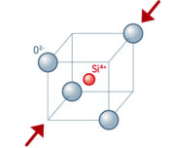

The piezoelectric effect is reversible in that piezoelectric crystals, when subjected to an externally applied voltage, can change shape by a small amount. (For instance, the deformation is about 0.1% of the original dimension in PZT.) The effect finds useful applications such as the production and detection of sound, generation of high voltages, electronic frequency generation, microbalance, and ultra fine focusing of optical assemblies.
HEART RATE:
Heart rate is a term used to describe the frequency of the cardiac cycle. It is considered one of the four vital signs. Usually it is calculated as the number of heart beats of the heart in one minute and expressed as "beats per minute" (bpm). See "Heart" for information on embryo fetal heart rates. The heart beats up to 120 times per minute in childhood. When resting, the adult human heart beats at about 70 bpm (males) and 75 bpm (females), but this rate varies among people. However, the reference range is normally between 60 bpm (if less termed bradycardia) and 100 bpm (if greater, termed tachycardia).
The pulse is the most straight forward way of measuring the heart rate, but it can be deceptive when some heart beats do not have much cardiac output. In these cases (as happens in some arrhythmias), the heart rate may be considerably higher than the pulse rate.

CHAPTER 3
OVERALL CIRCUIT DIAGRAM DESCRIPTION
3.1 POWER SUPPLY
3.2.1 BLOCK DIAGRAM
The ac voltage, typically 220V rms, is connected to a transformer, which steps that ac voltage down to the level of the desired dc output. A diode rectifier then provides a full-wave rectified voltage that is initially filtered by a simple capacitor filter to produce a dc voltage. This resulting dc voltage usually has some ripple or ac voltage variation.
A regulator circuit removes the ripples and also remains the same dc value even if the input dc voltage varies, or the load connected to the output dc voltage changes. This voltage regulation is usually obtained using one of the popular voltage regulator IC units.
LOAD
IC REGULATOR
FILTER
RECTIFIER
TRANSFORMER

Fig 5.1 Block diagram of Power supply

CHAPTER 4
CONCLUSION
4.1 CONCLUSION
The progress in science & technology is a non-stop process. New things and new technology are being invented. As the technology grows day by day, we can imagine about the future in which thing we may occupy every place.
These kinds of home automation systems are required because human can make mistakes and forgot to switch off the appliances when there is no use and in this case, they are useful in order to utilize the power effectively and also in a secured manner.
The principle of the development of science is that “nothing is impossible”. So we shall look forward to a bright & sophisticated world.

CHAPTER 5
OUTCOME & RESULT
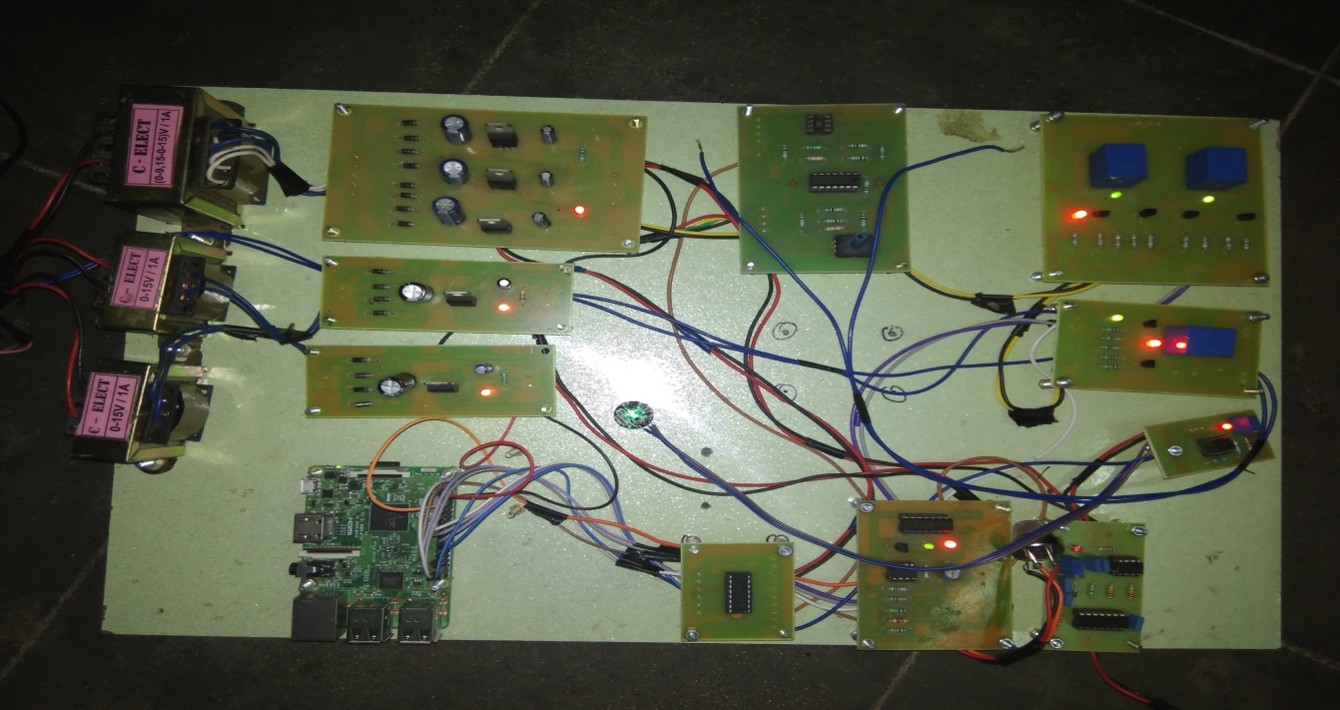
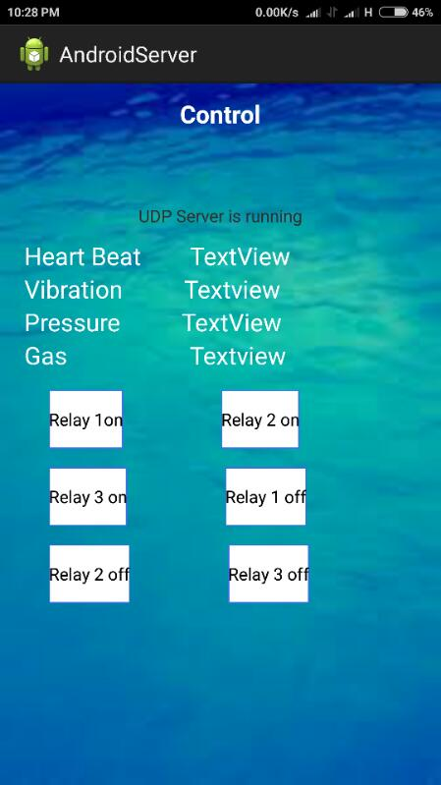
Fig 5.1 Photography of home automation control using raspberry pi

reference
- V.Sathya Narayanam, S.Gayathri, 2013, “Design Of Wireless Home Automation and Security System Using PIC Microcontroller”, M.E. Embedded System Technology, Anna University, Volume III , Special Issue Pp232-245
- Mr.Eswaravel.E, Mr.Lokeshwaran.V, Mr.Prabhu .D, Mr.SyedGhouse
Mr.sundar Ganesh.C.S. April 2015 “Micro processor based Home Auto system”, Volume.4 Issue 4,
- R.A.Khan,Upadhey Madhuri Ganesh, 2015, Raspberry Pi Home Auto Based On IOT , Volume 4, Issue 12
- Amit Narote, Abhishek Dsilva, Selma Misquitta, Palak Khandelwal, 2015, “Smart Home Automation Using ARM11”, Volume 5,
- Vijay P Jadhao, 2013, “ARM based Smart Home Automation”, volume 1,
- D.Naresh, B.Chakradhar, S.Krishnaveni, 2013, “Bluetooth Based Home Automation and Security System Using ARM9”, Volume 4, Issue 9,
- V.Srinivas, V.V.S.R.K.K.Pavan, 2015, “Smart Monitoring and Controlling of a System Using ARM11”, Volume 6, Issue 6, Pp 103-120.
- C.Bruhathireddy, Dr.G.N.Kodandramaiah, M.Lakshmipathy, 2014, “Design Implementation of Automation System Using Raspberry Pi” .

