ENERGY EFFICIENT FAST CARRY SELECT ADDER
CHAPTER 1
INTRODUCTION

  - AREA OF INTEREST

To reduce the power and time delay of the adder. Power consumption and performance are critical parameters in the design of digital circuit in general. In the case of digital processing systems (especially the portable ones), owing to limited power budgets and reliability concerns, achieving a desired performance level can be challenging. Adders are key building blocks in arithmetic and logic units (ALUs). Adders, which are utilized to perform other operations such as subtraction, multiplication, and division are among the most power hungry components in processors and are often hot-spot locations . Minimizing the delay and power consumption of these blocks is an important, yet challenging, undertaking.
To meet the power and speed design constraints, a variety of methods at different design abstraction levels have been suggested. Approximate computing which is an emerging paradigm deals with demand performance and power efficiency constraints for adders at the cost of reducing the computational accuracy of the result. This paradigm is especially suitable for applications where the answer is not unique and a set of approximate answers are acceptable. These applications include multimedia processing, machine learning, signal processing, and other error resilient computations .
In this paper, we present a Reconfigurable Approximate Carry Look-Ahead Adder (RAP-CLA) which has two operating modes of exact and approximate. The structure of the adder, which is based on the conventional CLA adder, does not require an external correction unit for the exact add operation. While the delay and power consumption of the proposed adder, in the exact mode, are about the same as those of the conventional CLA, they are considerably smaller in approximate mode. This is because, in the approximate mode by exploiting the power gating technique, the power consumption is significantly reduced. The rest of the paper is organized .
The project is based on Very Large Scale Integration(VLSI) and is developed using XilinxISE (Integrated SynthasisEnvironmet)

CHAPTER 4
SYSTEM ANALYSIS

4.1 EXISTING SCHEME
4.1.1 INTRODUCTION
A conventional carry select adder (CSLA) is an RCA–RCA configuration that generates a pair of sum words and output carry bits corresponding the anticipated input-carry (cin = 0 and 1) and selects one out of each pair for final-sum and final-output-carry. A conventional CSLA has less CPD than an RCA, but the design is not attractive since it uses a dual RCA. Few attempts have been made to avoid dual use of RCA in CSLA design. Kim and Kim used one RCA and one add-one circuit instead of two RCAs, where the add-onecircuit is implemented using a multiplexer (MUX). In a SQRT CSLA, CSLAs with increasing size are connected in a cascading structure. The main objective of SQRT-CSLA design is to provide a parallel path for carry propagation that helps to reduce the overall adder delay.two sets of 2-bit RCAs. Considering the delay values in the above table, the incoming time of carry c1 (t=7) to the 6:3 Mux is earlier than the summationS3 from the full adder to the mux and latter for S2 (t=6).The outputs from the RCA that is C3, S3, S2 are given as inputs to the mux. The output from the mux adds up a delay of 3 which makes C3 (t=10), Sum3 (t=11), Sum2 (t=10), this delay is caused because of the operation time of the mux. Where the C3 is given as the Cin to the next multiplexer to start functioning.Other than group2 the entry time of multiplexer selection input is much more than the entry time of data outputs from the RCA’s for every group shown in Fig.4, 5 and 6. Because of the delay caused by the multiplexer selection in each stage there is an overall increase in slight delay. The computation of RCAs in each stage of the CSLA happens in a parallel fashion and mitigates the problem of delay due to carry propagation by independently producing more than one carries and then choosing a carry to generate the sum.
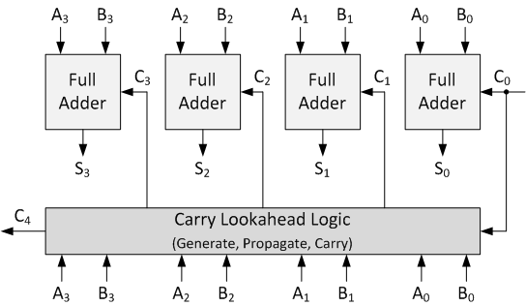
FIG-6 EXISTING SCHEME BLOCK DIAGRAM
4.1.2 DISADVANTAGES
- The existing RCA system is to consume more power and area.
- To consume more time for carry generation process.
- To affect the overall adder architecture performance level.

4.1.4 EXISTING SCHEME OUTPUT
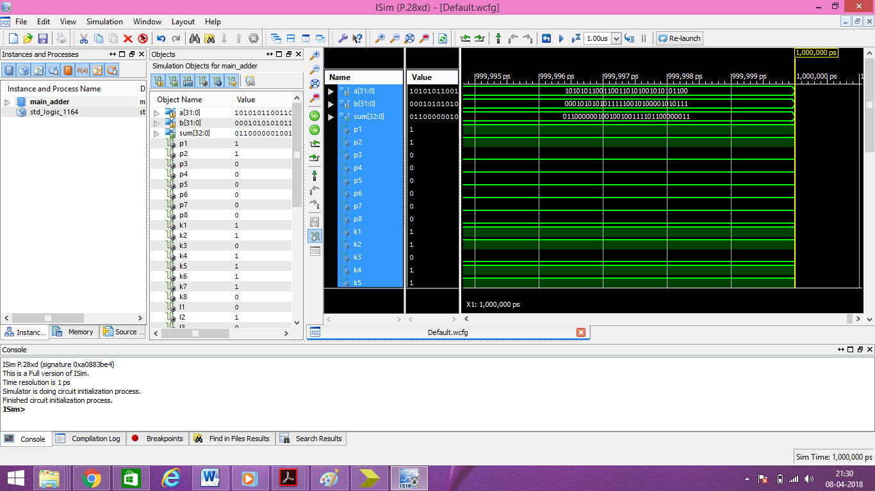

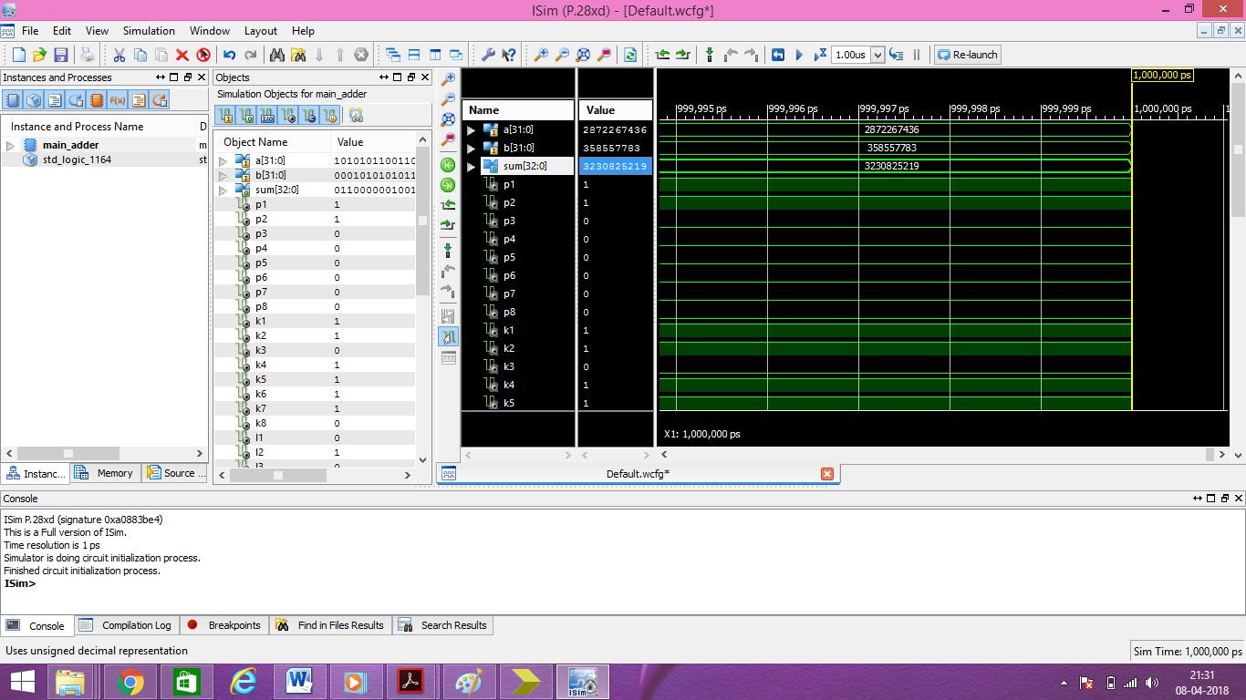FIG-7 EXISTING SCHEME OUTPUT
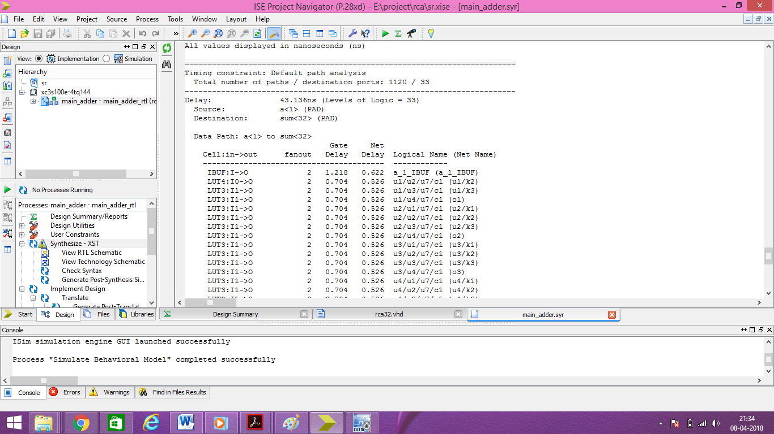
FIG-8 EXISTING SYSTEM TIME DELAY
The existing system time delay is 43.136ns.
4.2 PROPOSED SCHEME
In the proposed scheme, the carry select (CS) operation is scheduled before the calculation of final-sum, which is different from the conventional approach. Bit patterns of two anticipating carry words (corresponding to cin = 0 and 1) and fixed cin bits are used for logic optimization of CS and generation units. An efficient CSLA design is obtained using optimized logic units. The proposed CSLA design involves significantly less area and delay than the recently proposed BEC-based CSLA. Due to the small carry-output delay, the proposed CSLA design is a good candidate for square-root (SQRT) CSLA.In the proposed scheme, the CS operation is scheduled before the calculation of final-sum, which is different from the conventional approach. Carry words corresponding to input-carry ‘0’ and ‘1’ generated by the CSLA based on the proposed scheme follow a specific bit pattern, which is used for logic optimization of the CS unit.As in the regular SQRT CSLA, the Modified CSLA has one set of RCA and one set of BEC in each stage. Considering the delay values in the table I. the incoming time of carry c1 (t=7) to the 6:3 Mux is earlier than the summation S3 (t=9) and C3 (t=10) from the full adder to the mux and latter for S2 (t=4).The outputs from the RCA that is C3, S3, S2 are given as inputs to the mux. The output from the mux adds up a delay of 3 which makes C3 (t=13), Sum3 (t=12), Sum2 (t=10), this delay is caused because of the operation time required by the mux. Where the C3 is given as the carry input to the next multiplexer to start functi
CHAPTER – 6
RESULT ANALYSIS

6.1 ANALYSIS OF RESLUT
6.1.1 RESULT COMPARISON
Here we are comparing both the results of existing scheme and the proposed scheme of the reconfigurable carry look ahead adder. The proposed scheme is better than the existing scheme.

EXISTING SCHEME

VS
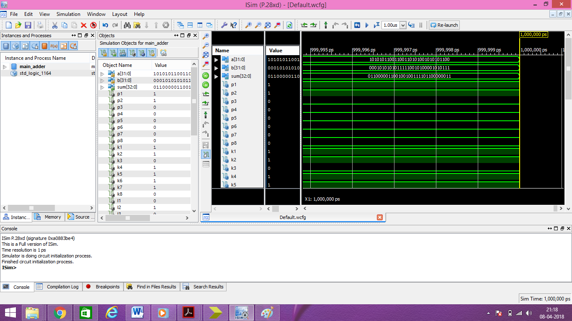
PROPOSED SCHEME
6.1.2 TIME DELAY COMPARISON
Here we compare the time delays of the existing scheme and the proposed scheme. The time delay is reduced from the existing scheme to the proposed scheme.
EXISTING SCHEME
Time delay is 43.136ns.

VS
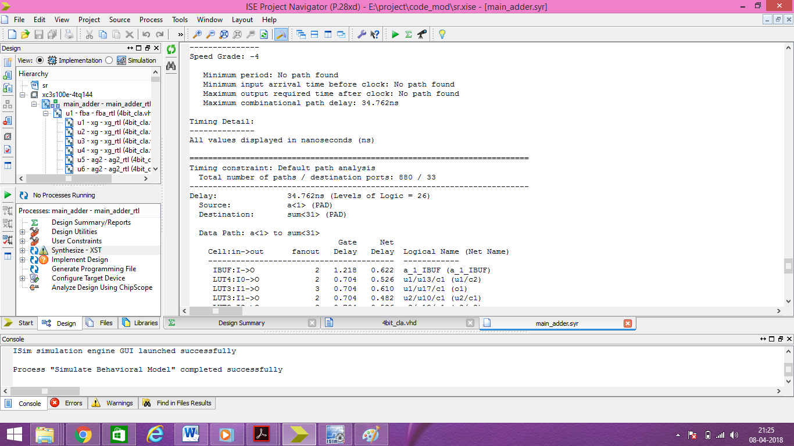
PROPOSED SCHEME
Time delay is 34.762ns.

CHAPTER -7
CONCLUSION
7.1 ADVANTAGES
- The proposed BEC function is to consume less power and area.
- To consume less time for carry generation process.
- Do not affect the overall adder architecture performance level.

7.2 APPLICATION
IMAGE PROCESSING APPLICATIONS
In this subsection, we employ proposed approximate adder in [14] (without utilizing the error reduction unit), GeAr, and RAP-CLA in smoothing and sharpening applications toevaluate the impact of the approximate adders on the quality of the output images. In both applications, 16-bit adders are utilized. In the sharpening algorithm, each output image pixel is obtained from
whereX and Y are the input and filtered images, respectively, and i and j are the pixel indices of the image , and MaskSharpeningis a 5×5 matrix defined in [18]. In the case of the smoothing algorithm, each output image pixel is determined from
whereMaskSmoothing is a 5×5 matrix defined in [19]. For both of these applications, the approximate adders (in approximate mode) along with the exact CLA are considered for 10 benchmark images. The peak signal-to-noise ratio (PSNR) of the output images (compared to the case of the exact filtering) are given in Table VII. The highest PSNR belongs to the adder of [14] while the GeAr leads to the lowest PSNR in both applications. Our proposed approximate adder increased the PSNR of ten benchmark images, on average, by 9.3% and 5.1% compared to the case of using the GeAr in smoothing and sharpening applications, respectively. Note that, as the accuracy analysis of Subsection IV.B also showed, the approximate adder of [14] provides the highest accuracy, and hence, the quality of the output images for this adder is higher than that of RAP-CLA. On average, the approximate adder of [14] results in 30.2% and 60.3% higher quality in smoothing and sharpening applications, respectively
7.3 CONCLUSION
In this paper, a high-speed yet energy-efficient reconfigurable approximate carry look-ahead adder was suggested. The adder enjoyed the ability of switching between the approximate and exact operating modes making it suitable for both error-resilient and exact applications. The structure of the proposed adder was based on some modifications to the structure of the conventional CLA. To assess the efficacy of the proposed structure, its design parameters were compared tothose of some suggested reconfigurable approximate adders. The parameters which included delay, power, energy energy-delay-product, and area were evaluated at a 15nm technology. The results showed up to 49% and 19% lower delay and power consumption, respectively, compared to the those of the approximate adders at the price of up to an error rate of 35.16%. Also, the effectiveness of the proposed adder on two image processing applications is studied as well.
The time delay has been reduced from the proposed scheme to the existing scheme.
The time delay has been reduced from 43.136nsto 34.762ns.

REFERENCE

[1] B. K. Mohanty and S. K. Patel, "Area–Delay–Power Efficient Carry-Select Adder," IEEE Transactions on Circuits and Systems II: Express Briefs, vol. 61, no. 6, pp. 418-422, June 2014.
[2] B. Shao and P. Li, "Array-Based Approximate Arithmetic Computing: A General Model and Applications to Multiplier and Squarer Design," IEEE Transactions on Circuits and Systems I: Regular Papers, vol. 62, no. 4, pp. 1081-1090, April 2015.
[3] A. Raha, H. Jayakumar, and V. Raghunathan, "Input-Based Dynamic Reconfiguration of Approximate Arithmetic Units for Video Encoding," IEEE Transactions on Very Large Scale Integration (VLSI) Systems, vol. 24, no. 99, pp. 1-1, May 2015.
[4] M. S. Khairy, A. Khajeh, A. M. Eltawil and F. J. Kurdahi, "Equi-Noise: A Statistical Model That Combines Embedded Memory Failures and Channel Noise," IEEE Transactions on Circuits and Systems I: Regular Papers, vol. 61, no. 2, pp. 407-419, Feb. 2014.
[5] R. Ye, T. Wang, F. Yuan, R. Kumar and Q. Xu, "On reconfiguration-oriented approximate adder design and its application," Proceedings of IEEE/ACM International Conference on Computer Aided Design (ICCAD), 2013, pp. 48-54.
[6] A. K. Verma, P. Brisk and P. Ienne, "Variable Latency Speculative Addition: A New Paradigm for Arithmetic Circuit Design," Proceedings of Design, Automation and Test in Europe (DATE), 2008, pp. 1250-1255.
[7] H.R. Mahdiani, A. Ahmadi, S.M. Fakhraie and C. Lucas, "Bio-Inspired Imprecise Computational Blocks for Efficient VLSI Implementation of Soft-Computing Applications," IEEE Transactions on Circuits and Systems-I: Regular Papers, vol. 57, no. 4, pp. 850-862, April 2010.
[8] D. Shin and S.K. Gupta, "A Re-design Technique for Datapath Modules in Error Tolerant Applications," Proceedings of 17th Asian Test Symposium(ATS), 2008, pp. 431-437.
[9] N. Zhu et al. "Design of Low-Power High-Speed Truncation-Error-Tolerant Adder and Its Application in Digital Signal Processing," IEEE Transactions on Very Large Scale Integration (VLSI) Systems, vol. 18, no. 8, pp. 1225-1229, Aug. 2010.
[10] N. Zhu, W.L. Goh and K.S. Yeo, "An enhanced low-power high-speed Adder for Error-Tolerant application," Proceedings of International Symposium on Integrated Circuits (ISIC), 2009, pp. 69-72.
[11] A.B. Kahng and S. Kang, "Accuracy-configurable adder for approximate arithmetic designs," Proceedings of 49th ACM/EDAC/IEEE Design Automation Conference (DAC), 2012, pp. 820-825.
[12] V. Gupta, D. Mohapatra, A. Raghunathan and K. Roy, "Low-Power Digital Signal Processing Using Approximate Adders," IEEE Transactions on Computer-Aided Design of Integrated Circuits and Systems, vol. 32, no. 1, pp. 124-137, Jan. 2013.
[13] M. Shafique, W. Ahmad, R. Hafiz and J. Henkel, "A low latency generic accuracy configurable adder," Proceedings of 52nd ACM/EDAC/IEEE Design Automation Conference (DAC), 2015, pp. 1-6.
[14] J. Hu and W. Qian, "A new approximate adder with low relative error and correct sign calculation," Proceedings of Design, Automation & Test in Europe (DATE) Conference & Exhibition, 2015, pp. 1449-1454.

