ZIGBEE BASED VEHICLE ANTI-THEFT MONITORING AND CONTROLLING SYSTEM
CHAPTER 1
INTRODUCTION
Vehicle anti-theft monitoring and controlling system especially useful for mining appliances inreal-time has been reported in this paper. The system principally monitors vehicle moving and tracking appliances such as position, and speed and subsequent detection. The novelty of this system is the implementation of vehicles internal and external parameter in different ways. The developed system is a low-cost and flexible in operation like mines and thus can avoid collision and traffic jam. The prototype has been extensively tested in real-life situations and experimental results are very encouraging for drivers and proprietors. A lot of vehicle theft occur and accident due to over speed can be controlled. GPS is increasingly being used in vehicle tracking and monitoring services. To resolve the problems like avoid speed and collision, pic microcontroller based vehicle monitoring and controlling is implemented as well providing information for the vehicle owner.
1.1 Area of interest
More recently, the advancement in wireless sensor technology shows a great promise in designing Intelligent Transportation System (ITS) due to its flexibility and costeffectiveness for deployment. The aim of this research is to develop a prototype vehicle speed monitoring system using accelerometer-based wireless sensor. The research focus on unifying the Global Positioning system with embedded wireless is the new approaches in intelligent vehicle control for critical remote location application using PIC, and we detect a accident location of the car using GSM & GPS, Zigbee is used for connect a control station and a car for a regular monitoring
In conventional system they are designed to control the speed of vehicles in all days. The main objective of the proposed system is to operate the vehicle in safe speed at critical zones. The functionality of the system has been simulated in laboratory environment bysetting different speed limits for monitoring single or multiple vehicle speed scenarios through appropriate algorithm and code development
The graphical user interface (GUI) of the software continuously presents the vehicle speeds with time and the over speeding conditions are indicated. The speed details are also continuously updated on the left hand side of the GUI.
1.2 Objective Project
Globally road accident is considered to be an important issue, which can be reduced by proper vehicle speed monitoring system. More recently, the advancement in wireless sensor technology shows a great promise in designing Intelligent Transportation System (ITS) due to its flexibility and costeffectiveness for deployment. The aim of this research is to develop a prototype vehicle speed monitoring system using accelerometer-based wireless sensor.
In our proposed system, we assume that the bus works on the basis of a timetable on every station. In addition, at the station that is just before the intersection, based on the amount of delay and the number of passengers (estimated by using innovative weight sensor), a priority value is assigned to each bus. Then, the bus requests the intersection agent its required green light time to cross the intersection

CHAPTER 2
LITERATURE REVIEW
Slavik,Michael,ImadMahgoub,and MohammedM.Alwakeel. Analysis and evaluation of distance-to-mean broadcast method for VANET”.Journal of king Saud university-computer and information science
Kumar,Neeraj,Naveen chilamkurti,and joel JPC Rodrigues.”Learning automata-based opportunistic data aggregation and forwarding scheme for alert generation in vehicular adhoc networks” computer communication
2.1 Existing system
Cumbersome and fixed mathematical models are abandoned in fuzzy control method. It is an artificial intelligent control method for imitating human thinking, understanding and deduction mode to certain degree. Human knowledge, common sense, etc. are well expressed by natural language form so that input and output process model can be perfectly processed by computer. Various traffic conditions are handled and responded by the same method according to previous experience of obtaining traffic police command.
2.2 Proposed system
Here, we describe our proposed architecture. First, we explain how agents work together, followed by a diagram of message passing of agents in our system. Then we explain the details of genetic algorithm used in our proposed method. When a bus is placed in the route of the bus, gets the station table from route agent. When the bus agent reaches to every bus stations, a message including its name and the bus station ID sends to the route agent.
Typical applications for RF modules include vehicle monitoring, remote controls, telemetry, small-range wireless networks, area paging, industrial data acquisition systems, wireless meter reading, access control systems, wireless home security systems, reading of radio tags, RF contact-less smart cards, wireless data terminals, wireless fire protection systems, robot remote control, wireless data transmissions, digital video/audio transmission, biological signal acquisition, hydrological and meteorological monitoring, digital home automation (ex: remote light switches), industrial remote controls, telemetry and remote sensing, alarm systems and wireless transmission for various types of low-rate digital signals, remote controls for various types of household appliances and electronics projects and several other applications related to RF wireless controlling.
ADVANTAGES:
we simulated our proposed system using five agents are designed as follows:
• Sensor agent
• Intersection agent
• Route agent
• Bus agent
• Supervisor agent

CHAPTER 3

PROJECT DESCRIPTION
2.4GHZ wireless communication was the first frequency band made available into the wireless networking consumer mass market, and this frequency band has become very popular in the small enterprise level networking and for home needs. 2.4 GHz transceivers networks can be used with high gain antennas along with point-to-point bridges if distance between the commercial buildings are longer. These networks can range upto kilometers in span areas. Some of the applications of electronicequipments which uses this frequency band are wireless phones, laptops, video devices, notebooks and many more devices. Let us look on some of these communication networks.

3.1 Hardware requirement
- Microcontroller
- Temperature sensor
- Speed sensor
- Vibration sensor
- Gsm modem
- Zigbee transmitter&receiver
- GPS receiver
- Power supply
- Pc with labview
- Android mobile phone
Transmitter unit:
16X2
LCD
GSM
MODEM
GPS
RECEIVER
ZIGBEE
Tx
ENGINE
ON/OFF
TEMPERATURE
SENSOR
SPEED
SENSOR
VIBRATION
SENSOR

PIC16F877A
MICROCONTROLLER
POWER
SUPPLY
MOTOR
DRIVER
M1
M2

Fig 3.1(a) Block diagram of Transmitter unit

Receiver unit:

ANDROID
MOBILE
PHONE
ZIGBEE
Rx

PC
With
LABVIEW

Fig 3.1(b): Block diagram of Receiver unit

3.2Block diagram Description
In our designed system, we assume that the bus works on the basis of a timetable on every station. In addition, at the station that is just before the intersection, based on the amount of delay and the number of passengers (estimated by using innovative weight sensor), a priority value is assigned to each bus. Then, the bus requests the intersection agent its required green light time to cross the intersection. The intersection agent also uses the estimated number of vehicles, as well as bus priority value and then produce the best and optimized timing using genetic algorithms.
The research focus on unifying the Global Positioning system with embedded wireless is the new approaches in intelligent vehicle control for critical remote location application using PIC, and we detect a accident location of the car using GSM & GPS, Zigbee is used for connect a control station and a car for a regular monitoring.

3.2.1 PIC Microcontroller
The microcontroller that has been used for this project is from PIC series. PIC microcontroller is the first RISC based microcontroller fabricated in CMOS (complimentary metal oxide semiconductor) that uses separate bus for instruction and data allowing simultaneous access of program and data memory.
Various microcontrollers offer different kinds of memories. EEPROM, EPROM, FLASH etc. are some of the memories of which FLASH is the most recently developed. Technology that is used in pic16F877 is flash technology, so that data is retained even when the power is switched off. Easy Programming and Erasing are other features of PIC 16F877.
Features
• High-performance RISC CPU
• Only 35 single word instructions to learn
• All single cycle instructions except for program branches which are two cycle
• Operating speed: DC - 20 MHz clock input
• Pin out compatible to the PIC16C73/74/76/77
• Interrupt capability (up to 14 internal/external
• Direct, indirect, and relative addressing modes
• Power-on Reset (POR)Power-up Timer (PWRT) and Oscillator Start-up Timer (OST)
• Watchdog Timer (WDT) with its own on-chip RC Oscillator for reliable operation
• Programmable code-protection
• Power saving SLEEP mode
• Wide operating voltage range: 2.5V to 5.5V
Architecture
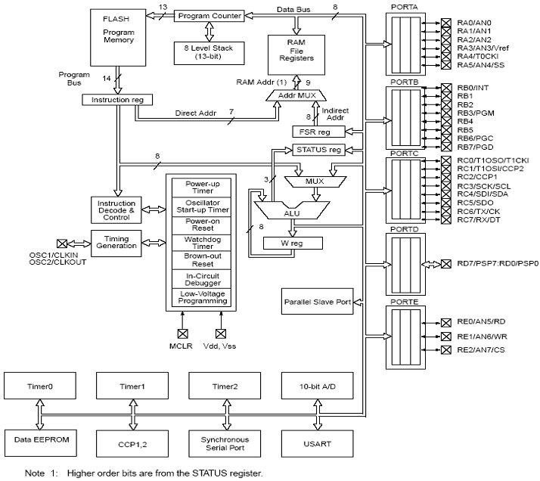
Fig 3.2 : Architecture of PIC 16F877
Pin Diagram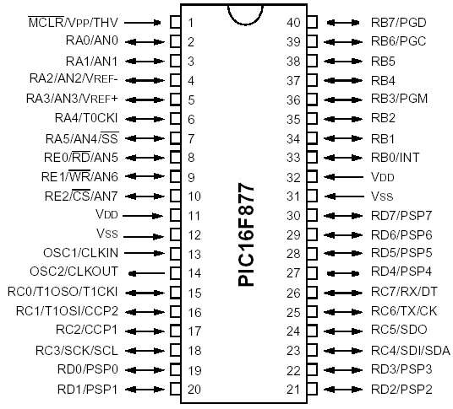
Fig 3.3: Pin diagram of 16F877
Legend: I = input O = output I/O = input/output P = power - = Not used TTL = TTL input ST = Schmitt Trigger input
Note
1. This buffer is a Schmitt Trigger input when configured as an external interrupt
2. This buffer is a Schmitt Trigger input when used in serial programming mode.
3. This buffer is a Schmitt Trigger input when configured as general purpose I/O and a TTL
input when used in the Parallel Slave Port mode (for interfacing to a microprocessor bus).

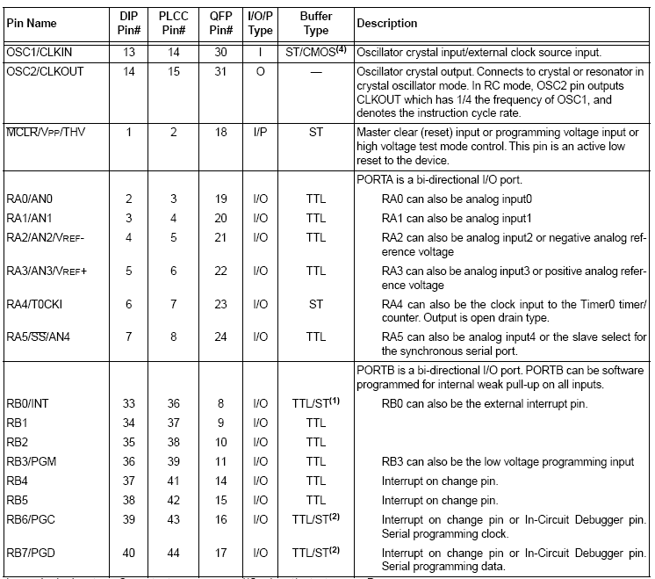
Table 3.1 : 16F877 Pin out details

3.2.2 LCD Display

Liquid crystal displays (LCDs) have materials which combine the properties of both liquids and crystals. Rather than having a melting point, they have a temperature range within which the molecules are almost as mobile as they would be in a liquid, but are grouped together in an ordered form similar to a crystal
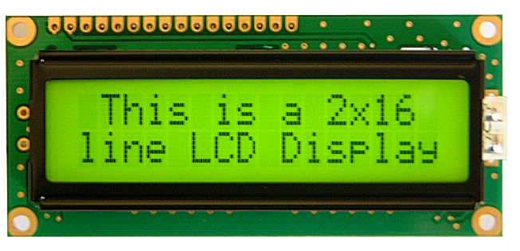
Fig 3.4 : LCD Display

.An LCD consists of two glass panels, with the liquid crystal material sand witched in between them. The inner surface of the glass plates are coated with transparent electrodes which define the character, symbols or patterns to be displayed polymeric layers are present in between the electrodes and the liquid crystal, which makes the liquid crystal molecules to maintain a defined orientation angle. One each polarizers are pasted outside the two glass panels. These polarizers would rotate the light rays passing through them to a definite angle, in a particular direction
A liquid crystal display (LCD) is a thin, flat Electronic visual display that uses the light modulating properties of Liquid crystals (LCs). LCs do not emit light directly.
They are used in a wide range of applications including:computer monitor, Television instrument panels, etc. They are common in consumer devices such as video players, gaming devices, clocks, watches, calculators, and telephones. LCDs have displaced CRT displays in most applications. They are usually more compact, lightweight, portable, less expensive, more reliable, and easier on the eyes. They are available in a wider range of screen sizes than CRT and plasma displays, and since they do not use phosphors, they cannot suffer image burn-in.LCDs are more energy efficient and offer safer disposal than CRTs. The earliest discovery leading to the development of LCD technology, the discovery of liquid crystals, dates from 1888. By 2008, worldwide sales of televisions with LCD screens had surpassed the sale of CRT units.
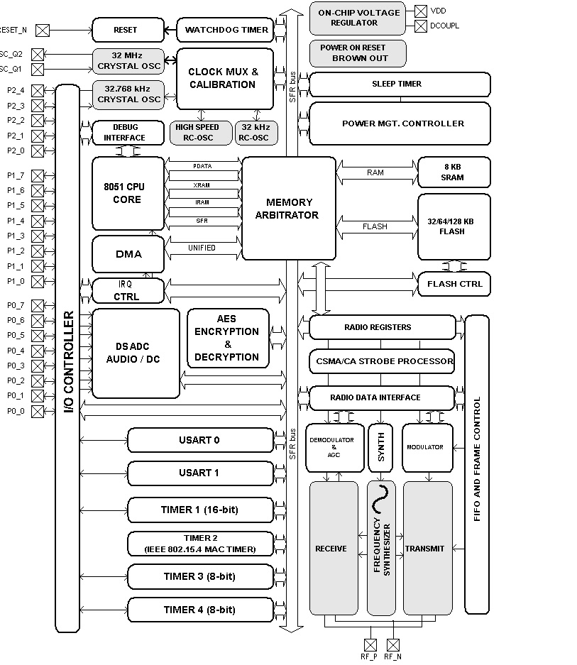
3.2.3 Zigbee

Fig 3.5 : Architecture of Zigbee

Zigbee system structure consists of three different types of devices such as Zigbee coordinator, Router and End device. Every Zigbee network must consist of at least one coordinator which acts as a root and bridgeof the network. The coordinator is responsible for handling and storing the information while performing receiving and transmitting data operations. Zigbee routers act as intermediary devices that permit data to pass to and fro through them to other devices. End devices have limited functionality to communicate with the parent nodes such that the battery power is saved as shown in the figure. The number of routers, coordinators and end devices depends on the type of network such as star, tree and mesh networks.
ZigbeeProtocol Architecture
Physical Layer: This layer does modulation and demodulation operations up on transmitting and receiving signals respectively. This layer’s frequency, date rate and number of channels are given below.

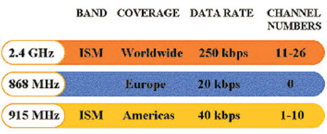

Physical Layer ofZigbee Protocol
MAC Layer: This layer is responsible for reliable transmission of data by accessing different networks with the carrier sense multiple access collision avoidance (CSMA). This also transmits the beacon frames for synchronizing communication.
Network Layer: This layer takes care of all network-related operations such as network setup, end device connection and disconnection to network, routing, device configurations, etc.
Application Support Sub-Layer: This layer enables the services necessary for Zigbee device object and application objects to interface with the network layers for data managing services. This layer is responsible for matching two devices according to their services and needs.
Application Framework: It provides two types of data services as key value pair and generic message services. Generic message is a developer defined structure, whereas the key value pair is used for getting attributes within the application objects. ZDO provides an interface between the application objects and APS layer in Zigbee devices. It is responsible for detecting, initiating and binding other devices to the network.

Zigbee Topologies
In mesh and tree topologies, the Zigbee network is extended with several routers wherein the coordinator is responsible for staring them. These structures allow any device to communicate with any other adjacent node for providing redundancy to the data. If any node fails, the information is routed automatically to otherdevice by these topologies. As the redundancy is the main factor in industries, hence mesh topology is mostly used. In a cluster-tree network, each cluster consists of a coordinator with leaf nodes, and these coordinators are connected to the parent coordinator that initiates the entire network.
3.2.4 Piezoelectric sensor
A piezoelectric sensor is a device that uses the piezoelectric effect to measure pressure, acceleration, strain or force by converting them to an electrical signal.
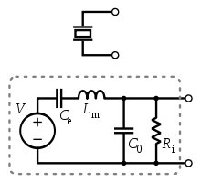
Fig 3.6 : Piezoelectric sensor

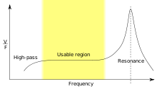
A piezoelectric transducer has very high DC output impedance and can be modeled as a proportional voltage source and filter network. The voltage V at the source is directly proportional to the applied force, pressure, or strain. The output signal is then related to this mechanical force as if it had passed through the equivalent circuit.

FIG:3.2.4Frequency response of a piezoelectric sensor; output voltage vs applied force
A detailed model includes the effects of the sensor's mechanical construction and other non-idealitiesThe inductance L_{m} is due to the seismic mass and inertia of the sensor itself. C_{e} is inversely proportional to the mechanical elasticity of the sensor, resulting from an inertial mass of infinite size.R_{i} is the insulation leakage resistance of the transducer element. If the sensor is connected to a load resistance, this also acts in parallel with the insulation resistance, both increasing the high-pass cutoff frequency.
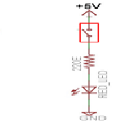
Fig:3.7 vibration sensor
In the flat region, the sensor can be modeled as a voltage source in series with the sensor's capacitance or a charge source in parallel with the capacitance
3.2.5GPS
Global Positioning System (GPS) arrived, researchers worked hard to arrive at a feasible solution to aid travellers from getting lost. Earlier, travellers used to rely on elaborate maps to track and monitor the route to their destination. But today, GPS technology has ensured hassle – free trips and increased safety for vehicle owners. The figure below illustrates a GPS satellite in orbit.
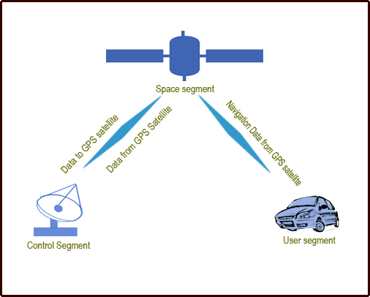

Fig 3.8 : Operating segment of GPS

Space segment – The satellites are the heart of the Global positioning system which helps to locate the position by broadcasting the signal used by the receiver. The signals are blocked when they travel through buildings, mountains, and people. To calculate the position, the signals of four satellites should be locked. You need to keep moving around to get clear reception.

User segment – This segment includes military and civilian users. It comprises of a sensitivereceiver which can detect signals (power of the signal to be less than a quadrillionth power of a light bulb) and a computer to convert the data into useful information. GPS receiver helps to locate your own position but disallows you being tracked by someone else.

Control segment – This helps the entire system to work efficiently. It is essential that the transmission signals have to be updated and the satellites should be kept in their appropriate orbits.

Types of GPS receivers
The three types of GPS receivers that offer different level of accuracy, and have different necessity to obtain the accuracies are:

Coarse Acquisition (C/A) code receivers – These receivers offer 1-5 meter GPS position accuracy with differential correction. With an occupation time of 1 second, these receivers offer 1-5 meter GPS position accuracy. The GPS position accuracies can be within 1-3 meters consistently if the occupation time is long.

Carrier Phase receivers – These receivers offer 10-30 meter GPS position accuracy with differential correction. The waves that carry C/A signal are counted to calculate the distance between the satellite and the receiver. High occupation time is required to obtain position accuracy.

Dual Frequency receivers – These receivers offer sub-centimeter GPS position accuracy with differential correction. These receivers accept signals from the satellites on two different frequencies to find out accurate position.
3.2.6 GSM
GSM (Global System for Mobile Communications: originally from Group SpecialMobile) is the most popular standard for mobile telephony systems in the world. The GSM Association, its promoting industry trade organization of mobile phone carriers and manufacturers, estimates that 80% of the global mobile market uses the standard.^{[1]} GSM is used by over 1.5 billion peopleacross more than 212 countries and territories.^{[3]} Its ubiquity enables international roaming arrangements between mobile network operators, providing subscribers the use of their phones in many parts of the world. GSM differs from its predecessor technologies in that both signaling and speech channels are digital, and thus GSM is considered a second generation (2G) mobile phone system. This also facilitates the wide-spread implementation of data communication applications into the system.
The ubiquity of implementation of the GSM (Global System Market) standard has been an advantage to both consumers, who may benefit from the ability to roam and switch carriers without replacing phones, and also to network operators, who can choose equipment from many GSM equipment vendors.^{[4]} GSM also pioneered low-cost implementation of the short message service (SMS), also called text messaging, which has since been supported on other mobile phone standards as well. The standard includes a worldwide emergency telephone numberfeature .
Newer versions of the standard were backward-compatible with the original GSM system. For example, Release '97 of the standard added packet data capabilities by means of General Packet Radio Service (GPRS). Release '99 introduced higher speed data transmission using Enhanced Data Rates for GSM Evolution (EDGE).

GSM carrier frequencies
GSM networks operate in a number of different carrier frequency ranges (separated into GSM frequency ranges for 2G and UMTS frequency bands for 3G), with most 2G GSM networks operating in the 900 MHz or 1800 MHz bands. Where these bands were already allocated, the 850 MHz and 1900 MHz bands were used instead (for example in Canada and the United States). In rare cases the 400 and 450 MHz frequency bands are assigned in some countries because they were previously used for first-generation systems.
Regardless of the frequency selected by an operator, it is divided into timeslots for individual phones to use. This allows eight full-rate or sixteen half-rate speech channels per radio frequency. These eight radio timeslots (or eight burst periods) are grouped into a TDMA frame. Half rate channels use alternate frames in the same timeslot. The channel data rate for all 8 channels is 270.833kbit/s, and the frame duration is 4.615ms.
The transmission power in the handset is limited to a maximum of 2 watts in GSM850/900 and 1 watt in GSM1800/1900.

Voice codecs
GSM has used a variety of voice codecs to squeeze 3.1 kHz audio into between 6.5 and 13kbit/s. Originally, two codecs, named after the types of data channel they were allocated, were used, called Half Rate (6.5kbit/s) and Full Rate (13kbit/s). These used a system based upon linear predictive coding (LPC). In addition to being efficient with bitrates, these codecs also made it easier to identify more important parts of the audio, allowing the air interface layer to prioritize and better protect these parts of the signal.GSM was further enhanced in 1997 with the Enhanced Full Rate (EFR) codec, a 12.2kbit/s codec that uses a full rate channel. Finally, with the development of UMTS, EFR was refactored into a variable-rate codec called AMR-Narrowband, which is high quality and robust against interference when used on full rate channels, and less robust but still relatively high quality when used in good radio conditions on half-rate channels.

Network structure
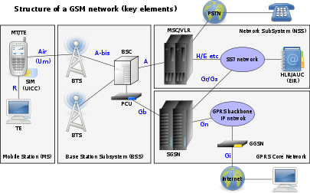

3.9:The structure of a GSM network
The network is structured into a number of discrete sections:
- The Base Station Subsystem (the base stations and their controllers).
- The Network and Switching Subsystem (the part of the network most similar to a fixed network). This is sometimes also just called the core network.
- The GPRS Core Network (the optional part which allows packet based Internet connections).
- The Operations support system (OSS) for maintenance of the network.
3.2.7 DC Motor
Geared DC motors can be defined as an extension of DC motor which already had its Insight details demystified here. A geared DC Motor has a gear assembly attached to the motor. The speed of motor is counted in terms of rotations of the shaft per minute and is termed as RPM .The gear assembly helps in increasing the torque and reducing the speed. Using the correct combination of gears in a gear motor, its speed can be reduced to any desirable figure. This concept where gears reduce the speed of the vehicle but increase its torque is known as gear reduction. This Insight will explore all the minor and major details that make the gear head and hence the working of geared DC motor.
Working of the DC Geared Motor
The DC motor works over a fair range of voltage. The higher the input voltage more is the RPM (rotations per minute) of the motor. For example, if the motor works in the range of 6-12V, it will have the least RPM at 6V and maximum at 12 V.

In terms of voltage, we can put the equation as:
RPM= K1 * V, where,
K1= induced voltage constant
V=voltage applied
In any DC motor, RPM and torque are inversely proportional. Hence the gear having more torque will provide a lesser RPM and converse. In a geared DC motor, the concept of pulse width modulation is applied.
In a geared DC motor, the gear connecting the motor and the gear head is quite small, hence it transfers more speed to the larger teeth part of the gear head and makes it rotate. The larger part of the gear further turns the smaller duplex part. The small duplex
when a target object comes between both elements, acting as an optical switch.part receives the torque but not the speed from its predecessor which it transfers to larger part of other gear and so on. The third gear’s duplex part has more teeth than others and hence it transfers more torque to the gear that is connected to the shaft.
3.2.8 Photo interrupter
A photo-interrupter (as shown below) is a sensor with a light-emitting component and light-receiving component packaged and placed on face-to-face. It applies the principle that light is interrupted when an object passes through the sensor. Therefore, photo-interrupters are widely used in speed measurement.
A Photo-interrupter is a transmission-type photosensor, which typically consists of a light emitting elements and light receiving elements aligned facing each other in a single package, that works by detecting light blockage.At ROHM, we refer to optical-type photosensors as photointerrupters.Unlike mechanical switches, photointerruptersare non-contact (optical) switches, improving reliability by preventing wear-and-tear due to abrasion.
Fig3.10:Schematic diagram of photo interrupter
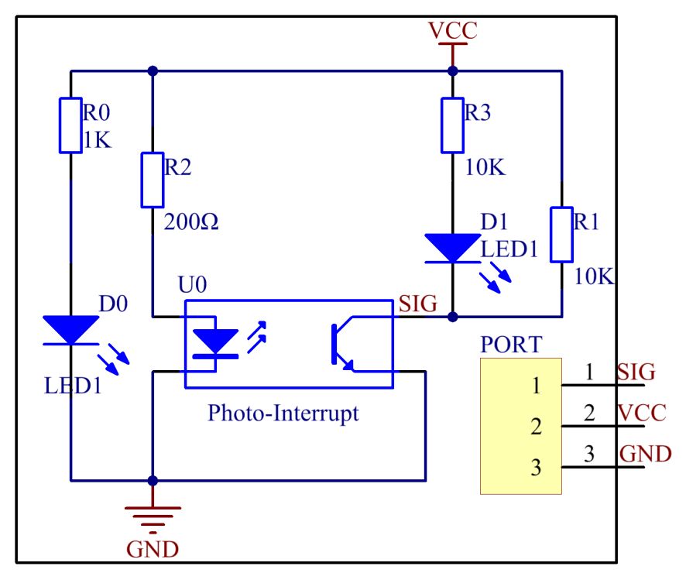
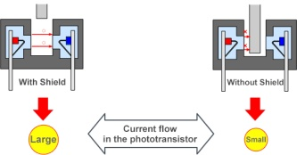
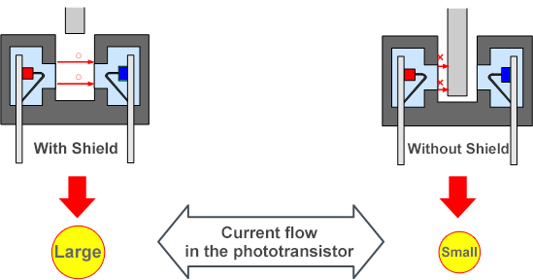

CHAPTER 4
SOFTWARE DESCRIPTION
Code-Vision-AVR software has been used to program the AVR MCU. It is the
ideal IDE (Integrated Development Environment) for the 8-bit Atmel AVR and XMEGA microcontrollers for the programming of Atmel AVR family of microcontrollers. It is a C cross – compiler and has an Automatic program generator. It allows easy access to EEPROM and Flash memory without the need for special functions like in other compilers for AVR. It offers a very efficient use of RAM. The program is written in C language. It is then build and the .C file is converted into .hex file before transferring the Program to microcontroller’s Flash memory.
4.1 About MPLAB
Microchip has a large suite of software and hardware development tools integrated within one software package called MPLAB Integrated Development Environment (IDE). MPLAB IDE is a free, integrated toolset for the development of embedded applications on Microchip's PIC and dsPIC microcontrollers. It is called an Integrated Development Environment, or IDE, because it provides a single integrated environment to develop code for embedded microcontrollers.

4.2 MPLAB – An Integrated Development Environment (IDE)

There are software simulators in MPLAB IDE for all PICmicro MCU and dsPIC DSC devices. These simulatorsuse the PC to simulate the instructions and some peripheral functions of the PICmicro MCU and dsPIC DSC devices. Optional in-circuit emulators and in-circuit debuggers are also available to test code as it runs in the applications hardware.

4.3 MPLAB Development tools
The MPLAB IDE has both built-in components and plug-in modules to configure the system for a variety of software and hardware tools.

Project Manager:
The project manager provides integration and communication between the IDE and the language tools.

Editor:
The editor is a full-featured programmer's text editor that also serves as a window into the debugger.

Assembler/Linker and Language Tools:
The assembler can be used stand-alone to assemble a single file, or can be used with the linker to build a project from separate source files, libraries and recompiled objects. The linker is responsible for positioning the compiled code into memory areas of the target microcontroller.

Debugger:
The Microchip debugger allows breakpoints, single stepping, watch windows and all the features of a modern debugger for the MPLAB IDE. It works in conjunction with the editor to reference information from the target being debugged back to the source code.

Execution Engines:
There are software simulators in MPLAB IDE for all PICmicro MCU and dsPIC DSC devices. These simulators use the PC to simulate the instructions and some peripheral functions of the PICmicro MCU and dsPIC DSC devices. Optional in-circuit emulators and in-circuit debuggers are also available to test code as it runs in the applications hardware
4.4 PIC SIMULATOR IDE
PIC Simulator IDE is powerful application that supplies micro chip microcontroller users with user-friendly graphical development environment for Windows with integrated simulator (emulator), pic basic compiler, assembler, disassembler and debugger. PIC Simulator IDE supports the extensive number of microcontrollers (MCUs) from the Microchip 8-bit PIC Mid-Range architecture product line (selected PIC16F, PIC12F, PIC10F models)
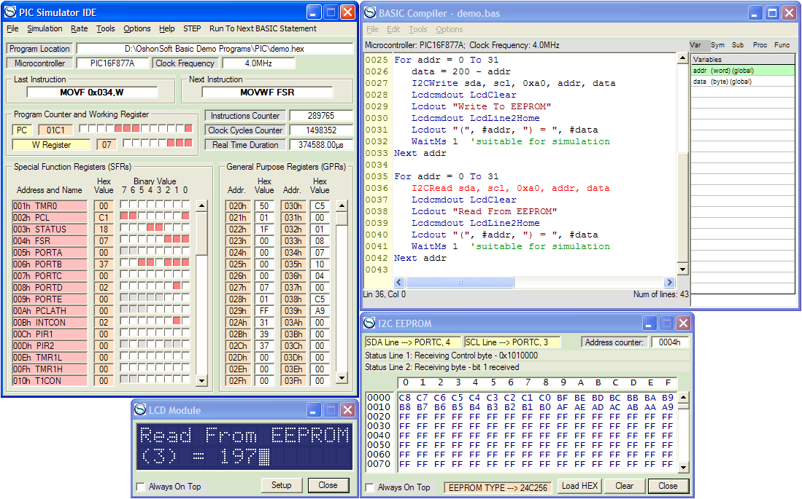

Fig 4.1: PIC Simulator IDE
PIC Simulator IDE requires a license to operate after the evaluation period. For more information please visit the licences page.
- PIC Simulator IDE main features:
- Main simulation interface showing internal microcontroller architecture,
- FLASH program memory editor, EEPROM data memory editor, hardware stack editor,
- Microcontroller pinout interface for simulation of digital I/O and analog inputs,
- Variable simulation rate, simulation statistics,
- Breakpoints manager for code debugging with breakpoints support,
- PIC assembler, interactive assembler editor for beginners, PIC disassembler,
- Powerful PIC Basic compiler with smart Basic source editor,
- PIC Basic compiler features: three basic integer data types (1-bit, 1-byte, 2-byte), 4-byte (32-bit) long integer data type with 32-bit arithmetics, 4-byte (32-bit) single precision floating point data type with single precision math functions, arrays, string data type with extensive set of string related functions, all standard Basic language elements, support for structured language (procedures and functions), Modbus master/slave implementation support, interfacing MMC/SD/SDSC/SDHC cards implementation (with FAT16 file system support and FAT32 file system support), high level language support for using internal EEPROM memory, using internal A/D converter module, using interrupts, serial communication using internal hardware UART, software UART implementation, I2C communication with external I2C devices, Serial Peripheral Interface (SPI) communication, interfacing character LCDs, interfacing graphical LCDs with 128x64 dot matrix, R/C servos, stepper motor control, 1-Wire devices, DS18S20, using internal PWM modules ...
- Configuration bits editor,
- PC's serial port terminal for communication with real devices connected to serial port,
- LCD module simulation interface for character LCD modules,
- Graphical LCD module simulation interface for 128x64 graphical LCD modules,
- Stepper motor phase simulation interface for stepper motor driving visualization,
- Simulation module for external I2C EEPROMs from 24C family,
- Hardware UART simulation interface,
- Software UART simulation interface for software implemented UART routines,
- Oscilloscope (with Zoom feature) and signal generator simulation tools,
- 7-segment LED displays simulation interface,
- DS18S20/DS18B20 digital thermometer simulation tool,
- Modbus simulation device tool (master/slave),
- Support for external simulation modules,
- Extensive program options, color themes, ...

CHAPTER 5
DESIGN AND IMPLEMENTATION
The ac voltage, typically 220Vrms, is connected to a transformer, which steps that ac voltage down to the level of the desired dc output. A diode rectifier then provides a full-wave rectified voltage that is initially filtered by a simple capacitor filter to produce a dc voltage. This resulting dc voltage usually has some ripple or ac voltage variation.
A regulator circuit removes the ripples and also remains the same dc value even if the input dc voltage varies, or the load connected to the output dc voltage changes. This voltage regulation is usually obtained using one of the popular voltage regulator IC units.
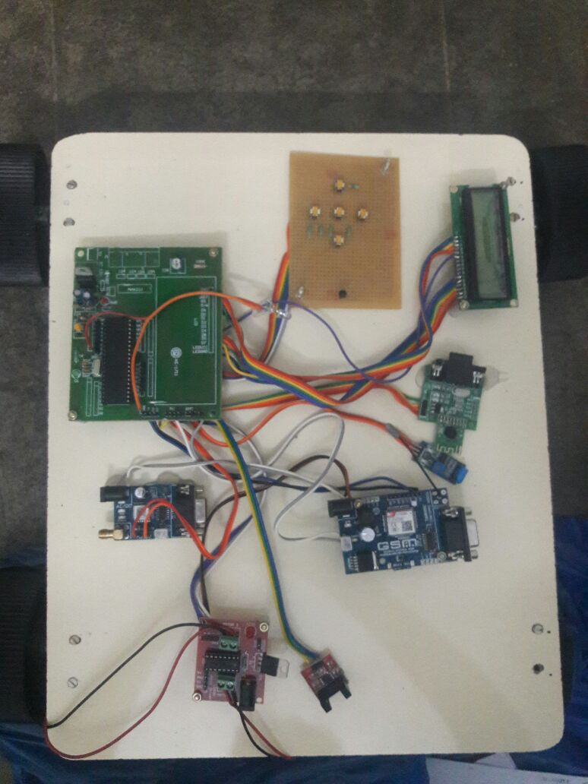
Fig 5.1 : Project kit top view

5.1 Power supply
The present chapter introduces the operation of power supply circuits built using filters, rectifiers, and then voltage regulators. Starting with an ac voltage, a steady dc voltage is obtained by rectifying the ac voltage, then filtering to a dc level, and finally, regulating to obtain a desired fixed dc voltage. The regulation is usually obtained from an IC voltage regulator unit, which takes a dc voltage and provides a somewhat lower dc voltage, which remains the same even if the input dc voltage varies, or the output load connected to the dc voltage changes.
A block diagram containing the parts of a typical power supply and the voltage at various points in the unit is shown in fig 19.1. The ac voltage, typically 120Vrms, is connected to a transformer, which steps that ac voltage down to the level for the desired dc output. A diode rectifier then provides a full-wave rectified voltage that is initially filtered by a simple capacitor filter to produce a dc voltage. This resulting dc voltage usually has some ripple or ac voltage variation. A regulator circuit can use this dc input to provide a dc voltage that not only has much less ripple voltage but also remains the same dc value even if the input dc voltage varies somewhat, or the load connected to the output dc voltage changes

TRANS-FORMER
RECTI-FIER
FILTER
IC REGULAT-OR
LOAD

Fig 5.2 :Block diagram of Power supply

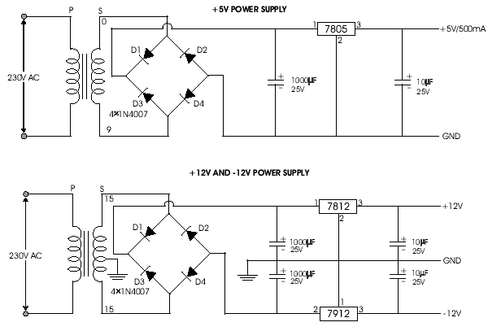Fig 5.3 : Circuit diagram of Power supply

5.1.1 Working principle
Transformer
The potential transformer will step down the power supply voltage (0-230V) to (0-6V) level. Then the secondary of the potential transformer will be connected to the precision rectifier, which is constructed with the help of op–amp. The advantages of using precision rectifier are it will give peak voltage output as DC, rest of the circuits will give only RMS output.

Bridge rectifier
When four diodes are connected as shown in figure, the circuit is called as bridge rectifier. The input to the circuit is applied to the diagonally opposite corners of the network, and the output is taken from the remaining two corners.
Let us assume that the transformer is working properly and there is a positive potential, at point A and a negative potential at point B. the positive potential at point A will forward bias D3 and reverse bias D4.
The negative potential at point B will forward bias D1 and reverse D2. At this time D3 and D1 are forward biased and will allow current flow to pass through them; D4 and D2 are reverse biased and will block current flow.
The path for current flow is from point B through D1, up through RL, through D3, through the secondary of the transformer back to point B. this path is indicated by the solid arrows. Waveforms (1) and (2) can be observed across D1 and D3.
One-half cycle later the polarity across the secondary of the transformer reverse, forward biasing D2 and D4 and reverse biasing D1 and D3. Current flow will now be from point A through D4, up through RL, through D2, through the secondary of T1, and back to point A. This path is indicated by the broken arrows. Waveforms (3) and (4) can be observed across D2 and D4. The current flow through RL is always in the same direction. In flowing through RL this current develops a voltage corresponding to that shown waveform (5). Since current flows through the load (RL) during both half cycles of the applied voltage, this bridge rectifier is a full-wave rectifier.
One advantage of a bridge rectifier over a conventional full-wave rectifier is that with a given transformer the bridge rectifier produces a voltage output that is nearly twice that of the conventional full-wave circuit.
This may be shown by assigning values to some of the components shown in views A and B. assume that the same transformer is used in both circuits. The peak voltage developed between points X and y is 1000 volts in both circuits. In the conventional full-wave circuit shown—in view A, the peak voltage from the center tap to either X or Y is 500 volts. Since only one diode can conduct at any instant, the maximum voltage that can be rectified at any instant is 500 volts.
The maximum voltage that appears across the load resistor is nearly-but never exceeds-500 v0lts, as result of the small voltage drop across the diode. In the bridge rectifier shown in view B, the maximum voltage that can be rectified is the full secondary voltage, which is 1000 volts. Therefore, the peak output voltage across the load resistor is nearly 1000 volts. With both circuits using the same transformer, the bridge rectifier circuit produces a higher output voltage than the conventional full-wave rectifier circuit.

IC voltage regulators
Voltage regulators comprise a class of widely used ICs. Regulator IC units contain the circuitry for reference source, comparator amplifier, control device, and overload protection all in a single IC. IC units provide regulation of either a fixed positive voltage, a fixed negative voltage, or an adjustable set voltage. The regulators can be selected for operation with load currents from hundreds of milleamperes to tens of amperes, corresponding to power ratings from mille watts to tens of watts.
A fixed three-terminal voltage regulator has an unregulated dc input voltage, Vi, applied to one input terminal, a regulated dc output voltage, Vo, from a second terminal, with the third terminal connected to ground.
The series 78 regulators provide fixed positive regulated voltages from 5 to 24 volts. Similarly, the series 79 regulators provide fixed negative regulated voltages from 5 to 24 volts.
- For ICs, microcontroller, LCD - 5 volts
- For alarm circuit, op-amp, relay circuits - 12 volts

ADVANTAGES
- Low power consumption
- Compatibility

5.2 HT12D Decoder IC
HT12D is a decoder integrated circuit that belongs to 2¹² series of decoders. This series of decoders are mainly used for remote control system applications, like burglar alarm, car door controller, security system etc. It is mainly provided to interface RF and infrared circuits. They are paired with 2¹² series of encoders. The chosen pair of encoder/decoder should have same number of addresses and data format.
In simple terms, HT12D converts the serial input into parallel outputs. It decodes the serial addresses and data received by, say, an RF receiver, into parallel data and sends them to output data pins. The serial input data is compared with the local addresses three times continuously. The input data code is decoded when no error or unmatched codes are found. A valid transmission in indicated by a high signal at VT pin. HT12D is capable of decoding 12 bits, of which 8 are address bits and 4 are data bits. The data on 4 bit latch typeoutput pin remain unchanged until new is received.
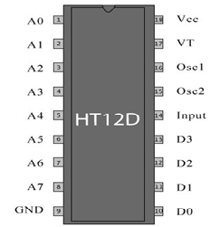

.

Fig5.4:pin diagram of HT12D Decoder IC
5.2.1 Pin Description
Pin No | Function | Name
1 | 8 bit Address pins for input | A0
2 | 8 bit Address pins for input | A1
3 | 8 bit Address pins for input | A2
4 | 8 bit Address pins for input | A3
5 | 8 bit Address pins for input | A4
6 | 8 bit Address pins for input | A5
7 | 8 bit Address pins for input | A6
8 | 8 bit Address pins for input | A7
9 | Ground (0V) | Ground
10 | 4 bit Data/Address pins for output | D0
11 | 4 bit Data/Address pins for output | D1
12 | 4 bit Data/Address pins for output | D2
13 | 4 bit Data/Address pins for output | D3
14 | Serial data input | Input
15 | Oscillator output | Osc2
16 | Oscillator input | Osc1
17 | Valid transmission; active high | VT
18 | Supply voltage; 5V (2.4V-12V) | Vcc

5.3 HT12E Encoder IC
HT12E is an encoder integrated circuit of 2¹² series of encoders. They are paired with 2¹² series of decoders for use in remote control system applications. It is mainly used in interfacing RF and infrared circuits. The chosen pair of encoder/decoder should have same number of addresses and data format.
Simply put, HT12E converts the parallel inputs into serial output. It encodes the 12 bit parallel data into serial for transmission through an RF transmitter. These 12 bits are divided into 8 address bits and 4 data bits.
HT12E has a transmission enable pin which is active low. When a trigger signal is received on TE pin, the programmed addresses/data are transmitted together with the header bits via an RF or an infrared transmission medium. HT12E begins a 4-word transmission cycle upon receipt of a transmission enable. This cycle is repeated as long as TE is kept low. As soon as TE returns to high, the encoder output completes its final cycle and then stops.

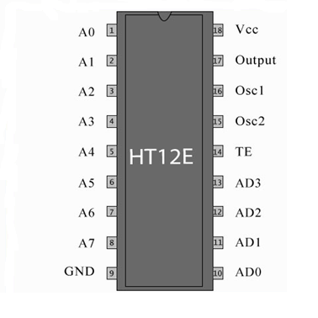
Fig 5.5 Pin diagram of HT12E Encoder IC

5.3.1Pin Description
Pin No | Function | Name
1 | 8 bit Address pins for input | A0
2 | 8 bit Address pins for input | A1
3 | 8 bit Address pins for input | A2
4 | 8 bit Address pins for input | A3
5 | 8 bit Address pins for input | A4
6 | 8 bit Address pins for input | A5
7 | 8 bit Address pins for input | A6
8 | 8 bit Address pins for input | A7
9 | Ground (0V) | Ground
10 | 4 bit Data/Address pins for output | AD0
11 | 4 bit Data/Address pins for output | AD1
12 | 4 bit Data/Address pins for output | AD2
13 | 4 bit Data/Address pins for output | AD3
14 | Transmission enable;active low | TE
15 | Oscillator output | Osc2
16 | Oscillator input | Osc1
17 | Serial data output | output
18 | Supply voltage; 5V (2.4V-12V) | Vcc

5.4 Motor driver IC

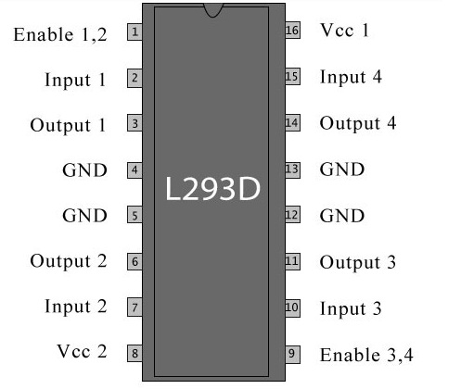

FIG:5.6 Pin diagram

5.4.1 Pin Configuration
Pin number | Pin name |  | Description
1 |  | Enable 1,2 | This pin enables the input pin Input 1(2) and Input 2(7)
2 |  | Input 1 | Directly controls the Output 1 pin. Controlled by digital circuits
3 |  | Output 1 | Connected to one end of Motor 1
4 |  | Ground | Ground pins are connected to ground of circuit (0V)
5 |  | Ground | Ground pins are connected to ground of circuit (0V)
6 |  | Output 2 | Connected to another end of Motor 1
7 |  | Input 2 | Directly controls the Output 2 pin. Controlled by digital circuits
8 |  | Vcc2 (Vs) | Connected to Voltage pin for running motors (4.5V to 36V)
9 |  | Enable 3,4 | This pin enables the input pin Input 3(10) and Input 4(15)
10 |  | Input 3 | Directly controls the Output 3 pin. Controlled by digital circuits
11 |  | Output 3 | Connected to one end of Motor 2
12 |  | Ground | Ground pins are connected to ground of circuit (0V)
13 |  | Ground | Ground pins are connected to ground of circuit (0V)
14 |  | Output 4 | Connected to another end of Motor 2
15 |  | Input 4 | Directly controls the Output 4 pin. Controlled by digital circuits
16 |  | Vcc2 (Vss) | Connected to +5V to enable IC function

5.4.2Features

Can be used to run Two DC motors with the same IC.
- Speed and Direction control is possible
- Motor voltage Vcc2 (Vs): 4.5V to 36V
- Maximum Peak motor current: 1.2A
- Maximum Continuous Motor Current: 600mA
- Supply Voltage to Vcc1(vss): 4.5V to 7V
- Transition time: 300ns (at 5Vand 24V)
- Automatic Thermal shutdown is available
- Available in 16-pin DIP, TSSOP, SOIC packages

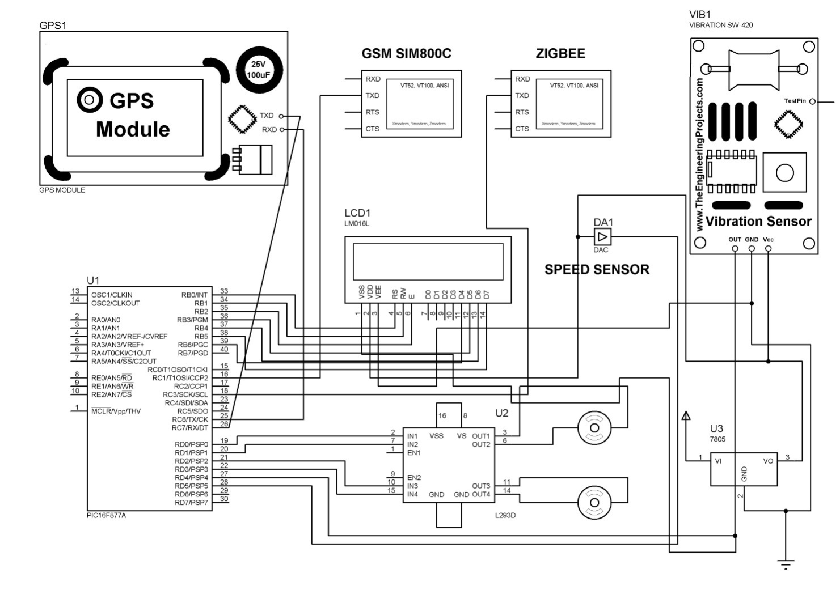
5.7 Circuit Diagram

CHAPTER-6
CONCLUSION:

Vehicle anti-theft, monitoring and controlling usingzigbeeto avoid vehiclecollision and reduce traffic jams on the road at the same time speed of the vehicle also monitored. The developed systemeffectively monitors and controls vehicle moving and indoor parameters of vehicle unit like temperature, speed &vibration. The system can be extended for monitoring the whole parameters like engine oil, fuel range &oil level in tank.The monitoring systems are programmed with various module interfaces suitable for users of varying ability and for expert users such that the system can be maintained easily and interacted with very simply. This system is useful in much application such as surveillance, security tracking, which may be installed in mining trucks, cargo trucks, cars, motorcycle, and robot. The system can be useful for many applications.

REFERENCES
[1] Priya et al,International Journal of Computer Science and Mobile Computing,vol.4 Issue.11,November-2015,Pg.199-206
[2] H. A. Omar, N. Lu, and W. Zhuang, “Wireless access technologies for vehicular network safety applications,” IEEENetw., vol. 30, no. 4, pp. 22–26, Aug. 2016.
[3] Hui Hu, LianFang, published a paper title “design and Implementation of vehicle monitoring system based on GPS/GSM/GIS”, Third International symposium on Intelligent information Technology Application 2009.
[4] E D Kalpan, Understanding GPS: Principle and applications,Artech house publishers.
[5] M.Mcdonald,H Keller ,J Kilinjihout and V.mauro “Intelligent Transport system in Europe’,Opportunity for future research “world scientific publishing company ,ISBN-981270082,2006
[6]V.Chris Thomson, using smart phone to detect car accidents provide situational awareness to Emergency responders” TN USA.
[7] S. Biswas, R. Tatchikou, and F. Dion, “Vehicle-to-vehicle wireless communication protocols for enhancing highway trafﬁc safety,” IEEE Commun. mag., vol. 44, no. 1, pp. 74–82, Jan. 2006.
[8] NJ.-P. Hubaux, S. C Apkun, and J. Luo “The security and privacy of smart vehicles”,IEEE security and Privacy magazine,vol 2.no3,pp 49-55,2004.
[10] Slavik, Michael, ImadMahgoub, and Mohammed M.Alwakeel. Analysis and evaluation of distance-to-mean broadcast method for VANET”.Journal of king Saud university-computer and information science
[11] Kumar, Neeraj, Naveen chilamkurti, and joel JPC Rodrigues.”Learning automata-based opportunistic data aggregation and forwarding scheme for alert generation in vehicular adhoc networks” computer communication

