VOICE CONTROL BASED ANDROID MOBILE SECURITY AND HOME AUTOMATION SYSTEM
CHAPTER 1
INTRODUCTION
Home automation or smart home is building automation for the home. It involves the control and automation of lighting, heating, ventilation, air conditioning, and security, as well as home appliances such as washer/dryers, ovens or refrigerators/freezers. Wi-Fi is often used for remote monitoring and control Home devices, when remotely monitored and controlled via the Internet, are an important constituent of the Internet of Things. Modern systems generally consist of switches and sensors connected to a central hub sometimes called as "gateway" from which the system is controlled with a user interface that is interacted either with a wall-mounted terminal, mobile phone software, tablet computer or a web interface, often but not always via Internet cloud services.
- Heating, ventilation and air conditioning (HVAC): It is possible to have remote control of all home energy monitors over the internet incorporating a simple and friendly user interface
- Lighting control system
- Security: A household security system integrated with a home automation system can provide additional services such as remote surveillance of security cameras over the Internet, or central locking of all perimeter doors and windows
- Leak detection, smoke and CO detector
- Indoor positioning systems
- Home automation for the elderly and disabled

  - EXISTING SYSTEM
The Home Automation System (HAS) was developed using Java ME and MoSync and a User Interfaced (UI) Android Application program implemented on an Android based Bluetooth enabled mobile phone, and an 8 bit microcontroller based relay driver circuit with Serial Bluetooth Module, which is able to communicate with the Home Appliances over Bluetooth link. The system is based on serial data transmission using Bluetooth wireless communication in order to facilitate the appliances control in a HAS.
1.4 PROBLEM IDENTIFICATION IN EXISTING SYSTEM

- The home appliance using Touch based control so Touch switch Problem will occur
- Elderly and disable people can’t access this type of Home Automation System
- Existing system cannot interfaced more than a device
- Bluetooth is used in home automation system, which have a range of 10 to 20 meters so the control cannot be achieved from outside this range
- High power consumption because of Bluetooth connectivity
- Application is connected after disconnect of the bluetooth
CHAPTER 2
PROPOSED SYSTEM

2.1 OVERVIEW OF PROPOSED SYSTEM

The proposed system is controlling of electrical appliance is done wirelessly through voice control application in android phone and by using the WiFi feature.The Android Smart Phone is used as voice based Remote Control for operating the electrical appliance. These include lighting, Fan, AC temperature control, and various intelligent appliances such as cellular phone, air conditioners, home security devices, etc.,. Security systems are designed for detecting the intrusion and unauthorized entry into the residential houses, commercial buildings, industries, and military surroundings. In our day-to-day life,security systems for home are a major concern to protect from burglary, property, and self defense from intruders are set to realize the concept of a smart home.
The security systems for home can also be designed by using Wifi based technology.It can be integrated with closed-circuit Mobile surveillance, and so on. The security systems for home can be designed by using vibration sensors, and all the environmental Application can be Controlled by using PIC Microcontroller.
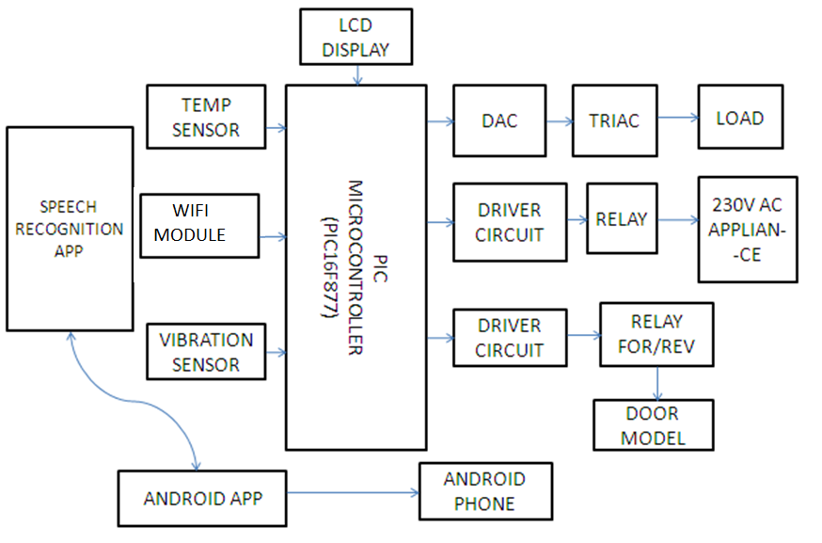
Fig 2.1 Block diagram for Proposed System
  - FUNCTION OF PROPOSED SYSTEM
The Controlling of electrical appliance is done wirelessly through voice application in android phone and by using the WiFi feature. In this project the Android Smart Phone is used as voice based Remote Control for Operating the Electrical Appliance Home automation involves introducing a degree of computerized or automatic control to certain electrical and electronic systems in a building. These include lighting, Fan, AC temperature control, etc.
Security systems for home can be designed using different technologies. Wifi based Android security systems for home, Wifi based Android security system integrated with closed-circuit Mobile surveillance, and so on. The security systems for home can be designed using vibration sensors, and so on the all environmental Application Control the processing for using PIC Microcontroller. This system ensures a secured exchange of data on wireless communication. It also supports Conventional ON/OFF system of appliances.
Security systems for home are designed using sensors for detection of indruders. Door knock vibration alarm home security system project is designed. The piezoelectric sensor is connected to the door using an adhesive. Piezoelectric sensor is basically called as piezoelectric transducer as it generator an electrical signal based on the measured input quantities such as vibrations.
A user interface (UI) on the Android enabled mobile phone offers system connection and control utilities. ULN 3803 relay driver and Serial WiFi Module from TINY OS as well as Keil Mvision IDE for compiling C Language Code and UC flash+ programmer for burning HEX file into microcontroller were used for the development. A PIC, 8 bit microcontroller was used as an embedded relay controller.
4.10 POWER SUPPLY
The ac voltage, typically 330V rms, is connected to a transformer, which steps that ac voltage down to the level of the desired dc output. A diode rectifier then provides a full-wave rectified voltage that is initially filtered by a simple capacitor filter to produce a dc voltage. This resulting dc voltage usually has some ripple or ac voltage variation. A regulator circuit removes the ripples and also remains the same dc value even if the input dc voltage varies, or the load connected to the output dc voltage changes. This voltage regulation is usually obtained using one of the popular voltage regulator IC units.
LOAD
IC REGULATOR
FILTER
RECTIFIER
TRANSFORMER

Fig 4.10 Block diagram for Power supply
Working principle
Transformer
The potential transformer will step down the power supply voltage (0-330V) to (0-9V) level. Then the secondary of the potential transformer will be connected to the precision rectifier, which is constructed with the help of op–amp. The advantages of using precision rectifier are it will give peak voltage output as DC, rest of the circuits will give only RMS output.
Bridge rectifier
A Bridge rectifier is an alternating current (AC) to direct current (DC) convertor that rectifies mains AC input to DC output. Bridge rectifiers are widely used in power supplies that provide necessary DC voltage for the electronic components or device. The input to the circuit is applied to the diagonally opposite corners of the network, and the output is taken from the remaining two corners. One advantage of a bridge rectifier over a conventional full wave rectifier is that with a given transformer the bridge rectifier produces a voltage output that is nearly twice that of the conventional full wave circuit. Depending on the load current requirements, a proper bridge rectifier is selected. Components ratings and specifications, breakdown voltage, temperature ranges, transient current rating, forward current rating, mounting requirements and other consideration are taken into account while selecting a rectifier power supply for an appropriate electronics circuits application.
IC voltage regulators (7805)
Voltage regulators comprise a class of widely used ICs. Regulator IC units contain the circuitry for reference source, comparator amplifier, control device, and overload protection all in a single IC. IC units provide regulation of either a fixed positive voltage, a fixed negative voltage, or an adjustably set voltage. The regulators can be selected for operation with load currents from hundreds of milli amperes to tens of amperes, corresponding to power ratings from milli watts to tens of watts.
A fixed three-terminal voltage regulator has an unregulated dc input voltage, Vi, applied to one input terminal, a regulated dc output voltage, Vo, from a second terminal, with the third terminal connected to ground. The series 78 regulators provide fixed positive regulated voltages from 5 to 34 volts. Similarly, the series 79 regulators provide fixed negative regulated voltages from 5 to 34 volts. For ICs, microcontroller, LCD -5 volts. For alarm circuit, op-amp, relay circuits-13 volts.
LCD DISPLAY WITH PIC MICROCONTROLLER
We connect the LCD display with PIC through PORT D.

PORT D AND TRIS D REGISTER

PORT D is an 8-bit wide bi-directional port. The corresponding data direction register is TRIS D. Setting a TRIS D bit (=1) will make the corresponding PORT D pin an input, i.e., put the corresponding output driver in a hi-impedance mode. Clearing a TRIS D bit (=0) will make the corresponding PORT D pin an output.
PORT D AND TRIS D REGISTER
This section is not applicable to the 38-pin devices. PORT D is an 8-bit port with Schmitt Trigger input buffers. Each pin is individually configurable as an input or output. PORTD can be configured as an 8-bit wide microprocessor Port (parallel slave port) by setting control bit PSPMODE (TRISE 4). In this mode, the input buffers are TTL.
a) Any read or write of PORT D. This will end the mismatch condition.
b) Clear flag bit RBIF. A mismatch condition will continue to set flag bit RBIF. Reading PORT D will end the mismatch condition, and allow flag bit RBIF to be cleared. The interrupt on change feature is recommended for wake-up on key depression operation and operations where PORT D is only used for the interrupt on change feature. Polling of PORT D is not recommended while using the interrupt on change feature. This interrupt on mismatch feature, together with software configurable pull-ups on these four pins, allow easy interface to a keypad and make it possible for wake-up on key depression.

RELAY CIRCUIT
A relay is an electrically operated switch. Many relays use an electromagnet to mechanically operate a switch, but other operating principles are also used, such as solid-state relays. Relays are used where it is necessary to control a circuit by a separate low-power signal, or where several circuits must be controlled by one signal. The first relays were used in long distance telegraph circuits as amplifiers: they repeated the signal coming in from one circuit and re-transmitted it on another circuit. Relays were used extensively in telephone exchanges and early computers to perform logical operations.
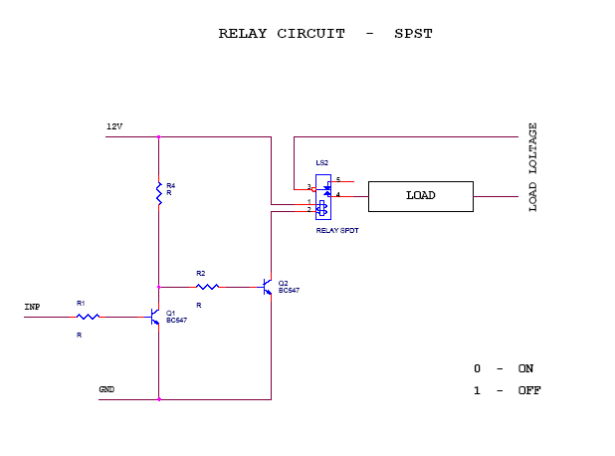
Fig 4.11 Relay circuit

Circuit description
This circuit is designed to control the load. The load may be motor or any other load. The load is turned ON and OFF through relay. The relay ON and OFF is controlled by the pair of switching transistors (BC 547). The relay is connected in the Q3 transistor collector terminal. A Relay is nothing but electromagnetic switching device which consists of three pins. They are Common, Normally close (NC) and Normally open (NO).
The relay common pin is connected to supply voltage. The normally open (NO) pin connected to load. When high pulse signal is given to base of the Q1 transistors, the transistor is conducting and shorts the collector and emitter terminal and zero signals is given to base of the Q3 transistor. So the relay is turned OFF state.
When low pulse is given to base of transistor Q1 transistor, the transistor is turned OFF. Now 13v is given to base of Q3 transistor so the transistor is conducting and relay is turned ON. Hence the common terminal and NO terminal of relay are shorted. Now load gets the supply voltage through relay.

Table 4.3 Voltage signal from microcontroller

Voltage Signal from Microcontroller or PC | Transistor Q1 | Transistor Q3 | Relay
1 | On | Off | Off
0 | Off | On | On

CHAPTER 5
SOFTWARE DESCRIPTION
5.1 EMBEDDED C
- It is a set of language extensions for the C programming language developed by the C standards committee.
- Embedded C programming requires nonstandard extensions to the C language in order to support exotic features such as fixed point arithmetic, multiple distinct memory banks and basic input output operations
- It also include a number of features not supported in normal C such as hardware input output addressing and named spaces
- Embedded C uses most of the syntax and semantics of standard including main function (), data types definition and declaration, unions, structures etc.
5.1.1 Features of Embedded C
- Code speed is governed by the processing power, timing constraints
- Code size is governed by available program memory and use of programming language. Goal of embedded system programming is to get maximum features in minimum space and minimum time.

5.1.2 Advantages of Embedded C
- It is small and simpler to learn, understand, program and debug
- It is compared to assembly language, C code written is more reliable and scalable
5.2 NET BEANS JAVA
Net Beans is a software development platform written in Java. The Net Beans Platform allows applications to be developed from a set of modular software components called modules. Applications based on the Platform, including the Net Beans integrated development environment (IDE), can be extended by third party developers. The Net Beans IDE is primarily intended for development in Java, but also supports other languages, in particular PHP, C/C++ and HTML5.
The Net Beans Team actively support the product and seek feature suggestions from the wider community. Every release is preceded by a time for Community testing and feedback. The NetBeans Platform is a framework for simplifying the development of Java Swing desktop applications.
Applications can install modules dynamically. Any application can include the Update Center module to allow users of the application to download digitally signed upgrades and new features directly into the running application. Reinstalling an upgrade or a new release does not force users to download the entire application again.The platform offers reusable services common to desktop applications, allowing developers to focus on the logic specific to their application. Among the features of the platform are
- User interface management (e.g. menus and toolbars)
- User settings management
- Storage management (saving and loading any kind of data)
- Window management
- Wizard framework (supports step-by-step dialogs)
CHAPTER 6
RESULT

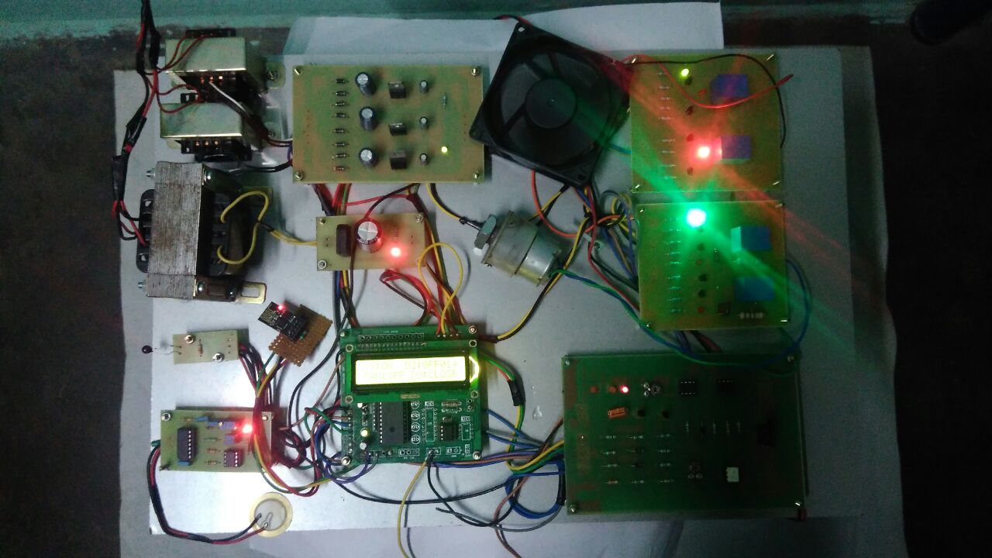
Fig 6.1 Snapshot of working model

The system is simplified by allowing appliances to be controlled by android mobile, just by giving the instruction to switch on or off will enable to control any home applianceWhen the room temperature is above 60 degree, the fan and AC will automatically turned on, and below 60 degree it will automatically turned off.The LCD will display all the instruction. Vibration sensor are devices which placed on the door to detect if someone is bangling or attempting force to open the door.
CHAPTER 7
CONCLUSION
The project conclusion based on Controlling of electrical appliance is done wirelessly through Speech Recognition application in android phone and by using the wifi feature Present in it. In this project the Android Smart Phone is used as voice based Remote Control for Operating the Electrical Appliance. Home automation involves introducing a degree of computerized or automatic control to certain electrical and electronic systems in a building. The security systems for home can be designed using wifi technologies. WiFi based Android security system integrated with closed-circuit Mobile surveillance, and so on. The security systems for home can be designed using vibration sensors, and so on the all environmental Application Control the processing for using PIC (16f877) based Design this Project.
FUTURE SCOPE
This project can be further developed by integrating it with the internet to monitor your home while sitting in a remote area. By doing this, one can keep an eye on home through an internet connected to the users mobile phone or PC or laptop. This will not only improve the security of your home in this modern day world but will also assist in conservation of energy like if you left any home appliance switched on by mistake, then you can check the status of the appliances on the graphical interface made on your mobile and can switch it off using the internet connectivity.
REFERENCE

- Bhavik Pandya, Mihir Mehta, and Nilesh Jain, “Android based Home Automation System Using Bluetooth”,(2016), International Journal of Engineering, Vol.03, Issue.03, pp.609-611

- Mohamed Abd El-Latif Mowad, Ahmed Fathy, and Ahmed Hafez, “Smart Home Automated Control System Using Android Application”,(2014), International Journal of Scientific and Engineering Research,Vol.05, Issue.05

- S. Kumar and S. R. Lee, “Android based smart home system with control via Bluetooth and internet connectivity”,(2014), IEEE International Symposium on Consumer Electronics (ISCE), Vol.04, pp. 141–149

- Thinagaran Perumal, Md Nasir, Sulaiman and Yatim Sharif, “Development of an Embedded Smart Home Management Scheme”,(2013), IEEE of Smart Home,Vol.7, No.3, pp 498-504

- J. Byun, B. Jeon, J. Noh, Y. Kim, and S. Park, “An intelligent self-adjusting sensor for smart home services based on ZigBee communications”,(2013), IEEE Transaction of Consumer Electronics, Vol. 58, No. 3, pp.794–803

- Baris Yuksekkaya, Alper Kayalar, Kaan Ozcan and Ali Ziya Alkar, “A GSM Internet and Speech controlled Wireless Interactive Home Automation System”,(2006), IEEE Transaction on Consumer Electronics,Vol.53, No.03, pp.837-843

- A.R.Al-Ali and M.Al-Rousan, “Java-based home automation system”,(2004), IEEE Transactions on Consumer Electronics, Vol. 50, No. 3, pp. 498-504
- Yuksekkaya, Baris, “A GSM, internet and speech controlled wireless interactive home automation system”,(2003), IEEE Transactions on Consumer Electronics,Vol 52,No.3 pp.837-843

- J.Shah, B.Modi, R.Singh, “Wireless Home Appliances Controlling System,” (2003), International Conference on Electronics and Communication Systems (ICECS),Vol 50, pp. 1-6

[10] S.-M.Tsai, P.-C. Yang , S.-S.Wu , S.-S.Sun, “A Service of Home Security System on Intelligent Network”,(2002), IEEE Transactions on Consumer Electronics, vol. 44, no. 4, pp. 1360-1366

