SYSTEM AND HOME APPLIANCES CONTROL USING MEMS ACCELEROMETER
CHAPTER 1
INTRODUCTION
1.1 EMBEDDED SYSTEM
Present industry is increasingly shifting towards automation. Two principle components of today’s industrial automations are programmable controllers and robots. In order to aid the tedious work and to serve the mankind, today there is a general tendency to develop an intelligent.
As the name signifies, an embedded system is embedded or builds into something else. Embedded system encompasses a variety of hardware and software components, which perform specific functions in host system, for example satellites, washing machine, automobiles. Embedded system has become increasing digital with a non digital peripheral and therefore both hardware and software coding signs are relevant. Most embedded control product must special requirement, cost effectiveness, low power, small-footprint and a high level of system integration.
The proposed system “SYSTEM AND HOME APPLIANCES CONTROL USING MEMS ACCELEROMETER” is designed and developed to accomplish the various tasks in an adverse environment of an industry. The intelligent This project is an owe to the technical advancement.

Microcontroller is the heart of the device which handles all the sub devices connected across it. We have used as microcontroller. It has flash type reprogrammable memory. It has some peripheral devices to play this project perform. It also provides sufficient power to inbuilt peripheral devices. We need not give individually to all devices. The peripheral devices also activate as low power operation mode. These are the advantages are appearing here.
MEMS are termed as micro electro mechanical system where mechanical parts like membranes have been manufactured at microelectronics circuits. It uses micro-fabrication technology. It has channels, cantilevers, membranes, holes, cavity, and additionally mechanical parts. Miniaturization of the device reduces cost by decreasing material consumption.
MEMS also increases applicability by reducing size and mass. Integrated MEMS already include data acquisition, filtering, data storage, communication interfacing and networking. MEMS technology makes the things smaller and better. A typical example is brought by the MEMS accelerometer development. An accelerometer is a device that measures the physical acceleration. The physical parameters are temperature, pressure, force, light etc.it measures the weight per unit mass.
Application Areas Of Embedded System
- Aerospace electronics
- Automotive
- Broadcast
- Data Communication
- Internet appliance
- Medical appliances
- Defense electronics
- Entertainment

Existing System
- Accelerometers are generally used in mobiles, vehicle, health monitoring application.
- Most of the system was generally controlled by wired mouse, in case any failures occur in physical components like wires the mouse does not work.
- Now a days Bluetooth mouse also available it covers only 10-20 meters.
- Bluetooth mouse operating voltage is 5v but the ZigBee operating voltage is 3.3v so the power consumption is less compare to Bluetooth.
1.3 PROPOSED SYSTEM
- Day by day the technology is improving in this world, compare to ZigBee the Bluetooth is older one. so this project done by using ZigBee technology.
- In this project the system is controlled by hand movements(accelerometer).
- In this project ZigBee technology is using because it covers more distance compare to Bluetooth technology.
- It not only performs the normal mouse operation also perform the keyboard operation (by using Visual Keyboard).
- In this project the circuit is also control the home appliances by using hand movements.
Advantages
- Power consumption is less.
- Cover more distance compare to Bluetooth.
- Easy to implement.

CHAPTER 4
SOFTWARE DESIGN
4.1 TOOLS USED
- The software tool MPLAB (IDE V 8.33) is used.
- The MPLAB C compiler produces files in a format which is compatible with the PIC simulator/debugger which they call studio and whose running program in this software tool.
MPLAB
MPLAB IDE is an integrated development environment that provides development engineers with the flexibility to develop and debug firmware for various Microchip devices. MPLAB IDE is a Windows-based Integrated Development Environment for the Microchip Technology Incorporated PIC microcontroller (MCU) and ds PIC digital signal controller (DSC) families. In the MPLAB IDE, you can:
- Create source code using the built-in editor.
- Assemble, compile and link source code using various language tools. An assembler, linker and librarian come with MPLAB IDE. C compilers are available from Microchip and other third party vendors.
- Debug the executable logic by watching program flow with a simulator, such as MPLAB SIM, or in real time with an emulator, such as MPLAB ICE. Third party emulators that work with MPLAB IDE are also available.

- Make timing measurements.
- View variables in Watch windows.
- Find quick answers to questions from the MPLAB IDE on-line Help.
MPLAB Simulator
MPLAB SIM is a discrete-event simulator for the PIC microcontroller (MCU) families. It is integrated into MPLAB IDE integrated development environment. The MPLAB SIM debugging tool is designed to model operation of Microchip Technology's PIC microcontrollers to assist users in debugging software for these devices.
4.2 CODING
#include<pic.h>
#include<stdio.h>
#include"pic_lcd8.h"
#include"pic_serial.h"
#include"pic_adc.h"
#define set RB0
#define mov RB1
#define inc RB2
#define dec RB3
#define ent RB4
#define key RC2
#define rl1 RC0 //TrigerAQ
#define rl2 RC1 //Ech0
//---------------------------------------------------------------------------------

unsigned int val1,val2,ax,ay,az,en=0,mov_val=0,val=0;
unsigned char g1,g2,g3,g4,d[5],cnt=0;
//---------------------------------------------------------------------------------
long int adc1_20_bit();
void startup(void);
void keypad();
//unsigned char rec[10],rec_len;
void main()
{
startup();
while(1)
{
Lcd8_Display(0X80,"X",1);
Lcd8_Display(0X85,"Y",1);
Lcd8_Display(0X8A,"Z",1);
ax=Adc8_Cha(0); Lcd8_Decimal3(0x81,ax);
ay=Adc8_Cha(0); Lcd8_Decimal3(0x86,ay);
az=Adc8_Cha(0); Lcd8_Decimal3(0x8B,az);
if(!set){while(!set);keypad();}
if(!key)
{
Lcd8_Display(0xC0,"M:ON",4);
//if(en==1)
//{
if(ax>75 && ax<80) {rl1=0;rl2=1;}
if(ax>95 && ax<100) {rl1=1;rl2=1;}
if(ax>83 && ax<86) {rl1=1;rl2=0;}
if(ax>80 && ax<83) {rl1=1;rl2=1;}
//}
}
if(key)
{
Lcd8_Display(0xC0,"M:OF",4);
//if(en==1)
//{
if(ax>75&&ax<80) {Serial_Conout("@A",2);Serial_Out(0x0D);Serial_Out(0x0A);}
if(ax>95&&ax<100) {Serial_Conout("@B",2);Serial_Out(0x0D);Serial_Out(0x0A);}
if(ax>83&&ax<86) {Serial_Conout("@C",2);Serial_Out(0x0D);Serial_Out(0x0A);}
if(ax>80&&ax<83) {Serial_Conout("@D",2);Serial_Out(0x0D);Serial_Out(0x0A);}
//}
}
}
}
void startup()
{
TRISC=0x84; //LCD RS&E
TRISD=0x00;
TRISE=0b000;//LCD Data Port
TRISB=0x1F;
PORTA=0xFF;
rl1=1;rl2=1;
Lcd8_Init();Delay(5000);
Serial_Init(9600);Delay(5000);
Lcd8_Display(0x80,"VIRTUAL REALITY4",16);
Lcd8_Display(0xC0,"MOTION RECOGNTON",16);Delay(65000);Delay(65000);
Receive(1);Delay(5000);
Lcd8_Command(0x01);
}
void GSM_INIT()
{
Lcd8_Command(0x01);
Lcd8_Display(0X80," MOB INIT. . . ",16);
Serial_Conout("AT",2);
Serial_Out(0x0d);Serial_Out(0x0a);
Delay(65000);
Serial_Conout("AT+CMGF=1",9);
Serial_Out(0x0d);Serial_Out(0x0a);
Delay(65000);
Serial_Conout("AT+CNMI=2,2,0,0,0",17);
Serial_Out(0x0d);Serial_Out(0x0a);
Lcd8_Display(0X80," MOB INIT. .Ovr",16);
Delay(65000);
}
void keypad()
{
Lcd8_Command(0x01);
Lcd8_Display(0x80,"ENT MAX VAL",11);
mov_val=0; val=0;
while(ent)
{
Lcd8_Command(0x8B+mov_val);
if(!mov)
{while(!mov);
if(mov_val<3)
{
mov_val++;
}
else{mov_val=0;}
}
if(!inc)
{
while(!inc);
if (val<9)val++;
else val=0;
Lcd8_Write(0x8B+mov_val,val+0x30);
d[mov_val]=val;
}
if(!dec)
{
while(!dec);
if (val>0)val--;
else val=9;
Lcd8_Write(0x8B+mov_val,val+0x30);
d[mov_val]=val;
}
}
while(!ent);
if(cnt==1)g1=d[0]*1000+d[1]*100 +d[2]*10+d[3];
if(cnt==2)g2=d[0]*1000+d[1]*100 +d[2]*10+d[3];
if(cnt==3)g3=d[0]*1000+d[1]*100 +d[2]*10+d[3];
if(cnt==4){g4=d[0]*1000+d[1]*100 +d[2]*10+d[3];en=1;}
Lcd8_Command(0x01);
}
CHAPTER 5
RESULT AND CONCLUSION
  - RESULT
The acceleration made by the hand motion is measured by the MEMS accelerometer are wirelessly transmitted to the computer by using zigbee wireless module and also control the home appliances using accelerometer.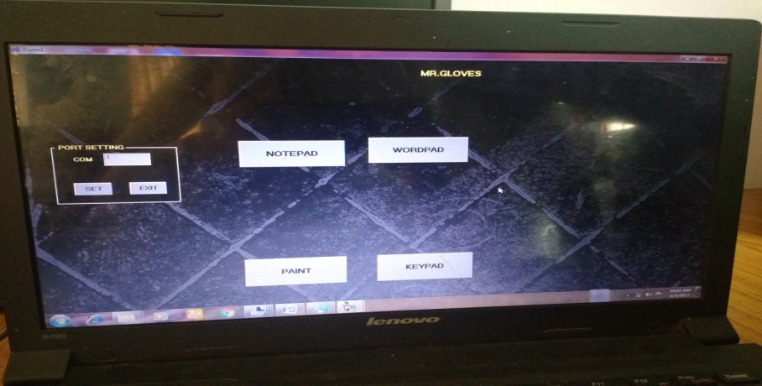

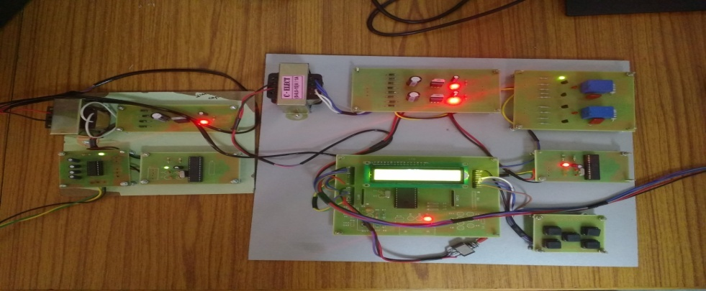
Mathematical Model

Bluetooth power consumption is rated at
V=5V,I=0.25A
P=V*I
P=5*(0.25)
P=1.25W

Zigbee power consumption is,
V=3.5V,I=0.25A
P=V*I
P=3.5*(0.25)
P=0.875W
When use Zigbee 0.375W power is saved.
5.2 CONCLUSION

The development of the MEMS accelerometer based portable device is used to generate desired commands by hand motions to control electronic devices without any space limitations. The acceleration made by the hand motion is measured by the MEMS accelerometer are wirelessly transmitted to the computer by using ZigBee wireless module. MEMS accelerometer based portable device is used to control mouse cursor of computer.
The progress in science & technology is a non-stop process. New things and new technology are being invented. As the technology grows day by day, we can imagine about the future in which thing we may occupy every place. The proposed system based on PIC microcontroller is found to be more compact, user friendly and less complex, which can readily be used in order to perform. Several tedious and repetitive tasks. Though it is designed keeping in mind about the need for industry, it can have extended for other purposes such as commercial & research applications.
Due to the probability of high technology (PIC microcontroller) used this “SYSTEM AND HOME APPLIANCES CONTROL USING MEMS ACCELEROMETER” is fully software controlled with less hardware circuit. The feature makes this system is the base for future systems. The principle of the development of science is that “nothing is impossible”. So we shall look forward to a bright & sophisticated world.

chapter 6
FUTURE WORK

Future work involves implementing the proposed gesture recognition system on a smartphone or any other personal device with a built-in accelerometer. The system proves a very competitive performance computationally and in terms of recognition accuracy by running the code in Embedded C on a computer. This entails running the code on a different platform which means converting the code to a different programming language such as JAVA, C++.
Another interesting topic for future work is to extend the proposed system to incorporate gesture spotting. In our proposed system, the starting point of a gesture trace was marked by pressing and holding the ‘trigger’ button on the bottom of the hand. This way of acquiring gesture traces by assuming known starting and end points is not realistic. Therefore, a more realistic scenario would be to detect meaningful gesture traces from a stream of hand movements and recognizing the gesture traces accordingly.
Another interesting work is can operate as handwritten recognition for identifying the digits and characters, and also it provides static authentication for the system by recognizing the characters and digits. MEMS accelerometer based 3D mouse can be treated as the new age input device. MEMS accelerometer based device is more natural in its feel and provides the user with efficient ease of use. Hand written digits and characters are one form of human interaction can be used effectively in human-computer interaction for gesture recognition and static authentication with better password protection.

REFERENCES
- Ahmad Akl ,Chen Feng and Shahrokh Valaee,(2011)“A Novel Accelerometer-Based GestureRecognition System”, IEEE Transactions On Signal Processing, Vol. 59, No. 12D.

- Alice Linsie A, Mangaiyarkarasi .J,(2013) “Hand Gesture Recognition Using MEMS For Specially Challenged People, International Journal of VLSI and Embedded Systems-IJVES, Vol 04, Issue 02; pp. 238-241.

- Arbab Waheed Ahmad, Research Assistant & Chankil Lee, Professor Hanyang University, Ansan, Korea, Naeem Jan, Research Assistant, UET Peshawar, Pakistan,(2011) “Implementation of ZigBee-GSM based Home Security Monitoring and Remote Control system”, IEEE .

- Bassam Sayed, Issa Traor´e, Isaac Woungang, and Mohammad S.Obaidat,(2013) “Biometric Authentication Using Mouse Gesture Dynamics”, IEEE systems journal, Vol. 7, pp. 262-274.

- Q.Chen N.Georganas and E. Petrriu,(2007) “Real-time Vision based handgesture recognition using Harr-like features ” in Proc. IEEE IMTC pp. 1-6.

- Z. Dong, U. C. Wejinya, and W. J. Li,(2010) “An optical-tracking calibration method for MEMSbased digital writing instrument,” IEEE Sens. J.,vol. 10, no. 10, pp. 1543–1551.

- A. EI-sawah N. Georganas and E. Petrriu,(2008) “A prototype for 3-Dhand tracking and gesture estimation ” IEEE Trans. Instrum. Meas.vol. 57 no. 8 pp. 1627-1636 .

- Jeen-Shing Wang and Fang-Chen Chuang,(2012) “An Accelerometer-Based Digital Pen with a Trajectory Recognition Algorithm for Handwritten Digit and Gesture Recognition”, IEEE Transactions on Industrial Electronics, Vol. 59, pp. 2998-3007.

- Mansour H. Assaf, Ronald Mootoo, Sunil R. Das, Emil M.Petriu, Voicu Groza, and Satyendra Biswas,(2012) “Sensor Based Home Automation and Security System”, IEEE .

- H.Nasser Dardas and Nicolas D. Georganas,(2011) “Real Time HandGesture Detection and Recognition using Bag of features andsupport vector machine Technique ” in IEEE Trans. On Instru. And Measurements Vol. 60 no. 11 pp 3592-3607.

- Ruize Xu, Shengli Zhou, and Wen J. Li,(2012) “MEMS Accelerometer Based Nonspecific-User Hand Gesture Recognition”, IEEE SENSORS JOURNAL, VOL. 12, NO. 5, pp. 1166 – 1173.

- Shiguo Lian,Wei Hu, Kai Wang,(2014) “Automatic User State Recognition for Hand Gesture Based Low-Cost Television Control System”,IEEE.

- Wan S1, Nguyen HT,(2008)“Human Computer Interaction using hand gesture”, Conf Proc IEEE Eng Med Biol Soc.2008:2357-60.

- Won S.H.P., Melek W.W. and Golnaraghi F., (2010)“A Kalman/Particle Filter-Based Position and Orientation Estimation Method Using a Position Sensor/Inertial Measurement Unit Hybrid System”, IEEE Transactions on Industrial Electronics, Vol. 57, pp. 1787-1798.

- Yilun Luo, Chi Chiu Tsang, Guanglie Zhang, Zhuxin Dong, Guangyi Shi, Sze Yin Kwok, Li W., Leong P.H.W. and Ming Yiu Wong,(2006) “An Attitude Compensation Technique for a MEMS Motion Sensor Based Digital Writing Instrument”, Proceedings of the IEEE International Conference on Nano/Micro Engineered and Molecular Systems, pp. 909-914.

- S. Zhou, Z. Dong, W. J. Li, and C. P. Kwong,(2008) “Hand-written character recognition using MEMS motion sensing technology,”in Proc.IEEE/ASME Int. Conf. Advanced Intelligent Mechatronics, pp.1418–1423.

- Zhuxin Dong, Wejinya U.C. and Li W.,(2010) “An Optical-Tracking Calibration Method for MEMS-Based Digital Writing Instrument”, IEEE Sensors Journal, pp. 1543.

