SMART RAILWAY TRACK SURVEILLANCE SYSTEM USING WIRELESS NETWORKS
CHAPTER 1
INTRODUCTION OF PROJECT
1.1 INTRODUCTION
Railway is lifeline of India and it is being the cheapest modes of transportation and it is preferred overall than other means of transportation. When we go through the daily newspapers we come across many accidents in railroad Railings. Railroad-related accidents are more dangerous than other transportation accidents in terms of severity, death rate, etc. Train collisions form a major catastrophe, as they cause severe damage to life and property. Train collisions occur frequently and therefore, more efforts are necessary for improving safety.

CHAPTER-3
SYSTEM ANALYSIS
3.1 EXISTING SYSTEM
In this system, it focuses on the limitation of methods in their ability to detect defects in the rail foot, especially in the side edges away from the region directly below the web and how the LRUT method provides a significant improvement for the same.
3.1.1LONG RANGE ULTRASONIC TESTING (LRUT)

Long Range Ultrasonic Testing (LRUT) technique is proposed as a complimentary inspection technique to examine the foot of rails, especially in track regions where corrosion and associated fatigue cracking is likely, such as at level crossings. LRUT technique is found to be suitable for examining inaccessible areas of railway tracks such as areas where corrosion occurs and susceptible areas of fatigue cracking. In different parts of the rail section (such as head, web and foot), the properties of guided waves are used and are examined for their capability to detect defects in each part. A suitable array of transducers is developed that is able to generate selected guided wave modes in rails which allow a reliable long-range inspection of the rail. The characteristics of ultrasonic guided waves in the rail complex geometrical profile have been identified.

3.1.2 VISION BASED SYSTEM

A rail track inspection technique using automated video analysis is proposed. The aim of this system is to replace manual visual checks performed by the railway engineers for track inspection. A combination of image processing and analysis methods is used in this paper to achieve high performance in automated rail track inspection. This paper focuses on the issues of finding missing clips and blue clips which have been recently replaced in place of damaged clips. The objective of the algorithm is to automatically find clips in video sequences and thereafter recognize whether they are broken and they are new or old as indicated by their color. Metal clips hold the rail track to the sleepers on the ground. Clips are searched to locate their position. Some clips on the track may be broken or missing due to excessive strain on them. These missing clips are identified as the train moving on the track may lead to the track failure. The clips used may be of different color depending on whether it is new (blue color) or old (grey color). So, a video color analysis is done on the clips and the results are given to track maintenance engineers. The main image pre-processing steps in the recognition of clips include smoothing, edge detection and short line removal. The irregularities in the railway track gauge reduces the service life of rail and vehicle. It even results in vehicle falling off rail or wheel trapping which causes driving accidents. A dynamic inspection method of track gauge based on computer vision is developed in. The inspection system is constructed by using four CCD (Charge-coupled Device) cameras and two red laser sector lights. The inspection principle and corresponding calibration method of inspection system are analyzed. Several image processing technologies such as image component extraction, differential, adaptive iteration threshold, dilation and thinning are used to extract gauge points. Experiment results have proved that the proposed inspection method is capable of fast obtaining track gauge value with high accuracy and repeatability and theymeets the requirement of dynamic inspection for track gauge. The method proposed in the paper confirms the calibration method for track gauge inspection. The method strictly controls the change of railway gauge and provides an effective inspection method with high precision to railway engineers.

3.1.3 TRAIN-MOUNTED GPR

A technique based on Ground-penetrating radar (GPR) is used for obtaining quantitative information about the depth and degree of deterioration of the track. The aim of this paper is to automate the processing and interpretation of data to the extent whereby on-site interpretations may be achieved with minimal intervention of the expert. This is done through the development of new image and signal processing tools specifically for GPR data and the range of anomalies found on the tracked. For monitoring track conditions and other infrastructure assets the most efficient way is by means of a train, which can collect data for many parameters simultaneously where possible at normal line speed. A multichannel ground- penetrating radar system is presented in this paper which is capable of operating at a speed up to 200 kmph. A road rail variant of the system is also presented which can collect up to 6 simultaneous continuous channels across the track and can deliver on-site interpretation of ballast thickness and quality, irregularities, weak spots and utilities. Novel multivariate signal and image processing techniques are used for automatically detect, quantify and map variations in ballast depth and condition. To enable automatic characterization and classification of regions of interest within the radar grams, multi-resolution texture analysis techniques are applied. The proposed system can probe the ballast both underneath and between the sleepers. Thus, thepotential problems can be identified with individual sleepers.

3.1.4 LED-LDR ASSEMBLY

An algorithm for crack detection in railway tracks is Light Emitting Diode and Light Emitting Resistor (LED-LDR) assembly which track the exact location of faulty track. The design proposed by the authors includes LED which are attached to one side of the rails and the LDR to the opposite side. When there are no cracks i.e. during normal operation, the LED light does not fall on the LDR and hence the LDR resistance is high. Subsequently, when the LED light falls on the LDR, the resistance of the LDR gets reduced and the amount of reduction will be approximately proportional to the intensity of the incident light. Consequently, the light from the LED deviates from its path due to the presence of a crack or a break and there is a sudden decrease in the resistance value of the LDR. This change in resistance indicates the presence of a crack or some other similar structural defect in the rails. In order to detect the current location of the device in case of detection of a crack, a GPS receiverwhose function is to receive the current latitude and longitude data is used. To communicate the received information, a GSM modem has been utilized. The function of the GSM module being used is to send the current latitude and longitude data to the relevant authority as an SMS. The robot is driven by four DC motors. If this system is employed only latitudes and longitudes of the broken track will only be received so that the exact location cannot be known. GPRS module is used to get exact location of the broken rail track. ARM7 controller is also used owning to is low cost and less power consumption it also decreases the time used in detecting cracks.

3.1.5 DISADVANTAGES OF EXISTING SYSTEM

- Delay in transmitting the information
- Cost is high
- Less accuracy

3.2 PROPOSED SYSTEM
The authors have proposed an architecture which has sensor nodes deployed along a railway track to survey the track effectively.

3.2.1 TRACK SURVEYING WITH SENSORS

The network consists of numerous control centers (sink nodes) that are connected through a wire lined connection, and the sensor nodes are deployed along the railway lines. The sensor nodes collect the necessary data and forward the data back to the sink. An innovative railway track surveying procedure is described that uses sensors and simple components like a GPS module, GSM Modem and accelerometer-based track detector assembly. The surveying system proposed in this method can be used for both ballast and slab tracks. The railway geometrical parameters which are Track axis coordinates are obtained with integrated Global Positioning System (GPS) and Global System for Mobile communication (GSM) receivers. Track damage status is monitored by the sensor and wireless modules, when the sensor does not get any signal immediately nearby wireless system notifies and alert or informs to the current train on the track.

3.2.3 ADVANTAGE OF PROPOSED SYSTEM

- cost is very low compared to existing system
- Very accurate detection
- checks surface and near surface of the cracking position
- Immediate transfer of transmitting signals
- Gate level controller
- Accidents reduced

CHAPTER-6
SOFTWARE DESCRIPTION
6.1 EMBEDDED SYSTEM
An embedded system is an application that contains at least one programmable computer and which is used by individuals who are unaware that the system is computer-based.Subsequent sections will discuss what Embedded C is, features of C language, similarities and difference between C and embedded C and features of embedded C programming.
6.2 EMBEDDED C
Looking around, we find ourselves to be surrounded by various types of embedded systems. Let it a digital camera or a mobile phone or a washing machine all of them has some kind of processor functioning inside it. Associated with each processor there is a embedded software. If hardware forms the body of an embedded system, embedded processor acts as the brain and embedded software forms its soul. It is the embedded software which primarily governs the functioning of embedded systems.During infancy years of microprocessor-based systems, programs were developed using assemblers and fused into the EPROMs. There used to be no mechanism to find what the program was doing. LEDs, switches, etc. were used to check correct execution of the program. Some very-fortunate developers had in-circuit simulators but they were too costly and were not quite reliable as well.
Initially C was developed by Kernighan and Ritchie to fit into the space of 8K and to write operating systems. Originally it was implemented on UNIX operating systems. As it was intended for operating systemsdevelopment it can manipulate memory addresses. Also, it allowed programmers to write very compact codes. This has given it the reputation as the language of choice for hackers too.As assembly language programs are specific to a processor, assembly language didn’t offer portability across systems. To overcome this disadvantage, several high-level languages including C came up. Some other languages like PLM, Modula-2, Pascal, etc. also came but couldn’t find wide acceptance. Among those, C got wide acceptance for not only embedded systems, but also for desktop applications. Even though C might have lost its sheen as mainstream language for general purpose applications, it still is having a strong-hold in embedded programming. Due to the wide acceptance of C in the embedded systems, various kinds of support tools like compilers and cross-compilers, ICE, etc. came up and all this facilitated development of embedded systems using C.

6.3MIKRO C FOR PIC MICROCONTROLLERS
The mikro C PRO for pic is a powerful, feature-rich development tool for PIC microcontrollers. It is designed to provide the programmer with the easiest possible solution to the developing applications for embedded systems without compromising performance or control.Mikro C PRO for PIC provides a successful match featuring like highly advanced IDE, ANSI compliant compiler, broad set of hardware libraries, comprehensive documentation and plenty of ready-to-run examples.
6.3.1PIC and C

PIC and C fit together well. PIC is the most popular 8-bit chip used in a wide variety of applications whereas C is prized for its efficiency and it is the natural choice for developing embedded systems.

6.3.2 FEATURES OF MIKRO C PRO FOR PIC

It allows you to quickly develop and deploy complex applications,
- Write your C source code using the built-in Code Editor (Code and Parameter Assistants, Code Folding, Syntax Highlighting, Auto Correct, Code Templates, and more).
- Use included mikroC PRO for PIC libraries to dramatically speed up the development: data acquisition, memory, displays, conversions, communication etc.
- Monitor your program structure, variables, and functions in the Code Explorer.
- Generate commented, human-readable assembly, and standard HEX compatible with all programmers.
- Use the integrated mikroICD (In-Circuit Debugger) Real-Time debugging tool to monitor program execution on the hardware level.
- Inspect program flow and debug executable logic with the integrated Software Simulator.
- Generate COFF (Common Object File Format) file for software and hardware debugging under Microchip's MPLAB software.
- Active Comments enable you to make your comments alive and interactive.
- Get detailed reports and graphs: RAM and ROM map, code statistics, assembly listing, calling tree, and more.
- MikroC PRO for PIC provides plenty of examples to expand, develop, and use as building bricks in your projects. Copy them entirely if you deem fit – that’s why we included them with the compiler.

6.4 PROTEUS

Proteus PCB design electronic circuits can be computer-aided design and circuit boards are designed.
6.4.1 ISIS (INTELLIGENT SCHEMATIC INPUT SYSTEM)
The ISIS (Intelligent Schematic Input System or Intelligent Switching input system) is the environment for the design and simulation of electronic circuits. The component library includes claims more than 10,000 circuit components with 6000 Prospice Simulations models. Own components can be created and added to the library. ISIS includes a base VSM engine with support for the following functions:
- DC / AC voltmeter and ammeter, oscilloscopes, logic analyzers
- Analog signal generators, digital pattern generator
- Timer functions, protocol analyzers (including RS232, I2C, SPI)
6.4.2 VSM (VIRTUAL SYSTEM MODELING)

The VSM Virtual System Modeling provides a graphical SPICE circuit simulation and animation directly in the ISIS environment. The SPICE simulator is based on the Berkeley SPICE3F5 model. It can microprocessor-based systems can be simulated. With the VSM engine can interact during the simulation directly with the circuit. Changes of buttons, switches or potentiometers are queried in real-time and LED indicators, LCD displays, "Hot / Cold" wires displayed.Proteus 7.0 is a Virtual System Modeling that combines circuit simulation, animated components and microprocessor models to co-simulate the complete microcontroller-based designs. This is the perfect tool for engineers to test their microcontroller designs before constructing a physical prototype in real time. This program allows users to interact with the design using on-screen indicators and/or LED and LCD displays andif attached to the PC, switches and buttons.
One of the main components of Proteus 7.0 is the Circuit Simulation - a product that uses a SPICE3f5 analogue simulator kernel combined with an event-driven digital simulator that allow users to utilize any SPICE model by any manufacturer. Proteus VSM comes with extensive debugging features including breakpoints, single stepping and variable display for a neat design prior to hardware prototyping.

CHAPTER-7

RESULT AND CONCLUSION

7.1 RESULT
Overall implementation of the project is shown below.
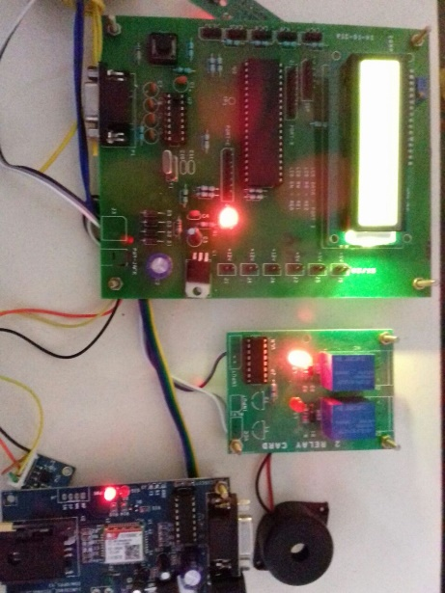

Fig 7.1.1 Overall Implementation of the Proposed Project
By implementing this project,

- When the crack detected in railway track by the accelerometer sensor, it gives alert messages or signal to the Authorized user.
For e.g.: The output is showed below in the LCD.
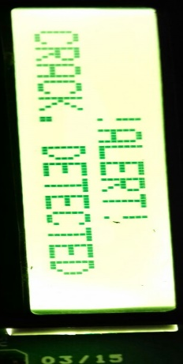
Fig 7.1.2 Shows the Alert Message in LCD

- When the crack detected in the track, the signal passed via pic micro-controller to the GSM connected to it.
- Later, GSM send the information as “CRACK DETECTED” with location as “LONGITUTE and LATTITUDE” to the authorized user.

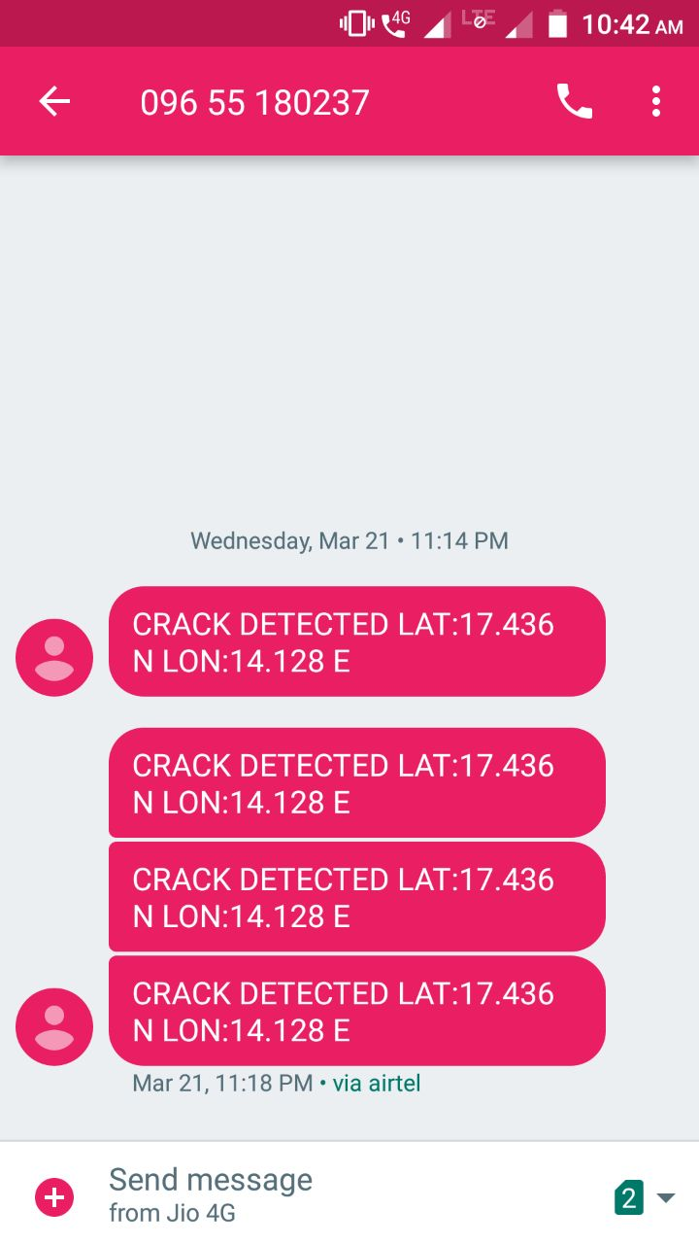
Fig: 7.1.3 shows the messages sended to the authority.

7.2 CONCLUSION

Accidents are reduced by locating the damage present in the track using corresponding devices and sensors previously. The information or details about the damage in track is transferred via message to the corresponding authority.
7.2.1 FUTURE ENHANCEMENT

In future, the project can be implemented by using CCTV systems with IP based camera for monitoring the visual videos captured from the track. It also increases the security for both rails and passengers from terrorism and crime.

REFERENCES

- F. Zhao and L. Guibas, “Wireless Sensor Networks”, Morgan Kaufmann Publisher, San Francisco, CA, 2004

- David Culler, Deborah Estrin, and Mani Srivastava, “Overview of Sensor Networks”, COMPUTER Published by the IEEE Computer Society, Vol. 37, No. 8; pp. 41-49, August 2004

- S. Tilak, N. Abu-Ghazaleh, and W. Heinzelman. A taxonomy of wireless micro-sensor network models. ACM SIGMOBILE Mobile Computing and Communications Review, 6(2):28–36, April 2002

- V. Murav’ev and E. Boyarkin, “Nondestructive Testing of the Structural-Mechanical State of Currently Produced Rails on the Basis of the Ultrasonic Wave Velocity”, Russian Journal of Nondestructive Testing, Vol. 39, No. 3, pp. 187-197, 2003

- Federal Railroad Administration Research Report RR04-02, “On-Line High-Speed Rail Defect Detection”, January 2004

