REAL TIME SMS – BASE HASHING SCHEME FOR SECURING FINANCIAL TRANSACTIONS ON ATM
CHAPTER 1
INTRODUCTION
1.1 Area of interest
An embedded system is some combination of computer hardware and software, either fixed in capability or programmable, that is designed for a specific function or for specific functions within a larger system. Industrial machines, agricultural and process industry devices, automobiles, medical equipment, cameras, household appliances, airplanes, vending machines and toys as well as mobile devices are all possible locations for an embedded system. Embedded systems are computing systems, but can range from having no user interface (UI) -- for example, on devices in which the embedded system is designed to perform a single task -- to complex graphical user interfaces (GUI), such as in mobile devices. User interfaces can include buttons, LEDs, touchscreen sensing and more. Some systems use remote user interfaces as well. Embedded systems can be microprocessor or microcontroller based. In either case, there is an integrated circuit (IC) at the heart of the product that is generally designed to carry out computation for real-time operations.
Microprocessors are visually indistinguishable from microcontrollers, but whereas the microprocessor only implements a central processing unit (CPU) and thus requires the addition of other components such as memory chips, microcontrollers are designed as self-contained systems. Embedded systems can be microprocessor or microcontroller based. In either case, there is an integrated circuit (IC) at the heart of the product that is generally designed to carry out computation for real-time operations. Microprocessors are visually indistinguishable from microcontrollers, but whereas the microprocessor only implements a central processing unit (CPU) and thus requires the addition of other components such as memory chips, microcontrollers are designed as self-contained systems.
With the development of computer network technology and e-commerce, the self-service banking system has got extensive popularization with the characteristic offering high-quality 24 hours service for customer. Nowadays, using the ATM (Automatic Teller Machine) which provides customers with the convenient banknote trading is very common. However, the financial crime case rises repeatedly in recent years; a lot of criminals tamper with the ATM terminal and steal user's credit card and password by illegal means. Once user's bank card is lost and the password is stolen, the criminal will draw all cash in the shortest time, which will bring enormous financial losses to customer. How to carry on the valid identity to the customer becomes the focus in current financial circle. Traditional ATM systems authenticate generally by using the credit card and the password, the method has some defectsUsing credit card and password cannot verify the client's identity exactly. Anyone who knows the PIN and have the ATM card can easily access the user account. ATM. This paper describes a new method combining with the traditional method. Here RFID and GSM is used to improve the security of the transaction
The Internet of Things (IoT) is a system of interrelated computing devices, mechanical and digital machines, objects, animals or people that are provided with unique identifiers and the ability to transfer data over a network without requiring human-to-human or human-to-computer interaction. The IoT is a giant network of connected things and people – all of which collect and share data about the way they are used and about the environment around them. That includes an extraordinary number of objects of all shapes and sizes – from smart microwaves, which automatically cook your food for the right length of time, to self-driving cars, whose complex sensors detect objects in their path, to wearable fitness devices that measure your heart rate and the number of steps you’ve taken that day, then use that information to suggest exercise plans tailored to you. There are even connected footballs that can track how far and fast they are thrown and record those statistics via an app for future training purposes.

CHAPTER 2
SYSTEM ANALYSIS
2.1 Existing scheme
The existing ATM Simulation System was built for the original concept of regional private banks. Small banks in villages and towns will service the needs of the local community and will only require ledgers to record account details. This system is prone to human error and causes undue frustration to users. This system was augmented with the introduction of excel sheets and emails. Banks could now record all information in an excel sheet and then set an update schedule when they will mail all records to a central hub where these records will again be processed and consolidated to form a unified record of all account transactions. These systems did not enable easy access to money and were greatly prone to grievous errors.
For the traditional ATM terminal customer recognition systems only rely on bank cards, passwords, and such identity verification methods which measures are not perfect and functions are too single. For solving the bugs of traditional ones, the author designs new ATM terminal customer recognition systems. The chip of S3C2440 is used for the core of microprocessor in ARM9, furthermore, an improved enhancement algorithm of fingerprint image increase the security that customer use the ATM machine

2.5 Proposed system
The proposed system aims to solve all this by constant updating of bank records. The Java based construction of the system will enable transactions at any bank or ATM to be registered within a matter of seconds. Security of these details is also a top priority in this system. This central hub will be accessed by an ATM for secure customer transactions. In our project we are going to place an extra button in ATM machines. When that button got pressed the control window will be telecasted to accountant cellular phone. Then the accountant can enter the pin and amount manually in his mobiles telecasted pop-up window. By this control system accountant can keep his pin number with him and he can vend the amount by his own control by the desired person

CHAPTER 5
SOFTWARE DESCRIPTION

5.1 Introduction to Embedded C
Looking around, we find ourselves to be surrounded by various types of embedded systems. Be it a digital camera or a mobile phone or a washing machine, all of them has some kind of processor functioning inside it. Associated with each processor is the embedded software. If hardware forms the body of an embedded system, embedded processor acts as the brain, and embedded software forms its soul. It is the embedded software which primarily governs the functioning of embedded systems.
During infancy years of microprocessor based systems, programs were developed using assemblers and fused into the EPROMs. There used to be no mechanism to find what the program was doing. LEDs, switches, etc. were used to check correct execution of the program. Some ‘very fortunate’ developers had In-circuit Simulators (ICEs), but they were too costly and were not quite reliable as well.As time progressed, use of microprocessor-specific assembly-only as the programming language reduced and embedded systems moved onto C as the embedded programming language of choice. C is the most widely used programming language for embedded processors/controllers. Assembly is also used but mainly to implement those portions of the code where very high timing accuracy, code size efficiency, etc. are prime requirements.
Initially C was developed by Kernighan and Ritchie to fit into the space of 8K and to write (portable) operating systems. Originally it was implemented on UNIX operating systems. As it was intended for operating systems development, it can manipulate memory addresses. Also, it allowed programmers to write very compact codes. This has given it the reputation as the language of choice for hackers too.
As assembly language programs are specific to a processor, assembly language didn’t offer portability across systems. To overcome this disadvantage, several high level languages, including C, came up. Some other languages like PLM, Modula-2, Pascal, etc. also came but couldn’t find wide acceptance. Amongst those, C got wide acceptance for not only embedded systems, but also for desktop applications. Even though C might have lost its sheen as mainstream language for general purpose applications, it still is having a strong-hold in embedded programming. Due to the wide acceptance of C in the embedded systems, various kinds of support tools like compilers & cross-compilers, ICE, etc. came up and all this facilitated development of embedded systems using C. Subsequent sections will discuss what is Embedded C, features of C language, similarities and difference between C and embedded C, and features of embedded C programming
5.2 Embedded Systems Programming
Embedded systems programming is different from developing applications on a desktop computers. Key characteristics of an embedded system, when compared to PCs, are as follows Embedded devices have resource constraints(limited ROM, limited RAM, limited stack space, less processing power) Components used in embedded system and PCs are different; embedded systems typically uses smaller, less power consuming components. Embedded systems are more tied to the hardware.

Two salient features of Embedded Programming are code speed and code size. Code speed is governed by the processing power, timing constraints, whereas code size is governed by available program memory and use of programming language. Goal of embedded system programming is to get maximum features in minimum space and minimum time.
Embedded systems are programmed using different type of languages:
Machine Code
Low level language, i.e., assembly
High level language like C, C++, Java, Ada, etc.
Application level language like Visual Basic, scripts, Access, etc.
Assembly language maps mnemonic words with the binary machine codes that the processor uses to code the instructions. Assembly language seems to be an obvious choice for programming embedded devices. However, use of assembly language is restricted to developing efficient codes in terms of size and speed. Also, assembly codes lead to higher software development costs and code portability is not there. Developing small codes are not much of a problem, but large programs/projects become increasingly difficult to manage in assembly language. Finding good assembly programmers has also become difficult nowadays. Hence high level languages are preferred for embedded systems programming.
Many of these advantages are offered by other languages also, but what sets C apart from others like Pascal, FORTRAN, etc. is the fact that it is a middle level language; it provides direct hardware control without sacrificing benefits of high level languages. Compared to other high level languages, C offers more flexibility because C is relatively small, structured language; it supports low-level bit-wise data manipulation.

Compared to assembly language, C Code written is more reliable and scalable, more portable between different platforms (with some changes). Moreover, programs developed in C are much easier to understand, maintain and debug. Also, as they can be developed more quickly, codes written in C offers better productivity. C is based on the philosophy ‘programmers know what they are doing’; only the intentions are to be stated explicitly. It is easier to write good code in C & convert it to an efficient assembly code (using high quality compilers) rather than writing an efficient code in assembly itself. Benefits of assembly language programming over C are negligible when we compare the ease with which C programs are developed by programmers.
5.3 Proteus

Proteus PCB design electronic circuits can be computer-aided design and circuit boards are designed.
5.3.1 Intelligent Schematic Input System (ISIS)
The ISIS (Intelligent Schematic Input System or Intelligent Switching input system) is the environment for the design and simulation of electronic circuits. The component library includes claims more than 10,000 circuit components with 6000 Prospice Simulations models. Own components can be created and added to the library.

ISIS includes a base VSM engine with support for the following functions:
- DC / AC voltmeter and ammeter, oscilloscopes, logic analyzers
- Analog signal generators, digital pattern generator
- Timer functions, protocol analyzers (including RS232, I2C, SPI)
5.3.2 Virtual System Modeling (VSM)
The VSM Virtual System Modeling provides a graphical SPICE circuit simulation and animation directly in the ISIS environment. The SPICE simulator is based on the Berkeley SPICE3F5 model. It can microprocessor-based systems can be simulated. With the VSM engine can interact during the simulation directly with the circuit. Changes of buttons, switches or potentiometers are queried in real-time and LED indicators, LCD displays, "Hot / Cold" wires displayed.

Proteus 7.0 is a Virtual System Modeling that combines circuit simulation, animated components and microprocessor models to co-simulate the complete microcontroller-based designs. This is the perfect tool for engineers to test their microcontroller designs before constructing a physical prototype in real time. This program allows users to interact with the design using on-screen indicators and/or LED and LCD displays andif attached to the PC, switches and buttons.
One of the main components of Proteus 7.0 is the Circuit Simulation - a product that uses a SPICE3f5 analogue simulator kernel combined with an event-driven digital simulator that allow users to utilize any SPICE model by any manufacturer. Proteus VSM comes with extensive debugging features including breakpoints, single stepping and variable display for a neat design prior to hardware prototyping. In summary, Proteus 7.0 is the program to use when you want to simulate the interaction between software running on a microcontroller and any analog or digital electronic device connected to it.

CHAPTER 6
RESULT

Step 1: Show the RFID tag in the RFID reader

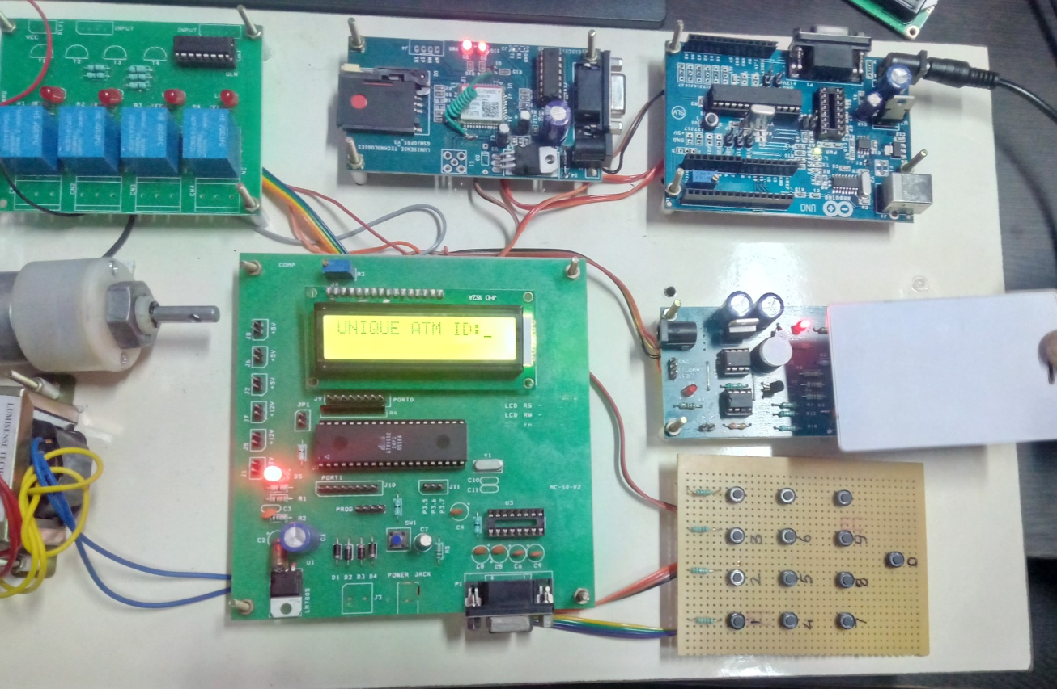

Fig .6.1 RFID reader

2: The GSM will send the sms to the mobile number



Fig 6.2 ATM link

Step 3: After clicking the link, we have to enter the amount and required datas.

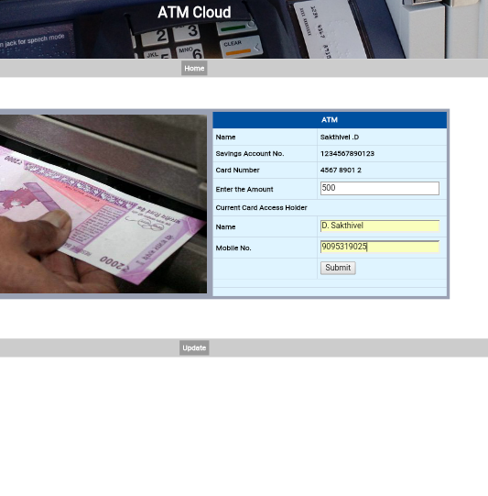
Fig 6.3 Entering details
Step 4: After clicking submit button , and the amount will be debited to the person in the ATM center and the SMS will received to the account holder.



Fig 6.4 Debited SMS

By implementing this project,
- The card holder can withdraw his amount with the help of third person without telling the details of the card to the third person
- If any fraudulence held in the holder’s account , the holder will not get doubt about the third person, because he did not tell the details about the account , so the third person couldn’t do anything without knowing the card details.
- The time of the card holder can be saved here, because he did not want to wait in a long queue for more time. He can give his card to his neighbor and he can lend his money by doing his work simultaneously

CHAPTER 7
CONCLUSION AND FUTURE ENHANCEMENTS
7.1 Conclusion
This whole implementation ensures us a secured and authenticated transaction through RFID and GSM technique with lowest cost and minimum maintenance. Mankind will utilize new and secured type of money transactions. The only thing is that initial cost of RFID conversion of the entire system is the required one time investment. The value added service that this system provides increases the credibility of the financial institutions, the banks improves the convenience to its customer. Hence as the world progresses through the inevitable and an indomitable quest for knowledge, the aspect of security bound systems are bound to concede with the growing innovations and obviously more vulnerabilities. Hence our application might well solve the aspect of transaction security to a precise and great extent.
7.2 Future Enhancement
In future the timing of each withdrawal can be minimized.. In our mobile phone we getting into an customer care number and the option are shown like offers , recharge and so on , likewise if our card is inserted in the ATM and the emergency button is clicked and immediately we will get the notification like “for withdrawal we have to press 1” likewise how we are doing with our network. If this come into real time process enormous time will be reduced for each withdrawal.
REFERENCE
[1] G.Udaya Sree, M.Vinusha “ Real Time SMS-Based Hashing Scheme for Securing Financial Transactions on ATM Terminal” ,IJSETR, ISSN 2319-8885 Vol.02,Issue.12, September-2013, Pages:1223-1227.
[2] Khatmode Ranjit P, Kulkarni Ramchandra V, “ARM7 Based Smart ATM Access & Security System Using Fingerprint Recognition & GSM Technology”, ISSN 2250-2459, ISO 9001:2008 Certified Journal, Volume 4, Issue 2, February 2014.
.[3] M.R.Dineshkumar,M.S.Geethanjali,“Protected Cash Withdrawal in ATM Using Mobile Phone”, International Journal Of Engineering And Computer Science ISSN:2319-7242 Volume 2 Issue 4 April, 2013 Page No. 1346-1350.
[4] Zaid Imran,Rafay Nizaami ,”Advance Secure Login”, International Journal For Science and Research Publications, Volume 1,Issue 1,December 2011.
[5] M. Ajaykumar and N. Bharath Kumar,” Anti-Theft ATM Machine Using Vibration Detection Sensor”, IJARCSSC Volume 3, Issue 12, December 2013 ISSN: 2277 128X.
[6] SURAJ B S and Dr. R GIRISHA, “ ARM7 based Smart ATM Access System”, International Journal on Recent and Innovation Trends in Computing and Communication ISSN: 2321-8169 Volume: 3 Issue: 5.
[7] K.annan K, “Microcontroller Based Secure Pin Entry Method For ATM”, International Journal of Scientific & Engineering Research, Volume 4, Issue 8, August-2013 ISSN 2229-5518.
[8] Hyung-Woo Lee,“Security in Wireless Sensor Networks: Issues and Challenges”, ICACT, ISBN 89-5519-129-4, Feb. 20-22, 2006.

