PIC MICRONCONTROLLER BASED SOLAR GRASS CUTTER
CHAPTER 1
INTRODUCTION
1.1 INTRODUCTION
Grass cutter machines have become very popular today. Most of the times grass cutter machines are used for soft grass furnishing. In a time where technology is merging with environmental awareness, consumers are looking for ways to contribute to the relief of their own carbon footprints. Pollution is man-made and can be seen in our own daily lives, more specifically in our own homes. Herein, we propose a model of the automatic grass cutting machine powered through solar energy, (nonrenewable energy). Automatic grass cutting machine is a machine which is going to perform the grass cutting operation on its own. This model reduces both environment and noise pollution.
Our new design for an old and outdated habit will help both customer and the environment. This project of a solar powered automatic grass cutter will relieve the consumer from mowing their own lawns and will reduce both environmental and noise pollution. This design is meant to be an alternate green option to the popular and environmentally hazardous fuel powered lawn mower. Ultimately, the consumer will be doing more for the environment while doing less work in their daily lives. The hope is to keep working on this project until a suitable design can be implemented and then be ultimately placed on the market.
1.2 OBJECTIVE OF THE PROJECT
Solar grass cutter is a grass cutting robotic vehicle powered by solar energy that also avoids obstacles and is capable of fully automated grass cutting, without the need of any human interaction. The system uses 12V batteries to power the vehicle movement motors as well as the grass cutter motor.
We also use a solar panel to charge the battery so that there is no need of charging it externally. The grass cutter and vehicle motors are interfaced to an PIC family microcontroller that controls the working of all the motors.
It is also interfaced to an IR sensor for object detection. The microcontroller moves the vehicle motors in forward direction in case no obstacle is detected. On obstacle detection, ultra sonic sensor monitors it and the microcontroller thus stops the grass cuter motor so as to avoid any damage to the object/human/animal. Microcontroller then turns the robotic vehicle offuntil it gets clear of the object and then moves the grass cutter in forward direction again.

CHAPTER 2
SYSTEM ANALYSIS
2.1 EXISTING SYSTEM
A normal grass cutter moving with IC engine will run based on the energy from petrol. The major drawbacks of this technology are high running cost; create noise pollution and air pollution. Also, an IC engine requires periodic maintenance such as changing the engine oil, mechanical maintenance. It is an innovative technology of cutting grass without any pollution, electric solar grass cutter are environmentally friendly. Nowadays, the labor charge is increased day by day. This technology can help the people who are living in rural areas. This project is mainly proposal for reduce the manpower and usage of electricity.
Nowadays pollution is a major issue for whole world. Pollution is manmade and can be seen in own homes. Due to the emission of gases it is responsible for pollution. Also the cost of fuel is increasing hence it is not efficient. So the Solar grass cutter is introduced. Solar grass cutter can be described as the application of solar energy to power an electric motor which in turn rotates a blade which does the moving of a cutter. Solar energy is the renewable energy. Grass cutter with a standard motor is an inconvenience, and no one takes pleasure in it. Cutting grass cannot be easily accomplished by elderly, younger, or disabled people. It creates noise pollution due to the loud engine, and local air pollution due to the combustion in the engine. Also, a motor powered engine requires periodic maintenance such as changing the engine oil. Even though electric grass cutter are environmentally friendly.
Along with motor grass cutter, electric grass cutter is also hazardous and cannot be easily used by all. Also, if the electric grass cutter is corded, mowing could prove to be problematic and dangerous. It can save significantly on labor costs. In large size of grass cutter in the park, schools, college, are maintained manually.
Cutting grass cannot be easily accomplished by elderly, younger, grass cutter moving with engine create noise pollution due to the loud engine, and local air pollution due to the combustion in the engine. It is not easy and also very difficult to maintain uniform size. Also a motor powered engine requires periodic maintenance such as changing the engine oil.
Even though electric solar grass is environmentally friendly, they too can be an inconvenience. Along with motor grass cutter, electric grass cutters are also hazardous and cannot be easily used by all. Solar grass cutter hence we design to make a grass cutter without any power source due to reduce the power consumption. Design a solar grass cutter that utilizes solar power as an energy source is meant to address a number of issues that standard internal combustion engine cutter do not. An electric grass cutter with a solar charger will be easier to use.
The unskilled gardener is enough to operate the grass cutter. Most importantly it eliminates the emissions of an internal combustion cutter which are mostly responsible for environmental pollution and causes the greenhouse gases effect believed to be responsible for the worsening global warming of our planet. This is so because solar energy is green/renewable energy.
Different designs have been made, each to suit a particular need or convenience. Making the process of cutting grass easier over the years, many individuals have added modification to the original design speed, efficiency and power of a mowing machine. The sun provides sustainable amount of the energy used for various purposes on earth for atmospheric system. The difference is just the application of the energy source. It uses the photovoltaic panel to generate the energy.

5.2 SIGNAL DIAGRAM

5.5 PIN DESCRIPTION
OSC1/CLKI:Oscillator crystal or external clock input. Oscillator crystal input or external clock source input. ST buffer when configured in RC mode. Otherwise CMOS. External clock source input. Always associated with pin function OSC1 (see OSC1/CLKI, OSC2/CLKO pins).
MCLR/VPP MCLR:Master Clear (input) or programming voltage (output). Master Clear (Reset) input. This pin is an active low RESET to the device. Programming voltage input.
OSC2/CLKO OSC2: Oscillator crystal or clock output. Oscillator crystal output.Connects to crystal or resonator in Crystal Oscillator mode. In RC mode, OSC2 pin outputs CLKO, which has 1/4 the frequency of OSC1 and denotes the instruction cycle rate.

5.6MEMORY ORGANIZATION
A microcontroller is a complete computer system on a single chip. It is more than just a microprocessor: It also contains a Read-Only Memory (ROM), a Read-Write Memory (RAM), some input/output ports, and some peripherals, such as, counters/timers, analog-to-digital converters, digital-to-analog converters, and serial communication ports.
The internal view of a typical microprocessor and is composed of three things: an arithmetic/logic unit (ALU) which performs calculations on data; a set of registers which hold the user’s data and the system’s data and a control unit which orchestrates everything and interprets and executes the user’s instructions.
As far as the microprocessor is concerned, it assumes that there are sets of data memories and program memories (RAM and ROM) in the system. The only thing the microprocessor has to do is run a cycle of getting new instructions and executing them from the memories.
Both the RAM and the ROM are organized as indexed sets of data words, where each “index” is the “address” of its corresponding data. Both the data and its address codes are numbers represented in binary or hexadecimal.
The RAM is a read-write memory which can rapidly read and write the data. It is a volatile memory which means that it loses its memory when power is removed (turned off). The ROM is for program memory and is “read-only” except in modern variants, such as Electrically Erasable Programmable Read Only Memory (EEPROM) and Flash Memory, which allow data words to be written as well as read. The writing of an EEPROM is not the same as a RAM since the data-writing time of the EEPROM is about ten thousand times as long as the data-writing time of the RAM.
The ROM and its variants are non-volatile memories that preserve their memories when the power is removed (turned off).

CHAPTER 6
6. SOFTWARE CODING
6.1SOFTWARE CODING

/*** lcd_com(0x80);
printf(lcd_putc,"Ambulance Rescue ");**/

void lcd_init();
void lcd_com(unsigned char a1);
void lcd_data(unsigned char a2);
void lcd_putc(char aaa);

void lcd_com(unsigned char a1)
{
unsigned char temp,temp1;

temp=a1;
temp=temp&0xf0;
output_d(temp);
output_low(reset);
output_low(read_write);
delay_ms(1);
output_high(enable);
delay_ms(1);
output_low(enable);
temp=a1<<4;
temp=temp&0xf0;
output_d(temp);
output_low(reset);
output_low(read_write);
delay_ms(1);
output_high(enable);
delay_ms(1);
output_low(enable);
delay_ms(1);
}

void lcd_data(unsigned char a2)
{
unsigned char temp,temp1;

temp1=a2;
temp1=temp1&0xf0;
output_d(temp1);
output_high(reset);
output_low(read_write);
delay_ms(1);
output_high(enable);
delay_ms(1);
output_low(enable);
temp1=a2<<4;
temp1=temp1&0xf0;
output_d(temp1);
output_high(reset);
output_low(read_write);
delay_ms(1);
output_high(enable);
delay_ms(1);
output_low(enable);

}

void lcd_init()
{
lcd_com(0x30);
delay_ms(20);
lcd_com(0x30);
delay_ms(20);
lcd_com(0x30);
delay_ms(10);
lcd_com(2);
delay_us(10);
lcd_com(0x28);
delay_us(10);
lcd_com(0x0c);
delay_us(10);
lcd_com(0x04);
delay_us(10);
lcd_com(0x06);
delay_us(10);;
lcd_com(0x01);
delay_us(10);
}

void lcd_putc(char *aaa)
{
lcd_data(aaa);

CHAPTER 7
7.1PHOTOGRAPHY

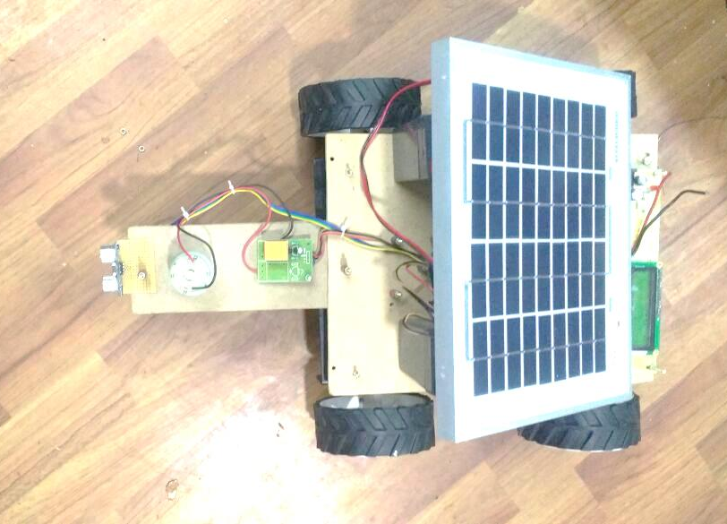

Fig 7.1: Outcome Of Project

CHAPTER 8
8. CONCLUSION AND FUTURE ENHANCEMENTS
8.1CONCLUSION
Our project entitled fabrication of solar powered grass cutter is successfully completed and the results were obtained . It will be easier for the people who are going to take the project for the further modifications. This project is more suitable for all lawns, grounds for the different shape of grass cutting. It has more advantages like no fuel cost, no pollution and no fuel residue. As we are nearer to Equator, the solar energy (non- conventional energy) is vastly available, so it is easy to charge the battery and is also pollution free. But the initial investments of the solar powered grass cutter ishigh. At present in order to curtail global warming and ozone depletion. So it is much more suitable for grass cutting also. The same thing can be operated in night time also, as there is a facility to charge these batteries in day light.
8.2FUTURE ENHANCEMENTS
We completed our project successfully with the available sources. But the results and modifications are not up to the expectations. This can be further improved by incorporating the following modifications to obtain better results. This efficiency can be increased by using some other mechanism. and speed of motor is reduce because we have used heavy material and this material can be replaced by using light weight material and design of blades should be done based on types of grass is used to cut. The project which we have done surly reaches the average families because the grass can be trimmed with minimum cost and with minimum time Finally this project may give an inspiration to the people who can modify and can obtain better results.

CHAPTER 9
9. REFERENCE
9.1REFERENCE
[1] “The Design of Equalizer Windings for Lap-Wound DC Machines”, Alaric Pagel, Member, IEEE, Alan S. Meyer, and Charles F. Landy, Senior Member, IEEE. IEEE TRANSACTIONS ON INDUSTRY APPLICATION VOL. 37, NO. 4, JULY/AUGUST 2001.
[2] “Cascaded DC–DC Converter Connection of Photovoltaic Modules”, Geoffrey R. Walker, Member, IEEE, and Paul C. Sernia, IEEE TRANSACTIONS ON POWER ELECTRONICS, VOL. 19, NO. 4, JULY 2004.
[3] “Energy Management Based on Frequency Approach for Hybrid Electric Vehicle Applications: Fuel-Cell/Lithium- Battery and Ultra capacitors”, Abdallah Tani, Mamadou Baïlo Camara, Member, IEEE, and Brayima Dakyo, Member, IEEE, IEEE TRANSACTIONS ON VEHICULAR TECHNOLOGY, VOL. 61, NO. 8, OCTOBER 2012.
[4] “MPPT CONTROLLER FOR PHOTO VOLTAIC SYSTEMS USING CUK DC/DC CONVERTOR”, Neeraj Tiwari1, D. Bhagwan Das2 1,2Dayalbagh Educational Institute (Deemed University), Agra, International Journal of Advanced Technology & Engineering Research (IJATER).
[5] “Design of a Voltage-Controlled PFC Cuk Converter-Based PMBLDCM Drive for Fan”, Rajesh R PG Scholar, Regional Centre, Anna University Chennai, Coimbatore, India, International journal of innovative research in electrical, electronics, instrumentation and control engineering vol. 1, issue 2, may 2013.

