Edgence: A Block chain-Enabled Edge Computing Platform for Intelligent IoT-Based dApps

ABSTRACT

Nowadays scalable IoT management is a bottleneck of IoT development due to the geographically dispersed distribution, fragmented ownerships, and ever growing population of IoT devices. To intelligently manage massive decentralized applications (dApps) in IoT use cases, Edgence (EDGe + intelligence) is proposed to use edge clouds to access IoT devices and users, and then use its in-built block chain to realize self-governing and self-supervision of the edge clouds. Edgence proposes to use master node technology to introduce IoT devices and users into a closed block chain system, which can extend the range of block chain to IoT-based dApps. Further, master nodes do good to scalability by raising the TPS (transactions per second) of the block chain network. To support various dApps, a three-tier validation is proposed, namely script validation, smart contract validation, and master node validation. To avoid energy consumption resulted by block chain consensus, Edgence proposes a random but verifiable way to elect a master node to generate each new block. The potential of the tailored Edgence is shown by examples of decentralized crowd sourcing and AI training.

CHAPTER-1
INTRODUCTION
As the population of cities becomes bigger and bigger, the number of challenges that these cities should face increases. These challenges are related to transport means, urban population, healthcare, citizens safety and criminality, energy, the industrial sector, economy, financial transactions, etc. In order for these challenges to be addressed, all parts and members could play an active role in their own city towards improving the urban conditions. In real cases, this concept could be enhanced using a novel economic model; Circular Economy. Circular Economy model minims waste by reusing most ofresources and provisions the use of emerging ICT technologies to achieve its main goals. The paradigm of the Internet of Things provisions networks of physical devices, like sensors, cameras, smart devices, like smart phones, vehicles, etc., whichobtain unique identifiers and can be connected to the Internet and exchange data between each other seamlessly. In Circular Economy, IoT can contribute to data collection, machine to machine communication and exchange of data, asset tracking, energy management and in many other cases. However, Bionetworks face several security and privacy vulnerabilities that can be exploited to compromise IoT devices. Furthermore, the performance of some services of IoT devices could beenhanced and improved. For example, the availability andusage of an asset, which is part of an IoT network can beregulated via smart contracts. For this reason, Blockchain canbe used. Blockchain is a new, well-known technology thatfirst appeared as a fundamental part of Bitcoin cryptocurrency[8]. It has emerged as a promising technology that has beenadopted not only for digital currencies purposes but in manyother applications as well, like in healthcare and transportationsectors. However, the adoption of this new technology is nota panacea and may raise significant issues. In the case ofBlockchain over IoT, significant challenges are posed fromthe highly-constrained nature of IoT devices in terms of avail-able computational and communication resources, availableenergy resources, etc. For instance, in Blockchain applications,each node of the network maintains a copy of the ledger,which may grow significantly in size (in some cases evenin the order of several GBs [21]). Furthermore, Blockchain applications are contradicted the IoT paradigm. In order toaddress these issues, Edge Computing can be employed. Our contribution. We present a novel and innovative hybridblockchain-based architecture for IoT networks, where the ledger is stored on the Edge Computing nodes and not on thenodes of the Blockchain network. We discuss the technologies that will be employed and the main idea behind this architecture, which is that the devices of the network run a Blockchain application and perform Proof of Work computations, however,the ledger is stored on Edge Computing rather than on the devices. The architecture is critically evaluated against other existing Block chain architectures and we discuss our findings in the broader context of emerging ICTs and their implications

Block chain Overview
At its core, a block chain is a distributed database with very interesting properties. Block chains are based on three well-known technologies)public key cryptog-raphy,ii)distributed peer-to-peer networks, andiii)consensus mechanisms, which have been blended in a unique and novel way. Since a block chain operates in an entrusted environment, public key cryptography is used to establish a secure digital identity for ev-ery participant. Each participant is equipped with a pair of keys (one public, one private) to be able to participate in the block chain. This digital identity is used to enforce control of ownership over the objects managed by the block chain. Peer-to-peer networks employed to be able to scale up the network, to avoid a single point of failure, and to prevent a single or small group of players to take over the network. A consensus protocol allows all participants, i.e., all copies of the block chain, to agree on a single version of the true state without the need of a trusted third-party.

Block chain-based iot framework with edge computing.

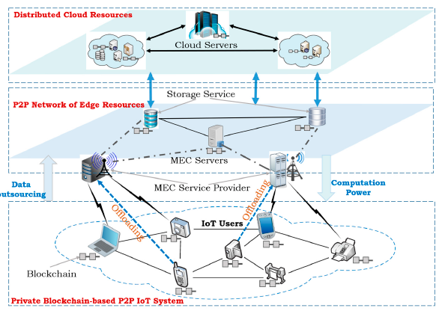

Our design was composed of three layers identified as the cloud layer, the edge layer and the device layer as illustrated in Figure 4 below. This framework adopts the same layers as those found in the edge computing architecture but enhanced with a P2P connectivity of devices in each layer to provide additional storage and computation capabilities. The device layer constitutes P2P connected IoT end users from whom data originates and they utilize resources in the edge network. The edge layer is comprised of servers and storage facilities that are connected in P2P fashion to provide additional storage ensure robustness and avoid risks of single points of failure. This layer irresponsible for short-term data storage, real-time data processing and analytics and handling communications for various data and messages exchanged among the different nodes. The cloud layer is made up of more powerful facilities to provide long-term data analytics and storage as well
Enterprise level reporting and communication. The resources in the cloud can also be configured as nodes on block chain to ensure privacy and integrity of data in the system.

FEC with Deep Learning Edge Computing
Figure shows the five-layer IoT architecture proposed by Al-Fuqaha et al. . Five-layer IoT architecture, in which the role of the service management layer is enhanced by giving its task to manage the device, edge, and cloud interactively. The object abstraction layer is extended to manage all components of EC from sensors and devices to a network; this makes the foundation for enhancement of the service management layer.

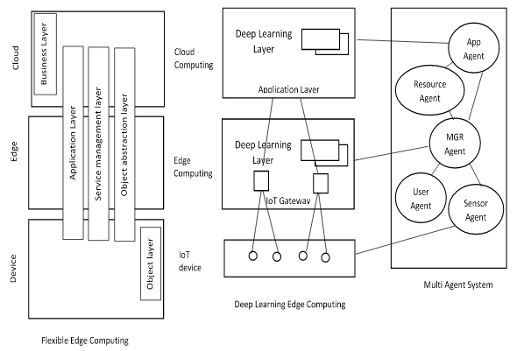

Furthermore, the application layer is extended to the device domain by reflecting the actual situation in which application services are provided. By these extensions, FEC architecture can have advantages including improvement of overall system performance, scalability enhancement, quick response to changes in IoT components, and so on. To realize FEC architecture, we adopt two system abilities: environment adaptation ability and user orientation ability. Environment adaptation ability autonomously determines the allocation of processing to an edge and a cloud according to the quality and quantity of work and their fluctuation, whereas user orientation ability provides services suitable for each user in real time by reflecting detailed information collected by IoT, such as a user’s behavior, intention, and preference by autonomous control. We think that these two abilities are missing in the current EC and that it makes the EC rigid, a disadvantage mentioned in the previous section.

Cloud Layer
The layer is the brain of the IoT service frame work with EC. It is usually composed of large cloud data centers with extra ordinary computing power. In the IoT service framework with EC, the cloud layer tends to be applied to further processing data from the edge layer, storing or updating significant information and carrying out advanced deployment. Nonetheless, in some special situations, the importance of cloud-edge collaboration is highlighted. Cloud-edge collaboration includes resource collaboration, managementcollaboration,safety collaboration, and so forth, which think of cloud and edge as all in one to reinforce each other and schedule dynamically. Specifically, when computing re-sources in the edge layer are insufficient, the cloud layer can offer computing support with virtual machines and containers. When a certain edge layer appears malicious traffic, the relevant cloud layer which is equipped with better security policy has the ability to discover and block it so as to prevent it from continuing spreading. The establishment o fcloud-edge collaboration has aroused wide concern. A few cloud-edge collaboration platforms such as Kube Edge, Edge Tunnel, and AWS Wavelength are pushing ahead with the prosperity of cloud-edge collaboration.*e application of IoT service with EC is booming andhot. Table 3 shows some typical examples of IoT service with EC.

Cloud Computing Types
Based on the location parameter, cloud computing can be divided [19][20]into following categories:

a) Public Cloud:
Here, computing infrastructure is provided by the vendor and customer has no visibility on the infrastructure. But the resources can be accessible publically.

b) Private Cloud:
Here, infrastructure is developed for a private organization. The services can be access by that private organization only. This type of cloud is more secure than a public one.

c) Hybrid Cloud:
A hybrid cloud is come into existence after merging a private as well asthepublic cloud. Critical applications may be deployed on a private cloud and the applications having less security can be connected to the public one.

D) Community Cloud:
Here, the infrastructure is shared between organizations of the same community.

CHAPTER 2
2. SYSTEM ANALYSIS
2.1 EXISTING SYSTEM

Despite the ongoing efforts for a suitable platform for block chain deployment in IoT applications; anonymity, adaptability and data integrity are crucial issues that are yet to be solved to ensure safe storage of data. Since only pseudonyms are guaranteed in block chain, and integrity relies only on massive numbers of honest miners and PoW’s complexity (which also affects the scalability); investigation for appropriate technologies to provide stronger anonymity than just pseudonymity and achieve adaptable data integrity must be done.

2.1.1 DRAWBACKS OF EXISTING SYSTEM

- The pseudonyms in block chain that are responsible to handle anonymity of transactions is rendered insufficient because of the demonstrated possibility to de-anonymize participants.
- Integrity issues arise in block chain when either of the reliability, accuracy and consistency aspects of transactions in the network is compromised.

2.2. PROPOSED SYSTEM
Presented in this section is the conceptual design for block chain integration with edge computing for IoT processing and storage requirements. The scheme is structured in layers to migrate block chain’s intensive operations in a separate layer outside the application layer containing IoT devices having constrained resources. We then proceeded to provide a description of the operations involved in each of the framework’s layers. As three IoT fundamental requirement categories: Computation offloading, outsourced data storage and control and management of network traffic, and their deployment in the framework was discussed next. The services deployment description was also accompanied with an illustration of how anonymity, integrity and adaptability solutions were implemented in the framework.
2.2.1. ADVANTAGES OF PROPOSED SYSTEM

- To achieve privacy in its services.
- The many connected systems in IoT communicate with each other over the internet, and thus, producing and Exchanging massive amounts of data, which may be of a sensitive nature.

2.5 MODULE DESCRIPTION

CHAPTER 3
SYSTEM DESIGN AND DEVELOPEMENT

CONCLUSION

In this article, we introduce the Edge Computing and how it can contribute to IoT networks that run Block chain, as the application of it brings some issues along with benefits. The main issue is the limited storage capacity of IoT devices that are located in a smart, circular city and the volume of data that they must keep. To this end, Edge Computing is employed. Devices of this network will be able to communicate with Edge Computing nodes and between each other, and store new blocks of data and transactions not locally, but, on Edge Computing. In this way, it is not necessary to consume their CPU and they can use these resources in a different way. Thus, we believe that the performance and efficiency of IoT devices will be increased, which is very important in a real world scenario. Furthermore, by storing data on Edge Computing nodes, the purposes of information circularity in a smart city concept can be fulfilled, as the extraction of data can be achieved in order to mitigate the resources consumption and the waste production in order to improve the services of this concept.

REFERENCE
[1] H. El Bakoury, M. A. R. Chaudhry, W. Cerroni, H. He, and A. Barbir, “Standards for major internet disruptors: Block chain, intents, and related paradigms,” IEEE Communications Standards Magazine, vol. 2, no. 3, pp. 14–15, 2018.

[2] L. Zhang, Y.-C. Liang, and D. Niyato, “6g visions: Mobile ultra broadband, super internet- of-things, and artificial intelligence,” China Communications, vol. 16, no. 8, pp. 1–14, 2019.

[3] F. Gao, L. Zhu, M. Shen, K. Sharif, Z. Wan, and K. Ren, “A blockchainbased privacy-preserving payment mechanism for vehicle-to-grid networks,”
IEEE Network, pp. 1–9, 2018.

[4] J. Kang, R. Yu, X. Huang, S. Maharjan, Y. Zhang, and E. Hossain, “Enabling localized peer-topeer electricity trading among plug-in hybrid electric vehicles using consortium block chains,” IEEE Transactions on Industrial Informatics, vol.
13, no. 6, pp. 3154–3164, 2017.

[5] W. Zhao, J. Liu, H. Guo, and T. Hara, “ETCIoT: Edge-node-assisted transmitting for the cloud-centric internet of things,” IEEE Network, vol. 32, no. 3, pp. 101–107, 2018.

[6] H. Liu, Y. Zhang, and T. Yang, “Blockchain-enabled security in electric vehicles cloud and edge computing,” IEEE Network, vol. 32, no. 3, pp. 78–83, 2018.

[7] T. Wang, G. Zhang, A. Liu, M. Z. A. Bhuiyan, and Q. Jin, “A secure IoT service architecture with an efficient balance dynamics based on cloud and
edge computing,” IEEE Internet of Things Journal, pp. 1–13, 2018.

[8] S. Guo, X. Hu, Z. Zhou, X. Wang, F. Qi, and L. Gao, “Trust access authentication in vehicular network based on blockchain,” China Communications,
vol. 16, no. 6, pp. 18–30, 2019.

[9] K. Wang, H. Yin, W. Quan, and G. Min, “Enabling collaborative edge computing for software defined vehicular networks,” IEEE Network, pp. 1–6, 2018.

[10] Z. Xiong, Y. Zhang, D. Niyato, P. Wang, and Z. Han, “When mobile blockchain meets edge computing,” IEEE Communications Magazine, vol. 56, no. 8, pp. 33–39, 2018.

[11] Y. Gilad, R. Hemo, S. Micali, G. Vlachos, and N. Zeldovich, “Algorand: Scaling Byzantine agreements for cryptocurrencies,” in Proceedings of the 26th Symposium on Operating Systems Principles, pp. 51–68, ACM, 2017.

[12] O. Novo, “Scalable access management in IoT using block chain: a performance evaluation,” IEEE Internet of Things Journal, pp. 1–8, 2018.

[13] X. Wang, X. Wei, and L. Wang, “A deep learning based energy efficient computational offloading method in internet of vehicles,” China Communications,
vol. 16, no. 3, pp. 81–91, 2019..

