NOISE CANCELLATION DURING VOICE CALLS USING KALMAN FILTER
CHAPTER - 1
INTRODUCTION
Quality of the speech is one of the important concerns in communications via mobiles phones. In order to achieve uninterrupted communication, the quality of the speech signal should be clear, so that person in other side can hear properly and reply, this should happen on both side. Real time noise cancellation mechanism can be provided as important feature in mobiles phones to provide better quality speech signal at receiver end. All of us have experienced trying to make a mobile phone call from a noisy street, crowded restaurant or train station where the background noise can make it impossible to hear the incoming call as shown in Figure 1, where background noise is added with speech of the person at transmitter side. It can be worse when the person next to you in these situations is yelling into the receiver in an attempt to be heard. These noises can be eliminated by applying some noise cancellation techniques using suitable filters.

Far end receiver

Noise
Near end transmitter
Noise
Outgoing call
Noise

Noise

Speech
Speech

Figure: 1.1 Speech corrupted with noise

Filtering is a signal processing operation whose objective is to process a signal in order to manipulate the information contained in the signal. For time-invariant filters the internal parameters and the structure of the filter are fixed, and if the filter is linear the output signal is a linear function of the input signal. Once prescribed specifications are given, the design of time-invariant linear filters involve three basic steps, namely: the approximation of the specifications by a rational transfer function, the choice of an appropriate structure defining the algorithm, and the choice of the form of implementation for the algorithm, but when the fixed specifications are unknown or the specifications cannot be satisfied by time-invariant filters such as application like active noise and vibration control, it is the rule rather than the exception the system to be controlled is unknown at design time.
1.1 FUNDAMENTAL STEPS INVOLVED IN AUDIO SIGNAL PROCESSING
Audio Signal Processing or Audio Processing is the intentional alteration of audio signals often through an audio effect or effect unit. Signal Processing may occur either analog or digital format. Analog Processors operate directly on the electrical signal. Digital Processors operate mathematically on the digital representation of the signal. Audio Signals are the electronic representation of sound waves – longitudinal waves which travel through air, consisting of compressions and rarefactions. Analog represented by a set of continuous values.
Analog Signal Processing (ASP) then involves physically altering the continuous signal by changing the voltage or current. Some of the applications of the ASP are Data compression, Filtering, Noise Cancellation, Level Compression etc. The most important audio processing takes place just before the transmitter.
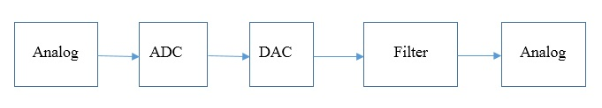
Figure: 1.2 Analog Signal Processing
1.2 NOISE
Noise is a random fluctuation in an electric signal, a characteristic of all electronic circuits. In communication system, noise is an error or undesired random disturbance of a useful information signal. The noise level in an electronic system is measured as an electrical power N in Watts or dBm, a RMS or MSE. Sound is measured based on the Amplitude & Frequency of a sound Wave. Noise is most commonly in terms of decibels, the measure of loudness or intensity of a Sound.
2.4 EXISTING SCHEME
- In existing system, Adaptive digital filters are used
- It’s not applicable for real time process
- Noise Cancellation System is available for android devices
2.5 PROBLEMS IDENTIFIED IN EXISTING SCHEME
- Use of two microphones increases the delay
- For processing it needs a higher end processor
- In order to reduce the delay this Active Noise Cancellation technique is introduced
2.6 PROPOSED SCHEME – KALMAN FILTER
Kalman Filter minimizes the mean square error of estimated parameters during estimation prediction and update techniques are used. Kalman Filter is an optimal estimator, so it gives good results. Kalman Filter is a recursive data processing algorithm that estimates the state of noisy linear dynamic system. The methodology and terms used in Kalman Filter have their influence in the design of Kalman filter. The Kalman filter processes all available measurements to estimate the state both stationery and non-stationery process.

5.5 Kalman Filter
In Kalman Filter the first thing we need is a state. The state is a description of all the parameters we will need to describe the current system and perform the prediction. For the example above, we'll use two numbers: The current vertical position (y), and our best estimate of the current slope (let's call it m). Thus, the state is in general a vector, commonly denoted x, and we of course can include many more parameters to it if we wish to model more complex systems. If all noise is Gaussian, the Kalman filter minimizes the mean square error of the estimated parameters.
Kalman Filter is a computational algorithm that processes measurements to deduce an optimum estimate of the past, present, or future state of a linear system by using a time sequence of measurements of the system behavior, plus a statistical model that characterizes the system and measurement errors, plus initial condition information.

The reasons to choose Kalman Filter can be the following.
- Good results in practice due to optimality and structure.
- Convenient form for online real time processing.
- Easy to formulate and implement given a basic understanding.
- Measurement equations need not be inverted.
Kalman Filter extensions can be the following.
- Validation gates - rejecting outlier measurements
- Serialization of independent measurement processing
- Numerical rounding issues - avoiding asymmetric covariance matrices
- Non-linear Problems - linearizing for the Kalman filter
5.6 Kalman Gain
A Kalman filter is an optimal estimator. It infers parameters of interest from indirect, inaccurate and uncertain observations. It is recursive so that new measurements can be processed as they arrive. Feedback is implemented to improve the result. We fix a value for Kalman Gain and observing the noise at the output. Until we get zero noise we keep on changing the value of Kalman Gain. When we obtain zero noise, we note the Kalman Gain value. For that Kalman Gain value the system will be designed.

CHAPTER 6
SOFTWARE TOOL / SIMULINK
  - Software Tool/Simulink
In this project, MATLAB (Matrix Laboratory) with Simulink is used for Simulation. Analyzing Data, Developing Algorithms, or Creating Models, MATLAB provides an environment that invites exploration and discovery MATLAB and add-on toolboxes are integrated with each other and designed to work together. Simulink is the block diagram environment for multi domain simulation and Model-Based design. It provides a graphical editor, Customizable block libraries and solvers for modeling and simulating dynamic systems
6.2 Simulink follows three steps
- Building the Model
- Simulating the Model
- Analyzing the Simulation Results

    - Building the Model
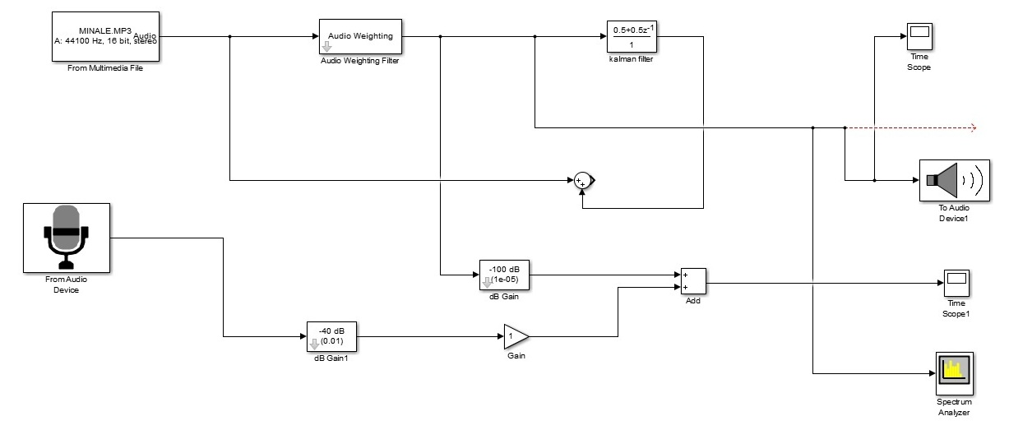
Figure: 6.1 Simulink Model
To create this model, you need four Simulink blocks. Blocks are the model elements that define the mathematics of a system and provide input signals:
- From Audio Device
- Time Scopes
- To Audio Device
- Spectrum Analyzer
- Audio Weighting Filter
- Kalman Filter

    - Simulating the Model
Modeling and simulation (M&S) refers to using models – physical, mathematical, or otherwise logical representation of a system, entity, phenomenon, or process – as a basis for simulations – methods for implementing a model (either statically or) over time – to develop data as a basis for managerial or technical decision making. M&S supports analysis, experimentation, and training. As such, M&S can facilitate understanding a system's behavior without actually testing the system in the real world. For instance, to determine which type of spoiler would improve traction the most while designing a race car, a computer simulation of the car could be used to estimate the effect of different spoiler shapes on the coefficient of friction in a turn. Useful insights about different decisions in the design could be gleaned without actually building the car.
In addition, simulation can support experimentation that occurs totally in software, or in human-in-the-loop environments where simulation represents systems or generates data needed to meet experiment objectives. Furthermore, simulation can be used to train persons using a virtual environment that would otherwise be difficult or expensive to produce. The use of M&S within engineering is well recognized. Simulation technology belongs to the tool set of engineers of all application domains and has been included in the body of knowledge of engineering management. M&S helps to reduce costs, increase the quality of products and systems, and document and archive lessons learned. M&S is a discipline on its own. Its many application domains often lead to the assumption that M&S is pure application. This is not the case and needs to be recognized by engineering management experts who want to use M&S. To ensure that the results of simulation are applicable to the real world, the engineering manager must understand the assumptions, conceptualizations, and implementation constraints of this emerging field.

    - Analyzing the Simulation Results
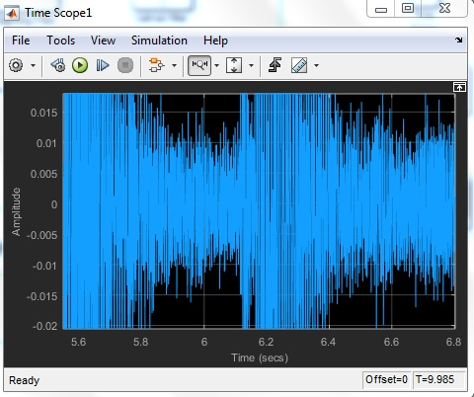
Figure: 6.2 Noisy Signal
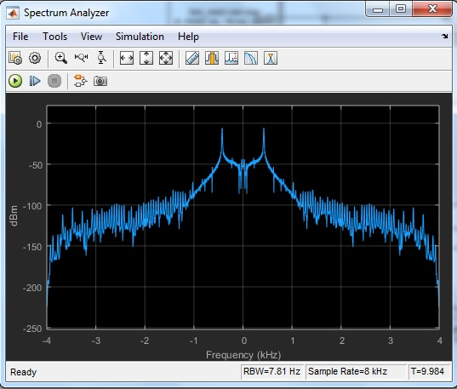
Figure: 6.3 Noiseless Signal
  - ADVANTAGES OF PROPOSED SCHEME
- Provides high definition voice calls
- Less computational complexity
- The Active Noise Cancellation system attenuates low frequency noise mostly in real life noises are below 2 KHz. So it is efficient.

  - APPLICATIONS
- Robotics
- Tracking targets in aircrafts using radar
- Weather forecasting
- Speech enhancement
- Satellite navigation systems

CHAPTER 7
RESULT / CONCLUSION
7.1 RESULT
In this project, cancel the noise which is present in the audio input signal. The outcome is the audio signal without noise. We can compare the output signal with filter and without filter. The filtered signal that does not have noise is our resultant signal.
7.2 CONCLUSION
The conclusion is to cancel the noise that is present in real time audio signals by means of designing proper Kalman Filter with required gain value. Eventually, we can experience to High Definition voice calls.
7.3 FUTURE ENHANCEMENT
In future further researches can be carried out for proper error estimation, more accurate method of gain calculation, etc., Improved audio output can be obtained by means of implementing the above methods.

REFERENCES
- Soleyman Shirzadi, Mohammed Saber Setoodeh Kia and Seyede Tahere Hashemi, (2016) “Noise Removing of Audio Speech Signals by Means of Kalman Filter”, International Journal of Advanced Biotechnology and Research, Vol-7, Special Issue3, page no. 99-100

- ER. Gaurav Badhwar, Dr. Amandeep Singh Sappal, (2016) “Noise Reduction Using Kalman Filter”, International Journal of National Trends in Engineering and Technology, Vol-7, Issue1, page no. 642-643

- Ravikanth.N and Sanket Dessai, (2012) ”Design and Development of Noise Cancellation System for Android Mobile Phones”, Vol-11,Issue 1, page no. 104-107

- Premananda B S and Dr. Uma B V, (2013) ”Speech Enhancement Algorithm to Reduce the Effect of Background Noise in Mobile Phones”, International Journal of Wireless and Mobile Networks, Vol-5, No.1, page no. 243-247

- Lakshmikanth.S, Natraj.K.R, Rekha.K.R, (2014) ”Noise Cancellation in Speech Signal Processing- A Review, International Journal of Advanced Research in Computer and Communication Engineering Vol.3, Issue 1, page no. 206-209

- C.Nandhini, S. Satheesbabu, (2015) ”Reduction of noise in GPS Using Kalman Filter”, International Journal of Innovative Research In Computer and Communication Engineering, Vol-3, Issue 11, page no. 135-138

- Bharathi, AP Shelej Khera, (2014) “Noise Reduction in Mobile Phone by using FIR, IIR and Adaptive Filter”, International Journal of Scientific Engineering and Research, vol 2, Issue 7, page no. 432-436
- M. Gabrea, E. Mandridake and M. Najim, (2003) ”A Single Microphone Noise Cancellation Based On Adaptive Kalman Filter, International Workshop on Acoustic Echo and Noise Control (IWAENC2003), Kyoto, Japan, page no. 245-247

- H. Kawahara, I. Masuda-Katsuse, and A. de Cheveigne, (2000) “Restructuring speech representations using a pitch-adaptive timefrequency smoothing and an instantaneous-frequency-based F0 extraction: Possible role of a repetitive structure in sounds, Speech Communication”, vol. 27, no. 3, page no. 187–208

- Bastian Sauert and Peter Vary, (2006) “Near End Listening Enhancement: Speech Intelligibility Improvement in Noisy Environments”, in: Proceeding of International Conference on Acoustics, Speech, and Signal Processing (ICASSP), page no. 493–496

- E. Grivel, M. Gabrea, and M. Najim, (2002) "Speech Enhancement as a Realisation Issue," Signal Processing, vol. 82, page no. 1963-1978

- T. Esch and P. Vary, (2009) “Efficient musical noise suppression for speech enhancement systems,” in Proc. IEEE Int. Conference on Acoustics, Speech and Signal Processing (ICASSP), Taipei, Taiwan, page no. 507 – 510

