MONITORING THE UNDERGROUND MINE ENVIRONMENT
CHAPTER 1
INTRODUCTION
  - AREA OF INTEREST

The disasters in underground coal mine are very serious issues to day. So the safe production of coal in the mine is an important factor to be considered. To improve the safety system in the mines, a reliable communication system must be there, between the workers of the mine, and the control base station. Wired communication system was used inside the mines, which is found to be ineffective mainly when a natural calamity or a roof fall occurred. So the reliability and long life of this conventional communication system is very poor. Due to the harsh environment inside the mine, the installation and maintenance of this wired system is very difficult also it is very difficult and costly to reinstall the entire system inside the mine after a landslide or any other damage occurred.

If the workers get trapped inside mines due to any reason, a continuous and reliable communication system is required to monitor the actual position and condition of the workers. The development of a wireless mine monitoring system. Accurately detect the temperature, pressure, flammable and poisonous gas inside mine. Also it will track the underground miners and vehicles on real time, to ensure the safety production and rescue of coal mine disaster. So a cost effective and flexible solution for the safety of underground mine workers is necessary.

Mine data communication is mainly possible through theuse of three different techniques such as through-the-wire(TTW), through-the-air (TTA), and through-theearth (TTE).Wire line communication system that exist today in most ofthe mines, has several limitations such as possibility of wire! Cable breakage and sparks or flames, etc. There is aneed to develop an online wireless network system to quicklydetect the environment conditions and accurately providelocation references to evacuate workers from the dangerouszone. But, the continuously changing underground mine,especially coal mines infrastructure possesses a number ofinherent challenges in wireless communication. There isno time-tested research available in literature that has beensuccessfully implemented in underground mines except somediscrete hand-held devices or laboratory based smalldevelopments.

The underground mine environmentcreates unique challenges, in that equipment used inhazardous areas must be explosion-proof or intrinsically safe,limiting the alternatives for communication and trackingsystems. The unique nature of the underground mineenvironment creates other impediments to new technology.Tight quarters and solid rock and coal barriers make signalpropagation difficult. Mine operations are also dynamic andunpredictable, making it difficult to determine how installedsystems will perform, and true performance may only beunderstood after systems are installed.

CHAPTER 2
SYSTEM ANALYSIS
2.1 EXISTING SYSTEM
The underground mine environment creates unique challenges, in that equipment used in hazardous areas must be explosion-proof or intrinsically safe, limiting the alternatives for communication and tracking systems. The unique nature of the underground mine environment creates other impediments to new technology. Tight quarters and solid rock and coal barriers make signal propagation difficult. Mine operations are also dynamic andunpredictable, making it difficult to determine how installedsystems will perform, and true performance may only beunderstood after systems are installed.
In last two decades, there is a tremendous development in communication technology, especially in the area of wireless transmission of data. ZigBee wireless communication protocols has provided specifications for devices that have low power, low data rates, and are thus characterized by long battery life. With the development of wireless sensor network, distributed sensor network based on agent has been raised. Wireless Sensor networks using this protocol have been used in various applications for monitoring and detecting sensitive parameters in the environment.
2.2 DISADVANTAGES OF EXISTING SYSTEM
2.2.1 WIRELESS TECHNOLOGY
Lesser range

Normally, the range of a medium-range wireless network is up to around 100 meters. This may be suitable for a home or a small office, but insufficient for larger structures. To increase the range, additional access points or repeaters will be required. This is an extra charge which increases the overall cost.
Security issues
Security is a major concern in any form of communication. Wireless networks involve the risk of modification and eavesdropping. So they make use of certain encryption techniques for security. There are also authentication mechanisms in place for the same. But it has been found that some of the encryption techniques can be easily compromised.
Reliability
Since wireless networks work with radio wave communication, the signal is affected by much interference. It is also subjected to certain propagation effects. The movement of the user also creates instability in the signals. These disturbances to the signal may become difficult to handle for the network administrator.
Less speed
The maximum speed of 802.11n standard network is 600Mbps. This is only almost half the speed of a wired network. Same is the case with all the wireless networks. When compared to wired, they are very slow. The speed further decreases in a busy network.
Lesser control
While wireless networks offer great flexibility in offices where you can work from anywhere, it becomes difficult to manage the employees. It is possible for them to work outside the office also if the signal is available. So, it may not be easy for the managers to monitor their work.
2.3 PROPOSED SYSTEM
A radio system usually includes both a source of an electromagnetic wave and an intended destination for that message. The source radio is referred to as the transmitter, while the destination radio is called the receiver. There are occasions where only the receiver is required, such as in radio astronomy. Similarly, home lighting can represent an example of an optical transmitter (usually your eyes would be the receiver, and you are usually receiving reflected signals). A digital camera would be an example of an optical receiver. Occasionally we do use light to transmit and receive information, such as the old-fashioned Aldis lamps (shuttered lamps that signal with Morse code) used by the navies of the world, or the modern-day high-speed fiber optic communication that uses diode lasers as a transmitter and photodiodes for the receivers.
RF wireless communication began at the turn of the 20th century, more than 100 years ago, when Marconi established the first successful and practical radio system. His experiment in 1895 demonstrated the transmission of radio signals a distance of 2 kilometers (Proakis & Salehi, 2002). He conducted additional experiments leading to 1901 when his radiotelegraph system transmitted radio signals across the Atlantic Ocean, from England to Newfoundland, about 1,700 miles away (“Mobile Telephone History,” n.d.). Only telegraphic codes were transmitted, however. On December 24, 1906, Reginald Fessenden accomplished the first radio communication of human speech over a distance of 11 miles from Brant Rock, Massachusetts, to ships in the Atlantic Ocean (“Mobile Telephone History,” n.d.). Radio was no longer limited to telegraph codes; it was no longer just a wireless telegraph. This was a remarkable milestone highlighting the beginning of the voice-transmitted age.
In the early years of RF wireless communication, radio broadcasting was the most deployed wireless communication technology. The invention of the vacuum tube and vacuum triode hastened the advancement in radio transmission of voice signals. Radio broadcast by way of amplitude modulation (AM) and, later by frequency modulation (FM), was made possible. Amplitude modulation of the radio frequency was used to carry information until FM was introduced in the late 1930s (Mark & Zhuang, 2003). After FM was introduced by Armstrong (Lathi, 1998), many other RF wireless systems such as television, one- and two-way radio, and radar, were introduced between the late 1920s and the mid-1950s. Another milestone was witnessed in the late 1970s, which marked the beginning of the growth in cellular mobile radios and personal communication services. The first successful commercial analog cellular mobile telephone was demonstrated in 1979 (Durgin, 2003). Currently, wireless communication of all kinds abounds in our society.
The source supplies the information to the transmitter in the form of audio, video, data, or combination of the three. The Tx and Rx combination is used to convert the signal into a form suitable for transmission and then to convert the signal back to its original form. This is achieved through the process of modulation (or encoding) at the Tx side and demodulation (or decoding) at the Rx side. The channel is the medium by which the signal propagates, such as free space, unshielded twisted pair, coaxial cable, or fiber-optic cable. In wireless communication the channel is the free space. Noise and interference is added to the signal in the channel, which increases attenuation, distortion, and eventually error in the received signal.
Because the wireless channel is not a reliable propagation medium, techniques to achieve reliable and efficient communication are necessary. In mobile channels, for example, the Rx has to constantly track changes in the propagation environment to ensure optimal extraction of the signal of interest. As the receiver moves, the surrounding environment changes affecting the received signal’s amplitude, phase, and delay. The multipath received signals are combined at the antenna either constructively or destructively. During destructive combining, the received signal may not be strong enough to produce reliable communication because of the degradation in the signal-to-noise ratio (SNR). It is not uncommon in shadowed signals for the amplitude of the received signal to drop by 30 dB or more within a distance of a fraction of a wavelength (Eng., 1996). Hence, achieving reliable communication over a wireless channel is a daunting task.
2.3.3 ADVANTAGES OF RF TECHNOLOGY
The term RF (Radio frequency) is measured in units called Hz (hertz), which denote the number of cycles/second when a radio signal is transmitted. One Hz (hertz) equals one cycle per second; radio waves range from 1,000 KHz to millions MHz to billions GHz of cycles per second. Microwaves are a kind of radio wave with higher frequencies. Radio frequencies (RF’s) are not visible to the human eye.
In a radio wave, the wavelength‘s’ is inversely proportional to the frequency ‘f”. If the frequency is measured in megahertz and the wavelength is measured in meters, thens = 300/f
As the frequency ‘f’ is enhanced beyond that of the RF spectrum, electromagnetic energy takes the type of IR, ultraviolet, visible, X-rays and also gamma rays
The characteristics of RF include the following
- Low power (Typically transmit less than 1mW of power)
- The operating range of RF is good (3 to 30meters)
- Supports data rate up to 1 to 2Mbps
- It Penetrates walls
- Does not require a direct transmission rout
CHAPTER 5
RESULTS AND DISCUSSIONS
5.1 EXPERIMENTAL RESULTS
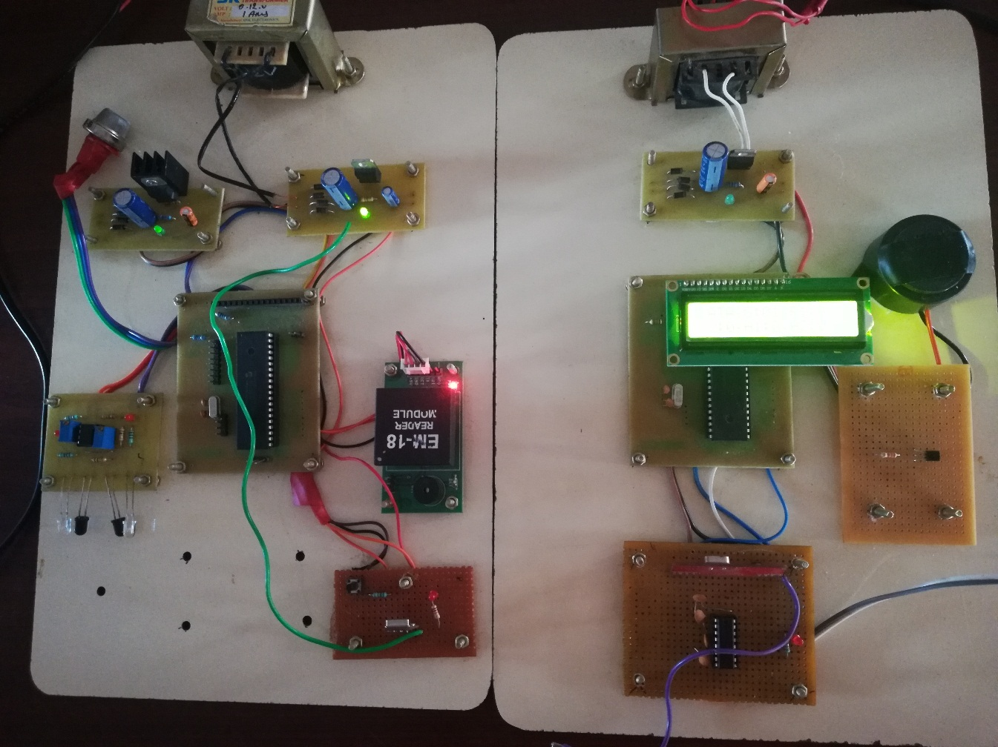
Fig. 5.1 Mine Environment Monitoring kit

5.2 HARDWARE OUTPUT

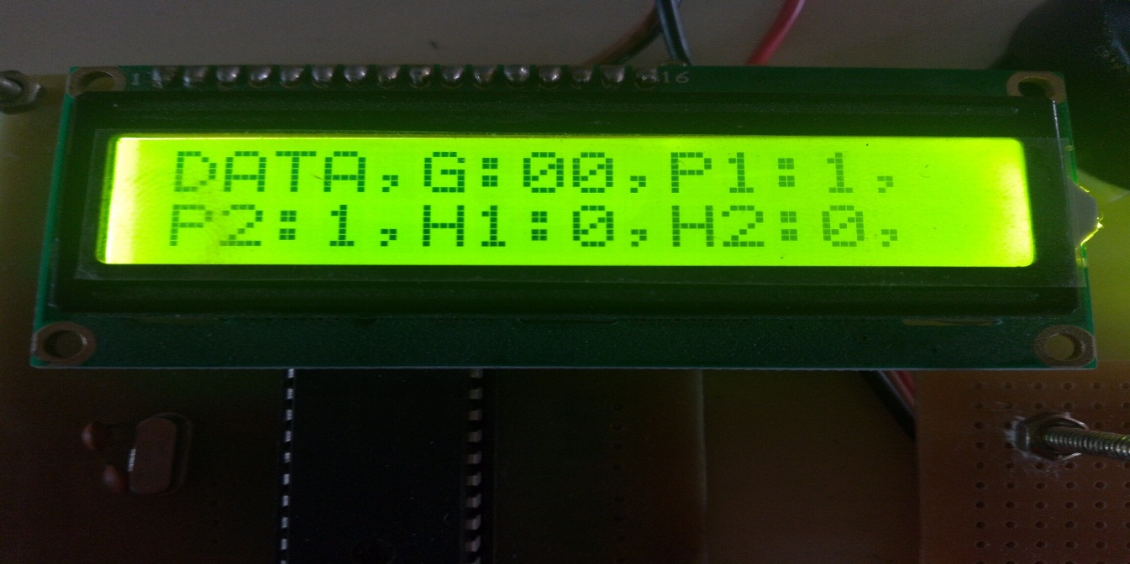
Fig. 5.2 LCD Output

5.3 SOFTWARE OUTPUT


Fig. 5.3 Software Output

CHAPTER 6
CONCLUSIONS & FUTURE ENHANCEMENTS
6.1 CONCLUSION
As the accidents and hazards inside coal mines are increasing now a day, a coal mine safety system seems to be very useful and relevant. With the help of the coal miner's helmet itself, we could sense the undesirable environmental parameters like temperature, humidity and methane gas inside the coal mine and could communicate efficiently through a most reliable and cost effective wireless communication system.
Sensing of different parameters and communication up to a length of 8 to 9 meters was observed in the final test. By properly fixing appropriate power ratings, this model is expected to fit for practical industrial applications. On time voice communication can also be provided with a microphone loud speaker set. Alerts can be given along with alarming tones which will be more noticeable. By minimization of all the components, size and weight of the circuit can be reduced to a much comfortable level.
6.2 FUTURE ENHANCEMENTS
Mine improvement and emergency response act (2006) in U.S. mines helped in undergoing rapid changes in the area of communication, tracking. Most of the researches proposed their work are hybrid of wired and wireless technologies. Low frequency(LF), medium frequency (MF), High frequency (HF) range signal transmission both independently and with parasitic coupling tried earlier, are least suitable for underground application for their limited information sharing and communication distance coverage (due to attenuation).
It is observed from the research works, VHF and UHF range transmission work better in underground especially in line-of-sight applications. Significant advances are there in UHF technologies in recent times which can overcome electromagnetic noise and accommodate high traffic. But those require lot of infrastructure like repeaters, routers to overcome the attenuation around bending.

Ultra wideband (UWB) technology also can be a better solution with its low power consumption, but having a limitation of short range coverage. The underground mine infrastructure is continuously changing which demands reconfiguration of wireless access points to maintain the network integrity. Blinds spots also occur regularly resulting missed assignments and reduced efficiencies. The previous researchers did not take care that issue. Moreover, they did not consider the power requirement and power supply intrinsic safety issues in their proposed hardware system.

Most of the cases, they did not test their system in real underground mines considering all the practical aspects. Recently advanced wireless multi-hop mesh network automatically locates, optimizes path and configures sensor nodes or access points within its range and this can be integrated with the existing mine computer network. The sensor nodes for their miniature size, low power and mobility, can be attached with the mine workers, resulting a flexible expandable mobile information network. So, there is tremendous scope of future research in this direction.

REFERENCES
- L. Mallet, C. Vaught, and M. J. Brnich Jr. (1993), “Sociotechnical communication in an underground mine fire: A study of warning messages during an emergency evacuation,” Safety Sci., vol. 16, no. 5, pp. 709–728.
- P. S. Paul. V.(2001), "Evaluation of Work Postures and Workload Related to Different Operations in Underground Coal Mining," M.E. Thesis, Department of Mining and Geology, B. E. College (DU), Howrah,pp. 46.
- X.-G. Niu, X.-H. Huang, Z. Zhao, Y.-H. Zhang, C.-C. Huang, and L.Cui. (2007), “The design and evaluation of a wireless sensor network for mine safety monitoring,” in Proc. IEEE GLOBECOM, pp. 1230–1236.
- M. Li and Y.-H. Liu. (2009), “Underground coal mine monitoring with wireless sensor networks,” ACM Trans. Sens. Netw., vol. 5, no. 2, pp. 1–29.
- Jie Cheng, Dianwu Gao, Junfei Wang and Dongge Wen. (2013), “Coal mine safety monitoring system based on ZigBee and GPRS”, Applied Mechanics and Materials, vol. 422, pp 215-220.
- G. Divya, B.A Sarath Manohar Babu. (July 2014), “Rescue System for Coal Mine Workers using Different Sensors Based on GSM and RF-PRO”, International Journal of Advanced Research in Computer Engineering& Technology, vol. 3, issue 7.
- Wu Li Song, Jing Qiao. (2015), "Research of Mine-shaft Wireless Sensor Network Based on Agent," International Conference on Education, Management, Commerce and Society (EMCS), pp.563-569.
- yogendra Singh Dohare, Tanmoy Maity, P. S. Paul, Hanuman Prasad. (2016), “A Smart low power wireless sensor network for underground mine environment monitoring,” 3rd Int'l Conf. On Recent Advances in Information Technology, RAIT-2016.

