INDOOR BLIND NAVIGATION USING VISIBLE LIGHT COMMUNICATION
CHAPTER 1
INTRODUCTION
The Blind person navigation system can be used in house, hospitals where the blind people are living. The system consists of indoor transmitter section and blind person receiver section. The transmitter section is kept in the indoor and receiver section given to blind person. Whenever the Li-Fi receiver receives the data from transmitter section, it gives voice output using voice playback IC either that is hall or bed room. The entire function is managed by microcontroller.
Wi Fi is great for general wireless coverage within buildings whereas Li-Fi is ideal for high density wireless data coverage in confined area and for relieving radio interference issues so the two technologies can be considered complimentary. The typical range of a common 802.11g network with standard equipment is o n the order of tens of meters. Range is insufficient for larger structures and needs repeaters .Costs for these items add up quickly. The speed on most wireless networks is typically 1 to 54 Mbps far slower than even the slowest common wired networks (100 Mbps up to several Gbps).
Li-Fi technology is based on Light emitting diodes (LEDs) for the transfer of data. The data transfer is carried out with the help of all kinds of light, no matter the part of the spectrum that they belong. That is, the light can belong to the invisible, ultraviolet or the visible part of the spectrum. The speed of the internet is incredibly high (100 times faster than Wi-Fi) and in just a few minutes’ movies, games, music etc can be downloaded with the help of this technology. Also, this technology removes limitations that have been put on the user by the Wi- Fi. There is no need to be in a region that is Wi-Fi enabled to have access to the internet. The persons can simply stand under any form of light and surf the internet as the connection is made in case of any light presence. There cannot be anything better than this technology.

  - EMBEDDED SYSTEMS
An embedded system can be defined as a control system or computer system designed to perform a specific task. An embedded system can also be defined as a single purpose computer.
- Perform a single task
  - Usually not general purpose
- Increasingly high performance and real time constrained
- Power, cost and reliability are important considerations
- HW-SW systems
  - Software is used for more features and flexibility
  - Hardware (processors, ASICs, memory etc. are used for performance and security
An embedded system is a specialized computer system that is part of a larger system or machine. Typically, an embedded system is housed on a single microprocessor board with the programs stored in ROM. Virtually all appliances like watches, microwaves, VCRs and cars have digital interface that utilize embedded systems. Some embedded systems include an operating system, but many are so specialized that the entire logic can be implemented as a single program.
Most embedded systems are time critical based applications meaning that the embedded system is working in an environment where timing is very important; the results of an operation are only relevant if they are obtained in a specific time frame.
1.4 THE PROPOSED SYSTEM
High brightness LED which act as a communication source. The transmitter unit is fitted to the wall/ceiling. In the transmitter the modulated information is transmitted through LED. The data is fed into LED light bulbs, it then sends data at rapid speeds to photodiode. If The Receiver detect the place means the Voice recoded circuit switch on the voice alerts.

CHAPTER 2
OVER VIEW OF PROPOSED SYSTEM
INTRODUCTION
The Proposed system’s block diagram consists of the following components. power supply will give operating to supply to microcontroller and other components. The LiFi transmitter is used to transmit a light signal to receiver section, Lifi reader is used to read the light signal which transmitted from LiFi transmitter.
POWER SUPPLY
All power supplies have a power input, which receives energy from the energy source, power supply that delivers energy to the load. In most power supplies the power input and output consist of electrical connectors or hardwired circuit connections, though some power supplies employ wireless energy transfer in lieu of galvanic connections for the power input or output. Some power supplies have other types of inputs and outputs as well, for functions such as external monitoring and control.
Transformer
Rectifier
Filter
IC regulator
Load

Figure .3.9 Block Diagram For Power Supply.
The transformer steps down the 120V AC supply to 12 V AC supply. The rectifier Converts the AC to DC. The filter converts the pulsated DC into uniform DC. The IC regulator regulates 12V DC into 5V and it is given to the controller. The ATmega 328 is compatible to work with 5V.
CHAPTER 4
SOFTWARE DESIGN

4.1 MP LAB IDE

4.1.1 An Overview of MP LAB IDE
MPLAB IDE is a Windows Operating System (OS) software program that runs on a PC to develop applications for Microchip microcontrollers. It is called an Integrated Development Environment, or IDE, because it provides a single integrated "environment" to develop code for embedded microcontrollers. Experienced embedded systems designers may want to skip ahead to Components of MPLAB IDE. It is also recommended that MPLAB IDE On-line Help and MPLAB IDE Updates be reviewed. The rest of this chapter briefly explains embedded systems development and how MPLAB IDE is used.
Implementing an Embedded System Design with MPLAB IDE
A development system for embedded controllers is a system of programs running on a desktop PC to help write, edit, debug and program code - the intelligence of embedded systems applications - into a microcontroller. MPLAB IDE runs on a PC and contains all the components needed to design and deploy embedded systems applications. The typical tasks for developing an embedded controller application are:

- Create the high level design. From the features and performance desired, decide which PIC MCU or dsPIC DSC device is best suited to the application, then design the associated hardware circuitry. After determining which peripherals and pins control the hardware, write the firmware - the software that will control the hardware aspects of the embedded application. A language tool such as an assembler, which is directly translatable into machine code, or a compiler that allows a more natural language for creating programs, should be used to write and edit code. Assemblers and compilers help make the code understandable, allowing function labels to identify code routines with variables that have names associated with their use, and with constructs that help organize the code in a maintainable structure.
- Compile, assemble and link the software using the assembler and/or compiler and linker to convert your code into "ones and zeroes" - machine code for the PIC MCUs. This machine code will eventually become the firmware (the code programmed into the microcontroller).
- Test your code. Usually a complex program does not work exactly the way imagined, and "bugs" need to be removed from the design to get proper results. The debugger allows you to see the "ones and zeroes" execute, related to the source code you wrote, with the symbols and function names from your program. Debugging allows you to experiment with your code to see the value of variables at various points in the program, and to do "what if" checks, changing variable values and stepping through routines.
- "Burn" the code into a microcontroller and verify that it executes correctly in the finished application. Of course, each of these steps can be quite complex. The important thing is to concentrate on the details of your own design, while relying upon MPLAB IDE and its components to get through each step without continuously encountering new learning curve.

Step 1 is driven by the designer, although MPLAB IDE can help in modeling circuits and code so that crucial design decisions can be made. MPLAB IDE really helps with
steps 2 through 4. Its Programmer's Editor helps write correct code with the language tools of choice. The editor is aware of the assembler and compiler programming constructs and automatically "color-keys" the source code to help ensure it is syntactically correct. The Project Manager enables you to organize the various files used in your application: source files, processor description header files and library files. When the code is built, you can control how rigorously code will be optimized for size or speed by the compiler and where individual variables and program data will be programmed into the device. You can also specify a "memory model" in order to make the best use of the microcontroller's memory for your application. If the language tools run into errors when building the application, the offending line is shown and can be "double clicked" to go to the corresponding source file for immediate editing. After editing, press the "build" button to try again. Often this write-compile-fix loop is done many times for complex code as the sub-sections are written and tested. MPLAB IDE goes through this loop with maximum speed, allowing you to get on to the next step.
Once the code builds with no errors, it needs to be tested. MPLAB IDE has components called "debuggers" and free software simulators for all PIC MCU and PIC DSC devices to help test the code. Even if the hardware is not yet finished, you can begin testing the code with the simulator, a software program that simulates the execution of the microcontroller. The simulator can accept a simulated input (stimulus), in order to model how the firmware responds to external signals. The simulator can measure code execution time, single step through code to watch variables and peripherals, and trace the code to generate a detailed record of how the program ran. Once the hardware is in a prototype stage, a hardware debugger, such as an in-circuit emulator or an in-circuit debugger, can be used. These debug tools run the code in real time.

Actual application by using special circuitry built into many devices with Flash program memory. They can "see into" the target microcontrollers program and data memory, and stop and start program execution, allowing you to test the code with the microcontroller in place on the application.
After the application is running correctly, you can program a microcontroller with one of Microchip's device or development programmers. These programmers verify that the finished code will run as designed. MPLAB IDE supports most PIC MCUs and all PIC DSCs.
HI-TECH Software is an Australian-based company that provides ANSI C compilers and development tools. Founded in 1984, the company is best known for its HI-TECH C PRO compilers with whole-program compilation technology, or Omniscient Code Generation (OCG).
HI-TECH Software was bought by Microchip on 20 February 2009, whereupon it refocused its development effort exclusively on supporting Microchip products. Microchip Technology PIC10, PIC12, PIC14, PIC16, PIC18, PIC24, PIC32 and dsPICHI-TECH Software has also provided compilers for the following manufacturers and architectures, but none of them are advertised since the Microchip acquisition.
CHAPTER 5
IMPLIMENTATION AND TESTING
5.1 IMPLIMENTATION
The proposed project is implemented by dumping the source code programmed according to the hardware setup. The blind person who has entered into the room or any other place in home and the technology Light Fidelity (Li-Fi) is used for giving information to the blind person. The led’s are acting as a transmitter unit fitted to the wall /ceiling. The light input for the receiver through Photo diode. In receiver side the Photo diode is used to demodulates the coded binary data and then generates original data. The data is processed and according to that micro controller initiates the transfer of data. Based on the location, the voice play back IC provides voice alerts about present location of visually challenged person.
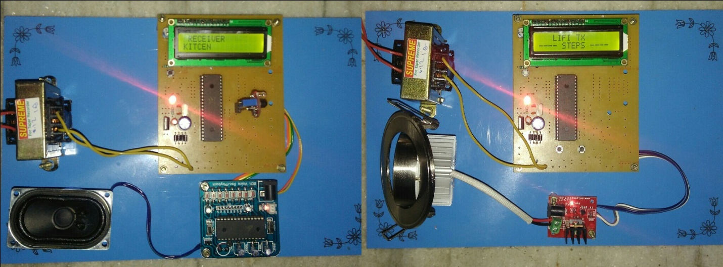Figure .5.1 Prototype Model of Proposed System

5.1.1 OUTPUTS SHOWN IN LCD DISPLAY
Here some snapshots comprising of LCD outputs.
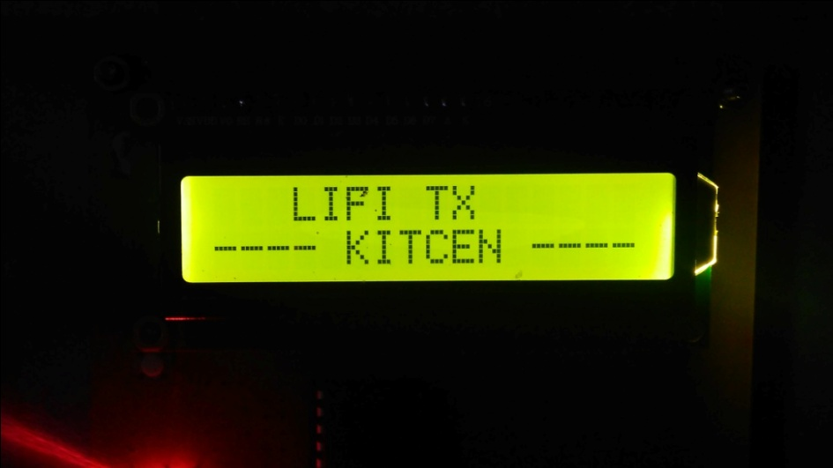

Figure: .5.2 Snapshot when blind person is in Kitchen(Transmitter)
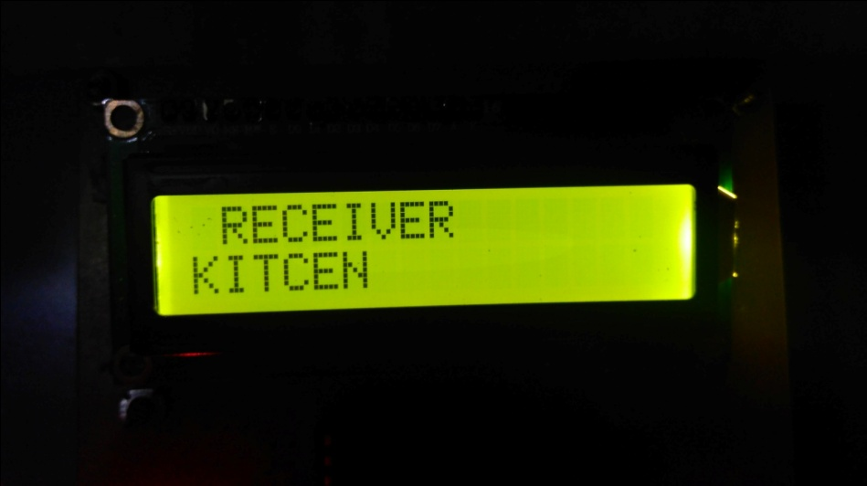
Figure: .5.3 Snapshot when blind person is in Kitchen(Receiver)

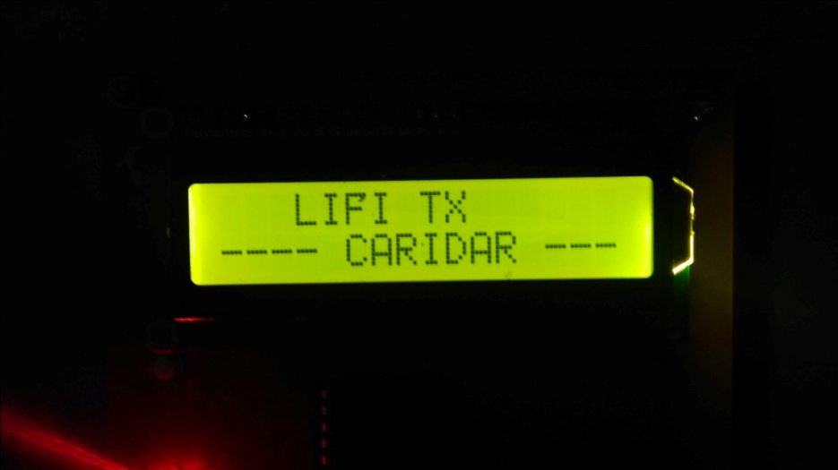
Figure: .5.4 Snapshot when blind person is in corridor (Tansmitter)

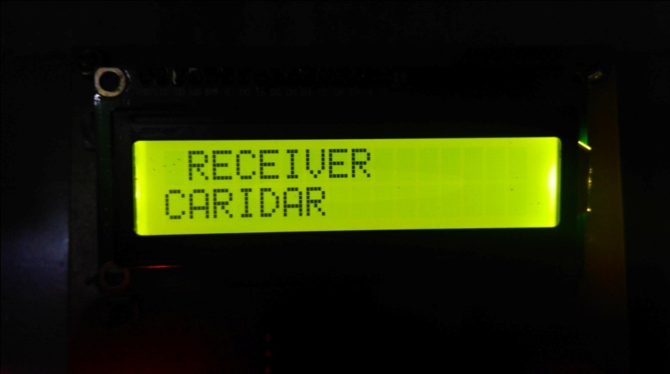
Figure: . 5.5 Snapshot when blind person is in corridor (Receier

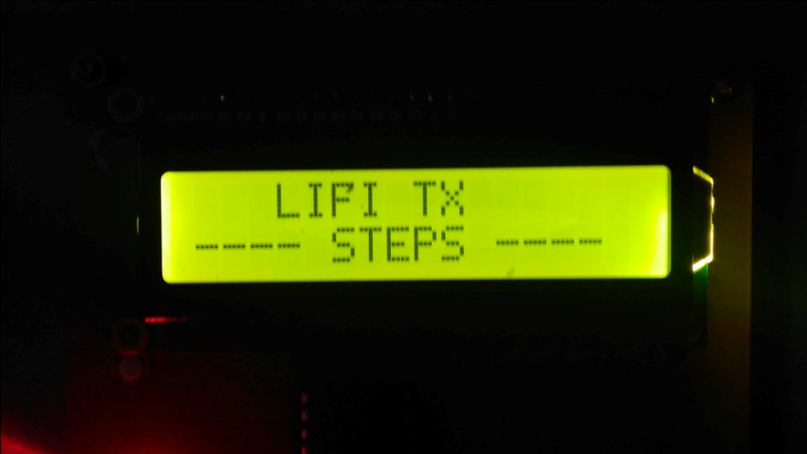
Figure: .5.6 Snapshot when blind person is in steps (Tansmitter)

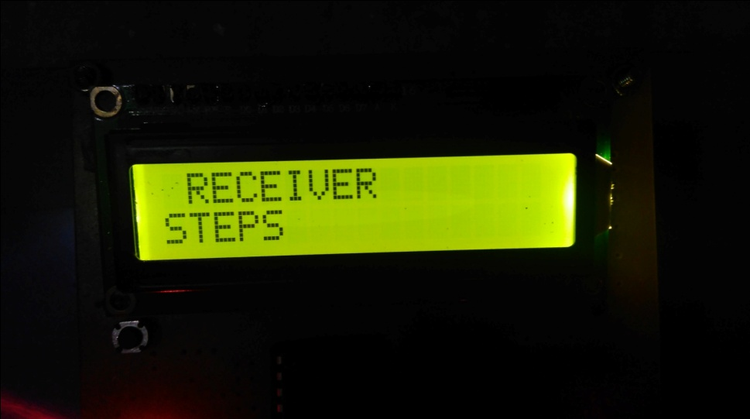
Figure:. 5.7 Snapshot when blind person is in steps (Receier)

CHAPTER 6
CONCLUSION
The blind person navigation system helps blind person by indicating them with a voice message whenever a person enters the room. This will inform the blind people about the person who has entered into the room. In existing system, the reliability is poor, data can be easily hacked. This method provides a cheap and highly reliable way transmit data.
The proposed method can be integrated into medical devices and in hospitals as it can easily be used in such places where Bluetooth, Infrared, Wi-Fi and internet are banned. Imagining blind persons walking into a Mall where GPS signals are unavailable but the mall is equipped with ceiling bulbs that create their own “Constellation’’ of navigation beacons.

REFERENCES
- V.Revathi, A.Santhi, V.Vishali, S.Vishnupriya, S.Chitra,(2016) “Blind Person Intimation Through Predefined Voice Alert”. An international joural of advanced computer and technology ISSN:2320-0790.

- H.Yang, E-M. Jung, and S-K. Han, (2013), “ Indoor Location Estimation Based On LED Visible Light Communication Using Multiple Optical Receivers”, IEEE commun.Lett.,vol.17,no.9, pp.1834-1837.

- Syeda Mahin, V.Srikanth Kumar., R.Amith Kumar, M.Sumera Banu, Sv. Sukumar. “Li-Fi Based Blind Indoor Navigation System For Visually Impaired People.”, International Journal of Emerging Research in Management &Technology ISSN: 2278-9359 (Volume-5).

- A.Burton.Z, Ghassembly,S.Rajbhandari, and S - K. Liaw. C, (2014), “Design And Analysis Of An Angular Segmented Full Mobility Visible Light Communications Receiver”. Trans. Emerging Telecommun. Tech. vol.25, no.6, pp.591-599.

- S,-W.Ho, J.Duan and C.S.Chen, (2015), “Location-Based Information Transmission Systems Using Visible Light Communications” Trans.Emerging Telecommun.Tech.

- H.Elagala, R.Mesleh,and H.Haas, (2013), “Indoor Optical Wireless Communication Potential And State-Of-The-Art”, IEEE communication.mag.vol.49, no.9, pp.56- 62.

- D.Tsonev, S.Sinanovic, and H.Haas, (2013), “Practical MIMO capacity for indoor optical wireless communication with white LEDs” ,in proc. IEEE VTC –Spring , pp.1.

